Unit 3 Labs

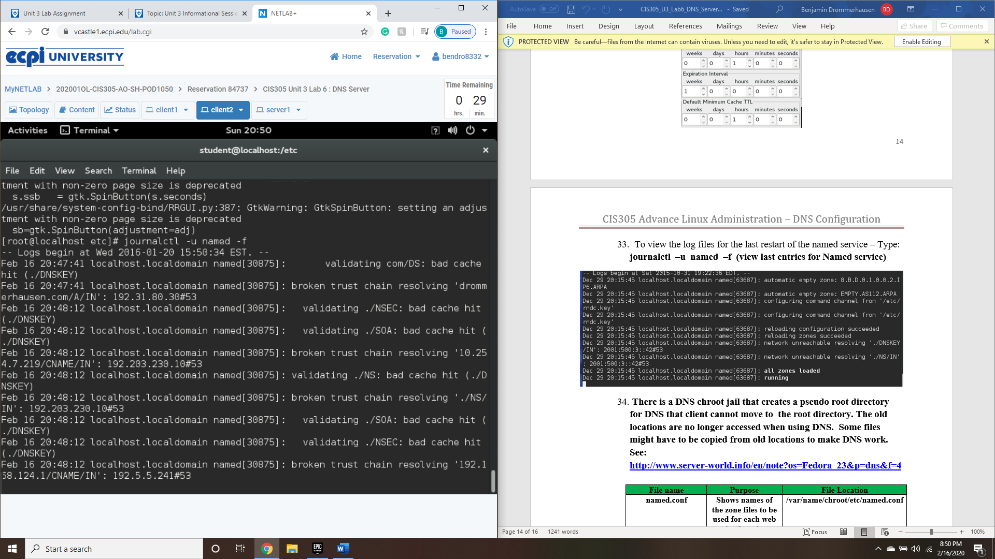

Lab6 covers setting up and configure a DNS server, as well as how to operate it (turn on/off and tie to boot). Also, went over how to access and read resource records and installation of chroot tool.

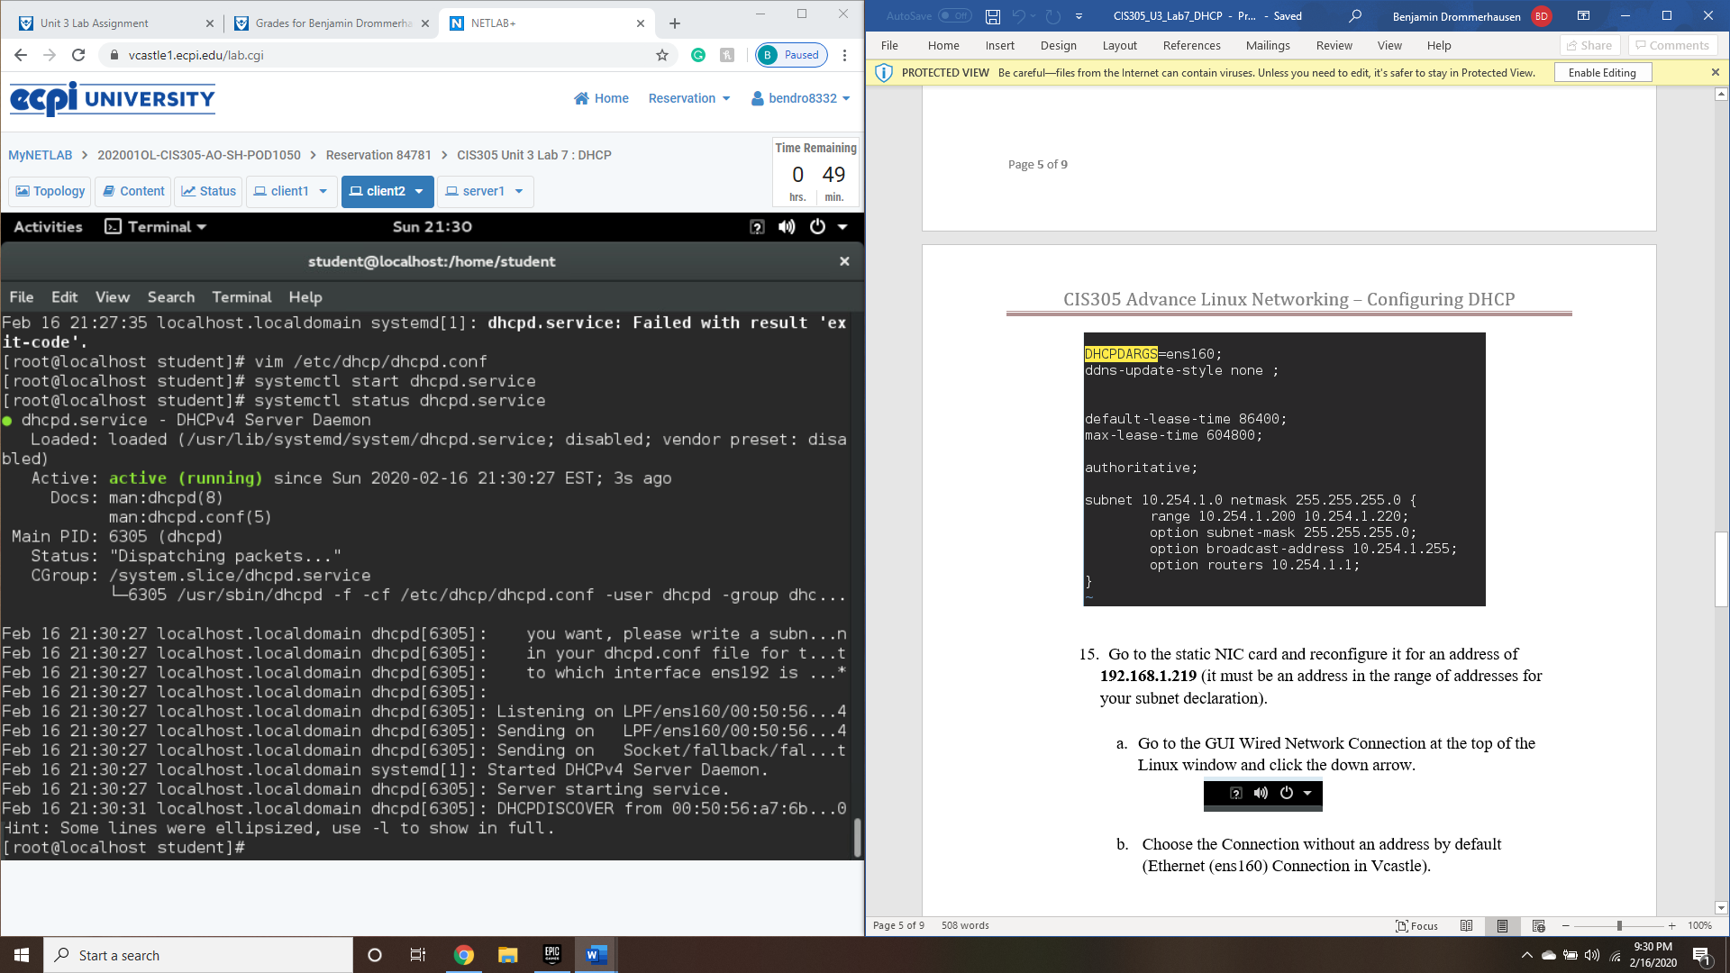

Much like lab6, lab 7 focuses on setting up a DHCP server rather than a DNS. Configuration, installation, and dulling out IP addresses are the primary points in this exercise.