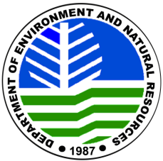
RELEASE FROM LIABILITY AND WAIVER OF ALL CLAIMS
(WARNING: By signing this document you give up the right to sue)

I ____________________ of legal age, Filipino citizen , hereby renounce or waive any and all claims I may have against and release from all liability and agree not to sue the Department of Environment and Natural Resources, the Office of the Protected Area Superintendent and/or any of its authorized representatives, the Protected Area Management Board of Northern Negros Natural Park for any untoward incident(s) / accident(s) that may result to my injury, death, and property damage or loss sustained by me as a consequence of circumstances beyond human control, or force majeure in nature, or otherwise directly or indirectly due to negligence of recklessness on the part of the expedition/ climbing party, arising out of our participation in mountaineering activity at Northern Negros Natural Park.

Further, the PAMB, DENR, PASu and/ or any of their authorized representatives, are not to be held liable/ responsible for any circumstances brought about by natural agents that may directly or indirectly affect, delay, or cause the abortion/ cancellation of a duly approved and already processed application.

I am aware that mountaineering in Northern Negros Natural Park has extreme dangers and risks. Furthermore, I was properly oriented on the terms and conditions of the mountaineering permit and I am taking full responsibility and willingly accept all the risks involved in my trek/ climb at Northern Negros Natural Park.

I am physically fit to undergo this seriously strenuous endeavor.

NAME | ADDRESS | SIGNATURE | ID NO.

Subscribed and sworn to before me this _____ day of at ________________________, Philippines. Affiant exhibited to me his/her Passport or CTC No. _____________ issued on ________________ at _______________.

_______________________________
Notary Public

Doc. No. ___________
Page No. ___________
Book No. ___________
Series No. ___________

