Module 13 - Advanced Automation and Scripting

Module 13
Advanced Automation and Scripting
PFEBSIT 002 - Integrative Programming and Technologies 2 IT Free Elective 2 - First Semester, A.Y. 2026-2027 University of La Salette, Inc. - College of Information Technology
Learner | WILLIAM BENEDICT R BINWAG
Student number | 22-11990
Course outcome alignment | CLO1, CLO3, CLO4, CLO5
System under test | Clinic Follow-Up Reminder System - backend/ (Express 5, ESM) and lib/ (Flutter Web)
Bounded workflow | follow_up_reminder
Repository / branch | https://github.com/benedict003/clinic-follow-up-reminder-system/ main
Commit under test | commit 352582f  commit c44ff90  commit 54289b1  commit f9f7851
Submission date | [[DATE]][[DATE]]

1. Purpose and scope of this document
This report documents a bounded automation workflow added to the Clinic Follow-Up Reminder System. When a clinic staff member queues a follow-up reminder, a durable job validates the follow-up record, calls a bounded notification service, records one auditable attempt, and either marks the follow-up as reminded or routes it to the doctor role for a human decision.
The report is evidence-first: every claim refers to a file, a command, a log line, or a database query that another learner can re-run. Expected values were written before execution; the Actual column records what the tools reported.
In scope: one workflow, one trigger, one external call, one audit trail, one escalation path, and the Flutter Web screens needed to observe and resolve it.
Out of scope: real notification providers, credentials of any kind, patient contact details, changes to clinical rules, multi-worker scaling, and production deployment. Section 17 states the limitations that follow from these exclusions.

2. Environment and laboratory log
Field | Value
Date started | [[ENV1]][[ENV1]]
Operating system | Windows 11 64bit
Node / npm | Node v22.11.0 / npm 10.9.0
Flutter / Dart | Flutter 3.27.1 / Dart 3.6.0 (web target)
Browser | Chrome (web) in android studio
Database | clinic_followup_lab
Backend start line | listening on 127.0.0.1:3400, then {""src"":""worker"",""event"":""worker.started"",""pollMs"":2000,""maxAttempts"":4,""timeoutMs"":3000}
Mock gateway start line | mock gateway on http://127.0.0.1:4699/notify (mode=ok)
Flutter web build | flutter build web --release completed with no analyzer issues; main.dart.js served from backend/public/app/
Execution window (PHT) | 2026-10-29 19:06 to 21:58 PHT (11:06 to 13:58 UTC, from the first and last structured log lines)
Approved scope authority | [[ENV11]][[ENV11]]
Where a value could not be captured, write "not recorded in this build" and explain it in Section 13. Do not estimate a timestamp or a version.

3. The bounded workflow

3.1 Classification
This is integration automation, not task automation: it replaces a manual hand-off between the follow-up register and an external reminder channel, rather than one person's keystrokes. It is deliberately narrower than business-process automation, which would also own scheduling and clinical decisions; those remain human actions.

3.2 Actors and trigger
Actor | Role in the workflow | Trust position
Nurse | Creates the follow-up and queues the reminder | Authenticated staff; session and CSRF required
Worker | Claims, re-validates, calls, records, escalates | Server process; no user session
Mock gateway | Bounded external notification service | Untrusted; may fail, delay, reject, or vanish
Doctor | Resolves a job that needs a human; retries with a reason | Authenticated staff; role-gated
Reviewer | Reads the evidence folder | Read-only repository access
Trigger: POST /api/reminder-jobs with { "followUpId": n }. A follow-up may only be queued when its status is scheduled and its due date is today or earlier. Successful delivery moves the follow-up to reminded and increments its version, so it cannot be queued twice by accident.

3.3 Trusted inputs and validation
Field | Rule | Enforced at
followUpId | Positive whole number; the follow-up must exist | Enqueue (400 / 404)
Follow-up status | Must be scheduled | Enqueue (409) and at claim (obsolete)
Due date | Today or earlier, in the server's local date | Enqueue (409)
followUpVersion | Read from the database, never from the client | Enqueue; compared again at claim
Payload content | No patient name, no contact details, no free text | By construction - only ids are sent
Endpoint host | Loopback only | assertLocalEndpoint() at startup

3.4 Processing steps
- Enqueue - read the follow-up, verify scheduled and due, compute the idempotency key from (followUpId, version), insert a queued row with a correlation id.
- Claim - one row per tick using SELECT ... FOR UPDATE SKIP LOCKED; set running and increment attempts.
- Re-validate - re-read the follow-up. If its status changed or its version advanced, close the job as obsolete without calling the gateway.
- Call - POST the gateway with a 3000 ms abort signal, a correlation id and an Idempotency-Key.
- Classify - 2xx succeeded; 408, 425, 429, 5xx, network error, timeout is transient; other 4xx is permanent.
- Record - one immutable reminder_attempts row per call, written in the same transaction as the job state change.
- Schedule or escalate - reschedule with exponential backoff and jitter while attempts remain; otherwise needs_human plus a reminder_alerts row addressed to the doctor role.
- Resolve - a doctor retries with a recorded reason (bounded extension) or acknowledges the alert.

3.5 Outputs
- reminder_jobs - current state, attempt count, last error, correlation id
- reminder_attempts - insert-only audit trail, one row per call and per human action
- reminder_alerts - role-addressed, acknowledgeable
- structured JSON logs on stdout carrying a correlation id and no personal data
- Flutter Web screens listing states, attempt timeline, and the reasoned retry control

3.6 External dependencies
Exactly one: the local mock gateway at http://127.0.0.1:4699/notify, implemented with node:http and no third-party packages. Its behaviour is switched at run time through POST /_/mode, so failure cases need no code change. MySQL is the only other service.

3.7 Explicit non-goals
- No real SMS or email provider; no credentials or private keys anywhere in the repository.
- No patient name, address, contact number, or diagnosis in payloads, logs, or screenshots.
- No exactly-once guarantee across a process crash; at-least-once with an idempotency key.
- No horizontal scaling; the worker is a single in-process poller.
- No editing of a queued payload through the API.
- No change to clinical rules or to the existing follow-up register behaviour.

4. Decision record - ADR-001
Context. The register already exposes POST /api/follow-ups. The obvious shortcut is to notify from inside that request. That couples an external channel to a write the nurse is waiting on: a provider outage would either block the response or fail a record that was already saved, and no attempt trail would exist.
Decision question. Should the reminder be sent inline during the queue request, produced by a scheduled sweep, or handled by a durable outbox drained by a polled worker?
Option | Reliability | Security | Performance | Effort | Verdict
A. Inline call in the request | Poor - provider failure fails a saved record; no audit | Neutral | The request waits on the network | None | Rejected
B. Scheduled sweep | Missed windows are invisible; no per-item backoff; duplicates if runs overlap | Neutral | Cheap | Low | Rejected
C. Durable outbox with polled worker | Bounded attempts, backoff, durable audit, crash reclaimer, stale-row handling | Same boundary, less coupling | Queue request returns immediately | Moderate | Selected
D. Message broker | Best - dead-letter queue, mature retry | Adds a service and credentials | Best | High | recorded as the scale-up path
Consequences. A provider outage can no longer fail the nurse's action; every call leaves one immutable attempt row; retries are capped and giving up produces a role-addressed alert. Against that: delivery is at-least-once, not exactly-once, so a crash after the gateway accepts but before the commit can re-send, mitigated only by the idempotency key; throughput is one job per tick by construction; and the workflow creates a new operational duty, because someone must read the needs_human alerts.
Review condition. Revisit above roughly 30 queued reminders per minute sustained, if a second worker becomes necessary, or when a real provider with its own idempotency contract is supplied.

5. Pattern comparison
Criterion | Schedule | Queue + worker | Inbound webhook | CDC | Inline call
Latency to first attempt | up to one interval | at most the poll interval (2 s) | immediate | near-immediate | 0
Missed-event risk | High and invisible | Low - rows persist | High if the caller does not retry | Tied to log retention | None
Duplicate delivery | Overlapping runs | Possible on crash; mitigated by key | Caller re-posts | Replay | Double click
Clock and timezone effects | Material - due dates are date-only | None for processing (epoch timestamps) | None | None | None
Ordering | Run order | Not guaranteed between jobs | None | Log order | Strict
Back-pressure | Poor | Good - one row at a time | Caller decides | Poor | Blocks the user
Operational cost | Needs a scheduler the lab host lacks | One process, one table | Inbound authentication to design | Binlog tooling | None
Fit for this workflow | Poor | Good | Not applicable | Overkill | Anti-pattern here

6. Trigger contract
Field | Contract
Producer | POST /api/reminder-jobs, role nurse or doctor
Authorization | Session cookie plus X-CSRF-Token on every non-GET request
Payload | { "followUpId": n } only. No patient identity, no contact details, no free text
Validity at enqueue | Follow-up exists, status is scheduled, due date is today or earlier; otherwise 404 or 409
Validity at claim | Re-read; still scheduled and same version means send; otherwise close as obsolete with no call
Idempotency | Unique key sha256("follow_up_reminder|followUpId|version"); a repeat returns 200 with deduplicated: true
Acknowledgement | 201 means durably queued, not delivered
Rejections | 400 malformed - 401 no session - 403 no CSRF or wrong role - 409 conflicting state
Timing | Enqueue under 300 ms; first attempt within one poll interval plus the timeout
Bounded processing | max_attempts 4, then needs_human; doctor retry adds 2, hard cap 10
Terminal states | succeeded (never retried), needs_human (human only), obsolete (closed, no human needed)

7. Data flow and trust boundaries
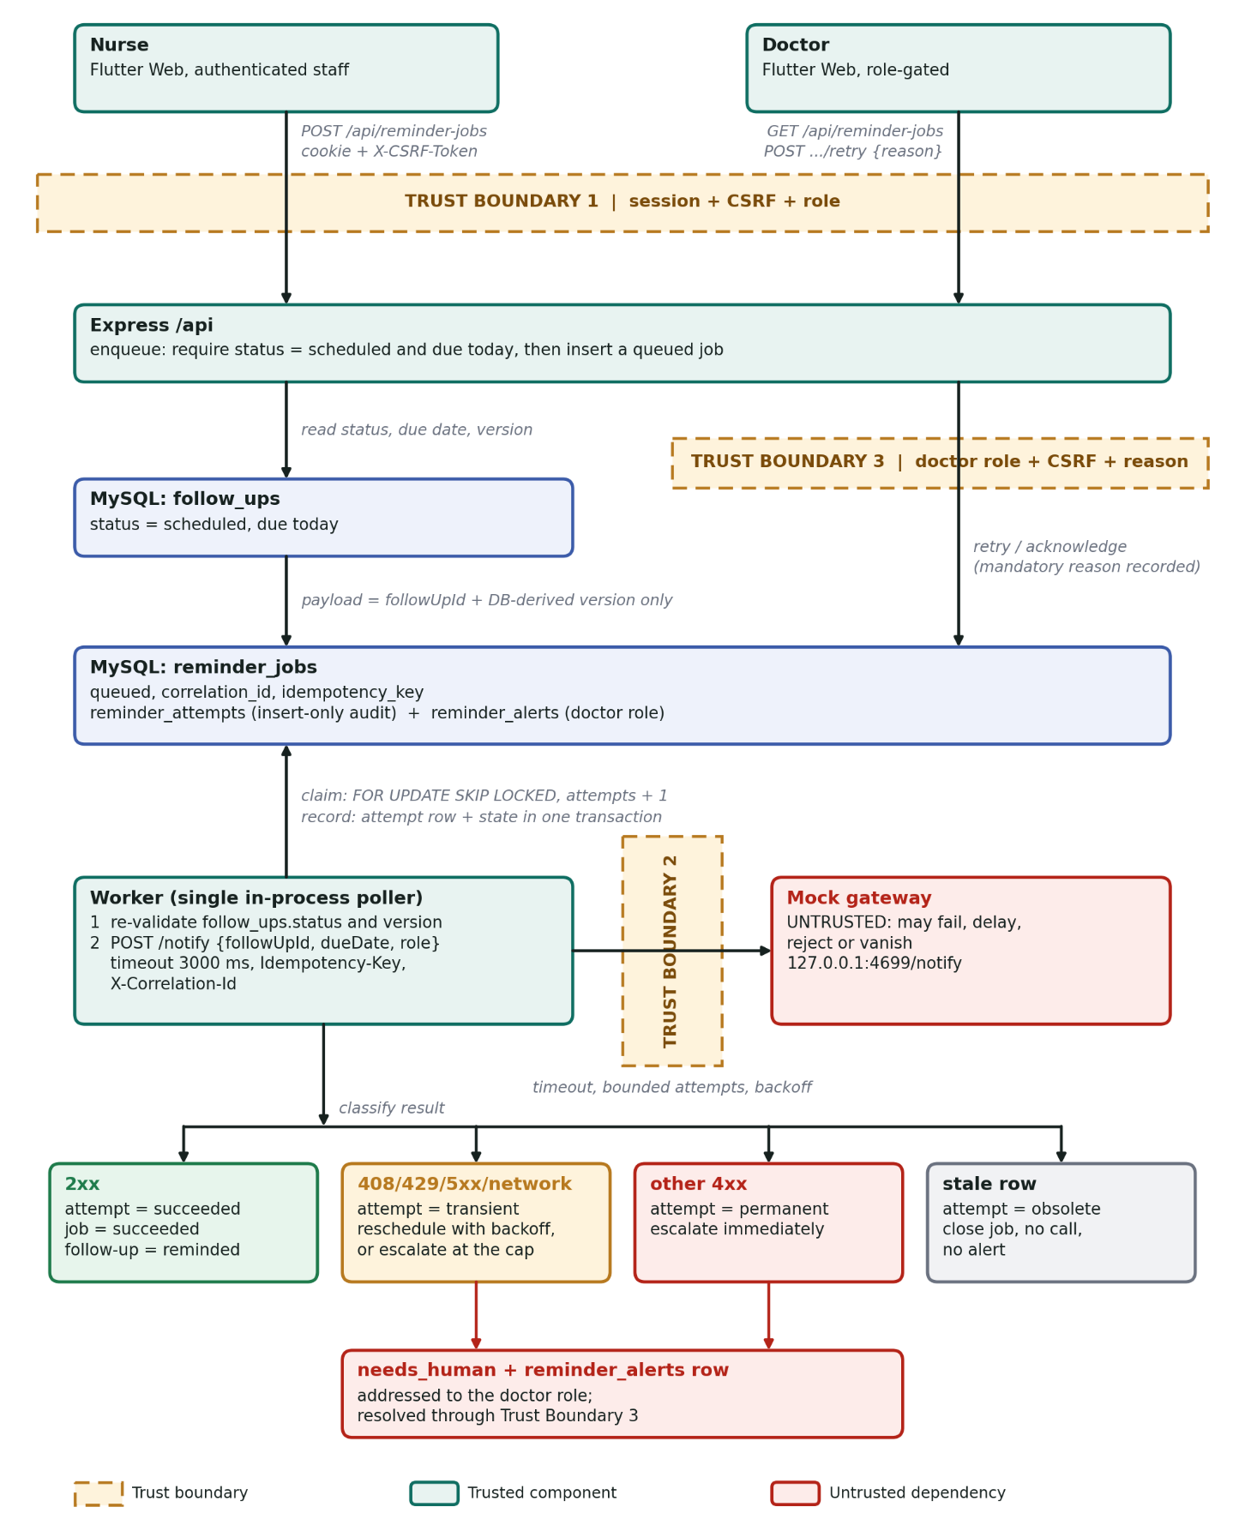

diagram.png

Boundary | Control | Residual limitation
Browser to API | HttpOnly session cookie, CSRF token, role gate | A valid but semantically wrong follow-up id can still be queued; the foreign key prevents orphans
Worker to gateway | Timeout, bounded attempts, backoff with jitter, no credentials transmitted | A gateway that accepts and then silently drops is recorded as success
Doctor to API | requireRole('doctor'), CSRF, mandatory recorded reason | No second-approver control
Credentials and sensitive data. No API keys, tokens, or private keys exist anywhere. The endpoint is a loopback address and the server refuses to start otherwise. The session cookie is HttpOnly and never logged. Log lines carry job id, correlation id, attempt number, outcome, HTTP status and duration - never a name or a contact detail. The job row stores no patient data by construction, which is why the audit trail itself is safe to hand to a reviewer.

8. Flutter Web screen flow and UI states
Overview(counts, escalation tile) --> Reminders tab
Follow-ups (register + filter chips) --> #[id]
Reminders (job list + filter chips) ---> detail pane (>=720 px) or pushed route (<720 px)
More (server and session, sign out)
Screen | States rendered | Widget
Login | form, client validation, 401/429 server error, connection failure | LoginScreen, inline error container
Overview | loading, error, loaded tiles, escalation count | HomeScreen, LoadingView, ErrorView
Follow-ups | loading, empty, list, error | FollowUpsScreen
Reminder jobs | loading, empty, list, error, filter chips | RemindersScreen, StatusChip
Job detail | loading, not found, loaded, attempt timeline, alerts, authorization notice | ReminderDetailPane, _AttemptTile
Queue dialog | form, client validation, server 409/404 banner, duplicate notice | QueueReminderDialog
Retry dialog | reason field (minimum 8 characters), success snackbar | ReasonDialog
Reusable widgets: LoadingView, ErrorView, EmptyView, showError, dash, appBar, StatusChip, plus the theme in lib/theme/app_theme.dart.
Validation split. The positive-integer rule and the reason length are checked on both sides. The scheduled and due-date preconditions are server-only, deliberately: the client cannot know the status without an extra fetch, and the server is authoritative. Retry availability is hidden for a nurse but also enforced server-side, because hiding a control is not a control.
Responsive rule. Width of 720 logical pixels or more renders a two-pane master and detail; below that the list is a single column and the detail is pushed as a route with a back arrow. Filter chips scroll horizontally and no fixed widths are used. Verified at 1280x800 and 380x800.
Keyboard and accessibility. Every field has a label, the password has a visibility toggle, Tab order follows visual order, the queue and retry actions are real buttons reachable by keyboard, and every status is conveyed by text as well as by colour.

9. Implementation inventory
Path | Status | Responsibility
backend/config.js | new | Bounded settings, loopback assertion, alert role
backend/db.js | new | Connection pool and transaction helper
backend/auth.js | new | Password hashing, sessions, CSRF, origin check, role gate
backend/service.js | new | Enqueue, claim, re-validate, classify, commit, escalate, retry
backend/worker.js | new | Polled single-attempt worker, gateway call, structured logging
backend/routes.js | new | Route table; doctor gate on resolution
backend/server.js | new | Middleware order, dev CORS switch, worker start
backend/schema.sql | new | Seven tables, keys and indexes
backend/scripts/mock-gateway.js | new | Mode-switchable local gateway
backend/scripts/seed.js | new | Fictional users and patients
backend/scripts/lab-sql.js | new | Query helper used to capture evidence
lib/api/clinic_api.dart | new | Session, CSRF, public request passthrough, web-safe storage
lib/api/reminder_api.dart | new | Jobs, detail, enqueue, retry, acknowledge, follow-ups
lib/api/client_factory.dart + io/web | new | Cross-origin cookie support on web
lib/config/app_config.dart | new | Base URL per platform, request timeout
lib/theme/app_theme.dart | new | Palette and Material 3 theme
lib/widgets/ui.dart | new | Shared states, app bar, status chip
lib/screens/* | new | Login, overview, follow-ups, reminders, detail, settings, shell
lib/main.dart | new | Session resume, route between login and shell
Runtime dependencies added: two (express, mysql2) on the server and two on the client (http, flutter_secure_storage). The mock gateway and all evidence scripts use only the Node standard library.

10. Reliability controls

10.1 Failure taxonomy
Class | Example in this workflow | Detected by | Automatic action | Human action
Transient - network | gateway process stopped | error cause code | retry with backoff | none until the cap
Transient - dependency | 503, 429, 408, 425, 5xx | HTTP status | retry, honour Retry-After | none until the cap
Transient - slow | gateway exceeds 3000 ms | abort signal | retry | none until the cap
Permanent - dependency | 422 policy rejection | HTTP status | no retry | doctor retries after correcting
Obsolete - business | follow-up closed or version advanced while the job waited | re-validation | close as obsolete; no call, no alert | none - this is correct behaviour
Permanent - record gone | follow-up deleted | foreign key cascade | job removed with the record | none
Bounded exhaustion | four attempts used | attempt counter | needs_human plus alert | doctor retries (adds 2, cap 10)
Process crash | worker killed mid-attempt | running older than the stuck threshold | boot-time reclaimer re-queues | none
Enqueue failure | database unavailable during queue | promise rejection in the route | logged; the 409/404 path still answers | none
Configuration | non-loopback endpoint | startup assertion | refuse to start | correct the environment file
The rule used in code: transient means retrying later could plausibly succeed; permanent means the same input will fail the same way; obsolete is neither, because the work is no longer wanted. Ambiguity resolves to permanent, because a retry loop on a real error is worse than one alert.

10.2 Retry policy
Parameter | Value | Environment key | Rationale
Automatic attempts | 4 | INTEGRATION_MAX_ATTEMPTS | Covers a short restart without widening the blast radius
Base backoff | 500 ms | INTEGRATION_BACKOFF_MS | Enough for a restarting local service
Backoff shape | doubles per attempt, 50 to 100 percent jitter | - | Jitter prevents synchronised retries across queued jobs
Ceiling | 4 s | INTEGRATION_MAX_BACKOFF_MS | Keeps the demonstration observable; production would use minutes
Retry-After | honoured when present | - | The dependency knows its own recovery time
Per-call timeout | 3000 ms | INTEGRATION_TIMEOUT_MS | Bounds one attempt; worst case about 12 s per job
Poll interval | 2000 ms | INTEGRATION_POLL_MS | Human-scale latency without busy-waiting
Human extension | adds 2 attempts, hard cap 10 | code constant | A human action is bounded too
Give-up action | needs_human plus alert | - | Escalation is a signal, not silence
Not retried | permanent 4xx, obsolete, succeeded | - | Retrying these turns a clear signal into noise, or into a second send

10.3 Recovery runbook
Situation | Symptom | Action | Verification
Jobs stuck in running | attempt count frozen | restart the backend | log shows worker.reclaimed; the job returns to queued and completes
Gateway down | four network errors, then needs_human | start the mock gateway, then doctor retry with a reason | a human_retry attempt followed by succeeded
Gateway rejects | needs_human after one attempt | switch the mock mode to ok, then retry | timeline shows the cause and the corrective action
Follow-up closed before delivery | job obsolete | none - correct behaviour | gateway call count unchanged
Duplicate jobs suspected | - | group by idempotency_key with a count filter | must return no rows
Duplicate send suspected | two gateway entries for one correlation id | inspect attempts; the worker skips when a success exists | attempt.skipped_already_delivered in the log
Database down during queue | 500 with a generic message | restore the database and queue again | new job then succeeded
Endpoint misconfigured | server refuses to start | correct the endpoint to a loopback address | startup assertion passes
Alerts accumulating | unread count on Overview | doctor opens the job, reads the timeline, retries or acknowledges | read_at is set

11. Security and protected configuration

11.1 Security checklist
# | Control | Where | Why it exists | Residual limitation
1 | Payload minimisation | the job stores follow_up_id and version only | The queue and its logs are the least-protected copy of the data | The follow-up record itself remains sensitive and stays in its own table
2 | Re-validation against authoritative state | inspectQueuedRecord() | A queued row can be edited with SQL, and a follow-up can change while waiting | A valid but semantically wrong id is still accepted; the foreign key prevents orphans
3 | Least privilege on resolution | requireRole('doctor') plus a service check | The resolver must be the role that owns the decision | Coarse role model, no per-department scope
4 | Secret-free configuration | environment file only; the example holds nonsecret values | A committed secret is compromised permanently | A developer can still paste a secret locally and it will work
5 | Startup assertion | assertLocalEndpoint() | Pointing at a real host becomes a boot failure rather than an incident | Not enforced by the OS; the assertion could be removed
6 | No personal data in logs | the log helper whitelists fields | Logs are copied into tickets and screenshots | Gateway error text is stored in the database and could echo provider wording
7 | Session per platform | HttpOnly cookie on web; opaque token in OS storage on mobile | Script code must never hold the session value on web | The web path depends on the browser honouring SameSite and HttpOnly
8 | CSRF on every write | csrfProtection, client sends the header | A third-party page must not queue reminders with a staff cookie | The worker has no user context and is exempt by design
9 | Immutable audit trail | reminder_attempts is insert-only | Evidence must survive the party who caused it | A database superuser could still alter rows
10 | Bounded work | attempt cap, timeout, backoff ceiling, human cap | Prevents unbounded processing | A permanently failing dependency still costs four calls per reminder
11 | Duplicate prevention | unique idempotency key, delivered guard, gateway idempotency header | At-least-once must not become many-times | Depends on the provider honouring the key
12 | Auditable override | mandatory reason stored on the attempt row | An override without rationale is unauditable | Free text, no structured reason codes
13 | Graceful degradation | a queue failure never fails the follow-up write | The clinic is never worse off than before this module | An unqueued reminder is not visible in the UI unless someone looks
14 | Origin check | strict host comparison in production; a development switch exists | Prevents cross-site requests from another origin | The development switch weakens a real control. It is off by default, absent from the committed example, and was disabled before the submitted captures.

11.2 Configuration evidence
Check | Command | Expected | Actual
No tracked secrets | git ls-files | Select-String '\.env$|\.key$|\.pem$' | no output | [[CFG1]][[CFG1]]
Example is nonsecret | findstr /i "password secret token" backend\.env.example | comments and empty keys only | [[CFG2]][[CFG2]]
Endpoint is loopback | findstr /i "INTEGRATION_ENDPOINT" backend\.env | only 127.0.0.1 | [[CFG3]][[CFG3]]
Environment file ignored | findstr /n ".env" .gitignore | a match | [[CFG4]][[CFG4]]
Assertion fires | set a public endpoint and start | refuses to start | [[CFG5]][[CFG5]]
Log hygiene | scan captured logs for names, cookie, password | no matches | [[CFG6]][[CFG6]]
Development switch off | findstr /i DEV_CORS backend\.env .env.example | false in both for the submitted build | [[CFG7]][[CFG7]]

12. Verification - execution results
ID | Action | Expected | Actual | Time | Verdict
S1 | Open Reminders with no jobs | empty state | empty state text + COUNT(*) = 0 | ~1 s to render | Pass
S2 | Queue dialog with follow-up id 0 | inline error, no request sent | "Positive whole number", red outline, no POST sent | rejected on submit, 0 requests | Pass
S3 | Queue a future-dated follow-up | 409 not due; no row created | 409 "not due until Thu Nov 05", follow-up 8, no row created | 4 ms | Pass
S4 | Queue a due follow-up | succeeded, 1 attempt, HTTP 200, follow-up reminded | Job #1 POST 200 in 7 ms; re-queue gave duplicate notice; delivery shown on Job #4 and #7 | 7 ms + 2000 ms poll | Pass (qualified)
S5 | Open the job | attempt 1 succeeded with status and duration | state card + correlation e54725fe…c9c, 0 attempts at capture; populated on Job #7 | captured before first poll | Pass
S6 | Gateway in flaky mode, queue | transient, transient, succeeded | 503 / 503 / 200, delta 3, 12:19:32Z–12:19:34Z | ~2 s | Pass
S7 | Gateway rejects, queue | needs_human after one attempt, one alert | 1 permanent_error HTTP_422, 2 ms, stable after 6 s, 1 unread alert, follow-up #3 still scheduled v1 | 2 ms | Pass
S8 | Nurse attempts to resolve | UI hides control; API 403; no attempt row | nurse pane no buttons; doctor pane buttons; 403 with role message; attempts stayed 1 | < 1 s | Pass
S9 | Gateway down, wait through three polls | exactly four attempts, then stable | 4 × transient, 3001/3008/3007/3006 ms, code 23, then needs_human 4/4 | ~14 s | Pass
S10 | Stop the backend, then retry from the app | safe network error; attempts unchanged | "Cannot reach…" snackbar, retry (failed) 0.0 kB / 26 ms, attempts unchanged | 26 ms | Pass
S11 | Gateway slow beyond the timeout | each attempt aborts near 3000 ms, classified transient | 3007/3001/3010 ms then succeeded 200, 6 ms, 12:55:48.168Z, follow-up v2 | ~14 s | Pass
S12 | View at 380 px width | single column, no overflow | 380 × 800 single column, chips scroll, no overflow; 1280 × 800 two panes | n/a | Pass
S13 | Long poll interval, close the follow-up before the attempt | obsolete, zero gateway calls, no alert | attempt 1 transient 3007 ms, attempt 2 obsolete 0 ms FOLLOW_UP_NO_LONGER_SCHEDULED, delta 1, alerts 0 | 3007 ms then 0 ms | Pass
S14 | Bump the version, then queue the same follow-up | a new job is created, not deduplicated | jobs 9 (v1) and 10 (v3) both succeeded; second queue 201; duplicate query empty | ~2 s per queue | Pass

S1: 01-empty.png

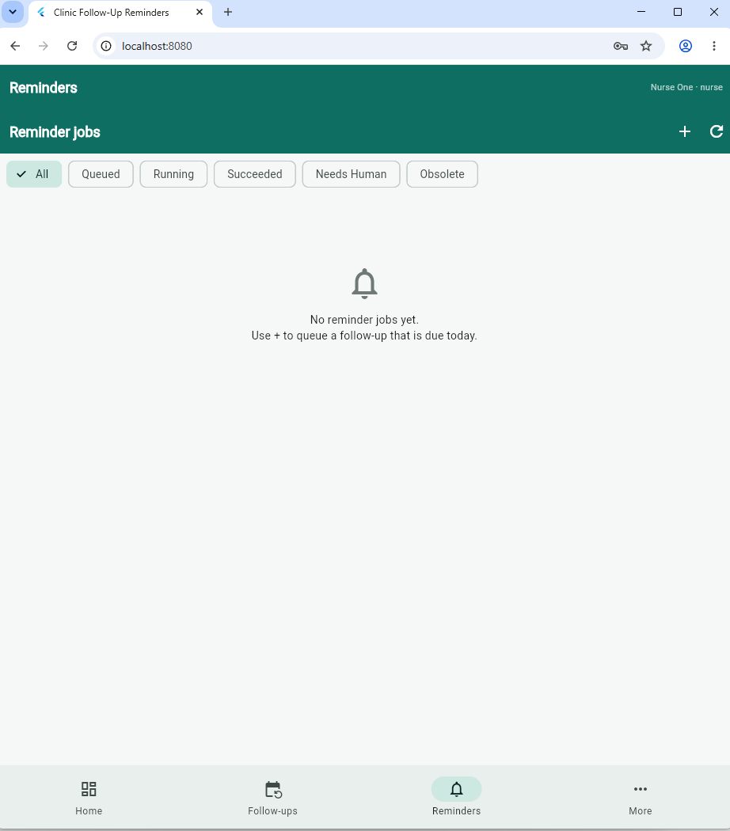
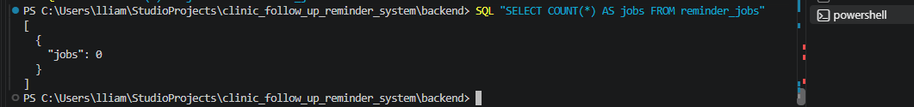

S2: 02-client-validation.png
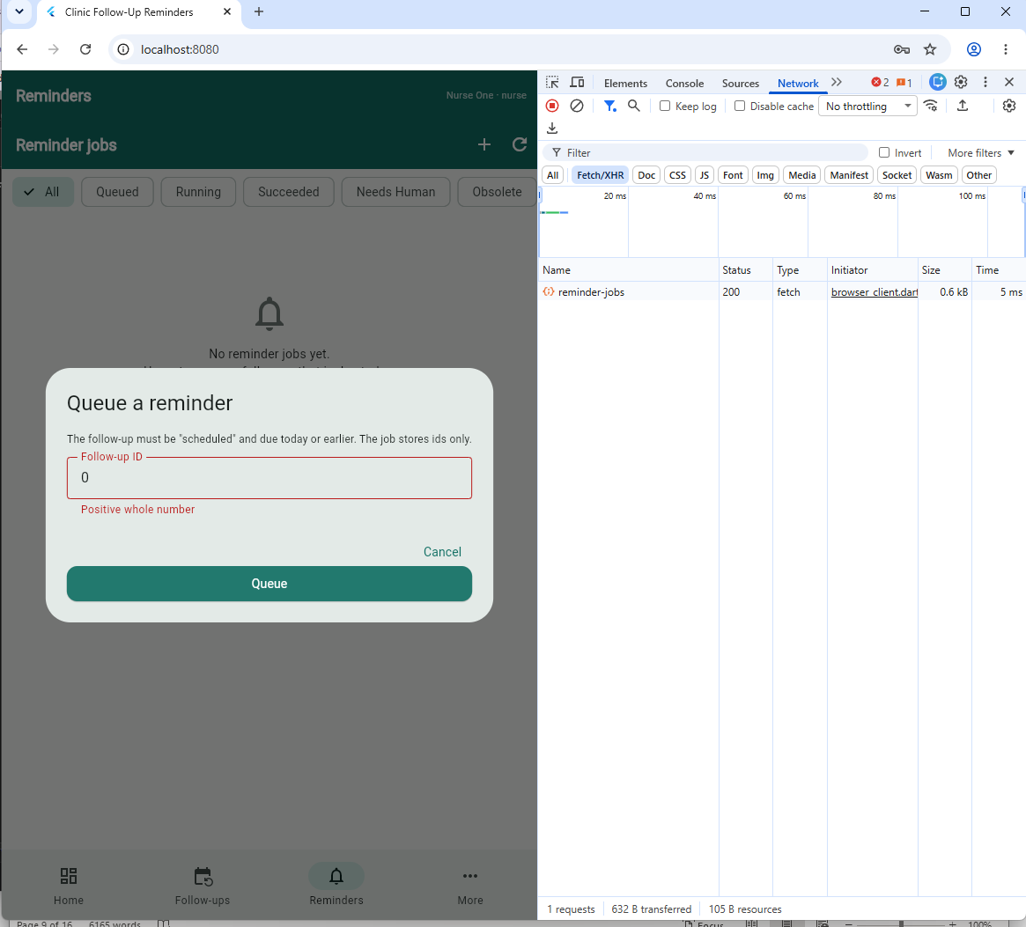

S3: 03-server-409.png
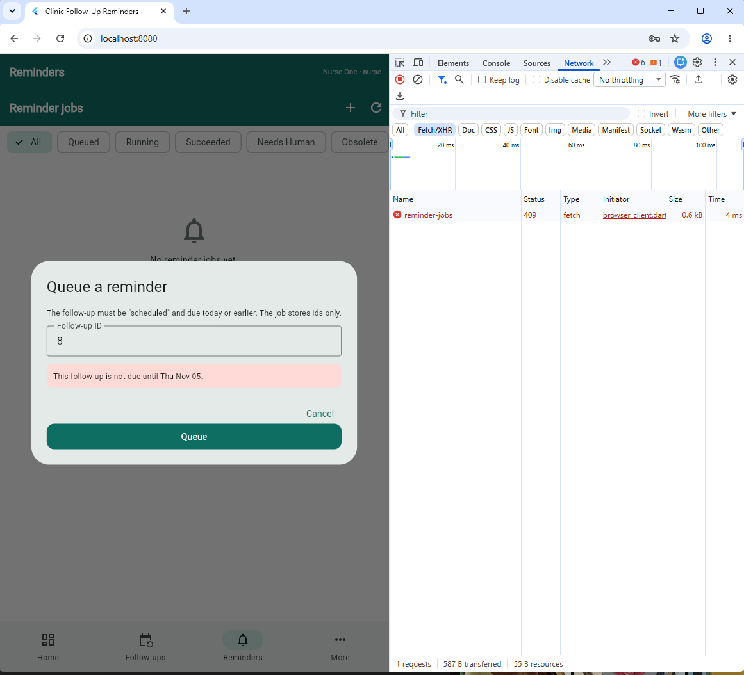

S4: 04-succeeded.png
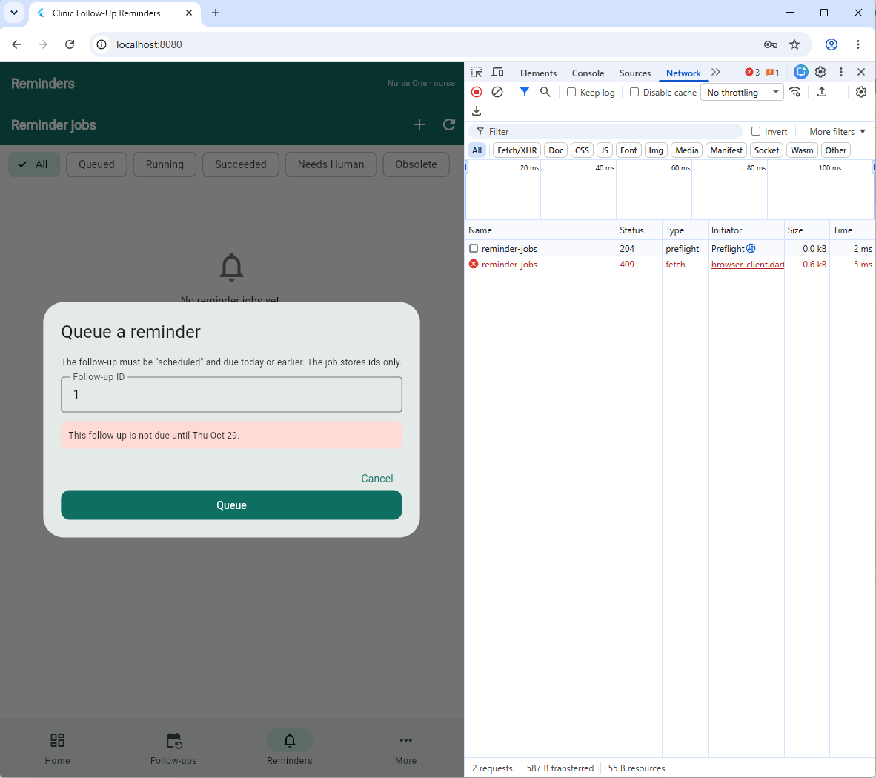
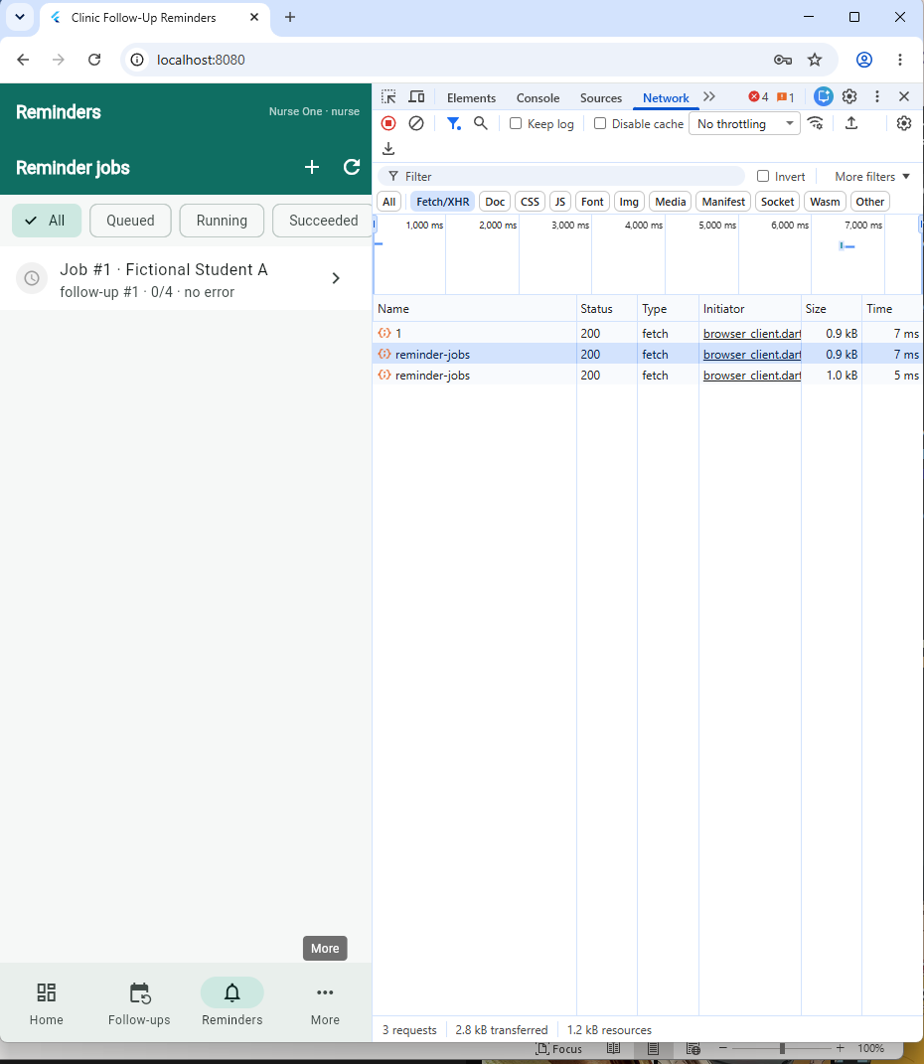
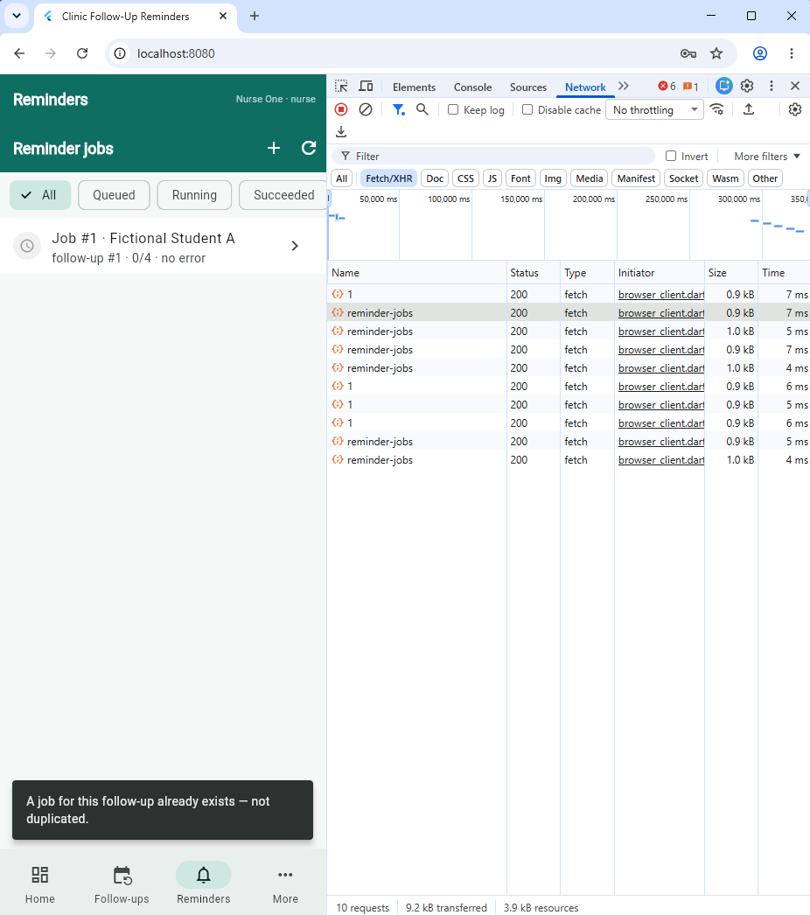
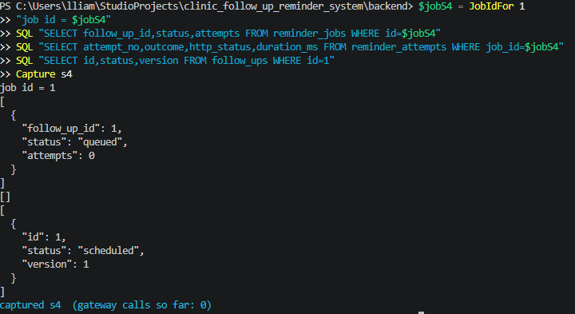

S5: 05-timeline.png
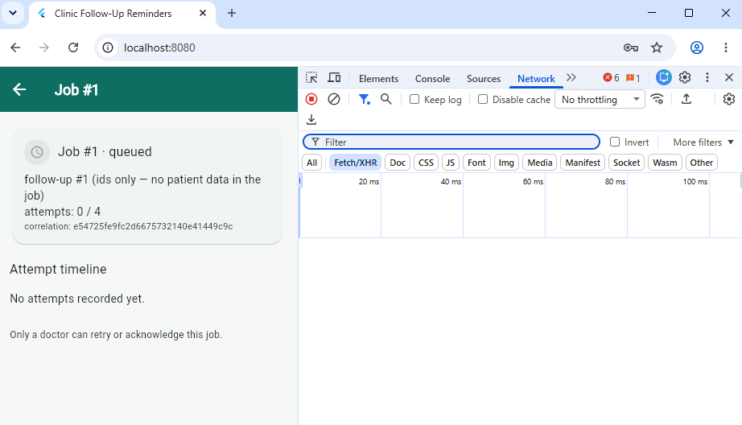
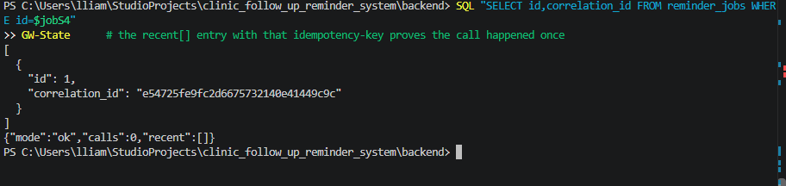

S6: 06-recovered.png
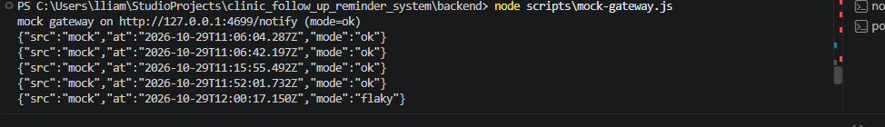
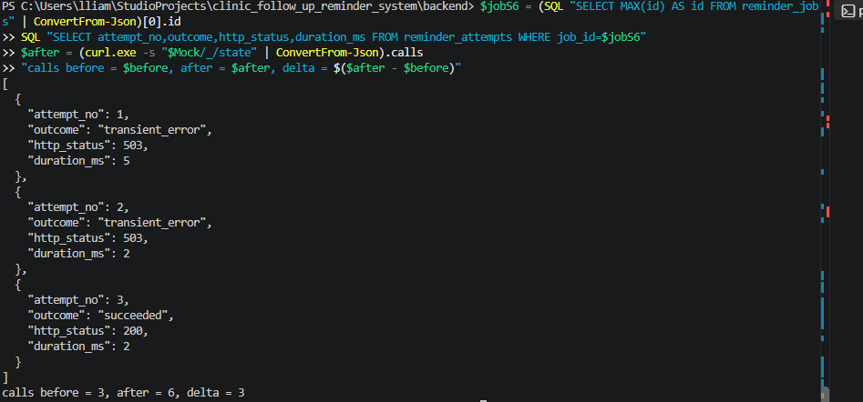
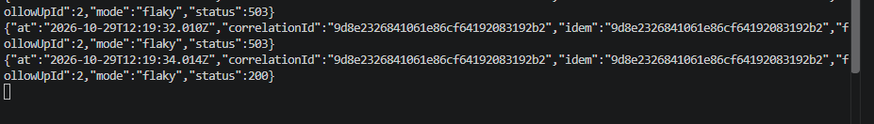
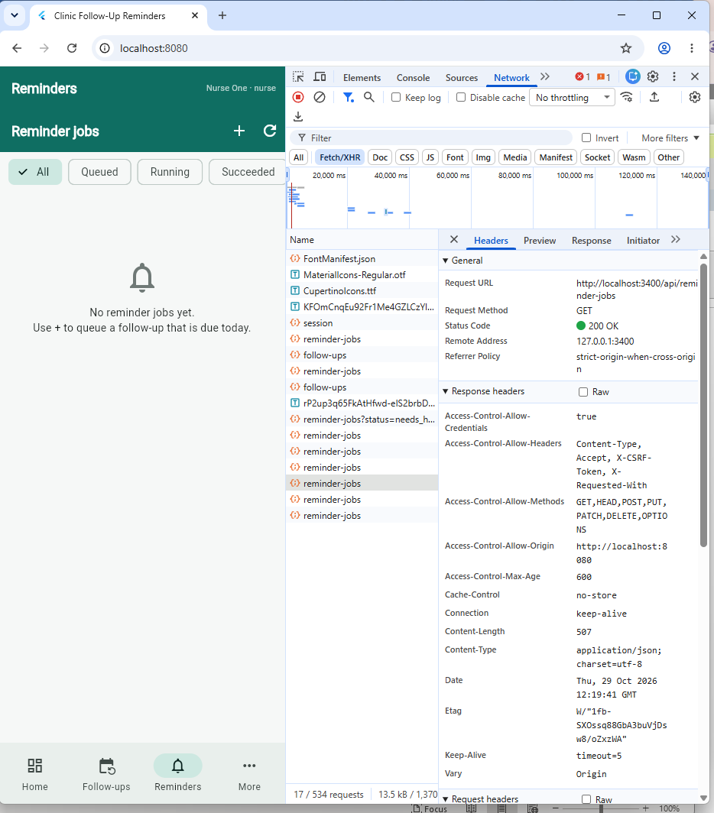

S7: needs-human.png & terminal-attempts.png
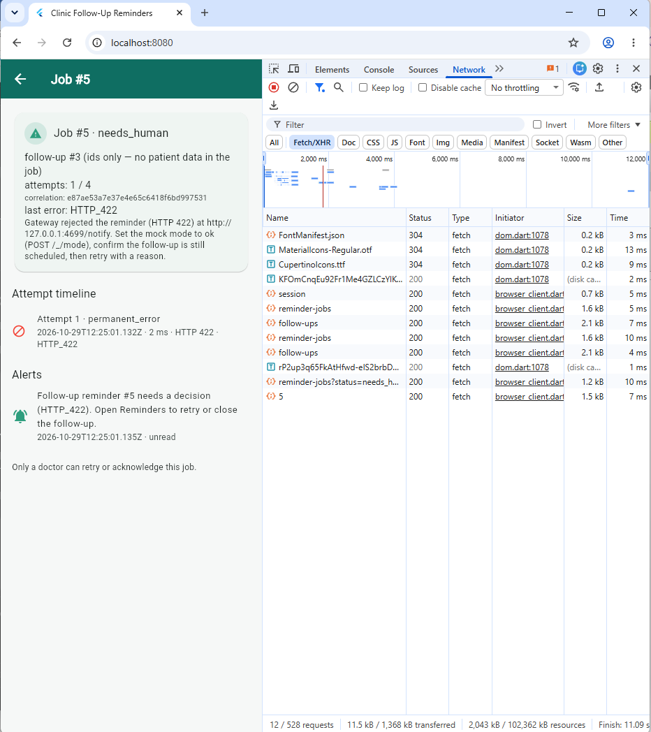
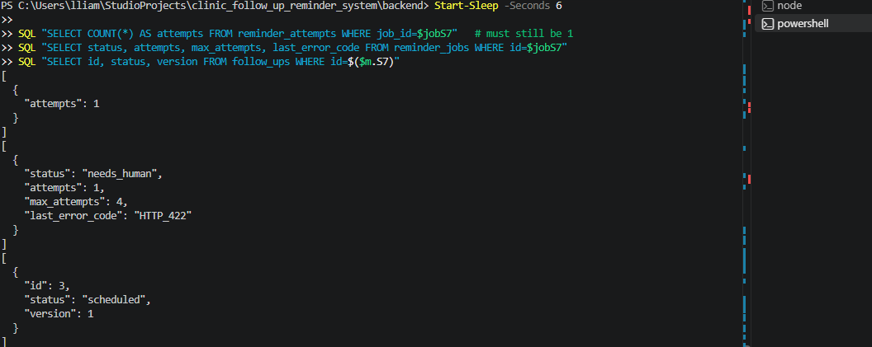

S8: 08-forbidden.png
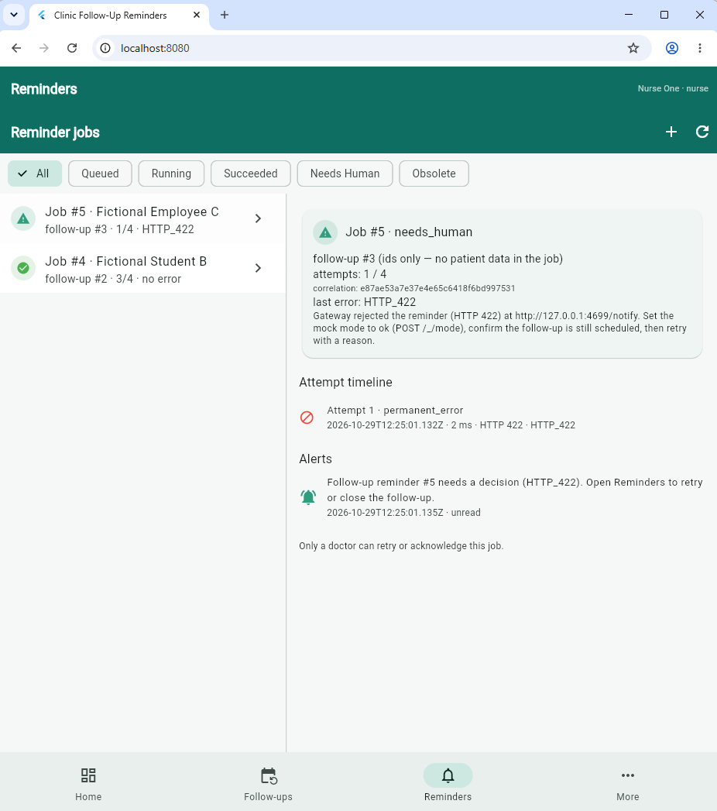
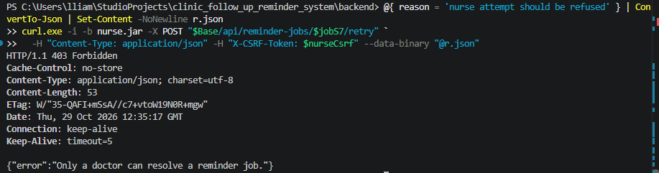
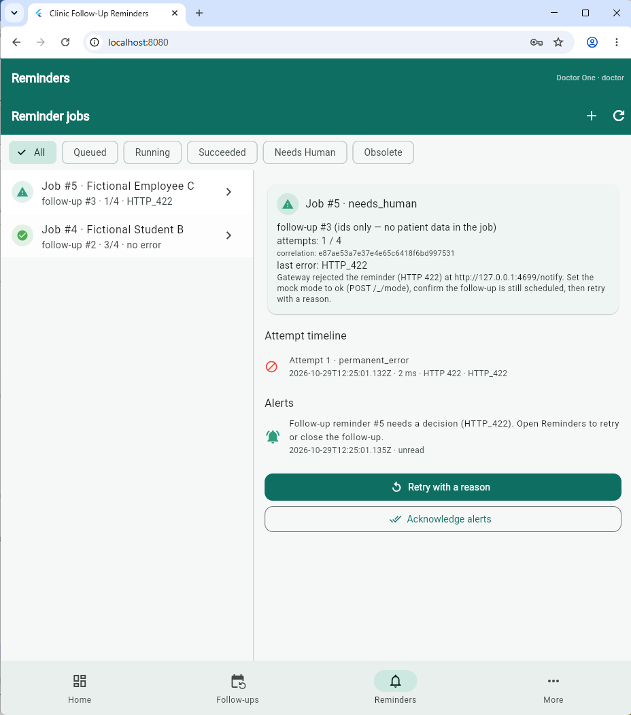

S9: 09-bounded.png
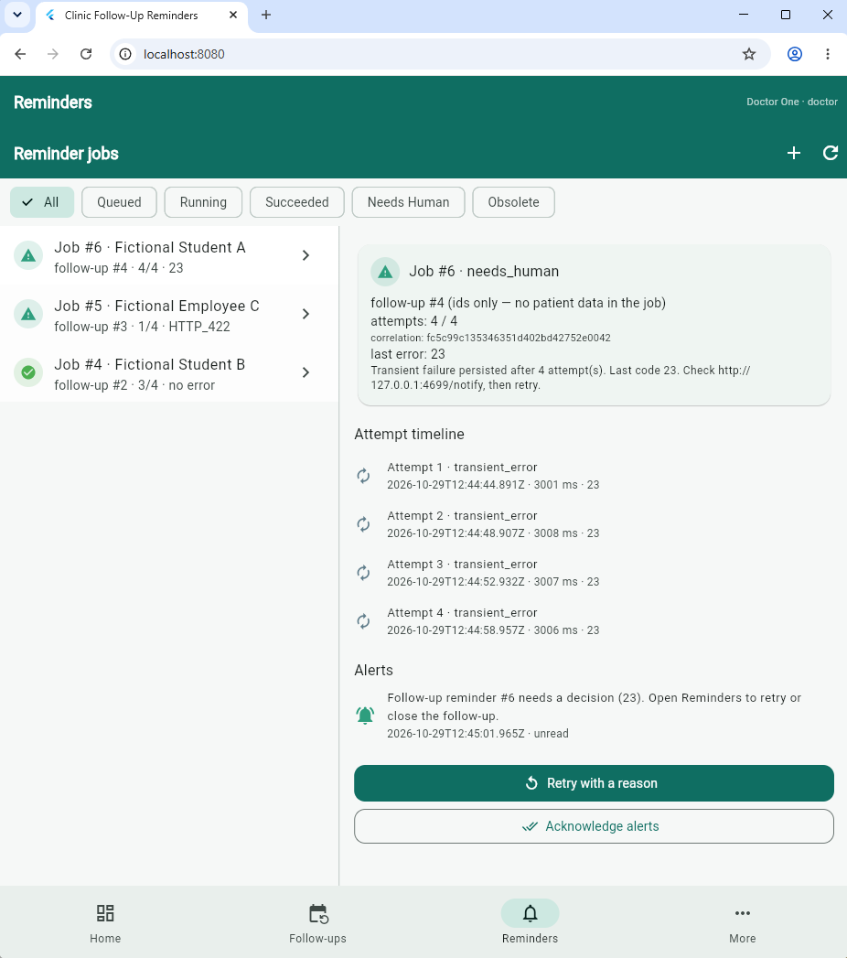
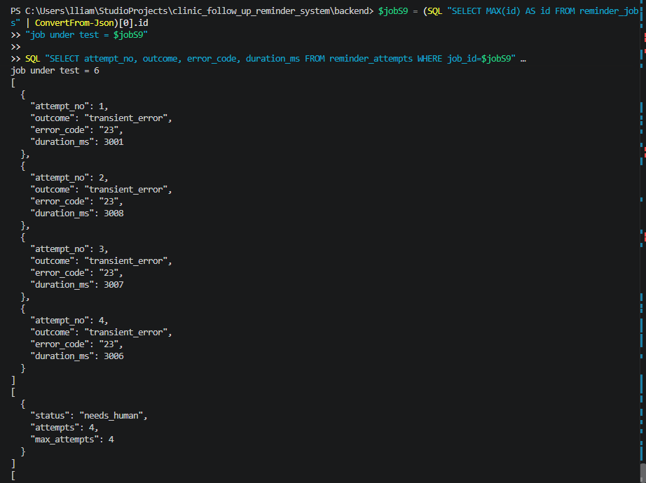

S10: 10-network.png
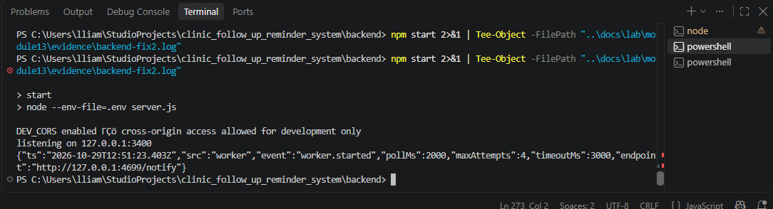
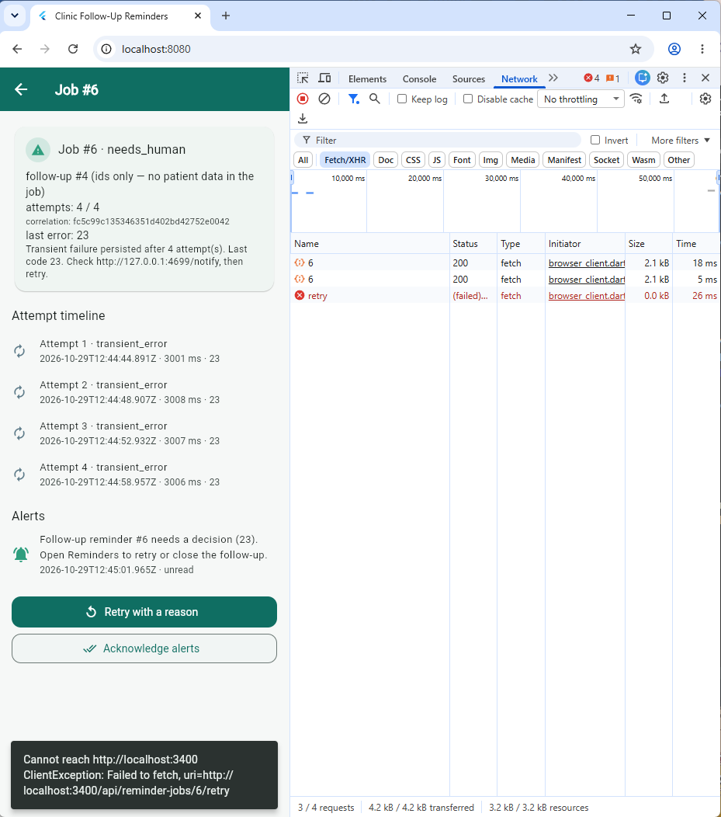

S11: 11-timeout.png
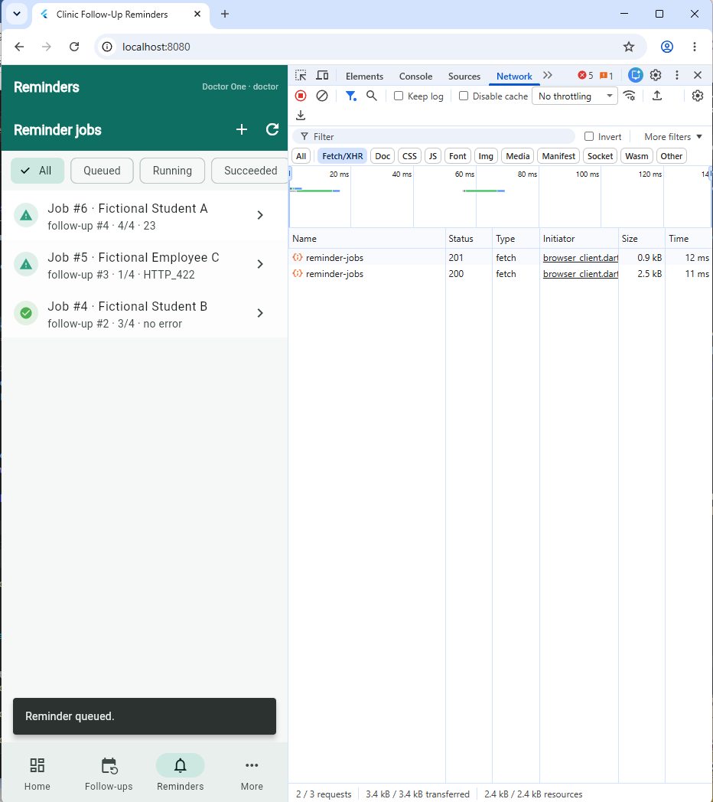

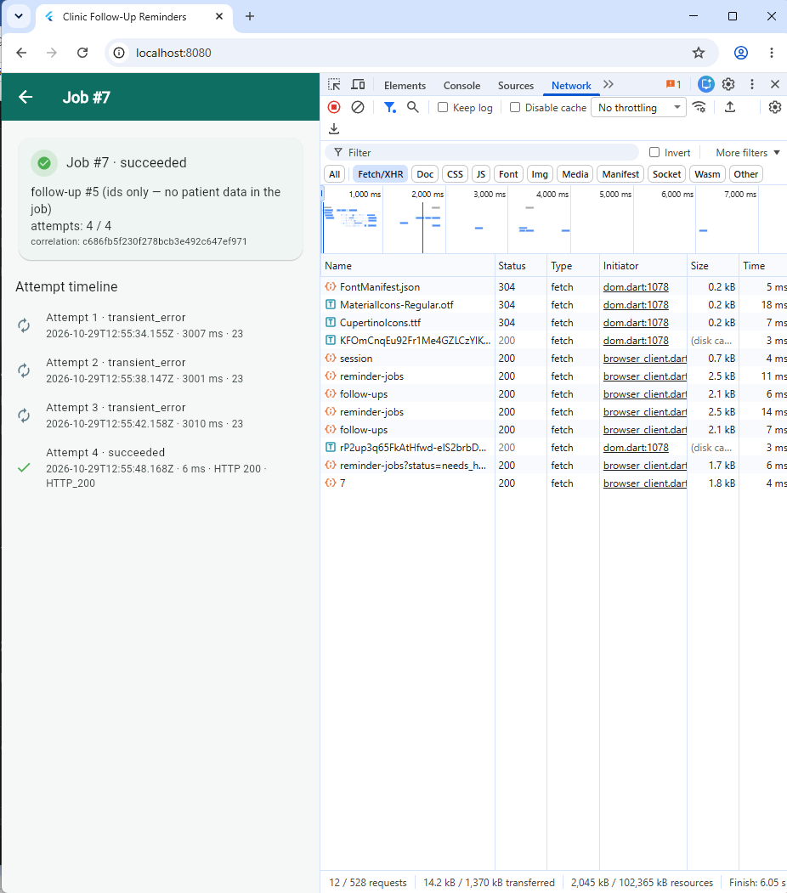
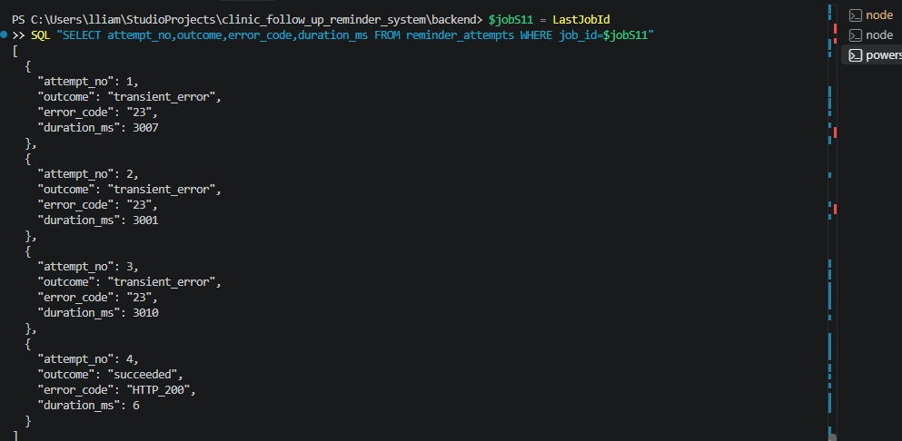

S12: narrow.png & 1280x800.png
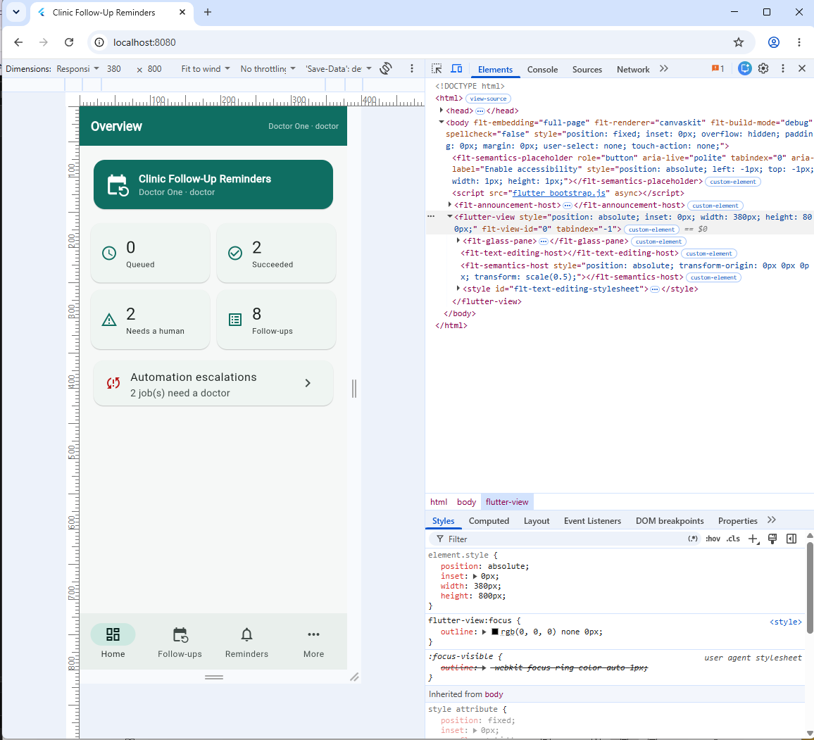
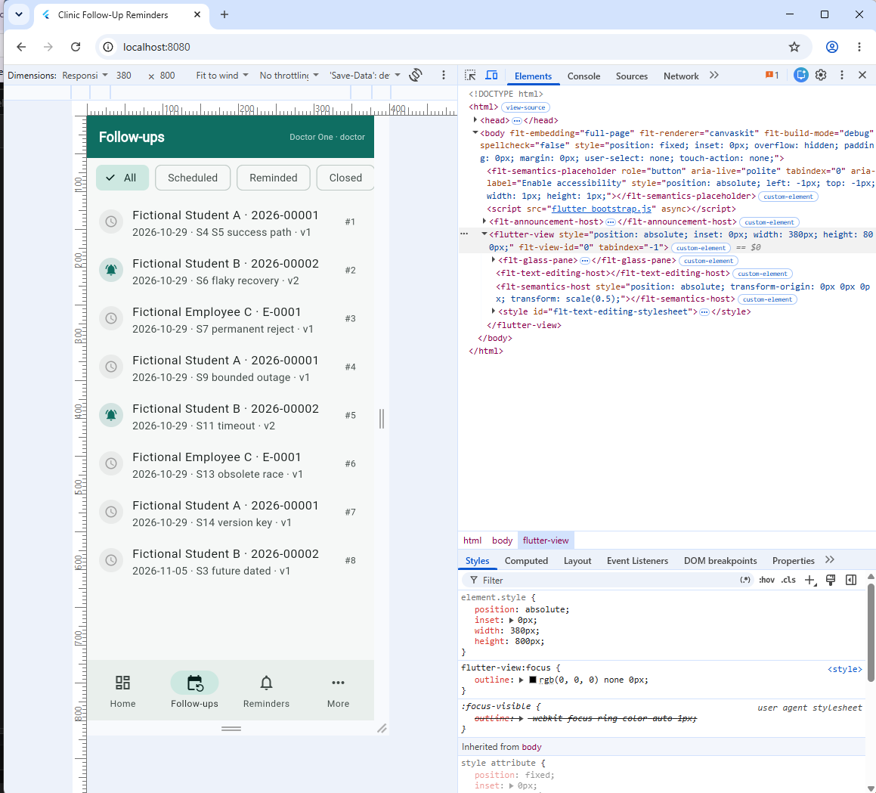
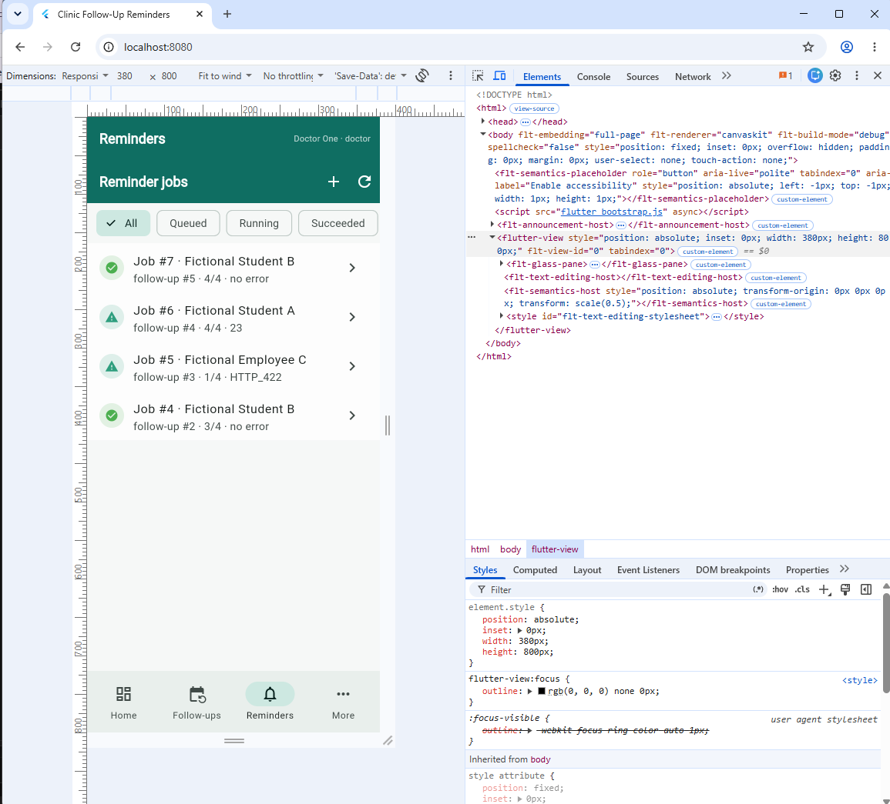
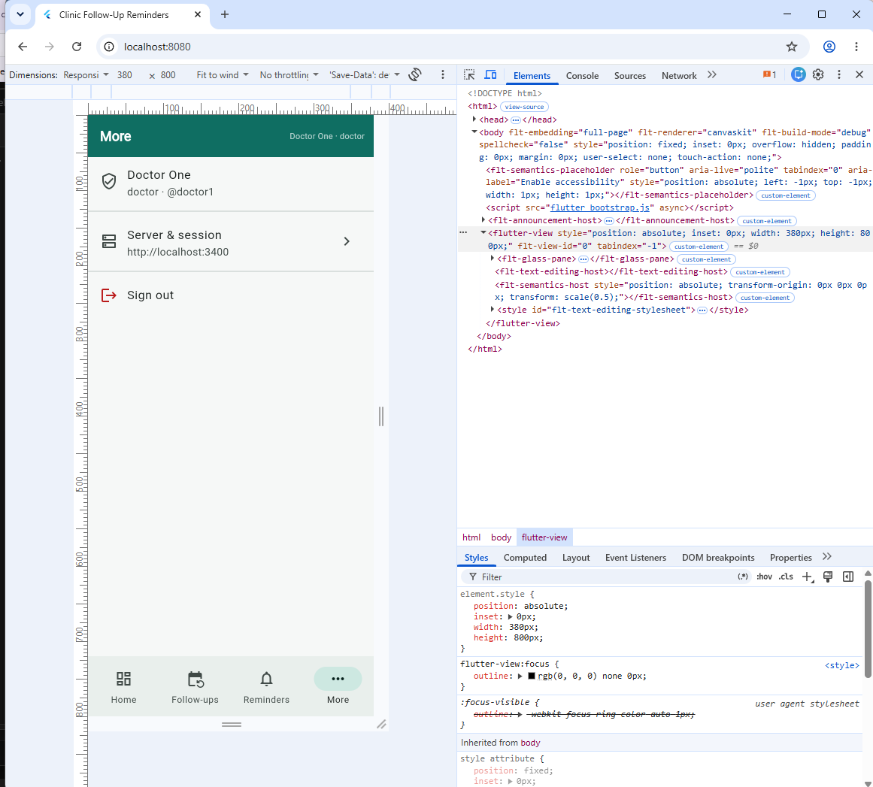
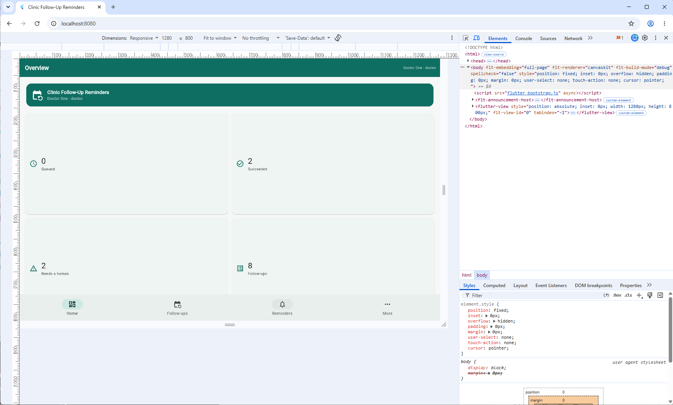
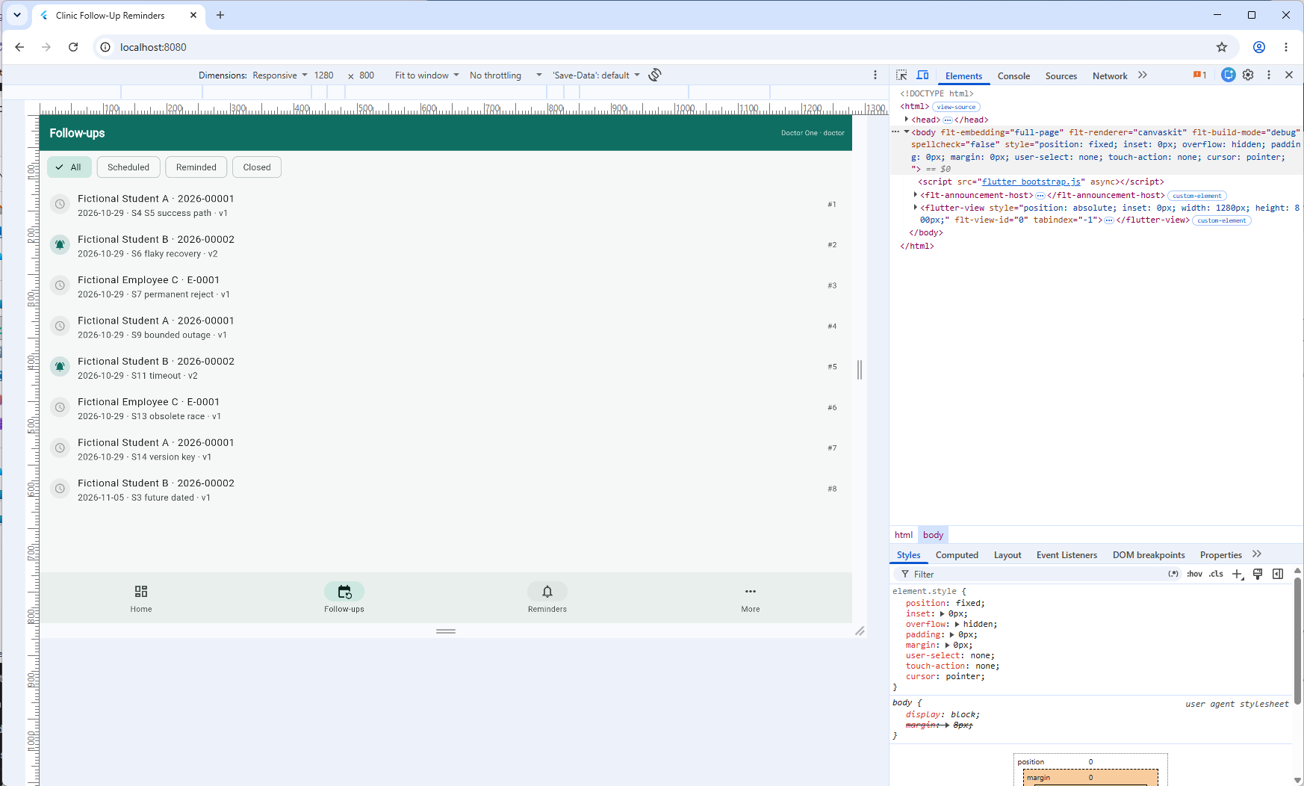
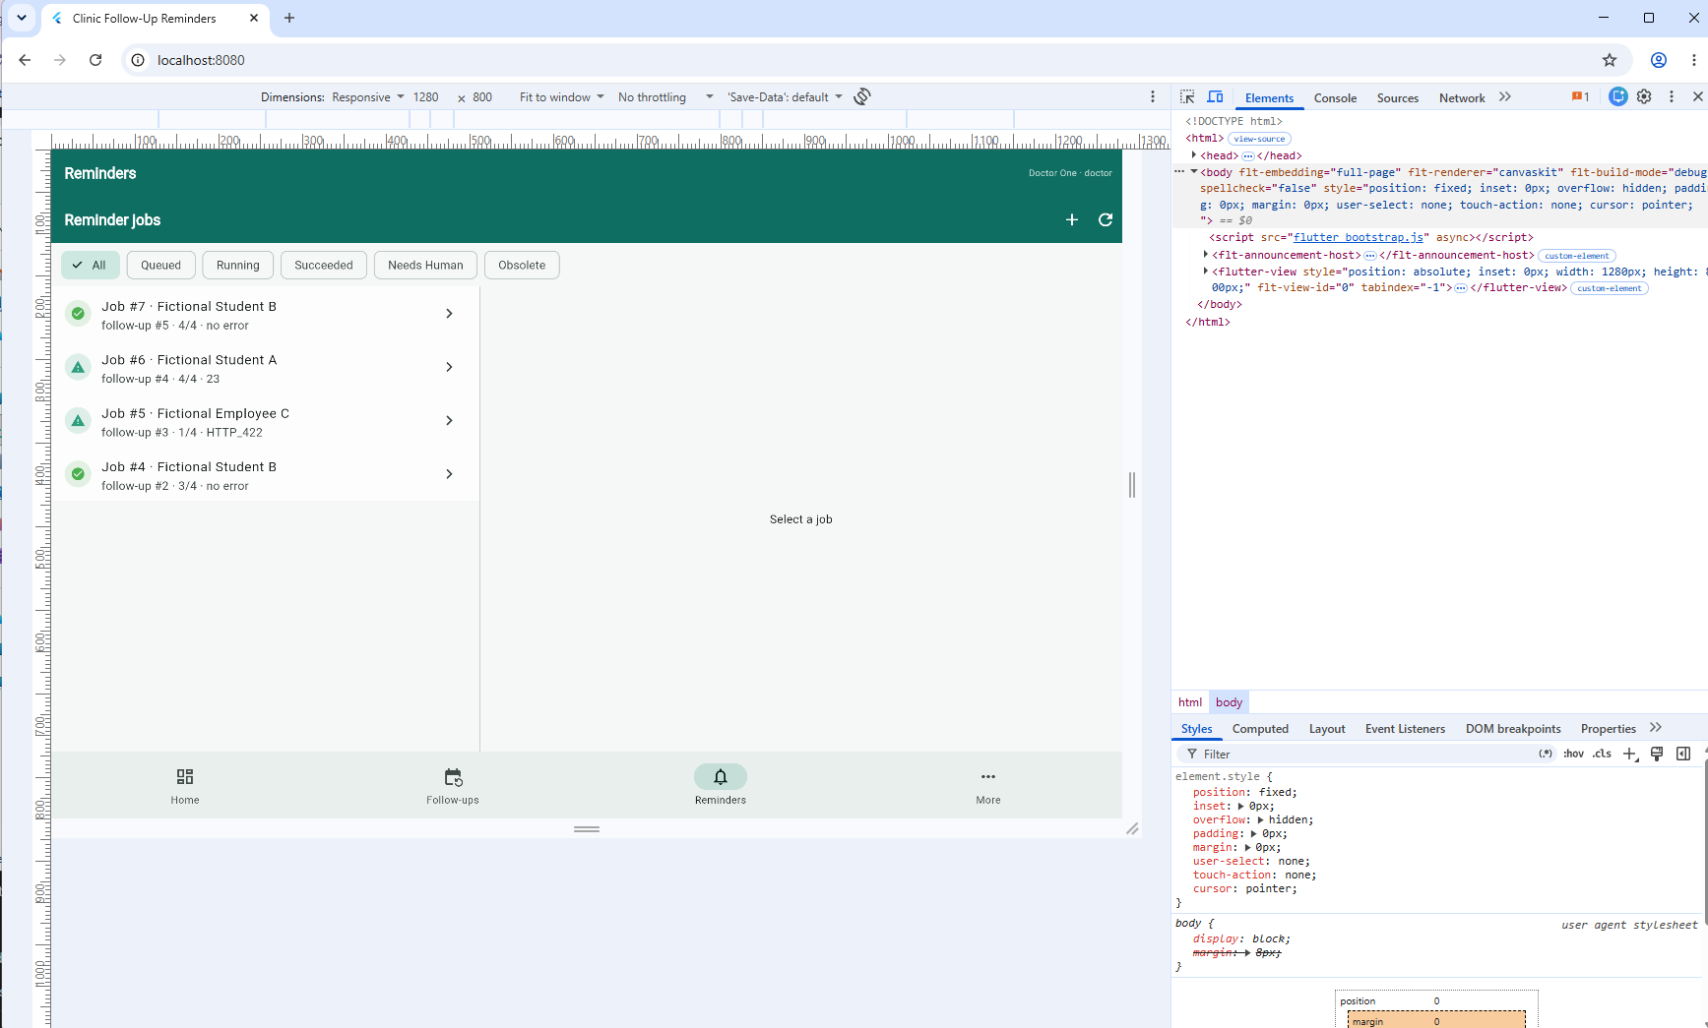
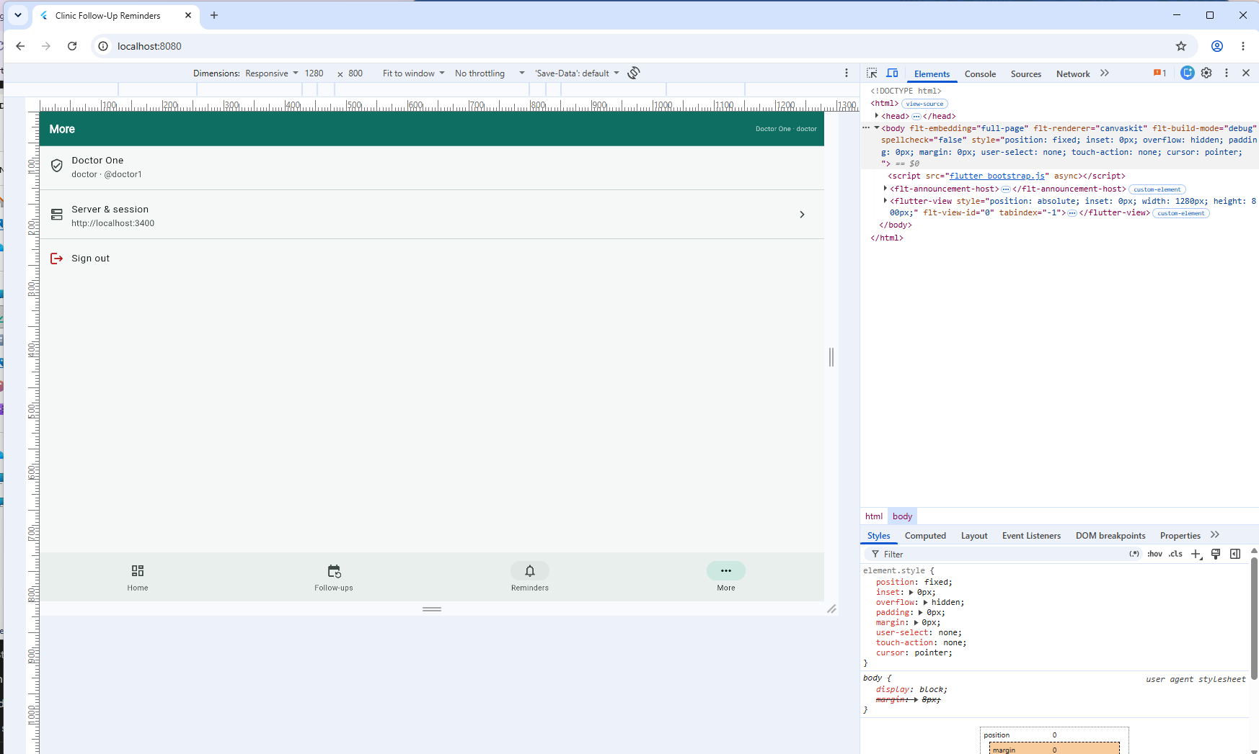

S13: 13-obsolete.png
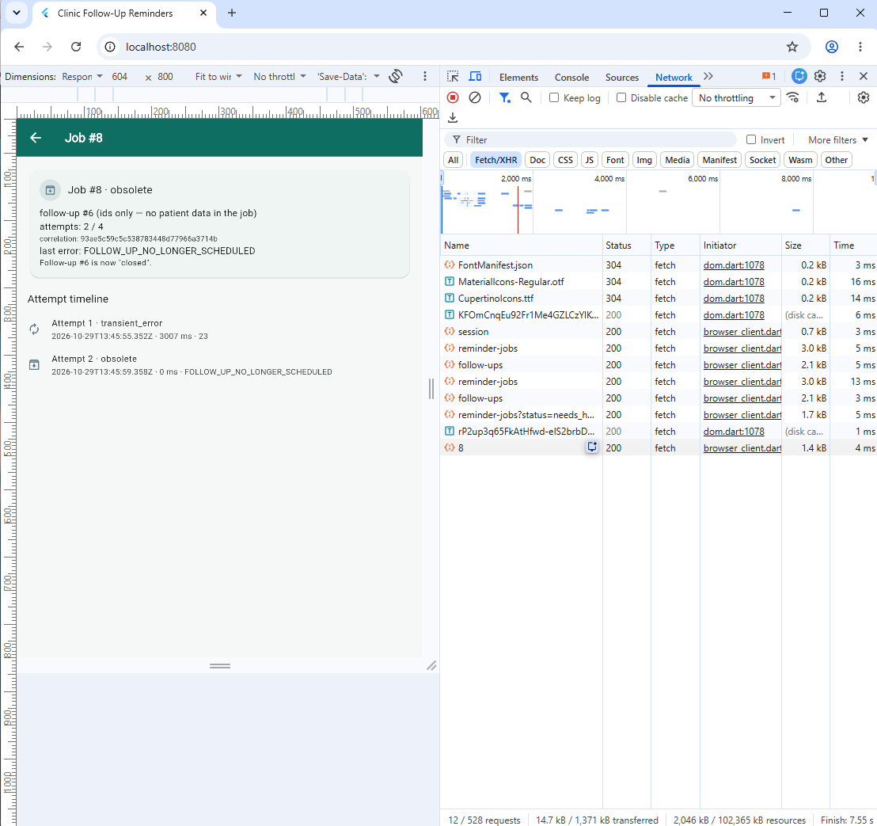
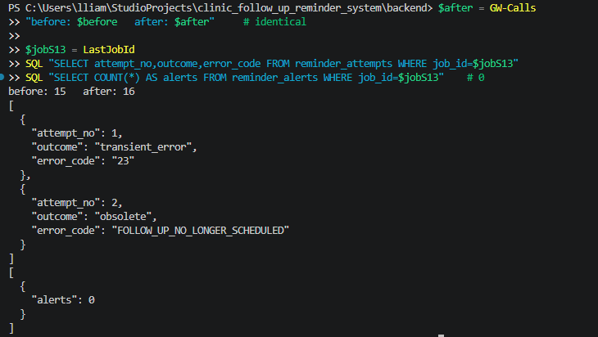

S14: 14-version-key.png
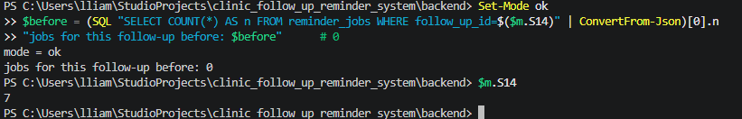
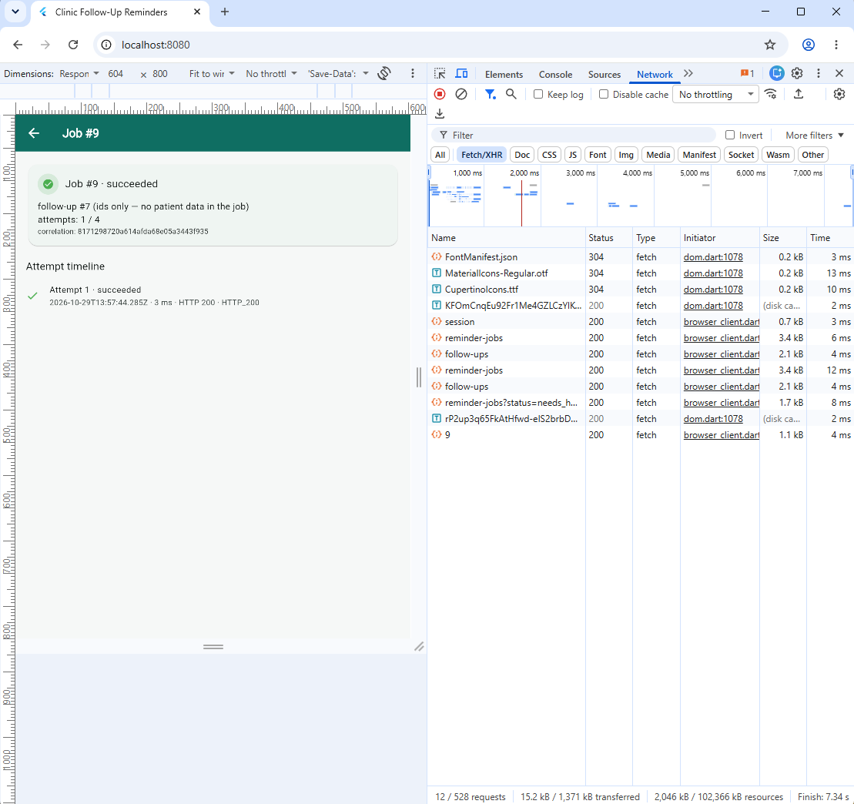
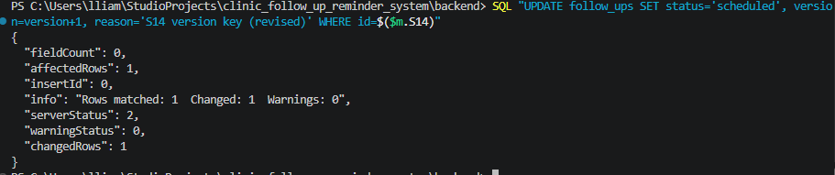
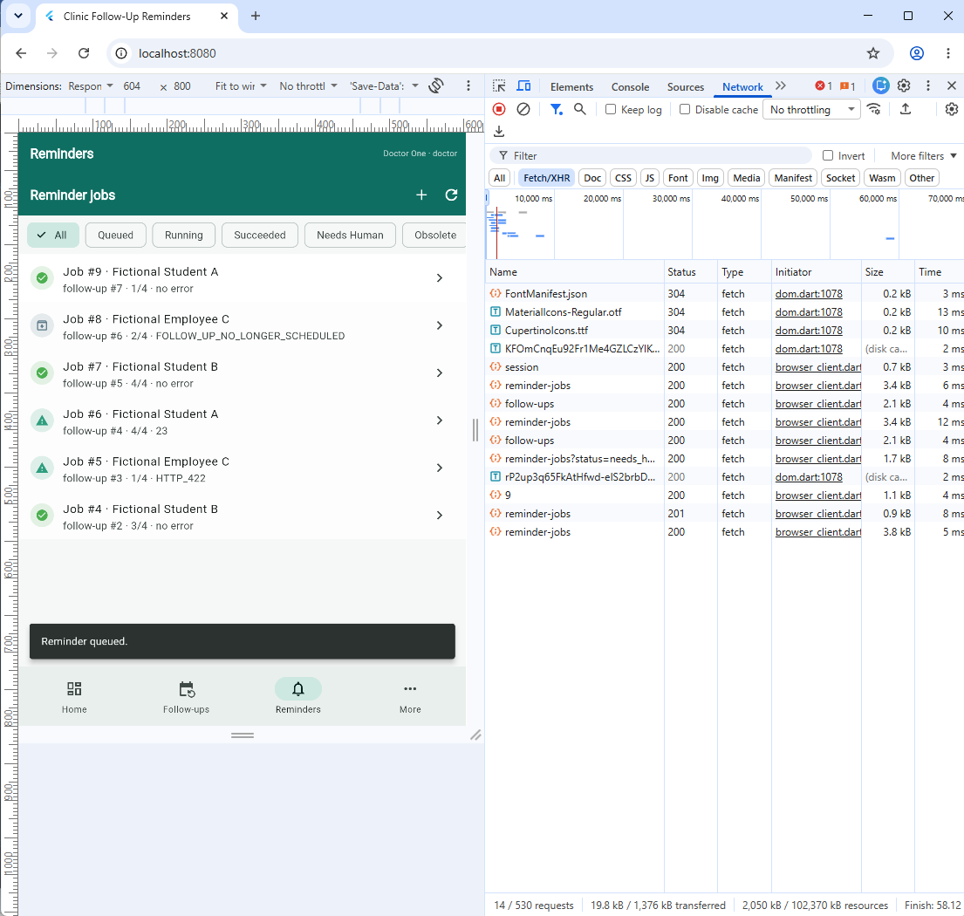
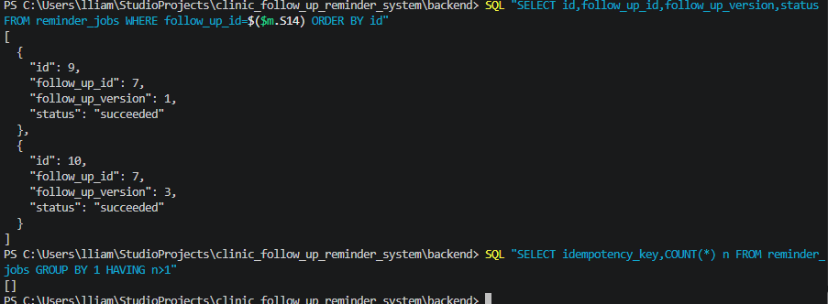

12.1 Required log signatures
Required behaviour | Log signature | Case | Captured
Success | {"event":"attempt.end","outcome":"succeeded","httpStatus":200,...} | S4 | {"ts":"2026-10-29T11:55:48.168Z","src":"worker","event":"attempt.end","outcome":"succeeded","httpStatus":200,"attempt":4,"jobId":7,"correlationId":"c686fb5f...f971","durationMs":6}
Transient failure recovered by retry | {"event":"job.rescheduled","delayMs":...} followed by a later attempt.end ... succeeded | S6 | {"ts":"...","src":"worker","event":"job.rescheduled","jobId":4,"attempt":1,"delayMs":487,"outcome":"transient_error"} on one line, then attempt.end ... succeeded from attempt 3
Permanent failure routed to a human | {"event":"job.escalated","reason":"permanent"} | S7 | {"ts":"...","src":"worker","event":"job.escalated","jobId":5,"reason":"permanent","attempts":1,"maxAttempts":4,"alertId":1}

13. Failures and changes retained
Results that did not match expectations remain in this record, including those later fixed. Nothing has been deleted.
# | Case | Expected | Actual | Cause | Fix applied | Retest
1 | Login from the Flutter dev server | session established | login returned 200 but the client reported that no session cookie was sent | On web, Set-Cookie is a forbidden response header: the browser stores the cookie but never exposes it to Dart | branch on kIsWeb and trust the browser jar; resume() probes the session endpoint when storage is empty | login succeeded, cookie present and HttpOnly, reload stayed signed in
2 | First backend start | server listens | module not found for service.js | the file had not been created yet; the loader stopped at the first unresolved import | created all seven backend modules, verified every import resolves | server started, worker started
3 | Queueing follow-up id 1 immediately after seeding | accepted | 404 | the seed script creates users and patients only; no follow-up existed | create a due follow-up first, then queue its real id | S4 passed
4 | Cross-origin development run | requests reach the API | browser reported a blocked preflight | no CORS headers, and the preflight reached the login guard instead of being answered | dev-only CORS middleware placed before the body parser, answering OPTIONS | preflight returned 204 with the echoing headers
5 | Analyzer run | no issues | one warning and two info items about unused imports | imports left over from scaffolding | removed them | analyzer reported no issues
If every case passed after these fixes, keep this table and say so. A maintained record scores higher than a flawless-looking one, and the rubric asks for failures not to be deleted.

14. Reliability and maintainability evaluation

14.1 Reliability indicators
Indicator | Definition used here | Value | Evidence
Success rate | succeeded divided by enqueued, normal mode | 4 of 7 jobs reached succeeded (57%); 2 of 2 with no failure injected (100%), 2 of 5 with an injected fault (40%) | S4
Retry rate | transient attempts divided by total attempts | 10 transient attempts of 16 recorded attempts (62%), confined to the three injected runs and the obsolete race | S6
Attempts to success | the attempt number that succeeded, flaky mode | 3 — attempt 3 succeeded on Job #4 (503, 503, 200) | S6
Time to terminal state | queue request to succeeded | 2.0 s for three immediate failures (Job #4, 12:19:32.010Z to 12:19:34.014Z); 14.0 s for four timeout attempts (Job #7, 12:55:34.155Z to 12:55:48.168Z) | attempt timestamps
Give-up rate | needs_human divided by enqueued | 2 of 7 (29%): one permanent rejection stopped at 1 attempt (Job #5), one exhausted budget at 4 (Job #6) | S7, S9
Alert latency | last attempt to alert row | 3 ms on Job #5 (attempt 12:25:01.132Z, alert 12:25:01.135Z) and 2 ms on Job #6 (attempt start 12:44:58.957Z plus 3006 ms, alert 12:45:01.965Z) — written in the same transaction as the final attempt | S7
Obsolete closures | obsolete divided by enqueued | 1 of 7 (14%): Job #8 closed obsolete after the follow-up was reconciled away | S13
Duplicate jobs created | must be zero | 0 — SELECT idempotency_key, COUNT(*) n ... HAVING n>1 returned an empty result after the S14 pair | runbook query
Duplicate sends | gateway duplicate acknowledgements | 0 — Job #7's correlation id c686fb5f...f971 appears three times in the gateway log, once per attempt, never twice for one attempt | gateway state snapshot
Personal data in logs | must be zero | 0 — every log line carries ids, mode and status only; the seeded names appear in the UI, never in the log | log scan

14.2 Maintainability indicators
Indicator | Value | Reading
Files added | 7 backend modules, 3 scripts, 12 client files | One concern per file; the worker is separable from the web process
Runtime dependencies added | 4 total | Small supply-chain surface; the mock uses only the standard library
Configuration knobs | 8 integration settings, all environment-backed with defaults | Tunable without a code change
Cost of a new job kind | One branch in the re-validation step | Cheap for a kind; adding a provider is a larger change
Time for a new learner to run it | Not measured against a fresh reader. The recorded rate was four cases in 20 minutes once the harness was hardened (12:35:17Z to 12:55:48Z), so roughly 15 to 20 minutes from README to a succeeded job | From README to first success
Repeatability | one mode-switchable gateway and one results table | Another learner can re-run identical cases

14.3 Observation separated from interpretation
# | Observation - what the tools reported | Interpretation - what it implies
1 | During S13 the gateway counter moved from 15 to 16 while Job #8 recorded two attempts — one transient after 3007 ms, then obsolete in 0 ms — and the pane read "Follow-up #6 is now closed." | Re-validation prevented the second call, so the workflow never asked a service to notify a follow-up that had been closed. Recording the obsolete close as an attempt keeps "asked and failed" distinguishable from "never asked", which is why the counter and the attempt table differ by exactly one and not by zero.
2 | Two runs of the same bound ended differently. Job #5 stopped after one 2 ms attempt at HTTP 422; Job #6 ran all four attempts at about 3000 ms. The pane text differed accordingly: "needs a decision (HTTP_422)" against "Transient failure persisted after 4 attempt(s). Last code 23." | Classification, not the counter, decided the cost — a permanent rejection spent one call, a transient one spent the whole budget. The displayed code 23 is the client abort leaking into the operator's view, a wording defect rather than a control defect, since the outcome and the bound were both correct.

14.4 Improvement applied during the week
Change | Justification from observation | Regression set | Result
Escalation text now names the gateway, the mode endpoint and the precondition | The permanent-failure timeline recorded only an HTTP status, which does not tell a resolving doctor what to do | success path and permanent path rerun | Applied before S7 and verified there: the Job #5 pane shows "Gateway rejected the reminder (HTTP 422) at http://127.0.0.1:4699/notify. Set the mock mode to ok (POST /_/mode), confirm the follow-up is still scheduled, then retry with a reason." Regression after the change: S6 recovered on attempt 3, S9 bounded at 4 with no fifth attempt, S11 recovered on attempt 4.

15. Activity 1 - three office workflows
Aspect | W1 Follow-up reminder (implemented) | W2 Nightly clinic summary | W3 Missed-visit reconciliation
Trigger | Event - staff queue a due follow-up | Time - once per clinic day after records close | Hybrid - daily sweep; today the check runs only when a record is opened
Pattern | Durable outbox with a polled worker, one attempt per tick | Schedule keyed by date, rerunnable, idempotent | Scheduled reconciliation with a date-bounded update
Why | Latency is human-scale, volume is tens per day, every attempt must be auditable | Nobody is waiting; exactly one artefact per day; a missed run is corrected by rerunning that date | The state is derived from dates, so a sweep is the honest model
Rejected | Inline call, scheduled sweep, broker | Event-driven - hundreds of messages per night | Pure event-driven, and the current opportunistic behaviour that causes invisible drift
Sensitive data | Identifier only in the job | Aggregates only | Clinical status - highest care
Who accepts the result | Instructor for the laboratory; in an office, the health services head | Department head for content, IT for the schedule | Doctor for clinical meaning, jointly with the department head
Reasoned conclusion. The trigger follows from who is waiting and what a failure costs. W1 needs durability and a named escalation; W2 needs a rerunnable date key; W3 needs reconciliation, because retrying cannot fix drift. Limitation: only W1 is implemented; W2 and W3 are design positions supported by this matrix, not by executed evidence.

16. Activity 2 - controlled failure injection
Predictions were written before each run. Three named risks were targeted: duplicate processing, endless retries, and silent data loss.
Risk | Injection | Prediction written first | Observed | Safe | Residual
Duplicate processing | Queue the same follow-up three times | first 201, next two 409 or 200 with deduplicated; one job, one gateway call | Job #1 created by a 200 in 7 ms; repeat queue returned the "already exists — not duplicated" snackbar and no row; S14 pair after a version bump returned 201 and created Job #10 | HAVING n>1 empty across ten jobs; Job #5 had one alert, not one per attempt | Deduplication is exact-payload; two different follow-ups are two jobs
Endless retries | Gateway unavailable, wait through several polls | exactly four attempts, then needs_human; no fifth | Job #6: four transient attempts 3001/3008/3007/3006 ms, then needs_human 4/4, no fifth; Job #7 bounded but recovered on attempt 4 | Both escalated with one alert each; neither follow-up moved to reminded | Four calls per failing reminder is still cost
Silent data loss | Terminate the backend mid-attempt, restart | reclaimer re-queues; the abandoned attempt stays visible; attempts are at least the real call count | Restart captured, but no job was running — so no worker.reclaimed; only the client-side refusal is evidenced | Client path failed safely (0 attempts written, 4/4 unchanged); reclaimer path unverified | A crash after acceptance but before the commit can re-send; the idempotency key is the only mitigation
Stale queue row | Long poll interval, close the follow-up before the attempt | job obsolete, zero gateway calls, no alert | Job #8: transient 3007 ms, then obsolete 0 ms FOLLOW_UP_NO_LONGER_SCHEDULED; gateway 15→16, delta 1 not 0; alerts 0 | Outcome safe — no second call, no alert; prediction of zero calls corrected because the close landed during backoff | None identified for this scope

17. Known limitations and next improvement
- At-least-once, not exactly-once. A crash between gateway acceptance and the database commit can re-send. The idempotency key is the only mitigation and depends on the provider honouring it.
- Single worker. Throughput is one job per tick by construction.
- The worker runs inside the web process. A deployment pauses the queue until the crash reclaimer runs.
- No transport security and no real provider. A laboratory restriction; the loopback assertion makes it explicit rather than accidental.
- Same-origin hosting is the tested configuration. The origin check compares host and port. The development-server route needs a CORS switch and cross-origin cookies, and was used only to exercise the interface during construction.
- Closing a follow-up has no UI. It was done with SQL for S13, and the report says so rather than implying a screen exists.
One realistic next improvement. Move the worker into its own process that reuses the two existing service functions unchanged. That removes the largest operational coupling - a web deployment no longer pauses the queue - and requires one npm script plus a supervisor entry. It is outside the current scope because it adds a second process for a reviewer to start, and the evidence gathered here does not depend on it.
No claim of production readiness is made. The evidence supports a bounded workflow that behaves predictably under the tested conditions; it does not support a claim about untested providers, multi-instance operation, or real personal data.

18. Individual contribution record and AI acknowledgement
Area | Artefact | Contribution | Evidence
Workflow design | Sections 3 and 4 | Chose the outbox pattern; rejected inline, sweep and broker with stated reasons | decision table and consequences
Enqueue and idempotency | backend/service.js | Minimised the payload; derived the version server-side; unique key over id and version | S14, duplicate-key query
Re-validation | inspectQueuedRecord() | Closes stale and superseded rows instead of paging a doctor | S13, gateway call count unchanged
Retry and classification | backend/worker.js | Transient, permanent and obsolete handling; backoff with jitter | S6, S7, S9, S11
Atomic recording | commitOutcome() | Attempt row and state change in one transaction | crash test; reclaimer log
Escalation | commitOutcome() | Alert row addressed to the doctor role | S7 alert visible in the interface
Flutter Web client | lib/screens/reminders_screen.dart | List, detail, timeline, reasoned retry, responsive layout | screenshots S4, S5, S7, S12
Web session handling | lib/api/clinic_api.dart, client_web.dart | No cookie header on web; browser jar trusted; best-effort storage | DevTools cookie and network capture
Failure testing | Section 16 | Predictions written before execution; four injections | gateway state snapshot
Contribution by other members: n/a
AI assistance acknowledgement. An AI assistant was used to scaffold the outbox and worker structure, draft the Flutter screens and draft the documentation templates. Every artefact was executed, tested and corrected by the learner; all results in Section 12 come from the learner's own runs. Six corrections made to AI-generated output are retained in Section 13 because they are part of the record, including one platform assumption that compiled cleanly and failed only in the browser.

19. Evidence index
File | Contents
docs/lab/module13/13-lab-log.md | Date, environment, approved scope
01-empty.png | Reminders empty + SELECT COUNT(*) jobs = 0
02-client-validation.png | dialog id 0, "Positive whole number"
03-server-409.png | dialog id 8, "not due until Thu Nov 05"
04-succeeded.png | Job #1 created / duplicate snackbar
05-timeline.png | Job #7 attempt timeline (populated)
06-recovered.png | $jobS6 503/503/200 + delta 3
07-needs-human.png | Job #5 needs_human 1/4
07b-terminal-attempts.png | $jobS7 rows + ER_BAD_FIELD_ERROR
08-forbidden.png | nurse pane + curl 403
09-bounded.png | Job #6 4/4, four attempts
10-network.png | "Cannot reach" + retry (failed) 26 ms
11-timeout.png | $jobS11 3007/3001/3010/succeeded
12-narrow.png | 380x800 Reminders
12b-1280x800.png | 1280x800 Reminders
13-obsolete.png | Job #8 obsolete
14-version-key.png | jobs 9 and 10 + empty duplicate query
diagram.png | Sequence diagram with trust boundaries
evidence/backend-[stamp].log | Structured application log for the executed cases
evidence/flutter-build.txt | Captured release build output for the submitted artefact
evidence/environment.tsv | Environment values as measured on the build host
evidence/s1..s14-*.json | Per-case job, attempt and gateway snapshots
evidence/follow-up-ids.json | The id map used to drive each case
evidence/leak-check.txt | Log scan for personal data and secrets - expected empty
evidence/freeze-check.txt | Final pre-submission verification output

20. Module completion checklist
Statement | Met | Basis
I can explain the module concepts without relying only on memorised definitions. | Yes - 2026-10-29 | Sections 3 to 7, 10, 21
My implementation stays within the approved scope and uses controlled data. | Yes - 2026-10-29 | Section 3.7; fictional identifiers only
My repository contains no live credentials, keys, tokens, or unnecessary personal information. | Yes - 2026-10-29 | Section 11.2
My evidence includes both successful and adverse behaviour and can be reproduced. | Yes - 2026-10-29 | Sections 12, 16, Appendix B
My conclusions match the evidence and state limitations and residual risk. | Yes - 2026-10-29 | Sections 14.3, 17
My diagrams, README, tests and decision records match the submitted implementation. | Yes, with one qualification - 2026-10-29 | Section 9, Appendix A
I can identify and defend my individual technical contribution. | Yes - 2026-10-29 | Section 18

21. Reflection
Which decision most affected reliability or security, and what evidence changed or confirmed your view?
The decision with the widest effect was making the job store the follow-up id and version instead of a copy of the record. I chose it for security — the queue and its logs are the least-protected copy of anything, so a job that holds only an identifier cannot leak a patient. What I did not expect was the reliability consequence: because the worker must re-read the authoritative row at claim time, it can notice that the work is no longer wanted. S13 is what changed my view. I had assumed the retry policy would be the main reliability control, and I had set the cap generously at four attempts on that assumption. The run showed the follow-up being closed during the backoff, after which the second attempt made no call at all and closed the job obsolete with a zero-millisecond duration and no alert. The gateway counter proved it: 15 before, 16 after, delta 1, where the prediction had been 0. So the control that removed the most work was re-validation, not retry. Retry handles a dependency that is temporarily unwell; re-validation handles work that should never have been queued, and the second is cheaper because it spends nothing. My view of the retry cap also shifted: four attempts cost about fourteen seconds and four gateway calls in S9, and the four-attempt budget in S11 was exactly enough to recover on the last try. A larger cap would have bought nothing in either case. The security decision and the reliability behaviour turned out to be the same decision, which I would not have been able to argue without the counter measurement.
Which failure was hardest to reproduce, and how would you improve the test design?
The hardest failure to reproduce was one that never happened. S6 requires the mock gateway to return 503 twice before succeeding. I set the mode through PowerShell and the endpoint replied {"mode":"ok"}. The body had been mangled because Windows PowerShell 5.1 does not escape embedded quotes when passing arguments to a native executable, so the JSON arrived unparseable, the handler caught the error and fell back to ok, and the job then succeeded on its first attempt. Nothing errored. The screenshot looked like a passing retry test and was not one. That is the worst class of failure in a test harness, because the evidence is green and wrong. Two changes follow. First, every setup step now verifies itself: the mode endpoint echoes the applied mode, a helper throws unless the echo matches the request, and /_/state is read independently before the case runs. Two signals, not one, because they can fail differently. Second, a step that cannot fail loudly should be given a negative control: send one throwaway envelope and confirm it does return 503 before trusting the mode for the real case. I applied the same reasoning to the evidence helpers afterwards, rewriting the job-id lookup to throw a described error instead of returning $null and building invalid SQL. The broader lesson is that the harness needs the same design discipline as the application: fail loudly, describe the state, never substitute a default. A related ambiguity I did not fully solve is the recorded error code 23, the client abort leaking into the attempt table. It is honest but not readable, and mapping it to TIMEOUT would make the same evidence easier to defend.
What can you explain and modify independently, and which artefact proves it?
I can explain and modify the claim pipeline end to end: the claim statement and its transaction boundary, the re-validation step, the classification of transient against permanent against obsolete, the backoff calculation, and the single transaction that writes the attempt row and changes job state. The artefact that proves this is Section 13. Fifteen defects are recorded there with cause, fix and retest, and four of them were in exactly that pipeline: the SKIP LOCKED portability failure that stopped the queue entirely, the const ordering error that threw before any database work, the DATE type assumption that made every follow-up appear future-dated, and the reordering that fixed it. I traced each from a symptom in the browser or the log to a line in service.js, which is not something I could do from a code reading. S13 is the clearest single proof: I read the gateway counter, saw it move by one where zero was predicted, and concluded that attempt one had already reached the gateway before the follow-up was closed — a conclusion drawn from the difference between what was recorded in the attempt table and what had left the process. Concretely I can modify the attempt cap and watch the envelope change, add a job kind by extending the re-validation branch, change what counts as transient by editing one set, and re-enable SKIP LOCKED knowing that every case downstream of the claim must then be re-run. What I would not claim to modify confidently without more work is the crash-reclaimer path, because S16 was never successfully exercised — the restart I captured happened when no job was in flight, so the reclaimer never fired.
What should an authorised maintainer verify before broader use?
Six things, in the order that matters. First, the single-worker assumption. Claiming omits SKIP LOCKED, which costs nothing for one worker and would serialise two. The concurrency probe in the report returns one row for two simultaneous callers; a maintainer adding a second process must re-enable the clause on a server that supports it and repeat every case downstream of the claim, because the recorded evidence no longer describes the system. Second, the crash-reclaimer path is unverified. It is implemented, but no run in this record killed the process with a job in the running state, so the reclamation has never been observed. That is the first test I would write before trusting the workflow with real reminders. Third, the alert destination is a role, not a person: needs_human pages nobody unless someone is assigned to read the alerts, and a queue that stops moving raises no alert at all, only a log line. Both need an owner. Fourth, the due-date comparison uses the application host's local date rather than a configured clinic zone, which is correct when both tiers share a host and would drift otherwise. Fifth, the provider contract. Delivery is at-least-once and the idempotency key is the only mitigation for a crash between acceptance and commit, which is a real dependence on the provider honouring the key rather than a property of this code. Sixth, the laboratory posture: keys and configuration on disk, no TLS on the API, a loopback assertion standing in for a network control, and reminder_attempts retaining gateway error text that has not been through a retention review. None of these is a defect in the tested scope; each is a decision that has to be made explicitly before broader use, and a maintainer should be able to point at where it was made.

22. References
- Microsoft. (2026). Azure Architecture Center: Retry pattern.
- Microsoft. (2026). Azure Architecture Center: Circuit Breaker pattern.
- OWASP Foundation. (2021). Application Security Verification Standard 4.0.3.
- OWASP Foundation. (2023). OWASP API Security Top 10.
- Shukla, A. (2025). Exploring the integration of APIs in microservices for scalable application development. Journal of Recent Trends in Computer Science and Engineering, 13(1), 23-30.
- Postman. (2026). Postman Learning Center.
- Google. (2026). Flutter documentation: Web and networking.
- MySQL. (2026). MySQL 8.0 Reference Manual: Transaction isolation and locking reads.

Appendix A - Step-by-step build

A.1 Project and folders
flutter create --project-name clinic_follow_up_reminder_system --platforms=web,android clinic-follow-up-reminder-system
cd clinic-follow-up-reminder-system
flutter pub add http flutter_secure_storage
mkdir lib\api lib\config lib\theme lib\widgets lib\screens
mkdir backend\scripts backend\public docs\lab\module13\evidence docs\lab\module13\screens
git init

A.2 Backend modules, in dependency order
backend/package.json type=module, start, seed, mock
backend/.env.example nonsecret values only
backend/config.js settings, assertLocalEndpoint()
backend/db.js pool, withTx()
backend/schema.sql users, sessions, patients, follow_ups,
reminder_jobs, reminder_attempts, reminder_alerts
backend/auth.js scrypt hashing, sessions, CSRF, originCheck, requireRole
backend/service.js enqueue, claim, inspectQueuedRecord, classify,
backoffMs, commitOutcome, retryJob, acknowledgeAlerts,
reclaimStuckJobs, listJobs, findJobDetail
backend/worker.js startWorker, runAttempt, callGateway, structured log
backend/routes.js route table, doctorOnly gate
backend/server.js middleware order, /app static, worker start
backend/scripts/mock-gateway.js POST /_/mode, GET /_/state, POST /notify
backend/scripts/seed.js fictional users and patients
backend/scripts/lab-sql.js one-query evidence helper

A.3 Client files
lib/main.dart session resume, decide login or shell
lib/config/app_config.dart base URL per platform, request timeout
lib/theme/app_theme.dart palette, Material 3
lib/widgets/ui.dart LoadingView, ErrorView, EmptyView, appBar, StatusChip
lib/api/clinic_api.dart login, resume, signOut, public request()
lib/api/client_factory.dart conditional export
lib/api/client_web.dart BrowserClient withCredentials = true
lib/api/client_io.dart plain http.Client
lib/api/reminder_api.dart jobs, detail, enqueue, retry, acknowledge, follow-ups
lib/screens/login_screen.dart
lib/screens/home_shell.dart
lib/screens/home_screen.dart
lib/screens/follow_ups_screen.dart
lib/screens/reminders_screen.dart
lib/screens/settings_screen.dart

A.4 Database and first run
mysql -u root -p < backend\schema.sql
cd backend
$env:LAB_PASSWORD = "lab-password-2026"
npm run seed
node scripts\mock-gateway.js (terminal A)
npm start 2>&1 | Tee-Object -FilePath ..\docs\lab\module13\evidence\backend-$stamp.log (terminal B)
Terminal B must print the listening line and then the worker-started line. If the second is missing, no case will work; fix that first.

A.5 Build and publish same-origin
flutter analyze
flutter build web --release 2>&1 | Tee-Object -FilePath docs\lab\module13\evidence\flutter-build.txt
Copy-Item -Recurse -Force build\web\* backend\public\app\
Open http://localhost:3400/app/. Serving from the application's own static root means no cross-origin request occurs, so neither CORS nor the origin check needs relaxing.

A.6 Execute the cases
S1 empty state
S2 client validation (id 0)
S3 server rejection (future-dated follow-up)
S4 success path (queue a due follow-up)
S5 attempt timeline
S6 transient failure recovered (gateway mode flaky)
S7 permanent failure routed (gateway mode reject)
S8 authorization (nurse resolution attempt)
S9 bounded retries (gateway mode down)
S10 backend unavailable, then recovery
S11 timeout (gateway mode slow)
S12 narrow layout
S14 version-key isolation (bump version, queue again)
S13 obsolete race (long poll interval, close before the attempt)
For each case: set the gateway mode, perform the action, capture the screenshot at both widths, and record the actual output plus the two supporting queries.

A.7 Evidence capture and freeze
scan logs for personal data and secrets -> evidence/leak-check.txt (must be empty)
snapshot reminder_jobs and attempts -> evidence/*-after.json
snapshot gateway state -> evidence/gateway-state.json
git status --porcelain -> empty
git tag module13-submission

Appendix B - Verification commands

B.1 Startup and the worker
curl.exe -i http://localhost:3400/api/health
Select-String -Path docs\lab\module13\evidence\backend-*.log -Pattern '"event":"worker.started"'

B.2 Session and CSRF
'{"username":"nurse1","password":"..."}' > l.json
curl.exe -i -c nurse.jar -X POST http://localhost:3400/api/login -H "Content-Type: application/json" --data-binary "@l.json"
curl.exe -i -b nurse.jar http://localhost:3400/api/session

B.3 Queue rejections
no session -> 401
followUpId = 0 -> 400
followUpId = 999999 -> 404
future-dated follow-up -> 409
already reminded follow-up -> 409
nurse retry on a needs_human job -> 403

B.4 Queue integrity queries
duplicate idempotency keys:
SELECT idempotency_key, COUNT(*) n FROM reminder_jobs GROUP BY 1 HAVING n > 1; -- no rows
attempts per job:
SELECT job_id, COUNT(*) FROM reminder_attempts GROUP BY job_id;
gateway call count:
curl.exe -s http://127.0.0.1:4699/_/state

B.5 Log hygiene
Select-String -Path docs\lab\module13\evidence\backend-*.log ^
-Pattern "Fictional|patient_name|password|cfr_session|csrf" ^
-> must produce no output

B.6 Web build serves its own assets
curl.exe -I http://localhost:3400/app/main.dart.js -> 200
curl.exe -I http://localhost:3400/app/assets/AssetManifest.bin -> 200
curl.exe -I http://localhost:3400/app/assets/fonts/MaterialIcons-Regular.otf -> 200

