11. Security test record
Twelve cases, executed against the commit in the title block. Predictions and expected codes were written before execution. T4 and T5 are the pair that matters: the first shows the signature rejecting an outsider, the second shows the AEAD tag still rejecting someone who holds the signing key and re-signs after tampering.
ID | Case | Expected | Actual | Time | Verdict
T1 | Genuine envelope accepted | 200 with a receipt | 200 receipt | 55 ms (1 request) | [[T1v]]
T2 | Identical envelope replayed | 409 REPLAY_DETECTED | 409 REPLAY_DETECTED | 5 ms (1 request) | [[T2v]]
T3 | Envelope past its expiry | 410 ENVELOPE_EXPIRED | 410 ENVELOPE_EXPIRED | 2 ms (1 request) | [[T3v]]
T4 | Ciphertext byte flipped, signature untouched | 422 SIGNATURE_INVALID | 422 SIGNATURE_INVALID | 2 ms (1 request) | [[T4v]]
T5 | Ciphertext flipped and re-signed with the sender key | 422 INTEGRITY_CHECK_FAILED | 422 INTEGRITY_CHECK_FAILED | 3 ms (1 request) | Pass
T6 | Authenticated header altered and re-signed | 422 INTEGRITY_CHECK_FAILED | 422 INTEGRITY_CHECK_FAILED | 3 ms (1 request) | Pass
T7 | Sealed to a public key the receiver does not hold | 422 KEY_UNWRAP_FAILED | 422 KEY_UNWRAP_FAILED | 3 ms (1 request) | Pass
T8 | Algorithm downgraded in the header and re-signed | 400 ALGORITHM_NOT_ALLOWED | 400 ALGORITHM_NOT_ALLOWED | 2 ms (1 request) | Pass
T9 | Truncated envelope | 400 MALFORMED_ENVELOPE | 400 MALFORMED_ENVELOPE | 2 ms (1 request) | Pass
T10 | Addressed to another recipient | 422 AUDIENCE_MISMATCH | 422 AUDIENCE_MISMATCH | 2 ms (1 request) | Pass
T11 | Receiver certificate not signed by the pinned CA | TLS handshake failure, no response body | no response DEPTH_ZERO_SELF_SIGNED_CERT | 6 ms - TLS refused before any HTTP exchange | Pass
T12 | Plaintext marker absent from envelope and receipt | 200; marker nowhere on the wire or in the response | status 200; envelope=false; response=false | 5 ms (1 request) | Pass
T13 | recipientDecrypt absent | absent | no HTTP request - process inspection | Pass | T13
T14 | senderSigning present | present (fp b27727ea7c3fdc25) | no HTTP request - process inspection | Pass | T14
T15 |  | 422 NOT_YET_VALID | 422 NOT_YET_VALID | 2 ms (1 request) | Pass
T16 |  | 422 SIGNATURE_INVALID | 422 SIGNATURE_INVALID | 2 ms (1 request) | Pass
T17 |  | 422 KEY_UNWRAP_FAILED | 422 KEY_UNWRAP_FAILED | 2 ms (1 request) | Pass
T18 |  | count unchanged after 409 | accept 200; replay 409; inbox 24 -> 25 -> 25 | 10 ms (2 requests) | Pass

11.1 TEST CASES
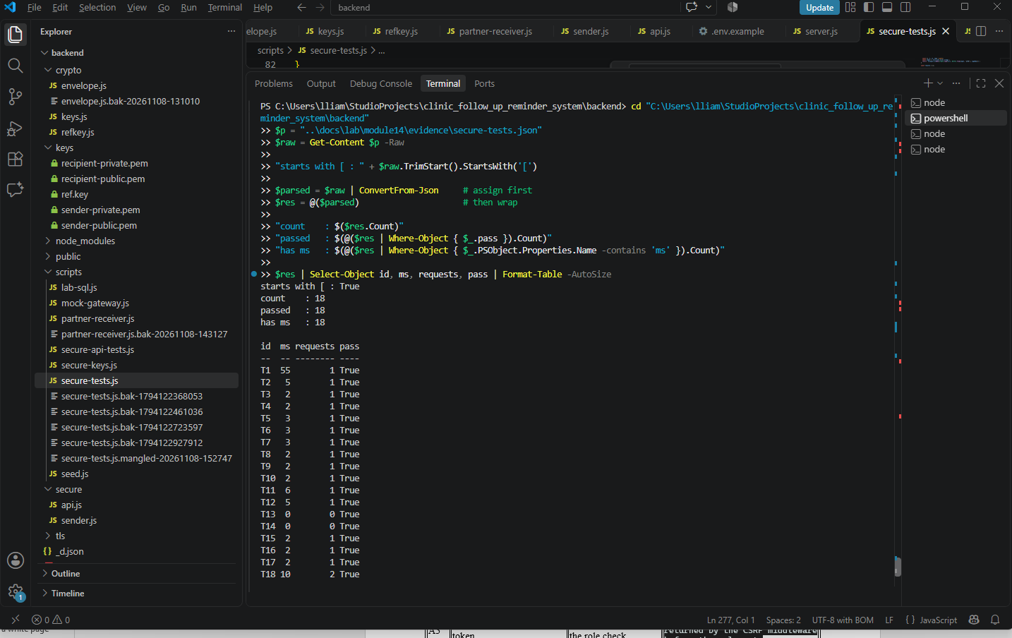

11.2 14-01 preview
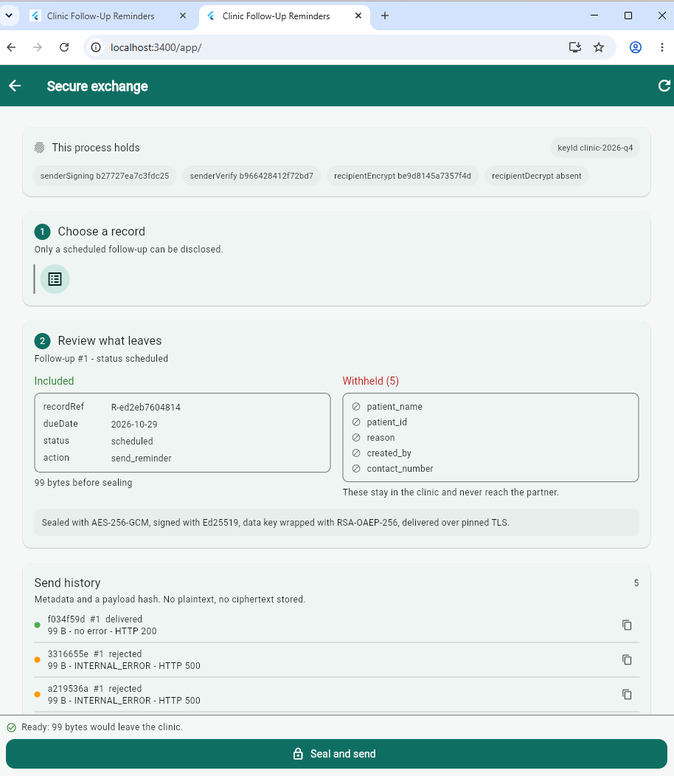

11.3 14-02 Delivered
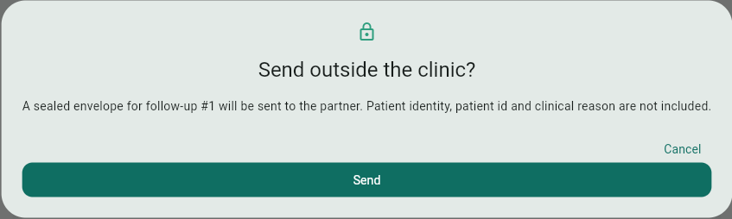
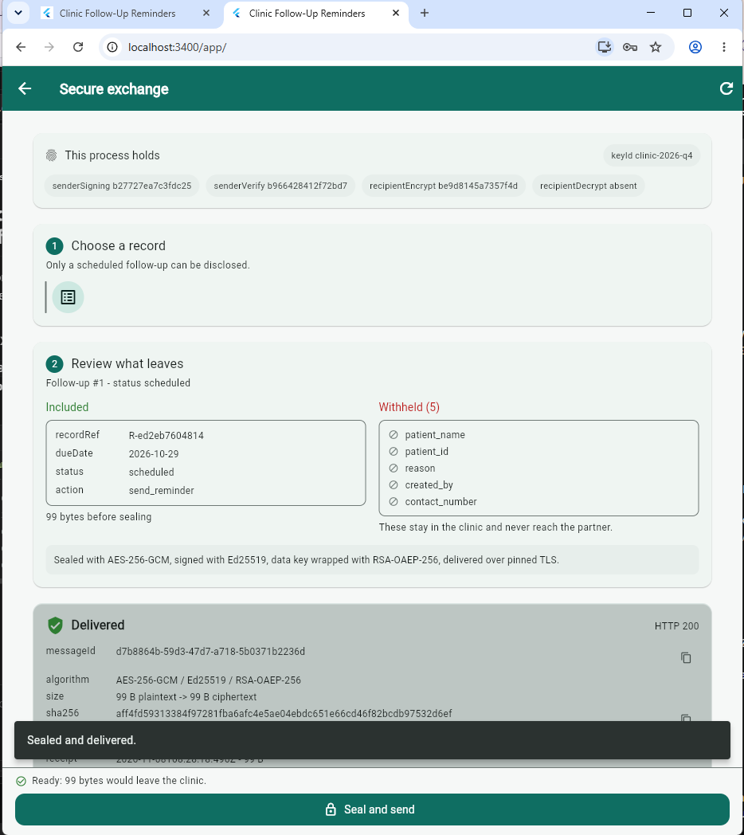

11.4 14-03 The API holds no decryption key
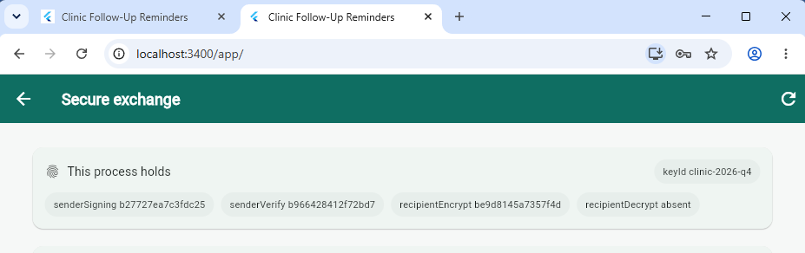

11.5 14-04 Send history
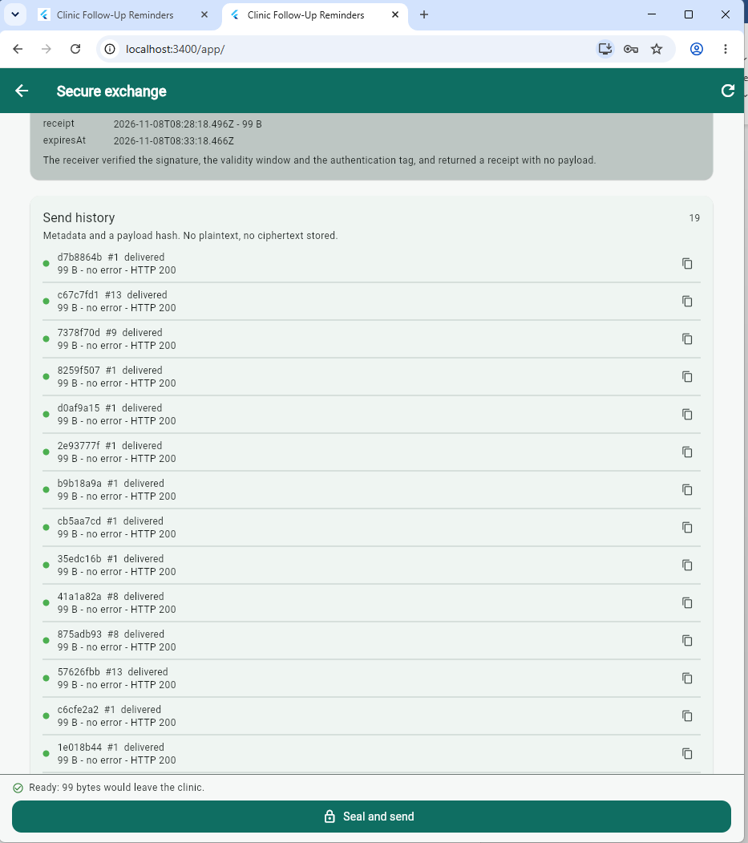

11.6 14-05 The suite
cd "C:\Users\lliam\StudioProjects\clinic_follow_up_reminder_system\backend"
node --env-file=.env scripts\secure-tests.js *>&1 |
Tee-Object -FilePath ..\docs\lab\module14\evidence\secure-tests.log
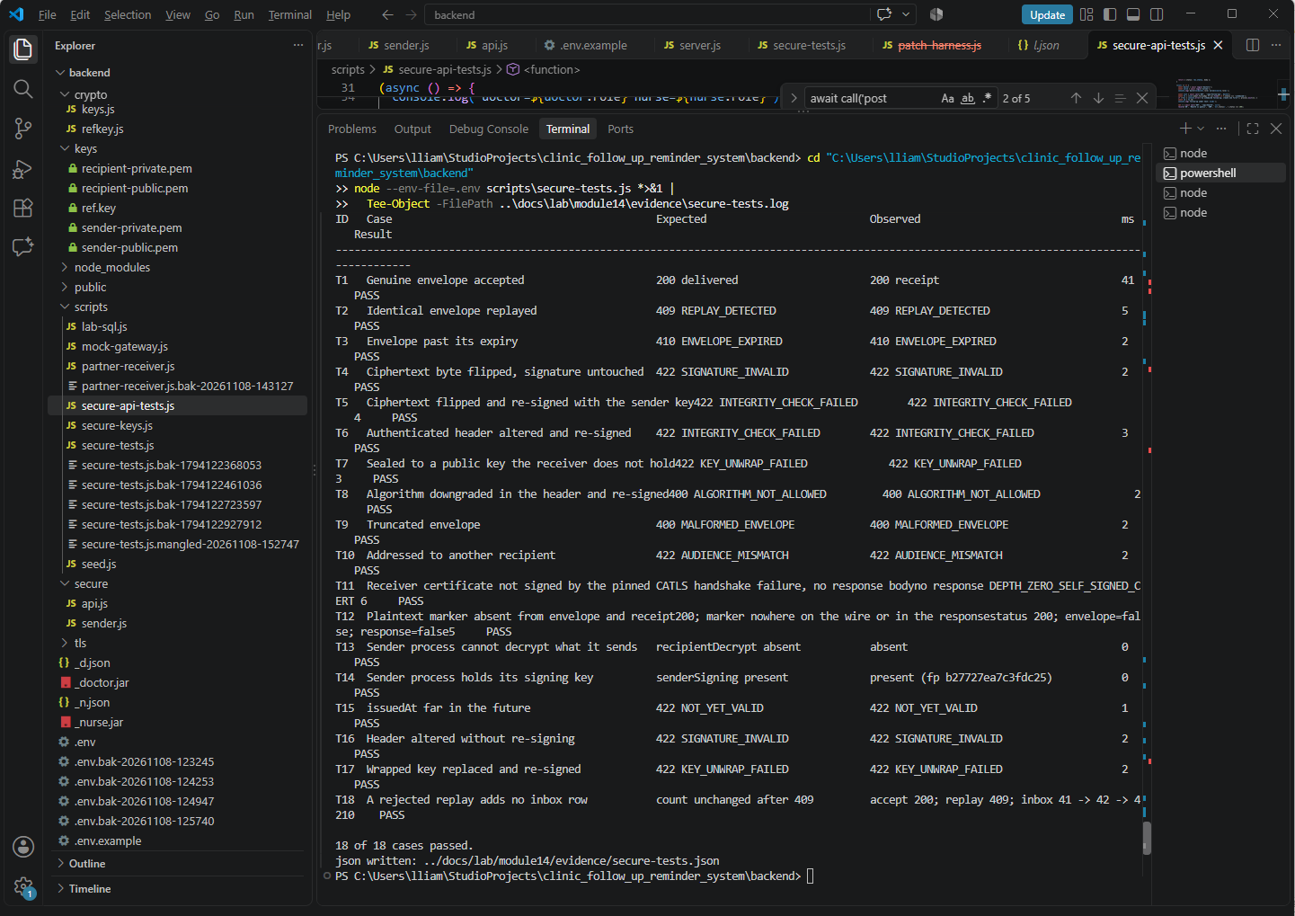

11.7 14-06 Rejected


