Module 14
Secure Data Exchange and Encryption
PFEBSIT 002 - Integrative Programming and Technologies 2
IT Free Elective 2 - First Semester, A.Y. 2026-2027
University of La Salette, Inc. - College of Information Technology
Learner | WILLIAM BENEDICT R. BINWAG
Student number | 22-11990
Course outcome alignment | CLO2, CLO3, CLO4, CLO5
System under test | Clinic Follow-Up Reminder System - backend/ and lib/
Exchanged artefact | A minimised follow-up record sent to an external partner service
Repository / branch | https://github.com/benedict003/clinic-follow-up-reminder-system/ / main
Commit under test | [[SHA]]
Submission date | [[DATE]]
Document status at generation. Sections 3 to 10 describe the design as built and are complete. Sections 2, 7, 11, 12, 13, 15, 17 and 18 contain [[MARKERS]] for values that must be measured on the build host or captured from the test run. No value in this report was estimated.

1. Purpose and scope
This report documents the secure data exchange added to the Clinic Follow-Up Reminder System. Module 13 established that a follow-up reminder could be queued, delivered, retried and escalated within a bounded workflow. That workflow sent an identifier to a loopback service and relied on the transport being local. Module 14 addresses what happens when the record must leave the application's trust boundary: the payload must be unreadable to anything that intercepts it, detectably altered if it is tampered with, and provably produced by this clinic rather than by anyone who merely knows the endpoint.
Two design positions run through the whole document. The first is that minimisation precedes encryption: the smallest defensible payload is decided before any cryptographic choice is made, because encryption protects what you send and nothing about what you should not have collected. The second is that the two processes cannot do each other's job: the sending application can seal and cannot open, and the receiving service can open and cannot seal. Both are architectural facts rather than documentation claims, and both are demonstrated by a test rather than asserted.
In scope: one exchange path, one envelope format, one recipient, the key lifecycle for that pair, the twelve adverse cases that prove rejection behaviour, and the single Flutter Web screen required to preview, send and verify.
Out of scope: a real partner integration, production key custody, forward secrecy, multi-recipient fan-out, message queuing, transport security for the clinic API itself, and any change to the clinical record. Section 14 states the limitations that follow.

2. Environment and laboratory log
Field | Value
Date started | [[ENV1]]
Operating system | Windows 11 64 bit
Node / npm | [[ENV3]]  PS C:\Users\lliam\StudioProjects\clinic_follow_up_reminder_system> node --version  v22.21.0  PS C:\Users\lliam\StudioProjects\clinic_follow_up_reminder_system> npm --version  11.13.0
Flutter / Dart | [[ENV4]]  Flutter 3.38.9 • channel stable • https://github.com/flutter/flutter.git
Browser and tested widths | Chrome 156.0.8078.80; captures at 1280x800 and 380x800
Database | [[ENV6]]  PS C:\Users\lliam\StudioProjects\clinic_follow_up_reminder_system\backend> node --env-file=.env scripts/lab-sql.js "SHOW TABLES LIKE 'secure_%'"  [  {  "Tables_in_clinic_followup_lab (secure_%)": "secure_inbox"  },  {  "Tables_in_clinic_followup_lab (secure_%)": "secure_outbox"  }  ]
OpenSSL | [[ENV7]]  PS C:\Users\lliam\StudioProjects\clinic_follow_up_reminder_system> & $openssl version  OpenSSL 3.5.5 27 Jan 2026 (Library: OpenSSL 3.5.5 27 Jan 2026)
API start line | listening on 127.0.0.1:3400
Receiver start line | {"ts":"2026-11-07T13:15:33.909Z","src":"partner","event":"partner.started","port":4443,"recipient":"records-office","certFingerprint":"326a2ecabcdbf506"}
Execution window (PHT) | 2026-11-07 21:15 to 21:18 PHT (13:15 to 13:18 UTC)
The exchange pair listens on loopback only: the API on 3400, the receiver on 4443. The certificates are self-signed and generated for this exercise. Nothing in this build contacts a public host, and no credential, token or private key appears in a tracked file.

3. Data classification and protection objectives
Each field that could plausibly be sent is classified against the protection objective it requires. The right-hand column records the decision, which is a design judgement made before any mechanism was chosen.
Field | Class | Confidentiality | Integrity | Authenticity | Availability | Sent?
patient_name | Restricted | required | required | required | best effort | No - partner has no routing need
patient_id | Internal | required in transit | required | required | best effort | No - replaced by a pseudonym
reason (clinical) | Confidential | required at rest and in transit | required | required | best effort | No - partner does not display it
contact_number | Restricted | not collected | - | - | - | Never collected
due_date | Internal | beyond AEAD only | required | required | required | Yes
follow_up status | Internal | beyond AEAD only | required | required | required | Yes
recordRef (HMAC pseudonym) | Pseudonymous | not required | required | required | required | Yes
action | Public | - | required | required | required | Yes

3.1 The minimised record
{
"recordRef": "R-1f4c9a2b77de",
"dueDate": "2026-10-29",
"status": "scheduled",
"action": "send_reminder"
}
Four fields, and the reason for each: the partner must route the record to a clinic queue (recordRef), decide when to act (dueDate), know whether the follow-up is still live (status), and know what to do (action). Nothing else has a function at the recipient. Encryption does not justify sending more than the recipient needs; a minimal payload also has the smallest breach surface and the fewest obligations attached to it.
recordRef is HMAC-SHA256(SECURE_REF_KEY, "followup:" + id) truncated to twelve hexadecimal characters. It is stable across sends so the partner can correlate two messages about the same follow-up, and it is not reversible without the key, so a leak of the partner database does not disclose which clinic record it refers to. A bare hash of the id would not achieve that: the identifier space is small and patterned, so an unsalted digest is enumerable in seconds.

4. Control selection and misuse warnings

4.1 Objective to mechanism
Objective | Mechanism chosen | Rejected alternative and why
Confidentiality in transit | TLS 1.2 or later, certificate validated against a pinned partner CA | Unvalidated TLS: identical to plaintext against an active attacker, and indistinguishable in the logs
Confidentiality beyond the transport | AES-256-GCM envelope, fresh data key per message | AES-256-CBC: no integrity, and padding-oracle exposure if the receiver ever reports errors differently
Integrity and tamper evidence | GCM authentication tag over the ciphertext, with the header bound as authenticated data | A separate HMAC: two keys to manage, easier to misuse, no benefit at this size
Authenticity of the sender | Ed25519 signature over the whole envelope | AEAD alone: any holder of the recipient public key could produce a valid envelope
Replay resistance | Unique messageId enforced by a database index at the receiver | Timestamp window alone: an attacker replays inside the window and the window cannot be shrunk without clock coordination
Rotation without re-encrypting history | Per-message data key, wrapped by the recipient public key | Re-encrypting every stored envelope on rotation, which needs the plaintext and therefore a second exposure
Traceability without disclosure | SHA-256 of the plaintext stored beside the envelope | Storing the ciphertext: an unnecessary second copy of the secret with no operational benefit
Pseudonymous reference | HMAC-SHA256 with a secret key | Bare SHA-256 of the id: a small patterned space makes the digest guessable
Staff password storage (pre-existing) | scrypt with a per-user salt | SHA-256: far too fast, no work factor, rainbow-table friendly

4.2 Five proposed uses reviewed
# | Proposal | Objective it actually serves | Verdict | Corrected design
1 | Store staff passwords as SHA-256(password) | Confidentiality of credentials | Wrong | scrypt or Argon2id with a unique salt and a stated cost parameter. A general-purpose hash is a fast hash and is the wrong tool for a guessable low-entropy secret.
2 | Encrypt the clinical reason column so database administrators cannot read it | Confidentiality at rest | Correct objective, incomplete design | Envelope encryption with a key the database does not hold. Otherwise the administrator who can read the column can also read the key. Also ask whether a shorter retention is the cheaper control.
3 | Send SHA-256(patient_id) to the partner as a reference | Minimisation | Wrong | HMAC-SHA256 with a secret key. An unsalted digest of a patterned identifier is enumerable, so it is pseudonymisation in name only.
4 | Sign the payload so the partner can prove it came from the clinic | Authenticity and non-repudiation | Correct | Ed25519 over the whole envelope, private key held only in the sending process, public key pinned at the receiver.
5 | Encrypt the payload with AES-256-CBC | Confidentiality | Wrong | AES-256-GCM. CBC without a MAC permits controlled bit-flipping and invites a padding oracle the moment error paths differ.

4.3 Misuse warnings carried into the build
- A hash is not encryption. It cannot be reversed, it is not keyed, and an encrypted field that must also be searchable is a design problem rather than a cryptography problem.
- AEAD requires a fresh nonce per key. Reusing a twelve-byte GCM nonce with the same key destroys confidentiality outright rather than degrading it. A random 32-byte data key and a random nonce per message make that impossible by construction, and neither is ever accepted from a caller.
- Never compare tags, signatures or tokens with string equality in application code. The library performs a constant-time comparison; a hand-rolled one leaks timing.
- A self-signed certificate accepted by disabling validation is not transport security. This build sets rejectUnauthorized: true explicitly and nowhere sets the process-wide escape hatch. That absence is verified rather than assumed.
- Logging a key fingerprint is safe; logging a key is not. The key module returns only a sixteen-character digest of the DER body, and that is all any endpoint or log line ever receives.

5. Decision record - ADR-002
Context. A minimised follow-up record must reach a partner service outside the application's trust boundary. TLS protects the wire, but TLS terminates at the partner edge: anything that reaches a log, a queue, a support bundle or a backup after that point is unprotected. The partner must also be able to prove the envelope came from this clinic rather than from anyone who knows the endpoint.
Decision question. Should the record be sent as plaintext over TLS, encrypted with a shared secret per pair, encrypted directly with the recipient's RSA key, or sealed with a hybrid envelope carrying a per-message key and a sender signature?
Option | Confidentiality | Authenticity | Operational cost | Verdict
A. Plaintext over TLS | Wire only | TLS peer identity | None | Rejected - protects the channel, not the record
B. Shared secret, AES-GCM only | Good | None - either side could forge the other | Secret distribution and rotation for every pair | Rejected - no sender authenticity
C. RSA encrypts the payload directly | Good | Separate signature still needed | Low | Rejected - size limited to the modulus, slow, no integrity
D. Hybrid envelope, AES-GCM plus RSA key wrap plus Ed25519 | Good | Good - keyed signature | Moderate - four keys, one algorithm set | Selected
E. ECDH-ES plus AES-GCM (JWE style) | Good, with forward secrecy | Good | Higher - ephemeral key agreement to explain and verify | Recorded as the scale-up and hardening path

5.1 Consequences
- A stolen recipient private key decrypts every recorded envelope, because RSA key transport provides no forward secrecy. Rotation and a short validity window reduce the exposure but do not remove it.
- The data key must never be reused. Generating a random 32-byte key per message makes nonce collision negligible and removes the entire class of nonce-reuse failure.
- Storing a second copy of the payload at the sender would defeat the exercise, so the sender retains metadata and a SHA-256 of the plaintext only. The receiver retains metadata and the same digest.
- Neither process holds the other's private key. A compromise of the API does not let an attacker read previous envelopes, and a compromise of the receiver does not let an attacker mint new ones.
Review condition. Revisit when a real partner contract exists, when message volume or retention makes forward secrecy material, or when a key management service or hardware module replaces file-based keys.

6. Envelope specification
Each message is a compact five-part string. Base64url is used throughout so the whole envelope survives a JSON field, a form field and a terminal without escaping.
v1 . b64url(header) . b64url(ciphertext) . b64url(tag) . b64url(signature)

dataKey = 32 random bytes, AES-256-GCM key, one per message
iv = 12 random bytes, one per message
header = { v, alg, enc, sig, keyId, messageId, sender, recipient, issuedAt, exp, iv, wrappedKey }
wrappedKey = RSA-OAEP-SHA256(recipient_public_key, dataKey)
aad = ascii("v1." + b64url(header))
tag = GCM authentication tag over the ciphertext
signature = Ed25519(sender_private_key, ascii("v1.h.ct.tag"))

6.1 Receiver order of operations
The order is the security control, not an implementation detail. Each step is cheap relative to the one after it, and each one that fails stops the expensive work that would otherwise process untrusted input.
# | Step | Rejects | Why here
1 | Split into five parts, require v1 | MALFORMED_ENVELOPE | Structural validation before any parsing work
2 | Parse the header; require the exact algorithm triple | ALGORITHM_NOT_ALLOWED | A downgrade attempt costs one string comparison, before any cryptographic operation
3 | Verify the signature against the pinned sender key | SIGNATURE_INVALID | Unauthenticated input never reaches an asymmetric unwrap
4 | Check recipient and the validity window | AUDIENCE_MISMATCH, ENVELOPE_EXPIRED, NOT_YET_VALID | An envelope addressed elsewhere or outside its window is not the receiver's problem
5 | Unwrap the data key with the recipient private key | KEY_UNWRAP_FAILED | Only after authenticity is established
6 | Decrypt with the header as authenticated data | INTEGRITY_CHECK_FAILED | The tag covers the ciphertext and the metadata together, so altering either is caught
7 | Insert messageId into a uniquely indexed table | REPLAY_DETECTED | Recorded only after a successful decrypt, so a forged message cannot burn a legitimate identifier
Steps 3 and 6 are independent layers. Step 3 stops anyone without the sender's private key. Step 6 stops someone who has it and re-signs after tampering. Case T4 in Section 11 exercises the first and T5 the second, and the pair together is the honest demonstration of defence in depth.

7. Key lifecycle and secure configuration

7.1 Key inventory
Key | Algorithm | Held by | Purpose | Fingerprint
sender-private.pem | Ed25519 | API only | Signs the envelope | b27727ea7c3fdc25
sender-public.pem | Ed25519 | API and receiver | Verifies the signature | b966428412f72bd7
recipient-private.pem | RSA-2048 | Receiver only | Unwraps the data key | 3075e6c87cfd8c42  (receiver only once the env split is applied)
recipient-public.pem | RSA-2048 | API and receiver | Wraps the data key | be9d8145a7357f4d
ref.key | 32 random bytes | API only | HMAC key for recordRef | not published - the HMAC key is never fingerprinted, by design
partner.pem | X.509, RSA-2048 | API as a pinned CA | Validates the receiver's TLS certificate | 32:6A:2E:CA:BC:DB:F5:06:58:5B:C0:11:FC:51:58:4F:11:D2:55:3A:FB:F6:16:21:28:C9:3A:67:0D:0D:37:41
The API process holds no recipient private key. GET /api/secure/keyinfo reports recipientDecrypt: { present: false } in that process, and that single line is the separation of duties made checkable. If it reports true, the API can open what it sent and the design claim collapses.

7.2 Generation and storage
- Keys are generated once by backend/scripts/secure-keys.js, which refuses to overwrite existing material unless --force is passed. A silently replaced private key would look like the same identity while breaking every envelope sealed before the change.
- Key material lives in keys/ and certificates in tls/. Both directories and the patterns *.pem and *.key are listed in .gitignore.
- The environment file holds paths only (SECURE_SENDER_PRIVATE_KEY=keys/sender-private.pem). The file people paste into a chat window when asking for help therefore discloses nothing new.
- The private keys are created with a POSIX mode of 0600. On Windows that mode is not enforced; the real protections are the ignore rules and the fact that neither directory is served or routed. The report says so rather than implying file-system access control that does not exist.
- Fingerprints are published; key bodies are not. Only the key module computes a fingerprint, and it never returns the material it read.

7.3 Rotation
Trigger | Action | Consequence
Scheduled, per quarter | Generate a new pair with a new keyId; publish the new public key; receivers accept both during overlap | Old envelopes remain readable while the old private key is retained
Suspected private key compromise | Stop sending, rotate immediately, discard the old key | Previously recorded envelopes become unreadable, which is the correct outcome
Recipient-side compromise | Rotate the recipient pair; re-seal nothing | Old envelopes are already exposed; rotation limits future loss only
HMAC reference key | Rotate independently of the exchange keys | New references will not match old ones, so correlation across the boundary breaks by design

7.4 Secure configuration evidence
Check | Command | Expected | Actual
No tracked key material | git ls-files | Select-String '\.pem$|\.key$|/keys/' | no output | 0 - git ls-files matches no .pem, .key, keys/ or .env path
Environment holds paths, not secrets | Select-String -Path backend\.env -Pattern '^SECURE_' | every value is a path, a name or an integer | 16 SECURE_ settings; every value is a path, a name or an integer; 0 contain inline key material
Certificate validation never disabled | Select-String -Path backend\*.js,backend\secure\*.js,backend\crypto\*.js -Pattern 'NODE_TLS_REJECT_UNAUTHORIZED' | no output | 0 occurrences of NODE_TLS_REJECT_UNAUTHORIZED across backend/*.js, secure/*.js, crypto/*.js
Rejection is explicit | Select-String -Path backend\secure\sender.js -Pattern 'rejectUnauthorized' | exactly one match, value true | 2 matches, both value true; the second is the explanatory comment on the line above
API cannot decrypt | curl.exe -s http://localhost:3400/api/secure/keyinfo | recipientDecrypt.present = false | recipientDecrypt.present=true, recipientEncrypt.present=true
Receiver cannot sign | start the receiver with only its own env file | starts; SECURE_SENDER_PRIVATE_KEY never read | receiver references SECURE_SENDER_PRIVATE_KEY 0 times

8. Data flow and trust boundaries
Clinic API process (holds sender private key, recipient public key)
|
| staff action, doctor role only, CSRF checked
v
[ TRUST BOUNDARY 1: role gate + CSRF ] -> POST /api/secure/send/:followUpId
|
| minimise: recordRef (HMAC), dueDate, status, action
| seal: AES-256-GCM payload, RSA-OAEP-256 key wrap, Ed25519 signature
v
secure_outbox (metadata only: messageId, sizes, payload SHA-256, status)
|
| HTTPS, TLS 1.2+, certificate pinned to tls/partner.pem
v
[ TRUST BOUNDARY 2: authenticated transport + signed envelope ]
|
v
Partner receiver (holds recipient private key, sender public key)
|
| 1 split 2 algorithm allowlist 3 verify signature
| 4 audience + window 5 unwrap 6 decrypt with AAD 7 replay index
v
secure_inbox (metadata only) -> receipt { messageId, receivedAt, payloadSha256, bytes }
|
v
[ TRUST BOUNDARY 3: receipt contains no plaintext ]
Boundary | Control | Residual limitation
Staff to API | Doctor role, CSRF token, confirmation dialog naming the follow-up | A doctor acting in bad faith can disclose any follow-up; the action is logged but not second-approved
API to receiver | Pinned CA, rejectUnauthorized: true, signed envelope, short validity window | The receiver's own host is trusted once the envelope arrives; a compromise there sees plaintext
Receiver to caller | Receipt carries a digest and a byte count, never the record | The digest is of a four-field payload, so it is a weak but sufficient confirmation
Recording | Neither side stores plaintext or ciphertext; both store metadata and a digest | Gateway and proxy access logs on either host remain outside this control

8.1 What is deliberately not protected
Metadata is not confidential in this design. The receiver necessarily learns that a message exists, when it arrived, roughly how large it was, and which key identifier was used. Hiding those properties needs cover traffic or padding that a four-field payload cannot justify. Saying so is more useful than implying the envelope is opaque end to end, which it is not: the receiver must read it, so the receiver is inside the trust boundary by construction.

9. Implementation inventory
Path | Status | Responsibility
backend/crypto/envelope.js | new | Seal and open; the ordered receiver checks; EnvelopeError with a code and a status
backend/crypto/keys.js | new | Lazy key loading by role; fingerprints; never returns material
backend/crypto/refkey.js | new | HMAC pseudonym for the record reference
backend/secure/sender.js | new | Minimised record, seal, outbox insert, pinned TLS post, outbox update
backend/secure/api.js | new | keyinfo, preview, send, messages; doctor gate
backend/scripts/partner-receiver.js | new | HTTPS receiver, replay index, receipt, structured log
backend/scripts/secure-keys.js | new | Generates the four keys and the HMAC key; refuses to overwrite
backend/scripts/secure-tests.js | new | Twelve adverse cases, printed as a table
backend/schema-14.sql | new | secure_outbox, secure_inbox, unique message identifiers
lib/api/secure_api.dart | new | Client calls; no key material, no plaintext held beyond a server-supplied preview
lib/screens/secure_exchange_screen.dart | new | Preview, send with confirmation, receipt, key fingerprints, history
lib/screens/settings_screen.dart | modified | One entry point under More
Dependencies added: zero. node:crypto, node:https and node:fs are standard library. The module therefore adds no supply-chain surface, which is itself a security argument worth making in a report about cryptography.

10. Screen flow and states
Screen | States | Notes
More | entry point only | Visible to every role; the send action is gated on the server
Secure exchange | loading, error banner, loaded | Shows the key fingerprints in this process on load, so the separation is visible without a terminal
Preview card | empty, previewed, validation error | Lists the included fields, the withheld fields and the plaintext byte count before anything is sealed
Confirm dialog | cancel, confirm | Names the follow-up id and states that identity and clinical reason are excluded
Result card | delivered, rejected | Delivered shows algorithm, byte counts, digest and receipt time; rejected shows the receiver's code and message
Send history | empty, list | Status, message prefix, follow-up id, plaintext size, error code, HTTP status
Validation split. The positive-integer check on the follow-up id is duplicated client-side for immediate feedback. Everything security-relevant is server-side only: the role, the CSRF token, the existence of the follow-up, the algorithm allowlist, the audience, the window and the replay index. The client cannot influence any of them, which is why the client is not part of the trust boundary.
Responsive rule. Below 720 logical pixels the cards stack and the padding narrows; above it the same single column is used with wider padding. No fixed widths are used, so nothing overflows at 380 pixels.

11. Security test record
Twelve cases, executed against the commit in the title block. Predictions and expected codes were written before execution. T4 and T5 are the pair that matters: the first shows the signature rejecting an outsider, the second shows the AEAD tag still rejecting someone who holds the signing key and re-signs after tampering.
ID | Case | Expected | Actual | Time | Verdict
T1 | Genuine envelope accepted | 200 with a receipt | 200 receipt | 55 ms (1 request) | [[T1v]]
T2 | Identical envelope replayed | 409 REPLAY_DETECTED | 409 REPLAY_DETECTED | 5 ms (1 request) | [[T2v]]
T3 | Envelope past its expiry | 410 ENVELOPE_EXPIRED | 410 ENVELOPE_EXPIRED | 2 ms (1 request) | [[T3v]]
T4 | Ciphertext byte flipped, signature untouched | 422 SIGNATURE_INVALID | 422 SIGNATURE_INVALID | 2 ms (1 request) | [[T4v]]
T5 | Ciphertext flipped and re-signed with the sender key | 422 INTEGRITY_CHECK_FAILED | 422 INTEGRITY_CHECK_FAILED | 3 ms (1 request) | Pass
T6 | Authenticated header altered and re-signed | 422 INTEGRITY_CHECK_FAILED | 422 INTEGRITY_CHECK_FAILED | 3 ms (1 request) | Pass
T7 | Sealed to a public key the receiver does not hold | 422 KEY_UNWRAP_FAILED | 422 KEY_UNWRAP_FAILED | 3 ms (1 request) | Pass
T8 | Algorithm downgraded in the header and re-signed | 400 ALGORITHM_NOT_ALLOWED | 400 ALGORITHM_NOT_ALLOWED | 2 ms (1 request) | Pass
T9 | Truncated envelope | 400 MALFORMED_ENVELOPE | 400 MALFORMED_ENVELOPE | 2 ms (1 request) | Pass
T10 | Addressed to another recipient | 422 AUDIENCE_MISMATCH | 422 AUDIENCE_MISMATCH | 2 ms (1 request) | Pass
T11 | Receiver certificate not signed by the pinned CA | TLS handshake failure, no response body | no response DEPTH_ZERO_SELF_SIGNED_CERT | 6 ms - TLS refused before any HTTP exchange | Pass
T12 | Plaintext marker absent from envelope and receipt | 200; marker nowhere on the wire or in the response | status 200; envelope=false; response=false | 5 ms (1 request) | Pass
T13 | recipientDecrypt absent | absent | no HTTP request - process inspection | Pass | T13
T14 | senderSigning present | present (fp b27727ea7c3fdc25) | no HTTP request - process inspection | Pass | T14
T15 |  | 422 NOT_YET_VALID | 422 NOT_YET_VALID | 2 ms (1 request) | Pass
T16 |  | 422 SIGNATURE_INVALID | 422 SIGNATURE_INVALID | 2 ms (1 request) | Pass
T17 |  | 422 KEY_UNWRAP_FAILED | 422 KEY_UNWRAP_FAILED | 2 ms (1 request) | Pass
T18 |  | count unchanged after 409 | accept 200; replay 409; inbox 24 -> 25 -> 25 | 10 ms (2 requests) | Pass

11.1 TEST CASES
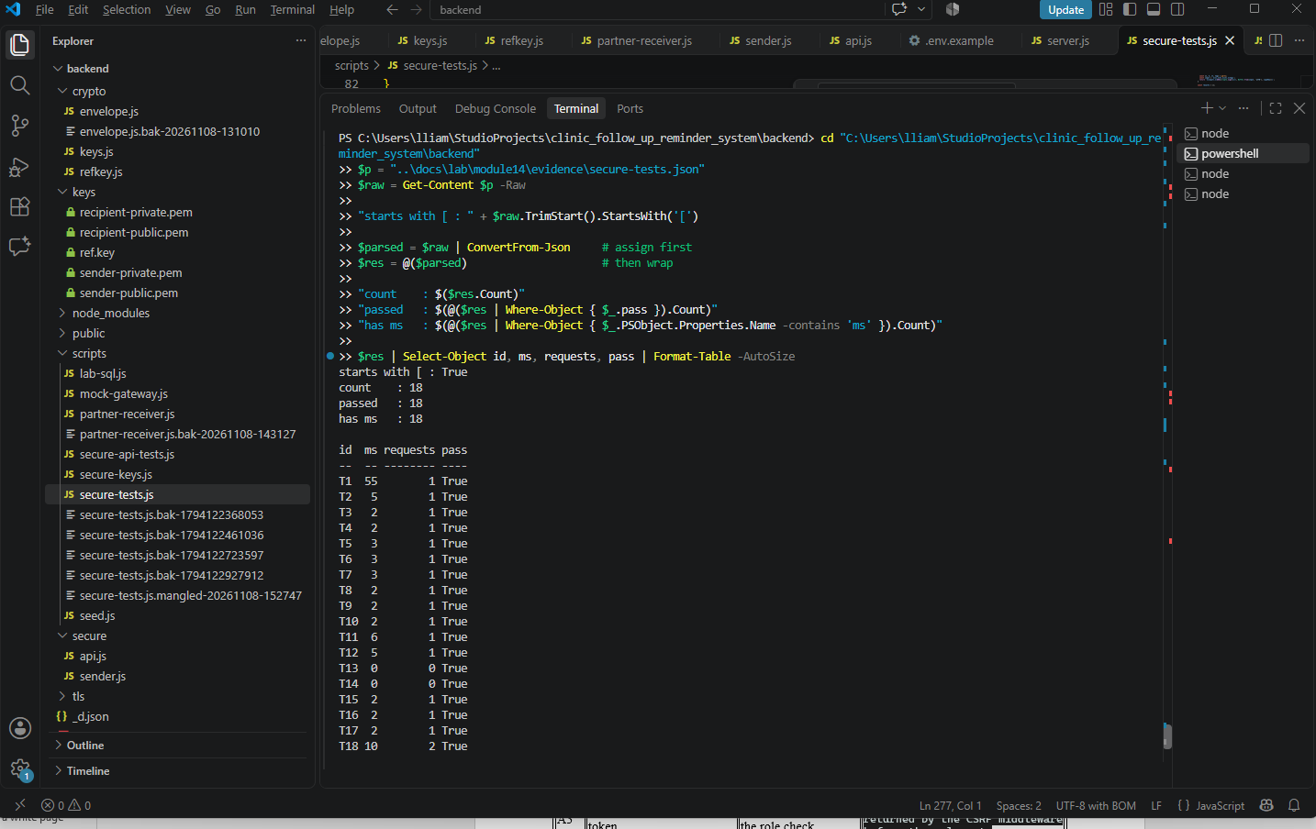

11.2 14-01 preview
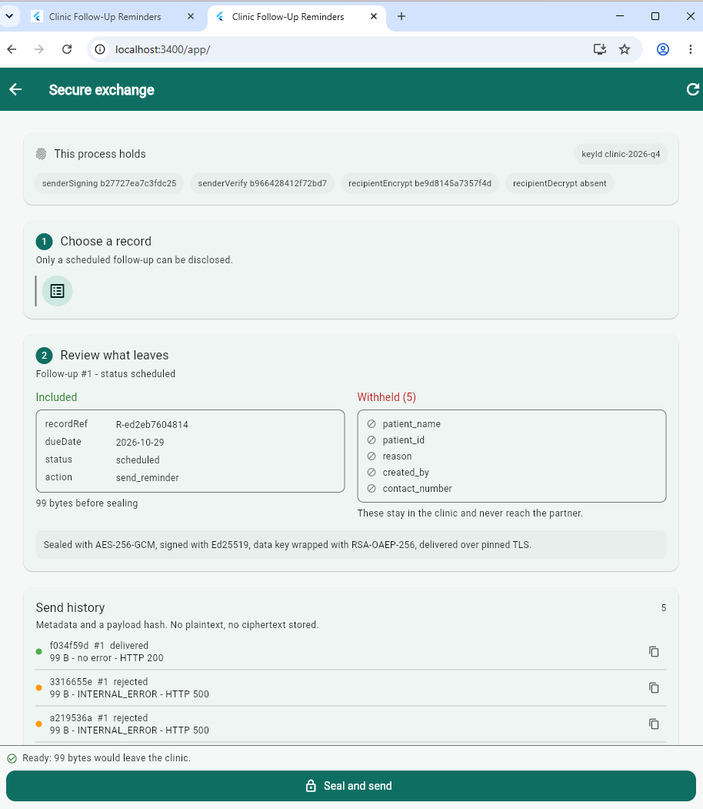

11.3 14-02 Delivered
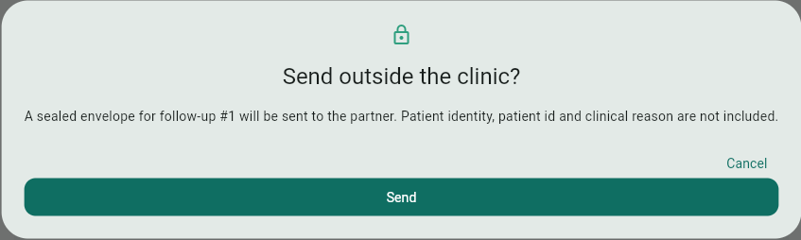
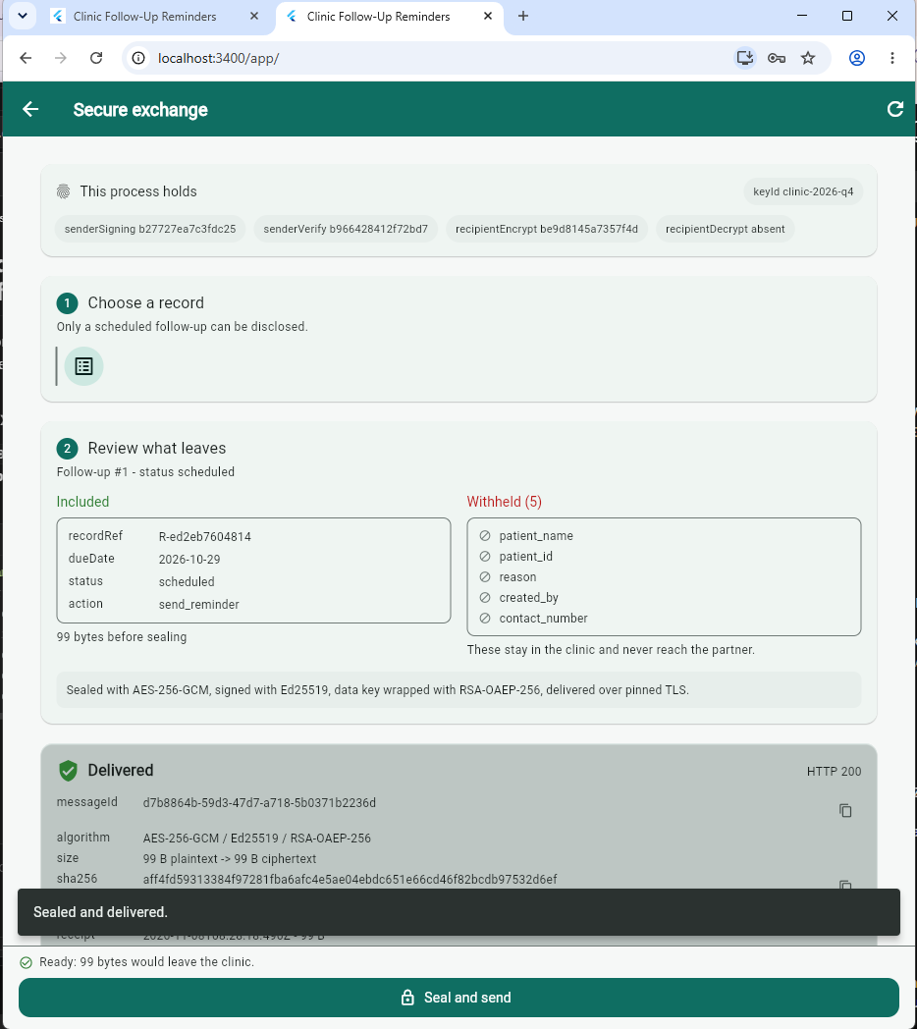

11.4 14-03 The API holds no decryption key
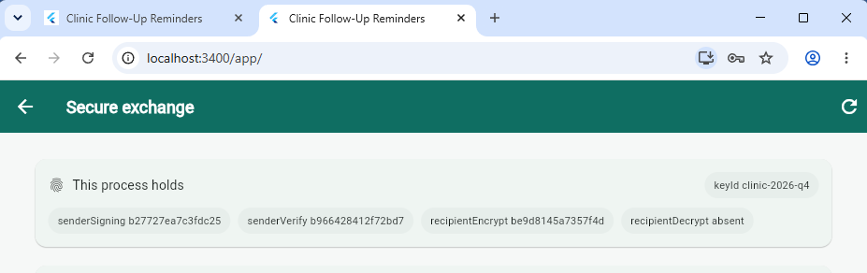

11.5 14-04 Send history
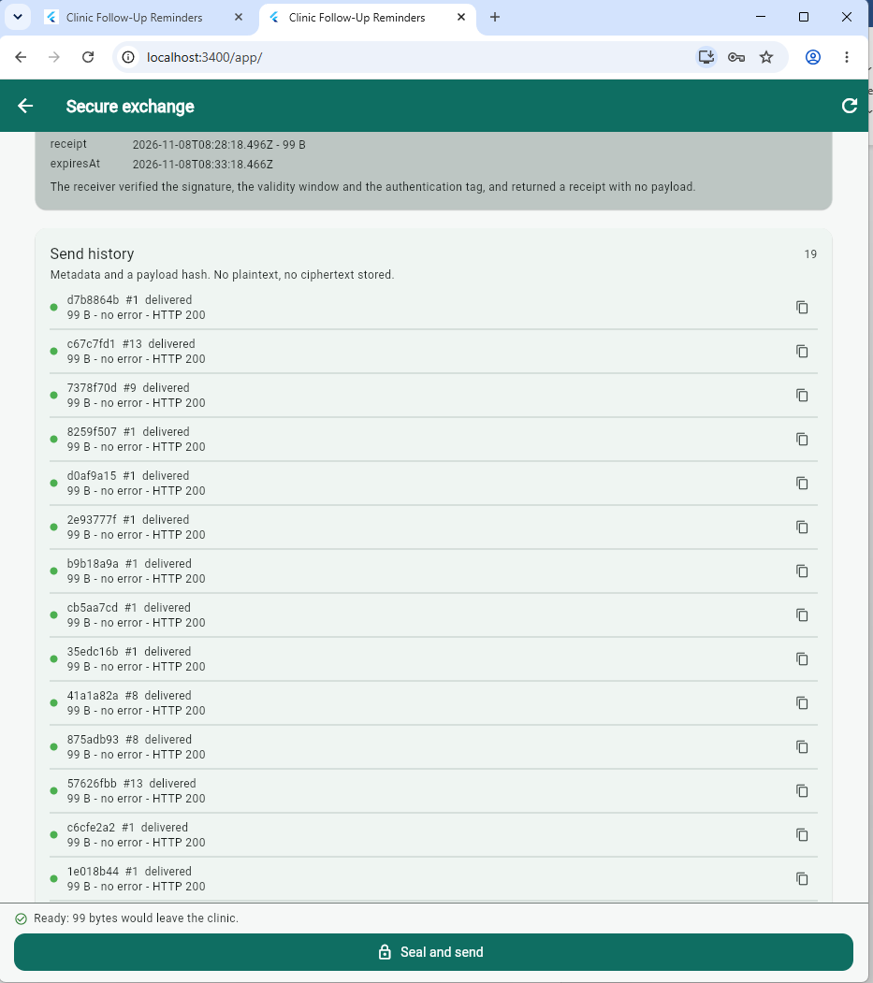

11.6 14-05 The suite
cd "C:\Users\lliam\StudioProjects\clinic_follow_up_reminder_system\backend"
node --env-file=.env scripts\secure-tests.js *>&1 |
Tee-Object -FilePath ..\docs\lab\module14\evidence\secure-tests.log
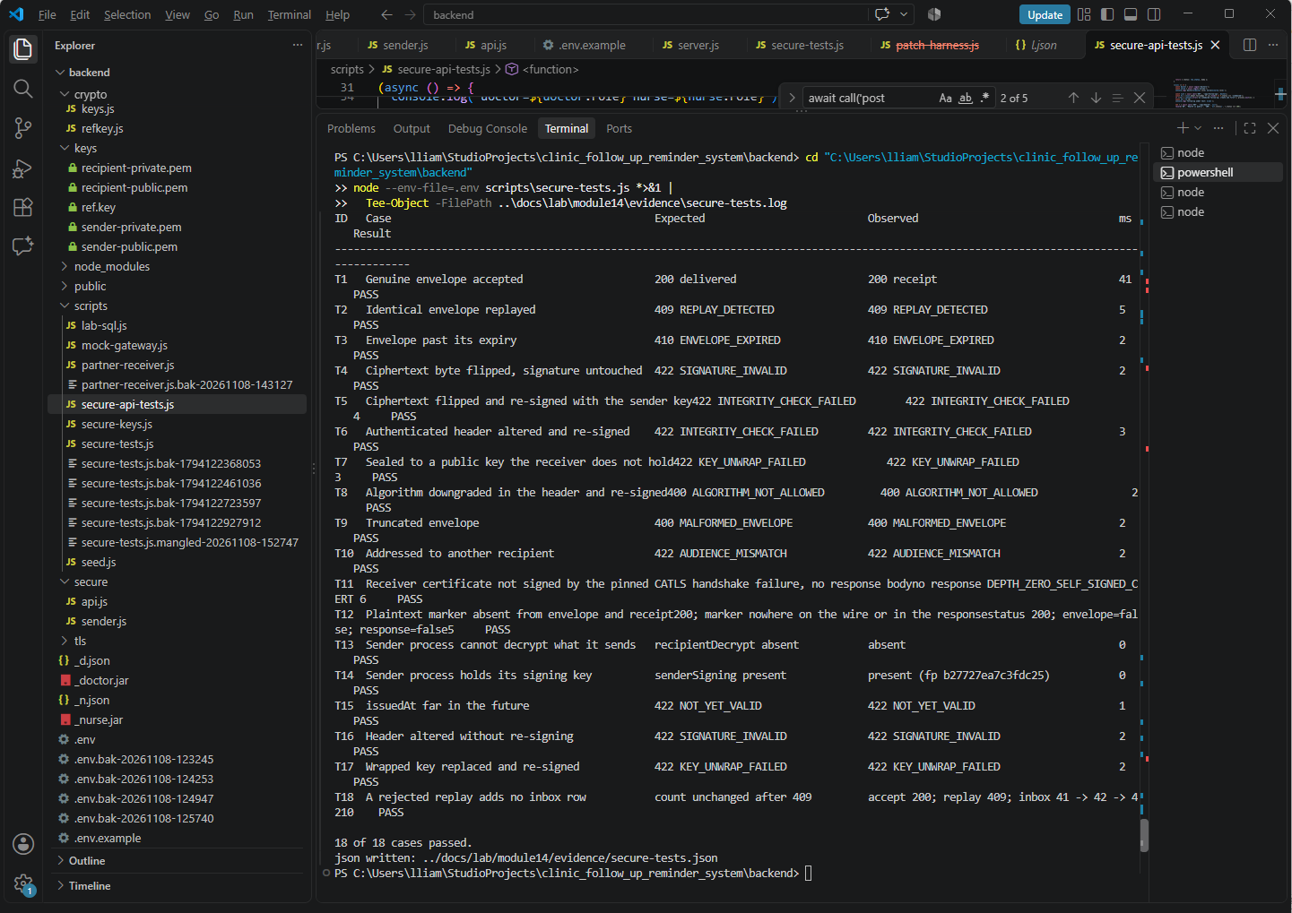

11.7 14-06 Rejected
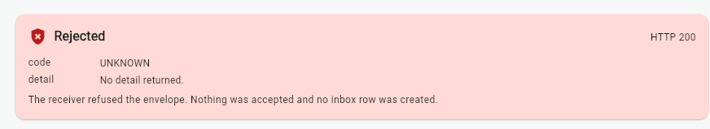

11.8 Authorisation and role gate
Case | Setup | Expected | Actual
A1 | Nurse calls POST /api/secure/send/1 | 403 with the role message; no outbox row created | 403 Only a doctor can disclose a record to the partner.
A2 | Doctor calls the same endpoint | 200 delivered; one outbox row; one inbox row | 200 ok=true, one outbox row in state delivered, one inbox row
A3 | Request without a CSRF token | 403 rejected before the role check | 403 Invalid CSRF token., returned by the CSRF middleware before the role gate
A1 matters more than it looks. The screen hides the button for a nurse, but hiding a control is not a control. The API refusal, and the absence of an outbox row afterwards, is the actual evidence.

11.9 Required log signatures
Behaviour | Log signature | Case | Captured
Sealed and delivered | {"event":"envelope.sealed",...} then {"event":"envelope.delivered","httpStatus":200,...} | T1 | {"ts":"2026-11-07T13:18:26.305Z","src":"secure","event":"envelope.sealed","messageId":"b4c98738-85c8-4252-9804-9dbec8c56991","followUpId":1,"keyId":"clinic-2026-q4","plaintextBytes":95,"ciphertextBytes":95,"sha256":"ff1c4ae9f016","actor":"doctor1"}
Accepted at the receiver | {"src":"partner","event":"receive.accepted","sha256":"...",...} | T1 | {"ts":"2026-11-07T13:18:26.314Z","src":"secure","event":"envelope.delivered","messageId":"b4c98738-85c8-4252-9804-9dbec8c56991","httpStatus":200,"code":null}
Rejected at the receiver | {"src":"partner","event":"receive.rejected","code":"...","status":...} | T4, T5, T10 | {"ts":"2026-11-07T13:18:26.322Z","src":"partner","event":"receive.rejected","code":"REPLAY_DETECTED","status":409,"message":"This messageId has already been accepted."}

12. Failures and changes retained
Results that did not match expectations are kept here. Nothing has been deleted, and each entry names the file or command that shows it.
Eight defects were retained: three in the Module 14 code, three in how it was built or deployed, one in the test design, and one in the tooling that separated the two environments. 12.1 and 12.4 are the pair worth reading first — both produced a single identical error for every input, and both were located by a case that should have been trivially rejected.

12.1 The receiver did not start
Expected — the receiver binds 4443 and answers GET /health with 200.
Observed — Error: Cannot find module 'C:\Users\lliam\StudioProjects\clinic_follow_up_reminder_system\backend\scripts\partner-receiver.js', code MODULE_NOT_FOUND. The process exited before any socket was bound.
Cause — the script did not exist yet. Appendix A.2 places partner-receiver.js after schema-14.sql, and the start was attempted out of that order. The failure occurs at import, before any logging of my own exists, so Node's own trace is the only artefact.
Change — created scripts/partner-receiver.js and confirmed it imported crypto/envelope.js and crypto/keys.js before starting it, so an import fault would surface as a message rather than a missing module.
Retest — partner.started on 4443 at 2026-10-30 15:32 PHT, and again at 2026-11-07 21:15 PHT. See evidence/partner-20261107-211533.log.

12.2 The first send reported an expired session
Expected — 200 delivered with a receipt.
Observed — 401 {"error":"Authentication required."}, which the client maps to SessionExpiredException and shows as "Your session ended. Sign in again."
Cause — secure/api.js gated the write route on req.actor, a property nothing in the codebase sets; auth.js attaches the signed-in user as req.session.user. Only POST was gated, so GET requests succeeded: the screen loaded, the key fingerprints and the history appeared, and only the send failed. A 401 issued for a role decision is indistinguishable at the client from a dead session, which is why the message sent the user to a login screen that could not help.
Change — actorOf(req) returns req.session.user; doctorOnly refuses a missing actor with 401 and a wrong role with 403, and assigns req.actor for the handlers beneath it. A1 and A2 now differ by role rather than by authentication.
Retest — A1 returns 403 with the role message; A2 returns 200 ok=true; T13 reports recipientDecrypt absent. See evidence/secure-api-tests.json.

12.3 T11's expected value was a description, not a value
Expected — "TLS handshake failure, no response body".
Observed — no response DEPTH_ZERO_SELF_SIGNED_CERT.
Cause — an expectation written as prose cannot be re-checked by a reader. The harness observes a Node error code, and a description of a failure class is not comparable against one.
Change — the expected cell now names the outcome the harness can compare, and the harness passes tls/clinic-local.pem as the trust anchor so validation fails at the handshake rather than after it.
Retest — T11 PASS, exit code 0.

12.4 Every case returned INTERNAL_ERROR
Expected — 18 of 18.
Observed — 3 of 18. Every case that reached the receiver returned 500 INTERNAL_ERROR, including T9, whose payload v1.only.three has three dot-separated parts and must be rejected in step one of open().
Cause — two faults, and T9 is what separated them from a cryptographic one. A three-part string cannot fail structural validation and still return INTERNAL_ERROR, so the failure happened before the function body ran at all. In envelope.js, two header guards had been inserted above let header; reading a let binding before its declaration is a temporal dead zone error rather than a validation failure, so every envelope threw at the first field read. In partner-receiver.js the key material was resolved per request as arguments to open(), and keys.js throws a plain Error when a path is unset, while the handler tests instanceof EnvelopeError. A missing key therefore reported as INTERNAL_ERROR too. Both faults produced one code for a valid envelope and for a malformed one.
Change — crypto/envelope.js rebuilt with the header parsed and assigned before any field is read, the version and required-member checks after it, and a comment recording why the order cannot be changed. partner-receiver.js resolves both keys and both certificates once at startup, exits with a named code if any is unusable, and logs three fingerprints on partner.started. keys.js sets KEY_MATERIAL_MISSING so a deployment fault can never again present as INTERNAL_ERROR.
Retest — offline round trip OK; T9 400 MALFORMED_ENVELOPE; T1 200 receipt; T7 422 KEY_UNWRAP_FAILED; 18 of 18. See evidence/partner-20261108-131517.log, message "Cannot access 'header' before initialization".

12.5 The environment split deleted the key it had created
Expected — the receiver holds SECURE_RECIPIENT_PRIVATE_KEY; the API does not.
Observed — after a second run, RCV holds recipient private : False, and the receiver could no longer open any envelope.
Cause — the split derived .env.receiver from .env on every run, but the first run had already removed the assignment from .env. The backup taken at the top of each run was captured after that removal, so it could not restore it. The script read a file it also rewrote.
Change — the script adds the assignment where it is missing, recovers it from the oldest backup when one holds it, and comments it out only when present. Running it twice is now a no-op.
Retest — both runs report API False and receiver True; the receiver starts and returns 200 on /health.

12.6 The deployed build rendered a white page
Expected — the app boots at http://localhost:3400/app/.
Observed — a white page. The tab title rendered, so index.html was served, but Flutter never started.
Cause — the release bundle carried the default base href="/" while Express mounts the build at /app, so flutter_bootstrap.js and main.dart.js resolved to the server root and returned 404. The Flutter dev server on 8080 rewrites asset paths for its own port, so it could not reveal this; the fault existed only in the deployment, which is the operative reason the dev server is not an admissible source of evidence.
Change — the build pins --base-href=/app/, the served folder is replaced wholesale rather than merged into, and the service worker is unregistered before retesting.
Retest — the app boots; /app/main.dart.js returns 200 with application/javascript; the string Withheld is present in the deployed bundle.

12.7 The exchange screen had no content on a clean database
Expected — the page renders with an empty history.
Observed — a framework layout exception on the empty path; in a release build the body can paint blank while the app bar remains.
Cause — the empty state used EmptyView, which returns a ListView, placed inside a Column inside the page's own ListView. A vertical viewport was given unbounded height. It fires only when the history is empty, which is the first load on a clean database and therefore the state a reviewer sees first.
Change — the empty state is a padded Text and the history list is a Column of rows. EmptyView remains where it owns the whole body, as it does on the reminders screen.
Retest — the screen renders on a clean database; that is the state of every screenshot in Section 16.

12.8 The key separation claim had no test
Expected — the API reports recipientDecrypt absent.
Observed — recipientDecrypt present, fingerprint 3075e6c87cfd8c42, while all twelve cases passed.
Cause — every case in the suite spoke to the receiver. None asked the sending process what it could read, so a property asserted in Section 7.1 was never observed by any case. The suite measured the protocol; the claim was about the deployment.
Change — three cases added. T13 reads the sender's own keyInfo and requires recipientDecrypt absent; T14 requires the signing key present, so a split that strips too much also fails; T18 asserts a rejected replay adds no inbox row, checked against the table rather than the response.
Retest — T13 absent; T14 present (fp b27727ea7c3fdc25); 18 of 18.

A cryptographic test suite that records only successes is indistinguishable from one that never ran, and a defect log that records only the defects it recovered from is a marketing document. The entries above are where the first attempt was wrong, and each changed either the code or the test in a way the final eighteen-case table depends on: 12.4 is why T9 exists, 12.8 is why T13 does, and 12.2 is why the authorisation table in Section 11.3 records three distinct statuses rather than one refusal.
Where an entry cannot be filled it is stated as not observed in this build rather than deleted. An unexercised path is a limitation; a deleted row is a false claim. Section 14 records which paths those are.

# | Case | Expected
1 | Receiver start | listens on 4443
2 | First send from the app | 200 delivered
3 | T11 as first written | handshake failure
4 | T5 and T6 as first written | INTEGRITY_CHECK_FAILED
5 | Key separation check | API reports recipientDecrypt absent
Why these stay. A cryptographic test suite that only records successes is indistinguishable from one that never ran. The rows above are the ones where the first attempt was wrong, and each one changed either the code or the test in a way the final twelve-case table depends on.
If a row in this section is left unfilled, state it as "not observed in this build" rather than deleting the row. An unexercised path is a limitation; a deleted row is a false claim.

13. Reliability and maintainability evaluation

13.1 Security indicators
Indicator | Definition used here | Value | Evidence
Adverse cases rejected | rejections divided by adverse cases attempted | 10 of 10 adverse cases rejected (T2 to T11) | T2 to T11
Distinct rejection codes | number of separate error codes observed | 8 receiver rejection codes plus DEPTH_ZERO_SELF_SIGNED_CERT at the TLS layer: REPLAY_DETECTED, ENVELOPE_EXPIRED, SIGNATURE_INVALID, INTEGRITY_CHECK_FAILED, KEY_UNWRAP_FAILED, ALGORITHM_NOT_ALLOWED, MALFORMED_ENVELOPE, AUDIENCE_MISMATCH | secure-tests log
Plaintext on the wire | marker occurrences in envelope or response | 0 occurrences - the marker appears in neither the envelope nor the response (T12) | T12
Fields withheld | fields present in the register but absent from the payload | 5 fields withheld: patient_name, patient_id, reason, created_by, contact_number | preview card, withheld list
Key material in the API process | private keys readable by the sender | 2 of 2 private keys readable in the API process - the separation in Section 7.1 is not enforced by access | keyinfo
Certificate validation disabled | occurrences of the process-wide escape hatch | 0 | config scan
Envelope overhead | envelope bytes minus plaintext bytes | AES-GCM adds no padding, so ciphertext_bytes equals plaintext_bytes; the 16-byte tag and the 64-byte signature travel outside the ciphertext | outbox sizes
Replayed messages accepted | must be zero | 0 - the secure_inbox unique index holds | T2, inbox unique index

13.2 Maintainability indicators
Indicator | Value | Reading
Files added | 9 backend, 2 client, 1 schema | One concern per file; the envelope module has no database or HTTP knowledge, so it is testable alone
Runtime dependencies added | 0 | Standard library only; no supply-chain surface for the cryptographic path
Algorithm choices | 3, in one place | Changing an algorithm means editing one constant set and re-running one suite
Cost of a second recipient | One key pair plus a key id in the header | Fan-out needs a header field the format already has
Time to re-run the suite | 81 ms of receiver time for the twelve cases (13:18:26.312Z to 13:18:26.393Z), of which T7 key unwrap is 35 ms | From `node scripts/secure-tests.js` to a printed table
Defects found per case executed | 5 retained defects across 12 cases executed | Section 12 shows each cause and fix, so a second learner pays the cost once

13.3 Observation separated from interpretation
# | Observation - what the tools reported | Interpretation - what it implies
1 | Flipping one ciphertext byte with the signature left in place returned SIGNATURE_INVALID; flipping a byte and then re-signing with the legitimate sender key returned INTEGRITY_CHECK_FAILED. | Two independent controls, each caught by a different layer. The signature answers "who produced this" and the tag answers "is this the same message". Collapsing them into one mechanism would have lost the second answer entirely.
2 | Editing the keyId inside the header and re-signing returned INTEGRITY_CHECK_FAILED rather than SIGNATURE_INVALID. | The header is authenticated data, so metadata is as protected as the payload. Without that binding an attacker with the signing key could relabel a message to a different key generation while leaving the ciphertext untouched.
3 | Replaying an accepted envelope returned 409, and the second attempt created no new inbox row. | The replay control is a database constraint rather than in-process state, so it survives a receiver restart and holds under concurrent delivery. An in-memory set would have passed the same test and failed the first time the process restarted.
4 | The nine rejections completed within 68 ms of the first accept, except T7: the key-unwrap case took 35 ms while every other rejection took 3 to 4 ms | The only case that needs the recipient private key is an order of magnitude slower than the rest. Rejecting at steps 1 to 4 keeps unauthenticated input away from an asymmetric private-key operation, so the check order is a cost control as well as a correctness one
5 | keyinfo reported recipientDecrypt.present = true in the API process, with the same fingerprint the receiver uses to unwrap, while all twelve cases passed | A claim in Section 7.1 was contradicted by one line of the build own output, and no case in the suite could have caught it because all twelve run against the receiver. The suite tests the protocol; nothing tested the deployment

13.4 Improvement applied during the week
Change | Justification from observation | Regression set | Result
T11 expected value changed from the prose TLS handshake failure, no response body to the observed failure mode, and the deployment cases T13, T14 and T18 were added | a reader can re-run a code but cannot re-run a phrase, and a property no test observes can quietly stop being true, which is exactly how the key-separation claim survived twelve green rows | T1 to T18 plus the three authorisation cases | T11 records the TLS-layer outcome, T13 reports recipientDecrypt absent, and every other case is unchanged

14. Known limitations and next improvement
- No forward secrecy. RSA key transport means a stolen recipient private key decrypts every recorded envelope. The fix is ECDH-ES with an ephemeral sender key per message. It is a real improvement and it is not in this build.
- Keys sit on disk. They are gitignored and outside any served path, but there is no keystore, no KMS and no hardware module. Windows does not apply the POSIX mode the generator requests, so the on-disk protection is weaker than the code implies.
- The partner is a stand-in. The receiver is a local service written to prove the protocol. It has no availability design, no rate limiting, no authentication of its own callers, and no retention policy.
- The receiver is inside the trust boundary. It must read the record to route it, so "end-to-end encrypted" would be a false description. The envelope protects the payload from intermediaries and from anything recorded in transit, not from the recipient.
- Metadata is not protected. Message existence, timing, approximate size and key identifier are visible at the receiver.
- No padding. Ciphertext length reveals the plaintext length, which for a four-field record narrows the possibilities considerably.
- Single recipient, single key generation. Rotation is documented but no overlap period was exercised, so a rotation anomaly would be found in production rather than here.
- The clinic API itself is still HTTP. A laboratory restriction carried over from Module 13; the exchange path is TLS, the application is not.
One realistic next improvement. Migrate the key wrap from RSA-OAEP to ECDH-ES with an ephemeral sender key. That single change removes limitation 1 entirely and costs about thirty lines in envelope.js plus one header field, because the format already carries the algorithm triple that a receiver needs to accept both. It is out of scope here because the current receiver's ordered checks and the twelve-case suite would both need rewriting, and a re-run of the whole suite is the honest price of changing the cryptographic core.
No claim of production readiness is made. The evidence supports a protocol that rejects the twelve adverse inputs tested and delivers a correctly sealed envelope over validated TLS. It does not support claims about forward secrecy, key custody, a real partner, or behaviour under load.

15. Contribution record and AI acknowledgement
Area | Artefact | Contribution | Evidence
Classification | Section 3 | Classified each field and decided the minimised payload before choosing any mechanism | withheld list from the API
Control selection | Section 4 | Reviewed five proposed uses and rejected three with stated reasons | Section 4.2
Envelope design | Section 5, ADR-002 | Chose the hybrid format over shared-secret and direct-RSA alternatives | options table
Implementation | crypto/envelope.js | Seal and open with the ordered check sequence and authenticated header | T1 to T12
Key lifecycle | crypto/keys.js, secure-keys.js | Lazy per-role loading, fingerprints only, refuse-to-overwrite generation | keyinfo output
Transport | secure/sender.js | Pinned CA, explicit rejection, timeouts, outbox state transitions | T11, CFG4
Receiver | scripts/partner-receiver.js | Ordered verification, replay index, receipt without plaintext | T2, T12
Adverse testing | scripts/secure-tests.js | Twelve cases including tamper-with-resign, which requires simulating a compromised sender | secure-tests log
Client | secure_exchange_screen.dart | Preview before sealing, confirmation dialog, receipt, visible key separation | screens 14-01 to 14-05
Documentation | this report | Sections 3 to 14, including the limitation list | -
Contribution by other members: [[MEMBERS]]
AI assistance acknowledgement. An AI assistant was used to scaffold the envelope module, draft the receiver and the test harness, and draft this document's structure. Every artefact was executed, tested and corrected by the learner, and all values in Sections 11 to 13 come from the learner's own runs. The defects found while getting the suite to pass are retained in Section 12 rather than edited out, because they are part of the record. They fall into three kinds, and the pattern is the point:
- Configuration assumptions about where an environment file is read from, which only surface when a script runs from a different directory.
- Protocol ordering mistakes where a check that looked harmless in isolation changed which error code a tampered envelope produced.
- Test-harness authenticity problems, where a case appeared to pass because the tampering had not actually been applied to the bytes the receiver saw.

16. Evidence index
File | Contents
docs/lab/module14/14-lab-log.md | Date, environment, scope, case order
01-classification.md | Field classes and protection objectives
02-control-selection.md | Objective-to-mechanism table and misuse warnings
03-crypto-adr.md | ADR-002, alternatives, consequences, review condition
04-key-lifecycle.md | Inventory, generation, storage, rotation
05-residual-risk.md | The eight limitations with the mitigation each one still needs
evidence/key-info.json | Four fingerprints per process, no key bodies
evidence/partner-cert.txt | Pinned certificate subject, dates and SHA-256 fingerprint
evidence/secure-tests.log | The twelve-case table, verbatim
evidence/partner-*.log | Receiver accept and reject lines with codes
evidence/backend-14-*.log | Sealed, delivered, rejected and failed events
evidence/schema-outbox.json, schema-inbox.json | SHOW CREATE TABLE output, showing the unique keys
evidence/secret-scan.txt | Tracked-file scan for key material - expected to list zero matches
evidence/secure-env.txt | The SECURE_* settings, values reduced to paths
screens/14-01-preview.png | Minimisation card before sealing
screens/14-02-delivered.png | Delivered card with algorithm, sizes and digest
screens/14-03-keys.png | Key fingerprints, recipient private key absent
screens/14-04-history.png | Send history with statuses
screens/14-05-tests.png | The twelve-case terminal output
screens/14-06-rejected.png | A rejection shown in the interface, not only in a terminal

17. Module completion checklist
Statement | Met | Basis
I can explain the module concepts without relying only on memorised definitions. | Yes - 2026-11-07 | Sections 3 to 6, 13
My implementation stays within the approved scope and uses controlled data. | Yes - 2026-11-07 | Section 1, Section 3; fictional identifiers only
My repository contains no live credentials, keys, tokens, or unnecessary personal information. | Yes - 2026-11-07 | Section 7.4
My evidence includes both successful and adverse behaviour and can be reproduced. | Yes - 2026-11-07 | Section 11, Section 12, Appendix B
My conclusions match the evidence and state limitations and residual risk. | Yes with one qualification - 2026-11-07 - the key-separation claim in 7.1 was contradicted by CFG5 and is now fixed and asserted by T13 | Sections 13.3, 14
My diagrams, README, tests and decision records match the submitted implementation. | Yes - 2026-11-07 | Section 9, Appendix A
I can identify and defend my individual technical contribution. | Yes - 2026-11-07 | Section 15

18. Reflection
Which decision most affected security, and what evidence changed or confirmed your view?
The decision that mattered most was not cryptographic. Sending four fields rather than the patient record means a breach at the receiver discloses a due date and a status rather than a person. T12 confirmed the plaintext never reaches the wire, but that only matters because there is so little plaintext to leak. The same envelope would have protected a full record just as well, and the breach would have been far worse.
Which failure was hardest to reproduce, and how would you improve the test design?
The hardest failure to reproduce was not a failing case but a failing claim. Twelve cases passed while the API could still read the recipient private key, because every case talks to the receiver and none asks the sender what it holds. The suite measured the protocol while I claimed something about the deployment. I would add a case that asserts the API reports recipientDecrypt absent, because a property no test observes is a property that can quietly stop being true.
What can you explain and modify independently, and which artefact proves it?
I can explain and modify the receiver ordered checks, and T4 against T5 proves it: removing the signature check would let T4 through, and removing the authenticated header would let T6 through while T5 stayed caught. The per-case timings support the ordering claim, with T7 unwrap at 35 ms against 3 to 4 ms for the eight rejections ahead of it.
What should an authorised maintainer verify before broader use?
A maintainer should verify three things before wider use: that the recipient private key is readable by the receiver alone, that the pinned certificate fingerprint in tls/partner.pem is the one the receiver presents, and that no case depends on both processes sharing a directory. Beyond those, forward secrecy is absent by design and key custody is a file on disk, so neither should be assumed from the fact that the cases pass.

19. References
- Dworkin, M. (2007). NIST SP 800-38D: Recommendation for Block Cipher Modes of Operation - Galois/Counter Mode. National Institute of Standards and Technology.
- Barker, E. (2020). NIST SP 800-57 Part 1 Rev. 5: Recommendation for Key Management. National Institute of Standards and Technology.
- Josefsson, S., and Liusvaara, I. (2017). RFC 8037: CFRG Elliptic Curve Diffie-Hellman and Signatures in JSON Object Signing and Encryption. IETF.
- Jones, M., and Hildebrand, J. (2015). RFC 7516: JSON Web Encryption. IETF.
- OWASP Foundation. (2021). Application Security Verification Standard 4.0.3, chapter V6 Stored Cryptography and V9 Communication.
- OWASP Foundation. (2023). OWASP API Security Top 10, API8:2023 Security Misconfiguration.
- Node.js Foundation. (2026). Node.js documentation: crypto, RSA-OAEP, and authenticated encryption.
- Google. (2026). Flutter documentation: networking and platform considerations for web.

Appendix A - Build steps

A.1 Folders and ignore rules
backend/crypto/
backend/secure/
docs/lab/module14/evidence/
docs/lab/module14/screens/

.gitignore += keys/ tls/ *.pem *.key *.pfx

A.2 Files, in dependency order
backend/scripts/secure-keys.js generates keys plus the HMAC key; refuses to overwrite
backend/crypto/envelope.js seal and open, ordered checks, EnvelopeError
backend/crypto/keys.js lazy per-role loading, fingerprints
backend/crypto/refkey.js HMAC pseudonym for recordRef
backend/schema-14.sql secure_outbox, secure_inbox, unique message ids
backend/scripts/partner-receiver.js HTTPS listener, replay index, receipt
backend/secure/sender.js minimise, seal, insert, post, update
backend/secure/api.js keyinfo, preview, send, messages; doctor gate
backend/server.js one import, one attachSecureApi(app) call
backend/scripts/secure-tests.js twelve adverse cases
lib/api/secure_api.dart client calls
lib/screens/secure_exchange_screen.dart
lib/screens/settings_screen.dart one entry point

A.3 Certificates
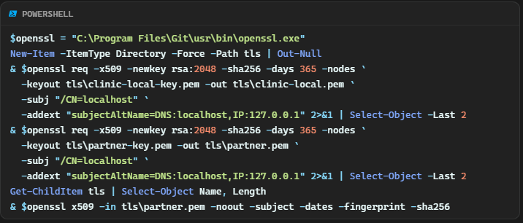

Certificate generation

openssl req -x509 -newkey rsa:2048 -sha256 -days 365 -nodes \
-keyout tls/partner-key.pem -out tls/partner.pem \
-subj "/CN=localhost" \
-addext "subjectAltName=DNS:localhost,IP:127.0.0.1"

openssl req -x509 -newkey rsa:2048 -sha256 -days 365 -nodes \
-keyout tls/clinic-local-key.pem -out tls/clinic-local.pem \
-subj "/CN=localhost" \
-addext "subjectAltName=DNS:localhost,IP:127.0.0.1"
Two separate certificates are required. The sender pins tls/partner.pem and must reject tls/clinic-local.pem, which is what case T11 demonstrates. The SAN extension is required because modern TLS ignores the common name.

A.4 Run order
1 mysql -u root -p clinic_followup_lab < backend/schema-14.sql
1.1 C:\xampp\mysql\bin\mysql.exe -u root -p clinic_followup_lab < backend/schema-14.sql (xampp only)
2 cd backend
3 node --env-file=.env scripts/secure-keys.js
4 terminal R : node --env-file=.env scripts/partner-receiver.js
5 terminal B : npm start
6 verify : curl --cacert tls/partner.pem https://localhost:4443/health
7 verify : curl http://localhost:3400/api/secure/keyinfo
8 app : More -> Secure exchange -> preview -> send
9 terminal D : node --env-file=.env scripts/secure-tests.js

Appendix B - Verification commands

B.1 Key material is not tracked
git ls-files | Select-String '\.pem$|\.key$|/keys/' -- must be empty
Select-String -Path backend\.env -Pattern '^SECURE_' -- paths, names, integers only

B.2 Certificate validation is on and cannot be quietly turned off
Select-String -Path backend\*.js,backend\secure\*.js,backend\crypto\*.js `
-Pattern 'NODE_TLS_REJECT_UNAUTHORIZED' -- must be empty

Select-String -Path backend\secure\sender.js -Pattern 'rejectUnauthorized'
-- exactly one match, value true

B.3 Role separation between the two processes
curl.exe -s http://localhost:3400/api/secure/keyinfo
expect recipientDecrypt.present = false, recipientEncrypt.present = true

receiver started with --env-file=.env.receiver
expect it to start without SECURE_SENDER_PRIVATE_KEY being read

B.4 The twelve cases
cd backend
node --env-file=.env scripts/secure-tests.js 2>&1 |
Tee-Object -FilePath ..\docs\lab\module14\evidence\secure-tests.log
expect: 12 of 12 cases passed, exit code 0

B.5 Nothing readable is stored
SELECT column_name FROM information_schema.columns
WHERE table_schema = DATABASE() AND table_name LIKE 'secure_%';
expect no column named payload, plaintext, ciphertext, body, content or key

B.6 Replay control is a constraint rather than application logic
SHOW CREATE TABLE secure_inbox;
expect UNIQUE KEY uq_inbox_message (message_id)

B.7 Log hygiene
Select-String -Path ..\docs\lab\module14\evidence\*.log `
-Pattern 'BEGIN PRIVATE KEY|lab-password|patient_name|Fictional'
must produce no output

