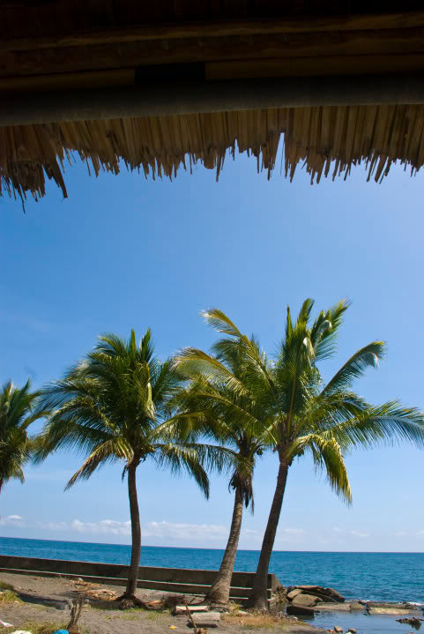
Virgin Treasures of Naujan
From Calapan, we went to Naujan through a 30-minute jeepney ride. Boundless greeneries and fresh air greeted us as we went into Naujan. We are not exaggerating, but the air reminded us of lavender. We breathed in all the air we could knowing that there was nothing like it in Manila.
After the short trip we went straight to the town’s city hall. It is located in front of the town plaza adjacent to the Catholic Church. The place was unbelievably quiet, but its stillness was not eerie like that of a ghost town. Rather, it was serene and peaceful—genuine probinsiya.
Upon the instruction of the municipality tourism officer, we went to talk to Mayor Norberto M. Mendoza. With him, we experienced our first taste of Mindoreño hospitality as he offered us dinuguan, puto, and a bottle of mineral water. We talked and joked about a lot of things—politics, education, and even today’s youth.
After that, the mayor asked one of his employees to bring us to Emerald Isle Beach Resort where we would spend the night.
Emerald Isle is located at Estrella (where three other beaches can be found). We arrived there at around 3 p.m.; we rested for a while before going to the Simbahang Bato. Simbahang Bato is located at Bancuro. We reached the supposed-to-be 30-minute-ride destination after an hour’s romance with rough travel.
The oldest church in the province of Naujan, Simbahang Bato is known for its architectural structure. It is made of adobe and sea corals and houses another church, thus earning the title “a church within a church.”
Legend has it that gold is buried inside the Simbahang Bato. Excavation had been done before, but the officials of Naujan stopped it.Going home, Kuya Amor (the tricycle driver) invited us to have dinner in his cousins’ house. We learned that they were celebrating the feast day of their patron, St. Augustine. Shy and bewildered, we accepted the offer and met his cousins, who turned out to be the owners of the beach resort where we were staying. We wolfed on leche flan, relienong bangus, inihaw na tilapia, and something that tasted like tocino. We were deeply moved by the generosity of their family. We talked about many things, one of which is the endangerment of tamaraws in Mindoro. After an hour, we left with heavy tummies. We immediately rested in complete darkness as the bad weather had cut power.

Walang Langit Falls
Gloria, Oriental Mindoro, Philippine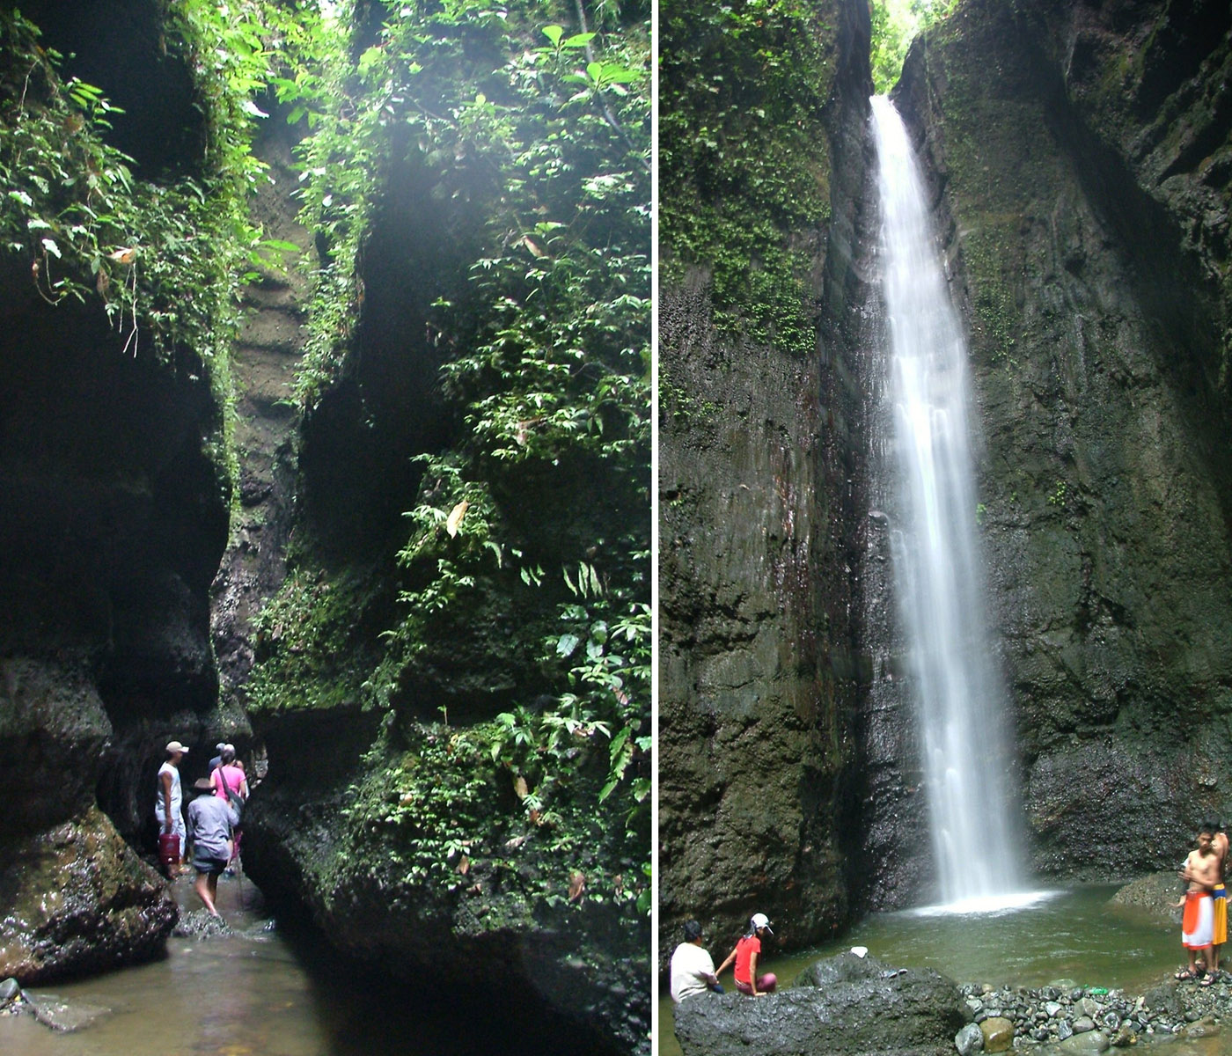

Translated as "no sky", Walang Langit Falls is named such because of the dense canopy of trees roofing the area in the early 1990s. To reach the falls, you'd have to secure a guide at the Barangay Hall of Buong Lupa at a rate that starts at P200. The trek lasts about an hour, and mostly consists of river trekking on shallow waters, in between two high walls of loose soil. Trekking to the falls feels like walking in a crack of an earthquake. Forty-five minutes into the trek, the trail forks into two: the left trail goes to the main waterfall, while the right trail leads to two smaller falls. Collectively, Walang Langit Falls is called "twin falls" by the locals despite having three falls.

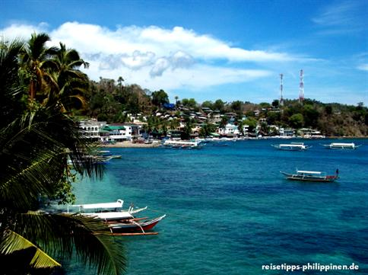
SABANG Puerto Galera is one of the oldest tourist destinations in the Philippines. The place is famous for his good and plentyful diving occasions, it`s only a short way from Manila and season is all the year around. In Sabang you will find also nightlife and bargirls. Familys and beachlovers like maybe more to stay at White Beach or in accommodations of the western lying bays (Small Laguna, Big Laguna).
In the last years there was a lot of renovation and creating of new buildings, meanwhile you will find resorts in all possible Bays. The hotels in Sabang, Small and Big Laguna growing higher every year, Aircon-rooms are nowadays standard, bamboo cottages doesn`t exist anymore. Nevertheless the place has still some flair, but it would be latest time, that they doing something against the dirty water from the village and all facilitys. If you walking on low tide through the middle of the village, close to the beachside, you can smell the problem - and you loosing all fun for go swimming!
The mix of the tourist was changing by the years, Sabang is very international, nowadays guests from Corea counting the biggest group and people from Russia have also discovered the place.
From the pier in Batangas small fast outrigger boats going to Sabang, Puerto Galera and White Beach (all 1 - 2 hours, the trip needs around 1 1/2 hours). Since some time they charge you an environment fee of 50 Peso. A car-ferry is going once a day to Botero (some km west of Puerto Galera).
From Manila you can go in 2 1/2 hours +/- (depends on the traffic) by public busses (JAM, Alps) to Batangas-Pier. Caution! Watch your luggage and valuables! There are professionel thieves on the route!

