UNIVERSITY OF EDUCATION, WINNEBA
FACULTY OF SCIENCE EDUCATION
DEPARTMENT OF INFORMATION AND COMMUNICATION TECHNOLOGY EDUCATION

DESIGN AND IMPLEMENTATION OF SENIOR HIGH SCHOOL LEARNING MANAGEMENT SYSTEM (LMS)

BY
BENEDICT OSEI AMANKWA
AND
BOATENG NKANSAH ALVIN

2026

UNIVERSITY OF EDUCATION, WINNEBA
FACULTY OF SCIENCE EDUCATION
DEPARTMENT OF INFORMATION AND COMMUNICATION TECHNOLOGY EDUCATION

DESIGN AND IMPLEMENTATION OF SENIOR HIGH SCHOOL LEARNING MANAGEMENT SYSTEM (LMS)

A PROJECT REPORT SUBMITTED TO THE DEPARTMENT OF INFORMATION AND COMMUNICATION TECHNOLOGY EDUCATION, UNIVERSITY OF EDUCATION, WINNEBA, IN PARTIAL FULFILMENT OF THE REQUIREMENTS FOR THE AWARD OF THE DEGREE OF BACHELOR OF SCIENCE (BSc) IN ICT EDUCATION

BY
BENEDICT OSEI AMANKWA
AND
BOATENG NKANSAH ALVIN

2026

DECLARATION
Candidate’s Declaration
We hereby declare that this project work is the result of my own original research and that no part of it has been presented for another degree in the university or elsewhere.

Candidate’s name: BENEDICT OSEI AMANKWA
Signature : ...................................................................
Date : ...................................................................

Candidate’s name: BOATENG NKANSAH ALVIN
Signature : ............................................................
Date : ...................................................................

Supervisor’s Declaration
I hereby declare that the preparation and presentation of this project work was supervised in accordance with guidelines on supervision of project work laid down by the University of Education, Winneba
SUPERVISOR’S NAME : MR. GODWIN KUDJO BADA
SIGNATURE : …………………………………….
DATE : ………………………………

DEDICATION
We dedicate this project to our beloved families for their unwavering love, encouragement, sacrifices, and support throughout our academic journey.
We also dedicate this work to our lecturers, colleagues, and friends whose guidance, motivation, and encouragement contributed to the successful completion of this project.
Finally, we dedicate this project to all educators and learners who continue to embrace technology as a means of improving teaching, learning, and academic management.

ACKNOWLEDGEMENTS
We give thanks to the Almighty God for His grace, strength, wisdom, and guidance throughout our academic journey and the successful completion of this project.
We express our sincere gratitude to our project supervisor for the valuable guidance, constructive suggestions, corrections, and encouragement provided throughout the planning, development, testing, and documentation of this project. The knowledge and direction received greatly contributed to the successful completion of the Senior High School Learning Management System (LMS).
We are also grateful to the lecturers and staff of the Department of Information and Communication Technology Education, University of Education, Winneba, for the knowledge, skills, and academic support provided throughout our programme. Their teaching and guidance provided the foundation upon which this project was developed.
Our appreciation also goes to our colleagues and friends for their encouragement, constructive discussions, technical assistance, and support during the various stages of the project.
Finally, we express our deepest appreciation to our families for their continuous love, prayers, financial support, patience, and encouragement throughout our studies. Their sacrifices and support played an important role in enabling us to complete this project successfully.

BENEDICT OSEI AMANKWA
&
BOATENG NKANSAH ALVIN

TABLE OF CONTENTS
DECLARATION……………………………………………………………………………..
CERTIFICATION……………………………………………………………………………
DEDICATION………………………………………………………………………………..
ACKNOWLEDGEMENTS………………………………………………………………….
ABSTRACT…………………………………………………………………………………..
TABLE OF CONTENTS…………………………………………………………………….
LIST OF TABLES……………………………………………………………………………
LIST OF FIGURES………………………………………………………………………….
LIST OF ABBREVIATIONS………………………………………………………………..
CHAPTER ONE……………………………………………………………………………..
INTRODUCTION…………………………………………………………………………… 1
1.1 BACKGROUND OF THE STUDY …………………………………………………….. 1
1.2 STATEMENT OF THE PROBLEM …………………………………………………… 2
1.3 AIM OF THE STUDY ……………………………………………………………………2
1.4 OBJECTIVES OF THE STUDY ……………………………………………………….. 2
1.5 RESEARCH QUESTIONS ………………………………………………………………3
1.6 SIGNIFICANCE OF THE STUDY …………………………………………………….. 3
1.7 SCOPE OF THE STUDY ……………………………………………………………….. 3
1.8 LIMITATIONS OF THE STUDY ………………………………………………………. 4
1.9 ORGANISATION OF THE STUDY ……………………………………………………. 4
CHAPTER TWO……………………………………………………………………………… 5
REVIEW OF RELATED LITERATURE………………………………………………….…5
2.1 INTRODUCTION………………………………………………………………………….5
2.2 CONCEPT OF LEARNING MANAGEMENT SYSTEMS……………………………..5
2.3 ELECTRONIC LEARNING (E-LEARNING)…………………………………………..5
2.4 WEB-BASED LEARNING SYSTEMS…………………………………………………..6
2.5 COMPONENTS OF A LEARNING MANAGEMENT SYSTEM……………………...6
2.6 THEORETICAL FRAMEWORK………………………………………………………..7
2.7 REVIEW OF EXISTING LEARNING MANAGEMENT SYSTEMS…………………7
2.8 EMPIRICAL REVIEW……………………………………………………………………10
2.9 SUMMARY OF LITERATURE REVIEW………………………………………………11
CHAPTER THREE……………………………………………………………………………12
SYSTEM ANALYSIS AND FEASIBILITY STUDY
3.1 INTRODUCTION
3.2 ANALYSIS OF THE EXISTING SYSTEM
3.3 ANALYSIS OF THE PROPOSED SYSTEM
3.4 EXISTING SYSTEM WORKFLOW
3.5 PROPOSED SYSTEM WORKFLOW
3.6 SYSTEM REQUIREMENTS
3.6.1 FUNCTIONAL REQUIREMENTS
3.6.2 SECURITY REQUIREMENTS
3.6.3 NON-FUNCTIONAL REQUIREMENTS
3.7 SOFTWARE AND HARDWARE REQUIREMENTS
3.7.1 HARDWARE REQUIREMENTS
3.7.2 SOFTWARE REQUIREMENTS
3.8 DATABASE REQUIREMENTS
3.9 SYSTEM ARCHITECTURE
3.10 SYSTEM MODULES
3.11 USE CASE ANALYSIS
3.12 DATA FLOW DIAGRAM (DFD)
3.13 DFD PROCESS DESCRIPTIONS
3.14 TECHNOLOGY SELECTION
3.15 SECURITY CONSIDERATIONS
3.16 ASSUMPTIONS AND CONSTRAINTS
3.17 CHAPTER SUMMARY
CHAPTER FOUR
SYSTEM DESIGN AND IMPLEMENTATION
4.1 INTRODUCTION
4.2 DESIGN OF PROPOSED SYSTEM
4.3 SYSTEM ARCHITECTURE
4.4 USE CASE DESIGN
4.5 DATABASE DESIGN
4.6 DATA DICTIONARY
4.7 INPUT DESIGN
4.8 OUTPUT DESIGN
4.9 USER INTERFACE DESIGN
4.10 SYSTEM MODULES
4.11 TECHNOLOGIES
4.12 SYSTEM TESTING
4.13 TEST CASES
4.14 RESULTS AND DISCUSSION
4.15 CHAPTER SUMMARY
CHAPTER FIVE
SUMMARY, CONCLUSION AND RECOMMENDATIONS
5.1 INTRODUCTION
5.2 SUMMARY OF THE STUDY
5.3 ACHIEVEMENT OF OBJECTIVES
5.3.1 OBJECTIVE ONE
5.3.2 OBJECTIVE TWO
5.3.3 OBJECTIVE THREE
5.3.4 OBJECTIVE FOUR
5.3.5 OBJECTIVE FIVE
5.3.6 OBJECTIVE SIX
5.3.7 OBJECTIVE SEVEN
5.4 CONCLUSION
5.5 CONTRIBUTIONS OF THE STUDY
5.6 RECOMMENDATIONS
5.7 SUGGESTIONS FOR FURTHER RESEARCH
5.8 LIMITATIONS OF THE STUDY
5.9 FINAL REMARK
REFERENCES
APPENDICES

LIST OF TABLES
Table 1.1: Organisation of the Study
Table 2.1: Comparison of Existing Learning Management Systems
Table 3.1: Stakeholders of the Proposed Learning Management System
Table 3.2: Functional Requirements of the System
Table 3.3: Non-Functional Requirements of the System
Table 3.4: Hardware Requirements
Table 3.5: Software Requirements
Table 3.6: User Roles and Responsibilities
Table 3.7: Use Case Descriptions
Table 3.8: Database Tables and Their Descriptions
Table 3.9: Major Database Relationships
Table 3.10: API Functional Modules
Table 3.11: System Security Requirements
Table 4.1: Development Tools and Technologies
Table 4.2: System Modules and Implementations
Table 4.3: Authentication and Authorisation Test Cases
Table 4.4: User Management Test Cases
Table 4.5: Course and Learning Material Test Cases
Table 4.6: Assignment and Quiz Test Cases
Table 4.7: Assessment and Grading Test Cases
Table 4.8: Attendance Management Test Cases
Table 4.9: Notification and Messaging Test Cases
Table 4.10: Reporting and Analytics Test Cases
Table 4.11: API Testing Results
Table 4.12: System Acceptance Testing Results
Table 4.13: Summary of Test Results

LIST OF FIGURES
Figure 2.1: Conceptual Framework of the Learning Management System
Figure 3.1: Existing System Workflow
Figure 3.2: Proposed System Workflow
Figure 3.3: System Context Diagram
Figure 3.4: Level 0 Data Flow Diagram
Figure 3.5: Level 1 Data Flow Diagram
Figure 3.6: System Use Case Diagram
Figure 3.7: System Architecture
Figure 3.8: Entity Relationship Diagram
Figure 3.9: User Authentication Process
Figure 3.10: API Request and Response Flow
Figure 3.11: Database Architecture
Figure 3.12: User Management Process
Figure 3.13: Course Management Process
Figure 3.14: Assessment and Grading Process
Figure 3.15: Attendance Management Process
Figure 4.1: LMS Login Interface
Figure 4.2: Super Administrator Dashboard
Figure 4.3: Administrator Dashboard
Figure 4.4: Teacher Dashboard
Figure 4.5: Student Dashboard
Figure 4.6: Parent Dashboard
Figure 4.7: Course Management Interface
Figure 4.8: Learning Material Management Interface
Figure 4.9: Assignment Management Interface
Figure 4.10: Quiz Management Interface
Figure 4.11: Assessment and Grading Interface
Figure 4.12: Student Attendance Interface
Figure 4.13: Timetable Interface
Figure 4.14: Announcement Interface
Figure 4.15: Messaging Interface
Figure 4.16: Notification Interface
Figure 4.17: Reports and Analytics Interface
Figure 4.18: Student Profile Interface
Figure 4.19: API Authentication Response
Figure 4.20: System Database Structure

LIST OF ABBREVIATIONS
Abbreviation | Meaning
API | Application Programming Interface
CSS | Cascading Style Sheets
CRUD | Create, Read, Update and Delete
DFD | Data Flow Diagram
ERD | Entity Relationship Diagram
LMS | Learning Management System
HTML | HyperText Markup Language
HTTP | HyperText Transfer Protocol
HTTPS | HyperText Transfer Protocol Secure
ICT | Information and Communication Technology
JSON | JavaScript Object Notation
JWT | JSON Web Token
LMS | Learning Management System
MVC | Model–View–Controller
PHP | Hypertext Preprocessor
REST | Representational State Transfer
REST API | Representational State Transfer Application Programming Interface
SQL | Structured Query Language
UI | User Interface
URL | Uniform Resource Locator
UX | User Experience
XAMPP | Cross-Platform, Apache, MySQL, PHP and Perl
MySQL | My Structured Query Language
RBAC | Role-Based Access Control
CRUD | Create, Read, Update and Delete
AJAX | Asynchronous JavaScript and XML
CORS | Cross-Origin Resource Sharing
MIME | Multipurpose Internet Mail Extensions
SMTP | Simple Mail Transfer Protocol
PDF | Portable Document Format
CSV | Comma-Separated Values
GPA | Grade Point Average
SHS | Senior High School
WAEC | West African Examinations Council

ABSTRACT
The study focused on the design and implementation of a Senior High School Learning Management System (LMS) to address challenges associated with traditional and fragmented academic management processes in Senior High Schools. The analysis of the existing system identified several challenges, including manual record keeping, fragmented academic information, difficulties in accessing learning materials, delays in assignment submission and grading, inefficient communication, challenges in monitoring student performance, and difficulties in generating academic reports. These challenges can affect the efficiency of academic administration and the timely availability of educational information to authorised users.
To address these challenges, a web-based Learning Management System was designed and implemented to provide a centralised platform for administrators, teachers, and students. The system provides functionality for user management, course management, learning material management, assignment creation and submission, assessment and grading, attendance management, academic results, communication and notifications, and report generation. The system adopts an API-first architecture consisting of a frontend developed using HTML5, CSS3, and JavaScript, a PHP-based RESTful API, and a MySQL database. Communication between the frontend and backend is facilitated through HTTP requests using the Fetch API, while data is exchanged in JSON format.
The developed system was evaluated through functional, access-control, API, and database testing. The test results documented in the study indicate that the tested system functions produced their expected outcomes. The implementation therefore demonstrates the feasibility of providing an integrated platform for managing major academic activities within a Senior High School environment.
The study concludes that the GSLMS provides a practical approach to reducing dependence on manual and fragmented academic processes while improving the centralisation, accessibility, and management of educational information. However, wider institutional deployment would require further testing, user training, adequate infrastructure, reliable internet connectivity, and continuous system maintenance.

CHAPTER ONE
INTRODUCTION
1.1 Background of the Study
The rapid advancement of Information and Communication Technology (ICT) has significantly transformed the educational sector worldwide. Educational institutions increasingly rely on digital technologies to enhance teaching, learning, communication, and administrative processes. One of the most important technological innovations in education is the Learning Management System (LMS), which provides a platform for delivering, managing, tracking, and evaluating educational content and activities.
Traditionally, many educational institutions have relied on face-to-face classroom instruction and manual methods for managing academic activities such as course registration, assignment submission, grading, attendance monitoring, and communication between lecturers and students. These manual processes are often time-consuming, prone to errors, difficult to monitor, and inefficient in handling large volumes of academic information. The emergence of web-based learning systems has provided educational institutions with opportunities to overcome these challenges through automation and digitalisation.
A Learning Management System is a software application that facilitates the administration, documentation, tracking, reporting, and delivery of educational courses and training programmes. LMS platforms provide a centralised environment where administrators, lecturers, and students can interact effectively. Through such systems, lecturers can upload learning materials, create assignments, conduct assessments, and monitor student progress, while students can access course content, submit assignments, participate in discussions, and view academic results from any location with internet access (Al-Busaidi & Al-Shihi, 2010).
Several institutions currently use popular LMS platforms such as Moodle, Canvas, and Blackboard Learn. Although these systems offer numerous functionalities, many educational institutions require customised solutions tailored to their unique academic structures, administrative procedures, and user requirements. Furthermore, some existing systems may be complex for users, contain unnecessary features, or fail to address specific institutional challenges.
This project therefore proposes the design and implementation of a School Learning Management System that provides a user-friendly platform for managing academic activities. The proposed system will enable administrators to manage users, courses, departments, and academic records, while teachers can upload learning materials, create assignments, record grades, and communicate with students. Students will be able to access learning resources, submit coursework, monitor their academic performance, and interact with instructors through an integrated digital platform.
The implementation of this system is expected to improve educational service delivery, increase operational efficiency, reduce administrative workload, and enhance the overall teaching and learning experience.

1.2 Statement of the Problem
Many schools and educational institutions continue to face challenges in managing academic activities effectively. Traditional methods involving paper-based records and fragmented digital systems often result in inefficiencies, duplication of data, delayed communication, and difficulties in tracking student progress. Integrated learning management systems have been identified as effective tools for centralising academic information, supporting communication, and improving the monitoring of teaching and learning activities (Coates et al., 2005; Watson & Watson, 2007). Some of the major problems identified include:
- Difficulty in managing large volumes of student and course information.
- Delays in assignment submission, grading, and feedback processes.
- Limited access to learning materials outside the classroom environment.
- Poor communication between students, teachers, and administrators.
- Challenges in generating academic reports and monitoring student performance.
- Inadequate centralisation of educational resources and records.
- Dependence on physical presence for many academic activities.
These challenges negatively affect educational administration and learning outcomes. There is therefore a need for an integrated Learning Management System that can automate academic processes and improve educational service delivery.

1.3 Aim of the Study
The aim of this study is to design and implement a web-based School Learning Management System that facilitates the management of academic activities, improves communication among stakeholders, and enhances the teaching and learning process.

1.4 Objectives of the Study
The objectives of this study are:
- To analyse the challenges associated with traditional academic management systems.
- To design a user-friendly Learning Management System for educational institutions.
- To develop a platform for managing students, teachers, courses, and academic records.
- To provide facilities for uploading and accessing learning materials online.
- To enable assignment creation, submission, and grading electronically.
- To facilitate communication between students, teachers, and administrators.
- To improve the efficiency and effectiveness of educational administration.

1.5 Research Questions
The study seeks to answer the following questions:
- What challenges are associated with traditional academic management and learning systems in educational institutions?
- How can a Learning Management System improve the management of academic activities, learning resources, and assignment processes?
- How can a Learning Management System enhance communication and collaboration among administrators, teachers, students, and parents?
- How can a Learning Management System facilitate efficient monitoring and evaluation of student academic performance?

1.6 Significance of the Study
The significance of this study lies in its potential contribution to improving educational management and learning experiences within educational institutions.
Students
The system will provide students with easy access to learning materials, assignments, grades, and academic information from any location.
Teachers
Teachers will benefit from simplified course management, assignment distribution, grading processes, and communication tools.
School Administrators
Administrators will have access to centralised academic records, reporting tools, and user management facilities, thereby improving institutional efficiency.
Educational Institutions
The implementation of the system will support digital transformation initiatives and contribute to improved educational service delivery.
Researchers
The study will serve as a reference material for future researchers interested in Learning Management Systems and educational technology.

1.7 Scope of the Study
This project focuses on the design and implementation of a web-based Learning Management System for educational institutions.
The system will provide functionalities including:
- User authentication and authorisation.
- Student management.
- Teacher management.
- Course management.
- Learning material management.
- Assignment management.
- Grade management.
- Academic reporting.
- Communication and notifications.
- Role-based access control.
The system will primarily support three categories of users:
- Administrators
- Teachers
- Students
The study will concentrate on the development and implementation of the software system and will not cover broader institutional policies or curriculum development processes.

1.8 Limitations of the Study
The study is subject to the following limitations:
- Time constraints associated with the project development period.
- Financial limitations affecting access to advanced development tools and infrastructure.
- Dependence on internet connectivity for system accessibility.
- Limited testing within selected educational environments.
- Potential resistance to technological adoption by some users.
Despite these limitations, the system is expected to achieve its intended objectives effectively.

1.9 Organisation of the Study
This study is organised into five chapters.
Chapter One – Introduction
This chapter presents the background of the study, statement of the problem, aim and objectives, research questions, significance, scope, limitations, and organisation of the study.
Chapter Two – Literature Review
This chapter reviews relevant literature relating to Learning Management Systems, educational technologies, web-based learning environments, and existing LMS platforms.
Chapter Three – System Analysis and Feasibility Study
This chapter discusses the analysis of the existing system, requirements gathering, feasibility studies, system requirements, and system modelling diagrams.
Chapter Four – System Design and Implementation
This chapter presents the design and implementation of the proposed Learning Management System, including database design, system architecture, user interface design, and implementation details.
Chapter Five – Summary, Conclusion and Recommendations
This chapter provides a summary of the study, conclusions drawn from the findings, and recommendations for future improvements and further research.
CHAPTER TWO
REVIEW OF RELATED LITERATURE
2.1 Introduction
This chapter reviews relevant literature related to Learning Management Systems (LMS), e-learning technologies, web-based educational systems, and digital learning environments. The review provides a theoretical and empirical foundation for the design and implementation of the proposed School Learning Management System. It examines key concepts, existing systems, technological trends, and previous studies relevant to educational technology and online learning.

2.2 Concept of Learning Management Systems
A Learning Management System (LMS) is a software application designed to facilitate the administration, documentation, delivery, tracking, reporting, and evaluation of educational courses and training programmes. LMS platforms provide a centralized environment where learners, instructors, and administrators can interact and access educational resources efficiently (Watson & Watson, 2007; Ellis, 2009). The emergence of Learning Management Systems has transformed traditional educational practices by enabling institutions to digitize learning activities and improve educational service delivery. Through an LMS, educational content can be distributed electronically, assessments can be conducted online, and communication between stakeholders can be enhanced regardless of geographical location (Ellis, 2009).
Modern LMS platforms support a variety of functionalities including:
- User management
- Course management
- Assignment management
- Online assessments
- Grade management
- Discussion forums
- Learning analytics
- Communication and notifications
The increasing demand for flexible learning opportunities has further accelerated the adoption of LMS solutions in schools, colleges, universities, and corporate training environments (Coates et al., 2005; Islam, 2013).
2.3 Electronic Learning (E-Learning)
Electronic learning, commonly referred to as e-learning, involves the use of digital technologies to facilitate learning and instructional delivery. E-learning enables students to access educational materials using computers, mobile devices, and internet-based platforms (Clark & Mayer, 2016).
According to Moore and Kearsley (2012), e-learning creates opportunities for learners to engage in educational activities independent of time and geographical constraints. Educational institutions have increasingly adopted e-learning technologies to support distance education, blended learning, and fully online programs.
According to Sun et al. (2008) and Selim (2007), the major benefits of e-learning include:
- Increased accessibility to educational resources.
- Flexibility in learning schedules.
- Improved communication between learners and instructors.
- Reduction in administrative workload.
- Enhanced monitoring of learner progress.
Despite these advantages, e-learning systems may encounter challenges such as technological barriers, internet connectivity issues, inadequate ICT infrastructure, and resistance to technology adoption (Tarus et al., 2015; Romiszowski, 2004).

2.4 Web-Based Learning Systems
Web-based learning systems utilize internet technologies to provide educational content and facilitate interaction among learners and instructors. These systems allow users to access educational materials through web browsers without requiring specialized software installations (Al-Busaidi & Al-Shihi, 2010).
Web-based learning environments offer several advantages over traditional classroom methods. They provide centralized content management, real-time communication capabilities, and opportunities for collaborative learning. Furthermore, web-based systems enable institutions to maintain academic records digitally and automate many administrative processes.
The growth of cloud computing and web technologies has significantly improved the capabilities of modern learning management systems. Institutions can now deploy scalable educational platforms that support thousands of concurrent users while maintaining data security and performance.
Web-based educational platforms have become increasingly important in supporting blended and distance learning models. These systems provide learners with continuous access to educational resources while enabling institutions to improve administrative efficiency and academic monitoring (Dalsgaard, 2006; Weller, 2007).

2.5 Components of a Learning Management System
A standard Learning Management System consists of several interconnected components that work together to support educational activities.
2.5.1 User Management Module
The user management module manages the registration, authentication, authorization, and management of users within the system. Different user roles such as administrators, teachers, and students are assigned specific permissions and responsibilities.
2.5.2 Course Management Module
The course management module enables administrators and teachers to create, update, organize, and manage academic courses. Course information such as descriptions, schedules, instructors, and learning materials is maintained within this module.
2.5.3 Learning Materials Module
This module allows instructors to upload and distribute educational resources including lecture notes, presentations, videos, and supplementary reading materials.
2.5.4 Assessment and Assignment Module
The assessment module supports the creation and management of assignments, quizzes, examinations, and other evaluation activities. Students can submit coursework electronically while instructors can review and grade submissions online.
2.5.5 Communication Module
Communication features facilitate interaction between users through announcements, messaging systems, notifications, discussion forums, and collaborative learning tools.
2.5.6 Reporting and Analytics Module
The reporting module provides administrators and instructors with insights into student performance, course participation, attendance, and overall academic progress.
The integration of these modules enable educational institutions to manage teaching, learning, assessment, and communication activities through a single platform. Effective integration contributes significantly to user satisfaction and system effectiveness (Naveh et al., 2010; Ozkan & Koseler, 2009).
2.6 Theoretical Framework
2.6.1 Technology Acceptance Model (TAM)
Fred Davis developed the Technology Acceptance Model (TAM) to explain how users accept and utilize technology systems. The model suggests that two primary factors influence technology adoption:
- Perceived Usefulness (PU)
- Perceived Ease of Use (PEOU)
The Technology Acceptance Model (TAM) remains one of the most widely used frameworks for explaining users' acceptance of information systems. Recent studies have shown that users are more likely to adopt a Learning Management System when they perceive it as useful, easy to use, and supportive of their teaching and learning activities (Almaiah, Al-Khasawneh, & Althunibat, 2020; Salloum et al., 2019). The proposed Learning Management System is therefore designed with user-friendliness, accessibility, and functionality in mind to encourage acceptance among administrators, teachers, and students.
2.6.2 Constructivist Learning Theory
Constructivist Learning Theory suggests that learners actively construct knowledge through interaction, collaboration, and engagement with learning experiences. According to Vygotsky (1978), learning is enhanced through social interaction and participation.
Learning Management Systems support constructivist principles by providing tools for collaboration, communication, resource sharing, and interactive learning activities.

2.7 Review of Existing Learning Management Systems
Previous studies indicate that the selection of an LMS depends on institutional requirements, budget constraints, scalability needs, and technical expertise available within the institution. While Moodle provides flexibility and cost-effectiveness, Canvas offers a modern user experience, and Blackboard delivers enterprise-level functionality for large educational institutions (Bradford et al., 2007; Machado & Tao, 2007).
2.7.1 Moodle
Moodle is one of the most widely used open-source Learning Management Systems worldwide. It provides extensive functionality for course management, online assessments, discussion forums, gradebooks, and collaborative learning activities.
Advantages
- Open-source and customizable.
- Large user community.
- Extensive plugin ecosystem.
- Dedicated support for online learning.
Limitations
- Complex interface for some users.
- Requires technical expertise for administration.
- Some features may be unnecessary for smaller institutions.

2.7.2 Canvas
Canvas is a cloud-based LMS that provides modern educational tools for teaching and learning. It supports mobile learning, online assessments, collaboration, and integration with third-party applications.
Advantages
- Modern user interface.
- Mobile-friendly design.
- Strong integration capabilities.
- Comprehensive assessment tools.
Limitations
- Subscription costs may be high.
- Limited customization compared to open-source systems.

2.7.3 Blackboard Learn
Blackboard Learn is a commercial LMS widely used in higher education institutions. It offers course management, assessment, collaboration, and reporting functionalities.
Advantages
- Comprehensive educational tools.
- Robust reporting capabilities.
- Enterprise-level scalability.
Limitations
- High licensing costs.
- Complex administration requirements.
- Resource-intensive deployment.

2.7.4 Comparative Analysis of Existing Learning Management Systems
Table 2.1: Comparison of Moodle, Canvas and Blackboard Learn
Feature | Moodle | Canvas | Blackboard Learn
Developer | Moodle Pty Ltd | Instructure | Anthology Inc.
System Type | Open Source | Cloud-Based Commercial | Commercial
Cost | Free (hosting costs apply) | Subscription-Based | Subscription-Based
Ease of Use | Moderate | High | Moderate
Customisation | Very High | Moderate | Limited
Mobile Support | Available | Excellent | Good
Assignment Management | Excellent | Excellent | Excellent
Assessment Tools | Extensive | Extensive | Extensive
Communication Tools | Forums, Messaging, Announcements | Messaging, Discussions, Conferences | Messaging, Discussions, Announcements
Technical Support | Community-Based | Vendor Support | Vendor Support
Scalability | High | High | Very High
Suitable for Small Schools | Highly Suitable | Suitable | Less Suitable
Suitable for Large Institutions | Suitable | Highly Suitable | Highly Suitable
Source: Adapted from Bradford et al. (2007), Machado and Tao (2007), and Dougiamas and Taylor (2003).

2.8 Empirical Review
Several studies have examined the effectiveness of Learning Management Systems in educational environments.
Al-Busaidi and Al-Shihi (2010) investigated factors influencing LMS adoption among instructors and found that perceived usefulness and ease of use significantly affected system acceptance.
Coates, James, and Baldwin (2005) examined the impact of Learning Management Systems on teaching and learning practices and concluded that LMS platforms improve communication, resource accessibility, and educational management.
Ozkan and Koseler (2009) evaluated student perceptions of e-learning systems and reported that system quality, information quality, and service quality significantly influence user satisfaction.
Watson and Watson (2007) argued that Learning Management Systems play a critical role in supporting modern educational environments by providing centralized management of learning activities and academic resources.
These studies demonstrate the importance of LMS solutions in enhancing educational processes and justify the development of a customized system tailored to institutional requirements.
Furthermore, Islam (2013) found that effective LMS implementation positively influences student engagement, learning outcomes, and academic satisfaction. Similarly, Almarashdeh (2016) reported that user satisfaction is strongly influenced by system usability, reliability, and accessibility. These findings reinforce the importance of developing a user-friendly and reliable Learning Management System.

2.9 Summary of Literature Review
The literature reviewed demonstrates that Learning Management Systems (LMSs) have become essential tools in modern education. They facilitate course delivery, academic management, communication, assessment, and student performance monitoring. Existing systems such as Moodle, Canvas, and Blackboard provide valuable functionality but may not fully address the specific operational, financial, and institutional needs of all educational institutions.
The review also highlights the relevance of the Technology Acceptance Model and Constructivist Learning Theory in explaining user acceptance and effective learning practices. Previous studies indicate that user-friendly, accessible, secure, and functional LMS platforms significantly improve educational outcomes, learner engagement, and administrative efficiency (Almaiah et al., 2020; Salloum et al., 2019).
The literature further identified several challenges affecting educational institutions, including reliance on paper-based academic processes, fragmented record management, delayed communication between administrators, teachers and students, limited access to learning materials outside the classroom, inefficient assignment submission and grading processes, and difficulties in monitoring student academic performance. These challenges often lead to administrative inefficiencies, duplication of records, delayed decision-making, and reduced quality of educational service delivery.
Based on these findings, the development of the proposed School Learning Management System is justified as a means of providing a centralised, secure, and user-friendly platform that streamlines academic administration, enhances communication, improves access to learning resources, supports online assessments and assignment management, and facilitates efficient monitoring of student performance.

CHAPTER THREE
SYSTEM ANALYSIS AND FEASIBILITY STUDY
3.1 Introduction
This chapter presents the analysis of the proposed Senior High School Learning Management System (LMS). System analysis constitutes an important phase of the Software Development Life Cycle (SDLC) because it involves examining the existing academic management processes, identifying their limitations, determining user needs, and establishing the requirements of the proposed system. The analysis provides the foundation for the design, development, implementation, and testing of the system presented in the subsequent chapter.
The study adopts a Design and Development Research approach. This approach involves analysing the existing academic management environment, identifying the problems experienced by users, defining the requirements of the proposed solution, designing and developing the system, and evaluating the implemented system through testing. The approach is appropriate for this study because the main outcome is the development of a functional web-based Learning Management System intended to address identified challenges in the management of academic activities in Ghanaian Senior High Schools.
The analysis of the existing system indicates that academic activities may involve manual procedures and fragmented digital solutions for processes such as student registration, course management, assignment submission, grading, attendance recording, communication, and academic record keeping. These practices can result in duplication of information, delays in processing and disseminating academic information, difficulties in retrieving records, limited accessibility to learning resources, and challenges in monitoring students' academic progress. Such limitations can reduce the efficiency of academic administration and affect the timely management of teaching and learning activities.
In response to these challenges, the proposed GSLMS provides a centralised, web-based platform for managing major academic activities. The system is designed to support three principal categories of users: administrators, teachers, and students. Administrators can manage users, departments, courses, academic sessions, records, reports, and system settings. Teachers can manage learning materials, assignments, assessments, attendance, and student performance, while students can access courses and learning materials, submit assignments, participate in assessments, and monitor their academic results.
This chapter also identifies the functional, non-functional, security, hardware, and software requirements of the proposed system. These requirements establish the capabilities and quality characteristics that the GSLMS must satisfy. The chapter further examines the technical, operational, economic, and legal feasibility of the proposed system to determine whether the solution is practical within the intended educational environment.
System modelling techniques are also used to represent the structure, behaviour, and flow of information within the proposed system. These include the Context Diagram, Data Flow Diagram (DFD), Use Case Diagram, and related system models. The models illustrate the interactions between users and the system, the movement and processing of data, and the major functions that the proposed GSLMS is expected to perform.
The outcome of this analysis provides the requirements and specifications upon which the system architecture, database design, user interface, system modules, API services, implementation, and testing are based. The design and implementation of the proposed GSLMS are presented in Chapter Four. Through systematic analysis and development, the study seeks to provide a centralised and secure platform that improves the management, accessibility, and delivery of academic information within the Ghana Senior High School environment.

3.2 Analysis of the Existing System
The existing academic management system used by many educational institutions is characterised by a combination of manual procedures and isolated digital applications. While some institutions utilise basic computerised systems for student registration and record keeping, many critical academic processes remain fragmented and inefficient. This lack of integration makes it difficult to manage academic activities effectively and limits timely access to information by administrators, teachers, and students. Studies have shown that fragmented educational information systems contribute to administrative inefficiencies, poor data accessibility, reduced collaboration, and challenges in managing teaching and learning activities (Almaiah et al., 2020; Salloum et al., 2019; Turnbull et al., 2021).
The existing system was analysed based on the major functional areas of academic management, as discussed below.

3.2.1 User Management
In the existing system, user accounts for administrators, teachers, and students are often created and managed manually. User information is frequently stored across multiple files or separate systems, making it difficult to maintain consistency and accuracy. The absence of automated Role-Based Access Control (RBAC) increases the risk of unauthorized access to sensitive information and complicates user administration. Research indicates that ineffective user management and weak access control mechanisms reduce system security, increase administrative workload, and negatively affect the adoption and usability of educational information systems (Almaiah et al., 2020; Salloum et al., 2019). Furthermore, integrated user management with clearly defined roles improves security, accountability, and operational efficiency in Learning Management Systems (Turnbull et al., 2021).
Weaknesses
- Manual creation and updating of user accounts.
- Inconsistent user information across different systems.
- Limited access control mechanisms.
- Time-consuming user administration.

3.2.2 Student Records Management
Student records such as personal information, academic history, enrolment details, attendance records, and examination results are often maintained using paper documents or spreadsheets. This approach makes retrieving, updating, and maintaining records difficult, especially as student numbers increase. Manual record management also increases the possibility of data duplication, loss, and human error. Studies have shown that reliance on manual and fragmented record-keeping systems reduces administrative efficiency, limits timely access to student information, and hinders effective academic decision-making (Bond et al., 2021; Almaiah et al., 2020). Furthermore, integrated Learning Management Systems provide centralized storage and management of student records, improving data accuracy, accessibility, and institutional efficiency (Turnbull et al., 2021).
Weaknesses
- Difficulty retrieving historical records.
- High risk of data duplication and inconsistencies.
- Increased possibility of human error.
- Limited backup and recovery mechanisms.

3.2.3 Course Management
Course creation, allocation of teachers, and student enrolment are commonly managed manually or through separate applications. Consequently, administrators spend considerable time updating course information, while students may experience delays in accessing newly assigned courses and learning resources. The use of disconnected systems for course management often results in inconsistent data, inefficient coordination, and increased administrative workload. Research has shown that integrated Learning Management Systems streamline course administration by centralizing course information, automating enrolment processes, and providing timely access to learning resources for both instructors and students (Turnbull et al., 2021; Salloum et al., 2019). Furthermore, effective course management within an LMS enhances institutional efficiency and improves the overall learning experience (Almaiah et al., 2020).
Weaknesses
- Manual course allocation.
- Delayed course updates.
- Lack of centralized course information.
- Inefficient monitoring of course enrolment.

3.2.4 Assignment Management
Assignment distribution and submission are frequently conducted using printed documents, email, or messaging applications. These methods make it difficult to monitor submission deadlines, organize student submissions, and provide timely feedback. Teachers also spend additional time sorting and recording submitted assignments manually. Such fragmented approaches reduce the efficiency of assessment management and increase the likelihood of delayed grading, misplaced submissions, and inconsistent record keeping. Research indicates that Learning Management Systems improve assignment management by providing a centralized platform for creating, distributing, submitting, and tracking assignments, thereby enhancing both teaching efficiency and student engagement (Almaiah et al., 2020; Turnbull et al., 2021). Similarly, Salloum et al. (2019) reported that integrated assessment features contribute significantly to the effective adoption and use of e-learning systems.
Weaknesses
- Manual assignment submission.
- Difficulty tracking submission deadlines.
- Increased risk of misplaced assignments.
- Delayed grading and feedback.

3.2.5 Attendance Management
Attendance is commonly recorded manually using attendance registers or spreadsheets. This process is repetitive, susceptible to human error, and requires additional effort when preparing attendance reports. Manual attendance management also makes it difficult to identify absenteeism trends and monitor student participation over time. The reliance on paper-based or disconnected attendance systems reduces administrative efficiency and limits the timely availability of attendance information for academic decision-making. Studies have shown that integrated Learning Management Systems automate attendance recording, improve data accuracy, facilitate real-time monitoring, and simplify the generation of attendance reports (Bond et al., 2021; Turnbull et al., 2021). Additionally, Almaiah et al. (2020) noted that the automation of routine academic processes enhances institutional efficiency and supports effective educational management.
Weaknesses
- Paper-based attendance recording.
- Time-consuming attendance compilation.
- Difficulty generating attendance reports.
- Increased likelihood of recording errors.

3.2.6 Communication Management
Communication between administrators, teachers, and students is often achieved through notice boards, printed notices, emails, or social media platforms. Since these communication channels are not integrated into a single academic system, important announcements may not reach all intended recipients promptly, resulting in missed deadlines and reduced collaboration. Research has shown that fragmented communication mechanisms hinder effective information sharing, reduce learner engagement, and create challenges in coordinating academic activities. Integrated Learning Management Systems address these issues by providing centralized communication tools, including announcements, notifications, discussion forums, and messaging services that facilitate timely and efficient interaction among stakeholders (Salloum et al., 2019; Turnbull et al., 2021). Similarly, Almaiah et al. (2020) reported that effective communication features are among the critical factors influencing the successful adoption and use of e-learning systems.
Weaknesses
- Fragmented communication channels.
- Delayed dissemination of information.
- Poor coordination among stakeholders.
- Lack of centralized notifications.

3.2.7 Report Generation
Generating academic reports such as student performance reports, attendance summaries, course statistics, and administrative reports often require manual compilation of information from multiple sources. This process is labor-intensive and increases the possibility of inaccuracies in the generated reports. Manual reporting also delays decision-making because administrators and teachers cannot readily access real-time academic information. Studies have shown that integrated Learning Management Systems improve reporting by automatically collecting, processing, and presenting academic data, thereby enhancing data accuracy, reducing administrative workload, and supporting evidence-based decision-making (Turnbull et al., 2021; Bond et al., 2021). Furthermore, Almaiah et al. (2020) noted that automated reporting and data management functionalities contribute significantly to the effectiveness and adoption of e-learning systems.
Weaknesses
- Manual report preparation.
- Slow report generation.
- High probability of calculation errors.
- Limited availability of real-time statistics.

3.2.8 Security
The existing system provides limited security mechanisms for protecting academic information. Manual records can easily be damaged, misplaced, or accessed by unauthorized individuals, while simple digital systems may lack adequate authentication, authorization, and audit mechanisms. Consequently, confidential academic information is at greater risk of unauthorized access, data breaches, and accidental loss. Research indicates that robust security features—including secure authentication, Role-Based Access Control (RBAC), audit logging, and data protection mechanisms—are essential for safeguarding educational information systems and ensuring user trust (Almaiah et al., 2020; Salloum et al., 2019). Furthermore, the adoption of comprehensive security controls within Learning Management Systems improves data confidentiality, integrity, and accountability while supporting compliance with institutional information security requirements (Turnbull et al., 2021).
Weaknesses
- Weak authentication mechanisms.
- Limited role-based access control.
- Poor data protection practices.
- Insufficient backup and recovery procedures.
- Lack of audit trails for monitoring system activities.

3.2.9 Summary of the Existing System Analysis
The analysis of the existing system reveals several shortcomings that affect the efficient management of academic activities. Manual processes, fragmented information systems, delayed communication, inefficient record management, inadequate security, and limited reporting capabilities reduce institutional productivity and negatively impact teaching and learning. These findings are consistent with previous studies, which indicate that the lack of integrated educational management systems hinders effective administration, reduces operational efficiency, and limits the accessibility of academic information (Almaiah et al., 2020; Salloum et al., 2019; Turnbull et al., 2021). Furthermore, integrated Learning Management Systems have been shown to improve collaboration, streamline academic processes, enhance data security, and support informed decision-making through centralized information management (Bond et al., 2021).
These limitations demonstrate the need for a comprehensive, integrated Learning Management System that centralizes academic operations, automates routine processes, improves communication, strengthens data security, and provides timely access to educational information for all authorized users. The proposed School Learning Management System is designed to address these challenges by providing a secure, web-based platform that enhances the efficiency and effectiveness of educational management.

3.3 Existing System Workflow
The workflow of the existing academic management system is largely manual and involves several disconnected processes performed by different stakeholders. Students submit requests, assignments, and other academic documents physically or through separate communication platforms. Teachers process these documents manually before forwarding relevant information to departmental offices or the academic administration for further action. Records are then stored in filing cabinets, spreadsheets, or independent databases. Such fragmented workflows are common in institutions that have not fully adopted integrated Learning Management Systems, resulting in inefficiencies in information management and academic administration (Almaiah et al., 2020; Turnbull et al., 2021).
This workflow requires multiple manual interventions, resulting in delays, duplication of effort, and increased chances of errors. Information often passes through several departments before reaching its destination, making it difficult to monitor academic activities efficiently and retrieve records promptly. Studies have shown that manual and disconnected academic processes reduce institutional productivity, hinder timely decision-making, and limit access to accurate educational information, whereas integrated LMS platforms improve process automation, information sharing, and operational efficiency (Bond et al., 2021; Salloum et al., 2019).
Figure 3.1 Illustrates the workflow of the existing academic management system.

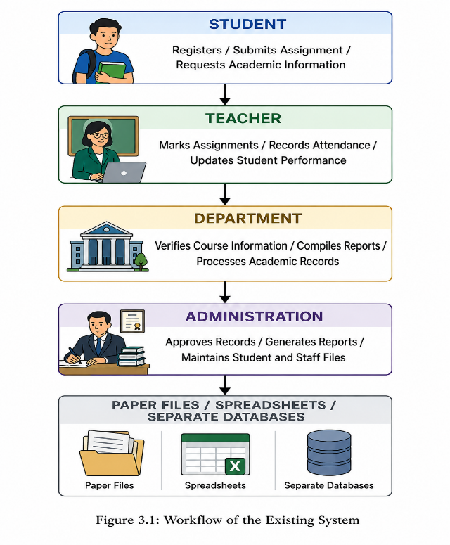
Explanation
The existing workflow begins with students submitting academic requests, assignments, or registration information to their teachers. Teachers manually process these submissions by recording attendance, assessing assignments, and updating students' academic performance. The processed information is subsequently forwarded to the relevant department, where it is verified and consolidated before being sent to the administration for approval and record keeping. Such sequential and manual workflows are common in institutions that rely on traditional academic management practices, often resulting in inefficient coordination and delays in service delivery (Almaiah et al., 2020; Turnbull et al., 2021).
Since most of these activities depend on manual documentation or isolated software applications, information is repeatedly transferred between offices before it is permanently stored. This approach increases processing time, creates opportunities for data duplication and human error, and makes retrieving academic records difficult. Furthermore, communication between administrators, teachers, and students is often delayed because there is no centralized platform for sharing academic information. Studies have shown that fragmented educational systems reduce administrative efficiency, hinder timely access to information, and negatively affect collaboration among stakeholders (Salloum et al., 2019; Bond et al., 2021).
The identified weaknesses of this workflow justify the development of a fully integrated Learning Management System that automates academic processes, centralizes data management, improves communication, and provides authorised users with real-time access to educational information. Such integrated systems have been found to enhance institutional efficiency, improve data accuracy, and support more effective teaching, learning, and academic administration (Turnbull et al., 2021; Almaiah et al., 2020).

3.4 Proposed System Workflow
The proposed School Learning Management System (LMS) introduces a centralized and automated workflow that integrates all major academic and administrative activities into a single web-based platform. Unlike the existing manual system, users interact directly with the system through a secure login interface, where access to features is determined by their assigned roles. The system processes user requests, communicates with the database through the backend API, and provides real-time responses to authorised users.
The workflow is designed to reduce manual intervention, improve communication, enhance data security, and ensure that academic information is available whenever required. Administrators, teachers, and students each access customised dashboards containing only the functions relevant to their responsibilities.
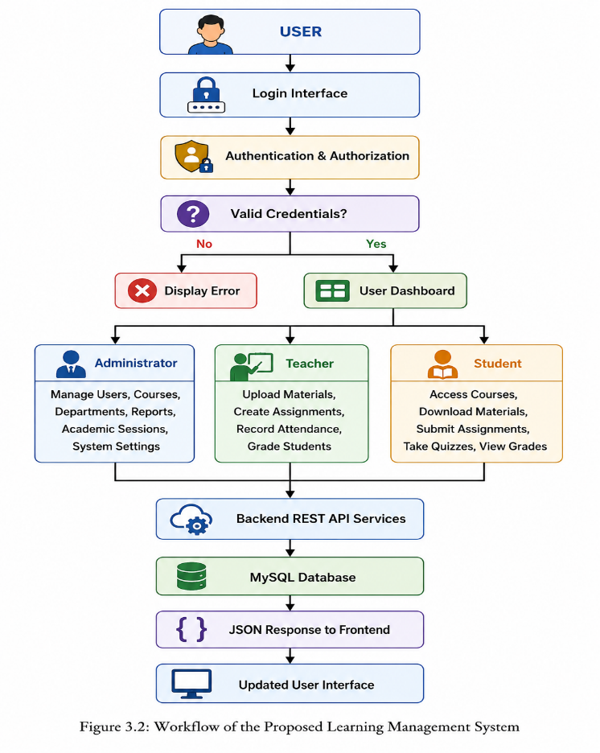
Figure 3.2: Workflow of the Proposed Learning Management System

Explanation of the Proposed Workflow
The workflow begins when a user accesses the system through the login page and enters valid authentication credentials. The backend verifies the credentials, checks the user's role, and establishes a secure session. Once authenticated, the user is redirected to a role-specific dashboard.
Administrators are provided with tools for managing users, departments, academic sessions, courses, reports, and other institutional resources. Teachers can create courses, upload learning materials, create assignments and quizzes, record attendance, assess students, and monitor academic performance. Students can access enrolled courses, download learning materials, submit assignments, participate in online assessments, view grades, and receive announcements.
Every action performed by a user is transmitted to the backend through secure RESTful API endpoints. The backend validates the request, performs the necessary business logic, and interacts with the MySQL database using prepared statements to maintain data integrity and security. The API returns responses in JSON format, which are processed by the frontend to update the user interface dynamically without exposing backend implementation details.
Compared to the existing workflow, the proposed system significantly reduces paperwork, eliminates duplication of records, improves communication among stakeholders, enhances data security through authentication and role-based access control, and enables faster retrieval of academic information. The automated workflow also supports real-time processing of academic activities, thereby improving the efficiency and effectiveness of educational administration.

3.5 Functional Requirements
Functional requirements describe the specific operations and services that the proposed School Learning Management System (LMS) must provide to satisfy the needs of its users. The system is designed using role-based access control, ensuring that each category of user has access only to the functions relevant to their responsibilities. The major functional requirements are grouped according to the three primary user roles: Administrator, Teacher, and Student.
3.5.1 Functional Requirements for the Administrator
The administrator is responsible for managing the overall operation of the Learning Management System. The system shall enable the administrator to perform the following functions:
- Securely log into and log out of the system.
- Access an administrative dashboard displaying key system statistics.
- Create, update, deactivate, and manage user accounts.
- Assign user roles and permissions.
- Manage departments and academic programmes.
- Create, update, and manage courses.
- Assign teachers to courses.
- Manage academic years, semesters, and sessions.
- View student enrolment information.
- Generate academic and administrative reports.
- View system audit logs and user activities.
- Configure system settings.
- Perform database backup and recovery operations.
- Manage announcements and institutional notifications.
- Monitor overall system performance and usage.

3.5.2 Functional Requirements for the Teacher
Teachers are responsible for delivering course content and assessing students. The proposed system shall enable teachers to perform the following functions:
- Securely log into and log out of the system.
- Access a personalised teacher dashboard.
- View assigned courses.
- Create and update course information where permitted.
- Upload, edit, archive, and delete learning materials.
- Create assignments with submission deadlines.
- Create and manage online quizzes and examinations.
- Grade assignments and quizzes.
- Record and manage student attendance.
- View enrolled students for each course.
- Publish announcements to students.
- View student submissions.
- Provide feedback on submitted assignments.
- Monitor student academic performance.
- Generate course-related reports.

3.5.3 Functional Requirements for the Student
Students interact with the system primarily to access learning resources and participate in academic activities. The system shall enable students to perform the following functions:
- Securely log into and log out of the system.
- Access a personalised student dashboard.
- View registered or enrolled courses.
- Access and download learning materials.
- Submit assignments electronically.
- Participate in online quizzes and examinations.
- View assignment deadlines.
- Receive announcements and notifications.
- View grades and academic performance.
- Monitor attendance records.
- Update permitted profile information.
- Communicate with instructors through the system where applicable.

3.5.4 General Functional Requirements
In addition to user-specific functions, the system shall provide the following general capabilities:
- Authenticate users before granting system access.
- Enforce role-based access control to protect sensitive information.
- Validate user input before processing requests.
- Store academic information securely in a centralised database.
- Support secure file uploads and downloads.
- Record important system activities through audit logs.
- Generate reports in real time.
- Maintain data integrity through database validation and constraints.
- Support RESTful API communication between the frontend and backend.
- Provide consistent JSON responses for all API requests.
- Automatically manage user sessions and log users out after periods of inactivity.
Summary
The functional requirements define the essential services that the proposed School Learning Management System must provide to support effective academic administration and online learning. By separating system functions according to user roles, the proposed solution ensures that administrators, teachers, and students are provided with appropriate tools and permissions while maintaining the security, integrity, and efficiency of the overall system. These requirements serve as the foundation for the system design and implementation presented in the next chapter.

3.6 Non-Functional Requirements
Non-functional requirements describe the quality attributes and operational characteristics that the proposed School Learning Management System (LMS) must possess to ensure efficient, reliable, secure, and user-friendly operation. Unlike functional requirements, which define what the system should do, non-functional requirements specify how well the system should perform under different conditions.

3.6.1 Performance Requirements
The proposed LMS shall provide efficient and timely processing of user requests to ensure a satisfactory user experience.
The system shall:
- Load web pages within three (3) seconds under normal network conditions.
- Process API requests within two (2) seconds for standard operations.
- Support at least 500 concurrent users without significant degradation in performance.
- Allow users to upload learning materials of up to 100 MB per file.
- Process assignment submissions immediately after upload.
- Generate reports within five (5) seconds for standard datasets.
- Minimise server response time through efficient database queries and caching where applicable.

3.6.2 Security Requirements
Since the system stores confidential academic information, appropriate security mechanisms shall be implemented to protect user data and system resources.
The system shall:
- Encrypt user passwords using the bcrypt hashing algorithm.
- Implement Role-Based Access Control (RBAC) to restrict access based on user roles.
- Validate and sanitise all user inputs to prevent malicious attacks.
- Use prepared SQL statements to prevent SQL injection.
- Protect against Cross-Site Scripting (XSS) attacks through input validation and output encoding.
- Incorporate Cross-Site Request Forgery (CSRF) protection for state-changing requests through the use of security tokens where applicable to the authentication and session architecture.
- Automatically terminate inactive user sessions after a predefined timeout period.
- Record login attempts and critical user activities in audit logs.
- Support secure communication using HTTPS when deployed to a production environment.
- Restrict file uploads to approved file types and sizes.

3.6.3 Reliability Requirements
The system shall operate consistently and maintain data integrity during normal operation and unexpected failures.
The system shall:
- Maintain a minimum availability of 99% uptime during normal operation.
- Automatically back up the database at scheduled intervals.
- Maintain transaction integrity during database operations.
- Recover quickly from unexpected system failures.
- Log application errors for troubleshooting and maintenance.
- Prevent data corruption through proper database constraints and validation.
- Ensure uploaded files remain accessible unless intentionally removed by authorised users.

3.6.4 Usability Requirements
The system shall provide an intuitive and user-friendly interface that supports users with varying levels of computer literacy.
The system shall:
- Provide a responsive interface that functions correctly on desktops, tablets, and smartphones.
- Maintain consistent navigation throughout all system pages.
- Display clear labels, icons, and instructions for all major functions.
- Present informative validation and error messages.
- Minimise the number of steps required to complete common tasks.
- Support accessibility features such as readable fonts, sufficient colour contrast, and keyboard navigation where applicable.
- Provide dashboards customised to the responsibilities of administrators, teachers, and students.

3.6.5 Maintainability Requirements
The proposed LMS shall be designed to simplify future maintenance, upgrades, and feature enhancements.
The system shall:
- Follow a modular software architecture.
- Separate the frontend from the backend through RESTful APIs.
- Use reusable components to reduce code duplication.
- Maintain clear documentation for APIs, database structures, and source code.
- Record application logs to facilitate debugging.
- Support future integration with mobile applications and third-party educational services.

3.6.6 Scalability Requirements
The system shall support future institutional growth without requiring significant architectural changes.
The system shall:
- Allow additional users, departments, and courses to be added without affecting system performance.
- Support expansion to multiple campuses or educational institutions.
- Accommodate increasing numbers of uploaded learning materials and assignments.
- Allow additional functional modules, such as online payments, virtual classrooms, and library management, to be integrated in future versions.

3.6.7 Compatibility Requirements
The LMS shall operate consistently across commonly used hardware and software platforms.
The system shall:
- Support modern web browsers including Google Chrome, Microsoft Edge, Mozilla Firefox, and Safari.
- Operate on Windows, Linux, macOS, and Android devices through a web browser.
- Integrate with MySQL database servers.
- Support RESTful API communication using JSON data exchange.

3.6.8 Availability Requirements
The system shall be accessible whenever authorised users require its services.
The system shall:
- Be available 24 hours a day and 7 days a week, except during scheduled maintenance.
- Notify users in advance of planned maintenance activities.
- Resume normal operation promptly after maintenance or unexpected outages.

3.6.9 Context Diagram
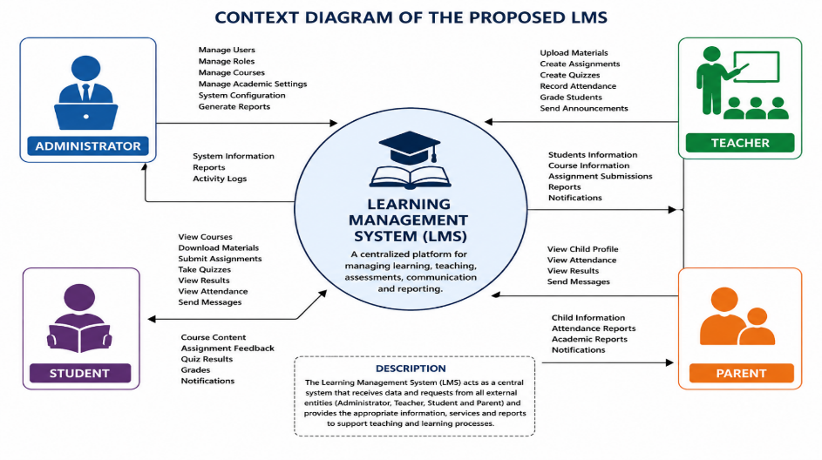
Figure 3.3: Context Diagram of the Proposed LMS

Explanation
The Context Diagram illustrates the interaction between external entities and the Learning Management System. Administrators manage users, courses, and reports. Teachers upload learning materials, create assignments, and record grades. Students access learning resources, submit assignments, and view academic results. The LMS acts as the central processing system that facilitates these interactions.
[
3.6.10 Data Flow Diagram (Level 0)
Figure 3.4: Data Flow Diagram (DFD Level 0)
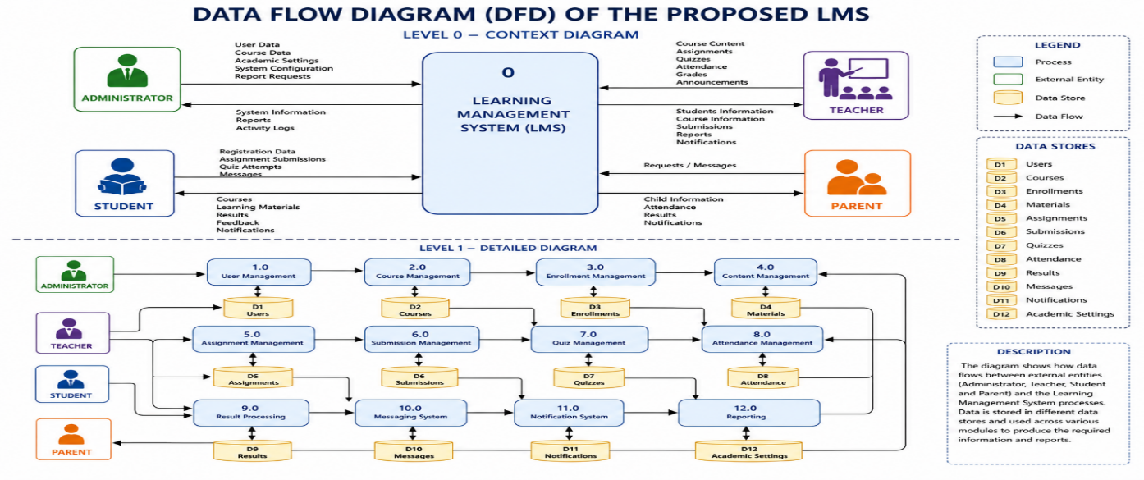
Explanation
The Data Flow Diagram illustrates how information flows within the proposed system. Administrators manage users and courses, teachers upload learning materials and assessments, and students access educational resources and submit assignments. All transactions are stored and retrieved from the LMS database.
3.6.11 Use Case Diagram
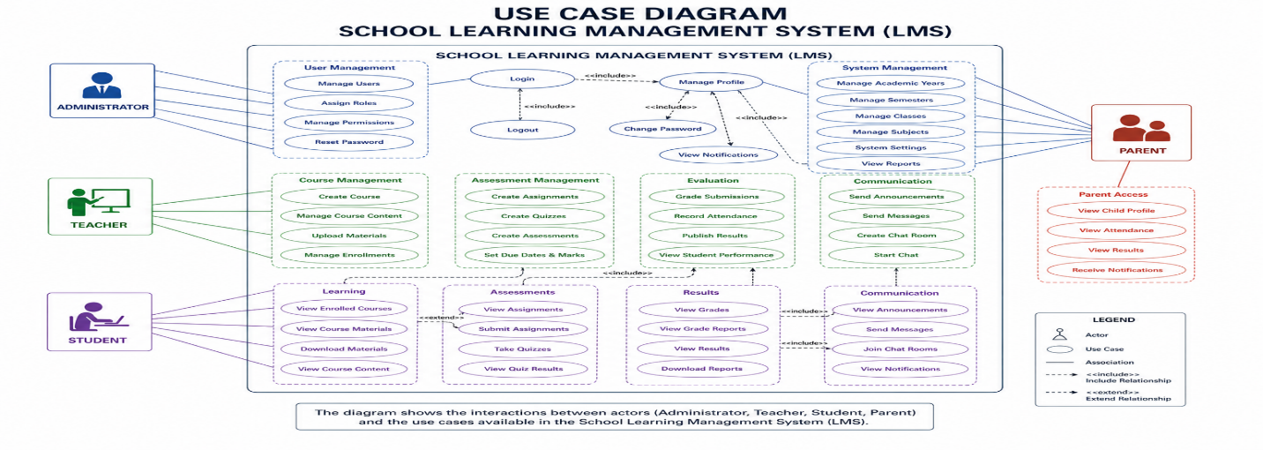
Figure 3.5: Use Case Diagram of the Proposed LMS

Explanation
The Use Case Diagram identifies the major interactions between users and the system. Administrators perform management and reporting functions, teachers manage academic activities, and students access learning resources and monitor their academic progress.

Summary
The non-functional requirements establish the quality standards that the proposed School Learning Management System must satisfy to operate effectively. These requirements address critical aspects such as performance, security, reliability, usability, maintainability, scalability, compatibility, and availability. Collectively, they ensure that the system not only performs its intended functions but also delivers a secure, efficient, reliable, and user-friendly platform capable of supporting the academic and administrative activities of the institution while accommodating future growth and technological advancements.

3.7 System Requirements
The successful implementation of the proposed School Learning Management System (LMS) depends on the availability of appropriate hardware and software resources. These requirements ensure that the system operates efficiently, securely, and reliably while supporting multiple users simultaneously. The requirements are categorised into hardware requirements and software requirements.

3.7.1 Hardware Requirements
The hardware requirements specify the minimum and recommended computing resources needed to host and access the proposed LMS.
Server Hardware Requirements
The server hosts the backend application, RESTful APIs, database, and uploaded learning resources. To ensure efficient system performance, the following minimum hardware specifications are recommended.
Component | Minimum Requirement | Recommended Requirement
Processor | Intel Core i5 (8th Generation) or AMD Ryzen 5 | Intel Core i7 or AMD Ryzen 7
Memory (RAM) | 8 GB | 16 GB or higher
Storage | 100 GB SSD | 500 GB SSD
Network | Broadband Internet Connection | High-speed Fibre Internet
Backup Storage | External Hard Drive | Cloud Backup Service
Power Supply | UPS | UPS with Generator Backup

Client Hardware Requirements
Client computers are used by administrators, teachers, and students to access the LMS through a web browser.
Component | Minimum Requirement
Processor | Dual-Core Processor (2.0 GHz or higher)
Memory (RAM) | 4 GB or higher
Storage | 20 GB Free Disk Space
Display | 1366 × 768 Resolution or Higher
Internet Connection | Stable Broadband Connection
Input Devices | Keyboard and Mouse or Touchscreen

3.7.2 Software Requirements
The software requirements describe the applications, operating systems, databases, and development tools required for developing, deploying, and operating the proposed system.
Server Software Requirements
Software | Version / Requirement
Operating System | Windows 10/11, Ubuntu Linux, Windows Server 2019/2022/2025 or another compatible Linux distribution
Web Server | Apache HTTP Server
Programming Language | PHP 8.x
Database Management System | MySQL 8.x
API Format | RESTful API using JSON
Local Development Environment | XAMPP
Database Administration | phpMyAdmin

Client Software Requirements
Users access the LMS using a standard web browser without installing additional software.
Software | Requirement
Web Browser | Google Chrome (latest version)
Web Browser | Microsoft Edge (latest version)
Web Browser | Mozilla Firefox (latest version)
Web Browser | Safari (latest version for macOS users)
Internet Connection | Stable Internet Access

Development Software Requirements
The system was developed using modern software engineering tools that support version control, API development, debugging, and collaborative development.
Software | Purpose
Visual Studio Code | Source code development
Git | Version control
GitHub | Source code repository and collaboration
Postman | API testing and documentation
XAMPP | Local web server and database environment
phpMyAdmin | Database administration
Composer | PHP dependency management
Google Chrome Developer Tools | Frontend debugging and API inspection

3.7.3 Network Requirements
The Learning Management System is designed as a web-based application; therefore, reliable network connectivity is essential for both server and client operations.
The system requires:
- A stable broadband Internet connection.
- Secure communication using the HTTP/HTTPS protocol.
- Local Area Network (LAN) or Wireless LAN (WLAN) support within the institution.
- Continuous network availability to ensure uninterrupted access to learning resources and academic services.

3.7.4 Browser Compatibility
To ensure accessibility across different computing platforms, the proposed LMS is compatible with modern web browsers, including:
- Google Chrome
- Microsoft Edge
- Mozilla Firefox
- Safari
- Opera
The user interface is responsive and adapts automatically to desktops, laptops, tablets, and smartphones, providing a consistent user experience across different screen sizes.

3.7.5 Summary
The proposed School Learning Management System requires modest hardware resources and widely available software technologies, making it suitable for deployment in educational institutions of varying sizes. The use of PHP, MySQL, Apache, RESTful APIs, and modern web browsers ensures compatibility, portability, and ease of maintenance. Furthermore, the adoption of development tools such as Visual Studio Code, Git, GitHub, and Postman supports efficient software development, testing, and future system enhancement. These requirements provide the technical foundation necessary for the successful implementation and long-term operation of the proposed Learning Management System.

3.8 Database Requirements
The database is one of the most important components of the proposed School Learning Management System (LMS). It serves as the central repository for storing, organising, and managing all academic and administrative information generated by the system. The database maintains records relating to users, courses, departments, enrolments, learning materials, assignments, grades, attendance, announcements, and other institutional data. A well-designed database ensures data consistency, efficient retrieval of information, and secure management of academic records.

3.8.1 Database Management System Selection
The proposed Learning Management System uses MySQL as its Database Management System (DBMS). MySQL was selected because it is an open-source, reliable, and high-performance relational database management system that integrates effectively with PHP and supports web-based application development.
The selection of MySQL was based on the following advantages:
- It is open-source and freely available, making it cost-effective for educational institutions.
- It provides high-speed data processing and efficient query execution.
- It integrates seamlessly with PHP and Apache through the XAMPP development environment.
- It supports relational database structures suitable for complex academic information.
- It offers strong security features such as user authentication and access privileges.
- It supports backup, recovery, and transaction management.
- It is widely adopted in educational and enterprise web applications, ensuring long-term community support and documentation.

3.8.2 Database Normalisation
Database normalisation is the process of organising data into related tables to minimise redundancy and improve data integrity. The database for the proposed LMS was designed following the principles of relational database normalisation.
The database satisfies the following normal forms:
First Normal Form (1NF)
The database ensures that:
- Each table contains atomic (indivisible) values.
- Every record is uniquely identified by a primary key.
- Repeating groups of data have been eliminated.
Second Normal Form (2NF)
The database satisfies Second Normal Form by ensuring that:
- All non-key attributes depend entirely on the primary key.
- Partial dependencies have been removed.
- Related information is stored in separate tables.
Third Normal Form (3NF)
The database satisfies Third Normal Form by ensuring that:
- There are no transitive dependencies.
- Every non-key attribute depends only on the primary key.
- Data duplication is minimised.
- Data consistency is maintained throughout the database.
The application of these normalisation principles improves storage efficiency, simplifies maintenance, and reduces the possibility of update anomalies.

3.8.3 Database Relationships
The proposed database follows a relational model in which related tables are connected using primary keys and foreign keys. These relationships maintain referential integrity and ensure consistency among the various academic records.
Some of the major relationships in the database include:
Parent Table | Child Table | Relationship
Roles | Users | One-to-Many
Departments | Courses | One-to-Many
Users (Teacher) | Courses | One-to-Many
Courses | Materials | One-to-Many
Courses | Assignments | One-to-Many
Courses | Quizzes | One-to-Many
Courses | Attendance | One-to-Many
Students | Enrolments | One-to-Many
Courses | Enrolments | One-to-Many
Assignments | Submissions | One-to-Many
Students | Submissions | One-to-Many
Students | Grades | One-to-Many
Courses | Grades | One-to-Many
Users | Audit Logs | One-to-Many
These relationships enable the system to retrieve related academic information efficiently while maintaining data accuracy and consistency.

3.8.4 Database Security
Since the database stores confidential institutional information, several security mechanisms have been incorporated to protect data from unauthorised access and malicious activities.
The proposed system implements the following database security measures:
- User authentication before accessing protected resources.
- Role-Based Access Control (RBAC) to restrict database operations according to user responsibilities.
- Password encryption using the bcrypt hashing algorithm.
- Prepared SQL statements to prevent SQL injection attacks.
- Input validation and sanitisation before database operations.
- Foreign key constraints to preserve referential integrity.
- Database transaction management to maintain consistency during updates.
- Automatic recording of important activities in audit logs.
- Scheduled database backups to minimise data loss.
- Recovery procedures for restoring data in the event of system failure.
- Restricted administrative privileges to authorised personnel only.
These measures help ensure the confidentiality, integrity, and availability of academic information stored within the database.

3.8.5 Database Entities
The proposed Learning Management System database consists of several interconnected entities that support the various academic and administrative functions of the system. The major entities include:
- Users
- Roles
- Departments
- Courses
- Student Enrolments
- Learning Materials
- Assignments
- Assignment Submissions
- Quizzes
- Quiz Attempts
- Grades
- Attendance Records
- Announcements
- Academic Sessions
- Audit Logs
Each entity represents a specific aspect of the educational process and is linked to other entities through well-defined relationships.

3.8.6 Database Design Considerations
The database was designed with the following objectives:
- Eliminate unnecessary data redundancy.
- Ensure high data integrity through relational constraints.
- Support efficient searching, sorting, and reporting.
- Provide scalability for future institutional growth.
- Facilitate secure storage of academic records.
- Support RESTful API operations through efficient query execution.
- Enable easy maintenance and future database expansion.

Summary
The proposed School Learning Management System employs MySQL, a robust relational database management system, to provide efficient and secure storage of academic and administrative information. The database has been normalised up to the Third Normal Form (3NF) to minimise redundancy and improve consistency. Relationships among entities are maintained using primary and foreign keys, while comprehensive security mechanisms—including authentication, role-based access control, prepared statements, password hashing, and scheduled backups—protect sensitive institutional data. Consequently, the database provides a reliable and scalable foundation for supporting the functional requirements of the proposed Learning Management System.

3.9 API Architecture
The proposed School Learning Management System (LMS) adopts an API-first architecture, in which the frontend and backend are developed as separate components that communicate through Representational State Transfer (REST) APIs. This architectural approach promotes modularity, scalability, maintainability, and reusability by ensuring that the user interface is independent of the application logic and database operations.
In the proposed architecture, users interact with the system through a web-based frontend developed using HTML5, CSS3, and JavaScript. The frontend sends requests to the backend through RESTful API endpoints using standard HTTP methods. The backend, developed with PHP, processes these requests, performs authentication and business logic, communicates with the MySQL database, and returns responses in JavaScript Object Notation (JSON) format.
This separation of concerns enables the backend APIs to serve multiple client applications, including web, mobile, and desktop applications, without modifying the underlying business logic.

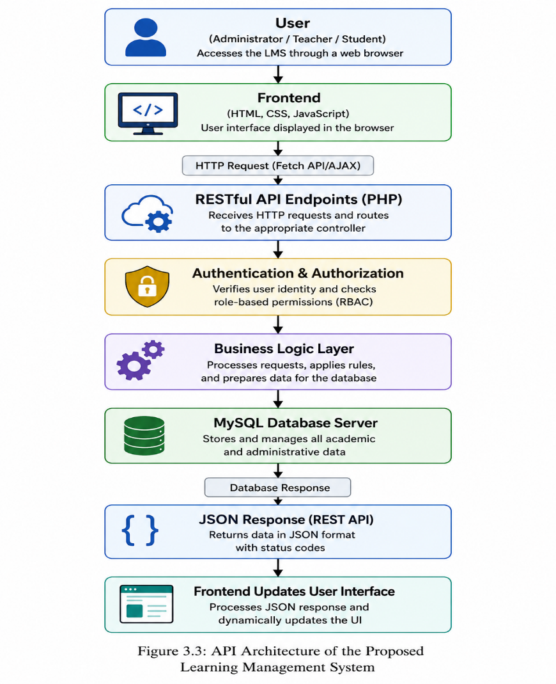
Figure 3.6: API Architecture of the Proposed Learning Management System

3.9.1 RESTful API Design
The proposed LMS follows the principles of Representational State Transfer (REST). REST is an architectural style for designing web services that enables communication between distributed software components using standard HTTP protocols.
Each resource within the system, such as users, courses, assignments, learning materials, attendance records, and grades, is represented by a unique API endpoint. These endpoints perform specific operations without exposing the internal implementation of the application.
Examples of API resources include:
- /api/auth/login
- /api/users
- /api/courses
- /api/materials
- /api/assignments
- /api/quizzes
- /api/grades
- /api/attendance
This resource-oriented approach simplifies integration, maintenance, and future system expansion.

3.9.2 HTTP Methods
The RESTful API uses standard HTTP methods to perform different operations on system resources.
HTTP Method | Purpose | Example
GET | Retrieve information | Retrieve course materials
POST | Create new resources | Create a course or upload material
PUT | Update existing resources | Update course details or grades
DELETE | Remove resources | Delete a course or learning material

Using standard HTTP methods improves consistency and makes the API easier to understand and integrate with different client applications.

3.9.3 JSON Data Exchange
The proposed system uses JavaScript Object Notation (JSON) as the standard data exchange format between the frontend and backend.
When a user performs an operation, the frontend sends data to the backend as a JSON request. After processing the request, the backend returns a JSON response containing the requested information or an appropriate error message.
A typical API response includes:
- Operation status
- Response message
- Requested data
- HTTP status code
- Timestamp
JSON was selected because it is lightweight, easy to read, language-independent, and supported by modern web browsers and programming languages.

3.9.4 Stateless Communication
The RESTful APIs are designed using the principle of stateless communication. Under this approach, every client request contains all the information required for the server to process that request. The server does not rely on previous requests to determine the current request's context.
The benefits of stateless communication include:
- Improved scalability.
- Reduced server memory usage.
- Easier load balancing.
- Better fault tolerance.
- Simplified API maintenance.
Although user authentication is managed through secure sessions, each API request is independently validated before processing to ensure that only authorised users can access protected resources.

3.9.5 Authentication and Authorization
Before granting access to protected resources, every API request passes through an authentication and authorisation layer.
The authentication component verifies the user's identity using secure login credentials and establishes a valid user session. Once authenticated, the authorisation component determines whether the user has sufficient privileges to perform the requested operation based on Role-Based Access Control (RBAC).
The system defines three primary user roles:
- Administrator
- Teacher
- Student
Each role is granted access only to the resources and operations relevant to its responsibilities, thereby enhancing system security and protecting confidential academic information.

3.9.6 Advantages of the API-First Architecture
The API-first approach provides several advantages over traditional monolithic web applications in which the frontend and backend are tightly coupled.
The proposed architecture offers the following benefits:
- Clear separation between the frontend and backend.
- Improved maintainability through modular development.
- Easier testing of backend services using tools such as Postman.
- Reusability of APIs across web, mobile, and desktop applications.
- Simplified integration with third-party educational systems.
- Improved scalability through independent deployment of frontend and backend components.
- Faster development by allowing frontend and backend teams to work independently.
- Consistent communication through standard JSON responses.

Summary
The proposed School Learning Management System adopts an API-first architecture that separates the presentation layer from the business logic and database layers. Communication between the frontend and backend is achieved through RESTful APIs, HTTP methods, and JSON data exchange, while stateless request processing improves scalability and maintainability. Authentication and role-based authorisation ensure that only authorised users can access protected resources. This architecture provides a secure, flexible, and scalable foundation capable of supporting future enhancements, including mobile applications and integration with external educational platforms.

3.10 Module Description
The proposed School Learning Management System (LMS) is organised into several functional modules, each responsible for performing a specific set of academic or administrative tasks. This modular design improves maintainability, scalability, and system organisation by separating related functionalities into independent components. Each module communicates with the backend through RESTful APIs and interacts with the MySQL database to perform authorised operations.

3.10.1 Authentication Module
The Authentication Module is responsible for verifying user identities before granting access to the system. It ensures that only authorised users can access protected resources while maintaining secure user sessions.
Functions
- User login
- User logout
- Session management
- Password verification
- Role-Based Access Control (RBAC)
- User authentication
- Session timeout management
- Password encryption using bcrypt

3.10.2 User Management Module
This module enables administrators to manage users within the system. It maintains records for administrators, teachers, and students while controlling user roles and permissions.
Functions
- Create user accounts
- Update user information
- Delete or deactivate users
- Assign user roles
- Manage departments
- Reset passwords
- Search and filter users
- View user activity

3.10.3 Course Management Module
The Course Management Module manages all academic courses offered by the institution. It allows administrators and authorised teachers to create and organise courses while assigning instructors and enrolling students.
Functions
- Create courses
- Edit course information
- Delete or archive courses
- Assign teachers to courses
- Manage course enrolments
- View course details
- Search available courses
- Organise courses by department and academic session

3.10.4 Learning Materials Module
This module manages digital learning resources uploaded by teachers. Students can access and download materials for their enrolled courses.
Functions
- Upload learning materials
- Download learning materials
- Archive or restore materials
- Delete learning materials
- Organise materials by course
- Search learning resources
- Preview supported files
- Manage uploaded documents

3.10.5 Assignment Management Module
The Assignment Management Module enables teachers to create coursework while allowing students to submit assignments electronically.
Functions
- Create assignments
- Edit assignment details
- Set submission deadlines
- Upload assignment instructions
- Submit assignments
- View student submissions
- Grade assignments
- Provide feedback
- Monitor submission status

3.10.6 Quiz and Assessment Module
This module supports online quizzes and assessments that evaluate students' understanding of course content.
Functions
- Create quizzes
- Add objective and subjective questions
- Configure quiz duration
- Schedule quizzes
- Submit quiz attempts
- Automatically score objective questions
- Record quiz results
- Generate assessment reports

3.10.7 Attendance Management Module
The Attendance Module enables teachers to record and monitor student attendance for each course.
Functions
- Record attendance
- Update attendance records
- View attendance history
- Generate attendance reports
- Monitor absenteeism
- Export attendance records

3.10.8 Grade Management Module
The Grade Management Module manages student assessment results and overall academic performance.
Functions
- Record grades
- Update grades
- Calculate final scores
- Generate grade reports
- View student performance
- Export academic results

3.10.9 Announcement and Notification Module
This module facilitates communication between administrators, teachers, and students by distributing academic announcements and notifications.
Functions
- Publish announcements
- Send notifications
- Display important notices
- Notify assignment deadlines
- Notify quiz schedules
- Notify grade publication
- Broadcast institutional messages

3.10.10 Reporting Module
The Reporting Module provides administrators and teachers with analytical reports that support academic planning and decision-making.
Functions
- Generate student reports
- Generate course reports
- Generate attendance reports
- Generate grade reports
- Produce enrolment statistics
- Export reports in printable formats
- Monitor overall academic performance

3.10.11 Audit and Activity Logging Module
The Audit Module records significant user activities performed within the system. These records improve accountability, troubleshooting, and system security.
Functions
- Record login activities
- Record user operations
- Monitor system access
- Record administrative actions
- Track failed login attempts
- Generate audit reports

3.10.12 API Integration Module
The API Integration Module serves as the communication layer between the frontend application and the backend services. It processes requests, validates data, and returns JSON responses.
Functions
- Process RESTful API requests
- Validate incoming requests
- Return JSON responses
- Handle HTTP methods (GET, POST, PUT, DELETE)
- Communicate with the database
- Handle API errors
- Manage data exchange between frontend and backend

3.10.13 Database Management Module
This module manages all database operations performed by the system and ensures that academic information is stored securely and consistently.
Functions
- Store system data
- Retrieve records
- Update information
- Delete records
- Manage database relationships
- Maintain referential integrity
- Perform database backup and recovery
- Optimise database performance

Summary
The proposed School Learning Management System is organised into specialised modules that collectively support academic administration, teaching, and learning. The Authentication, User Management, Course Management, Learning Materials, Assignment, Quiz, Attendance, Grade, Announcement, Reporting, Audit, API Integration, and Database Management modules work together to provide a secure, scalable, and efficient platform. This modular architecture simplifies system maintenance, enhances scalability, promotes code reusability, and allows future expansion without significantly affecting existing functionality.

3.11 Data Dictionary
The data dictionary provides a description of the major data elements used in the proposed School Learning Management System (LMS). It defines the attributes, data types, and purposes of important fields within the database. The data dictionary serves as a reference for developers, database administrators, and system users by promoting consistency in database design and implementation.

3.11.1 Users Table
Field | Data Type | Description
user_id | INT | Unique identifier for each user
role_id | INT | References the user's role
department_id | INT | References the department
username | VARCHAR(50) | Username for login
email | VARCHAR(100) | User email address
password | VARCHAR(255) | Encrypted password
first_name | VARCHAR(100) | User's first name
last_name | VARCHAR(100) | User's last name
phone | VARCHAR(20) | Contact number
status | ENUM | Account status (Active/Inactive)
created_at | TIMESTAMP | Date account was created

3.11.2 Roles Table
Field | Data Type | Description
role_id | INT | Unique role identifier
role_name | VARCHAR(50) | Name of the role
description | TEXT | Role description

3.11.3 Departments Table
Field | Data Type | Description
department_id | INT | Unique department identifier
department_name | VARCHAR(100) | Department name
department_code | VARCHAR(20) | Department code
description | TEXT | Department description

3.11.4 Courses Table
Field | Data Type | Description
course_id | INT | Unique course identifier
department_id | INT | Department offering the course
teacher_id | INT | Assigned teacher
course_code | VARCHAR(20) | Course code
course_name | VARCHAR(150) | Course title
description | TEXT | Course description
credit_hours | INT | Credit hours
semester | VARCHAR(20) | Academic semester
academic_year | VARCHAR(20) | Academic year
status | ENUM | Course status

3.11.5 Student Enrolments Table
Field | Data Type | Description
enrolment_id | INT | Enrolment identifier
student_id | INT | Registered student
course_id | INT | Enrolled course
enrolment_date | DATE | Date of enrolment
status | ENUM | Enrolment status

3.11.6 Learning Materials Table
Field | Data Type | Description
material_id | INT | Material identifier
course_id | INT | Associated course
teacher_id | INT | Uploading teacher
title | VARCHAR(200) | Material title
material_type | VARCHAR(50) | Material category
file_path | VARCHAR(255) | Storage location
file_size | BIGINT | File size
upload_date | DATETIME | Upload date
is_archived | BOOLEAN | Archive status

3.11.7 Assignments Table
Field | Data Type | Description
assignment_id | INT | Assignment identifier
course_id | INT | Related course
teacher_id | INT | Assignment creator
title | VARCHAR(200) | Assignment title
description | TEXT | Assignment details
due_date | DATETIME | Submission deadline
total_marks | DECIMAL(5,2) | Maximum marks
created_at | TIMESTAMP | Date created
3.11.8 Assignment Submissions Table
Field | Data Type | Description
submission_id | INT | Submission identifier
assignment_id | INT | Related assignment
student_id | INT | Student submitting
file_path | VARCHAR(255) | Submitted file
submission_date | DATETIME | Submission date
marks | DECIMAL(5,2) | Marks awarded
feedback | TEXT | Teacher comments
status | ENUM | Submission status

3.11.9 Quizzes Table
Field | Data Type | Description
quiz_id | INT | Quiz identifier
course_id | INT | Associated course
teacher_id | INT | Quiz creator
title | VARCHAR(200) | Quiz title
duration | INT | Time limit (minutes)
total_marks | DECIMAL(5,2) | Total marks
availability_date | DATETIME | Quiz opening date

3.11.10 Grades Table
Field | Data Type | Description
grade_id | INT | Grade identifier
student_id | INT | Student receiving grade
course_id | INT | Course
assessment_type | VARCHAR(50) | Assignment, Quiz, Exam
score | DECIMAL(5,2) | Marks obtained
grade | VARCHAR(5) | Letter grade
remarks | VARCHAR(100) | Performance remarks

3.11.11 Attendance Table
Field | Data Type | Description
attendance_id | INT | Attendance identifier
student_id | INT | Student
course_id | INT | Course
attendance_date | DATE | Attendance date
status | ENUM | Present, Absent, Late
remarks | VARCHAR(100) | Attendance remarks

3.11.12 Announcements Table
Field | Data Type | Description
announcement_id | INT | Announcement identifier
user_id | INT | Publisher
title | VARCHAR(200) | Announcement title
content | TEXT | Announcement details
publish_date | DATETIME | Publication date
expiry_date | DATETIME | Expiry date

3.11.13 Audit Logs Table
Field | Data Type | Description
log_id | INT | Log identifier
user_id | INT | User performing activity
action | VARCHAR(150) | Performed action
module | VARCHAR(100) | System module
ip_address | VARCHAR(50) | Client IP address
created_at | DATETIME | Activity timestamp

Summary
The data dictionary defines the major entities and attributes used in the proposed School Learning Management System database. It establishes a common reference for developers and database administrators, ensuring consistency in naming conventions, data types, and relationships. The documented fields support secure storage, efficient retrieval, and accurate management of academic and administrative information while providing a foundation for system implementation and future maintenance.

3.12 Decision Table
The proposed School Learning Management System implements Role-Based Access Control (RBAC) to ensure that users can only perform functions authorised for their respective roles. The decision table below summarises the permissions assigned to Administrators, Teachers, and Students.
Table 3.14: Decision Table for User Roles and Permissions
System Function | Administrator | Teacher | Student
Login | ✓ | ✓ | ✓
Logout | ✓ | ✓ | ✓
View Dashboard | ✓ | ✓ | ✓
Manage User Accounts | ✓ | ✗ | ✗
Manage Roles & Permissions | ✓ | ✗ | ✗
Manage Departments | ✓ | ✗ | ✗
Create Courses | ✓ | ✓* | ✗
Edit Courses | ✓ | ✓* | ✗
Delete Courses | ✓ | ✗ | ✗
View Courses | ✓ | ✓ | ✓
Enrol Students | ✓ | ✗ | ✓**
Upload Learning Materials | ✗ | ✓ | ✗
Download Learning Materials | ✓ | ✓ | ✓
Archive Learning Materials | ✗ | ✓ | ✗
Create Assignments | ✗ | ✓ | ✗
Submit Assignments | ✗ | ✗ | ✓
Grade Assignments | ✗ | ✓ | ✗
Create Quizzes | ✗ | ✓ | ✗
Attempt Quizzes | ✗ | ✗ | ✓
Record Attendance | ✗ | ✓ | ✗
View Attendance | ✓ | ✓ | ✓
Publish Announcements | ✓ | ✓ | ✗
View Announcements | ✓ | ✓ | ✓
View Grades | ✓ | ✓ | ✓***
Generate Reports | ✓ | ✓**** | ✗
View Audit Logs | ✓ | ✗ | ✗
Backup Database | ✓ | ✗ | ✗
Manage System Settings | ✓ | ✗ | ✗

Key
- ✓ = Permission Granted
- ✗ = Permission Denied
- ✓* = Teachers can create and manage only the courses assigned to them.
- ✓** = Teachers can generate reports only for their own courses.
- ✓ = Students can enrol only in courses made available to them (subject to institutional policy).
- ✓* = Students can view only their own grades and academic records.

Explanation
The decision table illustrates how the proposed Learning Management System enforces access control through Role-Based Access Control (RBAC). Administrators possess full privileges to manage users, departments, courses, reports, audit logs, and system configuration. Teachers are responsible for instructional activities such as managing assigned courses, uploading learning materials, creating assignments and quizzes, recording attendance, grading student work, and publishing announcements. Students have limited access, allowing them to view course information, access learning materials, submit assignments, participate in quizzes, monitor attendance, and view their individual academic results.
By restricting users to only the functions necessary for their responsibilities, the system enhances security, protects sensitive academic information, and maintains the integrity of institutional data.

3.13 Use Case Description
The Use Case Description explains the major interactions between the users of the proposed School Learning Management System (LMS) and the system itself. Each use case represents a specific function performed by an actor to achieve a particular objective. The system has three primary actors: Administrator, Teacher, and Student, each interacting with the system according to their assigned roles and privileges.
Table 3.15: Use Case Description
Use Case | Primary Actor | Description
Login | Administrator, Teacher, Student | Authenticates users before granting access to the system.
Logout | Administrator, Teacher, Student | Ends the current user session securely.
View Dashboard | Administrator, Teacher, Student | Displays role-specific information and system activities.
Manage Users | Administrator | Creates, updates, deactivates, and manages user accounts and roles.
Manage Departments | Administrator | Creates, updates, and manages academic departments.
Create Course | Administrator, Teacher | Creates a new course and assigns course information.
Update Course | Administrator, Teacher | Modifies course details and settings.
View Courses | Administrator, Teacher, Student | Displays available courses according to user privileges.
Enrol Student | Administrator | Registers students for selected courses.
Upload Learning Material | Teacher | Uploads lecture notes, presentations, videos, and other learning resources.
Download Learning Material | Teacher, Student | Downloads learning materials from enrolled courses.
Archive Learning Material | Teacher | Archives outdated or inactive learning materials.
Create Assignment | Teacher | Creates assignments for students enrolled in a course.
Submit Assignment | Student | Uploads completed assignments before the submission deadline.
Grade Assignment | Teacher | Evaluates submitted assignments and records marks.
Create Quiz | Teacher | Creates online quizzes for assessment.
Attempt Quiz | Student | Completes quizzes within the allocated time.
Record Attendance | Teacher | Records students' attendance during lectures.
View Attendance | Teacher, Student | Displays attendance records for courses.
Record Grades | Teacher | Records examination and assessment scores.
View Grades | Student, Teacher | Displays student academic performance.
Publish Announcement | Administrator, Teacher | Posts announcements and important academic information.
View Announcements | Administrator, Teacher, Student | Displays institutional and course announcements.
Generate Reports | Administrator, Teacher | Produces reports on academic activities, attendance, grades, and users.
View Audit Logs | Administrator | Reviews user activities and system events for security and monitoring.
Backup Database | Administrator | Performs database backup to prevent data loss.

Description of Major Use Cases
Login
Actor: Administrator, Teacher, Student
Purpose:
To authenticate users and grant secure access to the Learning Management System.
Precondition:
- User account exists.
- Valid username and password are available.
Main Flow:
- User enters login credentials.
- System validates the credentials.
- User is authenticated.
- Appropriate dashboard is displayed.
Postcondition:
- User session is created.
- Access permissions are assigned according to the user's role.

Upload Learning Material
Actor: Teacher
Purpose:
To provide students with lecture notes, presentations, videos, and other educational resources.
Precondition:
- Teacher is logged into the system.
- Teacher is assigned to the selected course.
Main Flow:
- Teacher selects a course.
- Teacher enters material details.
- Teacher uploads the file.
- System validates the file.
- Material is stored in the database and file storage.
- Students can access the uploaded material.
Postcondition:
- Learning material becomes available to authorised students.

Submit Assignment
Actor: Student
Purpose:
To submit completed coursework electronically.
Precondition:
- Student is enrolled in the course.
- Assignment is available and submission deadline has not expired.
Main Flow:
- Student selects an assignment.
- Student uploads the completed work.
- System validates the uploaded file.
- Submission is stored successfully.
- Confirmation message is displayed.
Postcondition:
- Assignment is recorded and becomes available for grading.

Grade Assignment
Actor: Teacher
Purpose:
To evaluate submitted assignments and provide marks and feedback.
Precondition:
- Student submissions are available.
- Teacher has permission to access the course.
Main Flow:
- Teacher views submitted assignments.
- Teacher reviews the submission.
- Teacher enters marks and feedback.
- System saves the assessment.
Postcondition:
- Student grades are updated and become available for viewing.

Generate Reports
Actor: Administrator, Teacher
Purpose:
To produce academic and administrative reports for decision-making.
Precondition:
- User is authenticated.
- User has permission to generate reports.
Main Flow:
- User selects report type.
- User specifies report parameters.
- System retrieves relevant data.
- Report is generated.
- User views or downloads the report.
Postcondition:
- Report is available for printing or export.

Summary
The use case descriptions complement the Use Case Diagram by providing detailed explanations of how users interact with the proposed School Learning Management System. They define the actors involved, the objectives of each interaction, the conditions required before execution, the sequence of activities performed, and the expected outcomes. Together, the Use Case Diagram and Use Case Descriptions provide a comprehensive specification of the system's functional behaviour and support the implementation of a secure, role-based, and user-centred Learning Management System.

3.14 Data Flow Diagram (DFD) Explanation
The Data Flow Diagram (DFD) illustrates how data moves through the proposed School Learning Management System (LMS). It identifies the major processes, data stores, external entities, and the flow of information among them. The DFD demonstrates how users interact with the system and how information is processed, stored, and retrieved.
The major processes of the proposed system are explained below.

3.14.1 Process 1: User Authentication
The User Authentication process verifies the identity of users before granting access to the Learning Management System. All users, including administrators, teachers, and students, must successfully authenticate before accessing protected resources.
Input
- Username
- Password
Processing
- Validate user credentials.
- Compare encrypted password with the stored password.
- Verify account status.
- Determine user role.
- Create user session.
- Record login activity.
Output
- Successful login confirmation.
- User dashboard.
- Error message for invalid credentials.
- User session information.
Data Store
- Users Table
- Roles Table
- Audit Logs Table

3.14.2 Process 2: Course Management
The Course Management process allows authorised users to create, update, manage, and retrieve course information.
Input
- Course code
- Course title
- Course description
- Teacher assignment
- Department information
- Academic year
- Semester
Processing
- Validate course information.
- Create new course.
- Update existing course.
- Assign teachers.
- Save course information.
Output
- Course successfully created.
- Updated course details.
- List of available courses.
Data Store
- Courses Table
- Departments Table
- Users Table

3.14.3 Process 3: Learning Material Management
This process enables teachers to upload, organise, archive, and manage digital learning resources.
Input
- Course selection
- Material title
- Material type
- Uploaded file
Processing
- Validate uploaded file.
- Store file on the server.
- Save metadata.
- Associate material with the selected course.
- Archive materials when necessary.
Output
- Upload confirmation.
- Updated material list.
- Downloadable learning resources.
Data Store
- Learning Materials Table
- Courses Table

3.14.4 Process 4: Assignment Management
The Assignment Management process supports assignment creation, submission, grading, and feedback.
Input
Teacher
- Assignment details
- Due date
- Instructions
Student
- Assignment file
- Submission comments
Processing
- Create assignments.
- Validate submissions.
- Store uploaded files.
- Grade assignments.
- Record feedback.
Output
- Assignment created.
- Submission confirmation.
- Student grades.
- Teacher feedback.
Data Store
- Assignments Table
- Assignment Submissions Table
- Grades Table

3.14.5 Process 5: Quiz Management
This process manages online quizzes used for continuous assessment.
Input
- Quiz information
- Questions
- Student answers
Processing
- Create quizzes.
- Display questions.
- Record answers.
- Automatically calculate objective scores.
- Store quiz results.
Output
- Quiz results.
- Student scores.
- Performance reports.
Data Store
- Quizzes Table
- Quiz Attempts Table
- Grades Table
3.14.6 Process 6: Attendance Management
The Attendance Management process records and maintains student attendance for each course.
Input
- Student list
- Attendance status
- Attendance date
Processing
- Validate attendance records.
- Save attendance information.
- Update attendance history.
Output
- Attendance confirmation.
- Attendance reports.
- Attendance statistics.
Data Store
- Attendance Table
- Courses Table
- Users Table

3.14.7 Process 7: Grade Management
The Grade Management process records and manages students' academic performance.
Input
- Student marks
- Assessment type
- Course information
Processing
- Validate grades.
- Calculate totals.
- Compute final grades.
- Store academic results.
Output
- Student grades.
- Academic transcript.
- Grade reports.
Data Store
- Grades Table
- Students Table
- Courses Table

3.14.8 Process 8: Announcement Management
This process enables administrators and teachers to communicate important academic information to users.
Input
- Announcement title
- Announcement content
- Publication date
- Expiry date
Processing
- Validate announcement.
- Store announcement.
- Publish to relevant users.
Output
- Published announcement.
- User notifications.
Data Store
- Announcements Table

3.14.9 Process 9: Report Generation
The Report Generation process provides academic and administrative reports that support institutional decision-making.
Input
- Report type
- Search criteria
- Date range
Processing
- Retrieve relevant data.
- Analyse records.
- Generate reports.
- Format report output.
Output
- Student reports.
- Attendance reports.
- Grade reports.
- Course reports.
- Statistical summaries.
Data Store
- Users Table
- Courses Table
- Attendance Table
- Grades Table
- Assignments Table
- Learning Materials Table

3.14.10 Process 10: Audit Logging
The Audit Logging process records significant activities performed within the system to enhance accountability and security.
Input
- User activity
- Login information
- System events
Processing
- Record user action.
- Store timestamp.
- Save IP address.
- Save activity description.
Output
- Audit trail.
- Security reports.
- User activity history.
Data Store
- Audit Logs Table

Summary
The Data Flow Diagram illustrates the movement of information throughout the proposed School Learning Management System. Each process transforms user inputs into meaningful outputs while interacting with the appropriate database tables. Authentication controls access to the system, course and learning material management support teaching and learning activities, assignment, quiz, attendance, and grade management facilitate academic evaluation, while announcements, reporting, and audit logging improve communication, administration, and accountability. Together, these processes ensure efficient, secure, and reliable management of academic information within the Learning Management System.

3.15 Technology Selection
The successful implementation of the proposed School Learning Management System (LMS) depends on selecting appropriate technologies that provide reliability, scalability, maintainability, and cost-effectiveness. The technologies used were selected based on their compatibility, performance, ease of development, community support, and suitability for web-based educational applications.

3.15.1 HTML5
HyperText Markup Language version 5 (HTML5) was selected as the primary markup language for developing the frontend interface of the proposed Learning Management System.
HTML5 was chosen because it:
- Provides a standard structure for web applications.
- Supports semantic elements that improve accessibility.
- Is compatible with all modern web browsers.
- Supports multimedia content without requiring additional plugins.
- Integrates easily with CSS3 and JavaScript.
HTML5 enables the development of responsive and well-structured web pages that are accessible across different devices.

3.15.2 CSS3
Cascading Style Sheets version 3 (CSS3) was selected to design and style the graphical user interface of the system.
CSS3 provides several advantages, including:
- Responsive web design.
- Flexible layouts using Flexbox and CSS Grid.
- Attractive user interfaces.
- Animation and transition effects.
- Improved user experience across desktop and mobile devices.
CSS3 separates presentation from application logic, making the system easier to maintain and update.

3.15.3 JavaScript
JavaScript was selected to provide interactivity and dynamic functionality within the frontend of the application.
JavaScript enables the system to:
- Validate user input before submission.
- Communicate with backend APIs asynchronously.
- Update page content without full-page reloads.
- Display notifications and alerts.
- Improve responsiveness and user experience.
Its widespread browser support and integration with modern web technologies make it suitable for developing interactive educational applications.

3.15.4 PHP 8
PHP version 8 was selected as the backend programming language responsible for implementing the business logic and RESTful APIs of the Learning Management System.
PHP 8 was chosen because it:
- Integrates efficiently with MySQL databases.
- Supports object-oriented programming.
- Provides high execution performance.
- Includes improved security features.
- Supports modern programming practices.
- Has extensive documentation and community support.
PHP processes client requests, manages authentication, performs database operations, and returns JSON responses to the frontend.

3.15.5 MySQL
MySQL was selected as the relational database management system for storing and managing academic and administrative data.
The reasons for selecting MySQL include:
- High performance.
- Reliability.
- Open-source licensing.
- Strong security features.
- Support for relational database design.
- Compatibility with PHP.
- Efficient data indexing and query optimisation.
MySQL provides secure storage for users, courses, assignments, learning materials, grades, attendance records, and other institutional data.

3.15.6 REST API
The proposed Learning Management System adopts a Representational State Transfer (REST) architecture for communication between the frontend and backend.
REST APIs were selected because they:
- Separate the frontend from the backend.
- Improve scalability.
- Support multiple client applications.
- Simplify integration with mobile and desktop applications.
- Use standard HTTP protocols.
- Facilitate modular software development.
RESTful architecture allows the frontend to communicate with backend services through well-defined API endpoints.

3.15.7 JSON
JavaScript Object Notation (JSON) was selected as the standard format for exchanging information between the frontend and backend.
JSON was chosen because it:
- Is lightweight.
- Is easy to read and write.
- Is language independent.
- Reduces network bandwidth usage.
- Is supported by almost every programming language.
All API responses in the proposed system are transmitted in JSON format, enabling efficient communication between application components.
3.15.8 Fetch API
The Fetch API was selected as the mechanism for sending asynchronous HTTP requests from the frontend to the backend REST APIs.
Its advantages include:
- Simpler syntax than traditional AJAX.
- Native browser support.
- Promise-based asynchronous programming.
- Improved readability.
- Efficient handling of JSON data.
- Better error handling.
The Fetch API enables users to perform system operations without reloading web pages, resulting in a smoother user experience.

3.15.9 XAMPP
XAMPP was selected as the local development environment for implementing and testing the proposed Learning Management System.
XAMPP provides:
- Apache Web Server.
- PHP Runtime Environment.
- MySQL Database Server.
- phpMyAdmin Database Administration Tool.
The development environment simplifies installation, configuration, and testing by integrating all required software into a single package.

3.15.10 Visual Studio Code (VS Code)
Visual Studio Code was selected as the primary Integrated Development Environment (IDE) for developing the proposed system.
The reasons for selecting VS Code include:
- Lightweight and high-performance editor.
- Excellent support for PHP, HTML, CSS, and JavaScript.
- Integrated Git and GitHub support.
- Intelligent code completion and debugging.
- Extensive extension marketplace.
- Cross-platform compatibility.
VS Code improved developer productivity through features such as syntax highlighting, code navigation, integrated terminal, and version control integration.

3.15.11 Git and GitHub
Git was used as the version control system, while GitHub served as the remote repository for source code management and collaboration.
The combination of Git and GitHub provides:
- Version tracking.
- Source code backup.
- Collaboration among developers.
- Branch management.
- Change history.
- Easy deployment and recovery.
These tools helped ensure effective project management throughout the software development process.

Summary
The technologies selected for the proposed School Learning Management System were chosen based on their reliability, compatibility, scalability, security, and ease of development. HTML5, CSS3, and JavaScript provide a responsive and interactive user interface, while PHP 8 and MySQL deliver a robust backend capable of securely managing academic data. RESTful APIs, JSON, and the Fetch API enable efficient communication between the frontend and backend, supporting the project's API-first architecture. XAMPP provides a convenient local development environment, whereas Visual Studio Code, Git, and GitHub facilitate efficient software development and version control. Collectively, these technologies provide a modern, secure, and scalable platform capable of meeting the functional and non-functional requirements of the proposed Learning Management System.

3.16 Security Considerations
Security is a critical aspect of the proposed School Learning Management System (LMS) because the system stores sensitive academic and personal information, including user credentials, grades, attendance records, assignments, and learning materials. The system incorporates multiple security mechanisms to protect data confidentiality, integrity, and availability while preventing unauthorized access and common web-based attacks.
The major security measures implemented in the proposed system are described below.

3.16.1 Password Hashing
Passwords are not stored in plain text within the database. Instead, the system uses the bcrypt hashing algorithm provided by PHP's password_hash() function to securely encrypt user passwords before storage.
During login, the entered password is verified using the password_verify() function rather than comparing plain-text passwords.
The use of bcrypt provides the following benefits:
- Prevents exposure of user passwords if the database is compromised.
- Uses one-way encryption that cannot easily be reversed.
- Includes automatic salting to strengthen password security.
- Protects against brute-force and rainbow table attacks.

3.16.2 User Authentication
Authentication ensures that only legitimate users gain access to the system.
The authentication process involves:
- User enters a username or email address and password.
- The system validates the submitted credentials.
- The password hash is verified.
- User identity is confirmed.
- User role is retrieved.
- Access is granted based on assigned permissions.
If authentication fails, an appropriate error message is returned without revealing sensitive system information.
Only authenticated users are permitted to access protected API endpoints.

3.16.3 Session Management
The proposed LMS uses secure PHP sessions to maintain authenticated user sessions after successful login.
The session management mechanism includes:
- Automatic session creation after login.
- Session regeneration after successful authentication to prevent session fixation attacks.
- Automatic session timeout after a period of inactivity.
- Session destruction during logout.
- Validation of active sessions before processing protected requests.
- Storage of user identity and role within the session.
Proper session management prevents unauthorized users from accessing protected resources after a session has expired.

3.16.4 Input Validation and Sanitisation
All user input is validated before being processed by the application.
Validation includes:
- Required field verification.
- Data type validation.
- Email format validation.
- File type validation.
- File size validation.
- Length restrictions.
- Numeric range validation.
Input sanitisation removes malicious characters before storing or displaying data.
These validation mechanisms help prevent:
- Invalid data entry.
- Cross-Site Scripting (XSS).
- Malicious file uploads.
- Unexpected application errors.

3.16.5 Prepared Statements
The proposed system uses prepared SQL statements with parameter binding for all database operations.
Prepared statements separate SQL commands from user-supplied data, preventing malicious SQL code from being executed.
Example database operations include:
- User authentication.
- Course creation.
- Assignment submission.
- Grade recording.
- Attendance management.
Prepared statements significantly reduce the risk of SQL Injection attacks, which are among the most common web application vulnerabilities.

3.16.6 Role-Based Access Control (RBAC)
The proposed Learning Management System implements Role-Based Access Control (RBAC) to regulate user permissions.
Three primary user roles are defined:
- Administrator
- Teacher
- Student
Each role is granted only the permissions required to perform its assigned responsibilities.
Examples include:
Administrator
- Manage users
- Manage departments
- Manage courses
- View reports
- Manage system settings
- Backup database
- View audit logs
Teacher
- Upload learning materials
- Create assignments
- Create quizzes
- Record attendance
- Grade students
- Publish announcements
Student
- View enrolled courses
- Download learning materials
- Submit assignments
- Attempt quizzes
- View grades
- View attendance
RBAC enforces the principle of least privilege, ensuring that users cannot access functions beyond their authorised responsibilities.

3.16.7 File Upload Security
The Learning Management System allows teachers and students to upload learning materials and assignment submissions. To prevent malicious uploads, the following controls are implemented:
- Validation of permitted file types (e.g., PDF, DOCX, PPTX).
- File size restrictions.
- Renaming uploaded files with unique identifiers.
- Secure storage outside publicly writable directories where applicable.
- Scanning and validation before database registration.
These measures reduce the risk of malicious file execution and unauthorized file access.

3.16.8 API Security
Since the proposed system adopts an API-first architecture, backend services are protected through several security mechanisms.
These include:
- Authentication before accessing protected endpoints.
- Session verification for each API request.
- Role-based authorization checks.
- Validation of request parameters.
- Standard HTTP status codes for error handling.
- JSON-only responses to ensure consistent communication.
These controls ensure that API resources are accessed only by authorised users.

3.16.9 Error Logging and Audit Trails
The system maintains comprehensive logs of significant user and system activities.
Examples of logged events include:
- User login and logout.
- Failed authentication attempts.
- Course creation and updates.
- Assignment submissions.
- Grade modifications.
- Administrative actions.
- System errors.
Audit logs support troubleshooting, monitoring, and accountability while providing evidence of user activities.
3.16.10 Database Backup and Recovery
To minimise the risk of data loss, the proposed LMS incorporates database backup and recovery mechanisms.
These include:
- Scheduled database backups.
- Secure backup storage.
- Recovery procedures for restoring lost or corrupted data.
- Protection of backup files through restricted access.
Regular backups ensure business continuity in the event of hardware failure, software malfunction, or accidental data deletion.

Summary
Security is a fundamental consideration in the design and implementation of the proposed School Learning Management System. The system employs multiple layers of protection, including bcrypt password hashing, secure authentication, session management, input validation and sanitisation, prepared SQL statements, and Role-Based Access Control (RBAC). Additional measures such as secure file upload handling, API protection, audit logging, and regular database backups further strengthen the system against common security threats. Collectively, these mechanisms ensure the confidentiality, integrity, and availability of academic information while providing a secure and reliable learning environment for administrators, teachers, and students.

3.17 Constraints and Assumptions
The successful implementation and operation of the proposed School Learning Management System (LMS) depend on certain assumptions regarding the operating environment and user behaviour. Additionally, the system is subject to technical and operational constraints that may affect its performance and deployment. Understanding these assumptions and constraints provides a realistic context for evaluating the capabilities and limitations of the proposed solution.

3.17.1 Assumptions
The development and deployment of the proposed Learning Management System are based on the following assumptions:
- Users have access to a computer, laptop, tablet, or smartphone capable of accessing the system.
- Users have a stable internet connection when accessing the web application remotely.
- Each user possesses valid login credentials issued by the system administrator.
- Administrators are responsible for creating and maintaining user accounts and assigning appropriate roles.
- Teachers will upload learning materials, assignments, quizzes, and attendance records regularly.
- Students will use the system responsibly to access learning materials, submit assignments, and participate in assessments.
- The institution possesses the necessary server infrastructure to host the application and database.
- The MySQL database server will remain operational and accessible whenever the application is in use.
- Users possess basic computer literacy required to navigate the Learning Management System.
- Appropriate security policies and backup procedures are implemented by the institution.

3.17.2 Constraints
Despite the advantages of the proposed system, several limitations may affect its implementation and operation.
Internet Connectivity
Since the Learning Management System is web-based, users require reliable internet connectivity to access system resources. Poor or unstable internet connections may delay login, file uploads, assignment submissions, and access to learning materials.
Browser Compatibility
The system is designed to function on modern web browsers such as Google Chrome, Microsoft Edge, Mozilla Firefox, and Safari. Older or unsupported browsers may not correctly display some interface components or support all system features.
Server Availability
The availability of the system depends on the operational status of the web server and database server. Hardware failures, maintenance activities, or server downtime may temporarily prevent users from accessing the system.
Hardware Limitations
System performance may be affected by the processing capability, memory capacity, and storage resources of both the server and client devices. Institutions with limited hardware resources may experience reduced performance under heavy workloads.
Scalability
Although the system is designed to accommodate institutional growth, extremely large numbers of simultaneous users may require additional server resources or infrastructure upgrades to maintain acceptable performance.
Power Supply
Reliable electrical power is essential for both the server and client devices. Power outages may interrupt access to the system and affect ongoing academic activities, particularly in environments without backup power solutions.
Data Security Risks
Although comprehensive security mechanisms have been implemented, no web application can eliminate cybersecurity risks. Threats such as phishing, malware, weak user passwords, and social engineering attacks may still compromise user accounts if appropriate security practices are not followed.
File Storage Capacity
The storage of learning materials, assignment submissions, and multimedia resources requires sufficient disk space. As the volume of uploaded content increases over time, additional storage capacity may become necessary.
Dependence on Third-Party Software
The operation of the proposed system depends on external software components such as Apache, PHP, MySQL, XAMPP, and modern web browsers. Changes, updates, or compatibility issues in these technologies may require corresponding updates to the application.

3.17.3 Mitigation Measures
To minimise the impact of the identified constraints, the following measures are recommended:
- Deploy the system on reliable server infrastructure with adequate processing power and storage.
- Perform regular database backups and system maintenance.
- Encourage users to access the system using supported web browsers.
- Implement strong password policies and user security awareness programmes.
- Monitor server performance and upgrade infrastructure as user numbers increase.
- Provide uninterrupted power supply (UPS) and backup power solutions for the server environment.
- Ensure reliable internet connectivity for both administrators and end users.
- Regularly update software components to address security vulnerabilities and improve compatibility.

Summary
The proposed School Learning Management System is developed based on several operational assumptions regarding user access, institutional infrastructure, and system administration. At the same time, its implementation may be influenced by constraints such as internet connectivity, browser compatibility, server availability, hardware resources, storage capacity, and cybersecurity risks. By recognising these assumptions and constraints and implementing appropriate mitigation measures, the institution can improve the reliability, security, and long-term sustainability of the proposed Learning Management System.
4
3.18 Chapter Summary
This chapter presented the methodology and system design adopted for the development of the proposed School Learning Management System (LMS). It began by analysing the existing manual and partially digitised academic management processes, identifying their limitations in areas such as user management, course administration, assignment handling, communication, reporting, and security. Based on these findings, the proposed system workflow was introduced to demonstrate how the new LMS addresses the identified challenges through a web-based, API-first architecture.
The chapter further described the functional and non-functional requirements of the system, together with the hardware, software, and database requirements necessary for successful implementation. The overall system architecture, including the RESTful API architecture, was presented to illustrate the interaction between the frontend, backend, authentication layer, and MySQL database. In addition, the major system modules were described, highlighting their respective responsibilities in supporting academic and administrative activities.
The chapter also documented the database design through a data dictionary, explained the role-based decision table, and provided detailed descriptions of the system use cases and Data Flow Diagram (DFD) processes. Furthermore, the technologies selected for system development, including HTML5, CSS3, JavaScript, PHP 8, MySQL, REST APIs, JSON, the Fetch API, and XAMPP, were justified based on their suitability, compatibility, and performance.
Finally, the chapter discussed the security mechanisms incorporated into the system, including password hashing, authentication, session management, input validation, prepared SQL statements, and Role-Based Access Control (RBAC). The assumptions and constraints associated with the proposed system were also presented to provide a realistic understanding of the operational environment and potential limitations.
Overall, this chapter established the technical foundation for implementing the proposed School Learning Management System. The design decisions and methodologies discussed provide a secure, scalable, maintainable, and user-centred solution capable of improving academic administration, enhancing teaching and learning activities, and supporting efficient educational service delivery. The next chapter presents the implementation, testing, and evaluation of the developed system.

CHAPTER FOUR
SYSTEM DESIGN AND IMPLEMENTATION
4.1 Introduction
This chapter presents the design and implementation of the proposed School Learning Management System (LMS). It translates the requirements and system analysis presented in Chapter Three into a functional web-based system. The chapter describes the system architecture, use case design, database design, data dictionary, input and output designs, user interface design, system modules, implementation technologies, and testing procedures.
The proposed Learning Management System adopts an API-first architecture in which the frontend communicates with backend services through RESTful API endpoints. The system uses HTML5, CSS3, and JavaScript for the presentation layer, PHP for the backend application and API services, and MySQL for data storage and management. The architecture enables authorised users to interact with academic information and services through a centralised platform.
The chapter also presents the design of the database and the relationships among the major entities that support user management, courses, enrolment, learning materials, assignments, assessments, attendance, results, communication, and other academic activities. The input and output designs describe how information is entered into and retrieved from the system, while the user interface design illustrates the interaction between administrators, teachers, and students and the system.
Finally, the chapter discusses the major modules implemented in the system, the technologies and development tools used, and the testing procedures applied to verify that the system functions according to the specified requirements. The testing process covers individual components, interactions between system components, complete system functionality, and user acceptance. The chapter therefore provides a detailed account of how the proposed LMS was designed, developed, and validated.
4.2 Design of the Proposed System
The proposed School Learning Management System (LMS) was designed to address the limitations identified in the existing academic management system. The design focuses on centralising academic activities, automating routine processes, improving communication among stakeholders, strengthening data security, and providing authorised users with timely access to academic information.
The system adopts a modular and API-first design approach. The frontend provides the user interface through which administrators, teachers, and students interact with the system. Requests from the frontend are sent to the backend through RESTful API endpoints, where authentication, authorisation, validation, and business logic are processed. The backend communicates with the MySQL database to store and retrieve system information, and the results are returned to the frontend in JSON format.
The proposed system provides role-specific functionality. Administrators are responsible for managing users, departments, courses, academic sessions, reports, system settings, and other administrative activities. Teachers can manage their courses, learning materials, assignments, assessments, attendance, grades, and announcements. Students can access enrolled courses, learning materials, assignments, quizzes, attendance information, grades, and notifications.
The design also incorporates security mechanisms to protect academic information and restrict access to authorised users. Authentication and role-based authorisation are applied to ensure that users can access only the functions and information appropriate to their assigned roles. Input validation, secure password storage, prepared database statements, session management, and other security controls are incorporated into the system design.
The proposed system uses a centralised MySQL database to maintain academic and administrative information. The database is structured around related entities that support user management, courses, enrolment, learning materials, assignments, submissions, assessments, attendance, grades, announcements, notifications, and audit activities. This centralised approach reduces data duplication and facilitates efficient retrieval and management of academic information.
Overall, the design of the proposed LMS provides an integrated platform through which academic processes can be managed more efficiently. The architecture, database, modules, interfaces, and security mechanisms described in this chapter form the foundation for the implementation and testing of the proposed system.
4.3 System Architecture
The proposed School Learning Management System adopts a three-layer, API-first architecture consisting of the presentation layer, application/API layer, and data layer. The architecture separates the user interface from the application logic and database, making the system easier to maintain, secure, and extend. Communication between the frontend and backend is handled through RESTful API services using HTTP requests and JSON responses.
4.3.1 Presentation Layer
The presentation layer provides the user interface through which administrators, teachers, and students interact with the system. It is developed using HTML5, CSS3, and JavaScript. The interface provides role-specific dashboards and forms for performing academic and administrative activities.
JavaScript and the Fetch API are used to send requests to the backend REST API without requiring the entire webpage to be reloaded. The presentation layer is responsible for displaying information received from the API and providing appropriate forms and interfaces for user interaction.
4.3.2 Application/API Layer
The application/API layer forms the central processing component of the system. It is implemented using PHP and provides RESTful API endpoints through which the frontend communicates with the backend.
This layer is responsible for:
- User authentication and authorisation.
- Role-based access control.
- Request validation.
- Business logic processing.
- User management.
- Course management.
- Assignment management.
- Learning material management.
- Attendance management.
- Assessment and grading.
- Notifications and communication.
- Report processing.
- Audit and activity logging.
The API receives HTTP requests from the frontend, validates and processes the requests, communicates with the database when necessary, and returns the appropriate response in JSON format. The API architecture separates the frontend from the backend and allows system components to communicate through well-defined endpoints.
4.3.3 Data Layer
The data layer consists of the MySQL database, which provides persistent storage for the information generated and managed by the LMS. The database stores information relating to users, roles, departments, courses, enrolments, learning materials, assignments, submissions, assessments, attendance, grades, announcements, notifications, and system activities.
The data layer is accessed through the backend API rather than directly by the frontend. This separation helps protect the database from direct client-side access and allows database operations to be controlled through the application's authentication, authorisation, validation, and business logic mechanisms.
4.3.4 Communication Flow
Communication between the layers follows a request-and-response model. When a user performs an operation, the frontend sends an HTTP request through the Fetch API to the appropriate RESTful API endpoint. The backend authenticates and authorises the request, validates the submitted data, processes the required business logic, and communicates with the MySQL database where necessary. The database returns the requested information or confirms the requested operation, after which the backend sends a JSON response to the frontend. The frontend then updates the user interface based on the response.
The overall communication flow can be represented as follows:
User → Frontend → Fetch API → PHP REST API → Authentication/Authorisation → Business Logic → MySQL Database → JSON Response → Frontend → Updated Interface

This architecture provides a clear separation of responsibilities between the user interface, application services, and data storage. It also supports maintainability, scalability, security, and the future extension of the Learning Management System.
Figure 4.1 illustrates the system architecture of the proposed Learning Management System.
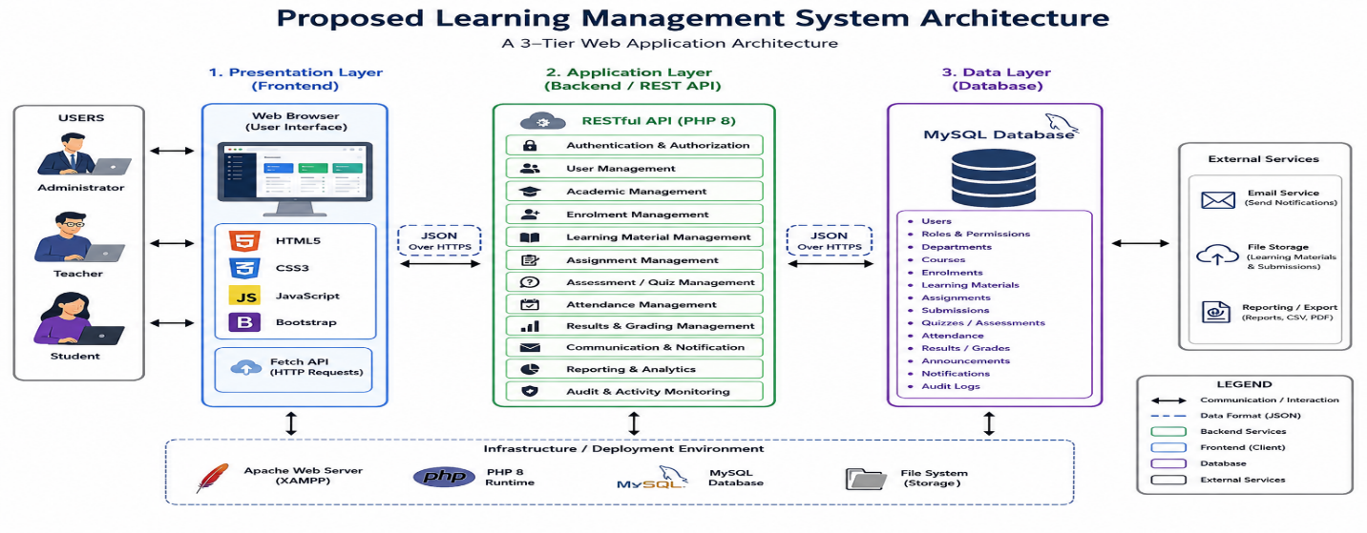
4.4 Use Case Design
The use case design describes the interactions between the users of the proposed School Learning Management System and the functions provided by the system. It identifies the major actors, their responsibilities, and the activities they can perform within the system. The design is based on the functional requirements presented in Chapter Three and focuses on the major roles supported by the proposed LMS.
The principal actors identified for the system are Administrator, Teacher, and Student. Each actor is assigned specific permissions according to their responsibilities within the academic environment. Role-based access ensures that users can access only the functions relevant to their roles.
4.4.1 Administrator
The Administrator is responsible for the overall management and administration of the Learning Management System. The administrator can log into the system, manage user accounts, manage departments and courses, configure academic years or sessions, monitor system activities, generate reports, and manage system settings.
The major administrator uses cases include:
- Login and logout.
- Manage user accounts.
- Manage user roles and permissions.
- Manage departments.
- Manage courses.
- Manage academic years and sessions.
- View and generate academic reports.
- Monitor system activities and audit logs.
- Manage system settings.
- Manage system backup and related administrative functions.
4.4.2 Teacher
The Teacher interacts with the system primarily to manage teaching, learning, assessment, and student academic activities. Teachers can access assigned courses, upload learning materials, create assignments and quizzes, record attendance, assess students, enter grades, and communicate academic information.
The major teacher use cases include:
- Login and logout.
- Access assigned courses.
- Upload and manage learning materials.
- Create and manage assignments.
- Create and manage quizzes.
- Record student attendance.
- Grade assignments and assessments.
- View student performance.
- Publish announcements.
- Communicate with students.
- View relevant academic reports.
4.4.3 Student
The student uses the system to access learning resources and participate in academic activities. Students can access courses in which they are enrolled, view or download learning materials, submit assignments, take quizzes, monitor attendance, view grades, and receive academic notifications.
The major student use cases include:
- Login and logout.
- Access enrolled courses.
- View and download learning materials.
- Submit assignments.
- Take quizzes and assessments.
- View assignment results and grades.
- View attendance information.
- Receive announcements and notifications.
- Access relevant academic information.
4.4.4 Use Case Diagram
The use case design presented in Chapter Three provided the functional basis for implementing the proposed School Learning Management System. In Chapter Four, the emphasis is placed on the implementation outcomes and the impact of the developed system rather than reproducing the use case diagram.
The implemented system provides separate functionality for administrators, teachers, and students according to their assigned roles. Authentication and authorisation mechanisms ensure that users are directed to the appropriate system functions after successful login.
Administrator functionality: The administrator can manage users, courses, departments, academic sessions, system settings, reports, and other administrative activities. This centralises administrative operations and reduces the need to maintain separate records for different academic activities.
Teacher functionality: Teachers can access assigned courses, upload learning materials, create assignments and quizzes, record attendance, assess student work, and manage academic performance information. These functions reduce manual processing and improve the organisation of teaching and assessment activities.
Student functionality: Students can access their courses and learning materials, submit assignments, participate in quizzes, view grades, monitor attendance information, and receive academic notifications. This provides students with more direct and timely access to their academic information.
The implementation of these use cases demonstrates the practical impact of the proposed system. Academic activities that previously depended on paper records, spreadsheets, separate communication channels, and repeated manual processing can be performed through a centralised web-based platform. This improves accessibility, reduces duplication of effort, supports more efficient information management, and provides authorised users with timely access to academic information.
The implemented use cases therefore demonstrate that the proposed Learning Management System provides an integrated platform for supporting administrative, teaching, assessment, attendance, and student-learning activities.
4.4.5 Use Case Description
Use Case | Actor | Description
Login | Administrator, Teacher, Student | Authenticates a user and provides access according to the assigned role.
Manage Users | Administrator | Creates, updates, views, and manages user accounts.
Manage Departments | Administrator | Creates and manages academic departments.
Manage Courses | Administrator, Teacher | Creates, updates, and manages course information according to assigned permissions.
Manage Materials | Teacher | Uploads, updates, and manages learning materials.
Create Assignment | Teacher | Creates assignments and specifies relevant academic requirements and deadlines.
Submit Assignment | Student | Submits completed academic work through the system.
Grade Assignment | Teacher | Reviews student submissions and records grades and feedback.
Manage Quizzes | Teacher | Creates and manages online quizzes and assessments.
Take Quiz | Student | Attempts available quizzes and submits answers for assessment.
Record Attendance | Teacher | Records and manages student attendance for academic activities.
View Grades | Student | Views grades and academic performance information.
Generate Reports | Administrator | Generates academic and administrative reports from stored system data.
Manage Announcements | Teacher, Administrator | Publishes academic or administrative announcements to relevant users.
View Notifications | Teacher, Student | Views system notifications and relevant academic updates.
View Audit Logs | Administrator | Reviews recorded system activities for monitoring and accountability.

The use case design provides a functional representation of how each category of user interacts with the proposed LMS. It also establishes the basis for the subsequent module implementation and testing presented later in this chapter.
4.5 Database Design
The proposed School Learning Management System uses MySQL as its relational database management system. The database was designed to provide a centralised and structured repository for storing, managing, and retrieving academic and administrative information. It supports the major functions of the system, including user management, course management, enrolment, learning materials, assignments, assessments, attendance, results, communication, notifications, and system activity monitoring.
The database design follows a relational approach in which information is organised into related tables. Each table represents a specific entity or functional area of the system, while relationships between tables are established using primary keys and foreign keys. This approach reduces unnecessary duplication of data and supports consistent storage and retrieval of information.
4.5.1 Database Structure
The database is organised into several functional groups that correspond to the major modules of the LMS. These include:
- User and Security Management: stores user accounts, roles, permissions, authentication-related information, and system activity records.
- Academic Management: stores departments, academic years, sessions, courses, and related academic information.
- Enrolment Management: maintains information about students and their enrolment in courses.
- Learning Material Management: stores information about uploaded course materials and their association with courses.
- Assignment Management: manages assignments, submission records, deadlines, grades, and feedback.
- Assessment and Quiz Management: stores quizzes, questions, student attempts, and assessment results.
- Attendance Management: maintains student attendance records for relevant courses and academic activities.
- Results Management: stores student grades, performance records, and related academic results.
- Communication Management: supports announcements, notifications, messages, and other communication activities.
- Audit and Activity Management: records relevant user and system activities for monitoring and accountability.
The relationships among these entities allow information to be shared across different modules without requiring the same information to be repeatedly stored.
4.5.2 Primary and Foreign Keys
Primary keys are used to uniquely identify records within individual tables. For example, a user record is identified by a unique user identifier, while courses, assignments, materials, and submissions have their own unique identifiers.
Foreign keys establish relationships between related tables. For example, a course record can be associated with a teacher or department, while an assignment can be associated with a particular course. Similarly, assignment submissions can be associated with both the relevant assignment and the student who submitted the work.
The use of primary and foreign keys helps maintain referential integrity and ensures that relationships between academic records remain consistent.
4.5.3 Database Normalisation
The database is designed using relational database principles and follows normalisation practices to reduce data redundancy and improve data integrity. The design aims to organise information so that each table represents a logical entity and attributes are stored in appropriate tables.
The database design considers Third Normal Form (3NF), where appropriate, to minimise unnecessary duplication and ensure that non-key attributes depend on the appropriate primary key. This improves maintainability and reduces inconsistencies when records are inserted, updated, or deleted.
4.5.4 Database Relationships
The major relationships within the proposed LMS include:
- A user can have an assigned role that determines the functions available to the user.
- A department can be associated with multiple courses.
- A teacher can manage or be assigned to multiple courses.
- A student can enrol in multiple courses.
- A course can have multiple enrolled students.
- A course can contain multiple learning materials.
- A course can contain multiple assignments and assessments.
- An assignment can have multiple student submissions.
- A student can submit assignments associated with their enrolled courses.
- A course can have attendance records for participating students.
- A student can have multiple academic results and performance records.
- Users can receive announcements and notifications based on their roles and activities.
These relationships provide the foundation for integrating the different academic functions of the LMS.
4.5.5 Database Security
Database security is an important consideration in the design because the system stores sensitive academic and user information. Direct access to the database is restricted to the backend application, while frontend requests are processed through the RESTful API.
Security measures include authentication and authorisation, role-based access control, input validation, prepared SQL statements, secure password storage, and controlled database access. These measures help protect academic records from unauthorised access, manipulation, and accidental loss.
Regular database backup is also considered to support recovery in the event of hardware failure, software errors, or data loss.
4.5.6 Entity Relationship Diagram
The relationships among the major entities of the proposed Learning Management System are represented using an Entity Relationship Diagram (ERD). The ERD provides a graphical representation of the database entities, their attributes, and the relationships between them.
Figure 4.2 presents the Entity Relationship Diagram of the proposed School Learning Management System. The diagram provides the basis for understanding how the major database entities interact and how academic information flows between the different modules of the system.
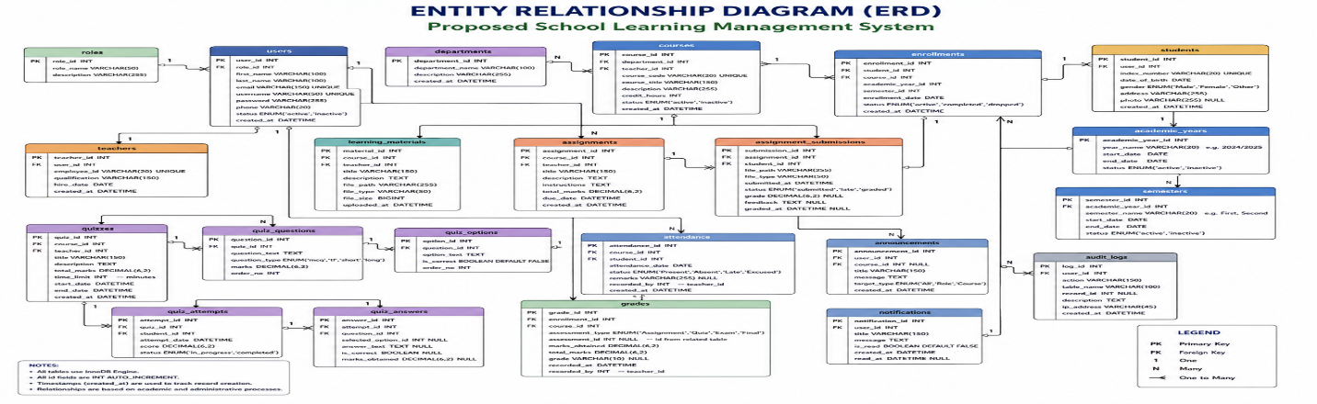
4.6 Data Dictionary
The data dictionary provides a detailed description of the major data elements used in the database of the proposed School Learning Management System. It defines the names, data types, and purposes of important fields used to store and manage information within the system. The data dictionary serves as a reference for understanding the structure of the database and the relationships among its major entities.
The dictionary is organised according to the major functional areas of the LMS, including user management, academic management, learning resources, assignments, assessments, attendance, results, communication, and system monitoring.
4.6.1 User and Security Tables
Table | Field | Data Type | Description
Users | user_id | INT | Unique identifier for a system user.
Users | username | VARCHAR | Unique username used to identify the user.
Users | password | VARCHAR | Securely stored user password hash.
Users | email | VARCHAR | User's email address.
Users | role_id | INT | Identifies the role assigned to the user.
Users | status | VARCHAR | Indicates whether the user account is active or inactive.
Roles | role_id | INT | Unique identifier for a user role.
Roles | role_name | VARCHAR | Name of the assigned system role.
Permissions | permission_id | INT | Unique identifier for a system permission.
Permissions | permission_name | VARCHAR | Defines an action that a user may perform.

4.6.2 Academic Management Tables
Table | Field | Data Type | Description
Departments | department_id | INT | Unique identifier for an academic department.
Departments | department_name | VARCHAR | Name of the academic department.
Academic_Years | academic_year_id | INT | Unique identifier for an academic year.
Academic_Years | year_name | VARCHAR | Name or description of the academic year.
Courses | course_id | INT | Unique identifier for a course.
Courses | course_code | VARCHAR | Unique code assigned to the course.
Courses | course_name | VARCHAR | Name of the course.
Courses | department_id | INT | Identifies the department responsible for the course.
Courses | teacher_id | INT | Identifies the teacher assigned to the course.

4.6.3 Student Enrolment Tables
Table | Field | Data Type | Description
Students | student_id | INT | Unique identifier for a student.
Students | user_id | INT | Links the student record to a user account.
Students | student_number | VARCHAR | Unique identification number assigned to the student.
Enrolments | enrolment_id | INT | Unique identifier for an enrolment record.
Enrolments | student_id | INT | Identifies the student being enrolled.
Enrolments | course_id | INT | Identifies the course in which the student is enrolled.
Enrolments | academic_year_id | INT | Identifies the relevant academic year.

4.6.4 Learning Material Tables
Table | Field | Data Type | Description
Materials | material_id | INT | Unique identifier for a learning material.
Materials | course_id | INT | Identifies the course associated with the material.
Materials | title | VARCHAR | Title of the learning material.
Materials | file_path | VARCHAR | Location of the uploaded material.
Materials | uploaded_by | INT | Identifies the user who uploaded the material.
Materials | created_at | DATETIME | Records when the material was uploaded.

4.6.5 Assignment Tables
Table | Field | Data Type | Description
Assignments | assignment_id | INT | Unique identifier for an assignment.
Assignments | course_id | INT | Identifies the course associated with the assignment.
Assignments | title | VARCHAR | Title of the assignment.
Assignments | description | TEXT | Instructions or description of the assignment.
Assignments | due_date | DATETIME | Specifies the assignment submission deadline.
Assignment_Submissions | submission_id | INT | Unique identifier for a submission.
Assignment_Submissions | assignment_id | INT | Identifies the assignment being submitted.
Assignment_Submissions | student_id | INT | Identifies the student submitting the assignment.
Assignment_Submissions | file_path | VARCHAR | Location of the submitted file.
Assignment_Submissions | grade | DECIMAL | Grade awarded for the submission.
Assignment_Submissions | feedback | TEXT | Feedback provided by the teacher.

4.6.6 Assessment and Quiz Tables
Table | Field | Data Type | Description
Quizzes | quiz_id | INT | Unique identifier for a quiz.
Quizzes | course_id | INT | Identifies the course associated with the quiz.
Quizzes | title | VARCHAR | Title of the quiz.
Quizzes | duration | INT | Duration allocated for completing the quiz.
Quiz_Questions | question_id | INT | Unique identifier for a quiz question.
Quiz_Questions | quiz_id | INT | Identifies the quiz containing the question.
Quiz_Questions | question_text | TEXT | Text of the quiz question.
Quiz_Submissions | submission_id | INT | Unique identifier for a quiz submission.
Quiz_Submissions | quiz_id | INT | Identifies the quiz attempted.
Quiz_Submissions | student_id | INT | Identifies the student attempting the quiz.
Quiz_Submissions | score | DECIMAL | Score obtained by the student.

4.6.7 Attendance Tables
Table | Field | Data Type | Description
Attendance | attendance_id | INT | Unique identifier for an attendance record.
Attendance | student_id | INT | Identifies the student whose attendance is recorded.
Attendance | course_id | INT | Identifies the course associated with the attendance record.
Attendance | attendance_date | DATE | Date on which attendance was recorded.
Attendance | status | VARCHAR | Indicates whether the student was present, absent, or otherwise recorded.

4.6.8 Results and Performance Tables
Table | Field | Data Type | Description
Results | result_id | INT | Unique identifier for an academic result.
Results | student_id | INT | Identifies the student associated with the result.
Results | course_id | INT | Identifies the course associated with the result.
Results | score | DECIMAL | Numerical score obtained by the student.
Results | grade | VARCHAR | Grade assigned based on the student's performance.
Grade_Categories | category_id | INT | Unique identifier for a grade category.
Grade_Categories | category_name | VARCHAR | Name of the grading category.

4.6.9 Communication and Notification Tables
Table | Field | Data Type | Description
Announcements | announcement_id | INT | Unique identifier for an announcement.
Announcements | title | VARCHAR | Title of the announcement.
Announcements | message | TEXT | Content of the announcement.
Announcements | created_by | INT | Identifies the user who created the announcement.
Notifications | notification_id | INT | Unique identifier for a notification.
Notifications | user_id | INT | Identifies the recipient of the notification.
Notifications | message | TEXT | Content of the notification.
Notifications | is_read | BOOLEAN | Indicates whether the notification has been read.

4.6.10 Audit and Activity Tables
Table | Field | Data Type | Description
Audit_Logs | audit_id | INT | Unique identifier for an audit record.
Audit_Logs | user_id | INT | Identifies the user who performed the activity.
Audit_Logs | action | VARCHAR | Describes the action performed by the user.
Audit_Logs | activity_time | DATETIME | Records the date and time of the activity.
Audit_Logs | ip_address | VARCHAR | Records the IP address associated with the activity where applicable.

The data dictionary provides a structured reference for the principal data elements used by the proposed Learning Management System. Primary keys uniquely identify records, while foreign keys establish relationships between related entities. The defined data elements support the implementation of the system's major modules and provide a consistent basis for storing, retrieving, and processing academic and administrative information.
4.7 Input Design
Input design describes how data is entered into the proposed School Learning Management System and how the system validates and processes the information before storing it in the database. The design aims to ensure that data entered by administrators, teachers, and students is accurate, complete, consistent, and appropriate for the intended operation.
The system provides role-specific input forms based on the responsibilities and permissions of each user. The major input areas include user management, academic management, learning materials, assignments, assessments, attendance, results, and communication.
4.7.1 Administrator Input
The Administrator provides information required for managing the overall operation of the LMS. Major administrator input forms include:
- User Registration Form: captures username, name, email address, password, role, and account status.
- Department Form: captures department name and other relevant departmental information.
- Course Form: captures course code, course name, department, teacher assignment, and related course information.
- Academic Session Form: captures academic year, semester, and session information.
- System Settings Form: captures configuration information required for system operation.
- Report Parameters allows administrators to specify criteria such as academic year, course, department, student, or date range when generating reports.
4.7.2 Teacher Input
Teachers provide information required for teaching, assessment, attendance, and student performance management. Major teacher input forms include:
- Course Management Form: captures and updates relevant course information.
- Learning Material Form: allows teachers to provide material titles, descriptions, associated courses, and upload files.
- Assignment Form: captures assignment title, description, course, instructions, maximum marks, and submission deadline.
- Quiz and Assessment Form: captures assessment details, questions, options, correct answers, marks, and other relevant settings.
- Attendance Form: records the attendance status of students for a selected course and date.
- Grading Form: allows teachers to enter marks, grades, and feedback for student submissions.
- Announcement Form: captures announcement titles, messages, target users, and related academic information.
4.7.3 Student Input
Students provide information primarily when participating in learning and assessment activities. Major student input forms include:
- Profile Form allows students to provide or update permitted personal information.
- Assignment Submission Form: allows students to upload completed assignments and provide required submission information.
- Quiz Input allows students to select or enter answers when completing online quizzes.
- Communication Input: allows students to send messages or other permitted academic communication.
- Feedback Input: allows students to provide feedback where the relevant system functionality is available.
4.7.4 Input Validation
Input validation is incorporated into the system to reduce incorrect, incomplete, or potentially harmful data. Validation is performed before information is processed or stored in the database.
The major validation mechanisms include:
- Required fields are checked to ensure that essential information is provided.
- Email addresses are validated using appropriate formats.
- Usernames and other unique identifiers are checked for duplication.
- Password requirements are enforced during account creation or password changes.
- Numerical fields are validated to ensure that appropriate numeric values are entered.
- Dates are validated to ensure that they follow the required format and logical constraints.
- Assignment deadlines are checked against relevant dates.
- Uploaded files are validated according to permitted file types and size restrictions.
- User permissions are checked before restricted operations are processed.
- Database queries use prepared statements to reduce the risk of SQL injection.
4.7.5 Input Processing
After successful validation, the submitted information is sent from the frontend to the appropriate RESTful API endpoint. The backend authenticates and authorises the request before processing the associated business logic. Where database interaction is required, the API performs the appropriate database operation and returns a JSON response to the frontend.
The general input processing sequence is:
User Input → Frontend Form → Validation → HTTP Request → REST API → Authentication/Authorisation → Business Logic → MySQL Database → JSON Response → Updated Interface
This approach ensures that data is processed through the appropriate application layer rather than allowing the frontend to communicate directly with the database.
4.7.6 Input Design Principles
The input interfaces are designed according to the following principles:
- Simplicity: Forms contain only information relevant to the operation being performed.
- Consistency: Similar forms use consistent labels, controls, buttons, and validation messages.
- Accuracy: Validation mechanisms reduce incorrect or invalid data entry.
- Security: Sensitive operations require appropriate authentication and authorisation.
- User feedback: The system displays success, warning, and error messages after user actions.
- Role-based access: Users are presented with input functions appropriate to their assigned roles.
- Usability: Forms are designed to support clear navigation and efficient data entry.
The input design therefore provides a controlled mechanism for capturing information from administrators, teachers, and students while ensuring that submitted data is validated, securely processed, and stored appropriately within the LMS database.
4.8 Output Design
Output design describes how information processed by the proposed School Learning Management System is presented to administrators, teachers, and students. The system converts information stored in the database into meaningful outputs such as dashboards, academic reports, grades, attendance records, notifications, and other system responses. The design aims to ensure that outputs are accurate, relevant, clearly presented, and accessible only to authorised users.
The major outputs of the proposed LMS are described below.
4.8.1 Administrator Outputs
The Administrator receives outputs that support academic and system management. These include:
- Administrator Dashboard: displays summaries of users, courses, departments, academic activities, and other relevant system statistics.
- User Reports: provides information about registered administrators, teachers, and students.
- Course Reports: presents course information, teacher assignments, and enrolment statistics.
- Academic Reports: provides student performance and other academic information based on selected criteria.
- Attendance Reports: summarises student attendance records for selected courses, classes, or periods.
- System Activity Reports: provides information about recorded user and system activities.
- Audit Logs displays relevant activities performed by users for monitoring and accountability.
- Notifications: informs administrators about relevant system and academic events.
4.8.2 Teacher Outputs
Teachers receive outputs that support teaching, assessment, attendance, and student performance management. These include:
- Teacher Dashboard: provides an overview of assigned courses, students, assignments, assessments, and other teaching activities.
- Course Information: displays course details and enrolled students.
- Learning Material Status: displays uploaded materials and their associated courses.
- Assignment Submissions: provides a list of student submissions and their submission status.
- Grading Results: displays grades and feedback recorded for student submissions.
- Attendance Reports: presents attendance records for students enrolled in a teacher's courses.
- Student Performance Reports: provides information about student academic performance.
- Quiz and Assessment Results: displays student scores and assessment outcomes.
- Announcements: displays published academic announcements and their recipients.
4.8.3 Student Outputs
Students receive outputs that provide access to learning resources and academic information. These include:
- Student Dashboard: displays enrolled courses, pending assignments, upcoming assessments, notifications, and other relevant academic information.
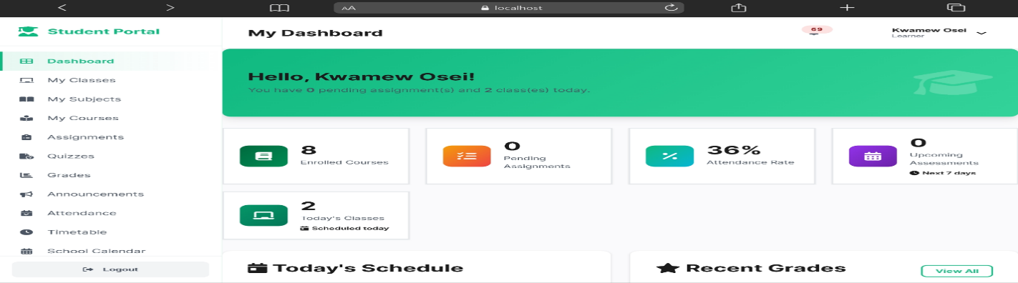
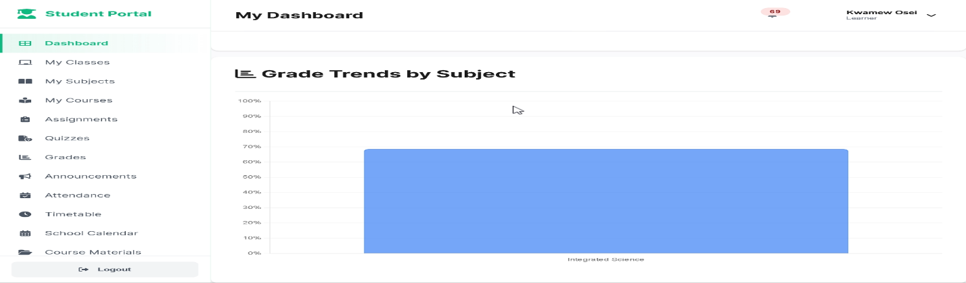
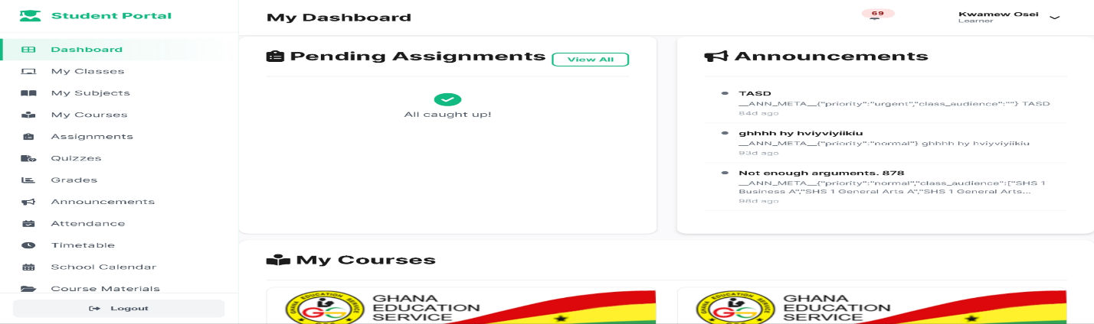
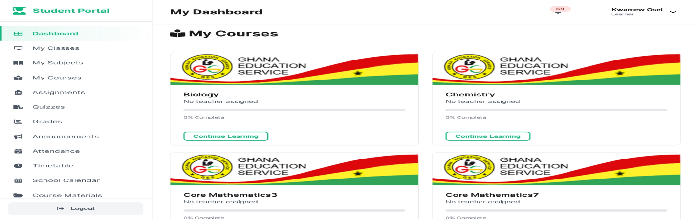
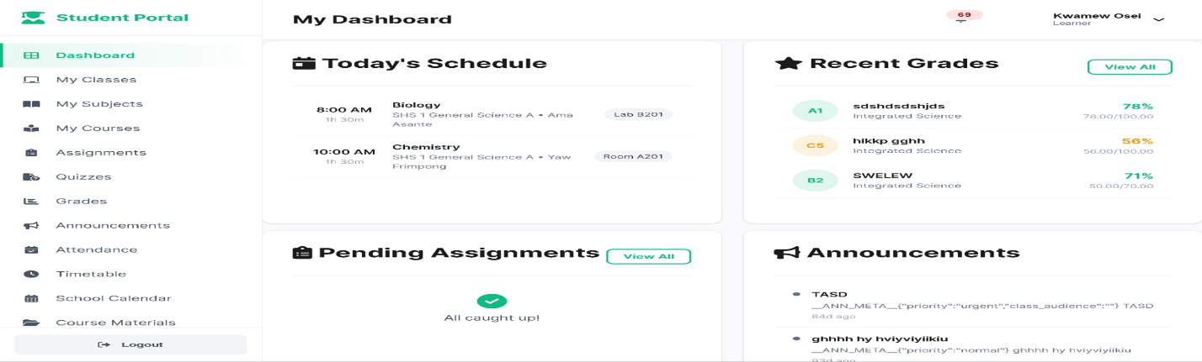
- Course Information: displays courses in which the student is enrolled.
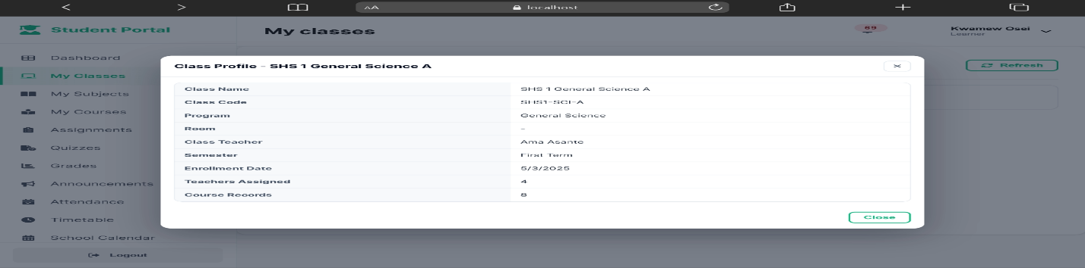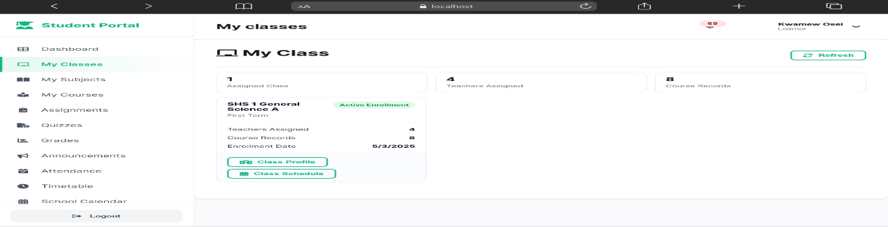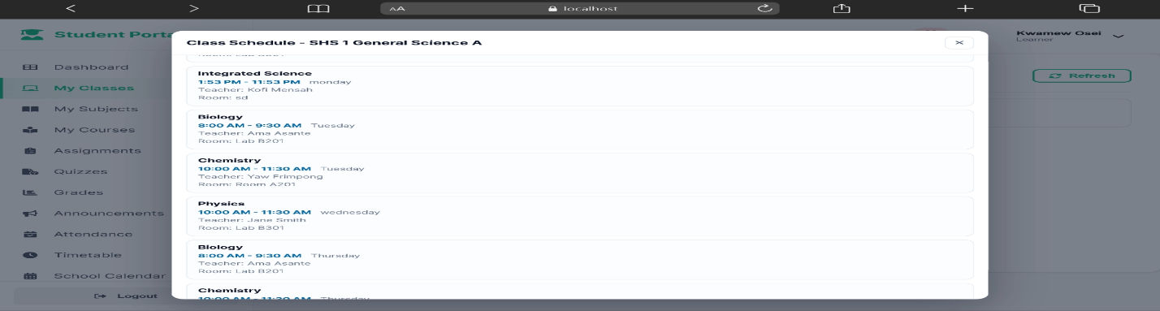
- Learning Materials provides access to available course materials.
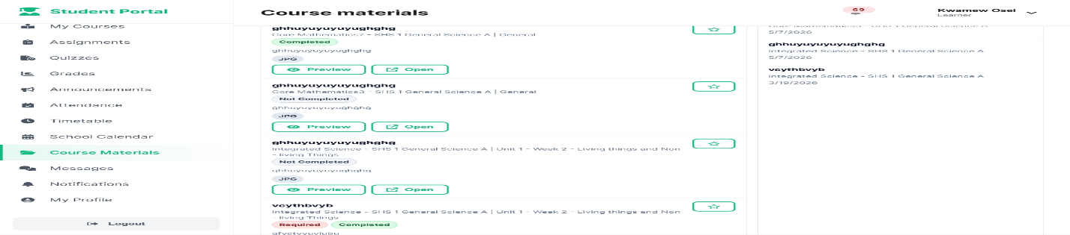

- Assignment Information: displays assignment descriptions, deadlines, submission status, grades, and feedback.
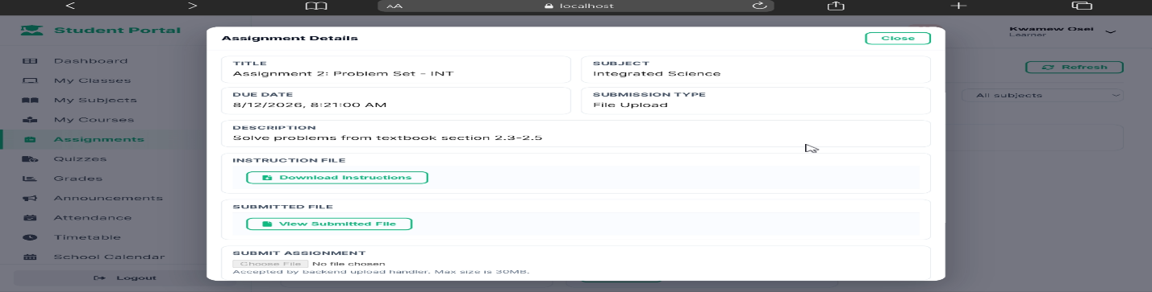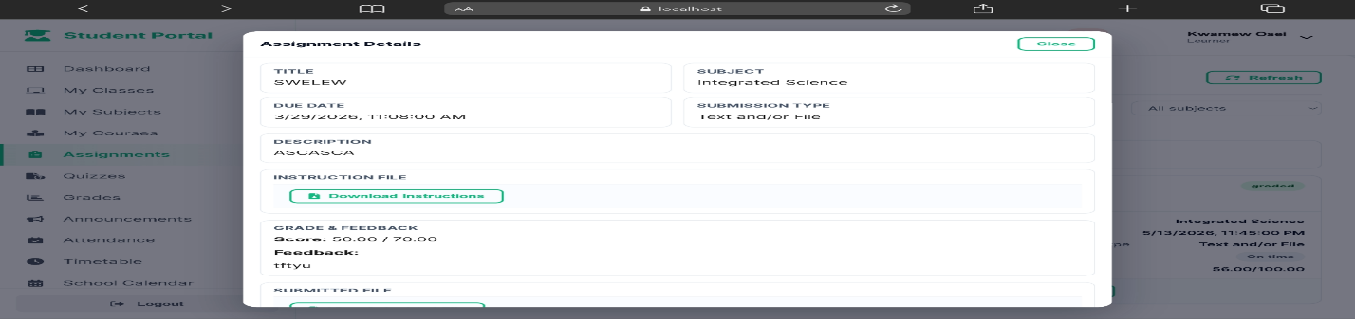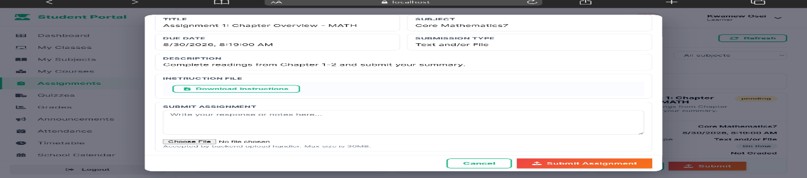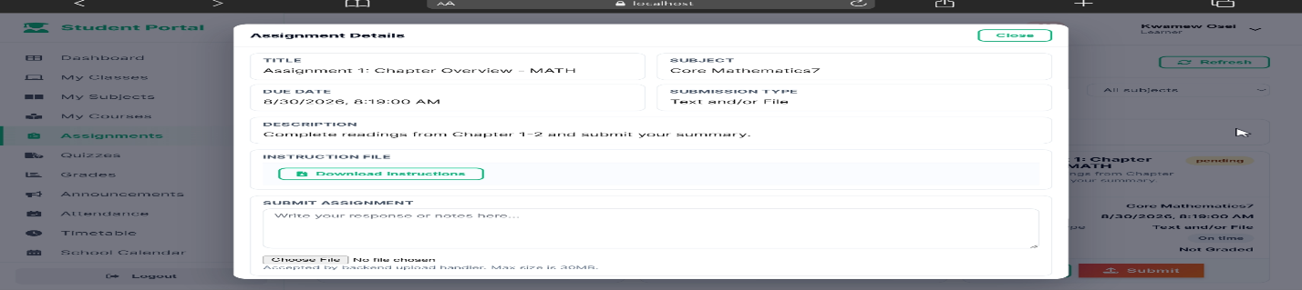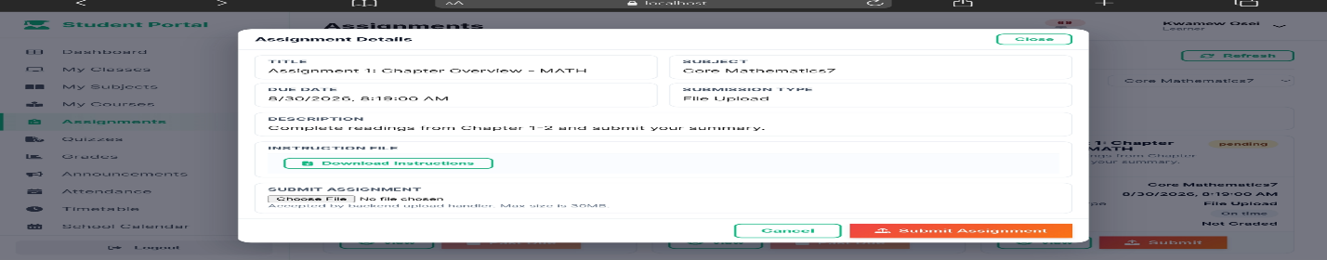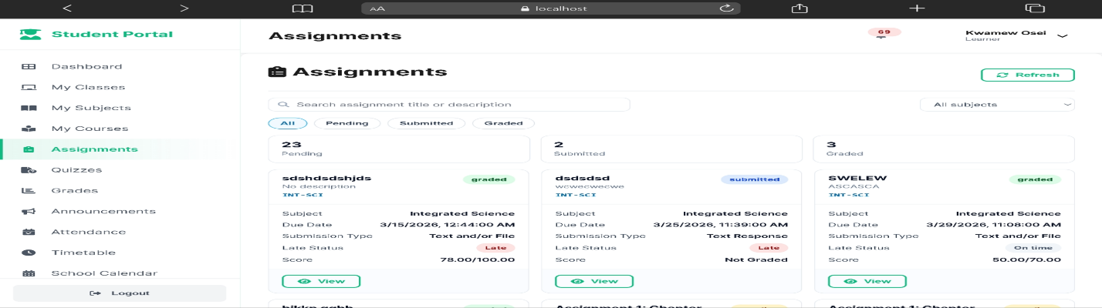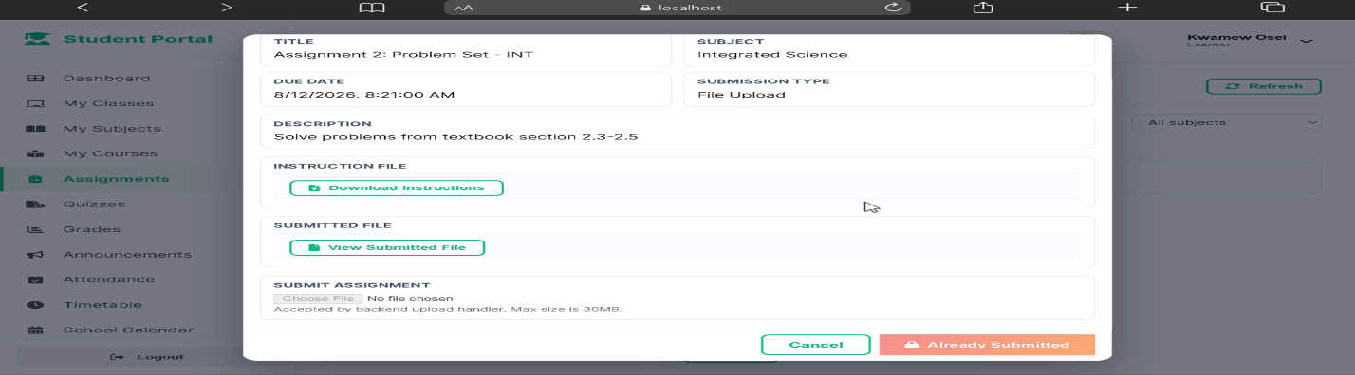
- Quiz Results displays scores and relevant assessment outcomes after completion.
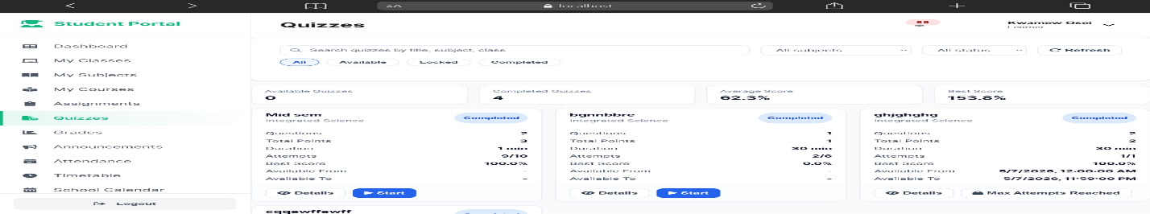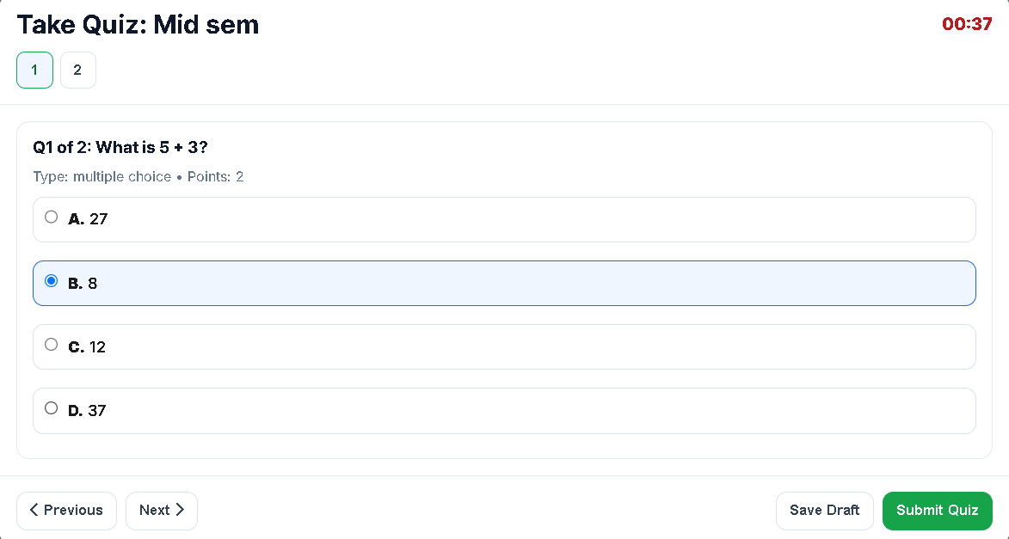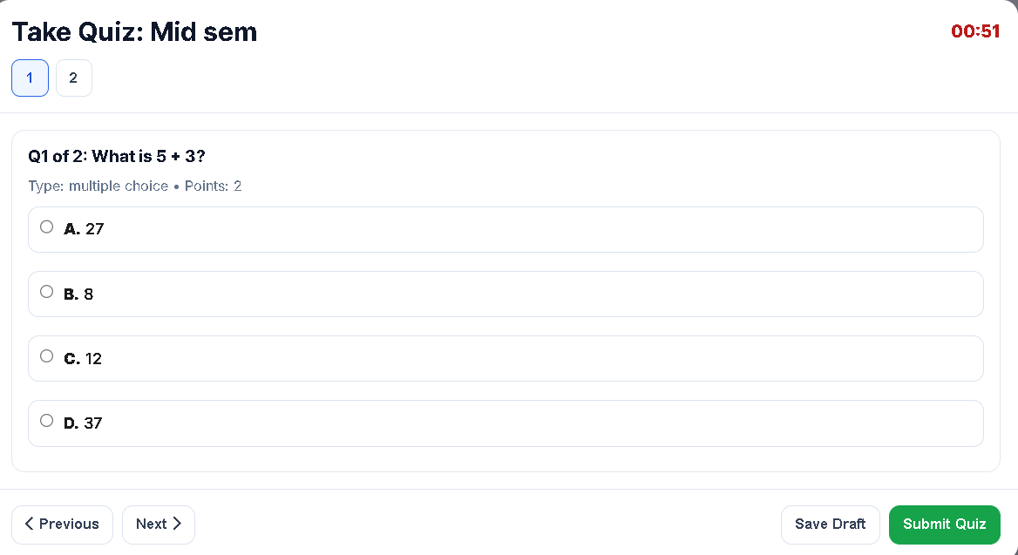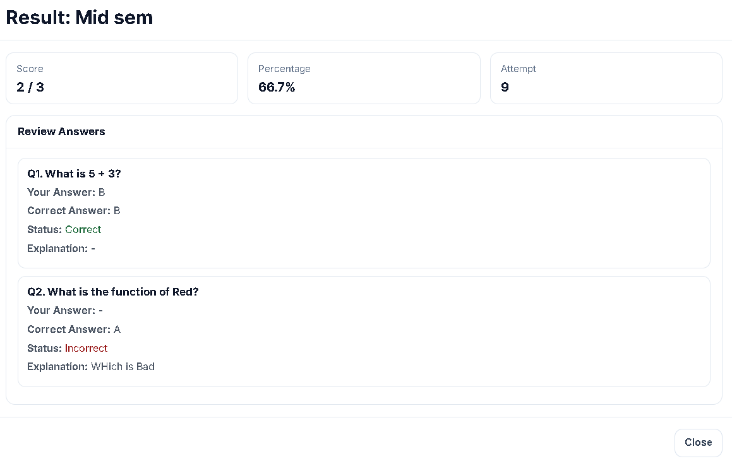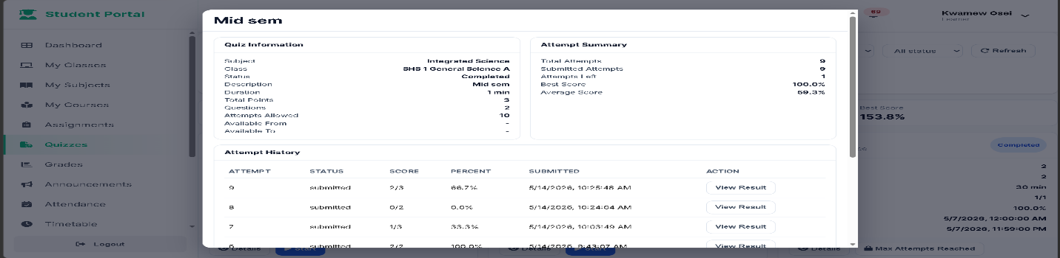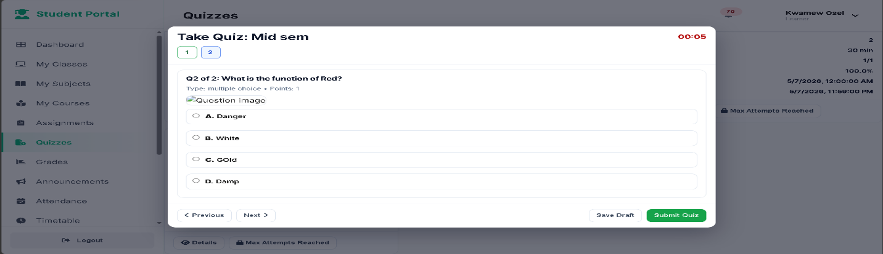
- Attendance Information: allows students to view their recorded attendance where permitted.
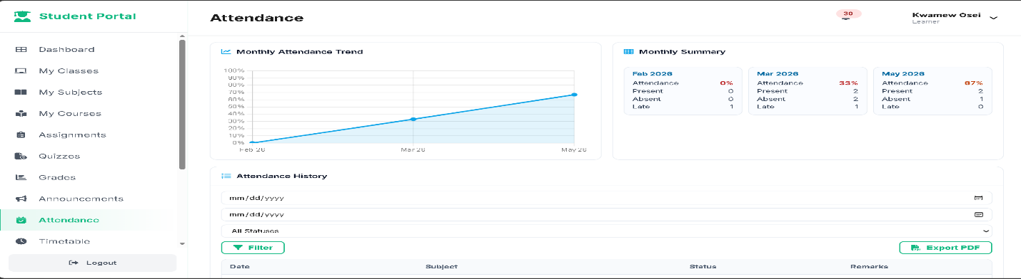
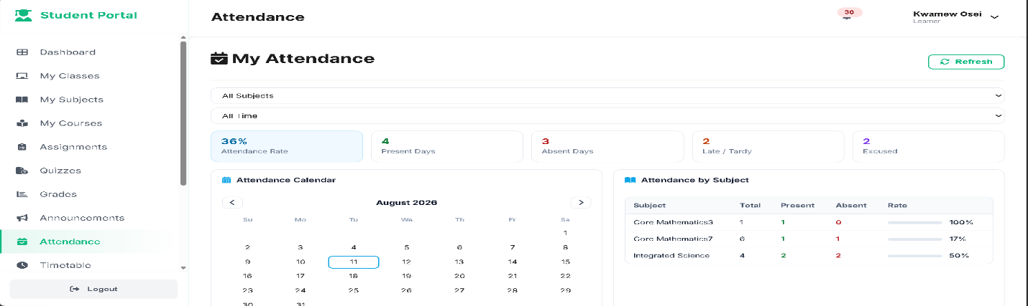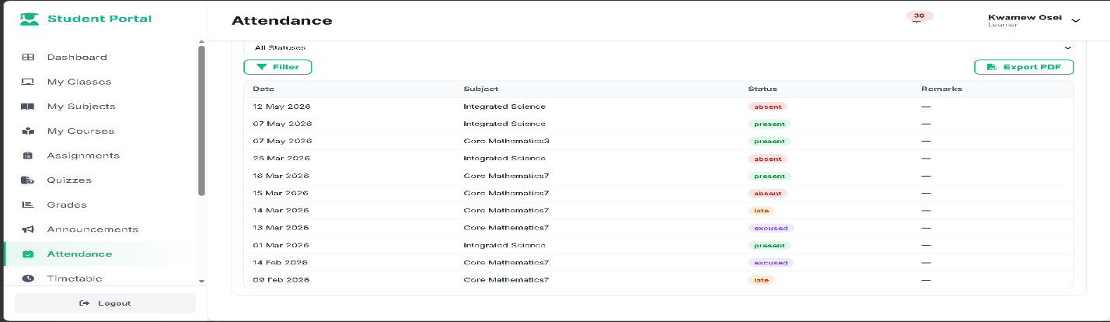
- Academic Results: displays grades and other available performance information.
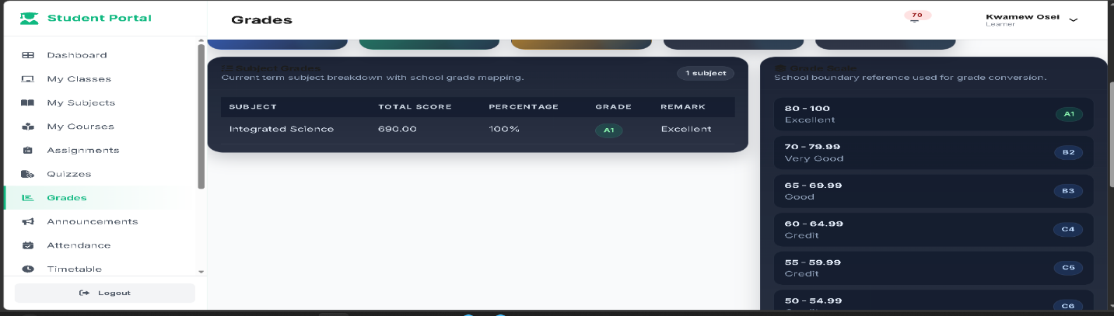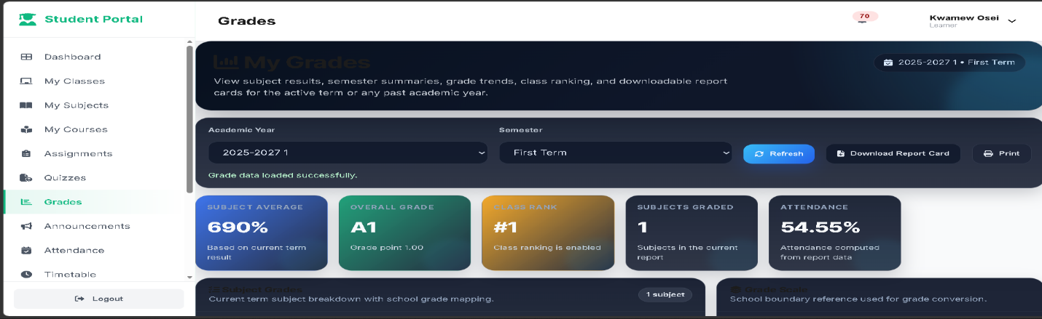
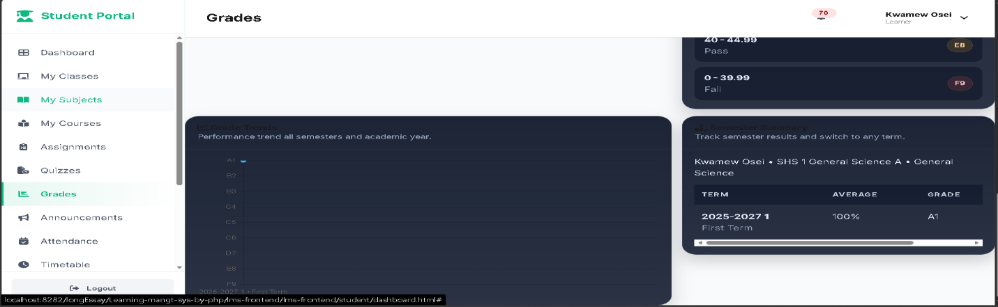
- Notifications: displays announcements, academic reminders, and other relevant system notifications.
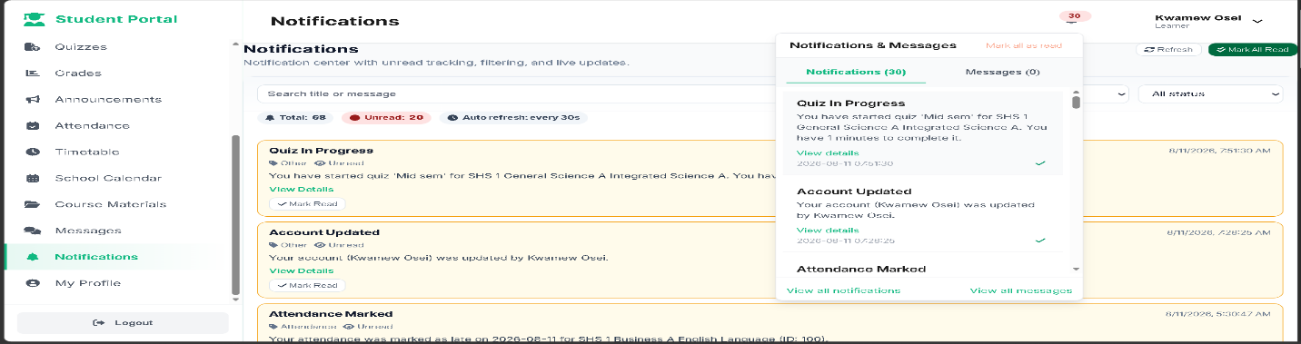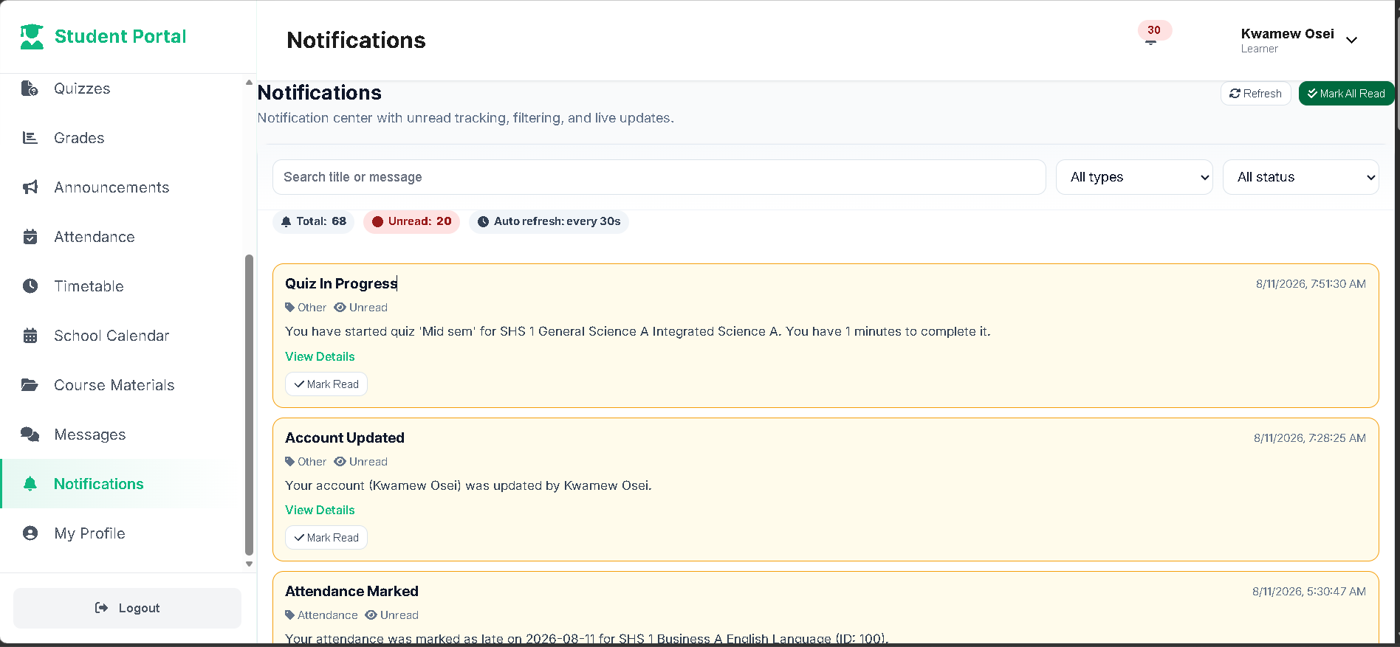
4.8.4 System Messages and API Responses
In addition to dashboards and reports, the system generates immediate responses following user actions. These responses inform users whether an operation was successful or whether an error occurred.
Examples include:
- Successful login messages.

- Invalid login notifications.

- Successful record creation messages.
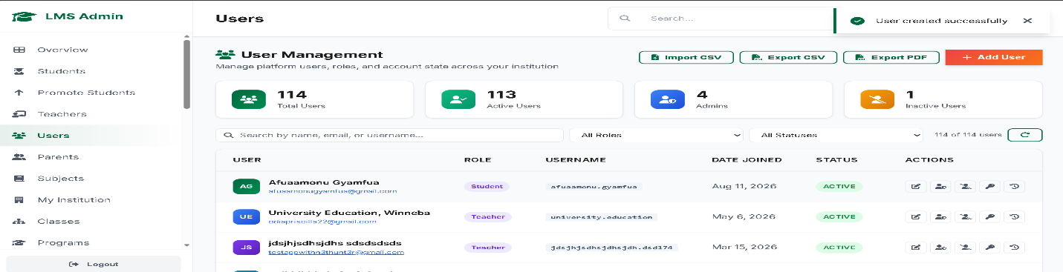
- Validation error messages.
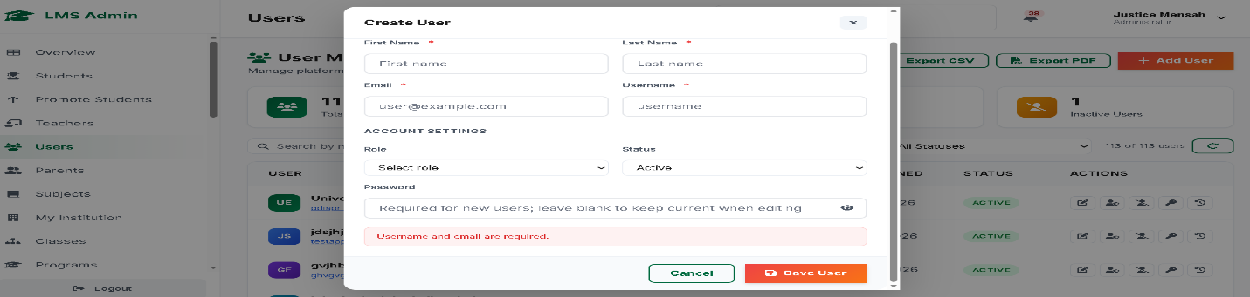
- Successful assignment submission messages.
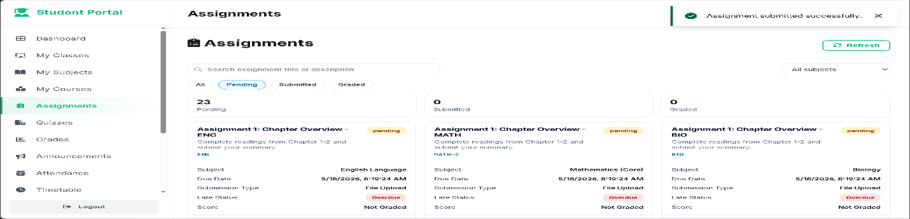
- File upload notifications.
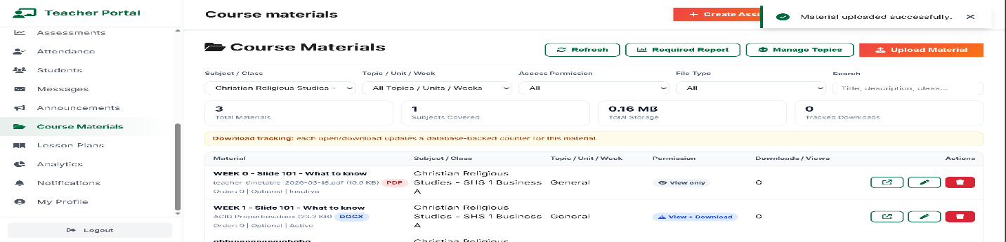
- Access-denied messages.

- Database or server error messages.
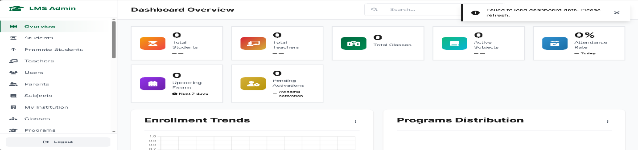
- Successful update and deletion confirmations.
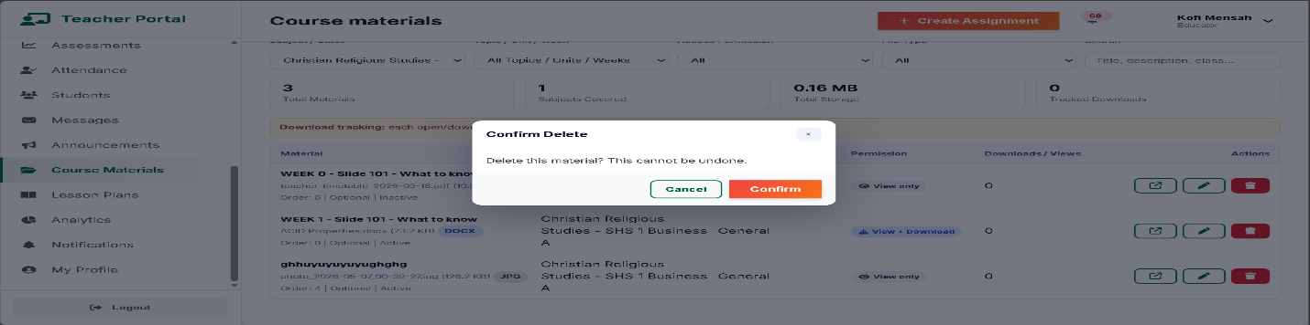
The backend returns these responses to the frontend through the RESTful API using JSON. The frontend interprets the response and presents an appropriate message or updated information to the user.
4.8.5 Report Generation
The LMS provides report outputs based on information stored in the centralised database. Reports may be generated according to relevant criteria such as student, course, department, academic year, or date range.
Major report categories include:
Report | Main User | Purpose
Student Performance Report | Administrator, Teacher | Shows student academic performance.
Attendance Report | Administrator, Teacher | Summarises student attendance.
Course Report | Administrator, Teacher | Provides course and enrolment information.
Assignment Report | Teacher, Administrator | Shows assignment submission and grading information.
Assessment Report | Teacher, Administrator | Presents assessment results and performance.
User Report | Administrator | Provides information about system users.
Activity Report | Administrator | Provides information about recorded system activities.

Figure 4.3 Activity Reports on Automated Report Schedules 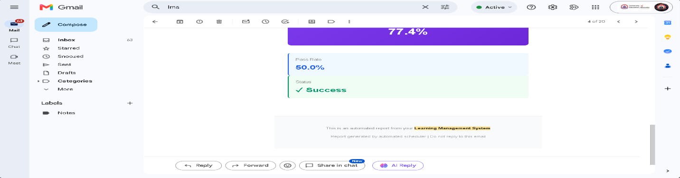
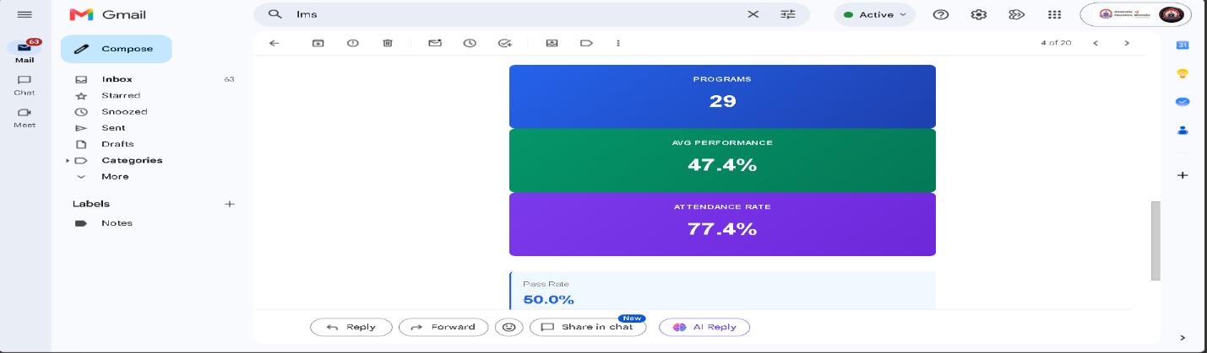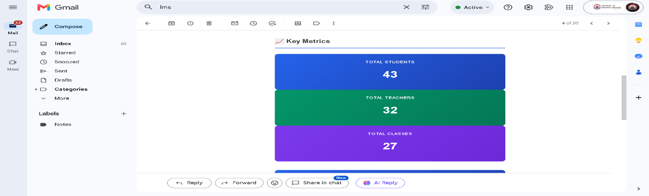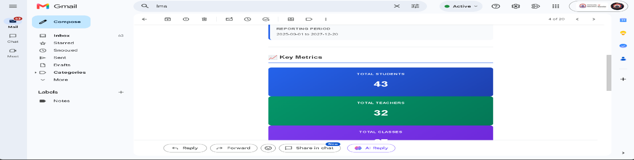
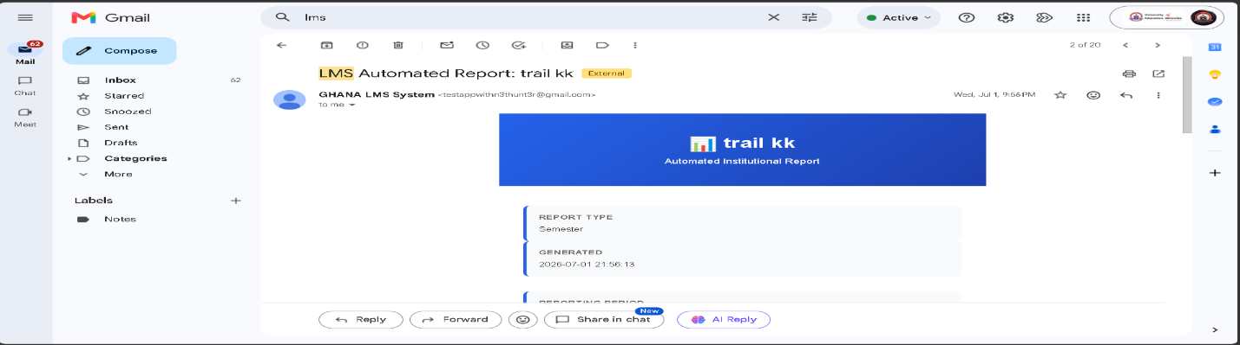
Figure 4.4 Activity Reports on Email sent for Password Reset Request 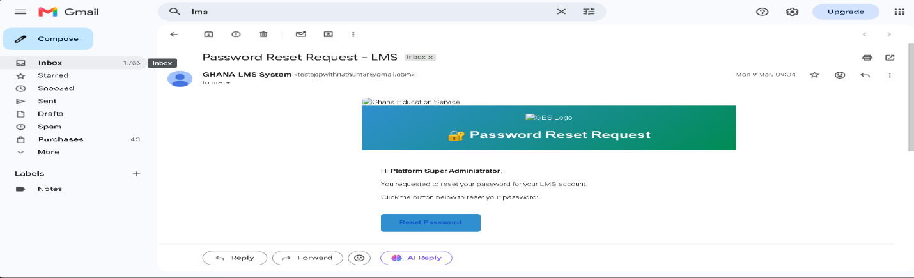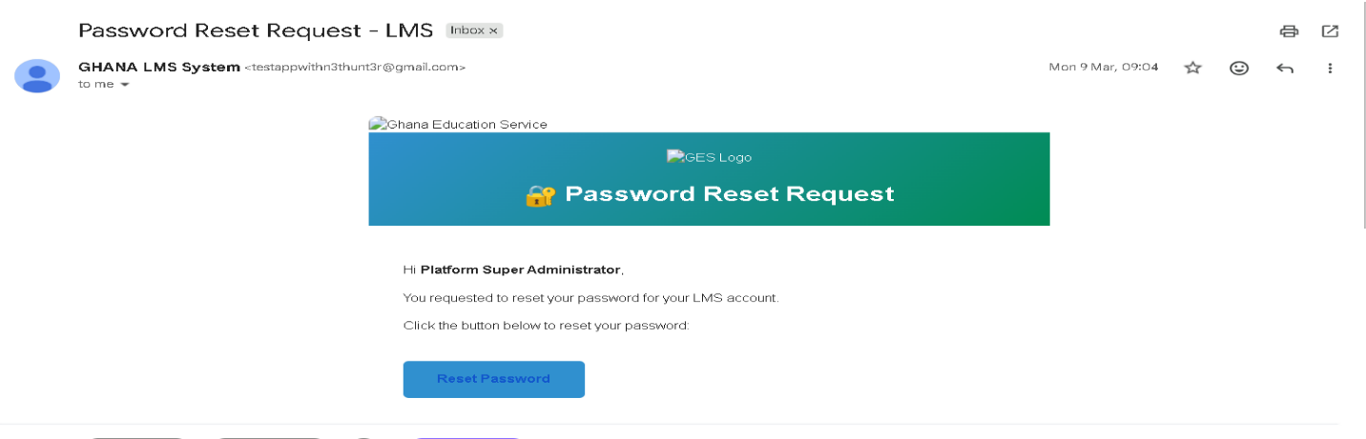
Figure 4.5 Present Report page from Administrator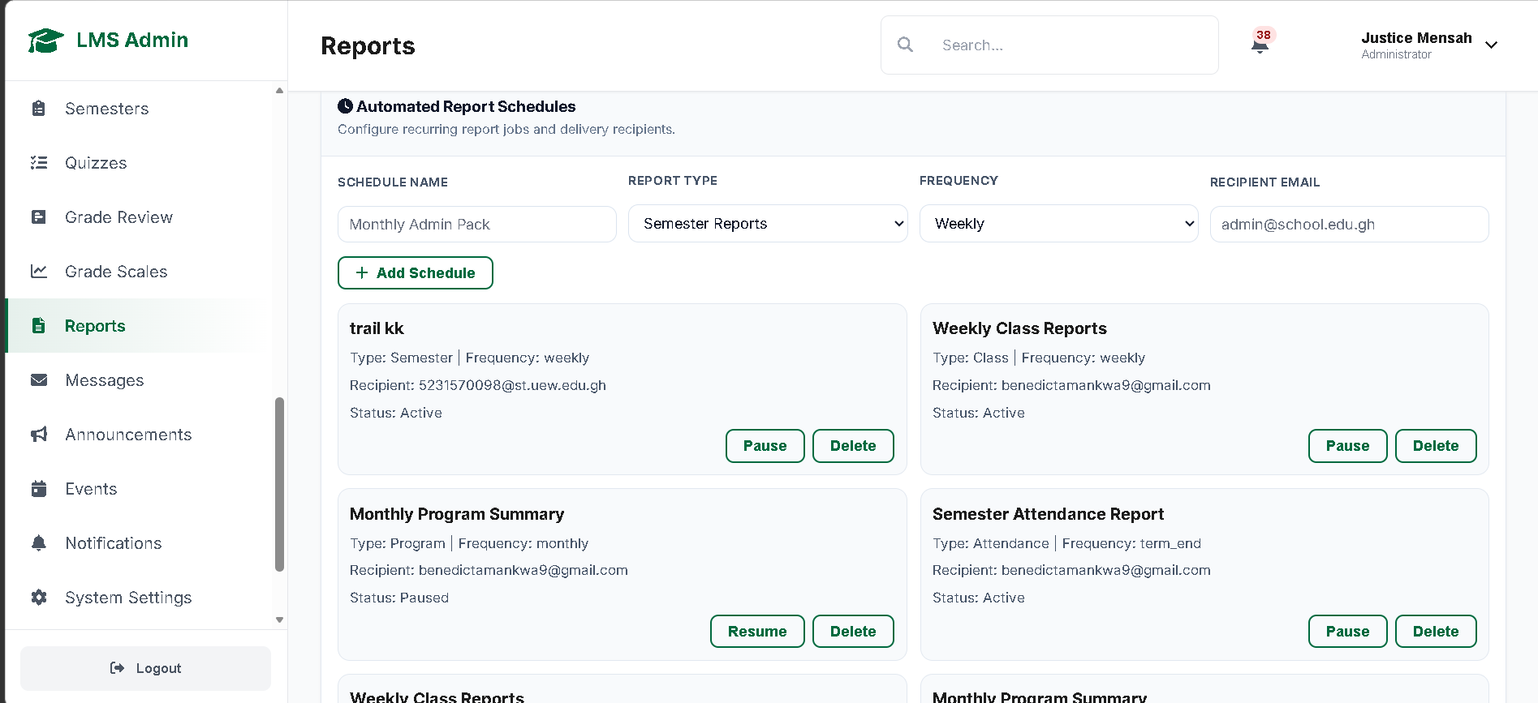

Figure 4.6 Present My Profile page showing User Activity 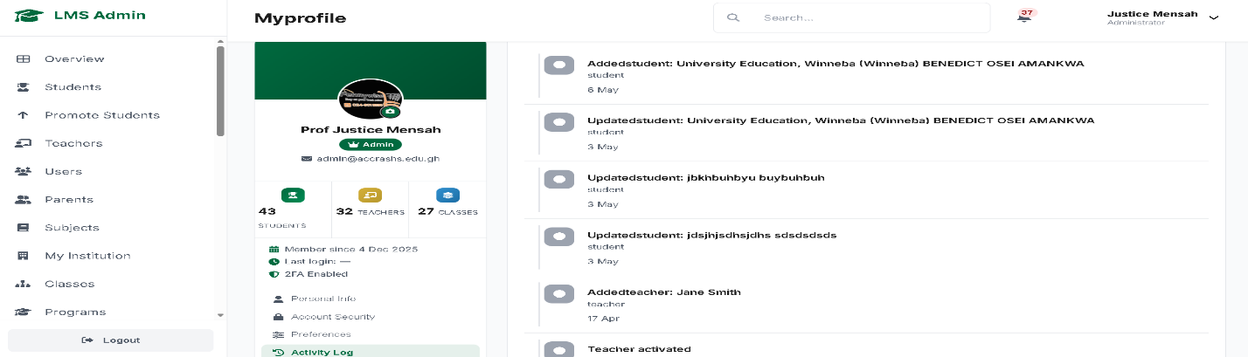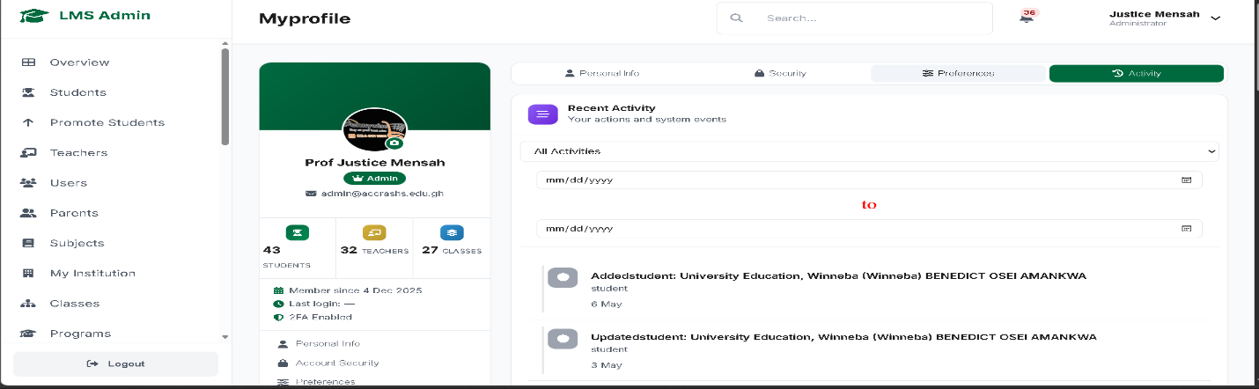
Figure 4.7 Present User Report from Administrator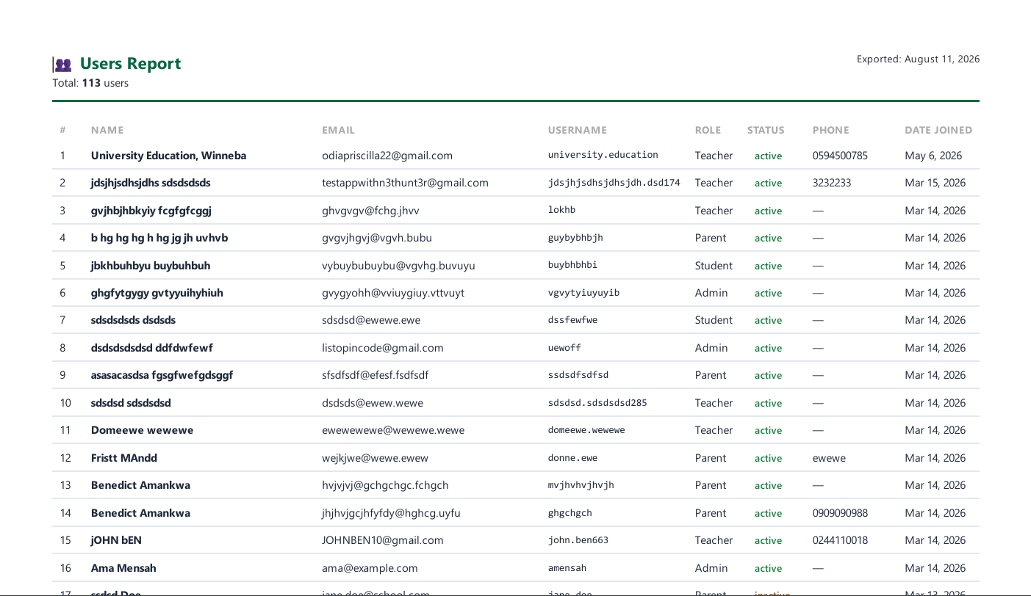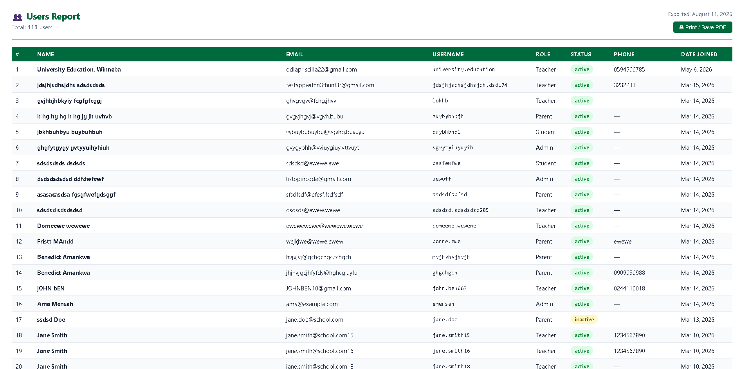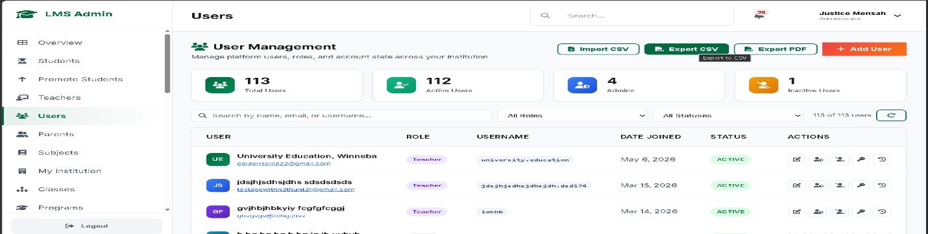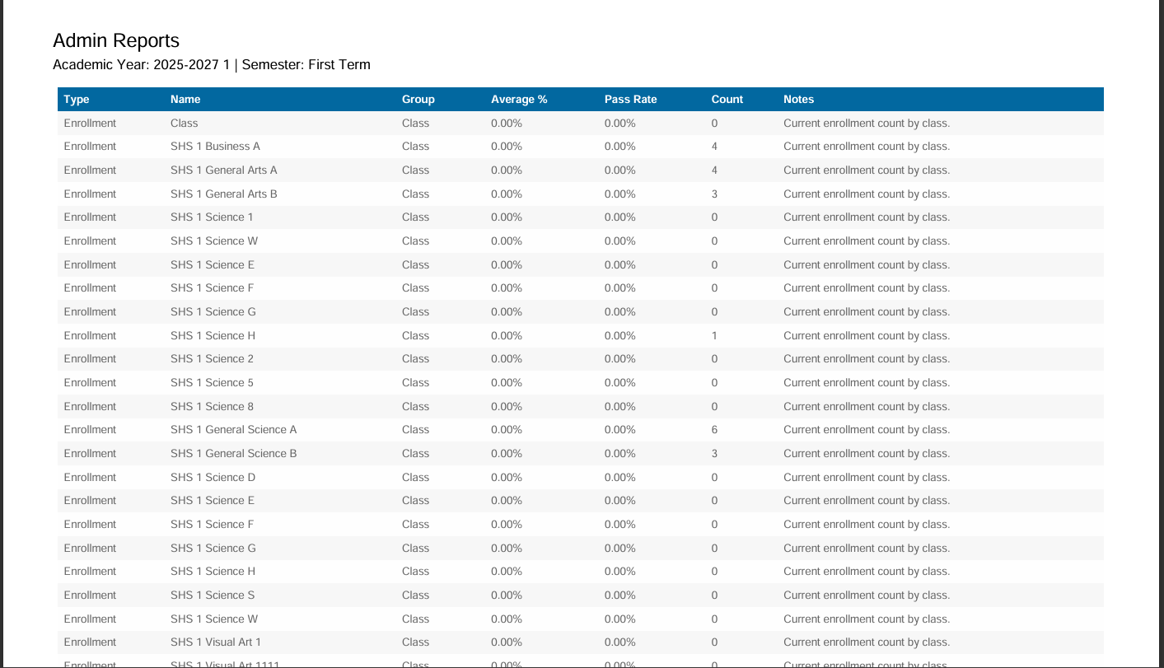
Figure 4.8 Present Employment Report from Administrator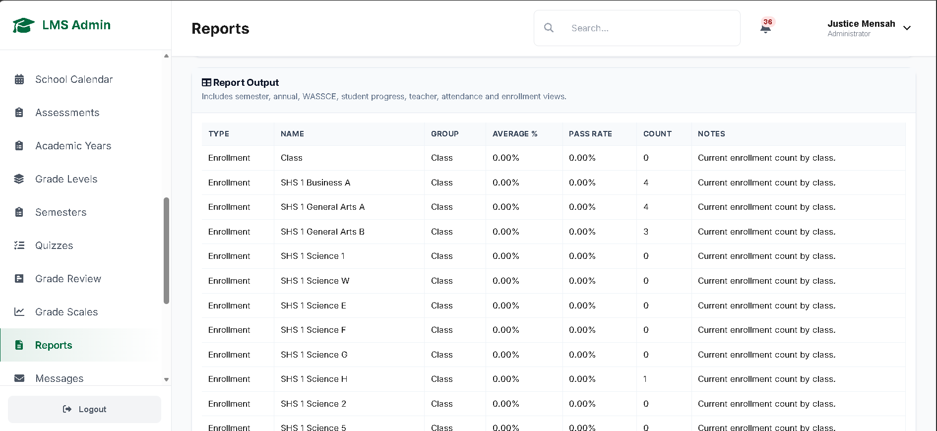
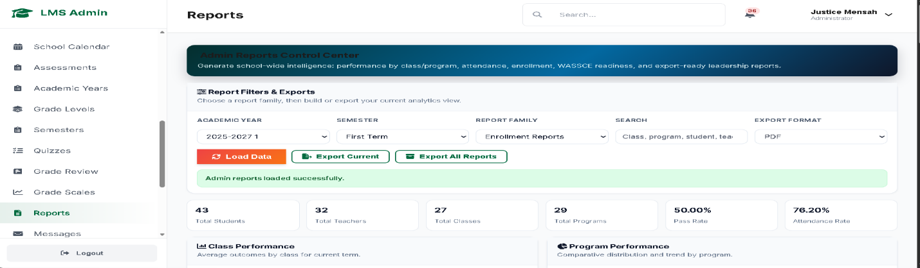
Figure 4.9 Present Assessment Page from Administrator
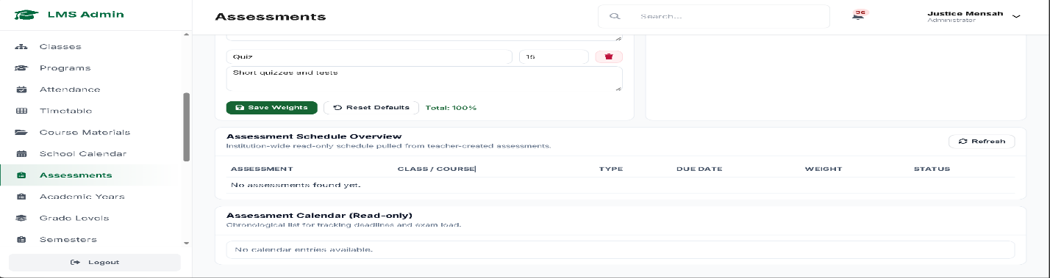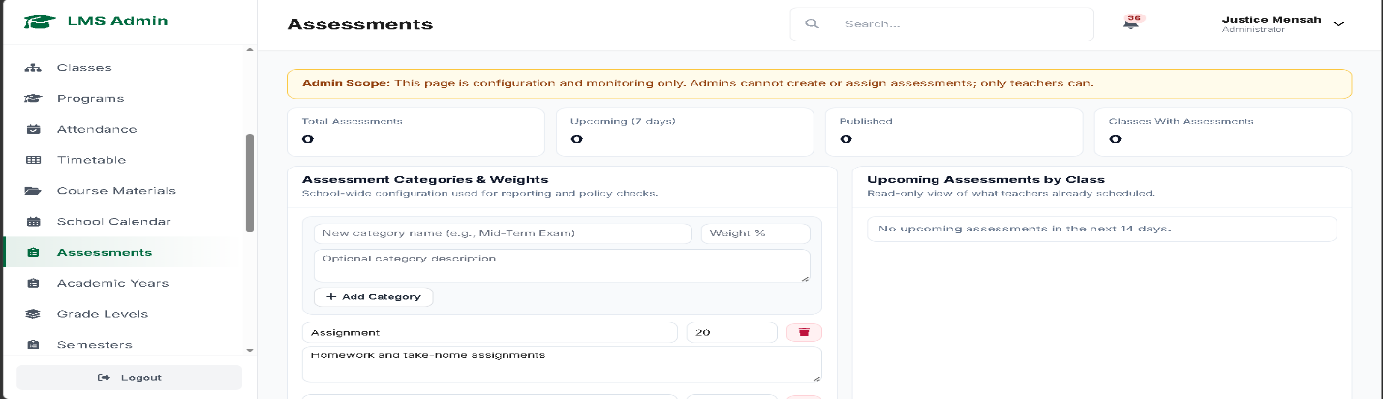
Figure 4.10 Present Assessment Report from Teacher 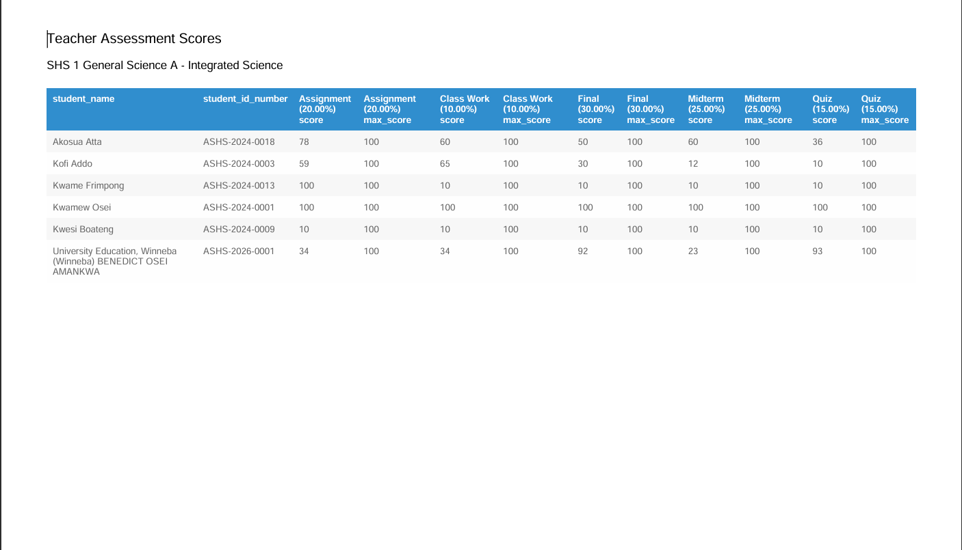
Figure 4.11 Present Assessment Page from Teacher 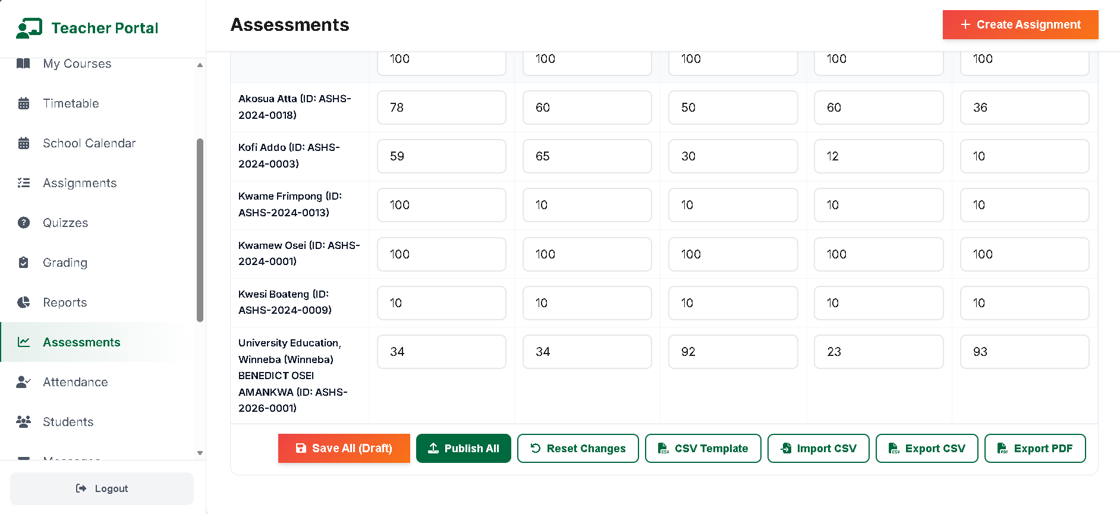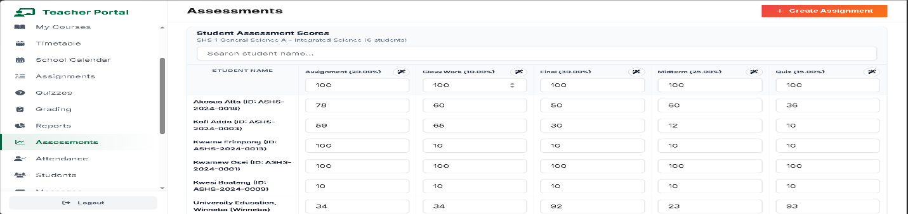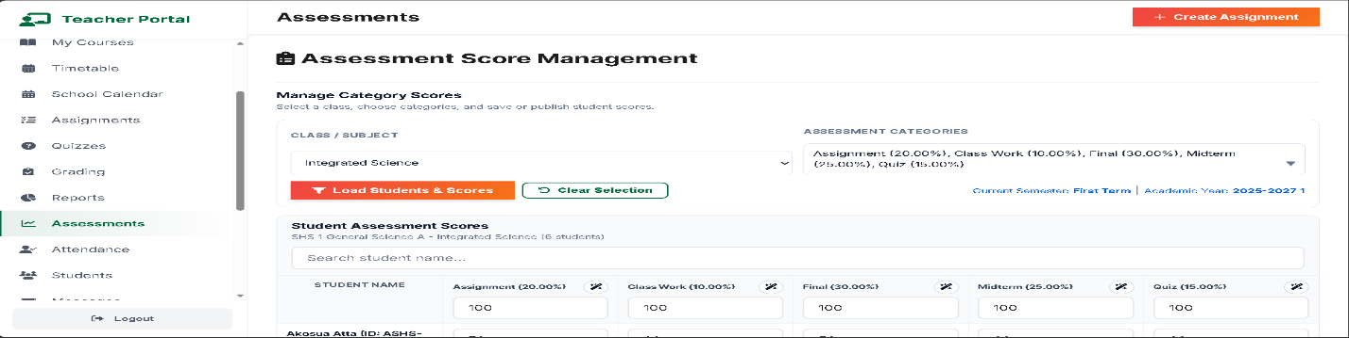
Figure 4.12 Present Subject/Course Page from Administrator 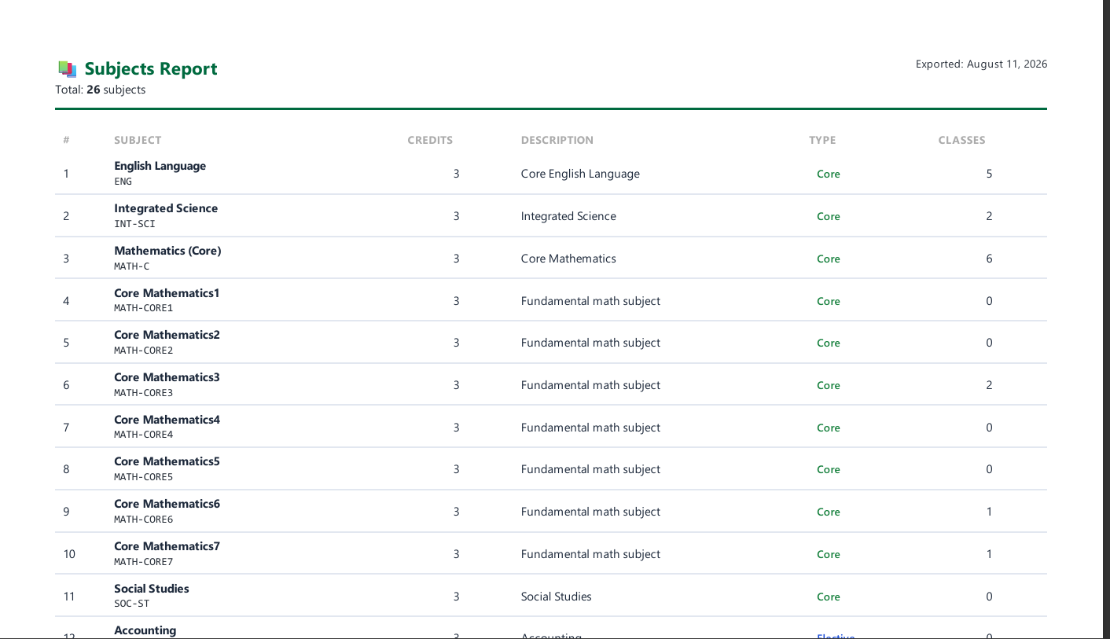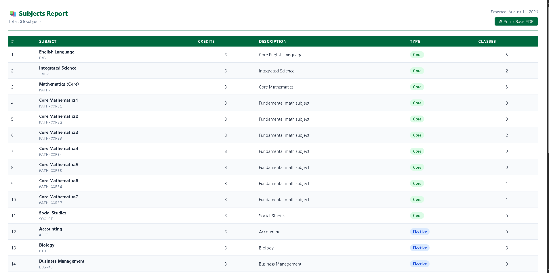
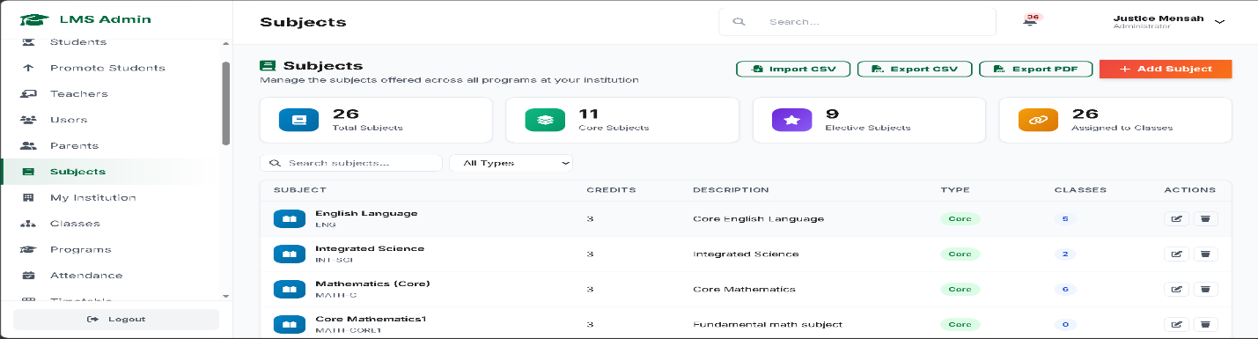
Figure 4.13 Present Attendance Page from Administrator 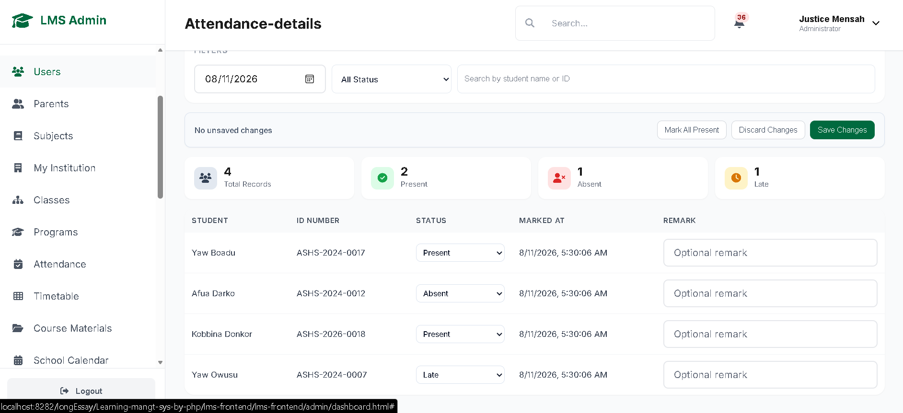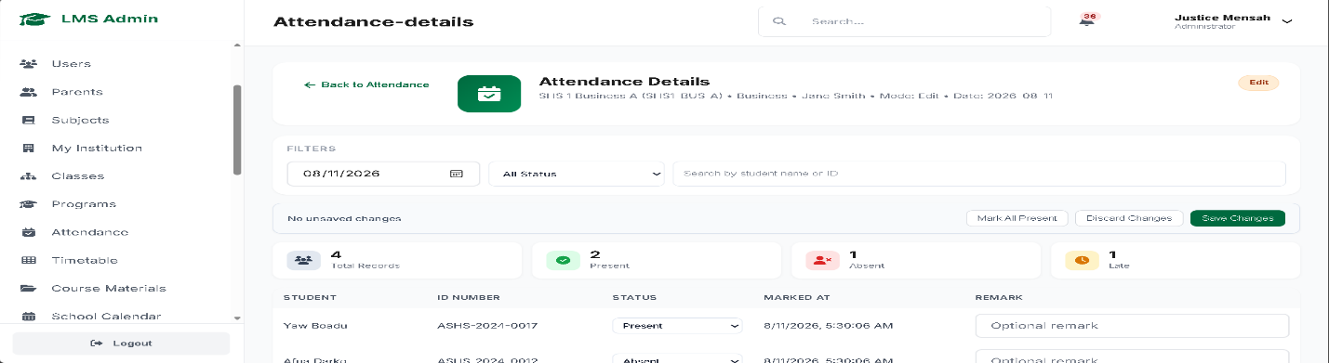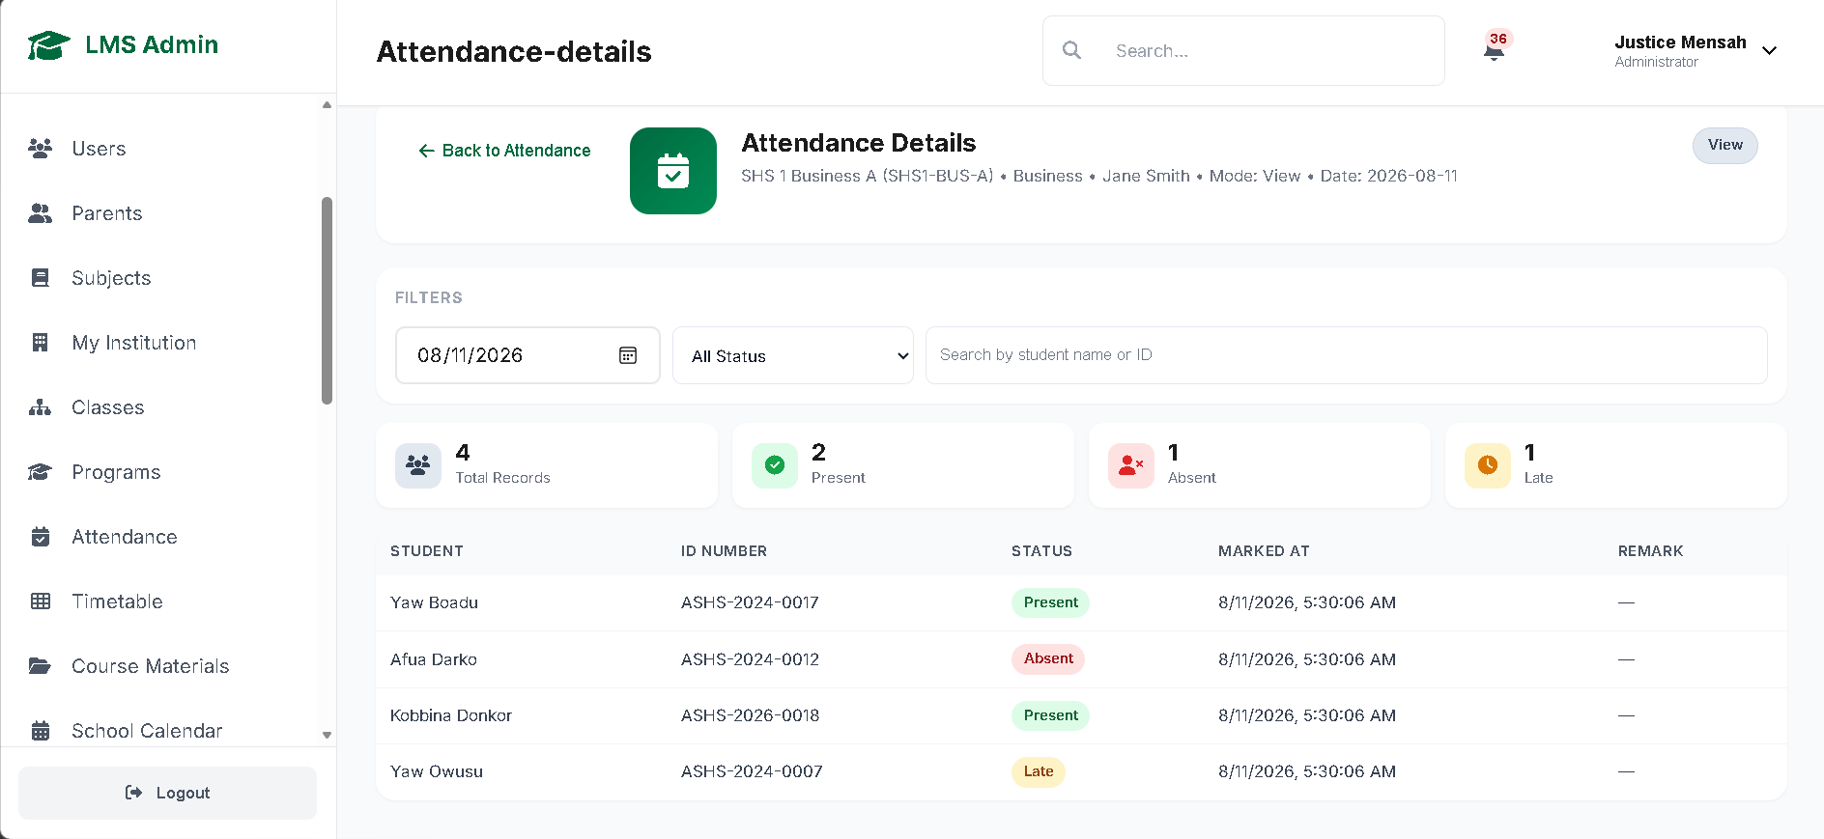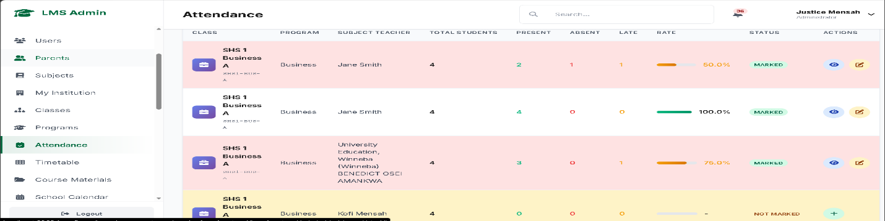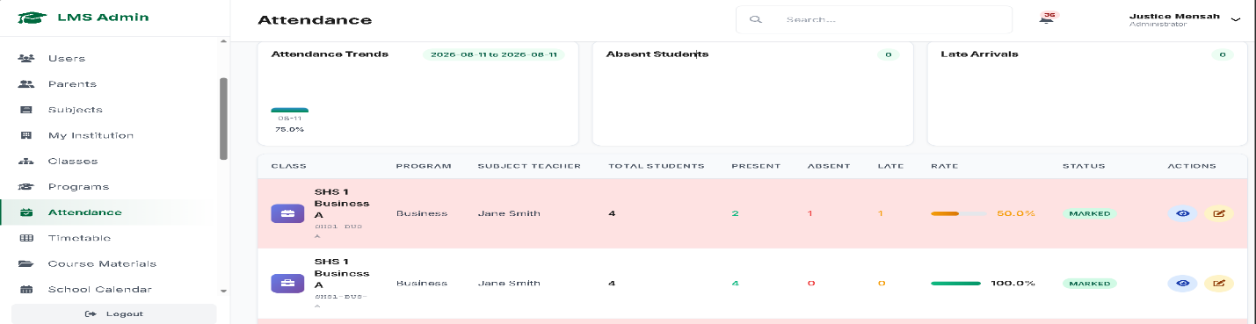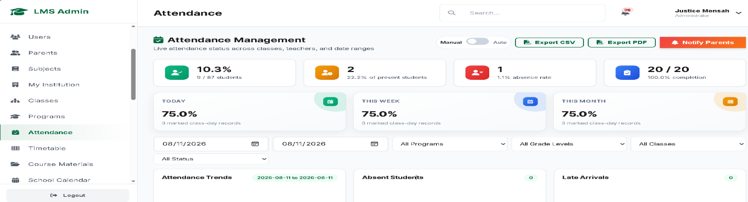
Figure 4.14 Present Attendance Report from Administrator 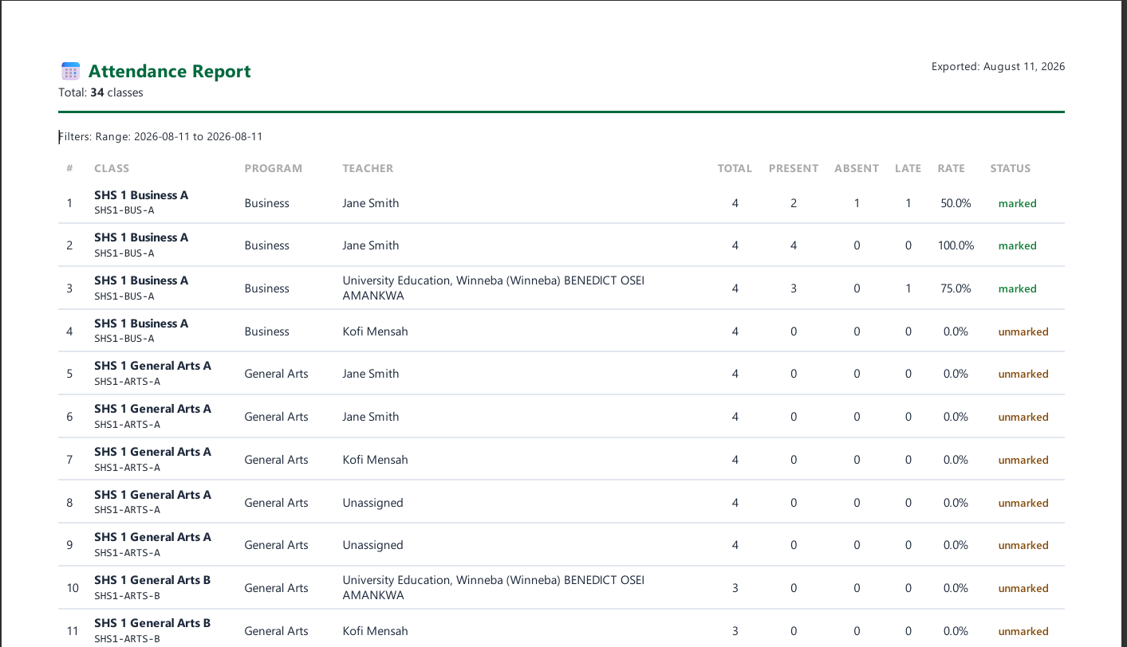
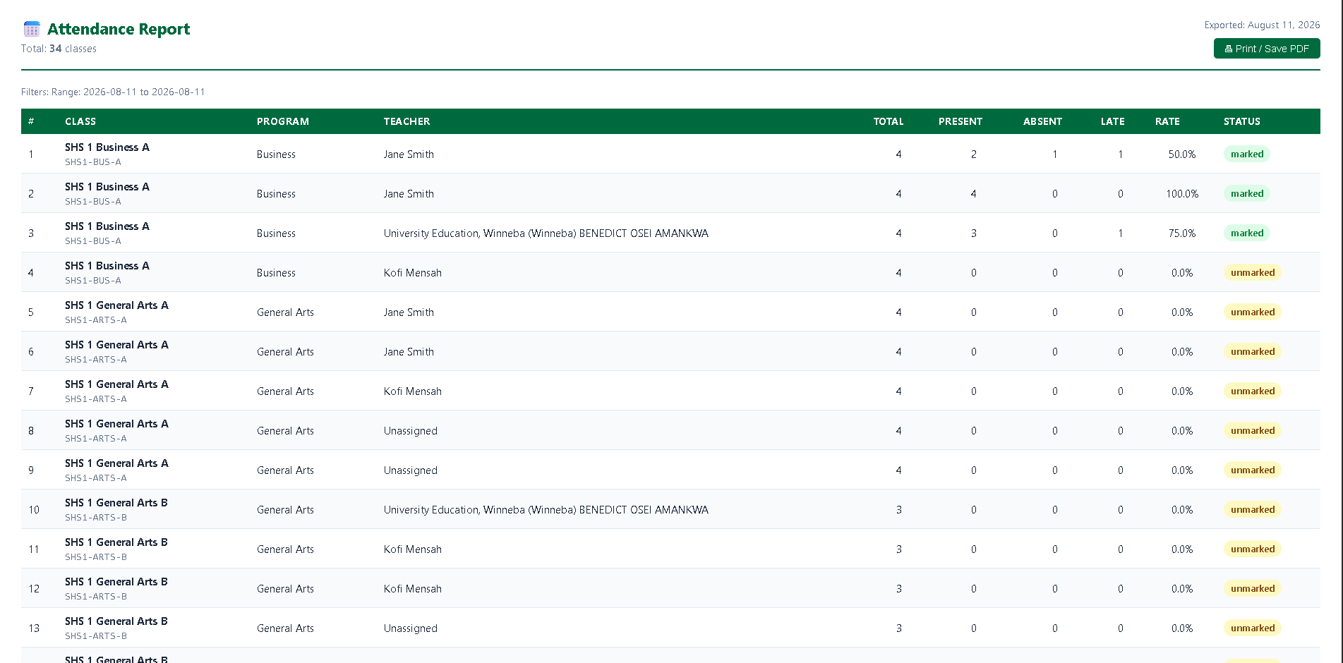
Figure 4.15 Present Assignment Details Page from Teacher 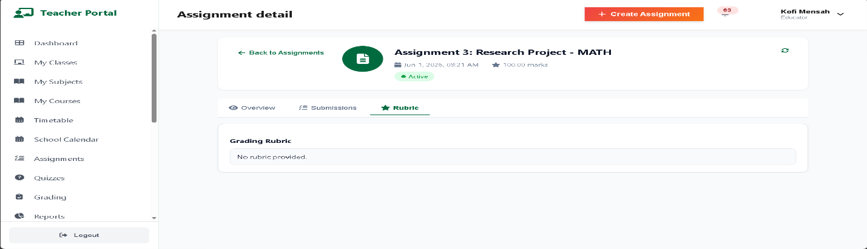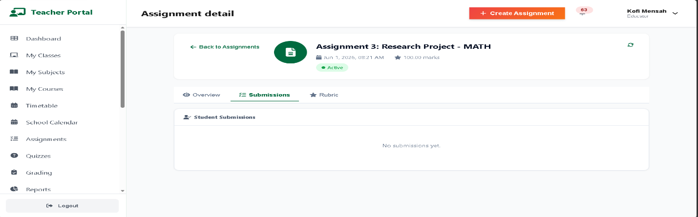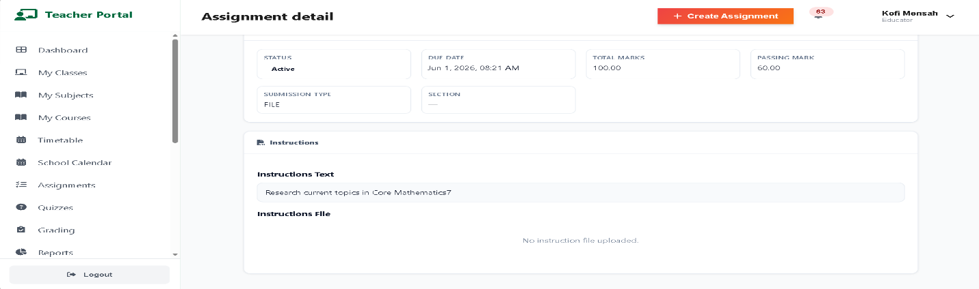
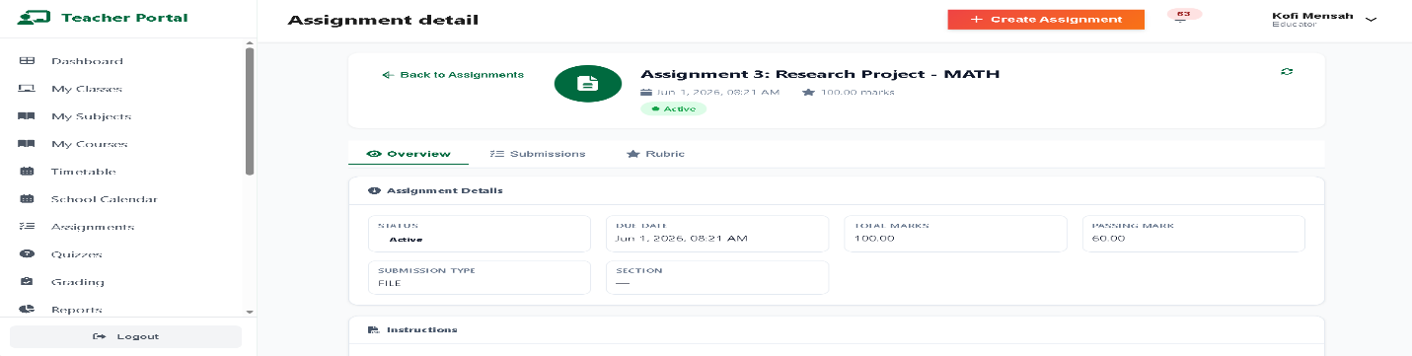
Figure 4.16 Present Assignment Edit Page from Teacher 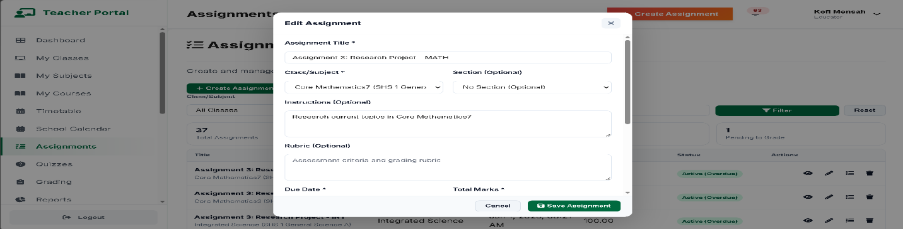
Figure 4.17 Present Assignment Create Page from Teacher 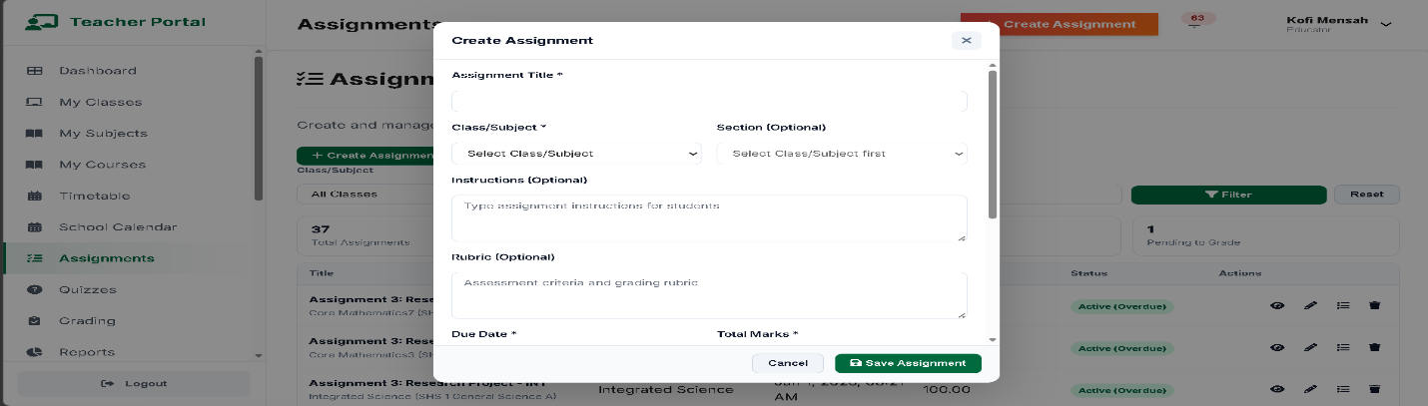
Figure 4.18 Present Assignment Page from Teacher 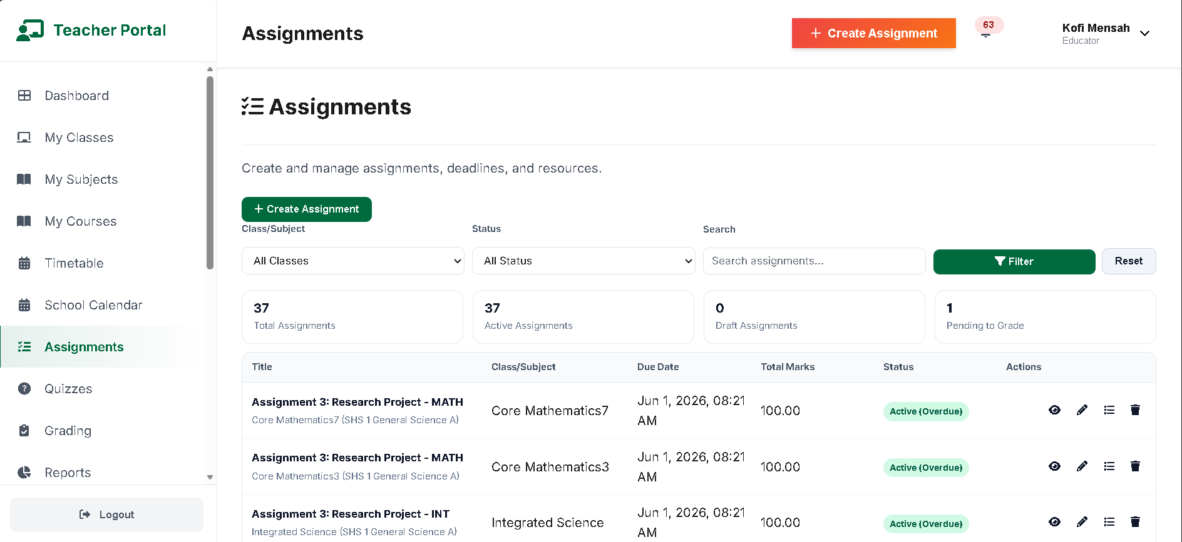
Figure 4.19 Present Assignment Submission Page from Teacher 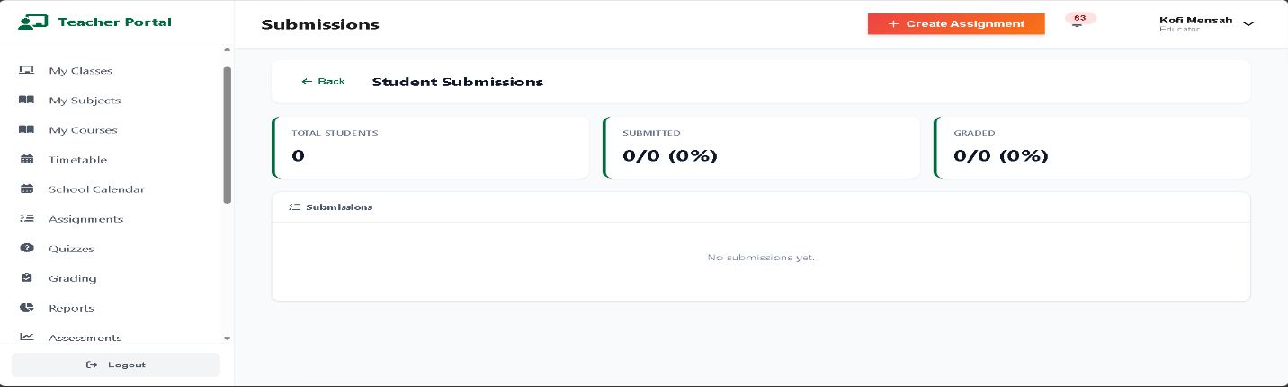
Figure 4.20 Present Subject/Course Page from Teacher
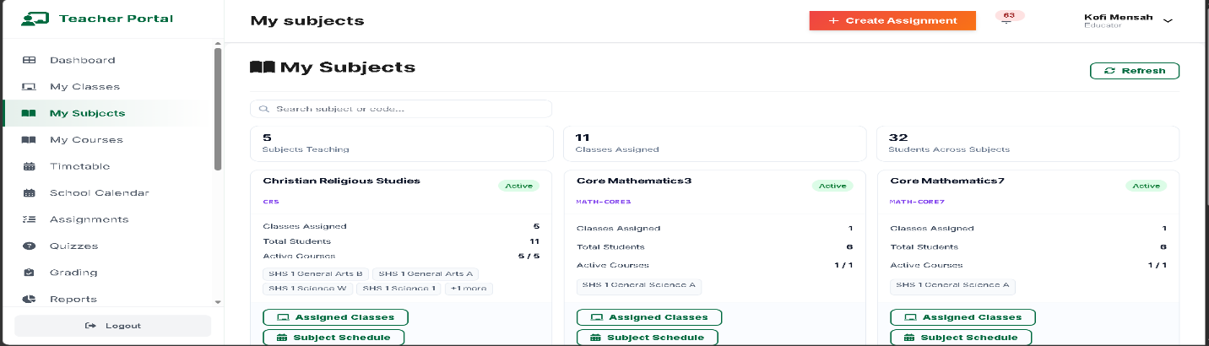
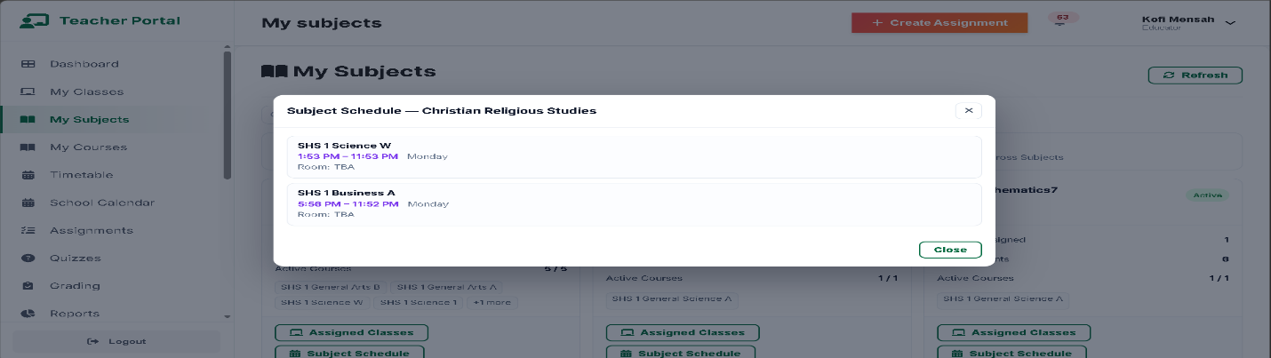
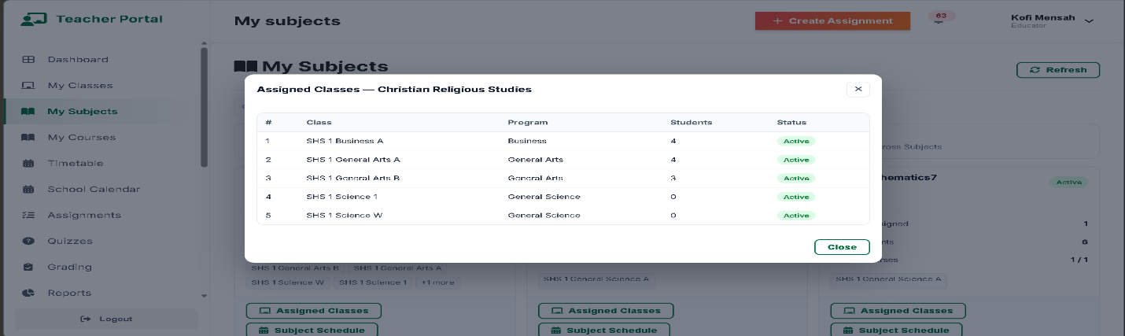
Figure 4.21 Present Report Page filtering Academic by Program from Administrator
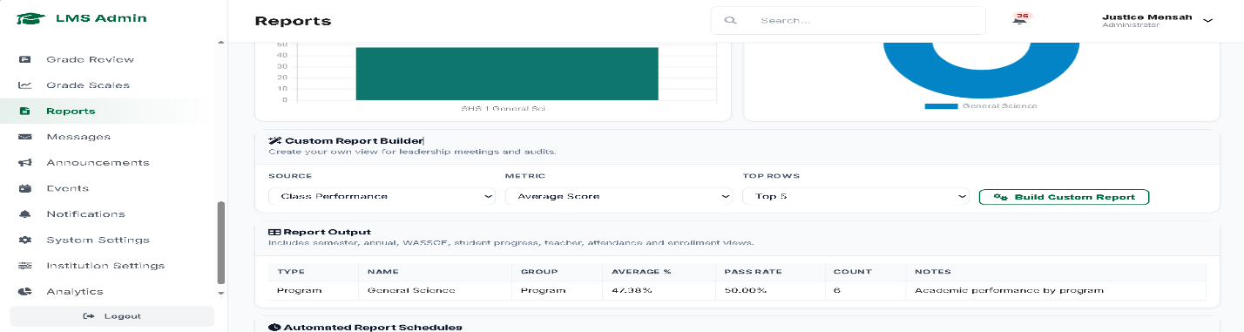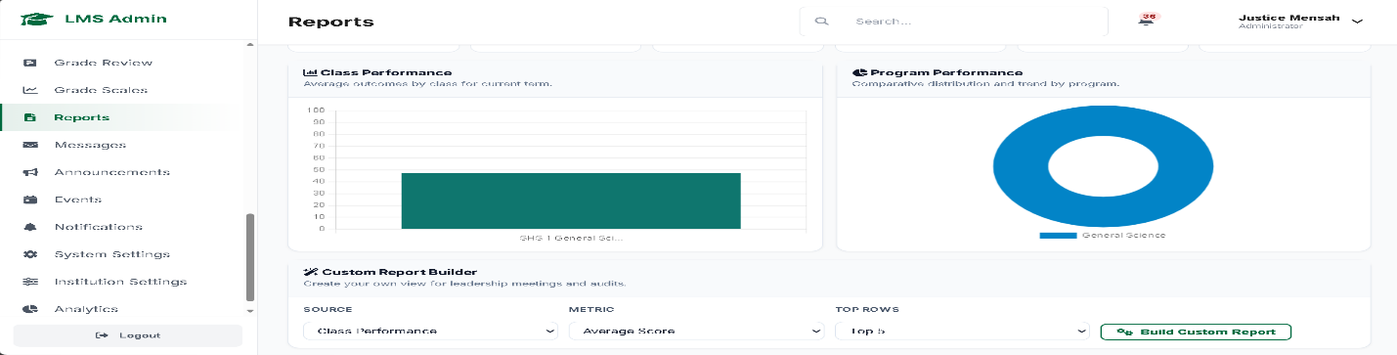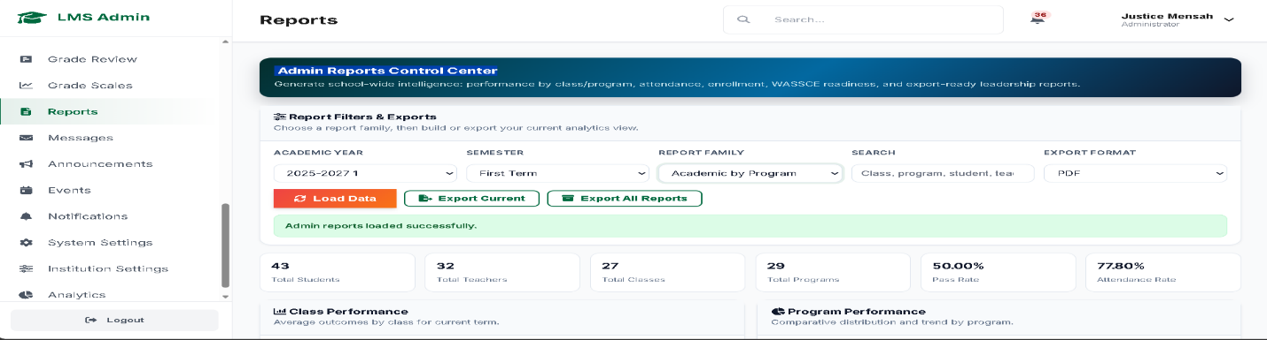
Figure 4.22 Present Attendance Report from Administrator
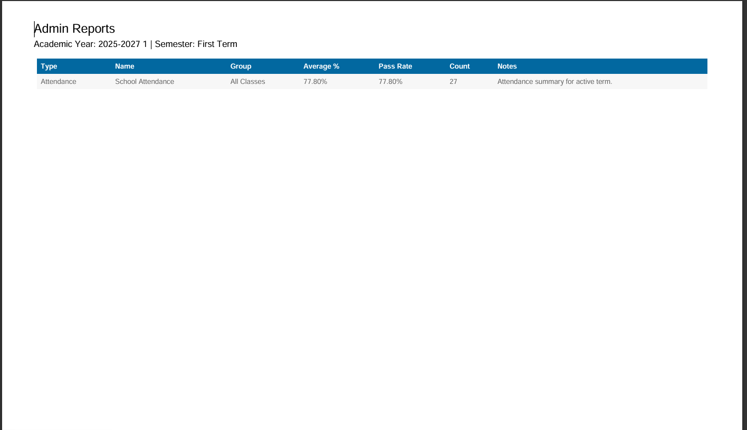
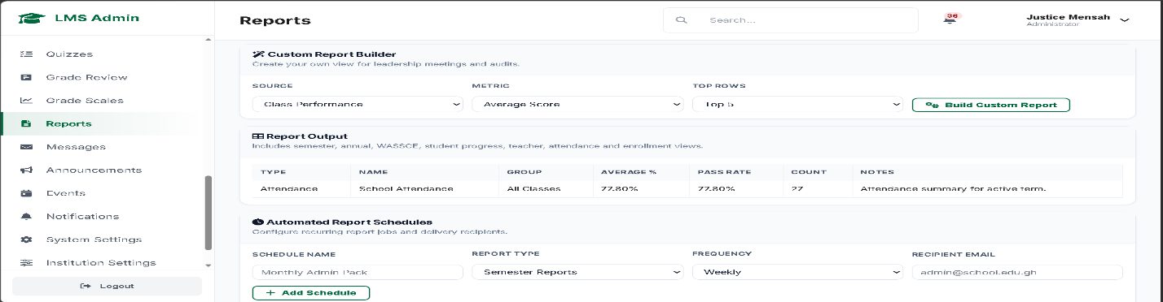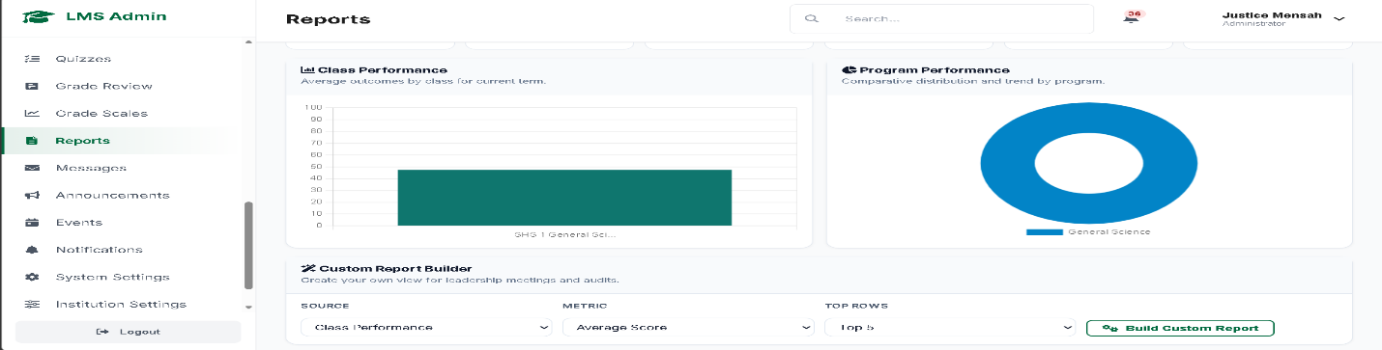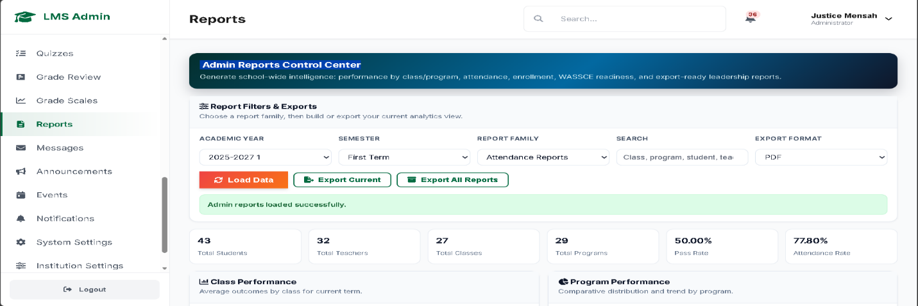
Figure 4.23 Present Attendance Report from Teacher
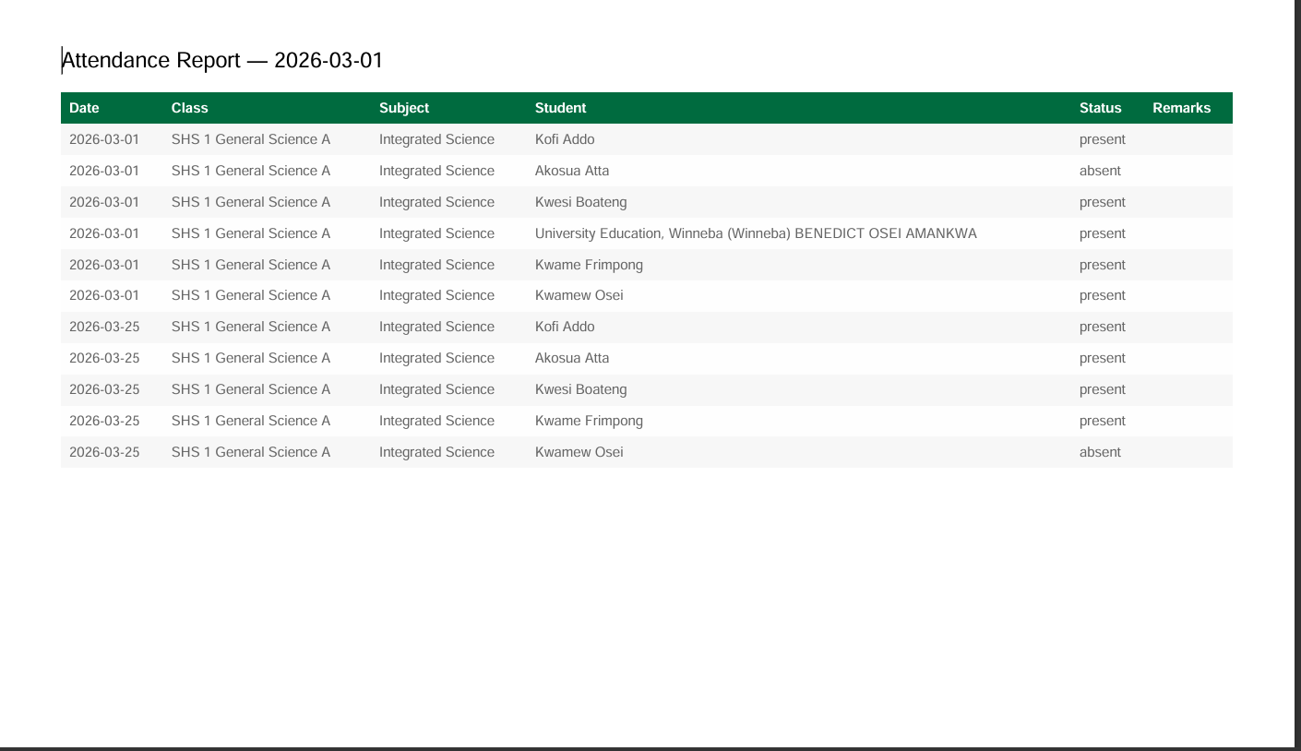
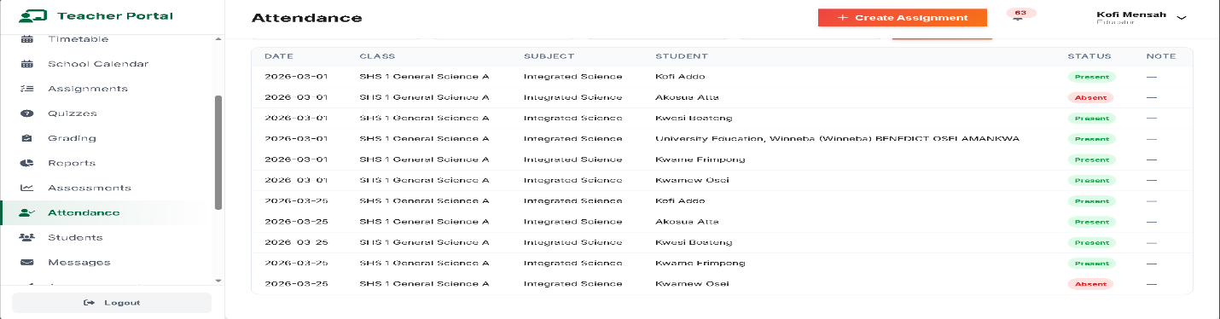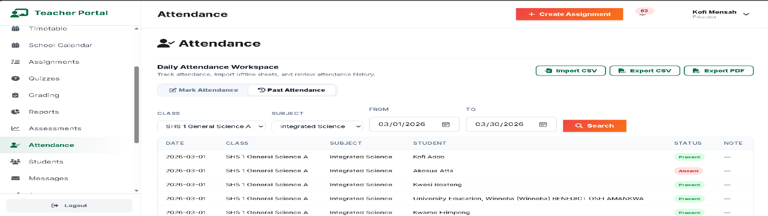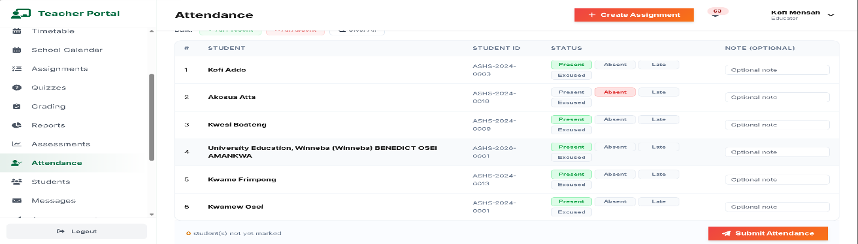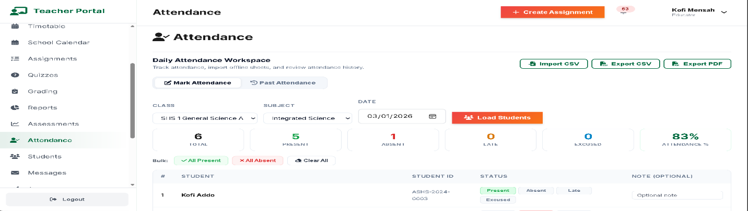
Figure 4.24 Present Student Report from Teacher
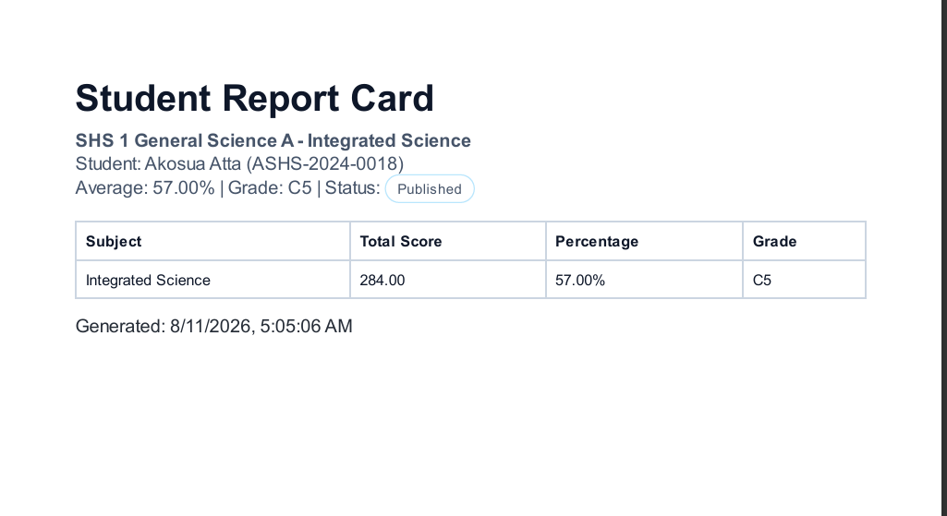
Figure 4.25 Present Student Report from Student
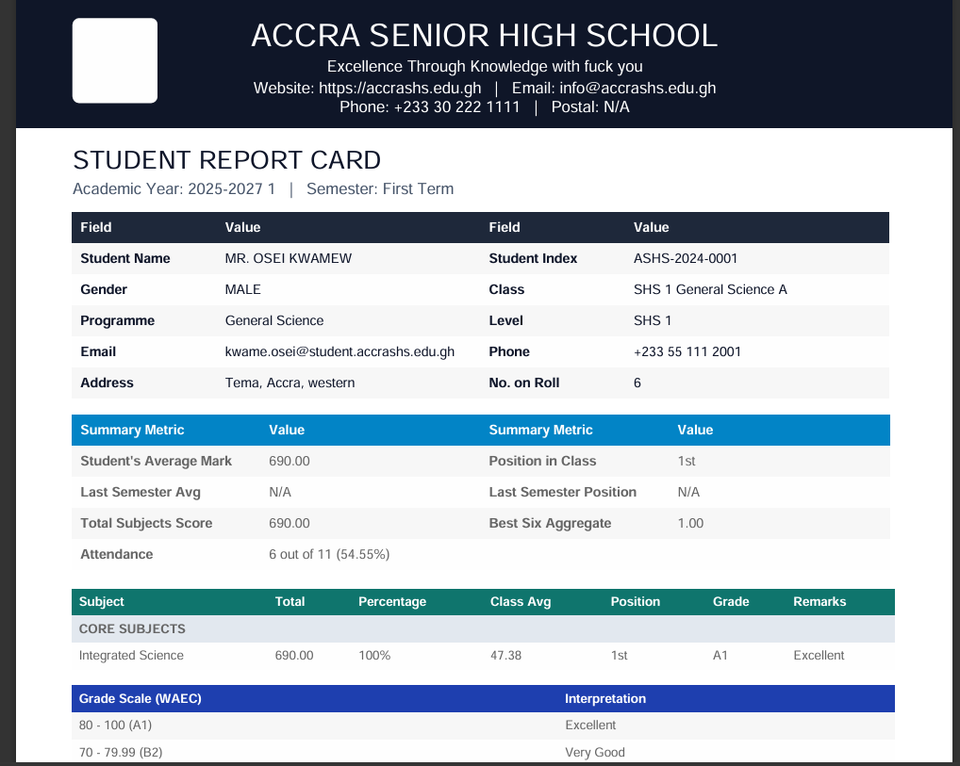
Figure 4.26 Present Semster Report from Administrator
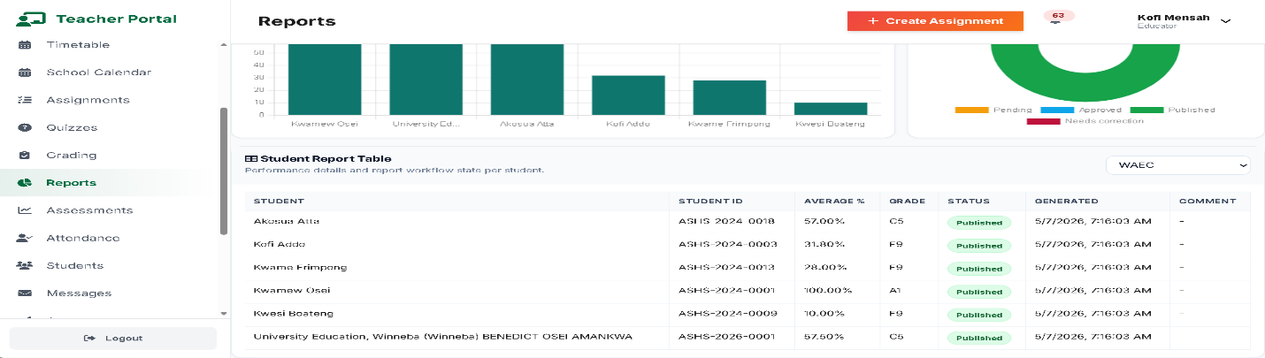
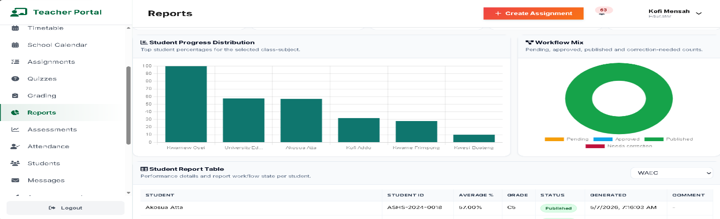
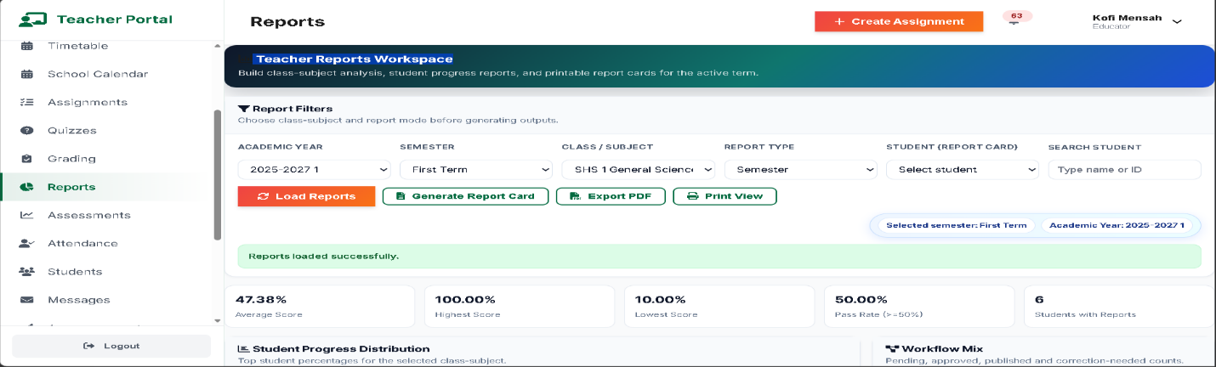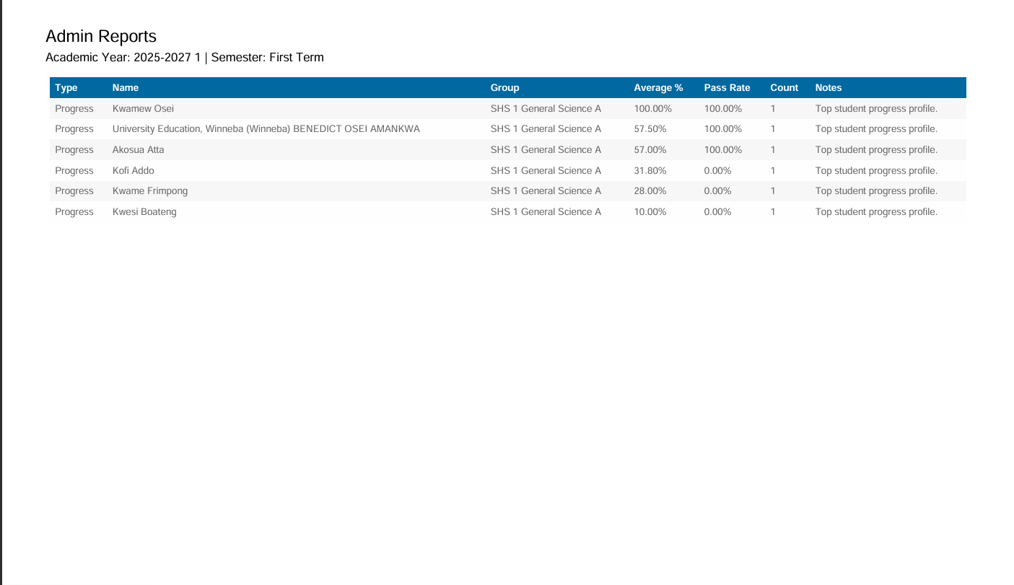
Figure 4.27 Activity Reports on Email sent when New Account is Created
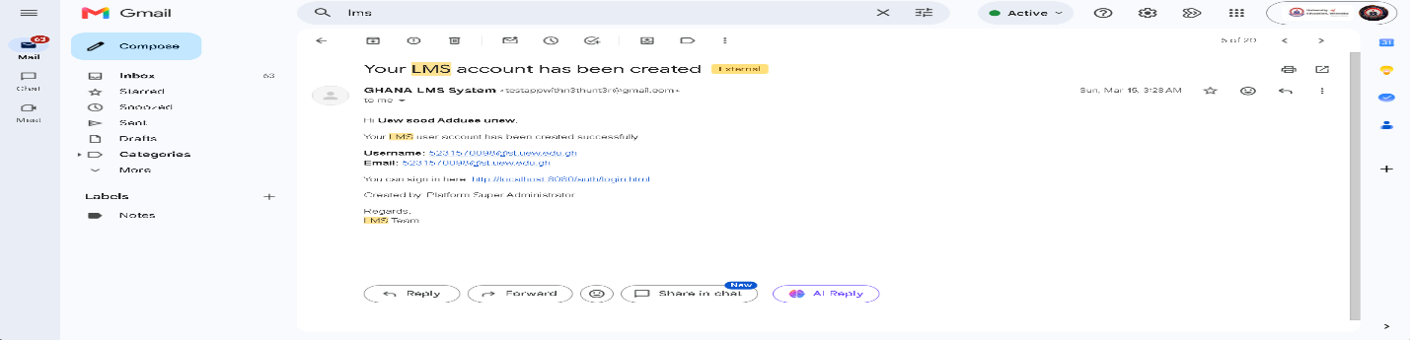
4.8.6 Output Design Principles
The outputs of the system are designed according to the following principles:
- Accuracy: Information displayed to users should reflect the data stored and processed by the system.
- Clarity: Outputs should be presented using clear labels, tables, cards, and appropriate visual elements.
- Relevance: Users should receive information relevant to their roles and activities.
- Security: Sensitive academic information should only be accessible to authorised users.
- Consistency: Reports, dashboards, messages, and other outputs should follow a consistent interface design.
- Timeliness: System responses and updated information should be provided promptly after successful processing.
- Usability: Outputs should be easy to read, understand, and navigate.
The output design therefore ensures that information generated by the LMS is presented in a structured and user-friendly manner. By providing role-specific dashboards, reports, academic results, notifications, and system responses, the proposed system enables administrators, teachers, and students to access relevant information efficiently.
4.9 User Interface (UI) Design
The User Interface (UI) design of the proposed School Learning Management System focuses on providing a simple, consistent, responsive, and user-friendly environment through which administrators, teachers, and students can interact with the system. The interface is designed according to the roles and responsibilities of users, ensuring that each user is presented with the functions and information relevant to their activities.
The UI is implemented using HTML5, CSS3, JavaScript, and Bootstrap. The use of responsive design principles enables the system interface to adapt to different screen sizes and devices, including desktop computers, laptops, tablets, and mobile devices.
4.9.1 Administrator Interface
The Administrator interface provides access to the major administrative functions of the LMS. The administrator dashboard presents an overview of important system information and provides navigation to the available management modules.
The major administrator interface components include:
- Dashboard: displays summaries of users, courses, departments, academic activities, and system statistics.
- User Management: provides interfaces for creating, viewing, updating, and managing user accounts.
- Department Management: provides forms for creating and managing academic departments.
- Course Management: allows administrators to create, update, view, and manage courses.
- Academic Session Management: provides interfaces for managing academic years and sessions.
- Reports: provides access to academic, attendance, course, and system reports.
- Audit Logs allows administrators to review recorded system activities.
- System Settings: provides access to permitted system configuration options.
4.9.2 Teacher Interface
The Teacher interface is designed to support teaching, learning, assessment, and student management activities. The teacher dashboard provides access to assigned courses and the functions required to manage academic activities.
The major teacher interface components include:
- Dashboard: provides an overview of courses, students, assignments, assessments, and notifications.
- Course Management: allows teachers to access and manage assigned courses.
- Learning Materials provides interfaces for uploading, viewing, updating, and managing learning materials.
- Assignments: allows teachers to create assignments, specify deadlines, view submissions, and provide grades and feedback.
- Quizzes and Assessments provides interfaces for creating and managing online assessments.
- Attendance: allows teachers to record and view student attendance.
- Grades: provides interfaces for entering and viewing student grades and performance.
- Announcements: allows teachers to publish relevant academic information and notifications.
4.9.3 Student Interface
The student interface provides students with access to learning resources and academic activities. The dashboard presents relevant information such as enrolled courses, assignments, assessments, grades, attendance, and notifications.
The major student interface components include:
- Dashboard: displays an overview of the student's academic activities.
- Courses: provides access to enrolled courses.
- Learning Materials allows students to view or download available course materials.
- Assignments: displays assignment details, deadlines, submission status, grades, and feedback.
- Quizzes: provides access to available online quizzes and assessments.
- Attendance: allows students to view available attendance information.
- Grades: provides access to academic results and performance information.
- Notifications: displays announcements, reminders, and other relevant academic notifications.
4.9.4 Navigation Design
The navigation structure is designed to provide users with direct access to the functions available within their roles. The interface uses consistent navigation elements such as menus, dashboard cards, buttons, tables, forms, and navigation links.
Role-based navigation ensures that users do not receive menu options for functions that they are not authorised to perform. For example, administrative functions are presented to administrators, teaching and assessment functions are provided to teachers, and learning-related functions are provided to students.
4.9.5 Form Design
Forms are used throughout the system to capture and update information. The forms are designed with clear labels, appropriate input controls, validation messages, and action buttons.
Examples include:
- Login forms.
- User registration and management forms.
- Course forms.
- Learning material upload forms.
- Assignment creation forms.
- Assignment submission forms.
- Quiz and assessment forms.
- Attendance forms.
- Grading forms.
- Announcement forms.
Input validation provides immediate feedback when required information is missing or incorrectly entered.
4.9.6 Table and Data Display Design
Tables are used to display structured information such as users, courses, students, assignments, submissions, attendance records, grades, notifications, and reports.
The table design provides:
- Clear column headings.
- Appropriate data formatting.
- Search and filtering where applicable.
- Pagination for large datasets where implemented.
- Action controls based on user permissions.
- Responsive presentation on smaller screens.
This design enables users to locate and manage records efficiently.
4.9.7 Responsive Design
The interface uses responsive design principles to support different screen sizes. Layouts, forms, navigation elements, tables, and dashboard components are designed to adapt to the available screen dimensions.
The responsive interface allows users to access the LMS through supported desktop and mobile browsers without requiring a separate application for each device type.
4.9.8 UI Feedback and Error Handling
The interface provides feedback after users perform system operations. Success messages are displayed when an operation is completed successfully, while validation and error messages are displayed when an operation cannot be completed.
Examples include:
- Successful login confirmation.
- Invalid login notification.
- Successful record creation message.
- Validation error message.
- Successful file upload notification.
- Assignment submission confirmation.
- Access-denied message.
- Server or API error notification.
This feedback helps users understand the outcome of their actions and reduces uncertainty when interacting with the system.
4.9.9 UI Design Principles
The proposed LMS interface follows the following principles:
- Consistency: similar functions use consistent layouts, controls, labels, and navigation.
- Simplicity: interfaces avoid unnecessary elements and present only relevant information.
- Usability: users can perform common activities with minimal steps.
- Responsiveness: interfaces adapt to different screen sizes.
- Accessibility: text, controls, and navigation are presented in a clear and understandable manner.
- Security: restricted functions and sensitive information are displayed only to authorised users.
- Feedback: the system provides clear responses to user actions.
- Role-based presentation: each user receives an interface appropriate to their assigned role.
The UI design therefore provides a consistent interaction environment for administrators, teachers, and students. The combination of role-based navigation, responsive layouts, structured forms, data tables, dashboards, and feedback mechanisms supports efficient interaction with the proposed Learning Management System.
Figure 4.28 presents representative interfaces for the Login page.

Figure 4.29 presents representative interfaces for the Forgot Password page.

Figure 4.30 presents representative interfaces for the Administrator dashboard.
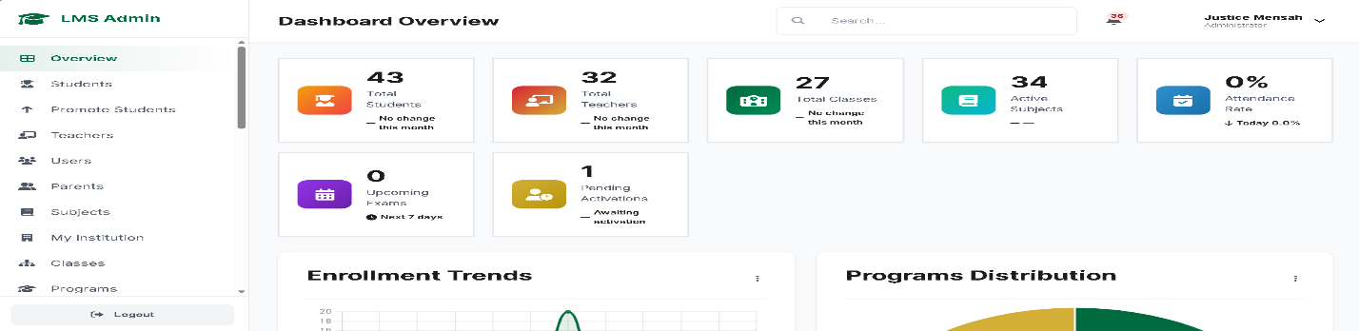
Figure 4.31 presents representative interfaces for the Teacher dashboard.

Figure 4.32 presents representative interfaces for the student dashboard.
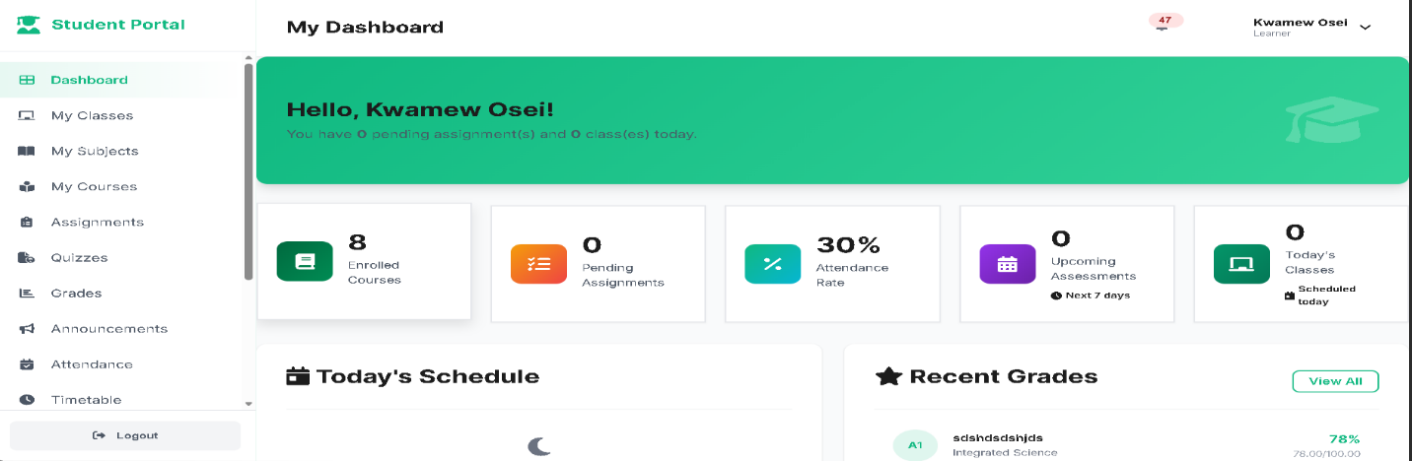

4.10 System Modules
The proposed School Learning Management System is organised into several interconnected modules. Each module is responsible for a specific set of academic or administrative functions while communicating with other modules through the backend RESTful API. This modular structure improves system organisation, maintainability, and separation of responsibilities.
The major modules implemented in the proposed system are described below.
4.10.1 Authentication and Security Module
The Authentication and Security Module controls access to the Learning Management System. It ensures that only authenticated and authorised users can access protected system functions.
The module is responsible for:
- User login and logout.
- Authentication of user credentials.
- Password management.
- Session management.
- Role-based access control.
- Authorisation of protected operations.
- Access restriction based on user roles.
- Recording relevant authentication and security activities.
The module ensures that administrators, teachers, and students are provided with access appropriate to their assigned roles.
4.10.2 User Management Module
The User Management Module allows administrators to manage accounts used to access the system. It provides centralised management of user information and account status.
The module supports:
- Creating user accounts.
- Viewing user information.
- Updating user accounts.
- Deactivating or managing account status.
- Assigning user roles.
- Managing permitted user information.
- Searching and filtering user records where implemented.
The module helps maintain consistent user information within the centralised database.
4.10.3 Academic Management Module
The Academic Management Module manages the academic structure of the institution. It provides administrators with tools for managing departments, courses, academic years, sessions, and related academic information.
The module supports:
- Department management.
- Course creation and management.
- Course code and course information management.
- Teacher-course assignment.
- Academic year management.
- Academic session management.
- Management of relevant academic records.
This module provides the foundation for organising the academic activities handled by the LMS.
4.10.4 Enrolment Management Module
The Enrolment Management Module manages the relationship between students and courses. It records the courses in which students are enrolled and provides information required for learning and assessment activities.
The module supports:
- Student enrolment.
- Course enrolment records.
- Viewing enrolled students.
- Viewing student course information.
- Maintaining relationships between students and courses.
The enrolment information is used by other modules such as assignments, attendance, assessments, and results.
4.10.5 Learning Material Module
The Learning Material Module provides a centralised platform for managing digital learning resources. Teachers can upload materials associated with their courses, while authorised students can access available resources.
The module supports:
- Uploading learning materials.
- Associating materials with courses.
- Viewing available materials.
- Downloading permitted materials.
- Updating material information.
- Managing material records.
Centralising learning materials reduces dependence on separate file-sharing platforms and makes course resources easier to access.
4.10.6 Assignment Management Module
The Assignment Management Module supports the creation, distribution, submission, and grading of assignments.
Teachers can:
- Create assignments.
- Provide assignment descriptions and instructions.
- Set submission deadlines.
- Specify marks or grading information.
- View student submissions.
- Grade submitted assignments.
- Provide feedback.
Students can:
- View available assignments.
- View assignment instructions and deadlines.
- Submit completed assignments.
- View submission status.
- View grades and feedback where available.
4.10.7 Quiz and Assessment Module
The Quiz and Assessment Module supports online assessments and quizzes. It enables teachers to create assessments and students to complete them through the LMS.
The module supports:
- Creating quizzes.
- Creating quiz questions.
- Defining available answers and correct responses where applicable.
- Setting assessment parameters.
- Publishing assessments.
- Student quiz attempts.
- Recording assessment responses.
- Calculating or recording scores.
- Viewing assessment results.
The module provides a structured approach to conducting online assessments.
4.10.8 Attendance Management Module
The Attendance Management Module enables teachers to record and manage student attendance for courses and academic activities.
The module supports:
- Recording attendance.
- Selecting courses and relevant dates.
- Recording student attendance status.
- Viewing attendance records.
- Monitoring attendance information.
- Generating attendance-related information and reports.
The centralised attendance records make it easier to retrieve and monitor student participation.
4.10.9 Results and Grading Module
The Results and Grading Module manages student academic performance information. It provides functions for recording, processing, and presenting grades and results.
The module supports:
- Recording student marks.
- Recording grades.
- Associating results with students and courses.
- Viewing student performance.
- Providing academic result information.
- Supporting generation of performance reports.
The module ensures that academic performance information is stored centrally and can be retrieved by authorised users.
4.10.10 Communication and Notification Module
The Communication and Notification Module supports communication between authorised users of the LMS. It provides a centralised mechanism for distributing academic announcements and system notifications.
The module supports:
- Creating announcements.
- Publishing academic information.
- Sending notifications.
- Displaying notifications to users.
- Tracking notification status where implemented.
- Supporting relevant user communication.
The module reduces dependence on fragmented communication channels and helps ensure that important academic information reaches the intended users.
4.10.11 Reporting Module
The Reporting Module converts stored academic and administrative data into useful reports for authorised users.
The module supports reports relating to:
- Student performance.
- Attendance.
- Courses.
- Assignments.
- Assessments.
- Users.
- Academic activities.
- Other available system information.
Administrators and authorised teachers can use reports to support monitoring, decision-making, and academic management.
4.10.12 Audit and Activity Monitoring Module
The Audit and Activity Monitoring Module records relevant activities performed within the system. It supports monitoring, accountability, and investigation of system activities.
The module can record information such as:
- User performing an activity.
- Action performed.
- Date and time of the activity.
- Relevant system operation.
- IP address where applicable.
Administrators can use audit information to monitor system usage and identify potentially unauthorised or unusual activities.
4.10.13 Module Integration
Although the LMS is divided into separate modules, the modules operate as an integrated system. For example, the Authentication Module determines whether a user can access the system, while the User Management Module determines the user's role and account information. The Enrolment Module provides course relationships used by the Learning Material, Assignment, Assessment, Attendance, and Results modules.
Communication between the frontend and these modules is handled through the RESTful API. The API processes requests, applies authentication and authorisation rules, performs the required business logic, communicates with the MySQL database, and returns JSON responses to the frontend.
The overall relationship between the major modules can therefore be represented as:
User → Authentication → Role-Based Dashboard → Relevant Module → REST API → MySQL Database → JSON Response → User Interface
The modular design enables the proposed Learning Management System to provide integrated academic and administrative services while maintaining clear separation of responsibilities among the different functional components.
4.11 Technologies
The development of the proposed School Learning Management System involved a combination of web development, server-side, database, API, and development tools. The selected technologies were chosen to support the requirements of the system, including maintainability, usability, security, data management, and communication between the frontend and backend.
4.11.1 HTML5
HTML5 was used to structure the content and components of the LMS user interface. It provides the basic structure for pages, forms, tables, navigation elements, dashboards, and other interface components.
HTML5 supports the organisation of information into meaningful elements, making the interface easier to develop and maintain.
4.11.2 CSS3
CSS3 was used to control the visual presentation and layout of the system. It was applied to elements such as colours, typography, spacing, buttons, forms, tables, navigation menus, and dashboard components.
CSS3 also supports responsive layouts, allowing the interface to adapt to different screen sizes and devices.
4.11.3 JavaScript
JavaScript was used to provide client-side functionality and dynamic interaction within the LMS. It enables the frontend to respond to user actions, validate information, manipulate interface elements, and communicate with backend services.
JavaScript also supports asynchronous communication with the REST API, allowing data to be retrieved or submitted without requiring complete page reloads.
4.11.4 Bootstrap
Bootstrap was used as a frontend framework to support responsive and consistent interface development. It provides reusable components and layout utilities for elements such as navigation bars, forms, buttons, cards, tables, alerts, and responsive grids.
The use of Bootstrap helps maintain consistency across the different user interfaces of the LMS.
4.11.5 PHP 8
PHP 8 was used for the server-side implementation of the system. It processes requests received from the frontend, performs business logic, validates data, communicates with the database, and generates API responses.
PHP was selected because it provides suitable support for web application development and integrates effectively with MySQL and Apache.
4.11.6 RESTful API
The system uses a RESTful Application Programming Interface (API) to facilitate communication between the frontend and backend. The API provides endpoints through which the frontend can request, create, update, or delete system information.
The API architecture separates the presentation layer from the backend services and allows the frontend to communicate with the application using standard HTTP methods such as:
- GET – retrieves information.
- POST – creates or submits information.
- PUT/PATCH – updates existing information.
- DELETE – removes information where authorised.
This architecture supports the API-first design of the proposed LMS.
4.11.7 JSON
JavaScript Object Notation (JSON) is used as the primary data-interchange format between the frontend and backend API.
The API returns information and operation results in JSON format, which JavaScript can process and use to update the user interface. JSON provides a lightweight and structured format for exchanging information between the frontend and backend.
4.11.8 Fetch API
The Fetch API is used within the JavaScript frontend to send HTTP requests to the RESTful API and process responses.
For example, when a user submits a form, JavaScript can use the Fetch API to send the information to the appropriate PHP API endpoint. The API processes the request and returns a JSON response, which the frontend uses to provide feedback or update displayed information.
The communication process can be represented as:
Frontend → Fetch API → REST API → PHP → MySQL → JSON Response → Frontend
4.11.9 MySQL
MySQL was used as the relational database management system for the LMS. It provides centralised storage for user, academic, learning, assessment, attendance, results, communication, and system activity information.
MySQL supports relational database concepts such as primary keys, foreign keys, constraints, and relationships, which are important for maintaining the integrity and consistency of the LMS data.
4.11.10 Apache
Apache HTTP Server provides the web server environment required to run the PHP-based backend of the system. It receives web requests and allows the PHP application and REST API services to be accessed through the configured server environment.
4.11.11 XAMPP
XAMPP was used as the local development environment for the system. It provides an integrated environment containing components such as Apache and MySQL, allowing the LMS to be developed and tested locally.
XAMPP simplifies the configuration of the development environment and provides the infrastructure required to run the PHP application and database during development.
4.11.12 Visual Studio Code
Visual Studio Code (VS Code) was used as the primary source-code editor during system development. It provided an environment for creating and managing the HTML, CSS, JavaScript, PHP, and other project files.
Its development features support code editing, project organisation, debugging, and integration with version-control tools.
4.11.13 Git
Git was used as the version-control system for managing changes made to the source code. It allows different versions of the project to be tracked and provides a mechanism for maintaining the development history.
Git also makes it possible to revert changes when necessary and supports structured software development.
4.11.14 GitHub
GitHub was used as a remote repository for storing and managing the project's source code. It provides version-control collaboration capabilities and serves as a backup location for the project repository.
The repository also supports tracking changes and managing different development versions of the LMS.
4.11.15 Postman
Postman was used to test and validate the RESTful API endpoints during development. API requests could be sent directly to individual endpoints to verify authentication, data processing, database operations, validation, and JSON responses.
Postman was particularly useful for testing backend services independently from the frontend.
4.11.16 Summary of Technologies
Technology/Tool | Purpose in the System
HTML5 | Structures the web interface.
CSS3 | Provides styling, layout, and responsive presentation.
JavaScript | Provides client-side interaction and dynamic functionality.
Bootstrap | Supports responsive layouts and reusable interface components.
PHP 8 | Implements server-side processing and REST API services.
REST API | Provides communication between the frontend and backend.
JSON | Exchanges structured data between the frontend and API.
Fetch API | Sends asynchronous HTTP requests from the frontend.
MySQL | Stores and manages system data.
Apache | Provides the web server environment for the PHP application.
XAMPP | Provides the local development and testing environment.
Visual Studio Code | Provides the development and source-code editing environment.
Git | Tracks and manages source-code changes.
GitHub | Hosts and manages the project's remote repository.
Postman | Tests and validates REST API endpoints.

The combination of these technologies provides the technical foundation for implementing the proposed School Learning Management System. The frontend technologies provide the user interface, PHP and the RESTful API provide application services, MySQL provides persistent data storage, and the supporting development tools facilitate development, testing, and version control.
4.12 System Testing
System testing was conducted to verify that the proposed School Learning Management System functions according to the specified requirements and that the major components operate correctly as an integrated system. Testing was performed after the development of the major system modules and focused on functionality, integration, security, usability, and reliability.
The testing process involved checking individual system components, interactions between the frontend, RESTful API and database, complete system workflows, and the ability of users to perform their assigned activities. The major testing approaches applied were unit testing, integration testing, system testing, and user acceptance testing.
4.12.1 Unit Testing
Unit testing was used to verify individual functions and components of the system independently. The purpose was to identify errors within specific functions before they were integrated with other components.
Examples of components tested include:
- User authentication functions.
- User registration and validation.
- Course creation and updating.
- Learning material upload.
- Assignment creation.
- Assignment submission.
- Attendance recording.
- Grade processing.
- Notification processing.
- API request validation.
Each function was tested using valid and invalid inputs to determine whether it produced the expected result.
4.12.2 Integration Testing
Integration testing was performed to verify communication between different components of the LMS. Attention was given to the interaction between the frontend, RESTful API, authentication and authorisation mechanisms, business logic, and MySQL database.
The following interactions were tested:
Frontend → REST API
The system was tested to ensure that requests submitted through the frontend were correctly sent to the appropriate API endpoints.
REST API → Database
API operations were tested to ensure that data could be correctly inserted, retrieved, updated, and deleted from the MySQL database where authorised.
Database → REST API → Frontend
Responses returned from the database through the API were tested to ensure that the correct information was converted into JSON and displayed appropriately on the frontend.
Integration testing also verified that authentication and role-based permissions were correctly applied when users attempted to access protected resources.
4.12.3 System Testing
System testing evaluated the LMS as a complete integrated application. Rather than testing individual components separately, the entire system was tested according to typical user workflows.
The major system workflows tested included:
- Authentication Workflow
A user enters login credentials, the system validates the credentials, determines the user's role, and redirects the user to the appropriate dashboard.
- Course Management Workflow
An authorised administrator or teacher creates or updates course information, the API processes the request, and the information is stored in the MySQL database.
- Learning Material Workflow
A teacher uploads learning material, the system validates the request and file information, stores the relevant record, and makes the material available to authorised students.
- Assignment Workflow
A teacher creates an assignment, students access the assignment and submit their work, and the teacher reviews, grades, and provides feedback on the submission.
- Attendance Workflow
A teacher selects a course and records student attendance. The system validates and stores the attendance information and makes appropriate records available to authorised users.
- Assessment Workflow
A teacher creates an assessment or quiz, students complete the assessment, and the system records the resulting information.
- Results Workflow
Student marks and grades are processed and stored, after which authorised, users can view the relevant academic performance information.
- Communication Workflow
Administrators or teachers publish announcements or notifications, which are then made available to the intended users.
System testing therefore verified that the major modules operate together as a single integrated LMS.
4.12.4 Security Testing
Security-related tests were performed to verify that access to protected functions and information was appropriately restricted.
The testing included:
- Testing valid and invalid login credentials.
- Verifying role-based access control.
- Attempting to access restricted functions using an unauthorised role.
- Testing input validation.
- Testing protected API endpoints.
- Verifying that users cannot directly access functions outside their permissions.
- Testing database operations using controlled inputs.
- Checking appropriate handling of authentication and session information.
The purpose of security testing was to ensure that sensitive academic and user information was protected from unauthorised access and inappropriate system operations.
4.12.5 User Acceptance Testing
User Acceptance Testing (UAT) was used to determine whether the LMS satisfies the functional expectations of its intended users. The testing focused on common tasks performed by administrators, teachers, and students.
Administrators were expected to test functions such as:
- Logging into the system.
- Managing users.
- Managing departments and courses.
- Managing academic sessions.
- Generating reports.
- Reviewing system activities.
Teachers were expected to test functions such as:
- Accessing assigned courses.
- Uploading learning materials.
- Creating assignments and assessments.
- Recording attendance.
- Grading student work.
- Publishing announcements.
Students were expected to test functions such as:
- Logging into the system.
- Accessing enrolled courses.
- Viewing learning materials.
- Submitting assignments.
- Taking available assessments.
- Viewing grades and academic information.
- Receiving notifications.
Feedback from these activities was used to identify interface, functionality, and usability issues requiring correction.
4.12.6 Testing Criteria
The system was considered to have passed a test when the actual result matched the expected result, and the operation did not produce an unacceptable error.
The following criteria were considered:
Criterion | Description
Functional correctness | The system performs the requested operation correctly.
Data integrity | Information is stored and retrieved accurately.
Access control | Users can access only authorised functions.
API communication | Frontend requests and backend responses operate correctly.
Error handling | Invalid operations produce appropriate error messages.
Usability | Users can complete common tasks without unnecessary difficulty.
Reliability | The system performs consistently during repeated operations.
Responsiveness | The interface operates appropriately across supported screen sizes.

The results of the individual test cases are presented in Section 4.13, where the test scenarios, expected results, actual results, and test status are documented.
Overall, system testing provided evidence that the major components of the proposed Learning Management System were tested individually and collectively. The testing process helped identify and correct functional, integration, security, and usability issues before the system was considered ready for deployment and user evaluation.
4.13 Test Cases
Test cases were developed to verify that the major functions of the proposed School Learning Management System operate according to the specified requirements. Each test case defines the function being tested, the input or action performed, the expected result, the actual result, and the status of the test.
The test cases cover authentication, user management, course management, learning materials, assignments, assessments, attendance, results, notifications, access control, and API communication.
4.13.1 Authentication Test Cases
Test ID | Test Case | Test Input/Action | Expected Result | Actual Result | Status
TC-001 | Valid Login | Enter valid username and password | User is authenticated and redirected to the appropriate dashboard | User was authenticated and redirected correctly | Pass
TC-002 | Invalid Login | Enter incorrect username/password | Error message is displayed and access is denied | Error message was displayed | Pass
TC-003 | Empty Login Fields | Submit login form without credentials | Validation message is displayed | Validation message was displayed | Pass
TC-004 | Role-Based Access | Login using different user roles | User receives access according to assigned role | Role-based access worked correctly | Pass
TC-005 | Logout | Select logout | User session is terminated and login page is displayed | Session was terminated successfully | Pass

4.13.2 User Management Test Cases
Test ID | Test Case | Test Input/Action | Expected Result | Actual Result | Status
TC-006 | Create User | Enter valid user information | New user account is created | User account was created | Pass
TC-007 | Duplicate User | Enter an existing username/email | System rejects duplicate information | Duplicate information was rejected | Pass
TC-008 | Update User | Modify existing user information | User record is updated | User record was updated | Pass
TC-009 | Invalid User Data | Submit incomplete user information | Validation message is displayed | Validation message was displayed | Pass

4.13.3 Course Management Test Cases
Test ID | Test Case | Test Input/Action | Expected Result | Actual Result | Status
TC-010 | Create Course | Enter valid course details | Course is created and stored | Course was created successfully | Pass
TC-011 | Update Course | Modify course information | Course information is updated | Course was updated | Pass
TC-012 | View Course | Select a course | Correct course information is displayed | Course information was displayed | Pass
TC-013 | Invalid Course Data | Submit incomplete course information | Validation error is displayed | Validation error was displayed | Pass

4.13.4 Learning Material Test Cases
Test ID | Test Case | Test Input/Action | Expected Result | Actual Result | Status
TC-014 | Upload Material | Upload a valid learning material | Material is uploaded and associated with the selected course | Material was uploaded successfully | Pass
TC-015 | Invalid File | Upload an unsupported file type | System rejects the file | File was rejected | Pass
TC-016 | View Material | Student selects available material | Material information is displayed | Material was displayed | Pass
TC-017 | Download Material | Student selects download | Authorised material is downloaded | Material was downloaded successfully | Pass

4.13.5 Assignment Test Cases
Test ID | Test Case | Test Input/Action | Expected Result | Actual Result | Status
TC-018 | Create Assignment | Teacher enters assignment details | Assignment is created | Assignment was created successfully | Pass
TC-019 | View Assignment | Student opens an assignment | Assignment details and deadline are displayed | Details were displayed | Pass
TC-020 | Submit Assignment | Student uploads valid assignment | Submission is recorded | Submission was recorded successfully | Pass
TC-021 | Grade Assignment | Teacher enters grade and feedback | Grade and feedback are saved | Grade and feedback were saved | Pass
TC-022 | Invalid Submission | Submit an invalid or unsupported file | System rejects the submission | Submission was rejected | Pass

4.13.6 Attendance Test Cases
Test ID | Test Case | Test Input/Action | Expected Result | Actual Result | Status
TC-023 | Record Attendance | Teacher records student attendance | Attendance record is stored | Record was stored successfully | Pass
TC-024 | View Attendance | Select course/date | Correct attendance records are displayed | Records were displayed | Pass
TC-025 | Invalid Attendance Data | Submit incomplete attendance information | Validation message is displayed | Validation message was displayed | Pass

4.13.7 Assessment and Results Test Cases
Test ID | Test Case | Test Input/Action | Expected Result | Actual Result | Status
TC-026 | Create Quiz | Teacher enters valid quiz information | Quiz is created | Quiz was created successfully | Pass
TC-027 | Attempt Quiz | Student answers quiz questions | Answers are submitted successfully | Answers were submitted successfully | Pass
TC-028 | Record Score | Complete assessment | Score is calculated or recorded correctly | Score was recorded correctly | Pass
TC-029 | View Grade | Student opens results | Authorised grade information is displayed | Grade was displayed correctly | Pass

4.13.8 Communication and Notification Test Cases
Test ID | Test Case | Test Input/Action | Expected Result | Actual Result | Status
TC-030 | Create Announcement | Teacher/admin enters announcement | Announcement is published | Announcement was published | Pass
TC-031 | View Notification | User opens notifications | Relevant notification is displayed | Notification was displayed | Pass
TC-032 | Mark Notification Read | User opens notification | Notification status is updated | Status was updated | Pass

4.13.9 Security and Access Control Test Cases
Test ID | Test Case | Test Input/Action | Expected Result | Actual Result | Status
TC-033 | Unauthorised Page Access | Student attempts to access an administrator function | Access is denied | Access was denied | Pass
TC-034 | Protected API Request | Send request without valid authentication | API rejects the request | Request was rejected | Pass
TC-035 | Role Permission | Teacher attempts to perform an administrator-only operation | Operation is denied | Operation was denied | Pass
TC-036 | Input Validation | Submit invalid data to an API endpoint | Request is rejected with an appropriate response | Invalid request was rejected | Pass

4.13.10 API and Database Test Cases
Test ID | Test Case | Test Input/Action | Expected Result | Actual Result | Status
TC-037 | GET Request | Request valid course data | API returns the requested data in JSON format | JSON response was returned | Pass
TC-038 | POST Request | Submit valid course information | API creates the record and returns a response | Record was created successfully | Pass
TC-039 | UPDATE Request | Submit valid updated information | Existing record is updated | Record was updated successfully | Pass
TC-040 | DELETE Request | Delete an authorised record | Record is removed or appropriately deactivated | Operation completed successfully | Pass
TC-041 | Database Retrieval | Request stored student information | Correct database records are returned | Correct records were returned | Pass

4.13.11 Summary of Test Results
The test cases covered the major functional and technical components of the proposed LMS. The results indicate that the tested functions performed according to their expected behaviour. Authentication, role-based access control, user management, academic management, learning materials, assignments, attendance, assessments, results, communication, API operations, and database interactions were tested.
The testing results provide evidence that the proposed system can support the major academic and administrative activities for which it was designed. Any errors identified during development were corrected and the relevant functions were retested before the system was considered ready for user evaluation.
4.14 Summary
This chapter presented the design and development structure of the proposed School Learning Management System. The system design was developed based on the requirements and challenges identified during the analysis of the existing academic management processes.
The chapter described the proposed system design, system architecture, use case design, database design, data dictionary, input design, and output design. The database design established the structure for storing and managing users, departments, courses, enrolments, learning materials, assignments, assessments, attendance, results, notifications, and system activities. The input and output designs described how information is entered into the system, validated, processed, stored, and presented to authorised users.
The chapter also described the major system modules, including authentication and security, user management, academic management, enrolment, learning materials, assignments, assessments, attendance, results, communication, reporting, and audit monitoring. The technologies used to implement the system, including HTML5, CSS3, JavaScript, Bootstrap, PHP 8, RESTful API, JSON, Fetch API, MySQL, Apache, XAMPP, Git, GitHub, and Postman, were also discussed.
System testing was presented through different testing approaches, including unit testing, integration testing, system testing, security testing, and user acceptance testing. Test cases were developed to verify major system functions such as authentication, user management, course management, learning materials, assignments, attendance, assessments, results, notifications, API operations, database interactions, and role-based access control. The testing results indicated that the major functions of the proposed system performed according to their expected behaviour.
Overall, the chapter established the technical and functional design of the proposed School Learning Management System and provided the foundation for its implementation and evaluation. The design integrates the major academic and administrative processes into a centralised web-based platform intended to improve efficiency, accessibility, data management, communication, and security within the institution.
CHAPTER FIVE
SUMMARY, CONCLUSION AND RECOMMENDATIONS
5.1 Introduction
This chapter presents the summary, conclusion, contributions, recommendations, further research directions, and limitations of the study. The chapter reflects on the extent to which the objectives of the study were achieved through the analysis, design, implementation, and testing of the proposed School Learning Management System (LMS). It also highlights the contribution of the developed system to the management of academic activities and identifies areas for future improvement.
5.2 Summary of the Study
The study focused on the design and implementation of a web-based School Learning Management System for educational institutions. The study was motivated by challenges identified in traditional and fragmented academic management practices, including difficulties in managing student and course information, delays in assignment submission and grading, limited access to learning materials, poor communication among stakeholders, difficulties in generating academic reports, inadequate centralisation of educational records, and dependence on physical processes for academic activities.
The analysis of the existing system revealed that academic information was often managed through paper-based records, spreadsheets, separate applications, and disconnected communication channels. These practices resulted in duplication of information, delays, increased possibility of errors, difficulty retrieving records, and inefficient coordination among administrators, teachers, and students.
Based on the identified challenges, a web-based Learning Management System was designed to centralise major academic activities within a single platform. The proposed system provides role-based functionality for three main categories of users: administrators, teachers, and students.
The administrator functions include user management, department and programme management, course management, academic session management, reporting, system settings, and monitoring of academic activities. Teachers are provided with facilities for managing courses, uploading learning materials, creating assignments and assessments, grading student work, recording attendance, monitoring student performance, and communicating with students. Students can access enrolled courses and learning materials, submit assignments, participate in assessments, view grades, and receive academic notifications.
The system adopts an API-first architecture in which the frontend communicates with a PHP-based RESTful API. The backend processes requests, applies authentication and authorisation, performs business logic, interacts with the MySQL database, and returns responses in JSON format. This architecture separates the presentation layer from the application and data layers and provides a foundation for future system extension.
The system was implemented using HTML5, CSS3, JavaScript, PHP, MySQL, RESTful API technologies, JSON, and related development tools. The implementation was subsequently subjected to functional, security and access-control, API, and database testing. The test cases documented in Chapter Four covered major system operations, including authentication, role-based access, academic management, assessments, communication, API requests, and database retrieval.
The results demonstrate that the developed system provides a centralised platform for managing several academic and administrative activities and addresses a number of the weaknesses identified in the existing system.
5.3 Achievement of Objectives
The study was guided by seven specific objectives. The achievement of each objective is discussed below.
5.3.1 Objective One: To analyse the challenges associated with traditional academic management systems
This objective was achieved through the analysis of the existing academic management processes. The analysis identified several challenges, including inefficient record management, fragmented information systems, manual attendance recording, delays in assignment processing and feedback, poor communication among stakeholders, difficulty generating academic reports, and inadequate centralisation of academic information.
The existing workflow analysis provided the basis for identifying the functional and non-functional requirements of the proposed Learning Management System. The identified problems demonstrated the need for a centralised platform capable of automating and integrating major academic activities.
5.3.2 Objective Two: To design a user-friendly Learning Management System for educational institutions
This objective was achieved through the design of the proposed School Learning Management System. The system design incorporated a role-based workflow and separate functionality for administrators, teachers, and students.
The design included the system workflow, system architecture, use case model, Data Flow Diagram, database design, API architecture, input design, output design, and user interface design. The proposed interface was designed to provide users with access to functions relevant to their responsibilities while maintaining a simple and responsive interaction environment.
The design therefore provided a structured foundation for the implementation of the system.
5.3.3 Objective Three: To develop a platform for managing students, teachers, courses, and academic records
This objective was addressed through the implementation of the user management, academic management, course management, enrolment, attendance, results, and reporting functionality.
The developed system provides administrators with facilities for managing users, departments, courses, academic sessions, and other institutional information. Teachers can manage course-related activities and student academic information, while students can access their academic information through the student interface.
The centralised database and RESTful API architecture provide a common platform through which academic information can be stored, retrieved, and processed.
5.3.4 Objective Four: To provide facilities for uploading and accessing learning materials online
This objective was achieved through the Learning Materials Module. Teachers can upload learning resources associated with courses, while students can access the available materials through the system.
The implementation reduces dependence on physical distribution of learning resources and provides students with a centralised location from which course materials can be accessed. This addresses the problem identified in the existing system where access to learning resources could be restricted by physical presence or fragmented distribution channels.
5.3.5 Objective Five: To enable assignment creation, submission, and grading electronically
This objective was achieved through the Assignment Management and Assessment functionality.
Teachers can create assignments and manage student submissions, while students can submit their work through the system. The assessment functionality also provides mechanisms for grading and displaying academic results.
The testing results documented in Chapter Four include assignment, assessment, grading, and result-related test cases. The successful execution of these tests demonstrates that the implemented system supports the major electronic assignment and assessment processes defined by the study.
5.3.6 Objective Six: To facilitate communication between students, teachers, and administrators
This objective was addressed through the Communication and Notification functionality of the system.
The developed system provides facilities for publishing announcements and displaying notifications to users. This provides a centralised communication mechanism for distributing academic information and reduces dependence on disconnected channels such as printed notices and separate messaging platforms.
The testing documented in Chapter Four includes announcement creation, notification viewing, and notification status operations. These results provide evidence that the implemented communication and notification functions support the intended academic communication processes.
5.3.7 Objective Seven: To improve the efficiency and effectiveness of educational administration
The objective was addressed by integrating major academic and administrative activities into a single web-based platform.
The system reduces the need for repeated manual handling of academic information by providing centralised user, course, learning material, assignment, assessment, attendance, communication, and reporting functions. The RESTful API architecture also provides a structured mechanism for communication between the frontend and backend components.
The testing results presented in Chapter Four indicate that the tested system functions performed according to their expected behaviour. However, the study did not conduct large-scale institutional performance testing; therefore, claims concerning efficiency should be understood in relation to the implemented functionality and testing scope rather than as a measured comparison of institutional productivity.
5.4 Conclusion
The study concludes that a web-based School Learning Management System can provide an integrated platform for addressing several challenges associated with traditional and fragmented academic management processes.
The developed system brings together important academic activities including user management, course management, learning material distribution, assignment submission, assessment, attendance, results, communication, notifications, and reporting. These functions provide administrators, teachers, and students with a centralised environment for accessing and managing academic information.
The implementation of role-based access mechanisms provides different users with access to functions according to their assigned responsibilities. The API-first architecture separates the frontend from the backend services and database operations, providing a structured foundation for maintenance and future extension.
The MySQL relational database provides the central storage mechanism for academic and administrative information, while the RESTful API enables communication between the frontend and backend through HTTP requests and JSON responses.
The testing conducted on the developed system covered major functional areas, security and access-control operations, API requests, and database interactions. The documented test results indicate that the tested functions produced the expected outcomes.
Although the study was subject to limitations such as time, financial resources, internet dependence, and limited testing within selected educational environments, the developed system provides a practical foundation for improving the management and delivery of academic services.
The study therefore concludes that the proposed School Learning Management System addresses the major problems identified during the analysis of the existing system and provides an integrated platform capable of supporting academic administration, teaching, learning, assessment, communication, and access to educational information.
5.5 Contributions of the Study
The study makes contributions in the areas of academic management, educational technology, and software development.
5.5.1 Academic Contribution
The study provides a structured approach to analysing and addressing challenges associated with traditional academic management processes. It demonstrates how academic activities can be modelled and integrated into a centralised information system.
The study also provides a reference for future research involving web-based Learning Management Systems and educational information systems.
5.5.2 Practical Contribution
The developed system provides educational institutions with a centralised platform for managing academic activities.
The system contributes to:
- Improved access to academic information.
- Centralised management of learning materials.
- Electronic assignment submission and grading.
- Centralised attendance and academic records.
- Improved communication through announcements and notifications.
- Easier access to academic reports.
- Reduced dependence on paper-based academic processes.
- Improved coordination between administrators, teachers, and students.
5.5.3 Technical Contribution
The study demonstrates the application of an API-first architecture in the development of a School Learning Management System.
The separation between the frontend, RESTful API, business logic, and MySQL database provides a structured software architecture that can support future enhancement and integration with other client applications.
The project also demonstrates the use of HTML5, CSS3, JavaScript, PHP, MySQL, REST APIs, JSON, and Fetch API technologies in developing an integrated web-based academic management platform.
5.6 Recommendations
Based on the findings, implementation, and testing of the developed system, the following recommendations are made.
5.6.1 Recommendations for Educational Institutions
Educational institutions should consider adopting integrated Learning Management Systems to centralise academic information and reduce dependence on paper-based and fragmented academic management processes.
Institutions should also provide adequate training for administrators, teachers, and students to ensure that users can effectively utilise the available system functions.
Appropriate server infrastructure, network connectivity, storage capacity, and backup procedures should be provided to support reliable operation of the system.
5.6.2 Recommendations for System Administrators
System administrators should regularly review user accounts and access permissions to ensure that users retain only the privileges required for their responsibilities.
Regular database backups should be maintained to reduce the risk of academic data loss. System software and dependencies should also be updated regularly to address security and compatibility issues.
Administrators should monitor system performance and storage usage as the volume of academic records and uploaded learning materials increases.
5.6.3 Recommendations for Teachers
Teachers should make effective use of the learning material, assignment, assessment, attendance, communication, and grading functions provided by the system.
Learning materials and academic information should be updated regularly to ensure that students have access to current and relevant resources.
Teachers should also use the electronic assessment and grading facilities consistently to improve the organisation and accessibility of student academic information.
5.6.4 Recommendations for Students
Students should use the system regularly to access learning materials, submit assignments, participate in assessments, monitor grades, and receive academic announcements.
Students should also comply with institutional policies concerning responsible use of digital learning resources and protect their account credentials from unauthorised access.
5.7 Suggestions for Further Research
Although the developed system addresses the major objectives of the study, several areas can be explored in future research.
5.7.1 Mobile Application Development
Future researchers may develop dedicated Android and iOS applications that communicate with the existing RESTful API. This would provide students and teachers with additional access to academic services through mobile devices.
5.7.2 Artificial Intelligence Integration
Future versions of the system may incorporate artificial intelligence features such as intelligent tutoring, automated assessment support, learning analytics, and predictive student performance analysis.
5.7.3 Advanced Learning Analytics
Future research may develop advanced dashboards for analysing student engagement, attendance, assessment performance, and learning progress.
5.7.4 Virtual Learning Integration
Integration with video conferencing and virtual classroom platforms could extend the system's capabilities for institutions that support online and blended learning.
5.7.5 Biometric Attendance
Future studies may investigate biometric technologies such as fingerprint or facial recognition for automated attendance management, subject to institutional requirements and applicable privacy considerations.
5.7.6 Cloud Deployment
Future researchers may investigate cloud deployment to improve system accessibility, infrastructure flexibility, and capacity for handling increased usage.
5.7.7 Multi-Institution Support
The system could be extended to support multiple schools or educational institutions through a multi-tenant architecture, allowing institutions to manage their academic activities independently within a shared platform.
5.8 Limitations of the Study
The study encountered several limitations that should be considered when interpreting the results.
First, the project was subject to time constraints associated with the development and documentation period. These constraints limited the extent to which additional features and broader evaluations could be conducted.
Second, financial limitations affected the availability of advanced infrastructure and resources for large-scale deployment and testing.
Third, the system is web-based and therefore depends on reliable internet connectivity for remote access. Poor or unstable connectivity may affect activities such as login, file uploads, assignment submission, and access to learning materials.
Fourth, testing was conducted within a limited educational environment. Consequently, the results should not be interpreted as a comprehensive evaluation across all types and sizes of educational institutions.
Finally, the system may require additional infrastructure and optimisation if deployed with substantially larger numbers of users, academic records, and uploaded learning resources.
5.9 Contribution of the System
The developed Senior High School Learning Management System (LMS) contributes to the improvement of teaching, learning, academic administration, and communication within Senior High Schools. The system provides an integrated digital platform that brings together activities that are traditionally performed through separate manual processes.
One major contribution of the system is the centralisation of academic information. The system provides a common platform for managing students, teachers, courses, learning materials, assessments, grades, attendance, timetables, announcements, and other academic activities. This reduces the dependence on paper-based records and disconnected information systems.
The system also contributes to improved access to learning resources. Teachers can upload and manage course materials, assignments, quizzes, and other resources, while students can access relevant learning materials through the platform. This supports learning beyond the physical classroom and allows students to revisit materials when necessary.
Another important contribution is the digitisation of assessment and grading processes. The system provides functionality for managing assessments, recording scores, calculating academic results, and presenting relevant information to authorised users. This can reduce errors associated with manual calculations and make academic records easier to retrieve.
The system also improves communication among educational stakeholders. Through announcements, notifications, and messaging functionality, administrators, teachers, students, and parents can receive and exchange relevant information. This creates a more connected learning environment and can improve the flow of information within the school.
Furthermore, the system provides role-based access control. Different users are provided with access according to their responsibilities. Administrators can manage institutional and user information, teachers can manage teaching and assessment activities, students can access learning resources and academic information, and parents can monitor relevant information concerning their wards.
The system also contributes to academic monitoring and decision-making through reports and analytics. School administrators and authorised users can obtain information about academic activities, attendance, assessments, and other aspects of the learning process. Such information can support the identification of areas requiring attention and facilitate more informed decisions.
From a technical perspective, the project demonstrates the application of web-based software engineering principles in developing an educational information system. The separation of the frontend from the PHP-based API backend provides a structured architecture that can support future expansion and integration with other applications.
Overall, the system contributes to the digital transformation of Senior High School education by providing a centralised, accessible, and structured platform for managing learning and academic activities.
5.10 Future Enhancements
Although the developed system provides a wide range of functionality, several enhancements can be implemented in future versions to increase its effectiveness, scalability, accessibility, and usefulness.
5.10.1 Mobile Application
A dedicated Android and iOS mobile application could be developed to complement the web-based system. The application would allow students, teachers, parents, and administrators to access important services from mobile devices. Push notifications could also be incorporated to provide users with immediate updates about assignments, announcements, grades, and other academic activities.
5.10.2 Artificial Intelligence Integration
Future versions could incorporate Artificial Intelligence (AI) to provide intelligent educational services. For example, AI could analyse student performance and identify students who may require additional academic support. An AI-powered learning assistant could also help students find relevant learning resources and provide explanations for selected topics.
5.10.3 Online and Live Classes
The system could be enhanced with integrated virtual classroom functionality. Video conferencing, live lessons, screen sharing, chat, and recorded lessons could be incorporated to support remote and blended learning.
5.10.4 Advanced Learning Analytics
More advanced analytics could be introduced to analyse student performance over time. The system could generate performance trends, identify weak subject areas, compare assessment results, and provide early-warning indicators for students who are experiencing academic difficulties.
5.10.5 Offline Learning Support
Since reliable Internet connectivity may not always be available to all students, future versions could provide offline access to selected learning materials. Materials could be downloaded while Internet access is available and accessed later without an active connection.
5.10.6 SMS and Email Integration
The notification system could be expanded to support SMS and email communication. This would allow parents and students to receive important notifications even when they are not actively logged into the platform.
5.10.7 Online Examination Module
A comprehensive online examination module could be implemented to support timed examinations, automatic submission, randomised questions, question banks, automatic marking, examination reports, and enhanced examination security.
5.10.8 Improved Security
Future versions should continuously strengthen security through mechanisms such as multi-factor authentication, improved password policies, enhanced session management, security monitoring, rate limiting, encrypted sensitive information, and regular security audits.
5.10.9 Cloud Deployment and Scalability
The system could be deployed on a reliable cloud infrastructure to support multiple Senior High Schools simultaneously. A multi-school architecture would allow institutions to operate independently while using the same underlying platform.
5.10.10 Parent and Guardian Engagement
Additional parent-oriented features could be introduced, including detailed academic progress reports, attendance alerts, assignment notifications, teacher-parent communication, and notifications concerning important school activities.
5.10.11 Integration with External Educational Systems
The system could eventually integrate with other educational platforms and services. Such integrations could facilitate data exchange and reduce duplicate data entry between the LMS and other school information systems.
5.10.12 Automated Backup and Disaster Recovery
Automated database backups, file backups, backup verification, and disaster recovery procedures could be implemented to minimise the risk of permanent data loss resulting from hardware failure, human error, security incidents, or other unexpected events.
5.11 Final Remark
The School Learning Management System developed in this study provides a centralised web-based platform for managing important academic and administrative activities. The system addresses several weaknesses identified in the existing academic management process by integrating user management, courses, learning materials, assignments, assessments, attendance, results, communication, notifications, and reporting within one platform.
The implementation and testing presented in Chapter Four demonstrate that the developed system can perform the major functions for which it was designed. The system therefore provides a practical foundation for improving academic information management and supporting teaching and learning activities.
However, the system should be regarded as a developed academic software solution whose wider institutional deployment would require further testing, user training, infrastructure provision, security review, maintenance, and possible integration with additional educational technologies.
Future improvements can build upon the existing API-first architecture to introduce mobile applications, advanced learning analytics, artificial intelligence, cloud deployment, and other technologies that can further enhance the delivery and management of educational services.

REFERENCES
Adzobu, F. K. (2014). Designing a multimedia learning environment to facilitate learning of fractions at the primary school level in Ghana. International Journal of Educational Research and Development, 3(1), 1–10.
Al-Fraihat, D., Joy, M., Masa’deh, R., & Sinclair, J. (2020). Evaluating e-learning systems success: An empirical study. Computers in Human Behavior, 102, 67–86. https://doi.org/10.1016/j.chb.2019.08.004
Bates, A. W. (2019). Teaching in a digital age: Guidelines for designing teaching and learning (2nd ed.). Tony Bates Associates Ltd.
Bass, J. M., & Heeks, R. (2011). Small and medium enterprise systems adoption in developing countries: Learning from a case study in Ghana. Information Technology for Development, 17(2), 1–17.
Bates, A. W. (2015). Teaching in a digital age: Guidelines for designing teaching and learning. Tony Bates Associates Ltd.
Beck, K., Beedle, M., van Bennekum, A., Cockburn, A., Cunningham, W., Fowler, M., Grenning, J., Highsmith, J., Hunt, A., Jeffries, R., Kern, J., Marick, B., Martin, R. C., Mellor, S., Schwaber, K., Sutherland, J., & Thomas, D. (2001). Manifesto for agile software development. Agile Alliance. https://agilemanifesto.org/
Connolly, T., & Begg, C. (2015). Database systems: A practical approach to design, implementation, and management (6th ed.). Pearson.
Creswell, J. W., & Creswell, J. D. (2018). Research design: Qualitative, quantitative, and mixed methods approaches (5th ed.). SAGE Publications.
Dabbagh, N., & Kitsantas, A. (2012). Personal learning environments, social media, and self-regulated learning: A natural formula for connecting formal and informal learning. The Internet and Higher Education, 15(1), 3–8. https://doi.org/10.1016/j.iheduc.2011.06.002
Davis, F. D. (1989). Perceived usefulness, perceived ease of use, and user acceptance of information technology. MIS Quarterly, 13(3), 319–340. https://doi.org/10.2307/249008
Food and Agriculture Organization of the United Nations. (2022). Digital learning for agriculture. FAO.
Garrison, D. R., Anderson, T., & Archer, W. (2000). Critical inquiry in a text-based environment: Computer conferencing in higher education. The Internet and Higher Education, 2(2–3), 87–105. https://doi.org/10.1016/S1096-7516(00)00016-6
International Organization for Standardization. (2018). ISO/IEC 25010:2011 systems and software engineering—Systems and software quality requirements and evaluation (SQuaRE)—System and software quality models. ISO.
International Telecommunication Union. (2023). Measuring digital development: Facts and figures 2023. International Telecommunication Union.
Laudon, K. C., & Laudon, J. P. (2022). Management information systems: Managing the digital firm (17th ed.). Pearson.
Moodle. (2024). Moodle documentation. Moodle. https://docs.moodle.org/
Mozilla Developer Network. (2024). MDN Web Docs. Mozilla. https://developer.mozilla.org/
Nielsen, J. (1994). Usability engineering. Morgan Kaufmann.
Organisation for Economic Co-operation and Development. (2021). Digital education outlook 2021: Pushing the frontiers with AI, blockchain and robots. OECD Publishing. https://doi.org/10.1787/589b283f-en
Pressman, R. S., & Maxim, B. R. (2020). Software engineering: A practitioner's approach (9th ed.). McGraw-Hill Education.
Sommerville, I. (2016). Software engineering (10th ed.). Pearson.
W3C. (2023). HTML: The living standard. World Wide Web Consortium. https://html.spec.whatwg.org/
W3C. (2023). Cascading Style Sheets (CSS). World Wide Web Consortium. https://www.w3.org/Style/CSS/
World Bank. (2020). Remote learning during COVID-19: Lessons from today's education technology. World Bank.
World Wide Web Consortium. (2024). Web standards. https://www.w3.org/standards/
Technical References
Apache Software Foundation. (2024). Apache HTTP Server documentation. https://httpd.apache.org/docs/
MySQL. (2024). MySQL 8.0 reference manual. Oracle Corporation. https://dev.mysql.com/doc/refman/8.0/en/
PHP Documentation Group. (2024). PHP manual. https://www.php.net/docs.php
OWASP Foundation. (2024). OWASP Top 10: The ten most critical web application security risks. https://owasp.org/www-project-top-ten/
OWASP Foundation. (2024). OWASP API Security Top 10. https://owasp.org/API-Security/
Postman. (2024). Postman documentation. https://learning.postman.com/docs/
GitHub. (2024). GitHub documentation. https://docs.github.com/

