# Sprint 3

Développements :

* Take appointments
* Register
* Authenticate
* Security

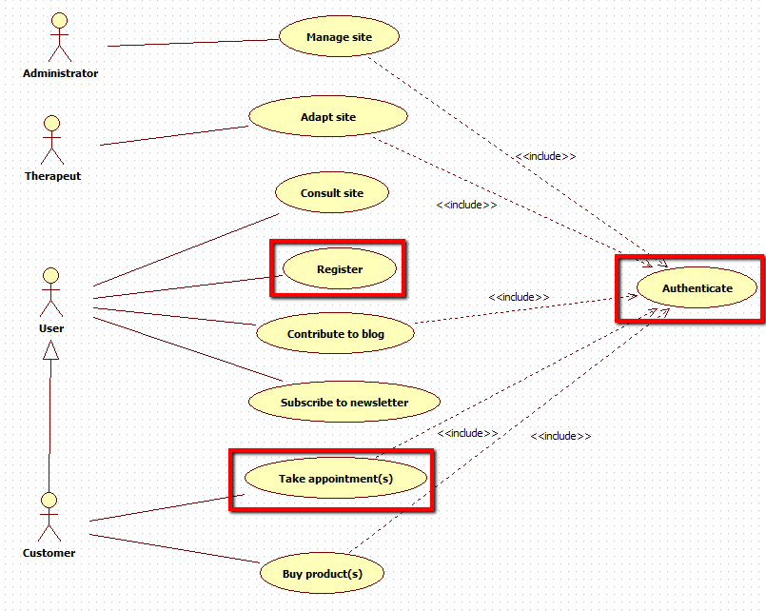

Replace H2 by MySQL

Tests unitaires

Put the project on heroku : [https://ostinato8.herokuapp.com](https://ostinato8.herokuapp.com/)