

Prog part 2

Benedict Tebogo Morokane



October 24, 2024

Table of Contents

Read Me file instructions 2

User Manual 3

# Read Me file instructions

Built using .NET Core, this project manages lecturers' claims on a monthly basis. These range from submission to verification of claims to uploading documents to tracing the claims in real time.

**Requirements:**

Ensure you have installed the following:

* SQL SERVER
* VISUAL STUDIO (with ASP.NET Core and SQL Server data tools installed)
* Git Hub

**Cloning the project:**

1. Open terminal
2. Navigate directory
3. Run the command

**Running the Application:**

1. Open the project in Visual Studio
2. After entering the project press F5 of click where it says “http” with a green logo on top.
3. It will take you straight to the web either google chrome or Microsoft edge, you can choose before running the project.

# User Manual

1. Home page

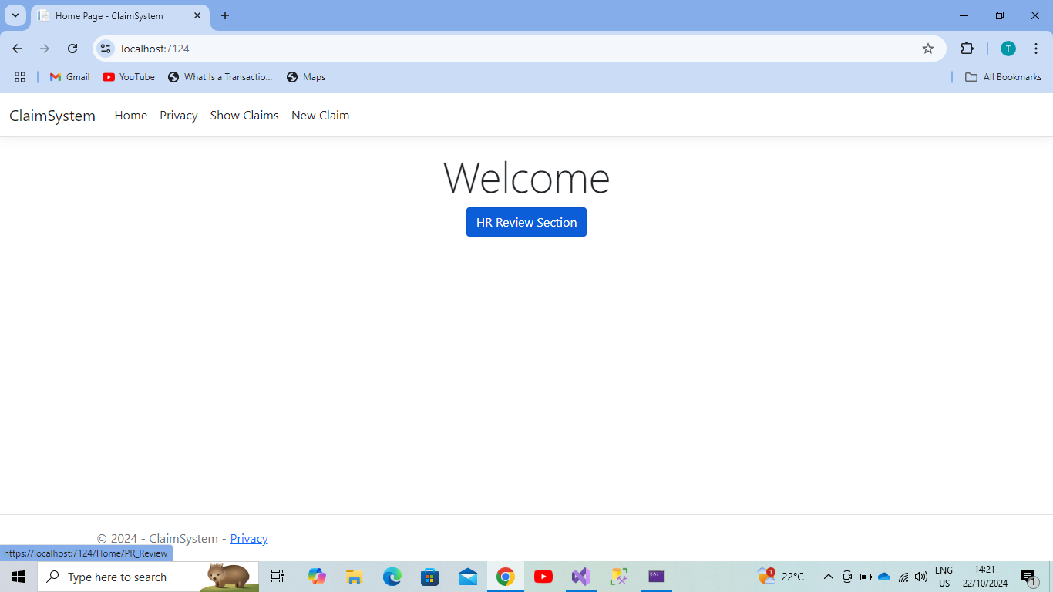

1. If you want to put the new claim, you’ll simply press “New Claims” and you will be taken to the New Claim page where you’ll be able to fill up the necessary information to be able to put the claim. This is what you will encounter:

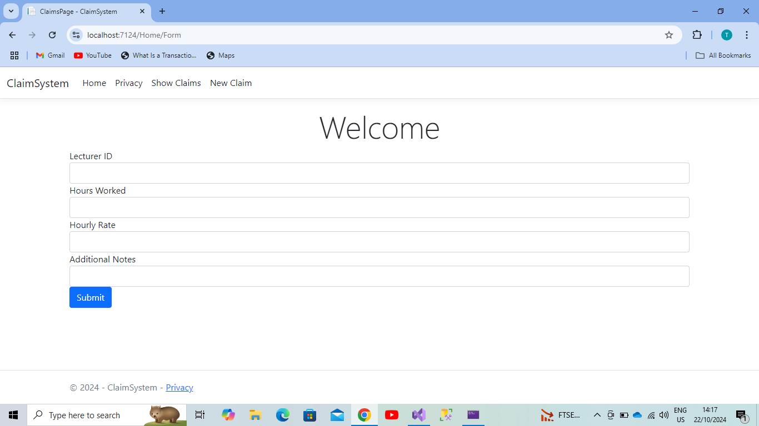

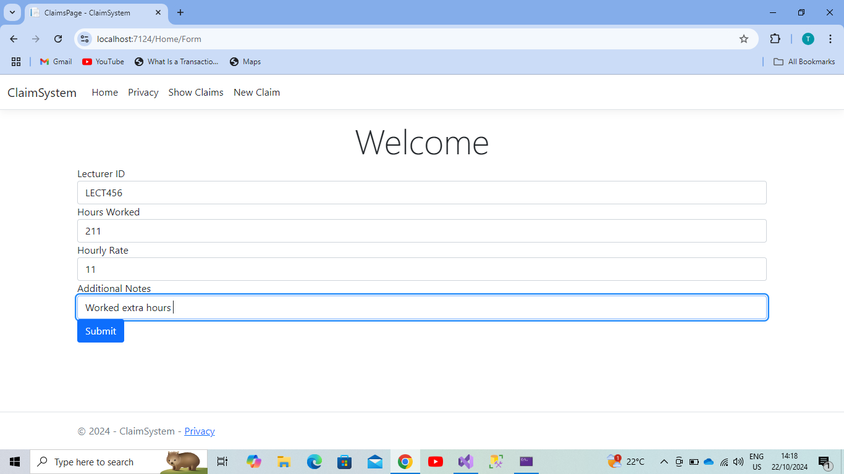

1. At this point after filling in the required information then you press the “Submit” button for your claim request to be submitted successfully. After pressing the “Submit” button it will take you to “Show Claims” page where you will see whether your application is approved, pending or rejected together with the details you have provided and the total amount. The image below shows exactly that:

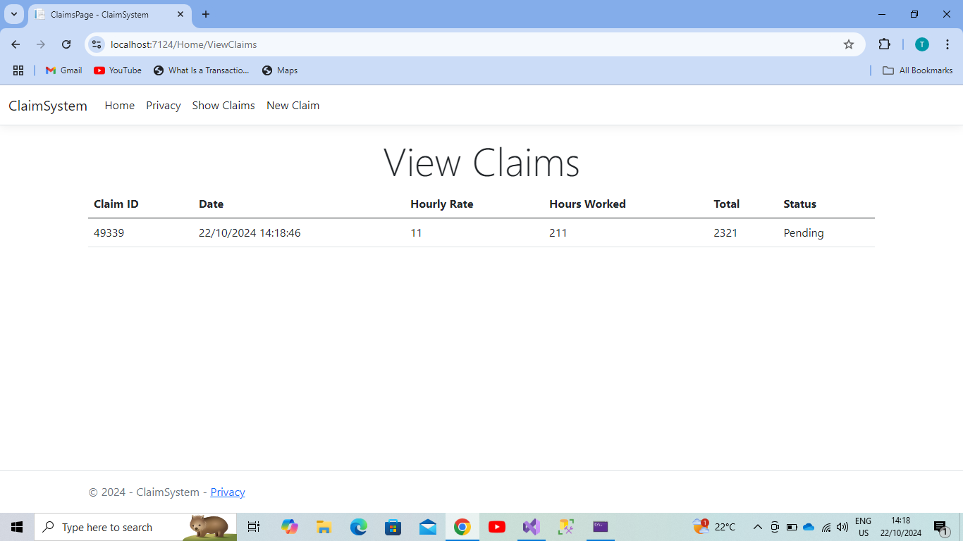

1. Then for the Academic Manager and Programme Coordinator page you will have to press the “HR Review Section” blue button on the “Home” page where they will be able to see the Lecturer’s details and be able to either approve or reject the claim. The Academic Manager and Programme Coordinator page looks like this:

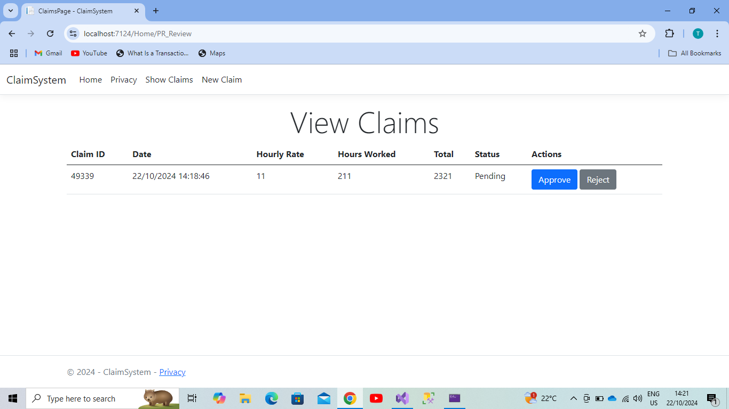

1. Then after rejection or approval it looks like this:

You will see “Pending” will turn to “Rejected” or “Approved” under Status column on the displayed table.

