**Supplement Figure 2: Model trace for Initial OAT treatment strategy**

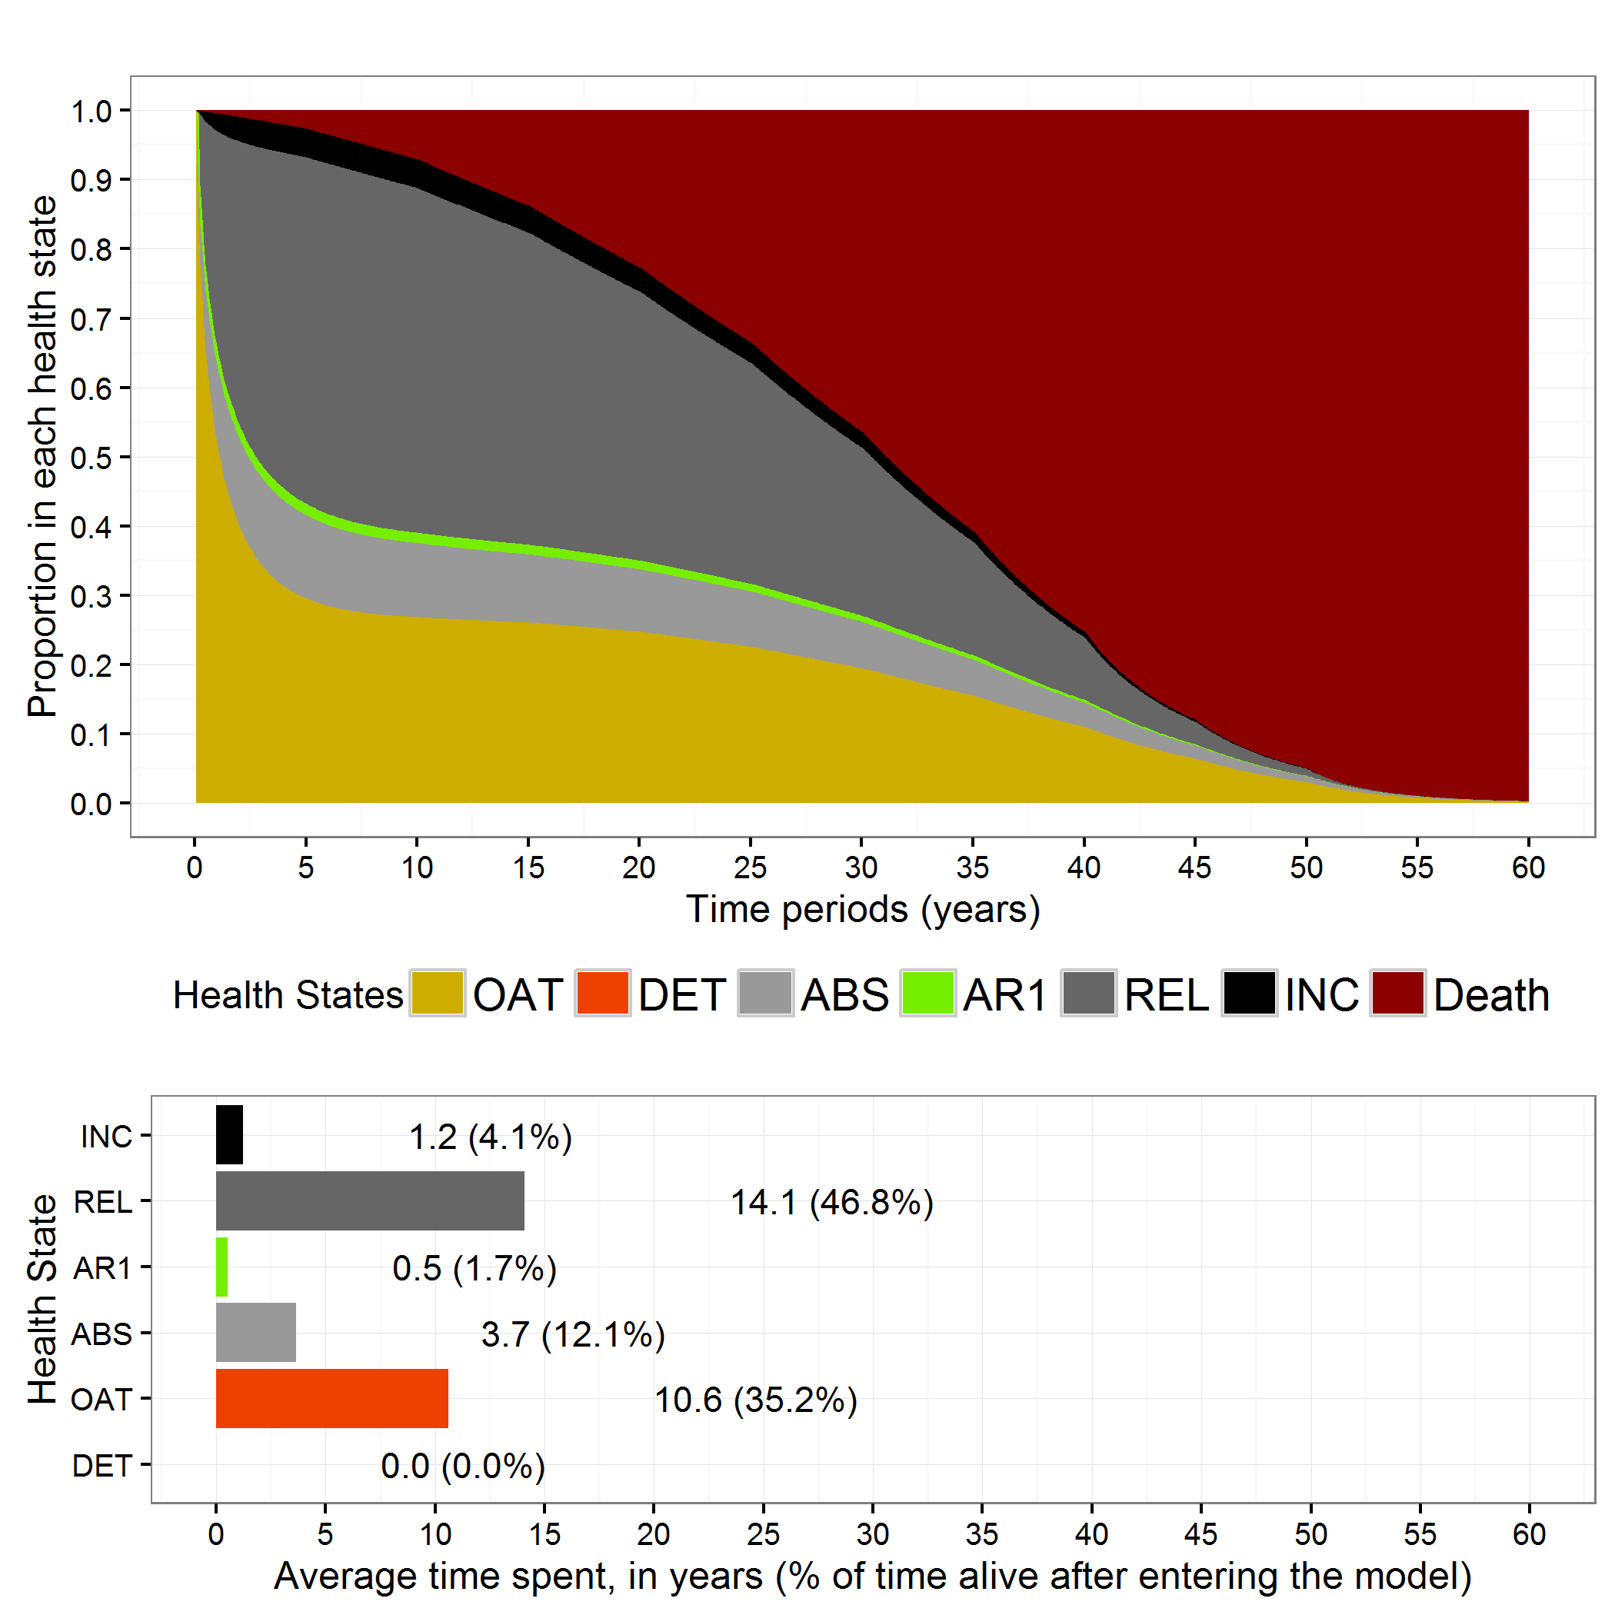

OAT: Opioid agonist treatment; DET: Medically managed withdrawal (detoxification); ABS: Abstinence; AR1: Acute relapse; REL: Relapse; INC: Incarceration; Initial OAT: all patients have immediate access to opioid agonist treatment with methadone with no restriction on the duration of treatment.