Kimi K2.5 / K2.6 / K2.7-Code in MXFP4 on AMD Instinct™ MI355X GPUs with ATOM outperforms NVIDIA B200
Authors: [@fty, @colorwinds, @jpy, @felix(++), @lingpeng(++), @bernard, @benenzhu, @xun, @daniel, @George, @Sunpeng, @guru] Date: [FILL: publication date] Tags: AI/ML, LLM, Inference, Optimization, Performance

Introduction
Serving Kimi K2.5/K2.6/K2.7-Code efficiently means keeping four things fast at once: the MLA attention kernels, the MoE GEMMs that dominate compute, the all-reduce collectives on every decode step's critical path, and the scheduler that decides when prefill is allowed to interrupt decode. Attention is already well covered by AITER's hand-tuned MLA kernels; this post is about pushing the other three on AMD Instinct™ MI355X GPUs with ATOM, running end-to-end in MXFP4, far enough to beat single-node NVIDIA B200.

At a Glance
- Kimi K2.5/K2.6/K2.7-Code (1T-parameter MoE) served in MXFP4 on a single MI355X node at TP=4 — the 4-bit weights fit comfortably in 4 × 288 GB of HBM3E, and one 8-GPU node hosts two independent TP4 replicas.
- Peak throughput of 5,369.6 tok/s/GPU on the 8k/1k workload, staying ahead of single-node NVIDIA B200 across multiple concurrency levels.
- Built together with the community: optimizations co-developed by AMD engineers and open-source contributors, merged upstream into AITER/ATOM/InferenceX through an AMD developer collaboration program.

Key Optimizations: From Kernel to Engine to Benchmark
Every gain in this post traveled the same three-stage, fully public pipeline: a kernel is optimized in AITER (ROCm/aiter, the AI Tensor Engine for ROCm), ATOM (ROCm/atom, AMD's PyTorch-native inference engine) wires it into serving, and the configuration lands in InferenceX, where it is re-measured continuously. We walk through each stage.

1. AITER: kernel-level optimization

1.1 Deeper-fused MXFP4 (A4W4) MoE backends for gfx950
The heart of Kimi K2.7-Code inference — and of every model on the shared K2 backbone — is the grouped GEMM inside the MoE block. AITER already ran this path in full A4W4 MXFP4 — activations and weights both entering the matrix units as 4-bit, using CDNA 4's native microscaling instructions with per-32-element E8M0 scales. The new backend (aiter #3832, building on #3470) rebuilds the MoE path around deeper fusion and Kimi-K2-specific tuning:
- Two grouped GEMMs, one fused bridge between them. The gate/up projection (gemm1) and the down projection (gemm2) run as two FlyDSL grouped GEMMs. Between them, a single kernel fuses the SwiGLU gate activation, the elementwise multiply, the MXFP4 quantization of the intermediate activations, and the E8M0 scale write in the sorted layout gemm2 expects — so the largest activation tensor in the model is never written out in high precision or re-read for a separate quantization pass.
- Inline activation quantization for decode. For small-batch decode shapes, gemm1 converts incoming bf16 hidden states to MXFP4 in its prologue as they are gathered, keeping quantization directly on the GEMM's input path.
- Sorting fused with the GEMM metadata. An adaptive MoE-sorting backend emits the token-gather metadata (m_indices / reverse-sorted indices) the grouped GEMM consumes, in the same pass rather than as a separate pre-step.
- Per-shape tuning for K2's experts. Tile shapes and split-K are tuned per expert shape (kimik2_fp4_tuned_fmoe.csv), and the per-32-element scale amax is computed with hardware DPP instructions instead of a separate reduction.
Two GEMM configurations are kept because MoE GEMMs live in two regimes — many small expert problems at decode, near-dense GEMM at prefill — so both ends of the Pareto curve benefit.
These kernels are authored in FlyDSL (ROCm/FlyDSL), ROCm's Python-first, MLIR-native kernel DSL that lets developers express tiling, layouts, and data movement at a high level without giving up expert-level performance — a big part of why community contributors can iterate on AITER kernels this quickly (see the FlyDSL introduction on ROCm Blogs).

1.2 Single-stage fused all-reduce at production batch sizes
Every transformer layer ends in an all-reduce that sits on the critical path of each decode step. AITER's Quick Reduce, the fused all-reduce ATOM uses over XGMI links, chooses between a low-latency one-stage algorithm and a lower-traffic two-stage one. aiter #3458 and aiter #3880 introduced TP-aware gating, selecting the one-stage path through batch 32 at TP4 and batch 16 at TP8 before switching to two-stage for larger decode batches. This keeps communication latency low at common serving batch sizes without sacrificing efficiency as concurrency grows.

1.3 Faster expert routing
Routing every token to 8 of 384 experts runs once per layer per decode step. aiter #3466 replaces the original top-k selection with a fused single-kernel reduction specialized for K2's expert count and group-routing scheme, trimming the per-step non-GEMM overhead that otherwise eats into decode throughput.

2. ATOM: wiring the kernels into the engine

2.1 Per-shape backend dispatch
Fast kernels only pay off if the engine picks them at the right moments. ATOM's dispatcher selects the MoE backend per shape, so the decode- and prefill-optimized A4W4 kernels each serve the regime they win in; AITER_MXFP4_INTERMEDIATE=1 turns on the 4-bit intermediate-activation path.

2.2 Prefill scheduling and parallelism
The engine-level tuning matters just as much. --scheduler-delay-factor 1 changes when ATOM admits new prefills into a busy decode loop: instead of greedily injecting them — which fragments decode batches and spikes every in-flight user's latency — the scheduler briefly accumulates prefills and co-schedules them, smoothing the concurrency-64/128 operating points at negligible TTFT cost. And the parallelism choice is deliberate: TP=4 keeps expert GEMMs above the kernels' efficiency knee and collectives cheap, so the InferenceX submission runs TP4 only.

3. InferenceX: shipping it and measuring it in the open
The last mile is the benchmark itself: bump the public rocm/atom image, set the two flags above, and let the harness sweep the workload at concurrency 4–128. Because InferenceX re-runs continuously, this stage is also the safety net — each merge is re-measured on the same public benchmark, so improvements show up on the dashboard within days and any regression is caught before it reaches users.

Performance Results
We benchmark with InferenceX's single-node fixed-sequence-length harness on the 8k/1k workload (ISL 8192 / OSL 1024), sweeping concurrency from 4 to 128 and plotting the resulting Pareto frontier of throughput (tok/s/GPU) versus interactivity (tok/s/user).
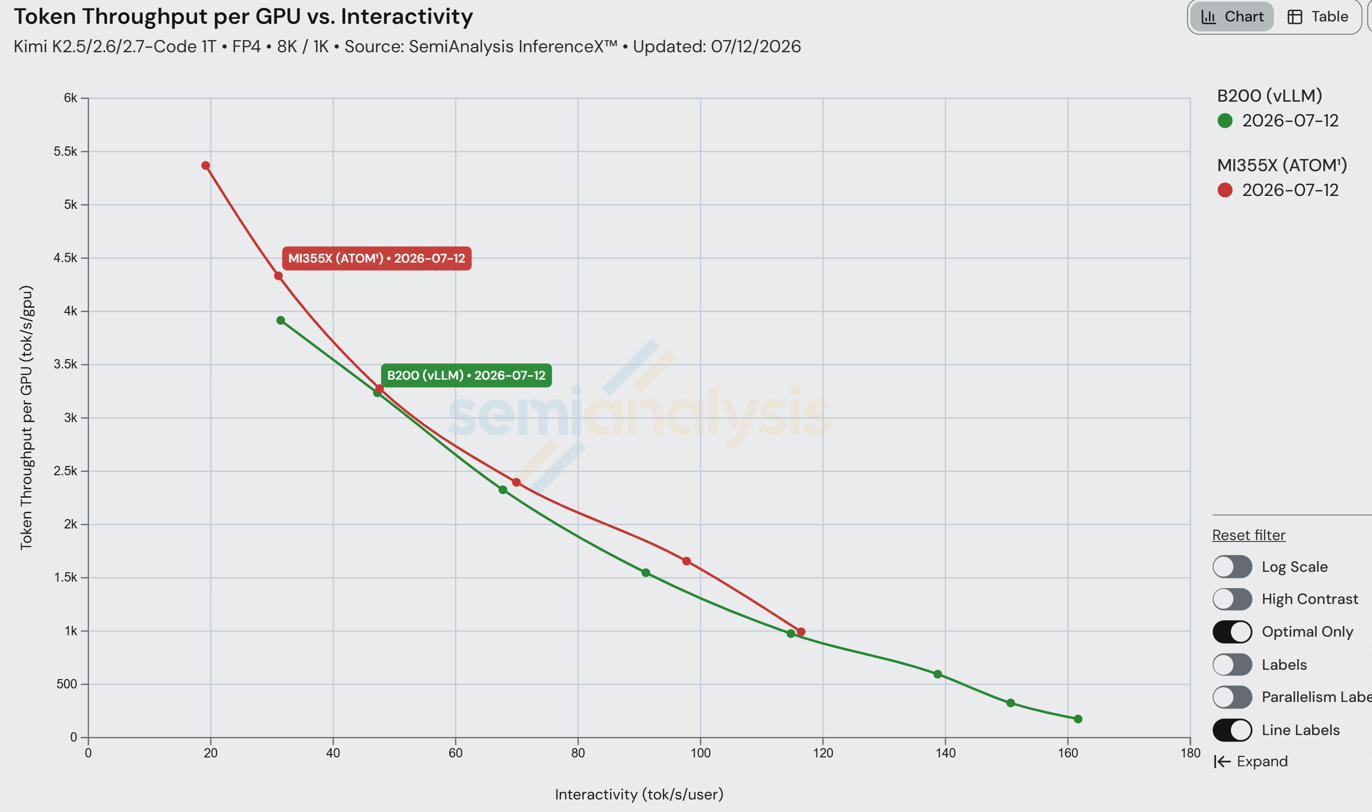
Figure 1: Throughput vs. interactivity, 8k/1k — MI355X + ATOM (MXFP4, TP4) vs. single-node B200. (source: InferenceX)
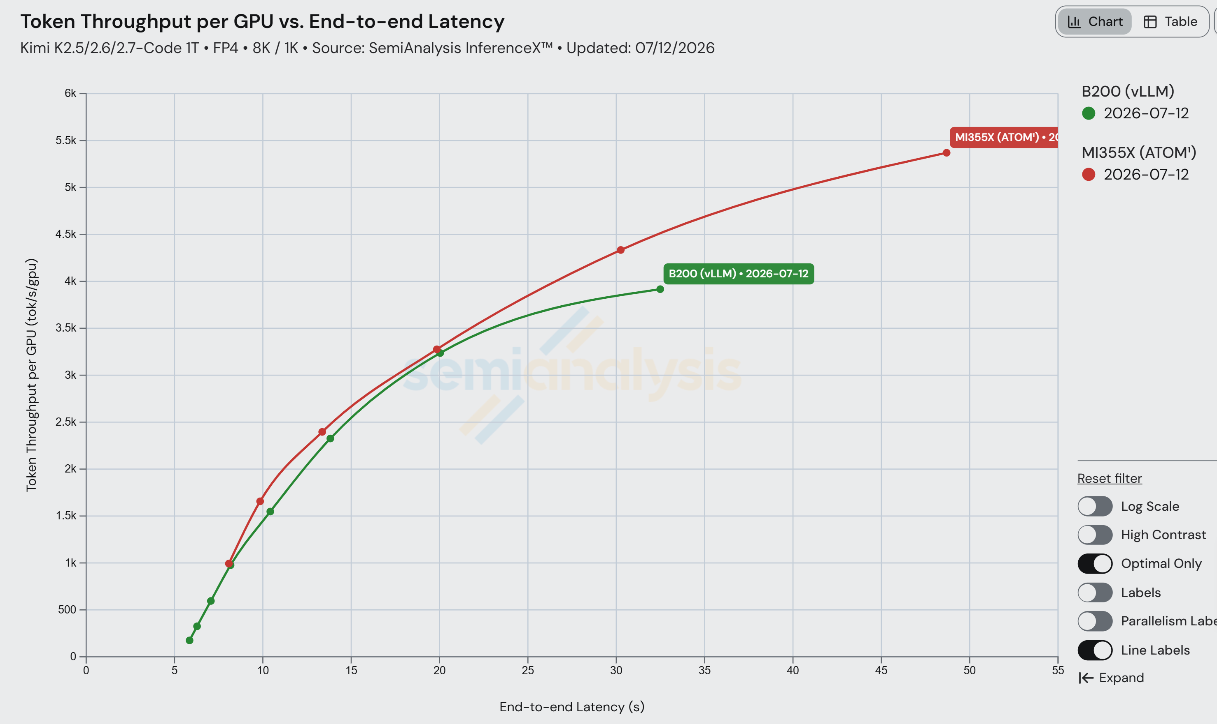
Figure 2: End-to-end latency vs. interactivity, same systems. (source: InferenceX)
On the 8k/1k workload, MI355X with ATOM reaches 5369.6 tok/s/GPU at concurrency 128 while sustaining 19.2 tok/s/user, and 116.4 tok/s/user at concurrency 4 on the interactive end. As Figure 1 shows, its Pareto frontier sits above single-node NVIDIA B200 (vLLM, NVFP4) across multiple concurrency levels — MI355X delivers more throughput at matched interactivity along the curve, not just at the peak.
Figure 2 tells the same story from the latency side: plotting end-to-end latency against interactivity, MI355X holds lower latency at matched interactivity, so users see faster responses at the same per-user token rate — the throughput lead in Figure 1 does not come at the cost of responsiveness.
This comparison is deliberately scoped to single-node serving. Rack-scale, disaggregated deployments — prefill/decode split across nodes with wide expert parallelism — are a separate deployment class that we'll cover on its own (see ATOMmesh in the roadmap below).

How to Reproduce
To serve Kimi K2 models with ATOM on MI355X and reproduce the numbers above, follow the official recipe: ATOM Kimi-K2 recipe — Launching Server. It pins the image, model, and serving flags used for these results.

Built With the Developer Community
The optimizations above were co-developed in the open by AMD engineers and community developers. Many of the ideas originated with the community; kernels, reviews, and benchmarks flowed in both directions; and everything landed as public PRs across AITER, ATOM, and InferenceX. The A4W4 MoE backend from the RadeonFlow team is one example, now shipping in the public rocm/atom image and selected by the dispatcher whenever it wins on a given shape.
Much of this grew out of an earlier AMD collaboration program that invited developers to push MI355X inference and rewarded the teams that met its performance bar [FILL: award amount, e.g. "with up to $XXK per team"]. The awards are real, but they are only part of the point: the lasting draw is a fully open stack where your work ships straight into production and is measured in the open, for everyone to build on.
The loop is open to anyone. If you have a faster kernel, a better scheduling heuristic, or a sharper configuration: write it (FlyDSL makes the kernel side far more approachable) and send a PR to AITER or ATOM — it ships in the open, reproducible by anyone. Open benchmarks like InferenceX give one fair, level field to compare results on, even though no single benchmark captures every workload and deployment. We are also upstreaming these optimizations into vLLM and SGLang, so the same gains will surface across those stacks over time. We want the ROCm software stack — kernels, serving engine, and everything around it, all open source — to be iterated by the community that runs on it.

Summary
Kimi K2.5/K2.6/K2.7-Code on MI355X is now a fully 4-bit serving stack: MXFP4 weights and activations through the MoE, running at TP=4 on a single node, at 5,369.6 tok/s/GPU on 8k/1k — ahead of single-node NVIDIA B200. The individual ingredients — A4W4 fused MoE kernels, the collective-strategy gating fix, a faster router, and calmer prefill scheduling — are each modest; compounded, and traveling the AITER → ATOM → InferenceX pipeline in public, they move the frontier past B200.
And more is coming: Two-Batch Overlap and DP Attention for the Kimi K2 family, ATOMmesh — ATOM's distributed serving layer with prefill/decode disaggregation for multi-node deployments — and the vLLM/SGLang upstreaming mentioned above.

Additional Resources
- ATOM on GitHub · AITER on GitHub · FlyDSL on GitHub
- InferenceX benchmark platform
- Upstream kernel PRs: aiter #3470 (A4W4 MoE), aiter #3832 (RadeonFlow A4W4 MoE), aiter #3466 (TopK), aiter #3458 / #3880 (fused all-reduce)
- Related reading: FlyDSL: Expert GPU Kernel Development with a Python-Native DSL · DP Attention and TBO for DeepSeek-V4 on MI355X

[FILL: standard ROCm blogs disclaimer / endnotes block — testing configuration, date of measurement, system details (CPU, ROCm version, ATOM version, node config 8× MI355X), and the B200 comparison source & date.]

