ASSIGNMENT – II

NAME: SOUMYADIP GHOSH

STREAM: CSE-A

ROLL NUMBER: 1951007

SUBJECT: MICROPROCESSORS LAB

Problem 1a: Write an ALP of 8085 to glow the LEDs connected in Port A, following the status of Switches connected in Port B of a PPI 8255a. Draw the block diagram.

Solution:

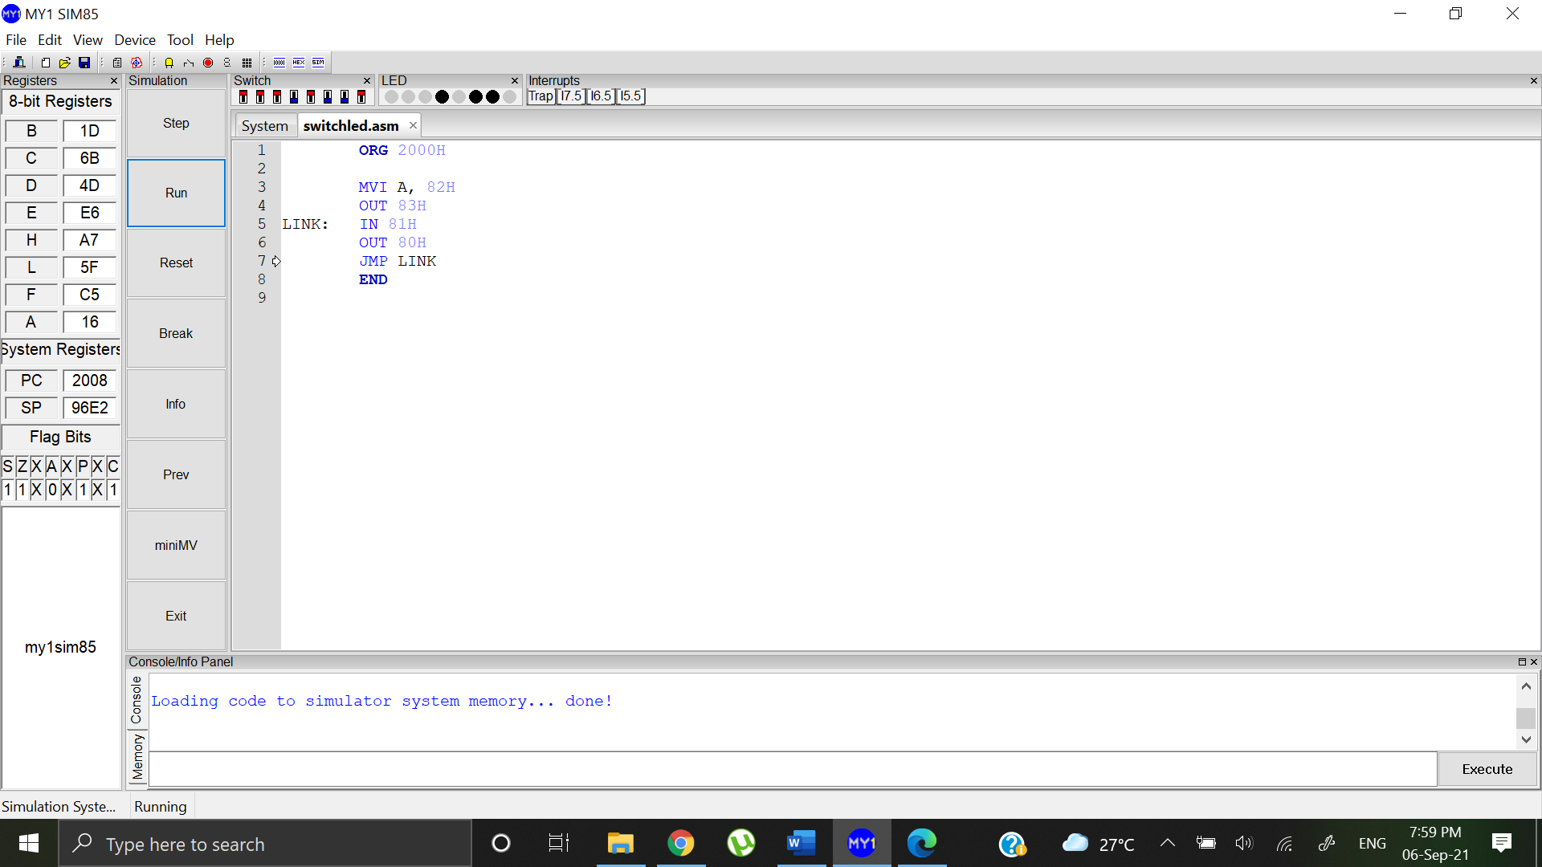

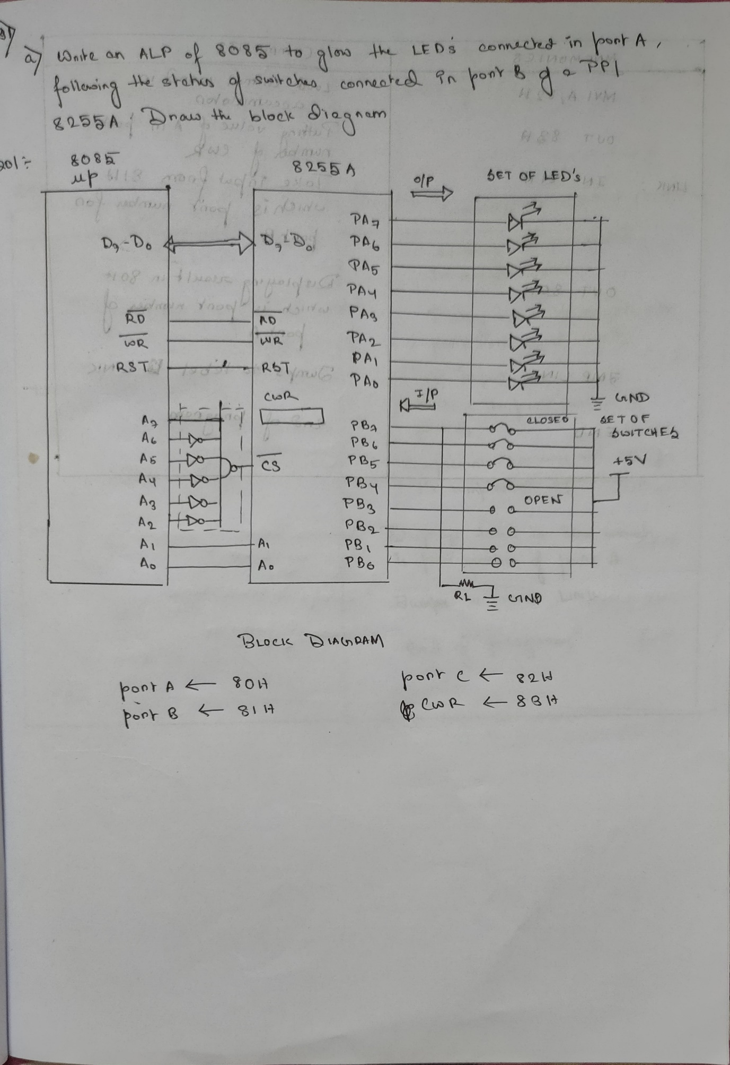

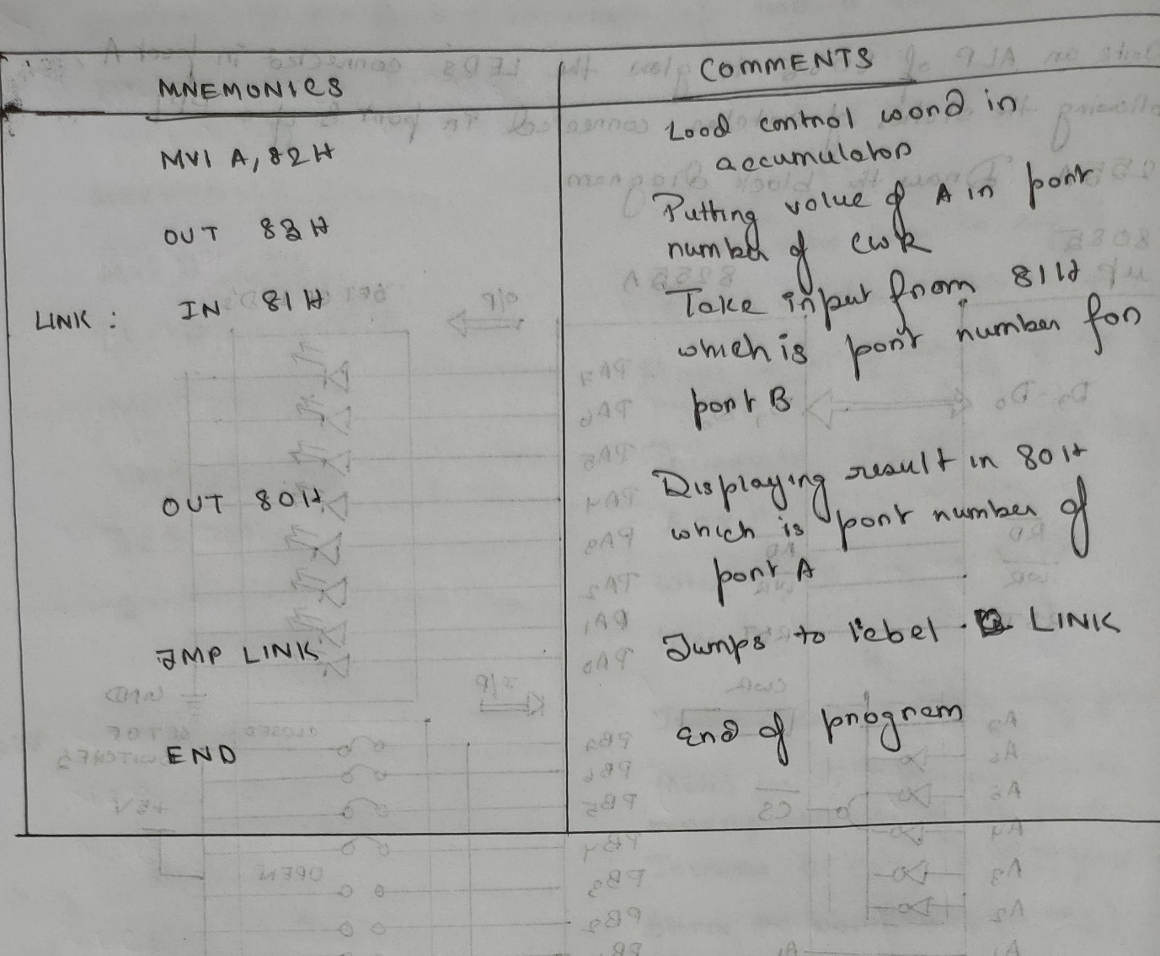

Problem 1b: Write an ALP of 8085 to glow the LEDs connected in Port A, in complemented fashion of the status of Switches connected in Port B of a PPI 8255a.

Solution:

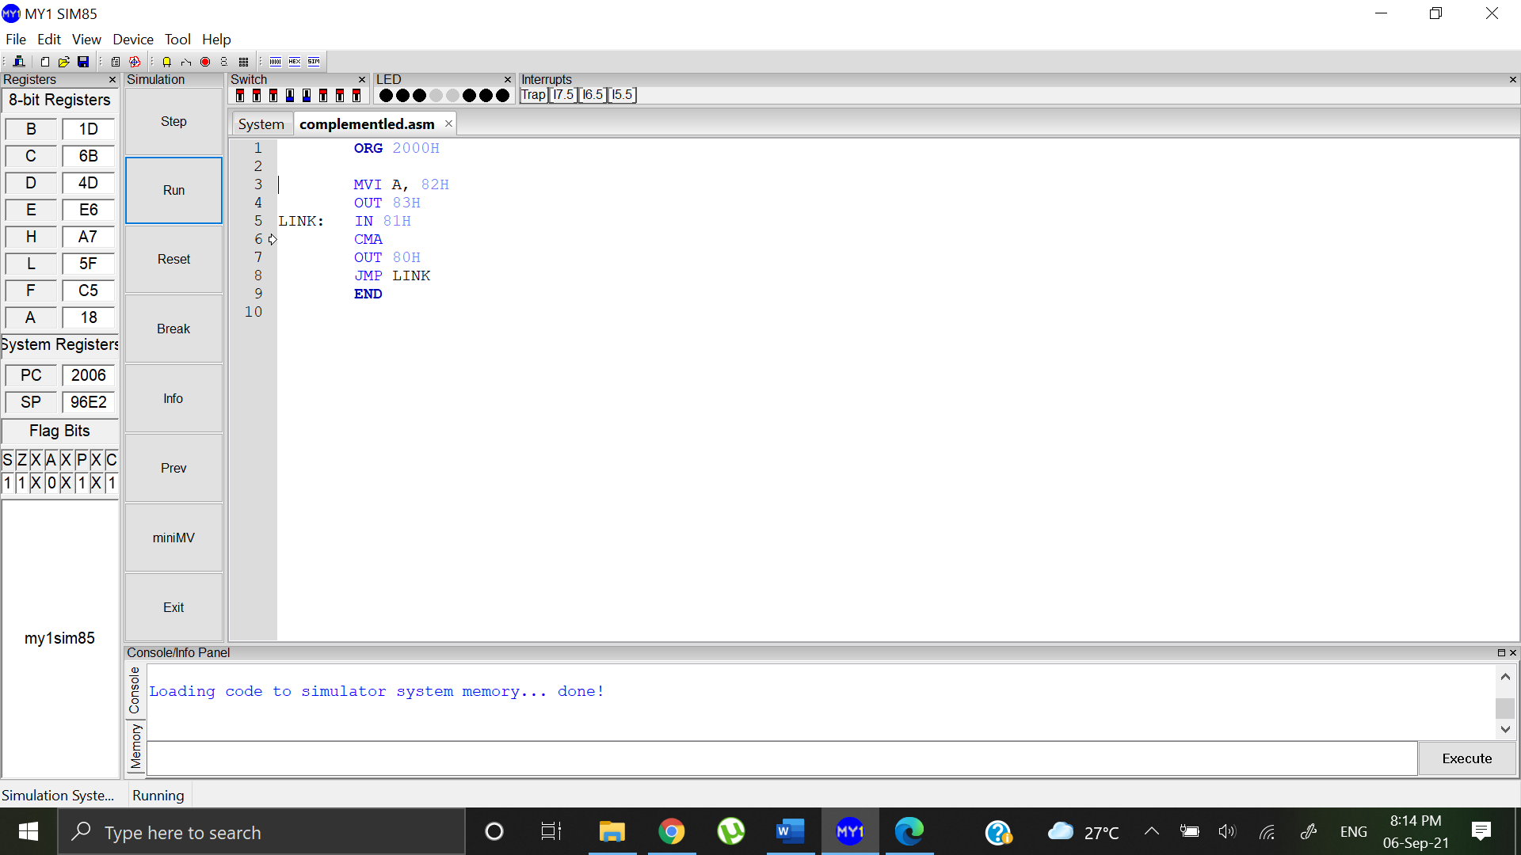

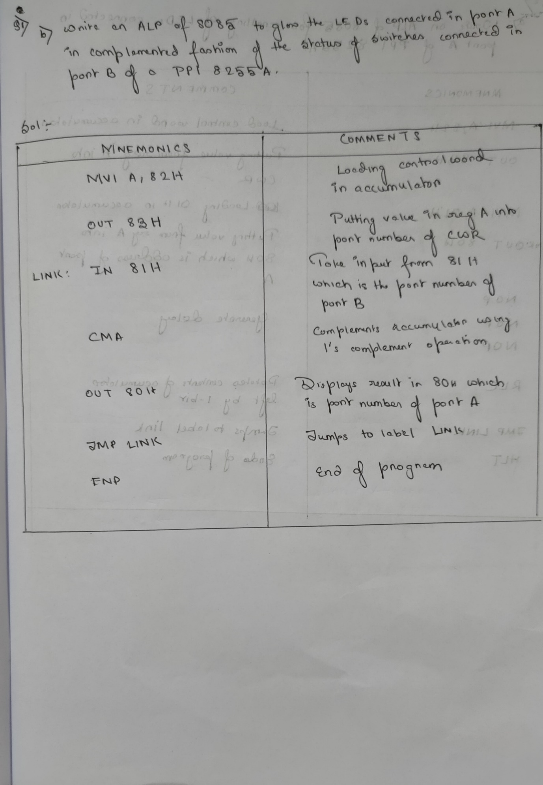

Problem 2a: Write an ALP of 8085 for the scrolling of LEDs connected in Port A of a PPI 8255a.

Solution:

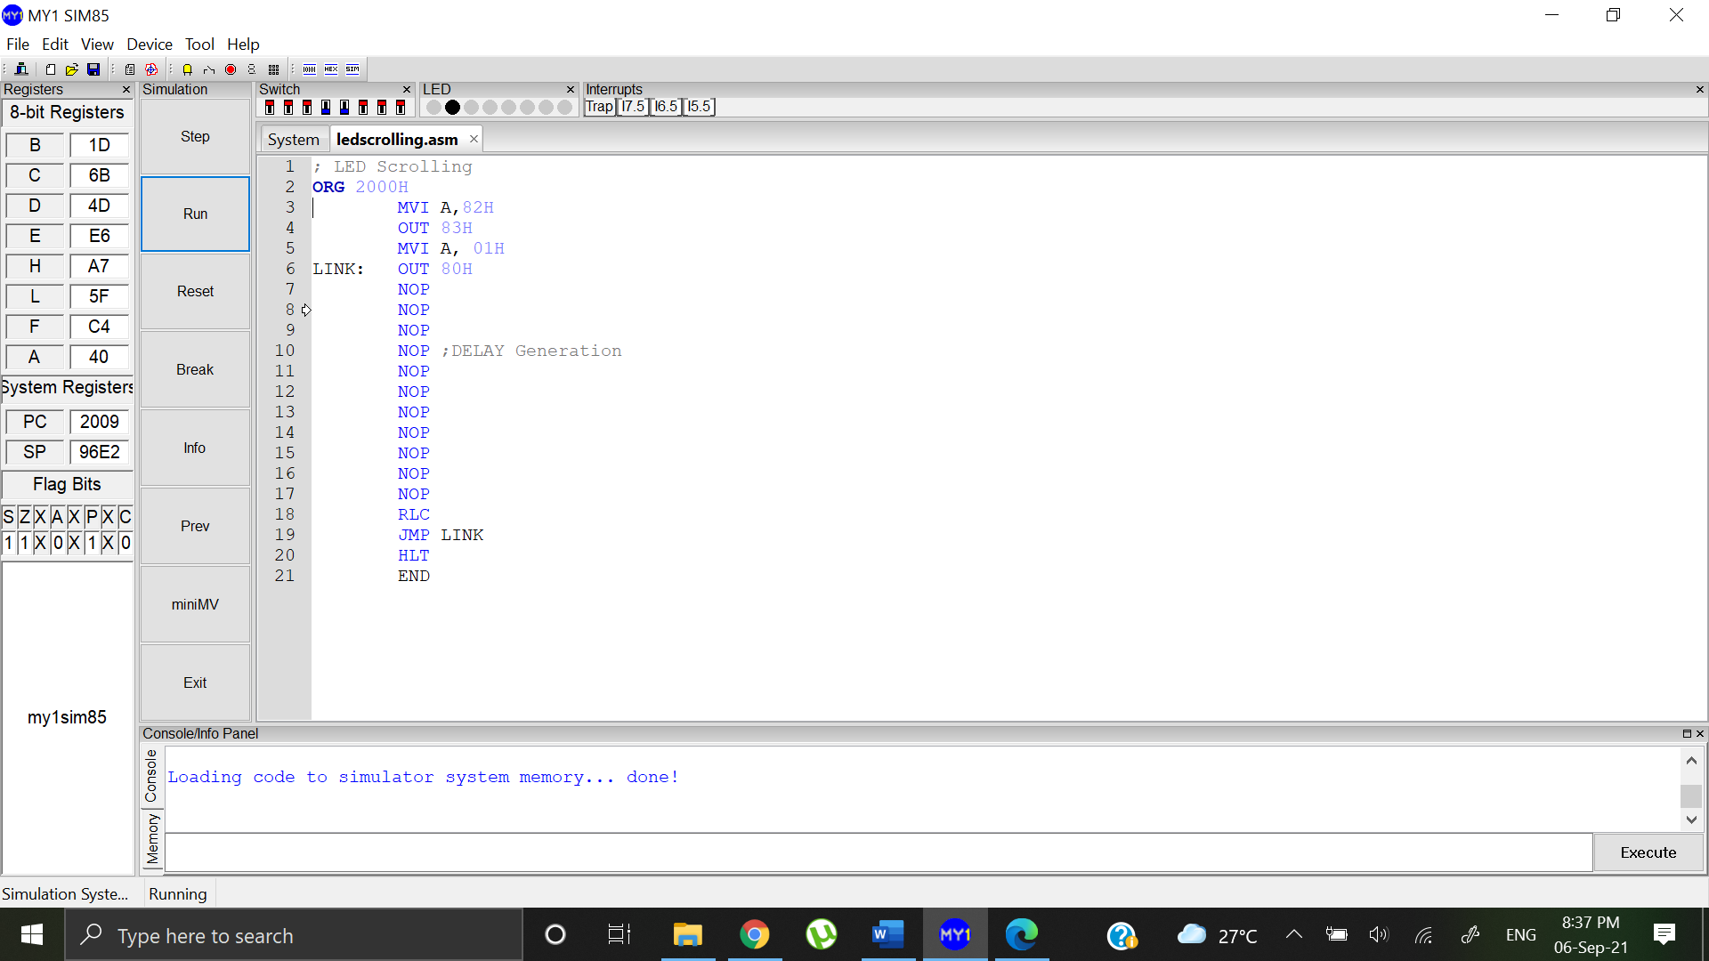

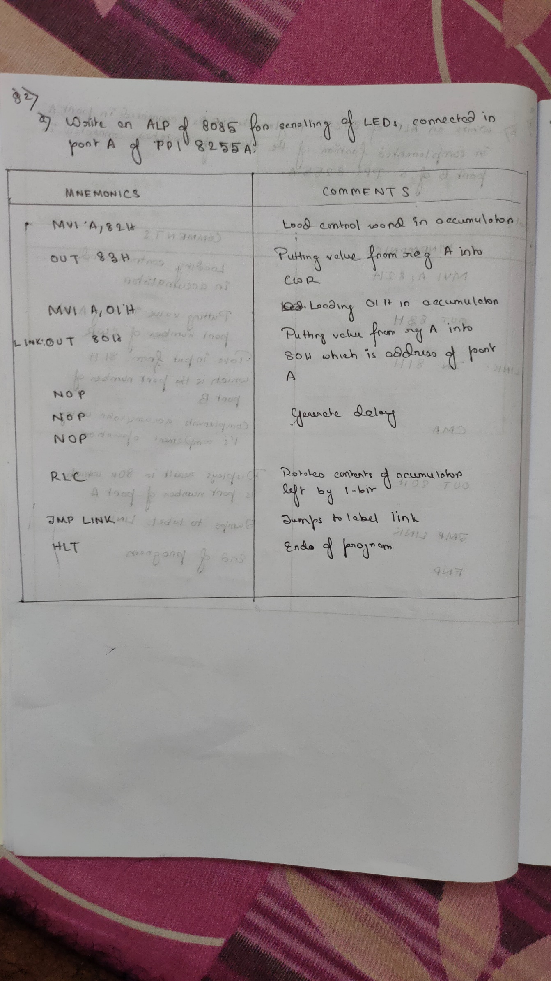

Problem 2b: Write an ALP of 8085 for the blinking of LEDs connected in Port A of a PPI 8255a.

Solution:

