ASSIGNMENT -III

NAME: SOUMYADIP GHOSH

STREAM: CSE-A

ROLL NUMBER: 1951007

SUBJECT: MICROPROCESSORS LAB

Circuit Diagram:

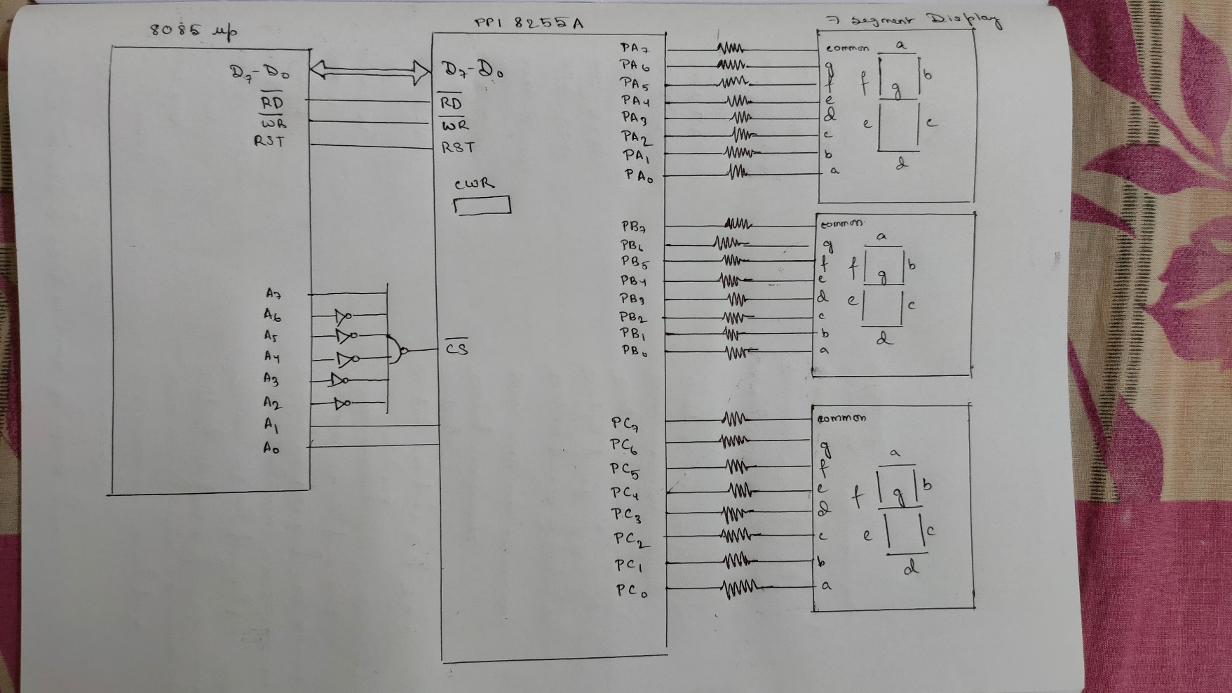

Question 1a:

Write an ALP of 8085 to glow CSE/ HIT (HIT) in Three Seven Segment Displays, connected through 8-bit Latches individually.

Code:

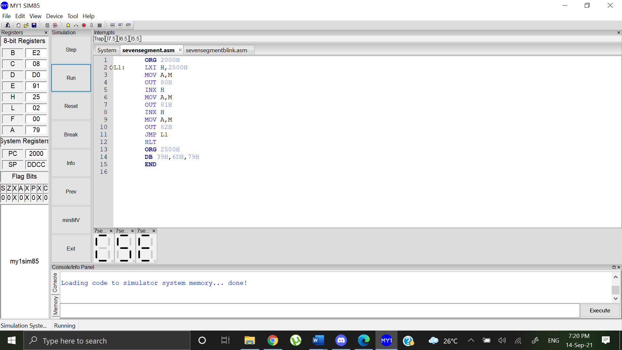

Output:



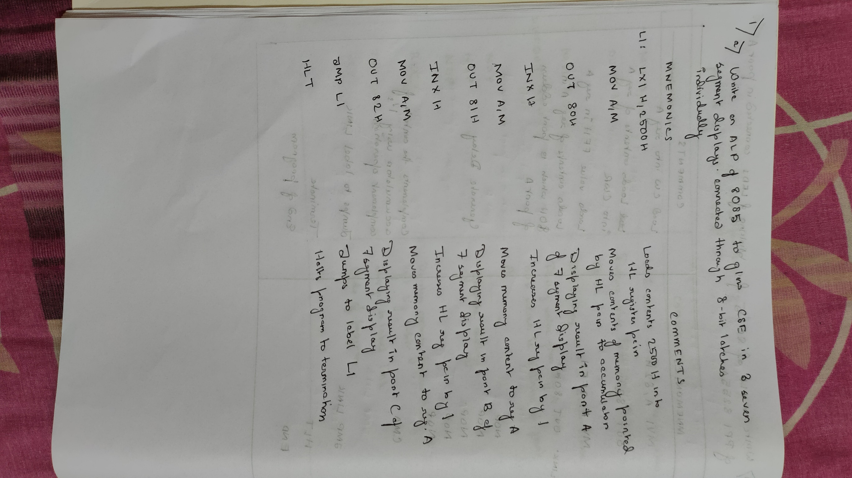

Question 1b:

Write an ALP of 8085 to blink the above glow.

Code:

ORG 2000H

LXI SP,3FFFH

MVI A,80H

OUT 83H

L1: LXI H,2500H

MOV A,M

OUT 80H

INX H

MOV A,M

OUT 81H

INX H

MOV A,M

OUT 82H

CALL 2600H ;subroutine DELAY

MVI A,00H

OUT 80H

OUT 81H

OUT 82H

CALL 2600H ;subroutine DELAY calling

JMP L1

ORG 2600H

MVI C,10H

L2: DCR C

JNZ L2

RET

ORG 2500H

DB 39H,6DH,79H

END

