ASSIGNMENT- IV

NAME: SOUMYADIP GHOSH

STREAM: CSE-A

ROLL NUMBER: 1951007

SUBJECT: MICROPROCESSORS LAB

INTERFACING OF 8051 WITH DAC AND LED DISPLAY

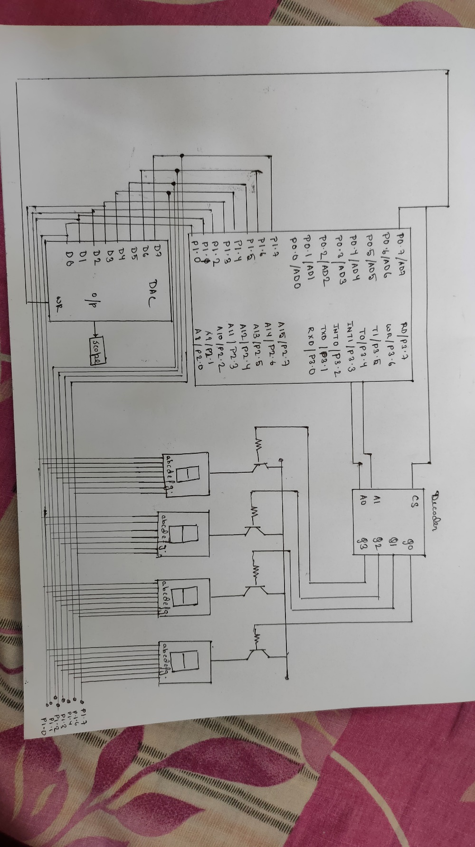

Question 1: Write an ALP of 8051 displaying the numbers 0 to 9 and back to 0 on the first 7-

segment display in continuous loop. Draw the interfacing diagram of 8051 with

Seven segment displays.

Code:

ORG 00H

MOV 30H, #11000000B

MOV 31H, #11111001B

MOV 32H, #10100100B

MOV 33H, #10110000B

MOV 34H, #10011001B

MOV 35H, #10010010B

MOV 36H, #10000010B

MOV 37H, #11111000B

MOV 38H, #10000000B

MOV 39H, #10010000B

MOV 3AH, #0

CLR P3.4

CLR P3.3

L1: MOV R0,#30H

L2: MOV A, @R0

JZ L1

MOV P1,A

INC R0

JMP L2

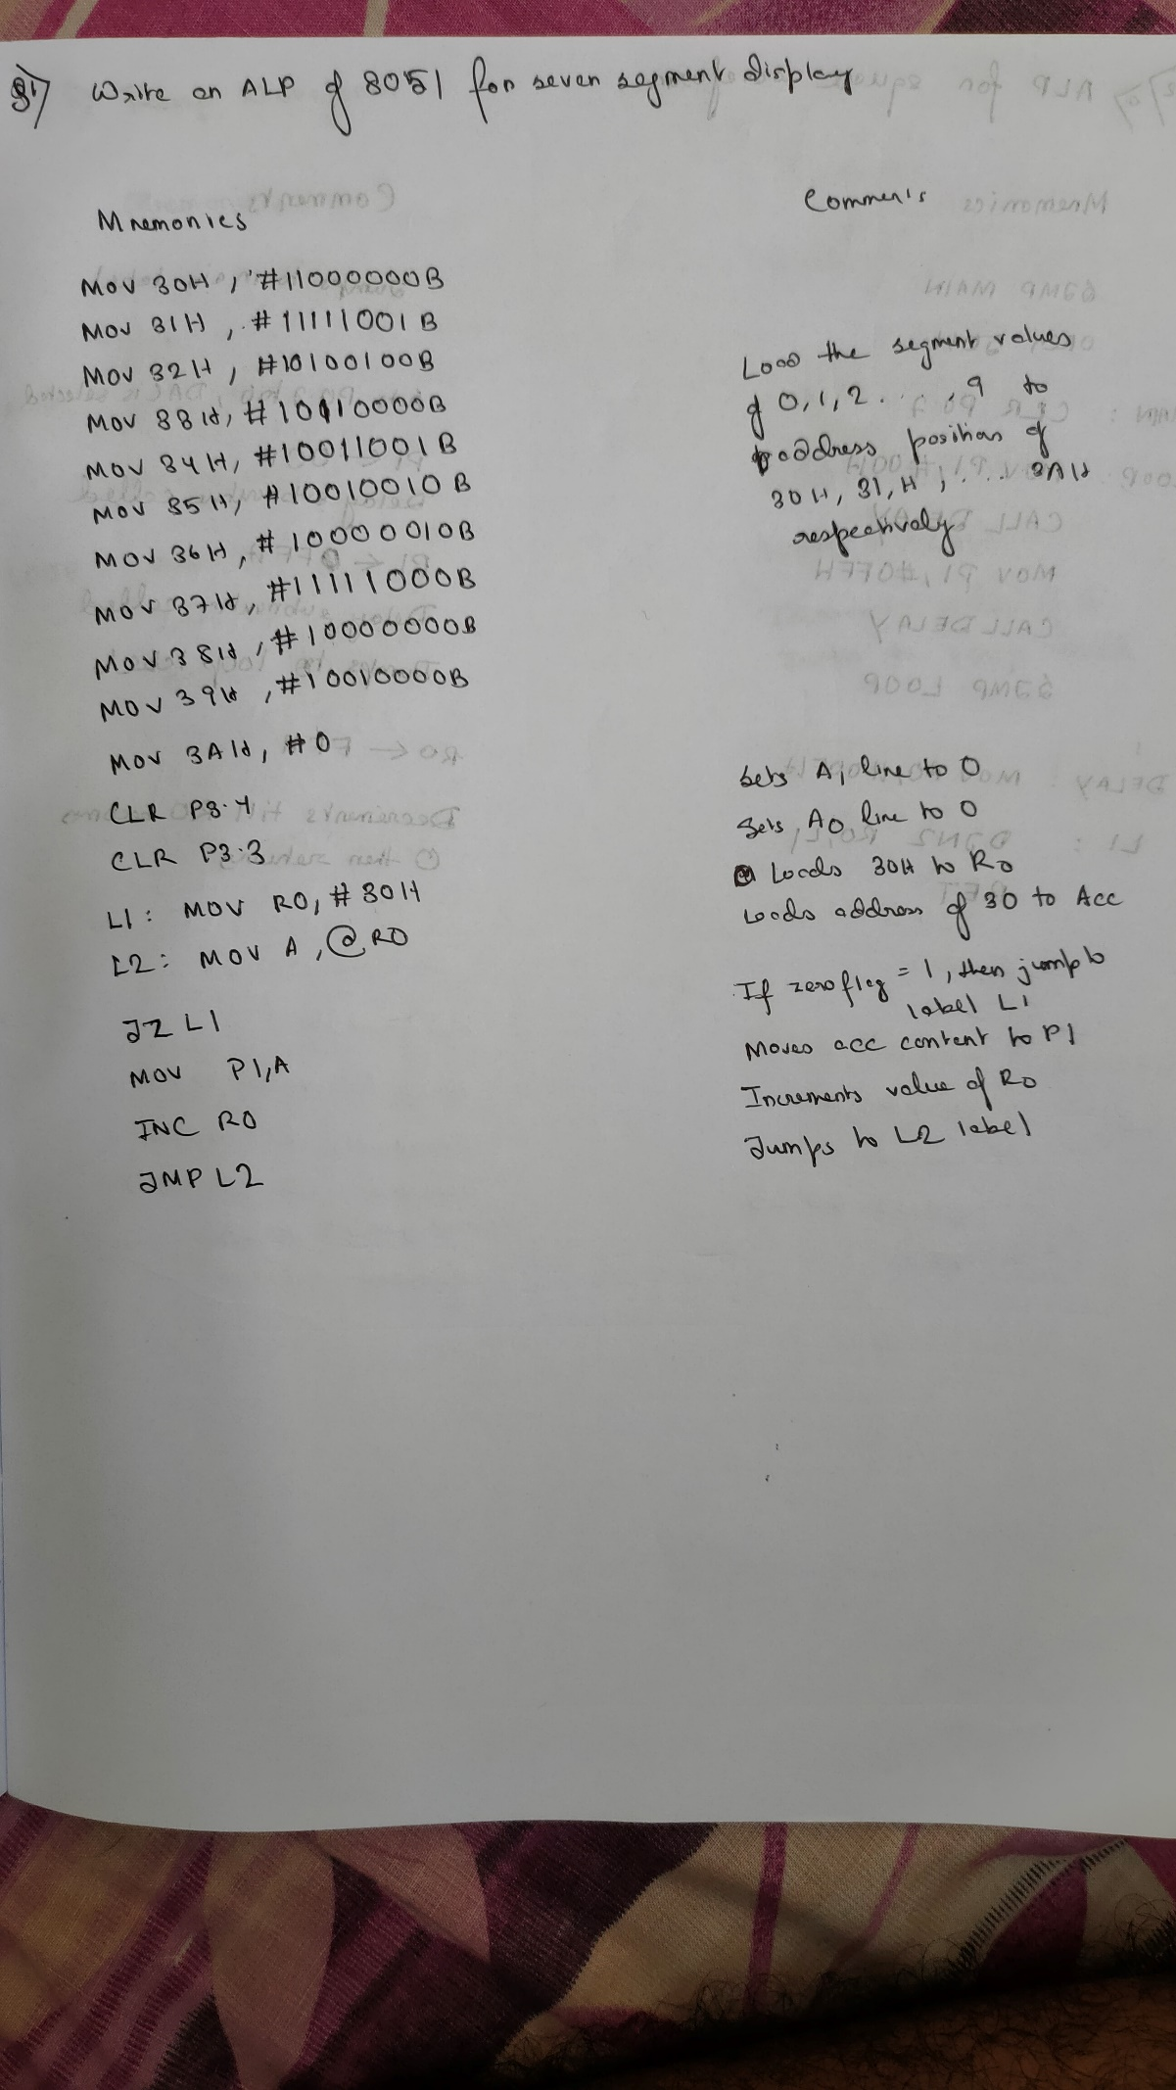

Question 2: Write an ALP of 8051 to generate square, ramp, saw tooth waveform. Show the DAC output on SCOPE. Draw the interfacing connection of 8051 and DAC.

Square Waveform Code:

ORG 00H

SJMP MAIN

ORG 50H

MAIN: CLR P0.7

LOOP: MOV P1, #00H

CALL DELAY

MOV P1, #0FFH

CALL DELAY

SJMP LOOP

DELAY: MOV R0, #00FH

L1: DJNZ R0,L1

RET

Output:

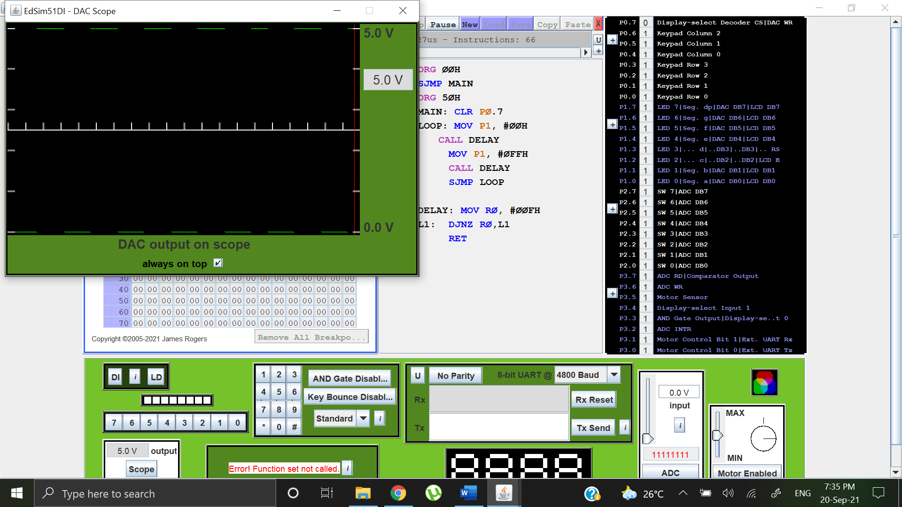

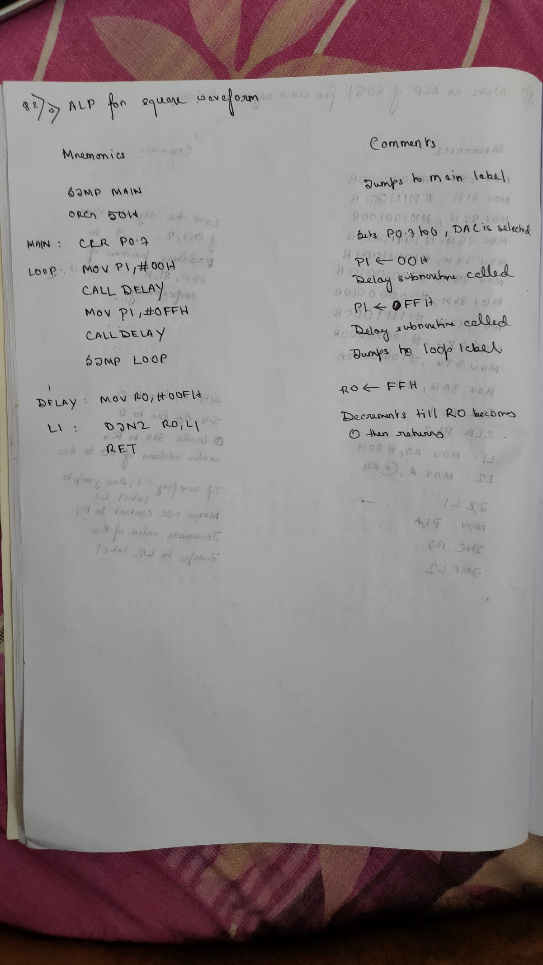

Ramp Waveform:

Code:

ORG 00H

SJMP MAIN

ORG 50H

MAIN: CLR P0.7

MOV A, #00H

LOOP: MOV P1,A

INC A

SJMP LOOP

Output Waveform:

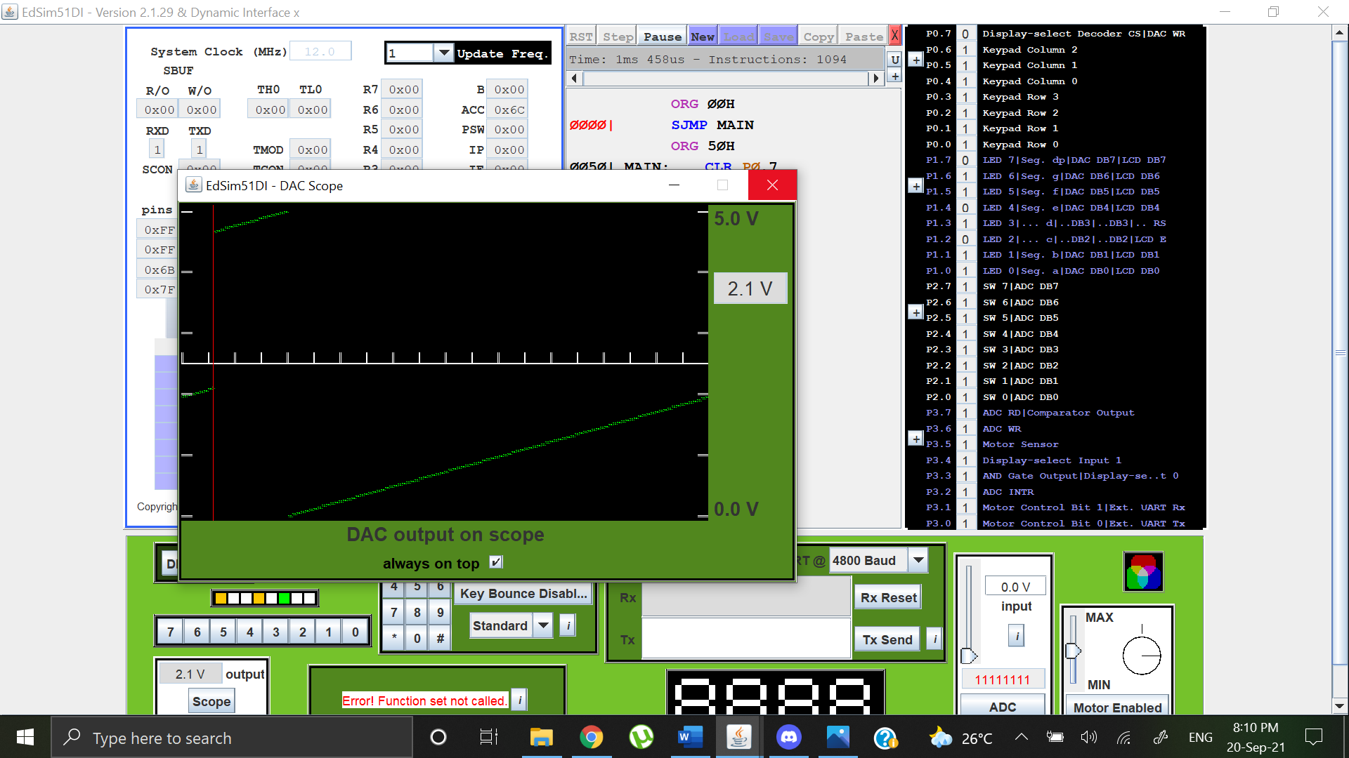

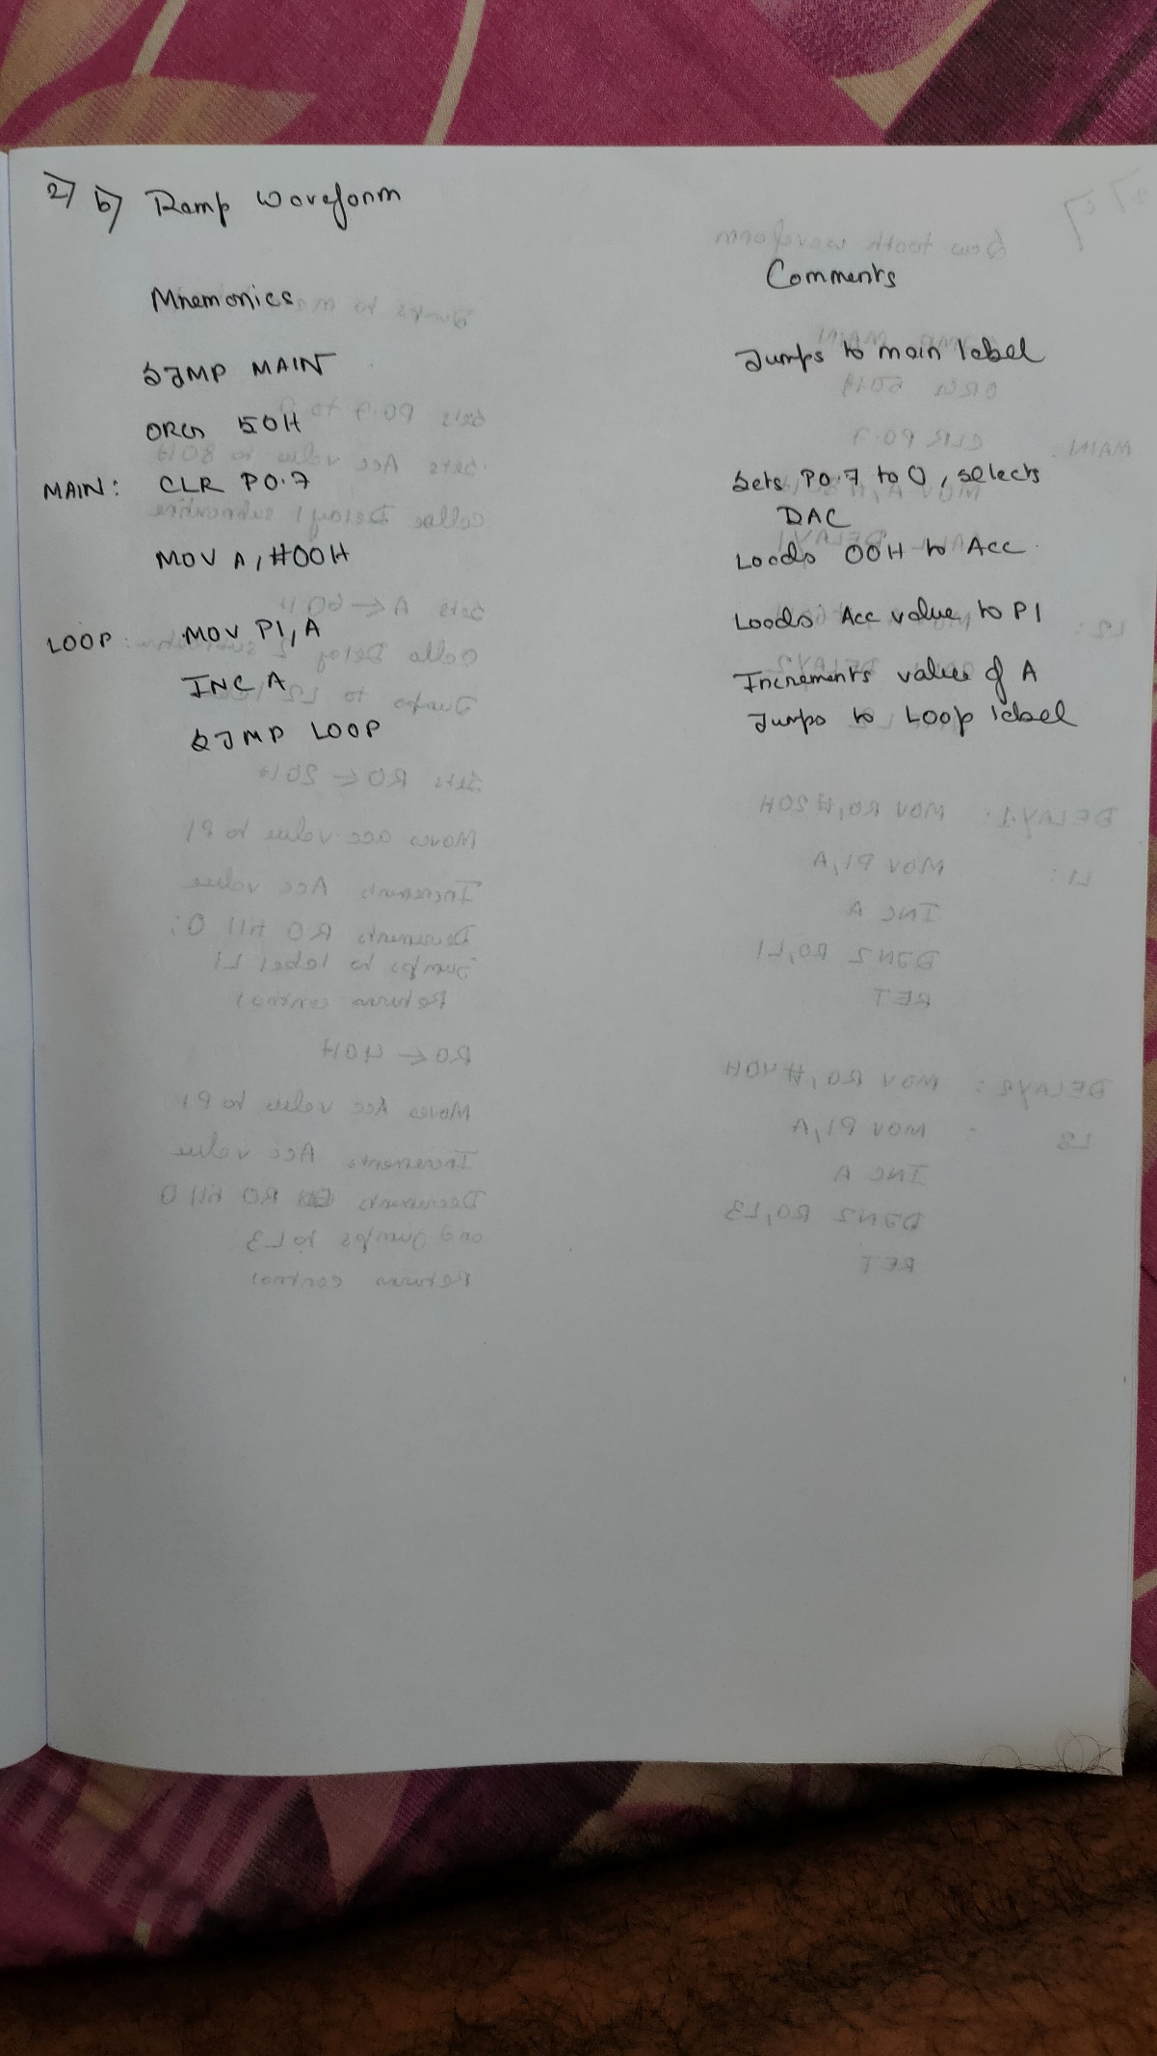

Saw Tooth Waveform:

Code:

ORG 00H

SJMP MAIN

ORG 50H

MAIN: CLR P0.7

MOV A, #80H

CALL DELAY1

L2: MOV A, #60H

CALL DELAY2

JMP L2

DELAY1: MOV R0,#20H

L1: MOV P1,A

INC A

DJNZ R0,L1

RET

DELAY2: MOV R0,#40H

L3: MOV P1,A

INC A

DJNZ R0,L3

RET

Output Waveform:

