ASSIGNMENT- IV

NAME: SOUMYADIP GHOSH

STREAM: CSE-A

ROLL NUMBER: 1951007

SUBJECT: ALGORITHMS LAB

Question:

To Implement the Network Flow Algorithm (Ford-Fulkerson Algorithm) in C consider the following things,  
1. Input should be taken from keyboard  
2. Print the Max Flow of the Network

Code:

#include <stdio.h>

#include<stdlib.h>

#define min(a,b) (((a)<(b))?(a):(b))

#define A 0

#define B 1

#define C 2

#define MAX_NODES 1000

#define O 999999999

int n;

int e;

int capacity[MAX_NODES][MAX_NODES];

int flow[MAX_NODES][MAX_NODES];

int color[MAX_NODES];

int pred[MAX_NODES];

int head, tail;

int q[MAX_NODES + 2];

void enqueue(int x) {

q[tail] = x;

tail++;

color[x] = B;

}

int dequeue() {

int x = q[head];

head++;

color[x] = C;

return x;

}

int bfs(int start, int target) {

int u, v;

for (u = 0; u < n; u++) {

color[u] = A;

}

head = tail = 0;

enqueue(start);

pred[start] = -1;

while (head != tail) {

u = dequeue();

for (v = 0; v < n; v++) {

if (color[v] == A && capacity[u][v] - flow[u][v] > 0) {

enqueue(v);

pred[v] = u;

}

}

}

return color[target] == C;

}

int fordFulkerson(int src, int dest) {

int i, j, k;

int max_flow = 0;

for (i = 0; i < n; i++) {

for (j = 0; j < n; j++) {

flow[i][j] = 0;

}

}

while (bfs(src, dest)) {

int increment = O;

for (k=n - 1; pred[k] >= 0; k = pred[k]) {

increment = min(increment, capacity[pred[k]][k] - flow[pred[k]][k]);

}

for (k = n - 1; pred[k] >= 0; k = pred[k]) {

flow[pred[k]][k] += increment;

flow[k][pred[k]] -= increment;

}

max_flow += increment;

}

return max_flow;

}

int main() {

int s, t,weight,i,src,dest;

printf("\nEnter the number of vertices and edges:");

scanf("%d %d",&n,&e);

for (int i = 0; i < n; i++) {

for (int j = 0; j < n; j++) {

capacity[i][j] = 0;

}

}

for(i=0;i<e;i++){

printf("\nEnter the source node and the destination node and weight for edge %d:",i+1);

scanf("%d %d %d",&src,&dest,&weight);

capacity[src][dest]= weight;

}

printf("\nEnter the source and sink:");

scanf("%d %d",&s,&t);

printf("\nMax Flow of the Network: %d", fordFulkerson(s, t));

}

Output Screen:

Input Graph:

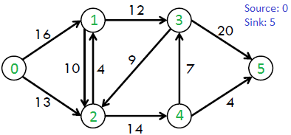

Output Screen:

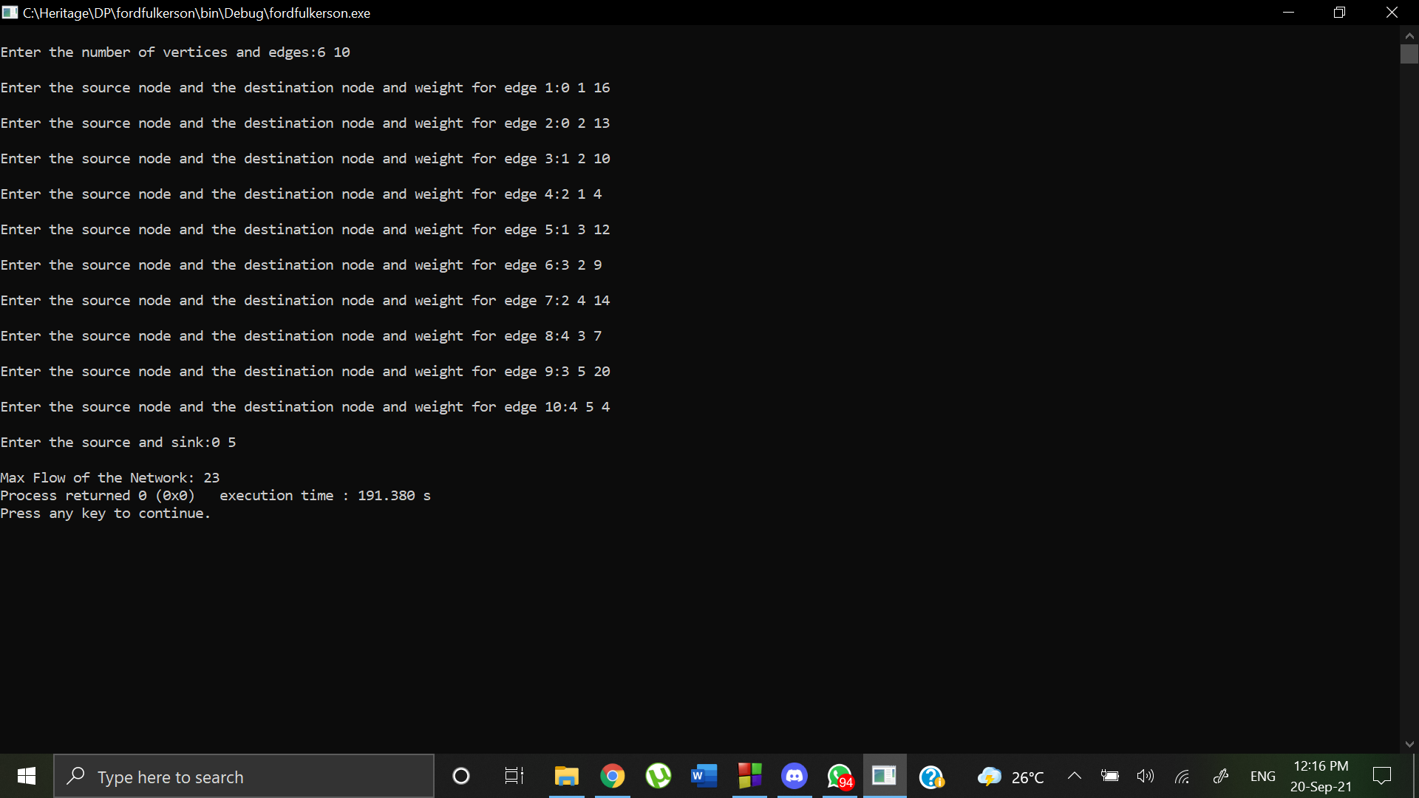

Input Graph:

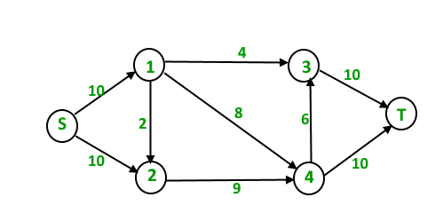

Output Screen:

