Course 03-BB-711.01
Cognitive Systems

Exercise #1
Documentation

Ben Thitigal: ben@tzi.de
Phillip Möller: pmoeller@tzi.de
Stefan Finke: sfinke@tzi.de

Table of Contents
Approach 3
Model 3
Tests/Reflection 4

Approach

Since we want our program to understand a task given and solve it in a way the cognitive system of a human would, we have put effort into testing the process on ourselves multiple times. We collected a number of pictures that show an amount of basic geometric shapes in different colors and tasked each other to find a requested shape in a specific color. We asked ourselves for amount and position on the picture. Based on our findings we figured that when no other hint is given beyond that the test-subject will be shown a picture, that human sight wanders to the center of the picture in first instance. We believe that as soon as the boundaries of the picture is sighted and understood by the human mind, that the focus wanders directly into the center of the picture to gain a quick understanding of the whole graphical body. From there the focus may wander into different directions depending on what stimulus may reach our perception, a general tendency towards the upper left corner was found. This we explain by the reading direction that is prominent in the western culture which goes from left to right and up to down.

Our program gets a new unknown two-dimensional array that is filled with different values. Based on our findings we found it to be realistic that our iteration starts at the center of the array and goes from there. We call this iteration-process "concentration", as our concentration follows there. But at the same time we are capable to collect information as we perceive vaguely shapes and colors in our peripheral perception. So we also run a second process called "peripheral" which iterates through the array in clusters. Whenever it finds something that vaguely directs towards a searched object, for example the right color, it directs the first process "concentration" towards that region to investigates if the shape of that correct colored object is also correct. By standard we assume that our process has limited time to progress through the array, which means that we also assume that it cannot iterate completely through arrays of a certain size. This is also inspired by the human mind which cannot perceive and memorize any given input.

Model
Our program consists of three major elements, the input, the process and the output. As input we created a random array generator which outputs a two-dimensional array of random size(within a certain range) and of random content. Each cell contains a string, which can be nothing or a combination of two words like "blue circle" or "red triangle". These strings are generated by a random number that is translated into these words that are understood by our process. A second input independent from the array generator is a task given to the process. That can be "Count all yellow triangles" The task request happens in form of the string combination that is to be found in our random generated two-dimensional array. The generated array will be also sent towards a process which will generate a picture.

The process consists of our iteration that is based and inspired by human cognitive abilities as elaborated in the approach-section. It gets a two-dimensional array consisting of strings and a string which the process is tasked to count in the given array. It outputs a number of found objects to our interface.

The interface is our output where we can check on the result the process came up with. The task gets also projected to this interface so that we can make a check on that. The interface can also show an image generated from our generated array to make a test if the process was able to count the correct amount of objects. The interface may also show a picture generated from the data we have given our cognitive system.

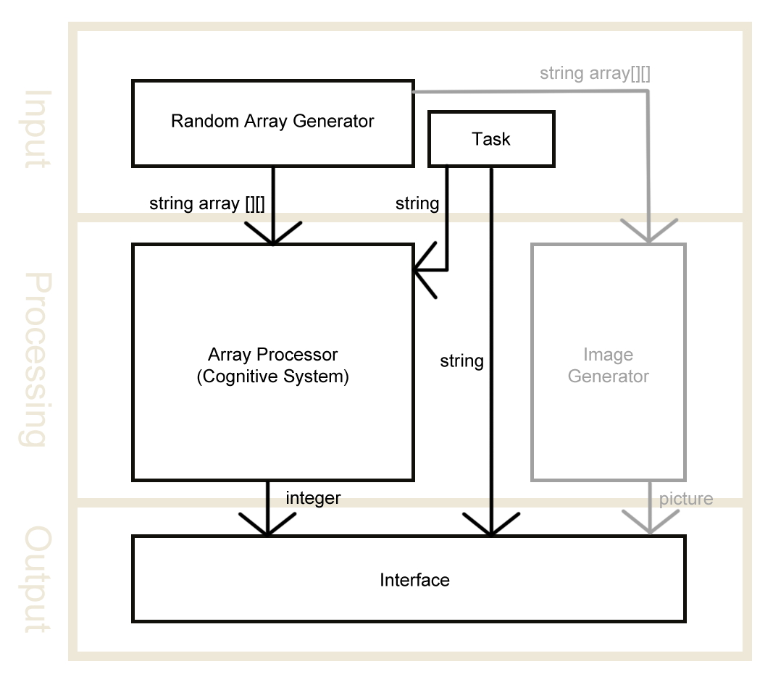

Tests/Reflection
Due to time limitations we were scrapping the interface and image generator to put more time into our cognitive system to work proper. Thus, we have decided to go by a console output to check the results of our program. It lists us every value of the two-dimensional array and then give us an idea of how it searches through the data by showing the Search Clusters generated by the peripheral process.

Next to this document we have generated a few tests and put them into txt-files for visibility.

We have found that our program finds most of the elements but is not always able to count every element. That may be decentered elements to which the algortihm doesn't get to. We deem the program to work positively when it iterates through the data in the same manner the human would do with being just as suspectible to mistakes. While the program is surely not a perfect as a mirror to the human mind, we find that the approach gets us close to it.

