

DECENTRALIZED FUNDING PLATFORM BASED ON BLOCKCHAIN TECHNOLOGY

**Anitha Moses V*1, Harini B*2, Beneta Getzie M*3, Deepika T*4**

*1Professor, Department of CSE, Panimalar Engineering College, Chennai, TamilNadu, India

*2Student, Department of CSE, Panimalar Engineering College, Chennai, TamilNadu, India

*3 Student, Department of CSE, Panimalar Engineering College, Chennai, TamilNadu, India

*4 Student, Department of CSE, Panimalar Engineering College, Chennai, TamilNadu, India

# Abstract:

Crowdfunding is a method of raising funds from a large number of funders to start a new business or for charitable purposes using the internet. An important factor for the people involved in raising these funds is trust and the temporary funds of the recipient is stored in the fundraising organization, so to attract funders to donate their funds to the recipient, trust is the important capital for the fundraising organization. In the existing method of online crowdfunding, the contributor does not have any control over the money that they have contributed. Since in the existing method the fundraising organization has all the control over the money contributed, they can very easily perform malicious activities. The problem faced by this existing system can be addressed by using blockchain concept. Blockchain in crowdfunding allows decentralization which suggests that nobody within the network as control over the blocks which makes it transparent to everyone within the blockchain. In this proposed method all the activities performed in a crowdfunding campaign are managed by using the blockchain concept. Each transaction is recorded in the blockchain network to ensure that the amount is received by the valid recipient.

# KEYWORDS:

Crowdfunding, Blockchain, Transaction.

# INTRODUCTION

Crowdfunding is a method of raising funds from a large number of funders to start a new business or for charitable purposes using the internet. Crowdfunding enables us to easily access a vast network of people through crowdfunding website that brings funder and fundraiser together. In this if the funder wishes to donate for any cause he can donate the money. In present day crowdfunding platform, the money donated by the funder is temporarily stored in fundraising platform so the funder will have no control over the money that they have donated. The third-party involvement incurs additional cost. To overcome this issue many decentralized application have been created for peer-to-peer communication between the funder and fundraiser. The advantages of blockchain have created a way to make peer to peer communication more secure, cost efficient and transparent. Hence by using blockchain in crowdfunding we can change the traditional way of crowdfunding.

# TYPES OF CROWDFUNDING:

There are three categories of crowdfunding platform.

* 1. Donation based crowdfunding platform
  2. Equity based crowdfunding platform
  3. Reward based crowdfunding platform

In donation based crowdfunding platform the fundraisers ask large number of funders to donate for a cause without expecting anything in return. It may include charitable institutions, NGO’s and disaster relief. In Reward based crowdfunding the fundraiser ask the large number of funders to donate certain amounts in exchange for rewards. Tokens or points can be given as rewards for the person who donates. When a person donates, he gets something in return. Equity crowdfunding is a type of crowdfunding in which the fundraiser launches a project with shares of the business as reward. Funders invest in the project in return for equity.

# BLOKCHAIN TECHNOLOGY:

Satoshi Nakamoto invented blockchain in 2008. Nakamoto’s view is that blockchain provides peer to peer topology, i.e. There is no third party involved. The payments are sent from the sender to the receiver without going through the third party. The central authority prevents dishonest users to prevent fraudulence activities. Blockchain is a distributed ledger in which all transaction of the funders is recorded. The transactions which occur are all stored permanently in the blockchain network. The main reason for the blockchain to be trusted is that the information that is stored in the blocks cannot be changed. Block are record book which contain the details of transaction data. A block consists of four details- hash of previous block, transaction data, value of nonce, hash. As each block contains the hash value of previous node, if one tries to change the data of one node it will affect all further node of it, thus other on the network can easily find that fault occurred on that blockchain or some data has been changed by someone. The categories of blockchain are permissioned and permissionless. In permissioned blockchain the users who publish the block must be an authorized user. In permissionless blockchain the user doesn’t need any permission from the authority to publish a block. Anyone can publish in it. The features of blockchain are- SHA-256 encryption, public & private key, distributed public ledger, proof of work, and mining. Blockchain is based on the transactions which occurs. The transactions are sent to each node. Each nodes records data for each new transaction. The current transactions are checked against the previous transactions. It is called as Proof of work. At each nodes proof of work is established. Once proof of work is generated, the nodes along with the proof of work is sent to all the other nodes. The other nodes validate and approves the transaction. A new block is formed in the blockchain when all the other blocks accept the transaction. The characteristics of blockchain are immutable, decentralized, consensus driven and transparent. The transactions which are stored in the blockchain cannot be chanced and increases the trust on the transactions that are recorded. Hence it is immutable. The information that are stored in blockchain can be accessed from anywhere. Hence it is decentralized. Blockchain contains certain rules to independently verify and it displays the efforts. Hence it is consensus driven. All the parties in the network can see and verify the transactions. Hence it is transparent.

# EXISTING SYSTEM:

In Present Crowdfunding system, the fundraiser and the funder will have to log in to the fundraising platform. And if they are a new user then they have to register in the fundraising platform. Here the fundraising platform is monitored by the fundraising agency(third-party). The fundraiser posts the need to raise funds in the fundraising platform. The funders who wish to donate can donate in this platform. Once the fundraiser received the entire amount that he has specified the post will be removed by the fundraising agency. But the funders will have no control over the money they have donated. The funder will have no idea if the money that he has donated has reached the fundraiser or not. The third-party i.e., the fundraising agency will have complete control over the money and hence they can perform malicious activities. The third-party involvement may also cause additional cost. As this platform is centralized by someone there is a chance to use the money the funders have donated in an illegal way.

# PROPOSED SYSTEM:

In crowdfunding we need to handle lot of transaction and document it accordingly. So here the blockchain concept is used to document these transactions. The main entities in this project are fundraise, funder, service provider platform and blockchain concept for tracking transactions. These blockchain concept is build using java. The fundraiser and funder have to login in the service provider platform. If they are a new user, they have to register in this service provider platform. For storing the Meta details about the fundraiser and funder we use the MySQL data base. Also, every time the immutable entry added in the table. This frontend development is done using flask framework in python.

1. CREATION:

This is the first stage in which the fundraiser will raise their funds by providing their information or needs with the proof of their needs. Now the funder can view the needs posted by the fundraiser and if they wish to donate then they can proceed with that.

1. DONATION:

If the funder wishes to donate for any cause they can donate the money to the particular fundraiser. The fundraiser name, funder name, amount to be transacted, date and time of the transaction are entered by the funder during the transaction and these data are stored in blocks, like wise for each transaction by each funder, the entries are stored in blocks and that form a blockchain. Then this money will be added to the account of the fundraiser which they can further use for their need. All these transactions are stored in transaction history. Funder, fundraiser and the admin can view these transactions details in transaction history. The funder can track their transaction and check whether the amount is received by the valid fundraiser. If the specified amount has been reached then the particular post will be removed from the platform by fundraiser. The admin can view all the login details of the funder and fundraiser and can also view all the transaction details that is being held. So, both the fundraiser and funder can trust this platform as this platform enables the fundraiser to receive all the amounts of the funder without any involvement of the third party and the funder can also verify that their amount is received by the valid fundraiser.

# CROWDFUNDING USING BLOCKCHAIN:

Blockchain allows decentralization so no one in the network will have control over the smart contract. It is a peer-to-peer network so no one in the network can change the information in the blockchain which makes this crowdfunding secure, safe and transparent. Anyone can post their information for their need in the website. Anyone who wishes to fund can fund to the need. Each transaction is validated and appended in the blockchain. These transactions which occurs in this crowdfunding platform are secured using cryptography. The transaction which occurs are handled by the blockchain concept and all the transacted amount are stored in blocks that form a blockchain, so that there is no need for any third party. The funder doesn’t have to worry whether the transacted money have reached the valid fundraiser or not, like in the traditional crowdfunding.

# SYSTEM DESCRIPTION:

This is a website-based system in which the fundraiser and funder have to register in the service provider platform. The fundraiser will raise their funds by describing the need and providing some proof if available. Then the funder can view all the information posted by various fundraiser. If the funder wishes to donate for any particular cause they can proceed with it. Then the money that is donated by the funder will be added to the account of the fundraiser. The sum of the amount that has been donated by all the funders will also be displayed, with the help of this we can identify whether the specified amount has been reached or not. If the specified amount has been reached then the particular post will be automatically removed from the platform. Once they donated the money to the fundraiser the information of the transaction is stored in blockchain and that information can be viewed by both the fundraiser and funder. The funder can track their money until the transacted amount reaches the valid recipient.

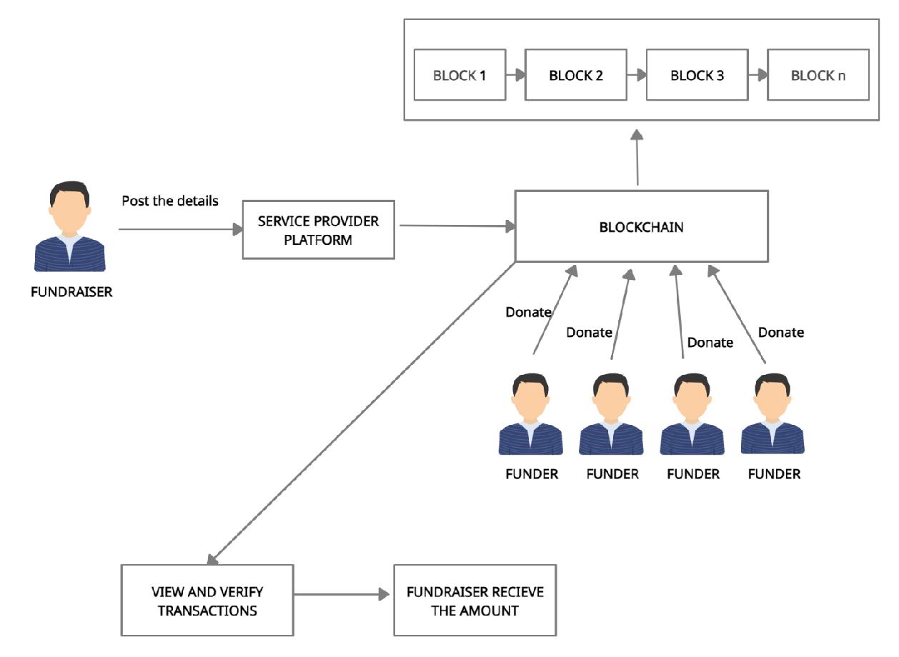

SYSTEM ARCHITECTURE

The modules involved in this project are

1. Registration-Fundraiser
2. Registration-Funder
3. Service provider platform
4. Transaction platform
5. Blockchain creating and mining

The fundraiser will register in the service provider platform. For storing the meta details about the fundraiser we can use the MySQL data base. Also, every time scanned the immutable entry added in the table. It consists of 2 entities, the registration platform and the fundraiser. Similar to the fundraising registration process, donors certainly need to register with a fundraising platform service provider. It consists of 2 entities, the registration platform and the fundraiser. For storing the meta details about the funder we can use the MySQL data base. Also, every time scanned the immutable entry added in the table. In the service provider platform, the fundraiser will raise their fund by posting their requirement and details about the requirement. These data are stored in MySQL database. In the transaction platform each transaction details are recorded in the blockchain for e.g.: If the funder donates the amount to the fundraiser this transaction is stored in the blockchain. All the transaction received can be viewed by the fundraiser. The funder can track the transaction and check whether the amount is received by the valid fundraiser. In blockchain creation and mining the blocks are created. The data is scanned on each new block created.

# CONCLUSION:

Finally, the disadvantages faced by the traditional crowdfunding has been overthrown with the help of blockchain technology in crowdfunding. An important factor for the people involved in raising these funds is trust. With the use of the blockchain concept in the crowdfunding, ensures trust of this crowdfunding platform and also reduces the cost of the third party. In future our work can be further enhanced by adding timestamp to the platform i.e., if the funder donates some amount to fundraiser and if the amount doesn’t reach the fundraiser within the timestamp specified then the amount is returned back to the funder. With the help of blockchain technology in the crowdfunding platform the people trust the crowdfunding platform and be a part in this crowdfunding network.

# REFERENCES:

[1]. Hassija, Vikas, Chamola, Vinay & Zeadally Sherali. (2020). “BitFund: A Blockchain-based Crowd Funding Platform for Future Smart and Connected Nation”. Sustainable Cities and Society. 60. 102145. 10.1016/j.scs.2020.102145, May 2020.

[2]. Nikhil Yadav and Sarasvathi V. “Venturing Crowdfunding using Smart Contracts in Blockchain”. Third International Conference on Smart Systems and Inventive Technology (ICSSIT 2020)), IEEE Xplore Part Number: CFP20P17-ART; ISBN: 978-1-7281-5821-1, November 2020.

[3]. Ms. S. Benila, V. Ajay, K. Hrishikesh, R. Karthick. “Crowdfunding using Blockchain”. Global Research and Development Journal for Engineering, Volume 4, Issue 4, ISSN: 2455-5703, March 2019.

[4]. Hasnan Baber. “Blockchain-Based Crowdfunding: A ‘Pay-it-Forward’ Model of WHIRL”. International Journal of Recent Technology and Engineering (IJRTE),

ISSN: 2277-3878, Volume-8 Issue-3, September 2019, September 2019.

[5]. Er. Waheeda Dhokley, Saurabh Gupta, Ganesh Pawar, Abrar Shaikh, “Crowdsourcing and Crowdfunding Platform using Blockchain and Collective Intelligence”. *International Journal of Computer Sciences and Engineering, Vol.7*, Issue.2, pp.668-673, February 2019.

[6]. Firmansyah Ashari, Tetuko Catonsukmoro, Wilyu Mahendra Bad, Sfenranto, Gunawan Wang (2020). “Smart Contract and Blockchain for Crowdfunding Platform”. International Journal of Advanced Trends in Computer Science and Engineering. 9.3036-3041.10.30534/ijatcse/ 2020/83932020, June 2020.

[7]. André Schweizer, Vincent Schlatt, Nils Urbach, Gilbert Fridgen. “Unchaining Social Businesses - Blockchain as the Basic Technology of a Crowdlending Platform”. Proceedings of the 38th International Conference on Information Systems (ICIS), Seoul, South Korea, December 2017.

[8]. Zhu, Huasheng; Zhou, Zach Zhizhong (2016). “Analysis and outlook of applications of blockchain technology to equity crowdfunding in China”. Financial Innovation, ISSN 2199-4730, Springer, Heidelberg, Vol. 2, Iss. 29, pp. 1-11, 2016.

[9]. Zhao Hongjiang & Coffie Cephas. (2018). The Applications of Blockchain Technology in Crowdfunding Contract. SSRN Electronic Journal. 10.2139/ssrn.3133176, January 2018.

[10][.Hissu Hyvärinen,](https://link.springer.com/article/10.1007/s12599-017-0502-4#auth-Hissu-Hyv_rinen) [Marten Risius](https://link.springer.com/article/10.1007/s12599-017-0502-4#auth-Marten-Risius) & [Gustav Friis](https://link.springer.com/article/10.1007/s12599-017-0502-4#auth-Gustav-Friis). “A Blockchain-Based Approach Towards Overcoming Financial Fraud in Public Sector Services”. Bus Inf Syst Eng 59, 441–456, 2017.

[11]. Claudia Gabriela Bîzderea. "ANALYSIS OF FUNDING ALTERNATIVES THROUGH FINANCIAL TECHNOLOGY SERVICES – FINTECH – THE PHENOMENON OF CROWDFUNDING". Revista de

Studii Financiare 3:109-127, November 2017.

[12]. Fridgen, Gilbert; Regner, Ferdinand; Schweizer, André; and Urbach, Nils, "DON’T SLIP ON THE ICO

– A TAXONOMY FOR A BLOCKCHAIN-ENABLED FORM OF CROWDFUNDING" (2018). Research Papers. 83, November 2018.