

TM

Quick Reference Card

Setting up the application

- Start the Martus application.
- Type a username. Enter a password using the on-screen keyboard. Click OK and then enter both
again to confirm them. Remember them, and keep them private.
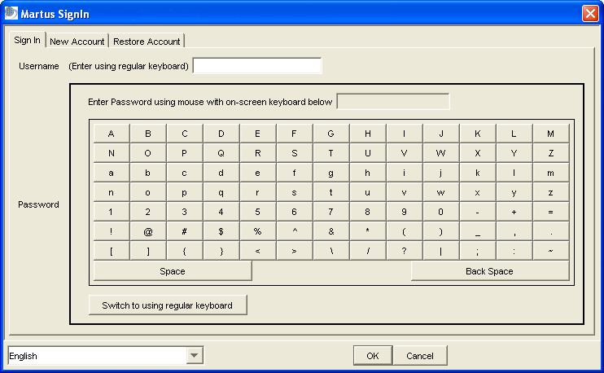

Multiple Martus accounts can exist on the same computer. Click the New Account tab in the Martus Signin dialog box to create additional accounts; click Restore Account to restore accounts from backup key pair files.

- Enter contact information for yourself or your organization.
- Choose Server > Select Martus Server, enter the IP address, public code, and
magic word for your server.

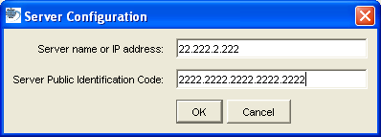

Creating bulletins

- Click Create to start a new bulletin.
- To make the entire bulletin private, select Keep ALL Information Private.
- Enter a short, descriptive title for the bulletin.
- Type a summary and detailed information about the incident.
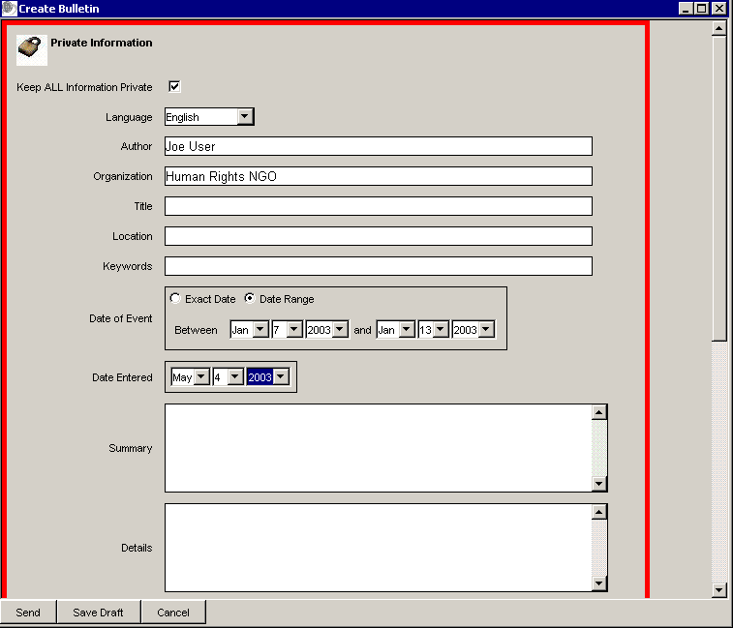

- Attach supplementary files, such as photos or media reports.
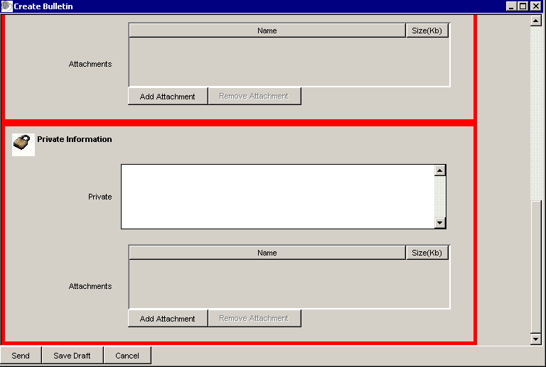

- Enter private data in the Private Information section. Attachments in the Private Information are also private. A red border indicates data is private.

- When you’re done, send the bulletin to the server (which seals it) or save it as a draft.

Managing bulletins

Organize your bulletins in folders—use the default folders or create your own.
The selected bulletin is displayed in the preview pane.
The list of bulletins in the selected folder is displayed.

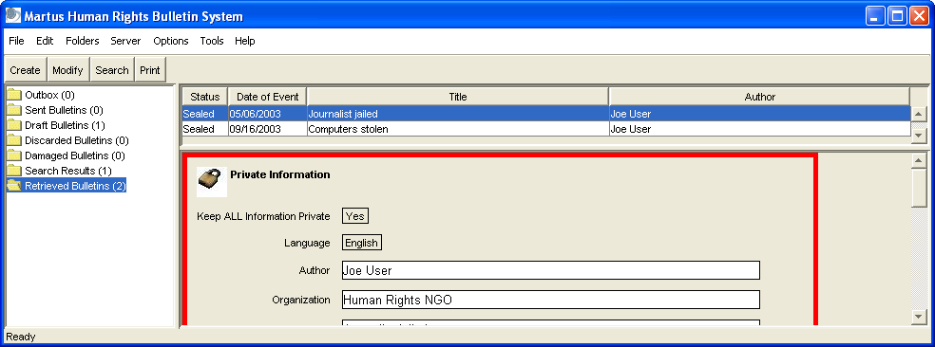

To discard a bulletin, right-click it and choose Discard Bulletin.
To delete a bulletin from the computer, delete it from the Discarded Bulletins folder.
To create a new folder, choose File > Add New Folder.
To copy a bulletin, select it, choose Edit > Copy Bulletin; then select the new folder and choose Edit > Paste Bulletin.

Finding the bulletin you need

To search for bulletins on your computer, click Search.
- Enter the words or phrase you want to search for.
- You can choose a range of dates to narrow your search.

To retrieve bulletins from the server, choose Server > Retrieve My Sealed Bulletins or
Server > Retrieve My Draft Bulletins.

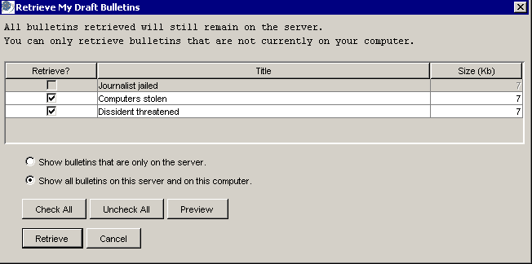

- Check each bulletin you want to download.
- Click Preview to see the contents of the selected bulletin.
- Click Retrieve to download bulletins to your computer.

