Name: Jooa Jaakkola
Self-assessment:
This exercise was OK for me because I was struggling a lot with the first coding exercise [2a(b)], but found the latter ones WAY easier.
Doing this exercise, I learned about cl-arguments and a little bit about arrays and pointers.
I am still wondering about the Armstrong-number task.
I do not really understand what’s the practical use for cl-arguments.
I did/did not know that… ;
I did not manage to do the Armstrong-number check properly.

Test report
Write the test report yourself to each coding task [task number, input/action, desired output and then the testing evidence (actual output)]. Add rows if necessary. Include answers to theoretical questions and pseudo-code to this return document as well.

Task | Input / action | Desired output | Actual output (use red color if desired output != actual output)
1a) | Any integer | Input – 2 times ”x=...y=...z=...\n  x + y + z = ...” | OK
 | not integer/negative | Should throw an error... | Just doesn’t enter loop at all and prints x=...y=...z=… OK
1b) | Any integer | Asks that amount of numbers from user and finally prints the biggest of them. | OK
 | not integer/negative | Should throw an error... | Skips the program and returns 0. OK
 | Letters in array | Should throw an error... | Stops running program. OK
4a) | Any integers in “actualArray” | @index0, @index1, @index2, …  Either in a list or at each line. | @index_0 : 0  @index_1 : 1 etc. OK
 | Any numbers, including 0, 1, -1,  -9, and 4.20 ... | Same output, special-case numbers shouldn’t matter. | OK except that decimal cuts off, but that’s also a non-issue.
 | Any characters | Should be same output if this was a real project since it shouldn’t matter. | OK
4b) | RNG numbers | Prints them the same way as above. | OK
4c) | RNG numbers as above | Prints them the same, but in ascending order. | OK
3a) | Any positive integer | Prints the number given as command-line argument and tells whether it’s a number or not, and too big or not. | OK
 | Too big integer, or negative | Prints the argument and tells that it’s erroneous | OK – argument too big… should  be 0 – 10 000 000
 | Otherwise erroneous, eg. character at any index, negative... | Prints the argument and tells that it’s invalid or negative. | OK
 | Too many or to few arguments | Stops the program and only prints that it’s either too much or too few. | OK
3b) | Valid argument as above. | Should print each Narcissistic number 0 to argument. | Doesn’t do that,  only tells if the argument is a narcissistic number.
 | Invalid argument as above | Gives an error message and obviously doesn’t complete that part of the program. | OK

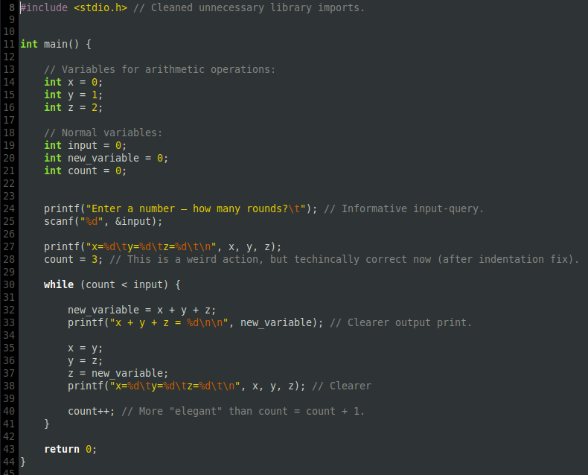
Exercise_5 1a

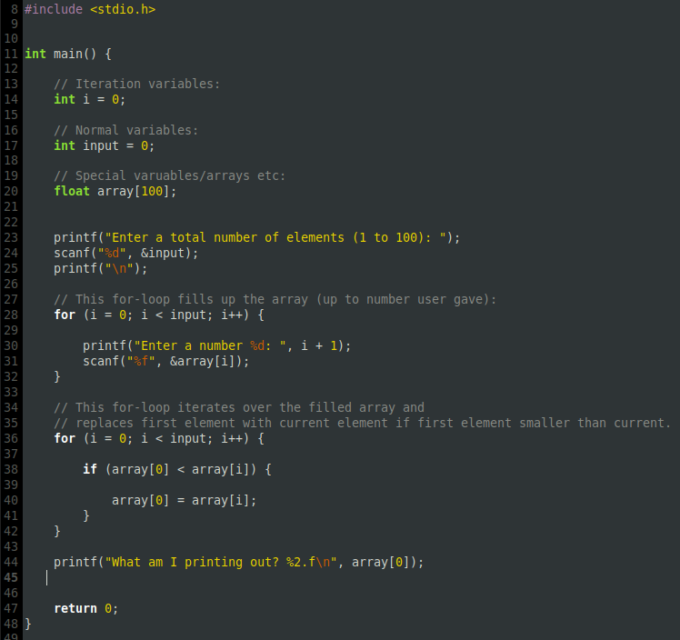
Exercise_5 1b

