CROCO - Coastal and Regional Ocean Community Model

CROCO is a primitive equation ocean model built on the ROMS-AGRIF architecture. This model uses a structured-grid domain with orthogonal curvilinear coordinates along the horizontal, and terrain-following coordinates along the vertical.

The CROCO setup consists of the following parts:

* Grid (netCDF format)
* Climatology input file(s) (netCDF format)
* Forcing file (netCDF format)
* Compilation file ‘jobcomp’
* Input parameters file (****.in)

# Compiling the code using jobcomp

jobcomp is the script used to compile the CROCO code. Compilation of CROCO creates an executable file, which is used to run the model.

In jobcomp, you have to assign the following directories:

* **SOURCE** directory which is ~/croco/OCEAN
* **ROOTDIR** which is the root directory ~/croco/

There are also the directories named **SCRDIR** and **RUNDIR**. Leave them as they are.

The jobcomp file sits inside the ~/croco/OCEAN directory.

You can set the compiler type in the variable FC (compiler options). If you have ifort compiler, you can set it there. If you have gfortran, write FC=gfortran

netCDF configuration has to be done in jobcomp. The variables NETCDFLIB and NETCDFINC denote the locations for the library files and include directory for netCDF respectively. You don’t have to edit them in jobcomp, since they are already set.

To compile CROCO using the jobcomp script, you have to make sure that the netCDF module is loaded in the cluster. To do that, you have to use the following command in terminal:

**module load netcdf-fortran/4.5.2/intel-19.0.5-mvapich-2.3.3**

That’s all is needed to edit jobcomp. You can compile jobcomp using the command

**./jobcomp**

Below, is a screenshot of the jobcomp script.

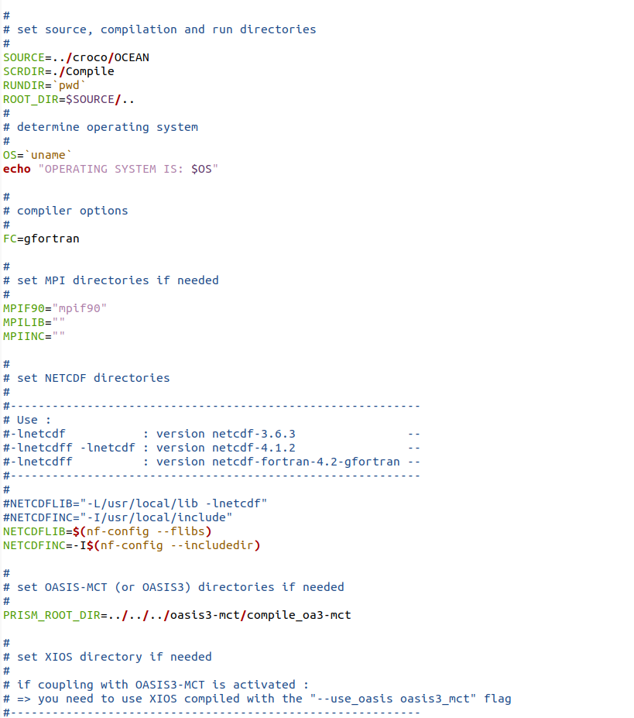

# Running the model

Compiling jobcomp creates an executable file called **croco** in the same directory. To run the model, use this instruction:

**./croco ~~input.in~~ croco.in**

Where, **input.in** is the script containing the input parameters.

## Input parameters

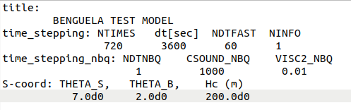

**title:** your project name

**NTIMES:** number of baroclinic time steps

**dt:** baroclinic time step

**NDTFAST:** Number of barotropic time-steps between each baroclinic time step

This means that if **dt = 30 seconds** and **NDTFAST = 100**, then the barotropic time step should be **dt/NDTFAST = 0.3 seconds.**

***Explanation:*** *Barotropic velocity is constant throughout the depth. It is the velocity of the entire water column, whereas baroclinic velocity is the velocity of the individual water particles at a specific depth. Baroclinic velocity varies throughout the depth. ROMS operates on two time steps: the* ***baroclinic and the barotropic time step****. Baroclinic time step is used to advance only the baroclinic variables: baroclinic velocity, temperature and salinity. The barotropic time step is only for advancing the barotropic variables: sea-surface height, and barotropic current velocities.*

## Grid parameters

**THETA_S:** Compression parameter near surface

**THETA_B:** Compression parameter near bottom

**Hc:** Surface boundary layer depth

These parameters are all set in the grid file. Just take the values from the grid file and write them in the input.in file.

Important files:

./parent/croco-v1.3/TESTOCEAN/jobcomp

./parent/croco-v1.3/Compile/jobcomp

./parent/croco-v1.3/OCEAN/jobcomp

/home/sonalm/croco-v1.3/OCEAN/progress.out

* Permission is denied
* ‘/ddnA/work/sonalm/out/parent/croco-v1.3/OCEAN/progress.out’ also says permission is denied, so it may be linked to the home directory file

/home/sonalm/croco-v1.3/OCEAN/errors.err

* ‘/ddnA/work/sonalm/out/parent/croco-v1.3/OCEAN/errors.err’ also says permission is denied, so it may be linked to the home directory file

/ddnA/work/sonalm/out/parent/croco-v1.3/OCEAN/croco.in

/ddnA/work/sonalm/out/parent/croco-v1.3/OCEAN/typeamp.in

/ddnA/work/sonalm/out/parent/croco-v1.3/OCEANTEST/typeamp.in

/ddnA/work/sonalm/out/parent2/croco_dia.nc

/ddnA/work/sonalm/out/parent2/croco_diaM.00000.nc

/ddnA/work/sonalm/out/parent2/croco_diaM.00003.nc

/ddnA/work/sonalm/out/parent2/croco_diaM.00006.nc

/ddnA/work/sonalm/out/parent2/croco_rst.nc