Final Project

Benjamin Foglia

8/20/2019

## Discussion

For this report, I examined the dataset sales_data.

## Initial Setup

## run important packages and read in data  
library(tidyverse)

## -- Attaching packages ------------------------------------------------------------- tidyverse 1.3.0 --

## v ggplot2 3.3.1 v purrr 0.3.4  
## v tibble 3.0.1 v dplyr 1.0.0  
## v tidyr 1.1.0 v stringr 1.4.0  
## v readr 1.3.1 v forcats 0.5.0

## -- Conflicts ---------------------------------------------------------------- tidyverse_conflicts() --  
## x dplyr::filter() masks stats::filter()  
## x dplyr::lag() masks stats::lag()

library(tidyr)  
library(ggplot2)  
library(readr)  
library(stringr)  
library(dplyr)  
  
Sales_data <- read_csv("F:/BAN 6003/sales_data.csv")

## Parsed with column specification:  
## cols(  
## flag = col_character(),  
## gender = col_character(),  
## education = col_character(),  
## house_val = col_double(),  
## age = col_character(),  
## online = col_character(),  
## customer_psy = col_character(),  
## marriage = col_character(),  
## child = col_character(),  
## occupation = col_character(),  
## mortgage = col_character(),  
## house_owner = col_character(),  
## region = col_character(),  
## car_prob = col_double(),  
## fam_income = col_character()  
## )

## Metadata

**flag** **gender** **education** **house_val** **age_bracket** - *which age bin the person falls in (1=unknown, 2=lowest, 7=highest)* **age_range** - *person’s age range (i.e. >65)* **online** **customer_psy** **marriage** **children** **occupation** **mortgage** **house_own** **region** **car_prob** **fam_income**

## Wrangling

The first thing I wanted to do with the initial dataset was change values like education and mortgage to numerical values. I also split age into 2 columns, one containting the number before the ’_’, and one after. I thought this made it easier to read, and that using the first number would making grouping people together by age easier.

## Education  
Sales_data$education <- str_remove_all(Sales_data$education, " <HS")  
Sales_data$education <- str_remove_all(Sales_data$education, " HS")  
Sales_data$education <- str_remove_all(Sales_data$education, " Some College")  
Sales_data$education <- str_remove_all(Sales_data$education, " Bach")  
Sales_data$education <- str_remove_all(Sales_data$education, " Grad")  
  
Sales_data$education <- extract_numeric(Sales_data$education)

## extract_numeric() is deprecated: please use readr::parse_number() instead

## Mortgage  
Sales_data$mortgage <- str_remove_all(Sales_data$mortgage, "low")  
Sales_data$mortgage <- str_remove_all(Sales_data$mortgage, "med")  
Sales_data$mortgage <- str_remove_all(Sales_data$mortgage, "high")  
  
Sales_data$mortgage <- extract_numeric(Sales_data$mortgage)

## extract_numeric() is deprecated: please use readr::parse_number() instead

## Age  
Sales_data <- separate(Sales_data, age, c("age_bracket", "age_range"), sep = "_")

## Transformation

From the original sales_data, I created multiple new data sets by filtering for specific values.

## Data from all who bought the product  
buyers_data <- Sales_data %>% filter(flag == "Y")  
  
## Data for all homeowners whose houses had value  
house_owners <- Sales_data %>% filter(house_val > 0, house_owner == "Owner")  
  
## House value by region  
val_by_region <- Sales_data %>% select(house_val, region)

## Functions, Vectors, Iterations

Per Doc B’s request, I have included the function and for loop that categorizes and counts house values by “below average”, “average to expensive”, and “very expensive”.

mean_val <- mean(Sales_data$house_val)  
very_high <- 2*sd(Sales_data$house_val) + mean_val  
  
house_expenses <- function(x){  
 if (x > very_high) {  
 print("Very Expensive")  
 } else if (x > mean_val){  
 print("Average to Expensive")  
 } else {  
 print("Below Average")}  
}  
# Test  
house_expenses(1200000)

## [1] "Very Expensive"

## For loop  
  
input <- c(1000, 310000, 1200000)  
output <- vector("character", length(input))  
  
for (i in seq_along(input)){  
 output[[i]] <- house_expenses(input[[i]])  
}

## [1] "Below Average"  
## [1] "Average to Expensive"  
## [1] "Very Expensive"

input_house_val <- Sales_data$house_val

for (i in seq_along(input_house_val)){  
 output[[i]] <- house_expenses(input_house_val[[i]])  
}  
v=0  
a=0  
b=0  
  
for (i in seq_along(output)){  
 if(output[[i]] == "Very Expensive") {v=v+1}  
 else if(output[[i]] == "Average to Expensive"){a=a+1}  
 else{b=b+1}  
}

house_results <- c("Very Expensive" = v, "Average to Expensive" = a, "Below Average" = b)  
house_results

## Very Expensive Average to Expensive Below Average   
## 1203 12654 26143

## most houses are below average value

## Visualizations

I focused on a couple of different things for my visualizations. First and foremost, I wanted to see what types of people were buying the product. Secondly, I did some of what Doc B asked for and looked for variations in in house values with respect to other variables.

## Using buyers_data, I looked at which genders and professions were buying the product. To simplify, I only used data where the gender of the person was known.  
ggplot(buyers_data %>% filter(gender != "U"))+  
 geom_bar(aes(x=gender, fill = occupation), position = "dodge")

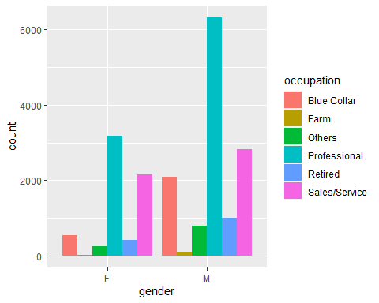

## For Doc B, I created a boxplot to compare education and house value using the house_owner dataset  
ggplot(house_owners, aes(x=education, y=house_val))+  
 geom_boxplot(aes(group = education))

## Warning: Removed 420 rows containing missing values (stat_boxplot).

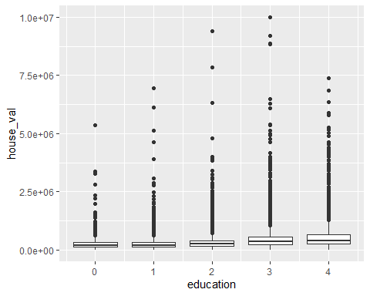

## based on the boxplot, while the most expensive houses are in education groups 2 & 3, there does seem to be evidence suggesting that someone with a higher education level will own a more expensive house.  
  
## Another Boxplot, this time comparing house value by region  
ggplot(val_by_region, aes(x=region, y = house_val, group = region))+  
 geom_point()+  
 geom_boxplot()

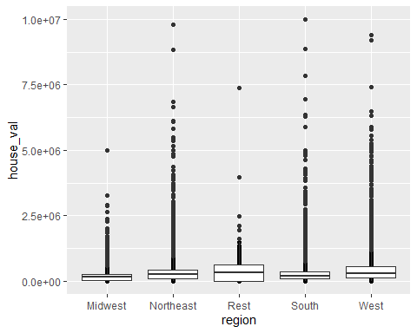

## Final Notes

I didn’t want to make a second boxplot; I would have much preferred to make a third type of visualization. I tried to spread my val_by_region and have each region be its own variable, but kept getiing errors saying “Each row of output must be identified by a unique combination of keys. Keys are shared for 40000 rows”. I then would have wanted to use the geom_map function to illustrate average price by region in the United States.