WTP Adaptor for Jetty 7.x/8.x

Sommaire
1.WTP Adaptor for Jetty 7.x/Jetty 8.x 2
2.Create Jetty server 3
3.Create Dynamic Web Project 11
4.How modify port? 17
5.How use external WEB Application? 18
6.How modify contextPath? 23
7.Jetty WebSocket Wizard 24

WTP Adaptor for Jetty 7.x/Jetty 8.x
This documentation explain how use WTP Adaptor for jetty 7.x/Jetty 8.x to start/stop WTP Dynamic Web Project(or external WEB application) with Jetty by using Eclipse WTP. Eclipse JEE Helios is required (don't works with Eclipse JEE Galileo). Those Jetty WTP Adaptor are developed by copying/pasting WTP Adaptor for Tomcat (so code is very , very uggly!!!) . It is managed with 2 Plug-Ins :

- org.eclipse.jst.server.jetty.core :
- org.eclipse.jst.server.jetty.ui :
- org.eclipse.jst.server.jetty.ui.websocket : which provides a Wizard to generate Jetty WebSocket.

You can find this documentation and thoses 2 Plug-In at SVN at https://dynaresume.googlecode.com/svn/trunk/org.eclipse.jst.server.jetty

Create Jetty server
To create a WTP Jetty/Server, go at File/New/Other... and select Server node :

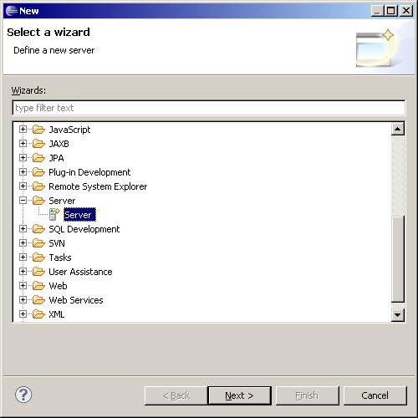

Click on Next button. You can use Jetty7x or Jetty 8x. In this documentation we will use Jetty 7.0 Server :

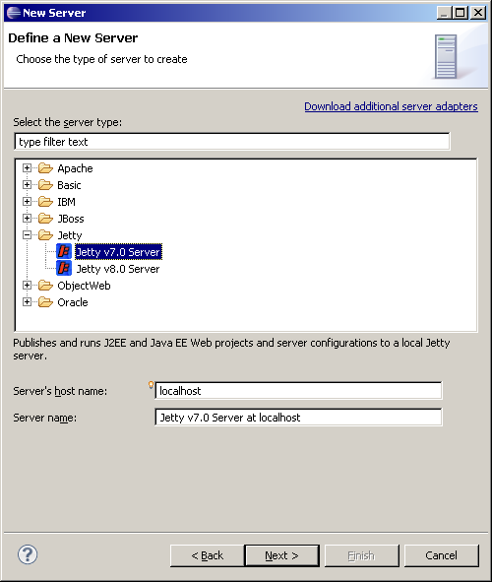

Click on Next button, now you must specify the installation directory for Jetty. Use Browse button to do that OR click on Download and Install... button to download the Jetty v7. In this documentation, we will do that. :

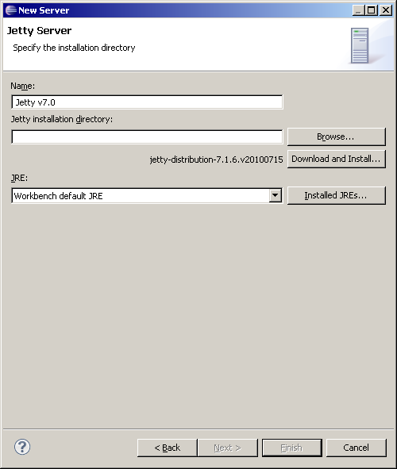

Click on Download and Install... the dialog opens :

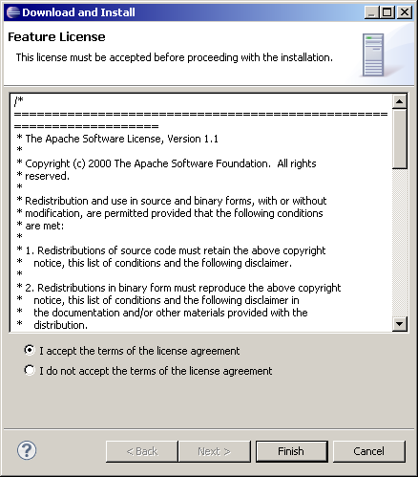

Accept the license and click on Finish button. Select the base directory where you wish install the Jetty. In my case I have selected D:\Servers\jetty-distribution-7.1.6.v20100715 and the download will set stable Jetty v7 server in this folder.

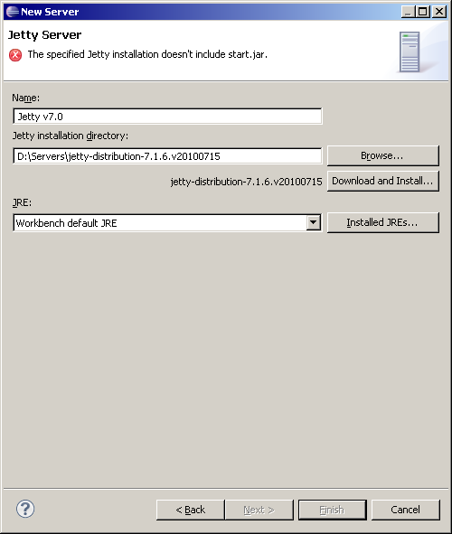
Once you have selected a folder, download is processed. You have an error because the wizard check that start.jar exist in the D:\Server\jetty-distribution-7.1.6.v20100715 (this JAR doesn't exist because the download is not finished).

In my case, download is slowly. Wait for enabling Finish button. Once Download is finished, Finish button is enable

Once download is finished, you will have D:\Server\jetty-distribution-7.1.6.v20100715 which contains start.jar...from the Jetty7 :

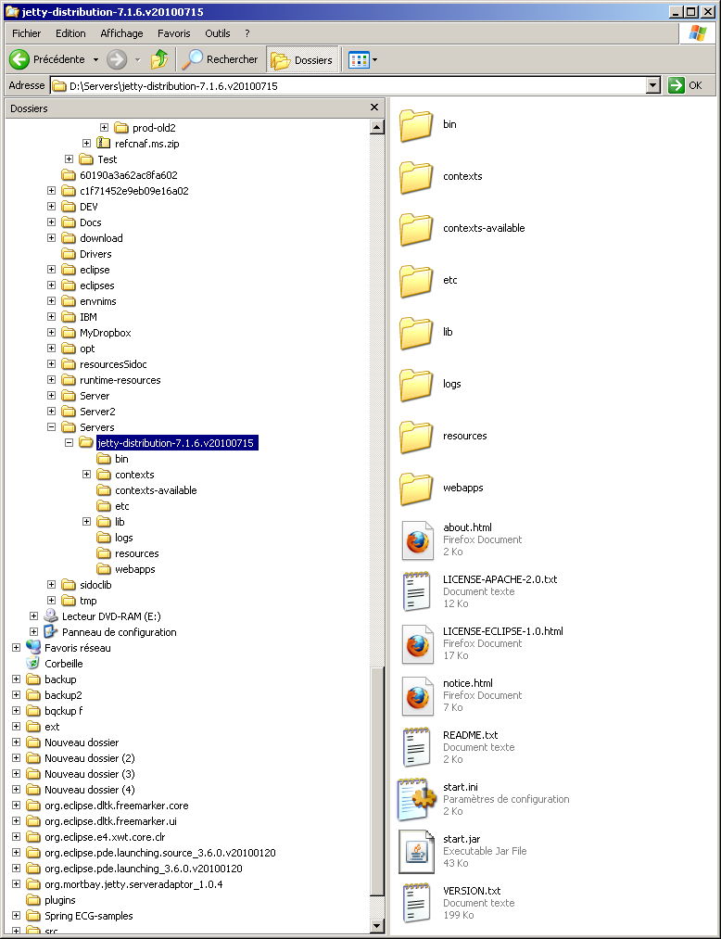

Click on Next button, here you can select existing Dynamic Web project from your workspace. In this documentation, teher are not WTP Dynamic WebProject.
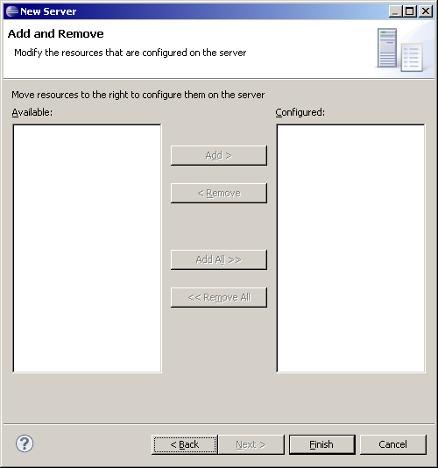
Click on Finish button :
- A Server Project is created in the workspace
- if you go at WTP Server View , you will see the launch Jetty v7.0 Server at localhost that you can use to start/stop/debug the Jetty install server.

Servers contains the Jetty v7.0 Server at localhost-config folder which contains :
- start.ini coming from the Jetty install (D:\Servers\jetty-distribution-7.1.6.v20100715)
- start.config : coming from the JAR start.jar from the Jetty install. You can notice Server/start.config is not the same than Jetty install/start.jar. Jetty Home is not the Jetty Install server but a WTP folder (created in the .metdata of your workspace). When Jetty server is called it use :
- -Djetty.home : which is the WTP folder.
  - -Dinstall.jetty.home : which is the Jetty install folder.
- the jetty*.xml files which are declared in the original start.ini. Jetty*.xml files are preprocessed too to transform <Property to <SystemProperty.
- webdefault.xml is modified to avoid locking HTML files (when sJetty is started and HTML files are modified (published) with the option : <init-param>
<param-name>useFileMappedBuffer</param-name>
<param-value>false</param-value>
</init-param>

Create Dynamic Web Project
To create a Dynamic WTP Project, go at File/New/Other... and select Web/Dynamic Web Project node :

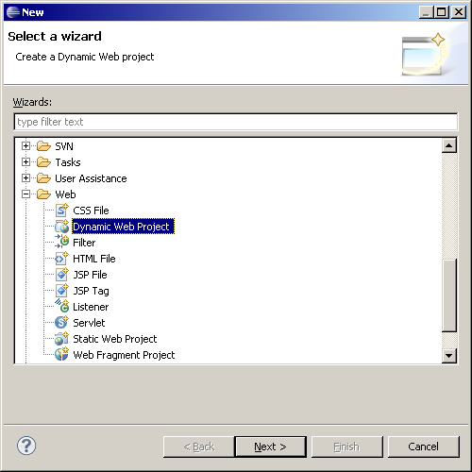

Click on Finish button, The WTP Dynamic Web Project is created and you can use JAR from the Jetty install with the Jetty v7.0 library which was created :

Create WebContent/index.htm like this :

<!DOCTYPE html PUBLIC "-//W3C//DTD HTML 4.01 Transitional//EN" "http://www.w3.org/TR/html4/loose.dtd">
<html>
<head>
<meta http-equiv="Content-Type" content="text/html; charset=ISO-8859-1">
<title>My first WEB Application</title>
</head>
<body>
My first WEB Application.
</body>
</html>

Drag and drop the project mywebapp to the launch Jetty v7.0 Server at localhost-config :

You can start/stop the Jetty server :

You can start the Jetty server, you will see in the console some Jetty logs :

2010-10-01 08:34:09.390:INFO::jetty-7.1.6.v20100715
2010-10-01 08:34:09.421:INFO::Deployment monitor D:\_Projets\Personal\runtime-EclipseApplication-Jetty-Demo\.metadata\.plugins\org.eclipse.wst.server.core\tmp0\contexts at interval 5
2010-10-01 08:34:09.421:INFO::Deployable added: D:\_Projets\Personal\runtime-EclipseApplication-Jetty-Demo\.metadata\.plugins\org.eclipse.wst.server.core\tmp0\contexts\mywebapp.xml
2010-10-01 08:34:09.734:INFO::Deployment monitor D:\_Projets\Personal\runtime-EclipseApplication-Jetty-Demo\.metadata\.plugins\org.eclipse.wst.server.core\tmp0\webapps at interval 5
2010-10-01 08:34:09.765:INFO::Started SelectChannelConnector@0.0.0.0:8080

You can notice that
- Jetty deploy mywebapp by using file mywebapp.xml (which configure org.eclipse.jetty.webapp.WebAppContext and it is generated with the WTP Jetty Adaptor).
- mywebapp.xml is stored in YOUR_WORKSPACE/.metadata\.plugins\org.eclipse.wst.server.core\tmp0\contextsfolder (your metdata). When you modify the file YOUR_WORKSPACE /mywebapp/index.htm (from your Eclipse project), the WTP Adaptor publish it to the OUR_WORKSPACE/.metadata\.plugins\org.eclipse.wst.server.core\tmp0/wtpwebapps\mywebapp folder.
- Port used is 8080. If you wish modify the port, please read How modify port?

Go at http://localhost:8080/mywebapp/

You will see the index.htm content. You can create a Servlet and debug it (I have testes it works).

How modify port?
It's possible to modify the port of the Jetty. To do that Open the Jetty v7.0 Server at localhost (with content menu or double clik). On the Overview tab (right panel) you have Ports section. You can modify the server port to use.

When you save it teh port modification (ex with 8081). If you go at jetty.xml, you will see

<Call name="addConnector">
<Arg>
<New class="org.eclipse.jetty.server.nio.SelectChannelConnector">
<Set name="host"><SystemProperty name="jetty.host"/></Set>
<Set name="port">8081</Set>

How use external WEB Application?
To read this section, please modify port with 8080.

Sometimes it can be usefull to use a WEB Application which was not created with Dynamic WEB Project (ex : you create your WEB Application with your ANT). You can start this external WEB Application.

For instance Jetty7 distribution provides a test.war which show you the features of Jetty 7 (WebSocket..). Here we will use this war (without creating Dynamlc Web Project) to start it.

Copy test.war from D:\Servers\jetty-distribution-7.1.6.v20100715\webapps

and unzip it in the D:\tmp :
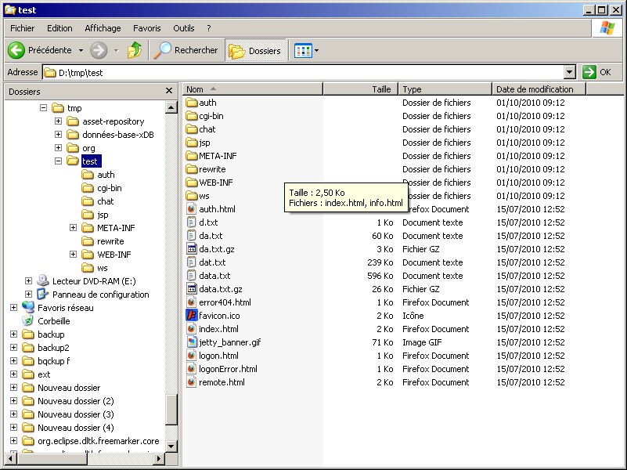

Open the launch, go at the Modules tab and click on « Add External Web Module » :

Fill the dialog like this :

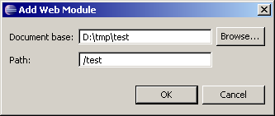
- document base : D:\tmp\test
- Path : /test (it's the context path)

Click on OK button, test module must appear :

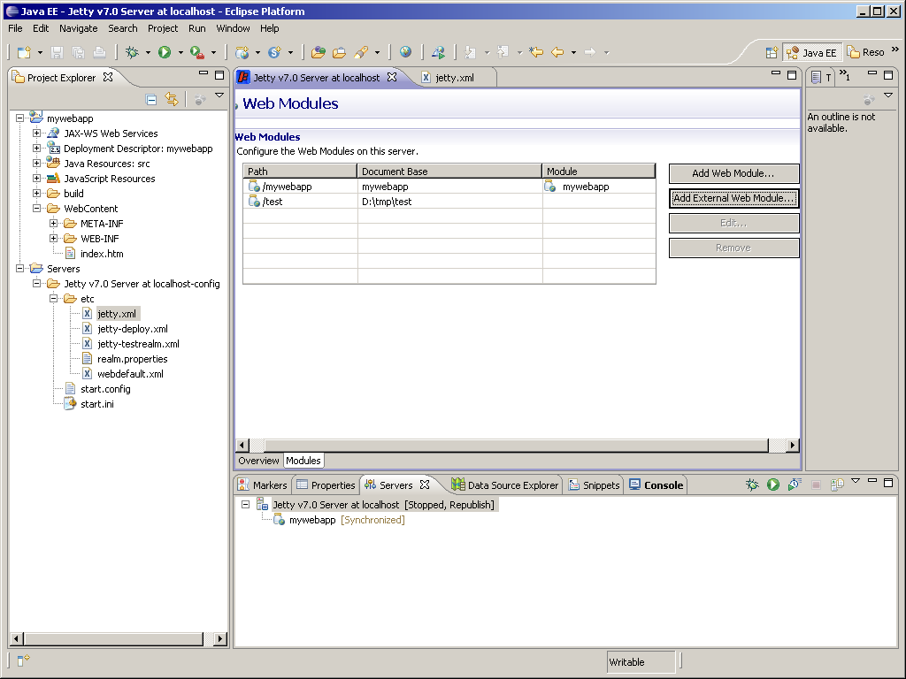

If you go at http://localhost:8080/test/ This page show you Jetty home test war :

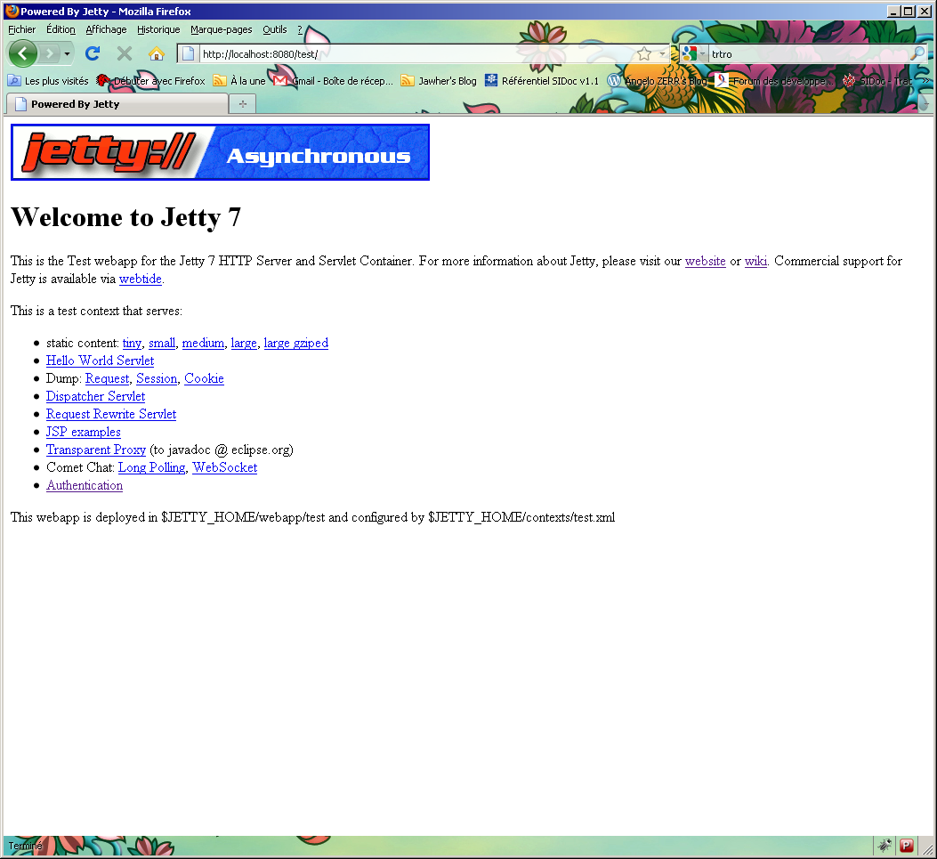
You can notice that http://localhost:8080/mywebapp/ is available too. You can add/remove as you wish any Dynamic Web Project or External WEB Application.

How modify contextPath?
When WTP Dynamic Web Project mywebapp was created, teh context path used is teh name of this project (mywebapp). But it's possible to change the contextPath name. To do that, open the launch and go at Modules tab. Select the mywebapp module and click on Edit button :

Change path with webapp :

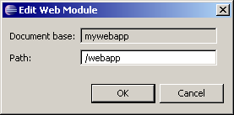
Save the launch, start the server and now you can go at http://localhost:8080/webapp/

Jetty WebSocket Wizard
The Plug-In org.eclipse.jst.server.jetty.ui.websocket provides wizard to create Jetty WebSocket :

- create an implementataion of the org.eclipse.jetty.websocket.WebSocketServlet. which use an implementation of org.eclipse.jetty.websocket.WebSocket
- modify the web.xml to declare the WebSocketServlet createdt-name + servlet-mapping).
- TODO : create an HTML page wich call the WebSocketServlet.

To create a WebSocketServlet go at menu File/New/Other... and select Web/Jetty WebSocket :

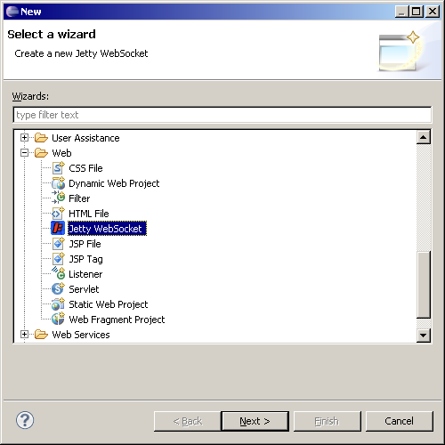

The first page you fill the name of the Jetty WebSocket Servlet class (ex : ChatWebSocketServlet) and package (ex : org.sample.websocket).Supperclass field is automaticly filled with org.eclipse.jetty.websocket.WebSocketServlet :

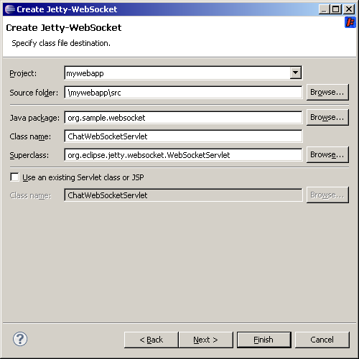

Click on Next button, the wieard page displayed is the same than Servlet. Here you can define teh servlet-mapping :

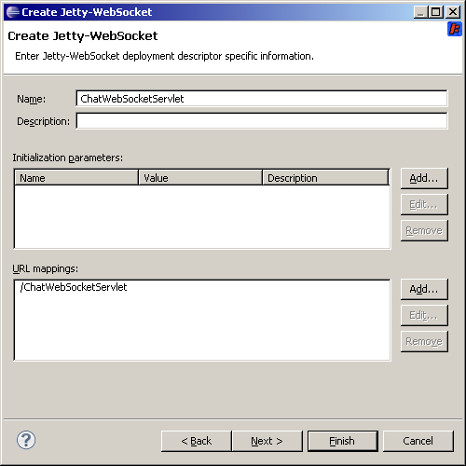

Click on Next button, here you can generate some methods. The doPost will be generated to use WebSocket using :

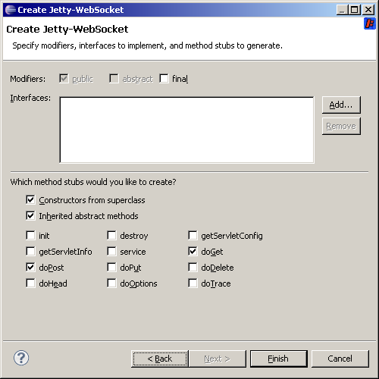

Click on Finish button, your workspace looks like this :

The wizard generate :

- a class ChatWebSocketServlet :

package org.sample.websocket;

import java.io.IOException;
import java.util.Set;
import java.util.concurrent.CopyOnWriteArraySet;
import javax.servlet.ServletException;
import javax.servlet.http.HttpServletRequest;
import javax.servlet.http.HttpServletResponse;
import org.eclipse.jetty.websocket.WebSocket;
import org.eclipse.jetty.websocket.WebSocketServlet;

/**
* Jetty WebSocketServlet implementation class ChatWebSocketServlet
*/
public class ChatWebSocketServlet extends WebSocketServlet {
private static final long serialVersionUID = 1L;

/**
* @see WebSocketServlet#WebSocketServlet()
*/
public ChatWebSocketServlet() {
super();
// TODO Auto-generated constructor stub
}
private final Set<ChatWebSocket> members = new CopyOnWriteArraySet<ChatWebSocket>();

/**
* @see HttpServlet#doGet(HttpServletRequest request, HttpServletResponse response)
*/
protected void doGet(HttpServletRequest request, HttpServletResponse response) throws ServletException, IOException {
// TODO Auto-generated method stub
}

/**
* @see HttpServlet#doPost(HttpServletRequest request, HttpServletResponse response)
*/
protected void doPost(HttpServletRequest request, HttpServletResponse response) throws ServletException, IOException {
getServletContext().getNamedDispatcher("default").forward(request, response);
}

/*
* @see org.eclipse.jetty.websocket.WebSocketServlet#doWebSocketConnect(javax.servlet.http.HttpServletRequest, java.lang.String)
*/
protected WebSocket doWebSocketConnect(HttpServletRequest request, String protocol) {
return new ChatWebSocket();
}

class ChatWebSocket implements WebSocket {
private Outbound outbound;

public void onConnect(Outbound outbound) {
this.outbound = outbound;
members.add(this);
}

/*
* @see org.eclipse.jetty.websocket.WebSocket#onMessage(byte, byte[],
* int, int)
*/
public void onMessage(byte frame, byte[] data, int offset, int length) {
}

/*
* @see org.eclipse.jetty.websocket.WebSocket#onMessage(byte,
* java.lang.String)
*/
public void onMessage(byte frame, String data) {

for (ChatWebSocket member : members) {
try {
member.outbound.sendMessage(frame, data);
} catch (IOException e) {
// org.eclipse.jetty.util.log.Log.warn(e);
e.printStackTrace();
}
}
}

/*
* @see org.eclipse.jetty.websocket.WebSocket#onDisconnect()
*/
public void onDisconnect() {
members.remove(this);
}
}

}

- web.xml is modified like this :

<servlet>
<description></description>
<display-name>ChatWebSocketServlet</display-name>
<servlet-name>ChatWebSocketServlet</servlet-name>
<servlet-class>org.sample.websocket.ChatWebSocketServlet</servletclass>
</servlet>
<servlet-mapping>
<servlet-name>ChatWebSocketServlet</servlet-name>
<url-pattern>/ChatWebSocketServlet</url-pattern>
</servlet-mapping>

- TODO : generate an HTML file which consume the WebSocket.

