Data-Driven Aerodynamic Prediction: High-Fidelity Lift Curve Estimation for Aerofoils Using Class-Shape Transformation and Artificial Intelligence

Authors
Benjamin Ian George Gawithª, *Ava Shahrokhi^{b}, Keivan Navaie^{c}

Affiliations
ª School of Engineering, Liverpool John Moores University, Liverpool, ^{b} Department of Maritime and Mechanical Engineering, Liverpool John Moores University, Liverpool, UK ^{c} School of Computing and Communications, Lancaster University, Lancaster, UK

Corresponding Author
Ava Shahrokhi, A.Shahrokhi@ljmu.ac.uk

Key Words
Aerodynamic prediction; Deep learning; Class-Shape Transformation; Lift curve; Surrogate modelling

Highlights
- Predicts full $C_{L}(α)$ curves from compact 12-parameter CST geometry.
- Distance-weighted loss enables training on heterogeneous datasets.
- Physics-aware scoring guides selection of optimal MLP architecture.
- Fast inference (0.033 ms) enables rapid aerodynamic design exploration.
- Sensitivity analysis validates learning of physical aft-loading effects.

Abstract
We study predicting the full lift curve $C_{L}(α)$ of two-dimensional aerofoils directly from compact geometry. A 12-parameter Class encodes each shape–Shape Transformation (CST) vector and mapped to $C_{L}(α)$ on a fixed 48-point grid from $-{20}^{∘}$to $+{20}^{∘}$ (angles in degrees). To handle heterogeneous angle-of-attack coverage in panel-method labels, we use a distance-weighted training loss that down-weights targets as the evaluation angle departs from the nearest measured $α$. Model selection is guided by a Physics Score, a composite of errors in $C_{L,max⁡}$, $α_{\text{stall}}$, $α_{L=0}$, and the linear-range lift slope, encouraging fidelity to aerodynamic landmarks rather than only pointwise fit. Using a leave-one-family-out protocol across aerofoil families, a lightweight multilayer perceptron trained with log-cosh loss attains $R^{2}≈0.967$ and a Physics Score of 1.537. Global sensitivity analysis (Sobol) reveals physically plausible contributions of upper and lower CST coefficients to linear-range slope and stall behaviour, enhancing interpretability. The predictor runs in $≈0.033$ ms per aerofoil on a consumer GPU, enabling rapid design-space exploration and closed-loop optimisation. Although trained on panel-method labels, the framework is compatible with multi-fidelity augmentation and uncertainty quantification (for example, ensembles with conformal bands) to improve post-stall reliability. Overall, the approach delivers an interpretable, data-efficient surrogate for aerofoil analysis that scales to fast, constraint-aware aerodynamic design.

Nomenclature
Symbol | Description | Units
$$α$$ | Angle of Attack | Degrees (˚)
$$C_{L}$$ | Lift Coefficient | -
$$c$$ | Chord length | m
$$ψ$$ | Non-dimensional chordwise coordinate $\left(x/c\right)$ | -
$$ζ$$ | Non-dimensional vertical coordinate $\left(z/c\right)$ | -
$$w_{i}$$ | Validity weight for grid point $i$ | -

Introduction
The design and optimisation of aerodynamic surfaces underpin efficiency and performance across aerospace, automotive, and renewable energy applications. Accurate prediction of aerodynamic forces, such as lift and drag, governs the iterative design cycle for wings, spoilers, and turbine blades. We study learning the full lift curve $C_{L}(α)$ for two-dimensional aerofoils from a compact geometric encoding, targeting a fixed $[-{20}^{∘},+{20}^{∘}]$ grid.
Physical wind-tunnel testing and high-fidelity simulations such as Computational Fluid Dynamics (CFD) remain the established methodologies. Although precise, they are resource intensive: long turnaround times, substantial financial costs, and significant computational burdens constrain rapid exploration of large design spaces, especially in early-stage studies [1,2,3].
To mitigate these constraints, the community increasingly adopts data-driven approaches, with Machine Learning (ML) used to accelerate aerodynamic analysis and aerodynamic shape optimisation (ASO) [4]. We previously used a multilayer perceptron (MLP) surrogate to replace CFD evaluations within an evolutionary aerodynamic optimisation pipeline [5,6]. More broadly, Artificial Neural Networks (ANNs) learn non-linear input–output relations from aerodynamic data, enabling near-instantaneous predictions once trained and supporting real-time design exploration [7,8].
Prior work spans a range of models and parameterisations: random forests predicting lift from PARSEC parameters with $R^{2}≈0.83\text{–}0.87$ [9], ANNs with radial-basis geometry encodings for 3D finite-wing optimisation [10], and studies analysing limits of shape parameterisations [11]. Most available research either ingest coordinate strings that are irregular and long or rely on parameterisations such as PARSEC and Hicks–Henne that can lack coverage of diverse aerofoil families [12].
Two gaps motivate this work: (i) most studies predict coefficients at isolated operating points rather than the entire $C_{L}(α)$ curve; and (ii) geometry inputs are often inefficient coordinate sequences or narrowly scoped parameterisations, complicating generalisation and learning efficiency.
We address these gaps with a deep learning framework that predicts the entire lift curve $C_{L}(α)$ from a compact geometry. A 12-parameter Class encodes each aerofoil–Shape Transformation (CST) vector for flexibility and efficiency [13] and mapped to $C_{L}(α)$ on a 48-point grid from $-{20}^{∘}$to $+{20}^{∘}$. To handle heterogeneous angle-of-attack coverage in panel-method labels, we introduce a distance-weighted loss that attenuates supervision as the evaluation angle departs from the nearest measured $α$, encouraging learning from physically grounded data rather than interpolation artefacts. We compare multilayer perceptron (MLP), gated recurrent unit (GRU), long short-term memory (LSTM) and 1D convolutional neural network (CNN) model‘s under a physics-aware hyperparameter search using Optuna [14] and validate with a leave-one-family-out protocol. Model selection is guided by a composite Physics Score that aggregates errors in $C_{L,max⁡}$, $α_{\text{stall}}$, $α_{L=0}$, and the linear-range lift slope; the formal definition appears in Section 3. Training uses public UIUC geometries paired with XFoil lift curves from Airfoil Tools at $Re={10}^{6}$, normalised over the same 48-point range of angles of attack (α) [23].
The contributions of this paper are the following:
- A fixed-length CST encoding (12 parameters) mapped to a 48-point $[-{20}^{∘},+{20}^{∘}]{ C}_{L}(α)$ curve.
- A distance-weighted loss paired with a physics-aware selection metric, the Physics Score, built from $C_{L,max⁡}$, $α_{\text{stall}}$, $α_{L=0}$, and slope errors.
- A leave-one-family-out protocol across aerofoil families to assess generalisation.
- A lightweight MLP that achieves $R^{2}≈0.967$, mean stall-angle error $≈{1.9}^{∘}$, and inference of approximately 0.033 ms per aerofoil on a consumer GPU.
- Global sensitivity analysis (Sobol) that yields interpretable attributions from CST coefficients to linear-range and stall behaviour [15].

Together, these elements provide an accurate, fast, and physically grounded surrogate for aerofoil analysis that is well suited to constraint-aware, closed-loop aerodynamic design.

Aerofoil Representation
The representation of aerofoil geometry must be compact for learning efficiency and sufficiently expressive to capture real-world variation. We adopt Class–Shape Transformation (CST) to encode each aerofoil as a fixed-length vector, and we standardise targets and weights to address heterogeneous angle-of-attack coverage in public datasets. This section details the CST formulation, the dataset, and the preprocessing pipeline used to construct supervised targets and per-sample validity weights.

CST Parameterisation
Traditional coordinate-based inputs are high dimensional and vary in length, which is inconvenient for neural networks [16,17]. CST offers a mathematically consistent, fixed length encoding that spans a wide range of shapes [13,18].

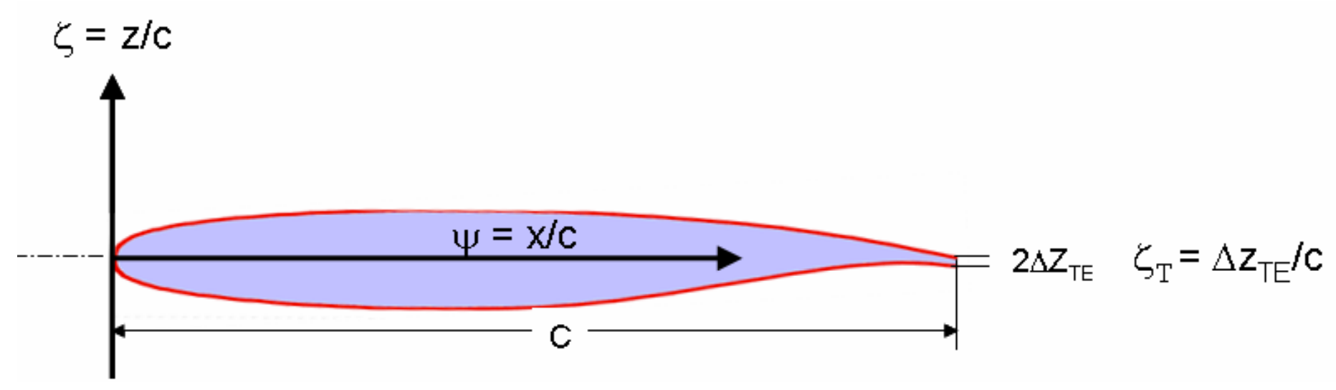
Figure 1: Cross-section of a typical aerofoil [19]
Let $ψ=x/c∈[0,1]$ denote the chordwise coordinate and $ζ=z/c$ the thickness-to-chord ordinate, displayed in Fig. 1. For both upper and lower surfaces, CST writes
$$\begin{matrix} & ζ(ψ) = C_{N_{2}}^{N_{1}}(ψ) S(ψ) + ψ ζ_{T}, & & \text{(1)}\end{matrix}$$
where $ζ_{T}=Δζ_{TE}/c$ encodes trailing-edge thickness. The class function is
$$\begin{matrix} & C_{N_{2}}^{N_{1}}(ψ) = ψ^{N_{1}} [1-ψ]^{N_{2}}, & & \text{(2)}\end{matrix}$$
with $N_{1}=0.5$ (rounded leading edge) and $N_{2}=1.0$ (sharp trailing edge) for subsonic sections [18,20]. The shape function is a Bernstein expansion
$$\begin{matrix} & S\left(ψ\right) = \sum_{i=0}^{N}{A_{i} B_{i}^{N}\left(ψ\right)}, where{ B}_{i}^{N}(ψ)=({N \atop i}) ψ^{ i}(1-ψ)^{ N-i}, & & \text{(3)}\end{matrix}$$
and $({N \atop i})=N!/[i!(N-i)!]$. Separate coefficient sets are used for upper and lower surfaces.

Final coefficient set
The Bernstein coefficients $A_{i}$serve as the compact parameters describing each aerofoil’s shape. To select the dimensionality, we generated datasets with 1–12 coefficients per surface and evaluated a baseline MLP on each. The best balance of geometric fidelity and model performance was obtained with five coefficients for the upper surface and five for the lower, together with a leading-edge modifier $Δz_{LE}$ and a trailing-edge thickness $ζ_{T}$, yielding a 12-parameter CST vector. Fig. 2 summarises the selection process, and Table 1 lists the resulting inputs adopted as the standardised feature set.
Table 1: The final 12 Class-Shape Transformation (CST) parameters used as input features for the machine learning models.
Parameter(s) | Description | Count
A_{L,0} to A_{L,4} | Lower Surface Bernstein Coefficients | 5
A_{U,0} to A_{U,4} | Upper Surface Bernstein Coefficients | 5
Δz_{LE} | Leading Edge Modification Weight | 1
ζ_{TE} | Trailing Edge Thickness | 1
Total |  | 12

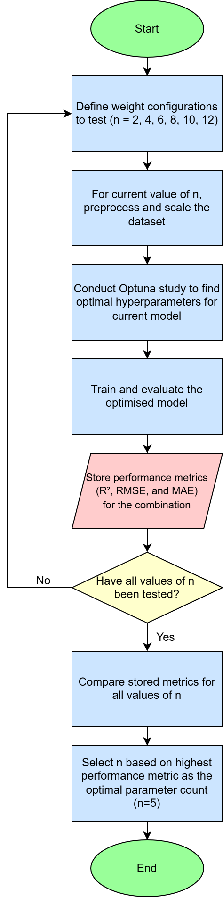
Figure 2: Optimal number of CST parameters script
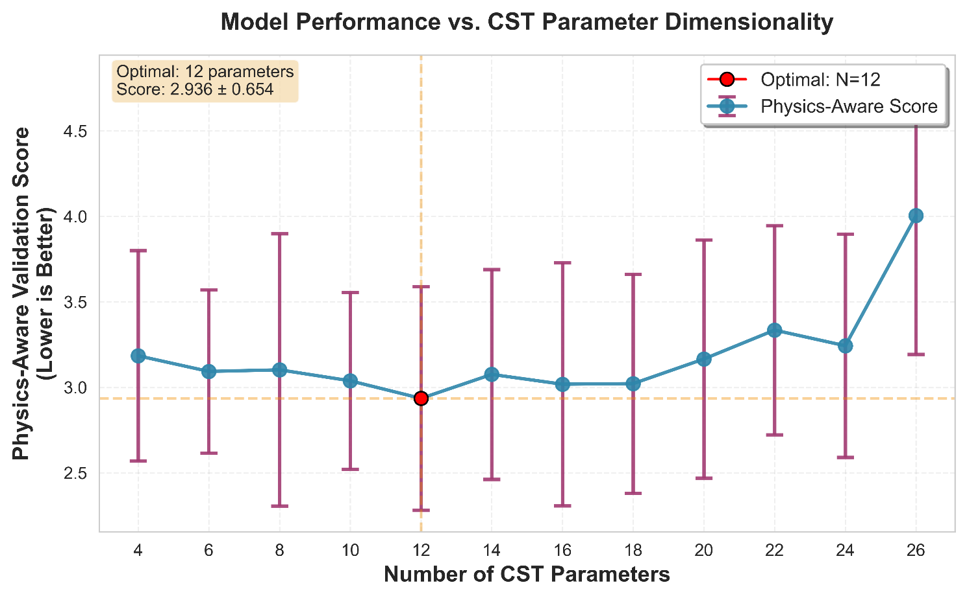
Figure 3: Model validation error as a function of CST parameter count, showing an optimal balance at 12 parameters
Fig. 3 displays the validation error versus CST dimension {8,10,12,14,16} for the baseline MLP, showing the selected knee at N=12.

Data Set Composition
A robust and diverse dataset is critical for developing a generalisable neural network. The geometric and aerodynamic data for this study were sourced from two public databases. Geometries for 1,568 unique aerofoils were obtained from the UIUC Airfoil Data Site [21]. Corresponding lift curves $C_{L}(α)$ precomputed with XFoil [22] were sourced from Airfoil Tools [23] at $Re={10}^{6}$. The set spans conventional families such as NACA, Wortmann, Selig, Eppler, and CLARK Y, as well as unconventional and bio-inspired shapes.
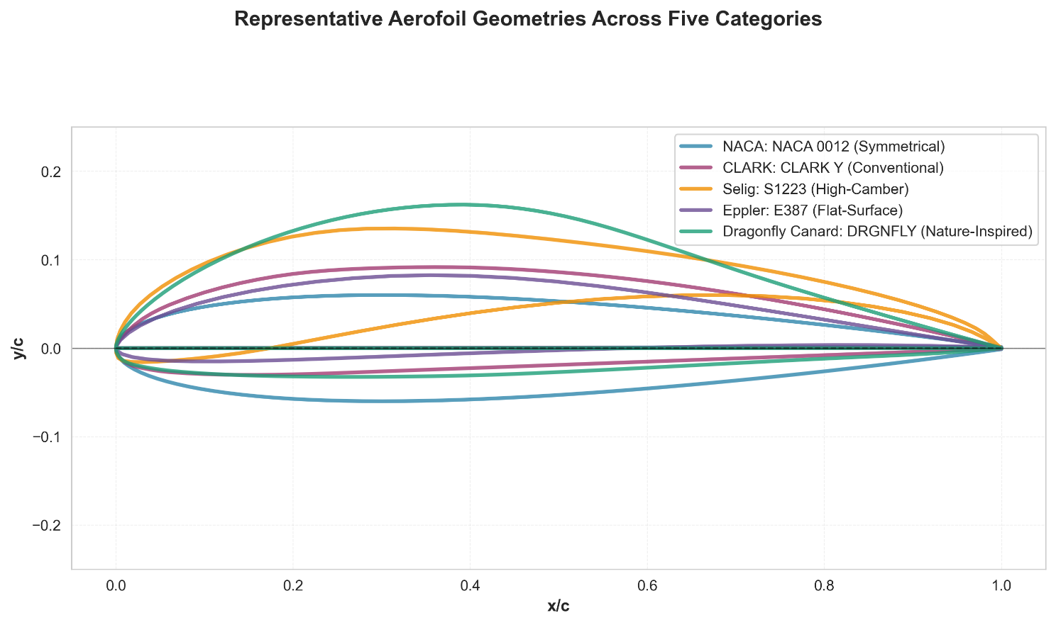
Figure 4: Representative geometries for five categories (symmetrical NACA 0012; conventional CLARK Y; high-camber Selig S1223; flat-surface Eppler E387; nature-inspired Dragonfly Canard).
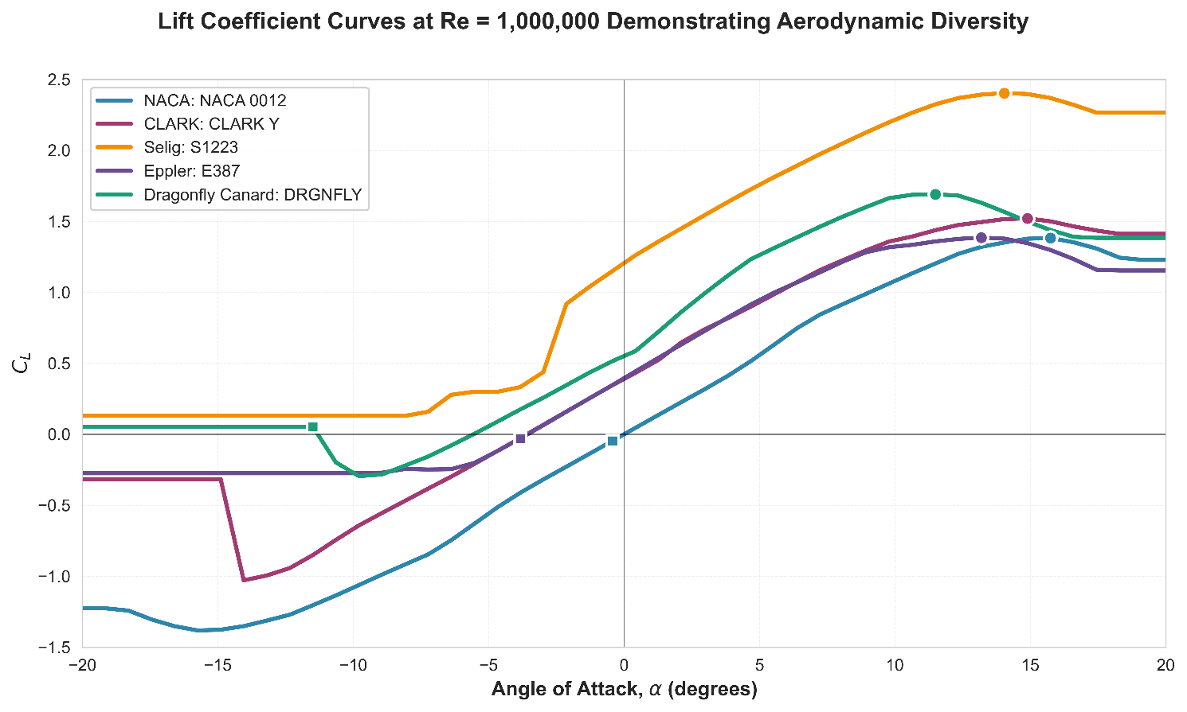
Figure 5: Corresponding $C_{L}(α)$ curves illustrating diversity.

These aerofoils cover a wide range of applications and consequently, include a diverse variety of shapes and C_{L}-α curve patterns. Some main shapes include high lift aerofoils of aerospace application with a thick leading edge and increased curvature, supercritical aerofoils for transonic speeds, wind turbine specifically designed aerofoils, marine and offshore Hydrofoils including fish liked shape, nature inspired for different applications such as low drag aerofoils designed similar to the shape of a shark [24], low Reynolds number aerofoils for applications such as UAVs [25], Gas turbine compressible aerofoils suitable for cascade [26], as well as historical aerofoils such as Joukovsky and Eppler.
In terms of their shapes only, we classified five distinguishable configurations [27]:
- Symmetrical aerofoils (NACA 0012)
- Non-symmetrical thick aerofoils (CLARK Y)
- Non-symmetrical cambered increased curvature (Selig S1223)
- Non-symmetrical flat upper or lower surface (Eppler E387)
- Nature inspired unconventional shapes (Dragonfly Canard)
Figs. 4 and 5 contain five example aerofoils, one from each of the described categories, displaying the geometric and physical diversity of the dataset as a whole.

Reproducibility Note on XFoil Settings
The configuration utilised for the XFoil calculations on Airfoil Tools at the Reynolds number of 1,000,000 are as defined in Table 2 [28].
Table 2: XFoil configuration
Parameter | Value | Source / Note
Reynolds Number (Re) | 1,000,000 | [28]; Data selected for this study.
Mach Number (M) | 0.0 | [28]; Default value.
Ncrit | 9 | [28]; Corresponds to "average wind tunnel" turbulence.
Transition Model | Default $e^{N}$method) | Implied by Ncrit usage [28].
Max Iterations | 70 | [28].
Convergence Tolerance | Default | Not specified in source [28].
Panel Smoothing | FILT command used | [28].
Panelling | PANE command used | [28]; Specific panel count not stated.

Target construction and validity weights
A primary challenge with this dataset is the inconsistency in the angle of attack range for each aerofoil. To create a standardised target for the neural network, each lift curve was mapped onto a fixed grid of 48 points, linearly spaced from -20° to 20°. This introduced the problem of "out-of-range" points for aerofoils whose original data did not span the full grid. Preliminary tests revealed that naive methods for handling this, such as simple padding and linear extrapolation, introduced non-physical artifacts that "contaminated" the training process.
To overcome this, a novel preprocessing technique was developed. While the target C_{L} vector was created using interpolation within the known data range and edge padding outside of it, a distance-based validity vector was simultaneously generated for each aerofoil. This 48-element vector contains a weight for each point on the standardised grid: 1.0 for points within the original data range, decaying exponentially towards 0.0 for points in the padded region. As will be detailed in Section 3, this vector is used to create a weighted loss function, which forces the model to prioritise learning from real, physical data. The final, optimised dataset used for this study consists of the 12 CST-parameters, the 48 $C_{L}$ values and the corresponding weights.
Public $C_{L}\left(α\right)$ series vary in coverage. We construct standardised targets and a per-sample weight vector to respect the available physics. A primary challenge with this heterogeneity is the contamination of the training process. Since models must map to a fixed 48-point output grid, aerofoils with limited measured data are filled using linear extrapolation or edge padding. If a naive loss function is used, the network is forced to learn from these unreliable, non-physical artifacts, leading to training instability and a degradation in predictive accuracy, especially near the boundaries of the measured range.

Grid and units:
Angles of attack are treated in degrees. Each curve is mapped to a fixed grid $α_{i}∈[-{20}^{∘},+{20}^{∘}]$ with $48$ equally spaced points.

Interpolation and Extrapolation:
Within the available range, we use piecewise-linear interpolation for $C_{L}(α)$. Outside the available range, we use edge padding with the nearest valid value. This choice avoids non-physical overshoot and keeps the target well defined at all grid points.

Distance-based validity weights:
For each grid angle $α_{i}$, a per-point validity weight $w_{i}$ is calculated. For any $α_{i}$ within the original measured range [$α_{min},α_{max}]$, the weight $w_{i}=1.0$. For any point $α_{i}$ outside this range, the weight decays exponentially based on a normalised distance. The absolute distance to the nearest valid edge, $d_{i}=min\left(\left|α_{i}-α_{min}\right|,\left|α_{i}-α_{max}\right|\right)$, is normalised by the total width of the valid data range, $L_{α}=α_{max}-α_{min}$. The weight is then given by:
$$w_{i}=\left\{\begin{aligned}1, &\text{if }α_{i} \text{∈} \text{[}{\text{α}}_{\text{min}}\text{,}{\text{α}}_{\text{max}}\text{]} \\ exp\left(-\frac{d_{i}}{L_{α}}\right), &\text{if }α_{i} \text{∉} \text{[}{\text{α}}_{\text{min}}\text{,}{\text{α}}_{\text{max}}\text{]}\end{aligned}\right. {\tilde{w}}_{i} = \frac{w_{i}}{\sum_{j=1}^{48}{w_{j}}}, \left(4\right)$$
we normalise weights per sample to keep the effective loss scale stable across coverage patterns. The relative scaling ensures decay is stricter for aerofoils with narrow data coverage, as illustrated in Fig. 6. These weights define the soft mask used in training; they prioritise learning from physically supported regions and de-emphasise padded regions. The training loss uses ${\tilde{w}}_{i}$with the log-cosh error; the explicit formula is given in Section 3.1.
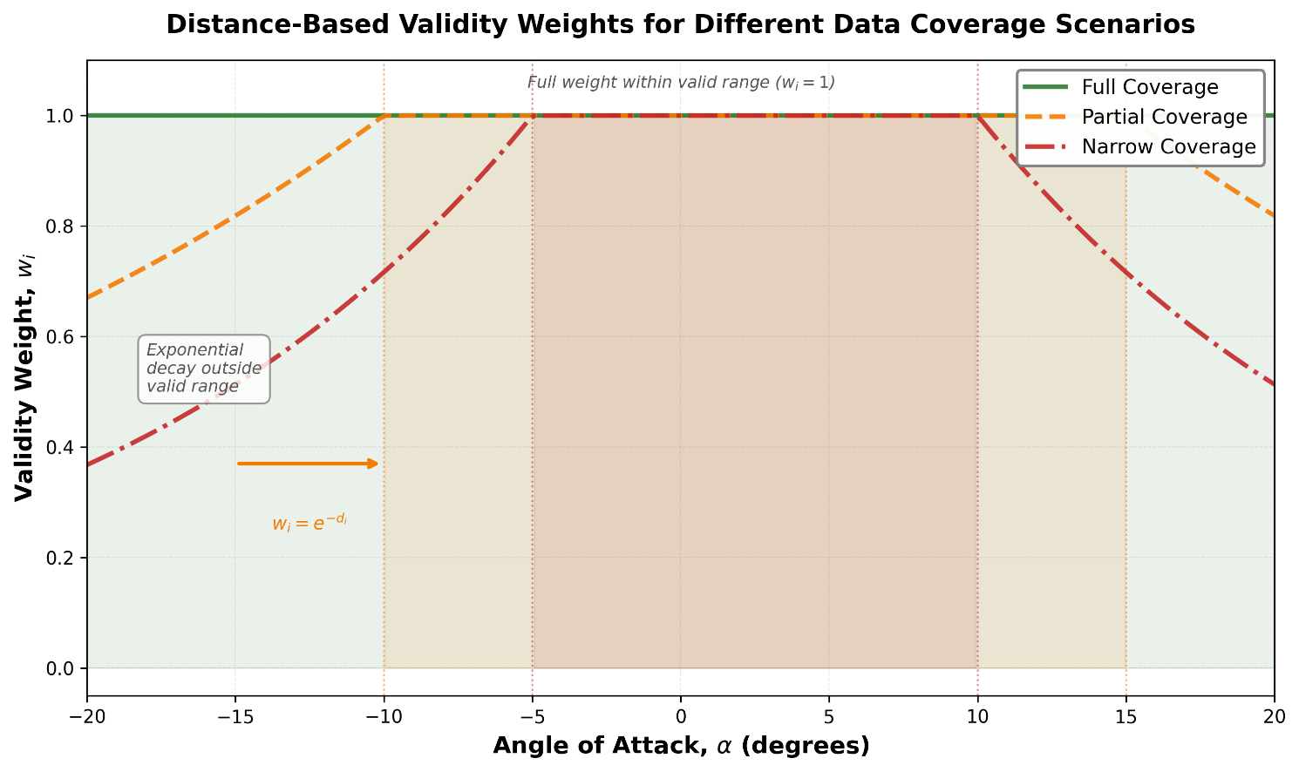
Figure 6: Visualization of the distance-based validity weights ($w_{i}$) for three different data coverage scenarios. The weight is 1.0 within the original measured range (shaded regions) and decays exponentially outside this range. The rate of decay is relative to the width of the valid data range, resulting in a steeper decay for aerofoils with "Narrow Coverage" compared to those with "Partial Coverage".

Family-aware splits and scaling
To ensure a robust and unbiased evaluation of the models' generalisation capabilities, a Leave-One-Family-Out (LOFO) cross-validation strategy was employed. Instead of a simple random split, which risks data leakage between similar aerofoils, the LOFO protocol iteratively holds out an entire aerofoil family (e.g., all NACA profiles, all Eppler profiles) for testing while training on the remaining families. This provides a true measure of the models ability to extrapolate to new, unseen classes of geometry. Prior to training each fold, the input features (CST parameters) were standardised using Z-score scaling, with the scaler being fit only on the training data to prevent data leakage.

Machine Learning Methodology
We develop a predictive pipeline that compares compact deep architectures, couples training with a physics-aware objective, and validates generalisation with a family-aware protocol. All models are implemented in PyTorch [29]. The input is a 12-dimensional CST vector; the output is a 48-point lift curve $C_{L}(α)$ on a fixed grid from $-{20}^{∘}$to $+{20}^{∘}$. Training uses per-angle validity weights derived from data coverage, as defined below [30].

Objective and physics-aware weighting
Let ${\hat{y}}^{(n)}∈R^{48}$and $y^{(n)}∈R^{48}$be the predicted and true $C_{L}$values for sample $n$. Let ${\tilde{w}}^{(n)}∈R^{48}$be the normalised distance-based weights (Section 2). The training loss is the weighted log-cosh:
$$\begin{matrix} & L=\frac{1}{N}\sum_{n=1}^{N}{\sum_{i=1}^{48}{{\tilde{w}}_{i}^{(n)} log⁡\text{ ⁣}cosh⁡\text{ ⁣}({\hat{y}}_{i}^{(n)}-y_{i}^{(n)})}} & & \text{(5)}\end{matrix}$$
where N is the number of samples in the batch, ${\tilde{w}}_{i}^{(n)}$ is the validity weight for the i-th point of the n-th sample and y and $\hat{y}$ are true and predicted $C_{L}$ values, respectively.
Model selection is guided by a Physics Score that aggregates errors in $C_{L,max⁡}$, $α_{\text{stall}}$, $α_{L=0}$, and the linear-range lift slope.

Model Architectures
We evaluate three neural architectures that map the 12-dimensional CST input to the 48-point output. Each model is trained with the objective in Eq. (5) and compared under identical data splits and optimisation settings.
To identify the most effective architecture for mapping an aerofoil's geometry to its lift curve, three distinct neural network types were implemented and compared. For each architecture, the objective was to map a 12-dimensional input vector (12 CST parameters) with a weighted loss function using 48 distance-validity indicators to a 48-dimensional target vector representing the lift coefficient C_{L} values on the standardised grid.

Multilayer Perceptron (MLP)
The MLP serves as a strong baseline for fixed-length encodings. It applies a sequence of affine layers with non-linearities to the 12-D input and produces a 48-D output. We use Rectified Linear Unit activations given their simplicity and gradient properties [31].

Gated Recurrent Unit (GRU)
To acknowledge the sequential nature of the lift curve along $α$, we implement a GRU-based model [32]. The network processes an internal sequence of length 48 and outputs $C_{L}$at each grid angle. GRU update and reset gates regulate information flow, enabling the model to capture local trends and mild hysteresis patterns with fewer parameters than more complex recurrent variants [33,34].

Long Short-Term Memory (LSTM)
We also evaluate an LSTM, which augments recurrence with a gated memory cell to represent longer-range dependencies across $α$ [35]. This capacity can be beneficial near stall where nonlinearity increases.

1D Convolutional Neural Network (CNN)
A 1D Convolutional Neural Network was also implemented as a strong baseline. As CNNs are highly effective at learning hierarchal features from spatial or sequential data [36]. In this application, the 12-parameter CST input vector is treated as a 1D sequence of length 12. One or more 1D convolutional layers are applied to learn local patterns and interactions between adjacent CST coefficients (e.g., the relationship between 'Lower 2', 'Lower 3', and 'Lower 4'). The resulting feature maps are typically flattened and passed through a dense (fully connected) network, which maps the learned features to the final 48-point $C_{L}$ output vector [37]. This architecture serves as a modern alternative to the standard MLP, testing whether local feature extraction provides an advantage over the MLP's fully connected approach.

Optimisation and validation protocol
Hyperparameters for all architectures are tuned using a physics-aware search: the optimisation target is the validation Physics Score, with Eq. (5) as the training loss [14]. We use leave-one-family-out (LOFO) folds to assess generalisation to unseen aerofoil families; scaling statistics are computed on training data only.

Parameter Optimisation with Optuna
Table 3: Summary of the final optimised architectures and parameter counts for each model type, obtained from the physics-aware hyperparameter search (Optuna).
Model Type | Architecture Details | Trainable Parameters | Model Size (MB)
MLP | 3 hidden layers + wide/deep branches, 128 hidden units, ×2 width factor, ~0.36 dropout | 157,488 | 0.60
GRU | Unidirectional 2 layers, 128 hidden units, 4-head attention, ~0.11 dropout | 242,864 | 0.93
LSTM | Unidirectional 2 layers, 128 hidden units, 4-head attention, ~0.26 dropout | 294,064 | 1.12
CNN | 3 conv layers, filters {64, 128, 256}, kernels {5, 5, 3}, ~0.10 dropout | 421,168 | 1.61

We used a two-stage optimisation process. First, as described in Section 2.1, we selected a 12-parameter CST vector by evaluating validation error versus CST dimensionality. Second, for each architecture and loss function, we performed a physics-aware hyperparameter search with Optuna [14]. The use of Optuna alleviated the need for manual iterative refinement. Optuna efficiently searches a defined hyperparameter space aiming to find this optimal configuration.
Each study minimised the validation Physics Score while training with the weighted loss. The search space covered depth, width, learning rate, dropout, and weight decay for all models; recurrent depth and hidden size for GRU/LSTM; filter blocks and kernel sizes for the CNN; and the decay parameter $τ$in the distance-weighted loss. Unless noted otherwise, each study ran 250 trials with asynchronous pruning; the top configuration per study was re-trained to convergence under the same validation protocol.

Search space (high level):
- Shared: hidden layers $\{1,5\}$, width $\{64,512\}$, activation ReLU, dropout $\{0.0,0.4\}$, Adam learning rate $\{{10}^{-5},3×{10}^{-3}\}$(log-uniform), weight decay $\{0,{10}^{-3}\}$, batch size $\{64,128,256,512\}$.
- RNNs: layers $\{1,4\}$, hidden units $\{64,512\}$, sequence output at 48 steps.
- Weighting: $τ∈\{1^{∘},6^{∘}\}$ for the exponential decay of validity weights.
- 1D-CNN: filter blocks {2, 4}, base filters {32, 128} (doubling per block), kernel sizes {3, 7} per block, dropout {0.1, 0.4}.
We used early stopping on the validation Physics Score with patience 20 and restored the best epoch. To reduce variance, each candidate was evaluated over the LOFO validation fold with fixed seeds; the final numbers in Table 3 aggregate performance across the five LOFO test folds for the winning configuration in each study.

Training and Validation Strategy

Objective and weighted loss
For all models, the training process was driven by the Adam optimiser [35]. This is an adaptive learning rate optimisation algorithm that is well-suited in training large neural networks due to the stability and efficiency it exhibits. To prevent overfitting, an early stopping mechanism was employed, monitoring the validation Physics Score and restoring the model weights from the best-performing epoch.
A significant innovation of this work is the use of a custom weighted loss function to address the "out-of-range" data points created during grid standardisation. A naive loss calculation would be corrupted by the artificial data from edge padding. To solve this, the element-wise loss (e.g., Log-Cosh) between the 48-point prediction and the 48-point target was multiplied by the corresponding 48-element distance-based validity vector (as described in Section 2) before being averaged. The loss can be expressed as:
$$L_{weighted}=\frac{\sum_{i=1}^{N}{w_{i}}⋅L_{pointwise}\left(y_{i},\hat{y_{i}}\right)}{\sum_{i=1}^{N}{w_{i}}} (6)$$
where w_{i} is the validity weight for point i. This "soft masking" technique forces the optimiser to prioritise accuracy on the real data (where $w_{i}=1.0$) while progressively ignoring the artificial padded data (where $w_{i}→0.0$).
To provide a more physically meaningful evaluation, four key aerodynamic characteristics were extracted from each predicted and actual lift curve: Maximum Lift Coefficient (C_{L,max}), Stall Angle (α_{stall}), Zero-Lift Angle of Attack (α_{L=0}), and the Lift Curve Slope (dC_{L}/dα). A composite Physics Score was defined as the primary metric for model selection and hyperparameter tuning. It is a weighted sum of the mean absolute errors of these four physical metrics, designed to penalise models that are physically inconsistent, even if statistically accurate.
$$\text{Physics Score}=\sum_{k∈\text{metrics}}{λ_{k}}⋅\left|\text{error}\left(k\right)\right| (7)$$
where the weights $λ$ were set to [1.0, 0.5, 0.3, 10.0] for $C_{L,max}$, $α_{stall}$, $α_{L=0}$, and slope error, respectively, to prioritise accuracy on the critical stall characteristics while bringing all values to a closer scale ensuring a weighting from each component. For final performance reporting, standard regression metrics were also computed, including Mean Squared Error (MSE) and the Coefficient of Determination (R²) [36].
We apply gradient clipping at 1.0 and cosine learning-rate decay after a linear warm-up of 5 epochs for stability on the recurrent models.

Evaluation Metrics
For each predicted and true curve, we extract four aerodynamic features: $C_{L,max⁡}$, $α_{\text{stall}}$, $α_{L=0}$, and the linear-range slope $dC_{L}/dα$. The Physics Score is a weighted sum of the absolute errors in these features:
$$\begin{matrix} & \text{Physics Score}=\sum_{k∈\{ C_{L,max⁡}, α_{\text{stall}}, α_{L=0},\text{ slope }\}}{λ_{k} ∣e_{k}∣}, & & \text{(}\text{8}\text{)}\end{matrix}$$
with $λ=\{1.0, 0.5, 0.3, 10.0\}$ to emphasise stall-related fidelity. For final performance reporting, standard regression metrics were also computed, including Mean Squared Error (MSE) and the Coefficient of Determination (R²) [36].

Validation Protocol
Model comparison and hyperparameter tuning use LOFO cross-validation over the five most populous aerofoil families. For final performance reporting, we train on a fixed 70/15/15 split (train/validation/test) drawn from the full dataset, using early stopping on the validation Physics Score. Test metrics are computed on the valid $α$range for each aerofoil. Physics Score on the validation set, halting training after 20 epochs of no improvement and restoring the best model weights.
The definitive performance metrics reported in Section 4 are calculated on the unseen 15% test set. In all cases, metrics on test data were calculated only on the known valid data range for each aerofoil to ensure a fair and scientifically sound comparison.

Results and Discussion
The following section outlines the processes taken and the results gained from this research.

Hyperparameter Optimisation and Model Selection
Following the establishment of the dataset and validation protocol, a rigorous hyperparameter optimisation and model selection process was conducted. The objective was to systematically identify the optimal combination of model architecture (MLP, GRU, LSTM, or CNN) and loss function (MSE, Huber, Log-Cosh, or Smooth L1) that yielded the most physically accurate predictions. The primary metric for this selection was the custom Physics Score, ensuring that the chosen model excelled not just in statistical accuracy but in capturing key aerodynamic characteristics.
We evaluated sixteen model–loss combinations: $\{$MLP, GRU, LST$, CNN\}$ × $\{$MSE, Huber, Log-Cosh, Smooth L1$\}$. For each combination, an Optuna study (250 trials) minimised the validation Physics Score under the LOFO protocol. Table 4 summarises the mean performance of the resulting best configurations across the five LOFO folds. The process taken is described in Fig. 7.

Table 4: Performance comparison of the twelve model–loss combinations across all five LOFO folds. The Physics Score is the primary selection criterion.
Model | Loss | Physics Score | Physics Std | MSE | MSE Std | $$ΔCL_{max}$$ | $Δα_{stall}$(°) | Is Best
CNN | MSE | 1.702084 | 0.296846 | 0.030519 | 0.009788 | 0.150293 | 2.036629 | ✓
CNN | LogCosh | 1.808518 | 0.385392 | 0.035599 | 0.012320 | 0.150294 | 2.240679
CNN | Huber | 1.867123 | 0.331329 | 0.038790 | 0.012884 | 0.161292 | 2.205466
CNN | SmoothL1 | 1.874068 | 0.348249 | 0.080894 | 0.097401 | 0.235716 | 2.202350
GRU | Huber | 2.147171 | 0.349643 | 0.059742 | 0.004019 | 0.170207 | 2.446271 | ✓
GRU | LogCosh | 2.209661 | 0.337851 | 0.043525 | 0.009372 | 0.140127 | 2.906488
GRU | MSE | 2.394587 | 0.331380 | 0.061278 | 0.009592 | 0.171664 | 3.060116
GRU | SmoothL1 | 2.407800 | 0.289368 | 0.069846 | 0.008320 | 0.181029 | 2.786351
LSTM | MSE | 2.255144 | 0.294205 | 0.079334 | 0.008536 | 0.197118 | 2.378218 | ✓
LSTM | LogCosh | 2.262400 | 0.220310 | 0.072126 | 0.006546 | 0.179708 | 2.491768
LSTM | Huber | 2.507436 | 0.393904 | 0.056292 | 0.009367 | 0.161804 | 3.094472
LSTM | SmoothL1 | 2.542241 | 0.563978 | 0.111276 | 0.027177 | 0.268026 | 2.610972
MLP | LogCosh | 1.537353 | 0.394111 | 0.027444 | 0.013454 | 0.116628 | 1.910389 | ✓
MLP | Huber | 1.539776 | 0.351717 | 0.028529 | 0.011520 | 0.132527 | 1.853145
MLP | SmoothL1 | 1.601638 | 0.358149 | 0.031137 | 0.016366 | 0.138584 | 1.923247
MLP | MSE | 1.609627 | 0.304341 | 0.033070 | 0.016395 | 0.135923 | 1.961418

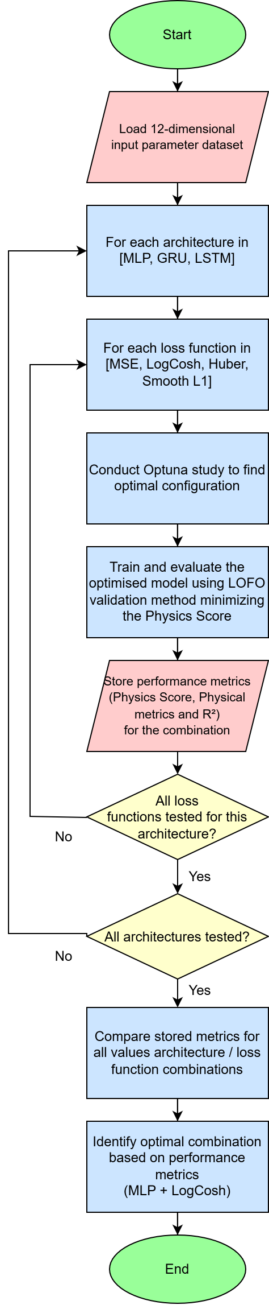
Figure 7: Hyperparameter search and selection workflow.
The results indicate that an MLP with Log-Cosh achieves the lowest mean Physics Score (1.537) and the tightest distribution across LOFO folds. GRU, LSTM and CNN do not outperform the MLP on physics-aware metrics despite their sequential capacity. We therefore select the MLP-Log-Cosh configuration as the final model for in-depth evaluation.
The justification for using the Physics Score over a standard metric like MSE is illustrated in Fig. 8. While a strong correlation exists between the two metrics, the model with the absolute lowest MSE is not guaranteed to be the most physically accurate. The Physics Score provides a more robust objective for selecting models that adhere to the underlying aerodynamic principles.
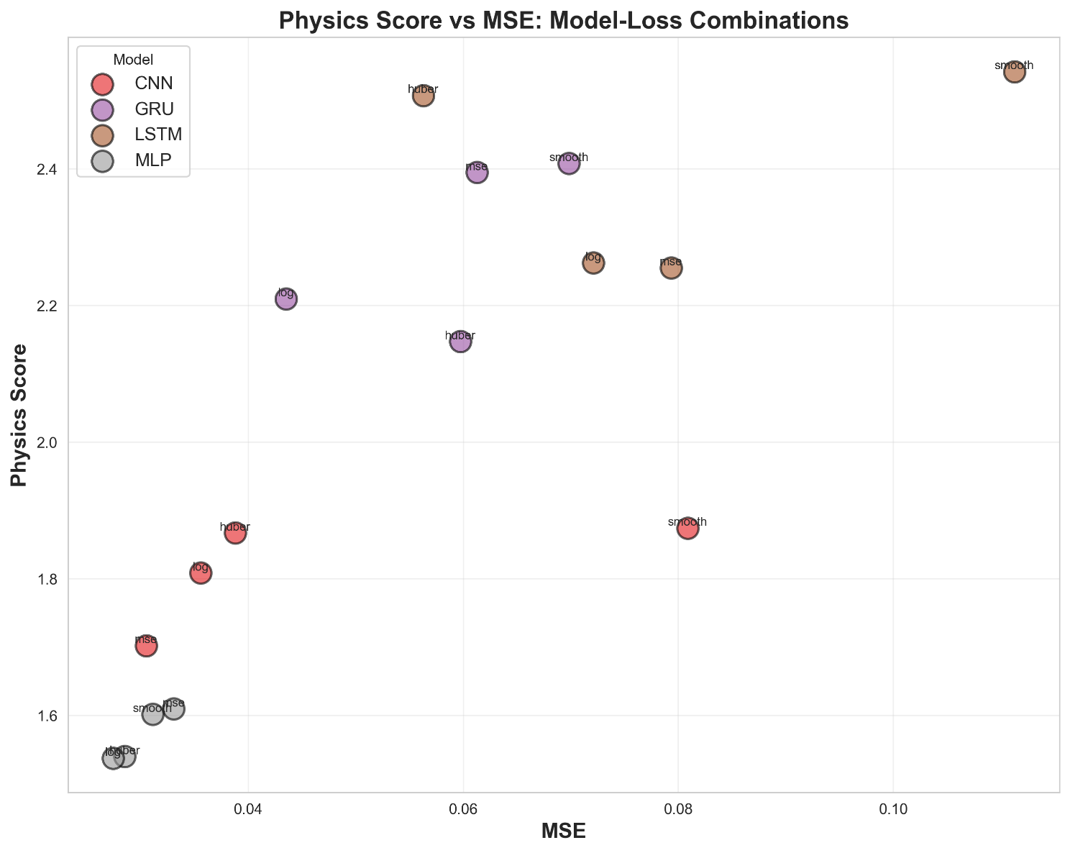
Figure 8: Correlation between the validation Mean Squared Error (MSE) and the Physics Score for the best model from each of the 250 Optuna trials.
While a general trend exists, the model with the lowest MSE is not always the one with the best (lowest) Physics Score, validating the use of the latter as the primary optimisation objective.
Fig. 9 visually summarises the performance of all sixteen combinations, reinforcing the superior performance of the MLP with Log-Cosh loss. The variance in performance across the five LOFO folds, shown in Fig. 10, further highlights the robustness of this combination, which exhibits not only the best mean performance but also a tight distribution of scores across different held-out aerofoil families.
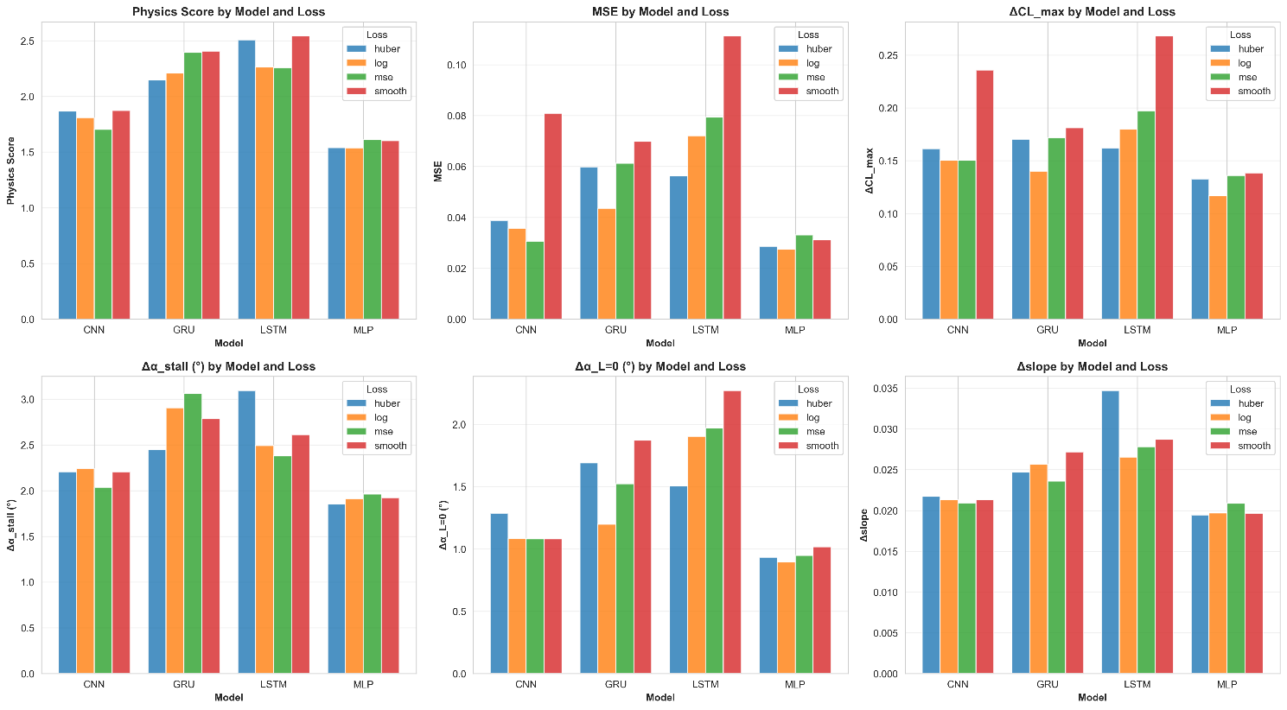
Figure 9: Comparison of the mean Physics Score for each of the sixteen model-loss function combinations, evaluated across all LOFO folds. Lower values indicate better performance.
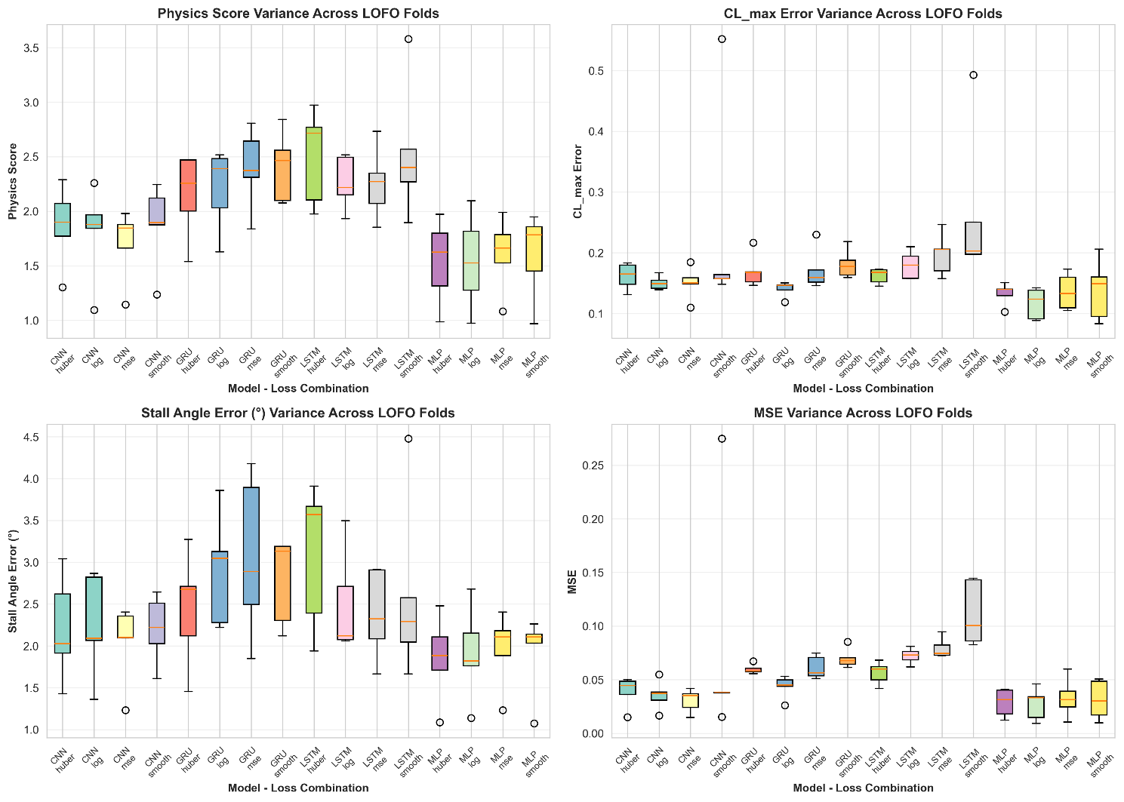
Figure 10: Boxplot showing the distribution of Physics Scores for each model across the five Leave-One-Family-Out (LOFO) folds. This illustrates the variance and robustness of each model when generalising to unseen aerofoil families.
Given its superior and robust performance on the primary physics-aware metric, its consistent behaviour across LOFO folds, and its relative computational efficiency, the MLP architecture trained with the Log-Cosh loss function was selected as the final, optimal model for the in-depth evaluation presented in the following section.

Ablation Study on Weighted Loss Function
Table 5: Comprehensive ablation study results validating the necessity and optimal configuration of our distance-weighted loss function
Approach | τ | Physics Score | MSE | R² Score | ΔCL_max | Δα_stall (°) | Δα_L=0 (°) | Δslope
Exponential_tau1.0 | 1 | 1.2730 | 0.0259 | 0.6558 | 0.1153 | 1.8824 | 0.7176 | 0.0060
Exponential_tau0.2 | 0.2 | 1.2765 | 0.0222 | 0.6414 | 0.1141 | 1.9221 | 0.6671 | 0.0056
Exponential_tau0.5 | 0.5 | 1.2894 | 0.0245 | 0.6554 | 0.1133 | 1.9149 | 0.7248 | 0.0058
NoMask |  | 1.3262 | 0.0273 | 0.6553 | 0.1173 | 1.9546 | 0.7681 | 0.0059
BinaryMask |  | 1.9976 | 0.0162 | 0.2990 | 0.1276 | 3.3285 | 0.6816 | 0.0060

Table 5 presents comprehensive ablation study results validating the necessity and optimal configuration of our distance-weighted loss function. We compare five approaches: (1) NoMask- uniform weighting treating all points, valid data and extrapolated data, equally (mask=1), (2) BinaryMask - hard binary threshold (mask=0 for extrapolated data or 1 for valid data), and (3-5) ExponentialMask with varying decay rates (τ=0.2, 0.5, 1.0) providing continuous distance-based weighting.
Results demonstrate that our best performing approach (Exponential_tau1.0, Exponential decay (τ=1.0, gradual)) achieves a Physics Score of 1.2730, representing a 4.0% improvement over the NoMask baseline (1.3262) and a 36.3% improvement over the hard BinaryMask (1.9976). This configuration also achieves superior statistical performance with R² of 0.6558 and weighted MSE of 0.025914. A visual display of these results and their variation about the NoMask baseline are displayed in Fig. 11.
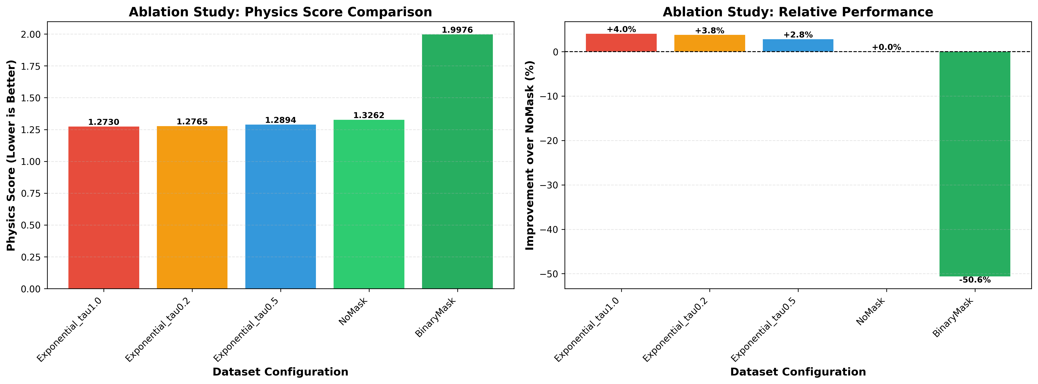
Figure 11: Visual representation of Physics Score by Ablation Study Approach Further Validating the Necessity of the ExponentialMask
The NoMask baseline validates the fundamental necessity of distance-aware weighting. Without it, the model treats high-confidence predictions within the valid data range and low-confidence extrapolations equally, forcing it to fit unreliable data in regions where aerodynamic behaviour is poorly defined. The 4.0% degradation proves that distance weighting is not merely an incremental refinement but a critical architectural component.
The BinaryMask approach, while better than NoMask, suffers from discontinuities at the decision boundary. Points just above and below the threshold (distance=0.99 vs 0.98) receive drastically different treatment (weight=1 vs 0), despite having similar confidence levels. This creates training instabilities and fails to capture the gradual degradation of prediction quality as we move further from the valid data range.
The Exponential Mask approaches provide smooth, continuous weighting that gracefully transitions between high-confidence and low-confidence regions. The τ parameter controls the decay rate: τ=0.2 produces strict decay (rapid weight reduction), τ=0.5 provides moderate decay, and τ=1.0 offers gradual decay. Our results show that τ=1.0 achieves optimal balance, aggressive enough to down-weight unreliable extrapolations but gradual enough to avoid over-penalising mid-range predictions.
These findings validate three key claims: (1) distance-aware loss weighting is necessary (4.0% improvement proves this is not optional), (2) continuous exponential weighting is superior to hard binary thresholding (36.3% improvement), and (3) τ=1.0 provides the optimal decay rate for aerodynamic prediction tasks. The distance-weighted loss function is established as a scientifically validated, critical component of the model architecture.

Final Model Performance Evaluation
After selecting the optimal MLP with Log-Cosh loss, we retrained it on a fixed split of the dataset: 70% for training and 15% for validation. Early stopping monitored the validation Physics Score and restored the best epoch (epoch 93); training converged smoothly and stopped at epoch 109, indicating good generalisation without overfitting, visualised in Fig. 12. We then evaluated the final model on the held out 15% test set to assess generalisation, physics fidelity, computational efficiency, and interpretability.
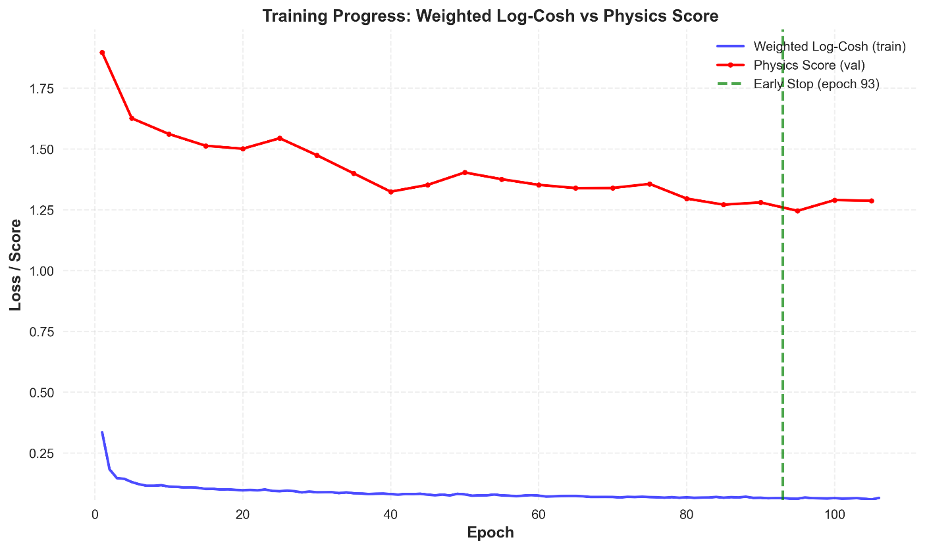
Figure 12: Training and validation loss curves for the final MLP model. The validation loss (Physics Score) closely tracks the trend of the training loss, indicating good generalisation and no significant overfitting with best epoch indicated.

Generalisation to Unseen Aerofoils
On the full test set (Fig. 13), the model achieved $R^{2}=0.9604$ and MSE $=0.028147$ over all pointwise $C_{L}(α)$ values on the standard grid. Restricting evaluation to high-quality points, defined as grid angles within the original measured range for each aerofoil (validity weight $=1$), performance improved to $R^{2}=0.9689$ and MSE $=0.022268$. The tight alignment around the $y=x$line in the predicted-versus-true scatter corroborates this correlation.
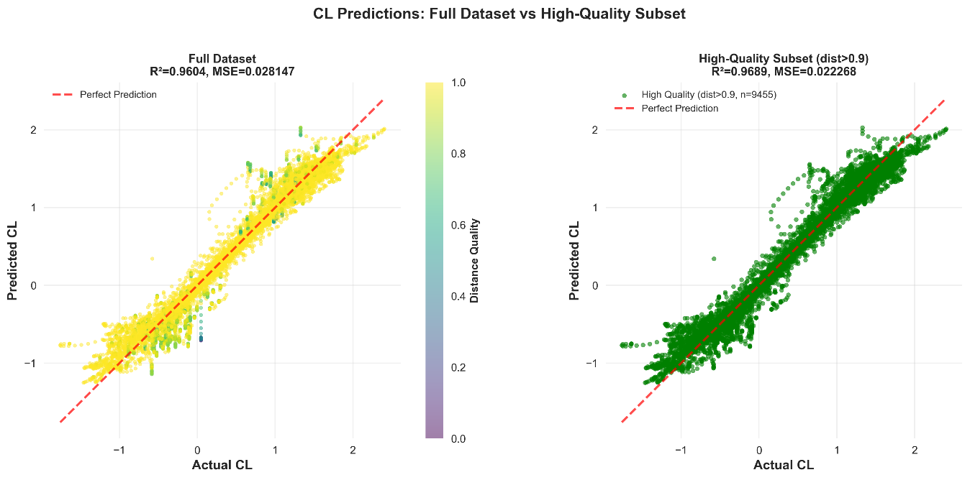
Figure 13: Predicted vs. actual lift coefficient ($C_{L}$) values on the held-out test set. The clear trend corresponds to the final R² score of 0.9604 and MSE of 0.028147 for full dataset predictions and a final R² score of 0.9689 and MSE of 0.022268 for high-quality predictions.

Physics-aware curve-level metrics
To move beyond pointwise scores, we extract four aerodynamic landmarks from each curve: $C_{L,max⁡}$, $α_{\text{stall}}$, $α_{L=0}$, and the linear-range slope $dC_{L}/dα$. Test-set correlations are:
- $C_{L,max⁡}$: $R^{2}=0.6000$
- $α_{L=0}$: $R^{2}=0.5920$
- $dC_{L}/dα$: $R^{2}=0.2666$
- $α_{\text{stall}}$: $R^{2}=0.2320$
Performance is strongest for linear-range metrics and weaker for stall, which is consistent with the nonlinearity and sensitivity of separation onset see, Fig. 14.
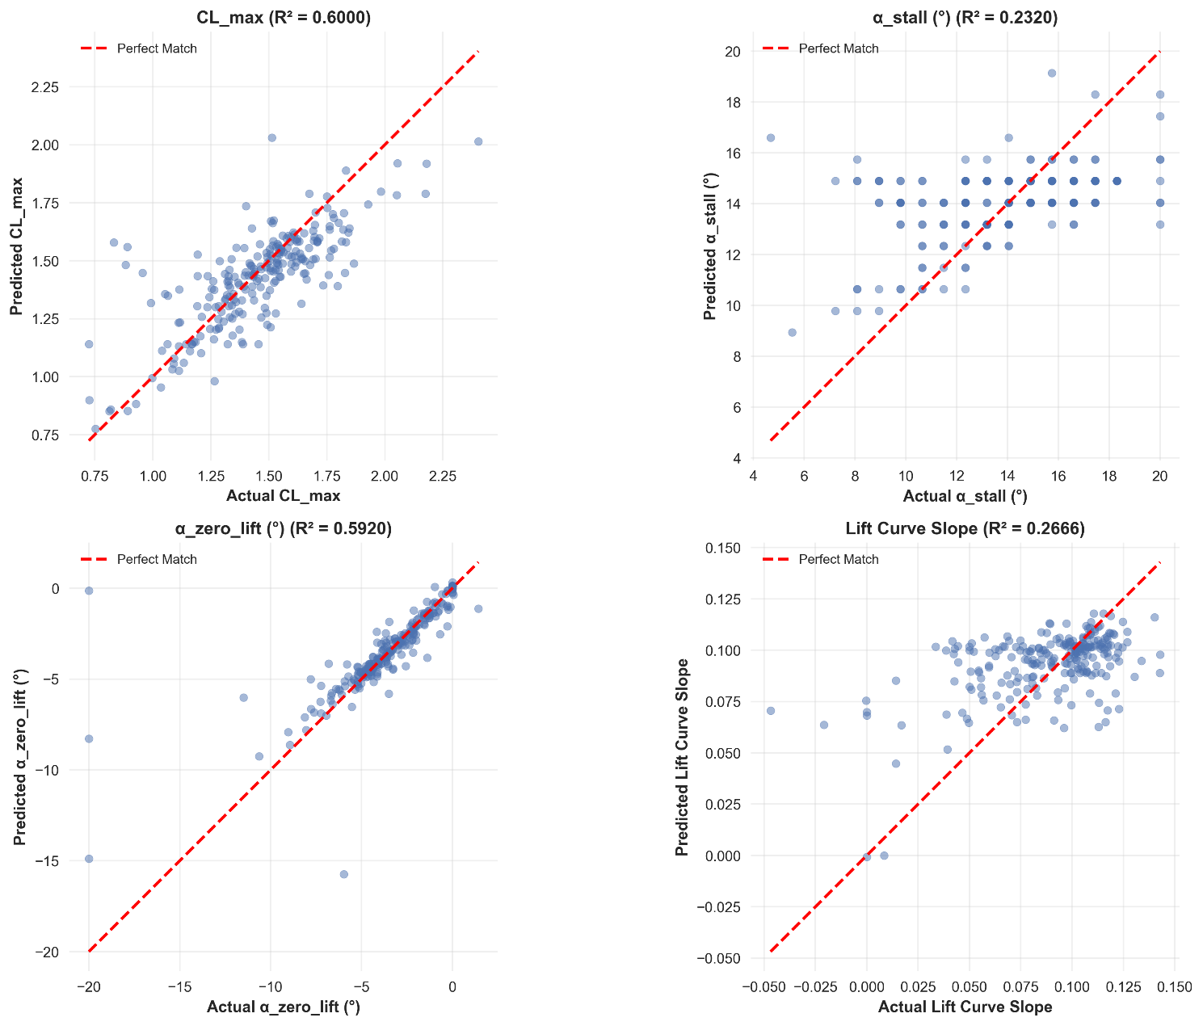
Figure 14: Comparison of predicted vs. actual values for the four key physical metrics on the test set. The model shows strong correlation for $C_{L,max}$ and $α_{L=0}$, with weaker but still positive correlation for lift curve slope and $α_{stall}$.

Error distributions and calibration
The error distributions for these physical metrics are presented in Fig. 15. Error histograms are centred near zero with modest right skew, indicating low bias and infrequent large deviations. For example, $∣ΔC_{L,max⁡}∣$has mean 0.1173 and median 0.0773; $∣Δα_{\text{stall}}∣$ has median ${1.7021}^{∘}$and mean ${1.7923}^{∘}$. These distributions support the Physics Score results and suggest stable behaviour across families.
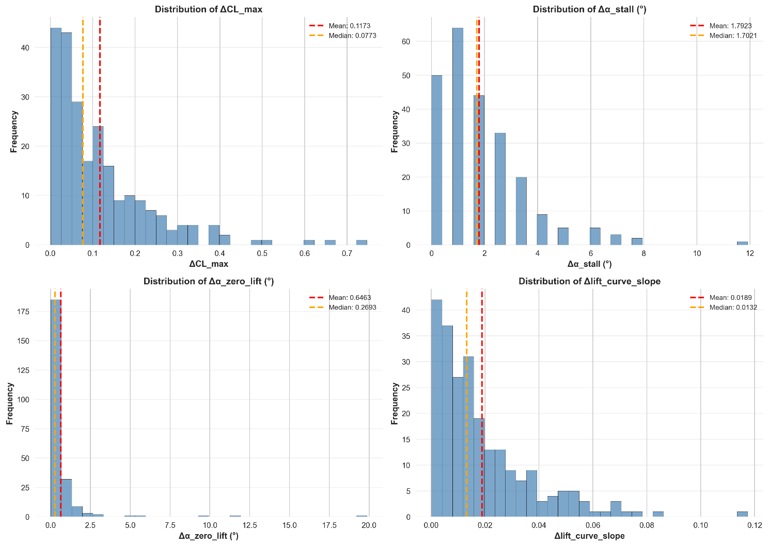
Figure 15: Distribution of prediction errors for the four key physical metrics on the test set. The distributions are centred near zero, indicating low bias.

Family-wise generalisation
Table 6 reports Physics Scores by held-out family. Results are robust across families, with best performance on Selig (0.9737) and highest Physics Score on FX (2.0965). The variation underlines the value of family-diverse training and indicates that the surrogate captures broad trends even for challenging shapes. The Physics Score is highest for the middle of the size range of these families, the FX (Vortman) family (2.0965). Although it had the highest Physics Score, it remains strong, indicating that the model successfully captures the fundamental aerodynamic trends even for challenging, out-of-distribution shapes. This variance underscores the importance of dataset diversity but also validates the models ability to generalise beyond the specific patterns of any single family.
Table 6: Top Five Most Populous and Chosen Leave One Family Out Families and Number of Samples in Test Set
Held-out Family | Number of Samples in Test Set | Physics Score
Gottingen | 396 | 1.5258
Eppler | 189 | 1.8155
FX | 114 | 2.0965
NACA | 103 | 1.2752
Selig | 65 | 0.9737

Case Studies and Physical Accuracy
Fig. 16 compares predicted and ground-truth curves for six representative test aerofoils. For profiles such as fx711530, ah82150a, and e1200, the predicted curve closely matches the true curve across the linear range and near stall, including $C_{L,max⁡}$. For naca65206, goe409 and goe494 which exhibits flatter stall characteristics, the model reproduces the pre-stall slope and overall trend but overpredicts $C_{L,max⁡}$. These qualitative results align with the aggregate metrics and illustrate readiness for design use.
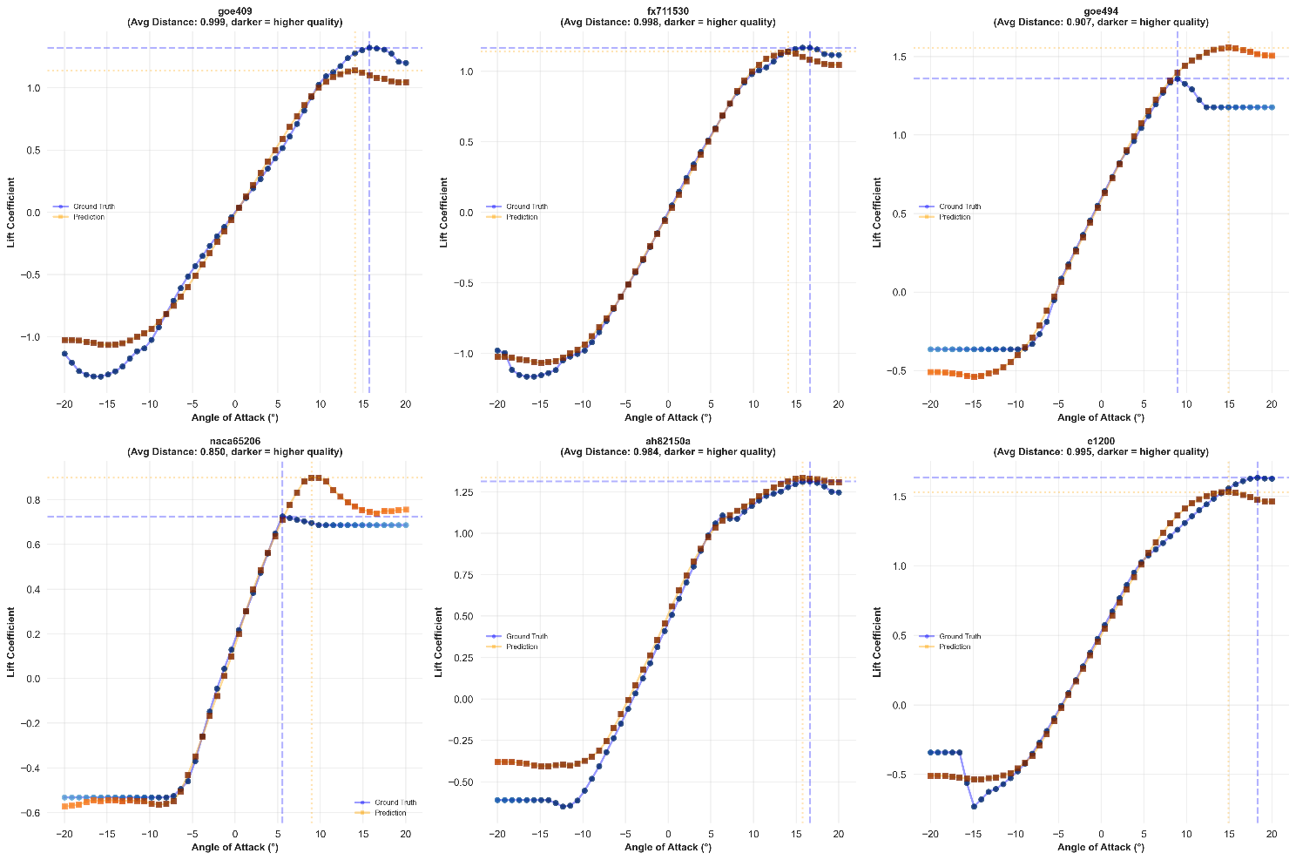
Figure 16: Comparison of predicted (orange squares) and actual (blue circles) lift curves for representative unseen aerofoils. The model demonstrates high fidelity across a range of geometric and aerodynamic complexities.

Computational Efficiency
All timing was measured on an Intel Core i5-9600K (6 cores, 6 threads), 15.94 GB RAM, and NVIDIA GeForce GTX 1660 SUPER (6 GB) using PyTorch 2.7.1 with CUDA 11.8. Inference benchmarks were conducted over 1000 timed iterations following 100 warmup runs, with all measurements performed under torch.no_grad() to disable gradient computation. For the final MLP model with LogCosh loss, single-sample prediction (batch size 1) achieved a mean inference time of 1.663±15.171 ms per aerofoil on GPU and 0.405±0.451 ms on CPU. With batch processing (batch size 32), mean inference time reduced to 0.033±0.017 ms per aerofoil on GPU (30,412 samples/sec) and 0.014±0.003 ms on CPU (72,656 samples/sec), demonstrating that CPU inference is significantly faster for this compact model due to reduced memory transfer overhead. This batched throughput represents several orders of magnitude improvement over XFoil per-curve runtimes and is vastly faster than high-fidelity CFD, enabling real-time design-space exploration and large-batch studies. The dramatic latency reduction from batch size 1 (1.663 ms) to batch size 32 (0.033 ms per sample) on GPU demonstrates efficient parallel processing. This near-instantaneous prediction capability unlocks opportunities for large-scale optimisation, real-time design exploration, and uncertainty quantification studies that would otherwise be intractable.

Model Interpretability via Global Sensitivity Analysis
We performed a Sobol global sensitivity analysis (GSA) to quantify how variance in the 12 CST inputs apportions to variance in the four aerodynamic metrics. We utilised the Saltelli sampling scheme with a base sample size of $N=512$, resulting in a total of 7,168 model evaluations and report first-order indices $S_{i}$ and total-order indices $S_{T_{i}}$ for each input. Large $S_{T_{i}}-S_{i}$ gaps indicate interaction effects.
- $C_{L,max⁡}$: lower-surface coefficients, especially “Lower 3” and “Lower 2,” have the highest influence, consistent with aft-loading control of lift [37].
- $α_{\text{stall}}$: strong interaction effects dominate; lower-surface terms again rank highest in total-order influence, reflecting coupling between circulation, stagnation-point location, and upper-surface separation [38].
- $α_{L=0}$ and slope: sensitivity is driven by camber-related lower-surface coefficients (“Lower 4,” “Lower 3,” “Lower 1”), consistent with classical theory [39].
The GSA was applied to the four key physical metrics predicted by the model. The results, presented in Figures 17 through 20, provide strong evidence that the model has learned nuanced and physically consistent relationships, particularly identifying the critical role of the aerofoil's aft geometry in determining global lift characteristics.
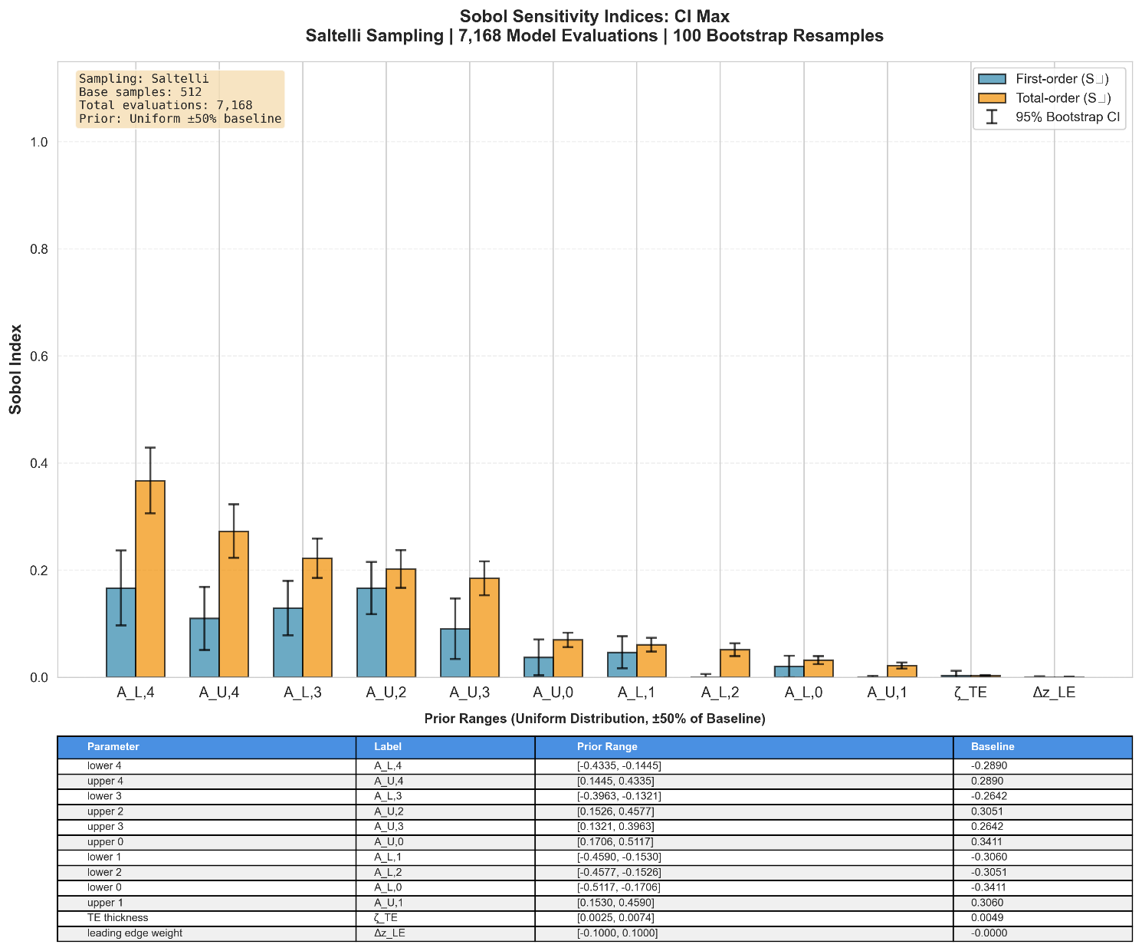
Figure 17: Sobol sensitivity indices for Maximum Lift Coefficient ($C_{L,max}$). The analysis identifies the aft-camber parameters ($A_{L,4}$, $A_{U,4}$) as the most influential.
For the Maximum Lift Coefficient ($C_{L,max}$) (Fig. 17), the analysis reveals that the geometry of the trailing edge region is the dominant factor. Specifically, the lower surface parameter $A_{L,4}$ and upper surface parameter $A_{U,4}$ exhibit the highest total-order indices. In the CST parameterisation, higher-index coefficients control the shape of the aerofoil near the trailing edge ($ψ→1$). This finding implies that the model has learned that aft loading (increasing camber near the trailing edge) is the primary mechanism for shifting the lift curve upwards and increasing maximum lift. This aligns with established aerodynamic theory, where aft camber increases the circulation and the pressure differential across the entire chord [37].

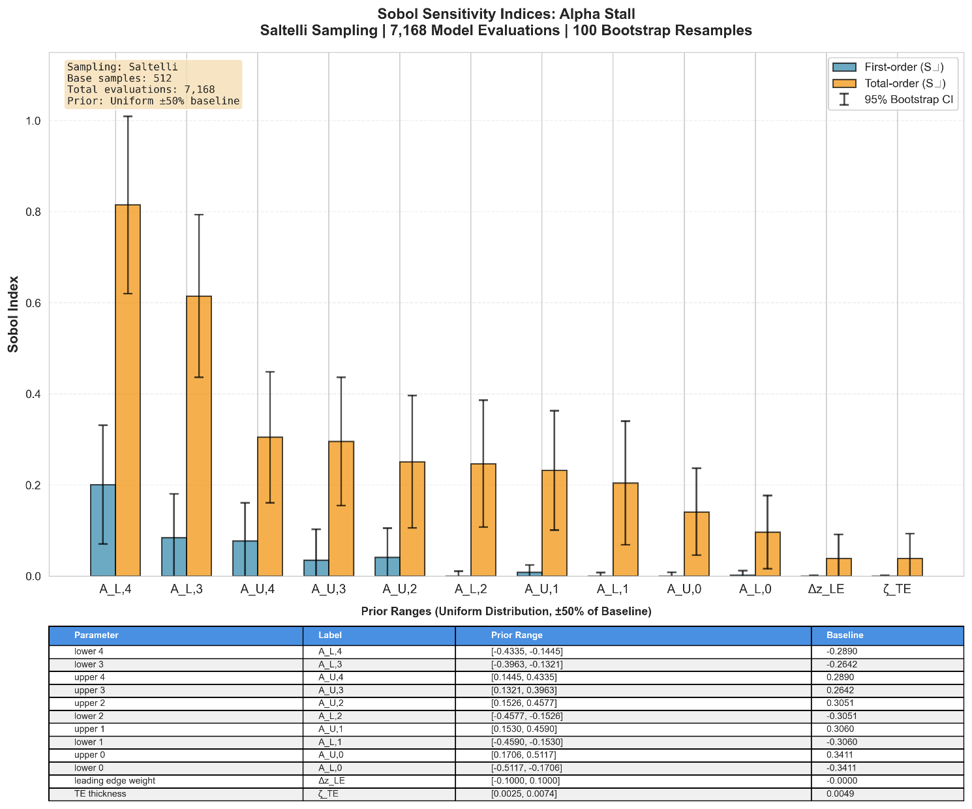
Figure 18: Sobol sensitivity indices for Stall Angle ($α_{stall}$). The analysis highlights massive interactive effects, dominated by the lower surface aft geometry ($A_{L,4}$, $A_{L,3}$).
The prediction of Stall Angle ($α_{stall}$) (Fig. 18) is governed by highly interactive effects, indicated by the substantial gap between the total-order ($S_{T}$) and first-order ($S_{1}$) bars for all parameters. The lower surface aft parameters $A_{L,4}$ and $A_{L,3}$ emerge as the most critical drivers. While stall is physically a flow separation event on the upper surface leading edge, the lower surface geometry dictates the global circulation and the stagnation point location. By modulating the "baseline" flow field, the lower aft geometry indirectly determines the effective angle of attack seen by the nose and the severity of the pressure gradient that leads to separation [38]. The models reliance on interactions confirms its ability to capture this complex coupling between geometric features.

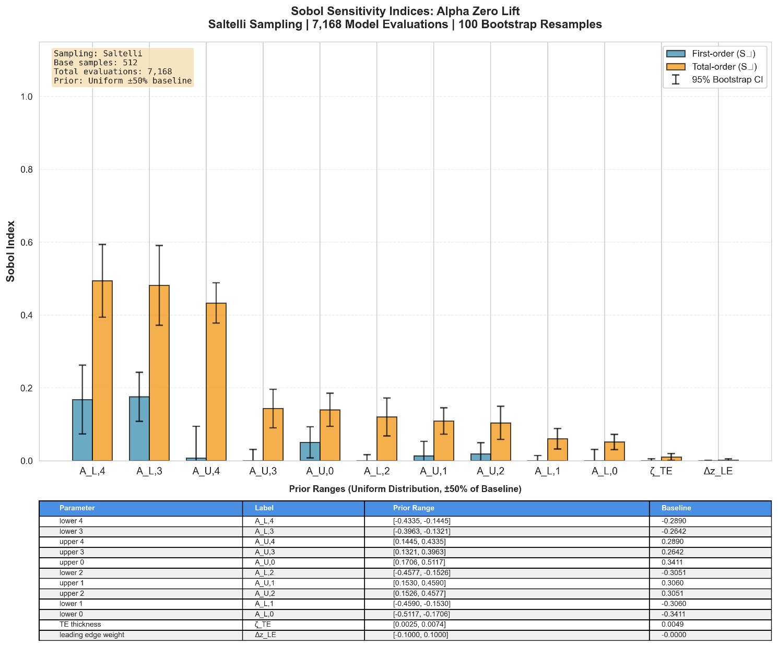
Figure 19: Sobol sensitivity indices for Zero-Lift Angle of Attack ($α_{L=0}$). The model correctly identifies that the lower surface shape ($A_{L,4}$), which dictates camber, is the primary driver.
For the Zero-Lift Angle of Attack ($α_{L=0}$) (Fig. 19), sensitivity is overwhelmingly dominated by the lower surface parameter $A_{L,4}$, followed by $A_{L,3}$. According to Thin Airfoil Theory, $α_{L=0}$ is determined entirely by the integral of the camber line [39]. Since CST defines surfaces relative to the chord line, modifying the lower surface coefficients, specifically $A_{L,4}$ which controls the "under-camber" near the trailing edge is the most direct way to alter the mean camber line. The model has correctly isolated this geometric property as the sole driver of the zero-lift angle.
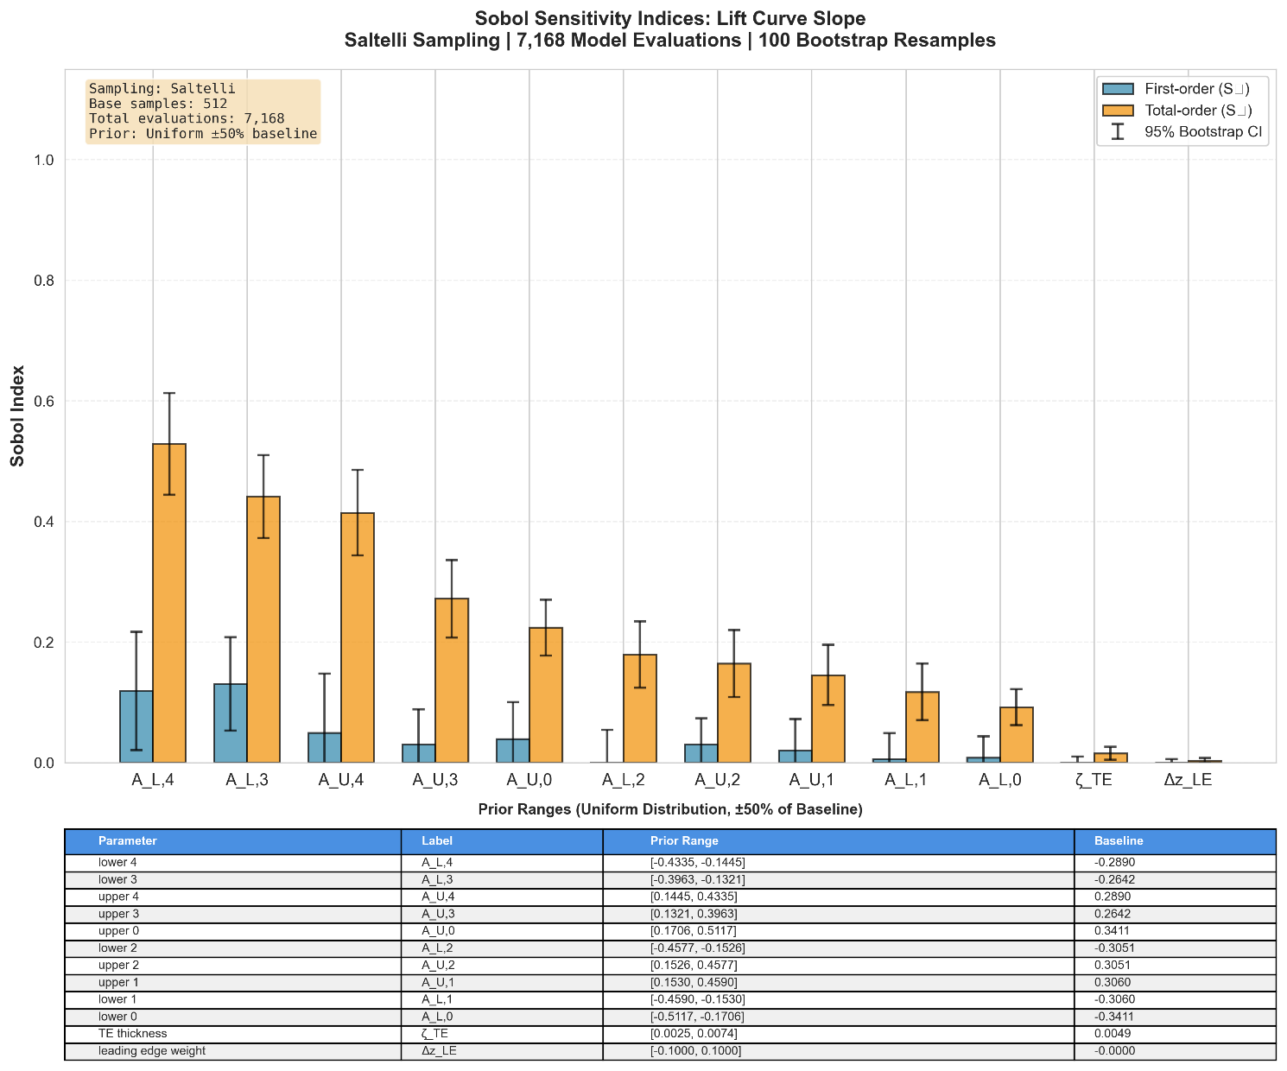
Figure 20: Sobol sensitivity indices for Lift Curve Slope. The aft geometry parameters ($A_{L,4}$, $A_{L,3}$) dominate, reflecting the influence of the trailing edge and viscous boundary layer effects.
Finally, for the Lift Curve Slope (Fig. 20), the results mirror those of $α_{L=0}$, with $A_{L,4}$ and $A_{L,3}$ ranking highest. While ideal potential flow predicts a constant slope of $2π$, real-world deviations are caused by viscous de-cambering and boundary layer growth, which are most pronounced near the trailing edge. By flagging the aft-geometry parameters as most sensitive, the model demonstrates an understanding that the geometry near the trailing edge regulates the efficiency of lift generation.
In summary, the Sobol analysis confirms that the model is not relying on spurious correlations. It has correctly identified that while the leading edge defines the local flow separation point, the aft geometry (camber and thickness) is the global driver for the lift curve's magnitude ($C_{L,max}$), offset ($α_{L=0}$), and slope.

Conclusion
We developed and validated a compact, physics-aware surrogate that predicts the complete lift curve $C_{L}(α)$of a two-dimensional aerofoil from a 12-parameter CST encoding. Model selection used leave-one-family-out folds and a composite Physics Score, while final reporting used a fixed 70/15/15 split. The chosen configuration, a multilayer perceptron trained with a weighted log-cosh objective, achieved $R^{2}=0.967$ on the held-out test set and a mean Physics Score of 1.537 across held-out families, indicating strong generalisation and good alignment with aerodynamic landmarks.
A central ingredient is the distance-weighted training loss that attenuates supervision outside the measured angle-of-attack range. Coupled with the Physics Score, which aggregates errors in $C_{L,max⁡}$, $α_{\text{stall}}$, $α_{L=0}$, and the linear-range slope, this focuses learning on physically supported data and improves curve-level fidelity. Global sensitivity analysis further showed that the models behaviour is interpretable: lower-surface CST coefficients, which modulate camber and aft loading, dominate the variance contributions for $C_{L,max⁡}$, $α_{L=0}$, slope, and influence $α_{\text{stall}}$ through interactions. This consistency with aerodynamic theory increases confidence that the network has learned meaningful structure rather than spurious correlations.
The surrogate is computationally efficient. On a consumer GPU it delivers approximately $0.033ms$per aerofoil for batch-size 32, enabling interactive design-space exploration, large parametric sweeps, and rapid outer-loop optimisation.
The primary constraint in the present study arises from the fidelity of the training dataset in separated-flow regimes, as the available labels were generated using panel-method predictions. Future work should focus on constructing a multi-fidelity dataset that combines broad, low-fidelity estimations with selectively acquired high-fidelity CFD or wind-tunnel measurements to enhance post-stall predictive accuracy. Incorporating uncertainty quantification—such as deep ensembles calibrated via conformal prediction across α—would provide meaningful confidence bounds for design and analysis. Extending the predicted outputs to include a wider range of Reynolds number as well as other key aerodynamic parameters such as drag and moment coefficients would further support and expand the framework’s applicability. In addition, publishing systematic ablation studies on CST dimensionality, weight-decay scheduling, and alternative network architectures would strengthen reproducibility and facilitate adaptation of the approach to other aerofoil families and operating conditions.

CRediT Authorship Contribution Statement
Benjamin Ian George Gawith: Conceptualization, Methodology, Software, Data curation, Formal analysis, Writing – original draft.
Ava Shahrokhi: Supervision, Conceptualization, Methodology, Writing – review & editing. Keivan Navaie: Supervision, Methodology, Writing – review & editing.

Declaration of Competing Interest
The authors declare that they have no known competing financial interests or personal relationships that could have appeared to influence the work reported in this paper.

Data Availability
The data that support the findings of this study are available from the corresponding author upon reasonable request.

Funding
This research did not receive any specific grant from funding agencies in the public, commercial, or not-for-profit sectors.

References
[1] Drela, M. & Giles, M. B. (1987). 'Viscous-inviscid analysis of transonic and low Reynolds number airfoils'. AIAA journal, 25(10), pp. 1347-1355.
[2] Fukami, K., Fukagata, K. & Taira, K. (2020). 'Assessment of supervised machine learning methods for fluid flows'. Theoretical and Computational Fluid Dynamics, 34(4), pp. 497-519.
[3] Vinuesa, R. & Brunton, S. L. (2022). 'Enhancing computational fluid dynamics with machine learning'. Nature Computational Science, 2(6), pp. 358-366.
[4] Li, J., Bouhlel, M.A. and Martins, J.R., 2019. Data-based approach for fast airfoil analysis and optimization. AIAA Journal, 57(2), pp.581-596.
[5] Shahrokhi, A. & Jahangirian, A. (2010). 'A surrogate assisted evolutionary optimization method with application to the transonic airfoil design'. Engineering Optimization, 42(6), pp. 497-515.
[6] Popescu, M.-C., Balas, V. E., Perescu-Popescu, L. & Mastorakis, N. (2009). 'Multilayer perceptron and neural networks'. WSEAS Transactions on Circuits and Systems, 8(7), pp. 579-588.
[7] Brunton, S. L., Noack, B. R. & Koumoutsakos, P. (2020). 'Machine learning for fluid mechanics'. Annual review of fluid mechanics, 52, pp. 477-508.
[8] Wang, H., Cao, Y., Huang, Z., Liu, Y., Hu, P., Luo, X., Song, Z., Zhao, W., Liu, J. & Sun, J. (2024). Recent advances on machine learning for computational fluid dynamics: A survey. arXiv preprint arXiv:2408.12171.
[9] Malecha, Z. & Sobczyk, A. (2024). 'Using Artificial Intelligence to Predict the Aerodynamic Properties of Wind Turbine Profiles'. Computers, 13(7), 167.
[10] Zhang, Z., Ao, Y., Li, S. & Gu, G. X. (2024). 'An adaptive machine learning-based optimization method in the aerodynamic analysis of a finite wing under various cruise conditions'. Theoretical and Applied Mechanics Letters, 14, 100489.
[11] Jahangirian, A. & Shahrokhi, A. (2011). 'Aerodynamic shape optimization using efficient evolutionary algorithms and unstructured CFD solver'. Computers & Fluids, 46(1), pp. 270-276.
[12] Li, J., Du, X. & Martins, J. R. (2022). 'Machine learning in aerodynamic shape optimization'. Progress in Aerospace Sciences, 134, 100849.
[13] Kulfan, B. M. (2008). 'Universal parametric geometry representation method'. Journal of aircraft, 45(1), pp. 142-158.
[14] Akiba, T., Sano, S., Yanase, T., Ohta, T. & Koyama, M. (2019). 'Optuna: A next generation hyperparameter optimization framework'. In: Proceedings of the 25th ACM SIGKDD international conference on knowledge discovery & data mining, pp. 2623-2631.
[15] Saltelli, A., Ratto, M., Andres, T., Campolongo, F., Cariboni, J., Gatelli, D., Saisana, M., & Tarantola, S. (2008). Global Sensitivity Analysis: The Primer. John Wiley & Sons.
[16] Mukesh, R., Lingadurai, K. & Selvakumar, U. (2014). 'Airfoil shape optimization using non-traditional optimization technique and its validation'. Journal of King Saud University-Engineering Sciences, 26(2), pp. 191-197.
[17] Sharpe, P. & Hansman, R. (2023). NeuralFoil: An airfoil aerodynamics analysis tool using physics-informed machine learning. GitHub.
[18] Kulfan, B. & Bussoletti, J. (2006). '"Fundamental" parameteric geometry representations for aircraft component shapes'. In: 11th AIAA/ISSMO multidisciplinary analysis and optimization conference, p. 6948.
[19] Kulfan, B. M. (2007). 'The “CST” universal parametric geometry representation method, Recent Extensions and Applications'. In: Proceedings of the Royal Aeronautical Society Conference, pp. 157-176.
[20] Lane, K. & Marshall, D. (2010). 'Inverse airfoil design utilizing CST parameterization'. In: 48th AIAA Aerospace Sciences Meeting Including the New Horizons Forum and Aerospace Exposition, p. 1228.
[21] Selig, M. (2010). UIUC Airfoil Data Site. [Online]. Available at: https://m-selig.ae.illinois.edu/ads/coord_database.html (Accessed: 15 March 2025).
[22] Drela, M. (1989). 'XFOIL: An analysis and design system for low Reynolds number airfoils'. In: Low Reynolds Number Aerodynamics: Proceedings of the Conference Notre Dame, Indiana, USA, 5–7 June 1989. Springer, pp. 1-12.
[23] Airfoil Tools (2019a). Airfoil Tools. [Online]. Available at: http://airfoiltools.com/ (Accessed: 8 November 2025).
[24] Domel, A. G., Saadat, M., Weaver, J. C., Haj-Hariri, H., Bertoldi, K. & Lauder, G. V. (2018). 'Shark skin-inspired designs that improve aerodynamic performance'. Journal of The Royal Society Interface, 15(139), 20170828.
[25] Jichao Li, Mengqi Zhang, Chien Ming Jonathan Tay, Ningyu Liu, Yongdong Cui, Siou Chye Chew & Boo Cheong, K. (2022). 'Low-Reynolds-number airfoil design optimization using deep-learning-based tailored airfoil modes'. Aerospace Science and Technology, 121, 107309.
[26] Farhat, H. (2021). Operation, maintenance, and repair of land-based gas turbines. Elsevier.
[27] Gudmundsson, S. (2013). General aviation aircraft design: Applied Methods and Procedures. Butterworth-Heinemann.
[28] Airfoil Tools (2019b). Xfoil. [Online]. Available at: http://airfoiltools.com/airfoil/details?r=polar/index/#xfoil (Accessed: 8 November 2025).
[29] Paszke, A., Gross, S., Massa, F., Lerer, A., Bradbury, J., Chanan, G., Killeen, T., Lin, Z., Gimelshein, N. & Antiga, L. (2019). 'Pytorch: An imperative style, high-performance deep learning library'. Advances in neural information processing systems, 32.
[30] Goodfellow, I., Bengio, Y. & Courville, A. (2016). Deep learning. Cambridge, MA: The MIT Press.
[31] Nair, V. & Hinton, G. E. (2010). 'Rectified linear units improve restricted boltzmann machines'. In: Proceedings of the 27th international conference on machine learning (ICML-10), pp. 807-814.
[32] Cho, K., Van Merriënboer, B., Gulcehre, C., Bahdanau, D., Bougares, F., Schwenk, H. & Bengio, Y. (2014). Learning phrase representations using RNN encoder-decoder for statistical machine translation. arXiv preprint arXiv:1406.1078.
[33] Chung, J., Gulcehre, C., Cho, K. and Bengio, Y., 2014. Empirical evaluation of gated recurrent neural networks on sequence modeling. arXiv preprint arXiv:1412.3555.
[34] Salehinejad, H., Sankar, S., Barfett, J., Colak, E. & Valaee, S. (2017). Recent advances in recurrent neural networks. arXiv preprint arXiv:1801.01078.
[35] Hochreiter, S. & Schmidhuber, J. (1997). 'Long short-term memory'. Neural computation, 9(8), pp. 1735-1780.
[36] Kiranyaz, S., Avci, O., Abdeljaber, O., Ince, T., Gabbouj, M. and Inman, D.J. (2021). '1D convolutional neural networks and applications: A survey'. Mechanical Systems and Signal Processing, 151, 107398.
[37] LeCun, Y. and Bengio, Y., 1998. Convolutional networks for images, speech, and time series. The handbook of brain theory and neural networks.
[38] Kingma, D. P. & Ba, J. (2014). Adam: A method for stochastic optimization. arXiv preprint arXiv:1412.6980.
[39] Chicco, D., Warrens, M. J. & Jurman, G. (2021). 'The coefficient of determination R-squared is more informative than SMAPE, MAE, MAPE, MSE and RMSE in regression analysis evaluation'. Peerj computer science, 7, e623.
[40] Abbott, I. H. & Von Doenhoff, A. E. (1959). Theory of wing sections including a summary of airfoil data. New York: Dover Publications.
[41] Van Dam, C. P. (2002). 'The aerodynamic design of multi-element high-lift systems for transport airplanes'. Progress in Aerospace Sciences, 38(2), pp. 101-144.
[42] Anderson, J. D. (2017). Fundamentals of aerodynamics. 6th edn. Columbus, OH: McGraw-Hill Education.

Appendix A
The final, best-performing model (MLP with Log-Cosh loss) was identified through a 250-trial hyperparameter search using Optuna, with the Physics Score as the objective function. The optimal hyperparameters are detailed below.
Hyperparameter | Value
Loss Function | Log-Cosh
Learning Rate | 0.006257
Number of Layers | 3
Neurons per Layer | {128, 128, 128}
Dropout Rate | 0.3593
Optimizer | AdamW

List of Figure Captions
- Cross-section of a typical aerofoil [19]
- Optimal number of CST parameters script
- Model validation error as a function of CST parameter count, showing an optimal balance at 12 parameters
- Representative geometries for five categories (symmetrical NACA 0012; conventional CLARK Y; high-camber Selig S1223; flat-surface Eppler E387; nature-inspired Dragonfly Canard).
- Corresponding $C_{L}(α)$ curves illustrating diversity.
- Visualization of the distance-based validity weights ($w_{i}$) for three different data coverage scenarios. The weight is 1.0 within the original measured range (shaded regions) and decays exponentially outside this range. The rate of decay is relative to the width of the valid data range, resulting in a steeper decay for aerofoils with "Narrow Coverage" compared to those with "Partial Coverage".
- Hyperparameter search and selection workflow.
- Correlation between the validation Mean Squared Error (MSE) and the Physics Score for the best model from each of the 250 Optuna trials.
- Comparison of the mean Physics Score for each of the sixteen model-loss function combinations, evaluated across all LOFO folds. Lower values indicate better performance.
- Boxplot showing the distribution of Physics Scores for each model across the five Leave-One-Family-Out (LOFO) folds. This illustrates the variance and robustness of each model when generalising to unseen aerofoil families.
- Visual representation of Physics Score by Ablation Study Approach Further Validating the Necessity of the ExponentialMask.
- Training and validation loss curves for the final MLP model. The validation loss (Physics Score) closely tracks the trend of the training loss, indicating good generalisation and no significant overfitting with best epoch indicated.
- Predicted vs. actual lift coefficient (C_L) values on the held-out test set. The clear trend corresponds to the final R² score of 0.9604 and MSE of 0.028147 for full dataset predictions and a final R² score of 0.9689 and MSE of 0.022268 for high-quality predictions.
- Comparison of predicted vs. actual values for the four key physical metrics on the test set. The model shows strong correlation for $C_{L,max}$ and $α_{L=0}$, with weaker but still positive correlation for lift curve slope and $α_{stall}$.
- Distribution of prediction errors for the four key physical metrics on the test set. The distributions are centred near zero, indicating low bias.
- Comparison of predicted (orange squares) and actual (blue circles) lift curves for representative unseen aerofoils. The model demonstrates high fidelity across a range of geometric and aerodynamic complexities.
- Sobol sensitivity indices for Maximum Lift Coefficient ($C_{L,max}$). The analysis identifies the aft-camber parameters ($A_{L,4}$, $A_{U,4}$) as the most influential.
- Sobol sensitivity indices for Stall Angle ($α_{stall}$). The analysis highlights massive interactive effects, dominated by the lower surface aft geometry ($A_{L,4}$, $A_{L,3}$).
- Sobol sensitivity indices for Zero-Lift Angle of Attack ($α_{L=0}$). The model correctly identifies that the lower surface shape ($A_{L,4}$), which dictates camber, is the primary driver.
- Sobol sensitivity indices for Lift Curve Slope. The aft geometry parameters ($A_{L,4}$, $A_{L,3}$) dominate, reflecting the influence of the trailing edge and viscous boundary layer effects.

