The Private investigator's Survival guide
By Zayve brock
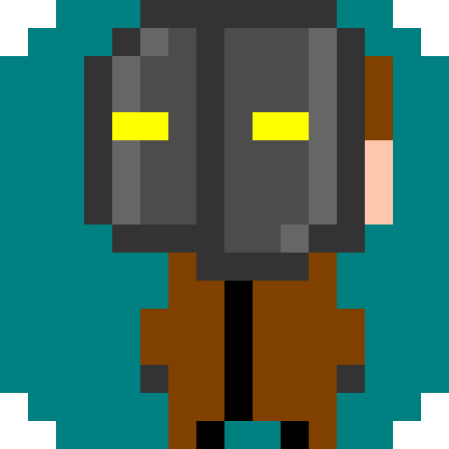
Table of contents
Page 3 – Introduction
Page 4 – controls
Page 5 – Weapons
Page 6 – major groups and people
Page 7 – drugs
Page 8 – Reputation
Introduction
Welcome to the colony. You are zayve brock, a small-time private investigator. You are living on a planet known as the colony, in a small community called haven. The colony was one of the few remaining human colonies after the war oF 2203. There is little government other than a small peacekeeping force made up of the remains of the colony's government.

controls
move – WASD
fire weapon – mouse 1
interact with object – mouse 2
Use chip - F
open inventory – E
Pause – ESC
scope ( scoped guns only ) - Q
Melee attack – hold space
switch weapon – Arrow Keys
Weapons

weapons are divided into melee weapons and firearms. Firearms fire projectiles while melee weapons work at close range. You can view a weapon's stats by clicking on it in your inventory. Each weapon uses ammunition. When you loot a body or container, you will automatically pick up all ammunition from it. There are a few different types of firearms. Plasma weapons are generally the least powerful, use plasma cells as ammo, and are used by civilians and small-scale groups. Ballistic weapons, the second type, are typically more powerful than plasma weapons, use bullets as ammunition, and are used by larger organizations. The third type, military weapons, are weapons used that were used by military before the war, are quite powerful, and use the same ammunition as ballistic weapons. Next are improvised firearms. These typically use extremely rare ammunition and are often unique and powerful. Last are laser weapons, extremely powerful weapons that were only in the prototype stage before the war and can only be found in pre-war military vaults.

Major groups
The colony has a few major factions residing in it. First and foremost is the resurgence, a secretive peacekeeping force working to eliminate the various crime rings in the colony and restore government. The next most prominent group is the stosthor triad, a powerful crime ring that controls much of the colony and dabbles in everything from theft and murder to extortion. There is also and assortment of small crime rings, such as the tenn cartel, which produces and sells drugs.
Major people
Cincuen cinquetel – the fifth in command of the stosthor triad. He is the highest ranked known member of the group
Chah tenn – the leader of the tenn cartel

Drugs
cigarette: reduces recoil and increases accuracy for a period of time, and displays hints about current objectives. Addictive. Nicotine gum removes withdrawal effects.
Adrenaline shot – speeds up and damages user.
Exenol: slows time, distorts vision. Very addictive.
Riftaine: takes user back to the last area they visited. No side effects.
Noctaine: restores user to full health. Causes temporary visual impairment. Withdrawal symptoms include visual impairment but no damage
Addictions
getting addicted to a substance lowers your maximum health. Going too long without using a substance you are addicted to causes withdrAwal symptoms ( normally health loss ).

Reputation
Your reputation is a measure of the sum of your good and bad deeds. Having low reputation will cause ally characters to attack you. However, It can also allow you to intimidate characters. Your reputation will have large effects on the outcome of the plot of the game, so be careful. Your reputation can be viewed in your inventory.

