

**Addis Ababa University**

**Addis Ababa Institute of Technology**

**School of Electrical and Computer Engineering**

አድዋ | ሶፍትዌር ኢንጅነሪንግ | November 19, 2015

Software Requirement Specification

For “Adwa” gaming application

**By:**

Biniam Kassahun ENR/5533/04

Robel Hayelom ENR/0000/04

Samrawit Demeke ETR/2456/03

Sura Dereje ENR/6920/04

Efriem Desalew ENR/4300/04

Amanuel Tedla ENR/5826/04

Selam Habtom ENR/2705/03

Solomon Gebreslasie ENR/5821/04

Kilet Meshesha ENR/5707/04

Bethlehem Biyansa ENR/3514/03

Dawit Tefera ENR/2511/03

Fraol Wondimu ENR2617/03

Nathan Mathewos ENR/5266/04

Biruk Gebreegziabhar ENR/5544/04

Ibrahim Elias ENR/3865/04

Hermela Belachew ETR/2463/03

Surafel Getachew ETR/2612/02

Abrham Fekade ETR/2534/03

Frezer Tadesse ETR/6227/04

Dawit Abraham ENR/3942/04

Bereket G/Mariam ENR/2514/04

Surafel Getachew ENR/5821/04

Betsegaw G/Yohaness ENR/2460/04

Sintayehu Girum ENR/2773/04

Tirusew Zerihun ENR/2514/04

Table of Contents

**1 INTRODUCTION** 1

1.1 Purpose 1

1.2 Scope 1

1.3 Overview 1

2 Overall Description 2

2.1Product perspective 2

2.2 Product functions 2

2.3 User Characteristics 2

2.4 General Constraints 2

2.5 Assumptions and Dependencies 2

Detailed Requirements 3

3.1 External Interface Requirements 3

3.1.1 User interfaces 3

3.1.2 Hardware interfaces 4

3.1.3 Software interfaces 4

3.1.4Communication interfaces 4

3.2 **Functional Requirements** 4

3.2.1 Game controls and Actions 4

3.2.2 Progress and Promotion 5

3.2.3 Life (Health) 5

3.2.4 **Fellow Warriors** 6

3.2.5 Commands 6

3.2.6 Interactivity 6

3.3 Performance Requirements 6

3.4 Design Constraints 7

3.4.1 **Time** 7

3.4.2 Lack of information 7

3.4.3 **Story** 7

# **1 INTRODUCTION**

## 1.1 Purpose

This document specifies all the requirements for the “The Battle of Adwa” gaming application. These requirements relate to the functionality, constraints, performance, and the system interface.

“The Battle of Adwa” is a computer program of 3D action gaming application. The main goal of this 3D action gaming application is to allow users to entertain themselves playing this action game and also to spread and thought the history of Ethiopia to others in an interactive way, so that most people become familiar with Ethiopian history and image.

## 1.2 Scope

This document describes the software requirements for the “The Battle of Adwa” 3D action gaming application. This document will be used by the end-users, tester, and developers of the game.

## 1.3 Overview

The remainder of this document includes four chapters and appendixes. The second one provides an overview of the system functionality and system interaction with other systems.

The third chapter provides the requirements specification in detailed terms and a description of the different system interfaces. Different specification techniques are used in order to specify the requirements more precisely for different audiences.

The fourth chapter deals with usability, reliability,performance, supportability, design constraints, and interfaces.

# 2 Overall Description

## 2.1 Product perspective

The game will be a 3D interactive game to simulate and narrate the historic battle of Adwa in a very engaging way. It follows the historic sequences of consecutive battles between the Italian colonialist army and the Ethiopian patriotic soldiers, men and women. The game environment will have a very realistic feel to make the game more entertaining while

## 2.2 Product functions

This game will be a very interactive and engaging way to narrate the story of the battle of Adwa. It will enable both kids and adults to experience simulations of the battle first hand.

## 2.3 User Characteristics

This game is not be developed for a specific range of ages of users. But it may contain graphic events and shocking scenes for kids. It is not advised for kids under the age of 10.

## 2.4 General Constraints

This 3D game will be based on the historic events leading to the battle of Adwa and the battle itself. Due to limited resources we may not create an exact replica of the environment and the event. The story line of our game may also have a few misconceptions and mismatches relative to most tales.

## 2.5 Assumptions and Dependencies

# Detailed Requirements

## 3.1 External Interface Requirements

### 3.1.1 User interfaces

The game will be a 3D game representing different scenarios in the battle of Adwa. It will be a first person game of an ordinary Ethiopian patriot participating in a heroic act of war against the colonialist army of Italy. The main character of the game will enter the arena of war with limited resources and willgain different war arms as it progresses through different stages of the game.

The game environment will also include different third person characters that will participate on either of the fronts. These characters will not be controlled by the player and will represent different army ranks.

Players will also be provided different materials like a compass, a life meter, inventory list, score board and other items to improve the gaming experience.

The life meter decreases every time the player gets hit by the enemy. The rate of decrement in life meter value varies with the type of arm the player gets hit with. The player also dies when the life meter value reaches zero.

The inventory list will display the list of arms the player has in its disposal. Number of spears, bullets and other gadgets will be displayed in one corner of the display to enable the player to manage his inventory. The score board will also be displayed in another corner of the display to keep track of the player’s activities in the arena.

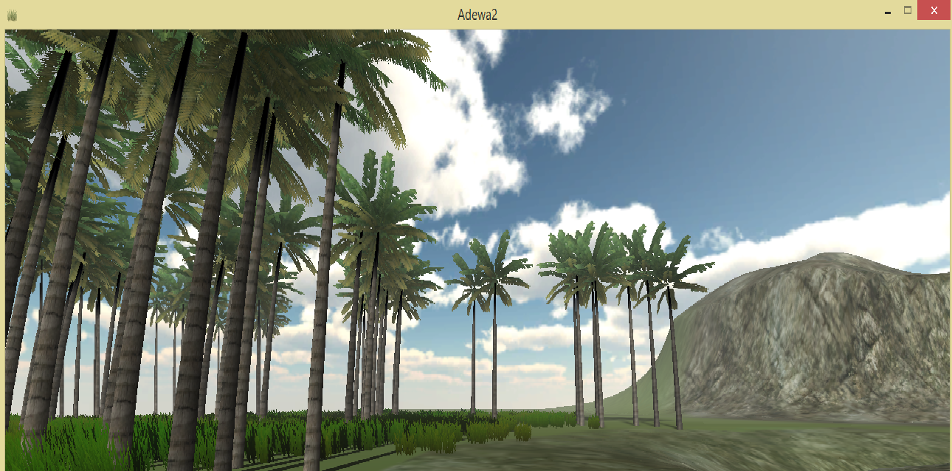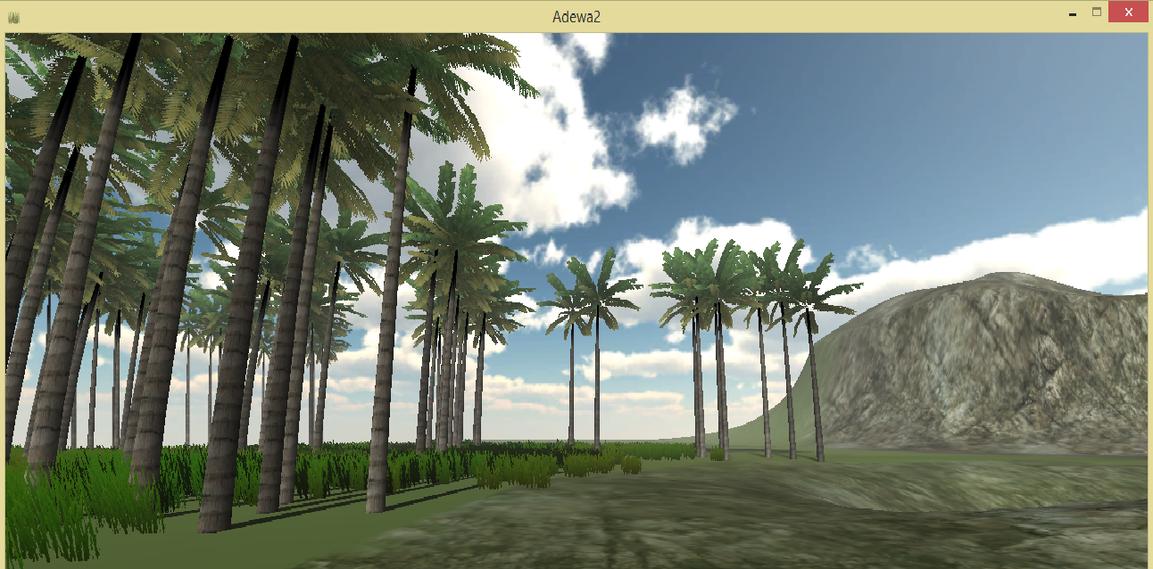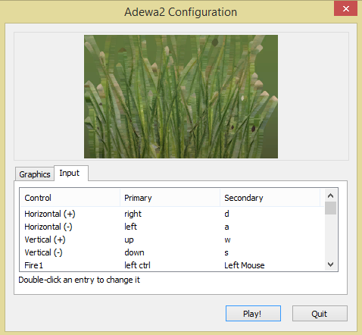

### 3.1.2 Hardware interfaces

The game will not require any hardware to play the game.

### 3.1.3 Software interfaces

The game will not require any additional software.

### 3.1.4Communication interfaces

The game can only be played in single player mode. It doesn’t require any connectivity.

## 3.2 **Functional Requirements**

### 3.2.1 Game controls and Actions

The main character of the game will be able to perform different combat actions. These actions will enable the player to progress through the game stages by killing and conquering enemy troops. The player controls the character using a mouse and a key board. The game will initially be configures to use the W-A-S-D. But it can also be modified for a different combination of control keys

1. Jogging: this is a basic action of jogging around the arena. This enables the player to attack fast and makes sure that the player doesn’t become an easy target.
2. Jumping: this is a basic movement to jump over obstacles
3. Sprint: this action enables the player to sprint forward fast to attack or hide. This makes the player and even harder target.
4. Swing: This is an attacking mechanism when the player has a sword as a primary weapon
5. Throwing: This is an attacking mechanism when the player has a spear as a primary weapon
6. Shooting: This is also an attacking mechanism when the player has a shot gun as a primary weapon
7. Blocking/Defending: this is a defense mechanism of raising a shield. The character may raise its shield to defend itself. This reduces the impact of being hit by an enemy
8. Crouching: This is a hiding mechanism that may be helpful when sneaking behind enemy lines or when trying to dodge enemy bullets

### 3.2.2 Progress and Promotion

The main character will initially have limited resources to attack or defend. As the game progresses, additional more powerful weapons and promotions will be issued to the player as a reward for its accomplishments.

The additional weapons will provide additional power, accuracy and efficiency to the main character. These weapons include spears, shields, shot guns (Minishir), and other Ethiopian traditional war armaments.

### 3.2.3 Life (Health)

This feature indicates the amount of hit (damage) the player has taken so far in the game. It starts off at 100 (Green) and decreases as the player takes more hits. The amount of decrement in health (Life) depends on the type of weapon the player got hit with.

The player can also heal itself by acquiring a special medic kit. This increases the health (Life) of the player

### 3.2.4 **Fellow Warriors**

The main character is going to fight alongside other fellow patriots to defeat the colonialist army. These fellow warriors will not be controlled by the player. These characters will provide aid to the main character to eliminate the enemy’s army. They also represent different ranks of the army and have different attacking skill and power.

### 3.2.5 Commands

As part of a big army, the player needs to be aware of the battle strategy. This enables the player to make the best out of the fellow warriors fighting alongside. These commands may come from different ranks of the army starting from the militia commander all the way up to the emperor /empress. This also enables us to reflect the contributions by various heroes of the war.

The game environment will display strategic commands from different leaders at one corner of the screen with an image and name of the leader.

### 3.2.6 Interactivity

The game characters will interact with both the environment and each other. These interactions include killing one another, colliding with static objects, and jumping. These interactions only reflect the realistic interactions of war scenes.

## 3.3 Performance Requirements

The game environment will be a simulation of a battle arena. These scenes need to be realistic and need to be very responsive for user input. In addition, these scenes need to have a very good rendering speed to provide the player with a very good gaming experience.

## 3.4 Design Constraints

### 3.4.1 **Time**

Due to the short development time we have, some characters and feature of the war scene may be omitted. These omitted characters and features may include basic elements like animals like horses, visual effects like blood and other features.

### 3.4.2 Lack of information

Due to lack of accurate information regarding the exact strategies and location of the battles, we will not be able to recreate the exact replica of the landscape and environment variables

### 3.4.3 **Story**

To create coherence between each levels of the game, we may include fictitious events at certain points of the game without altering the main story. These modifications will enable us to create a better gaming experience for the player.