|  |
| --- |
|  |
| The Documentation |
| [Type the document subtitle] |
|  |
| **[Your Name]** |
| **[Pick the date]** |

[Type the abstract of the document here. The abstract is typically a short summary of the contents of the document. Type the abstract of the document here. The abstract is typically a short summary of the contents of the document.]

Table of Contents

[To update the table of contents, right click the message below and select Update Field (F9 on PC, ⌥⌘U on Mac).]

**No table of contents entries found.**

1. Pages
   1. Page Tree

Flow Diagram  
Checkpoint  
Screens  
 PAGE 1.0 Login  
 PAGE 2.0 Dashboard  
 PAGE 3.0 About  
 PAGE 4.0 Team  
Responsive  
 Mobile  
 Tablet  
REST APIs  
 Model  
 AuthenticateUser  
 RetrieveUserDetails  
STYLE  
 Global Styles

* 1. Flow Diagram
     1. User Interface

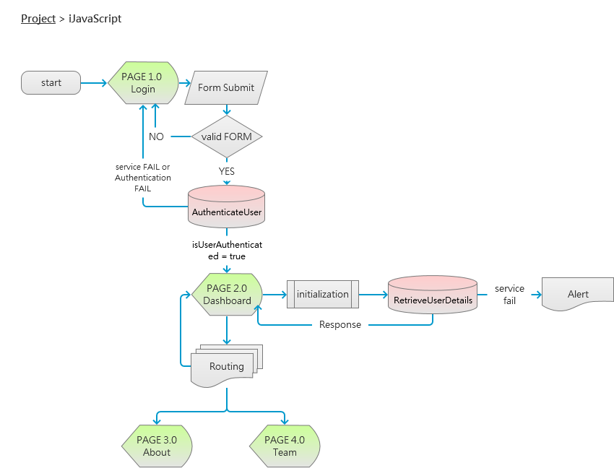

* 1. Checkpoint
     1. User Interface

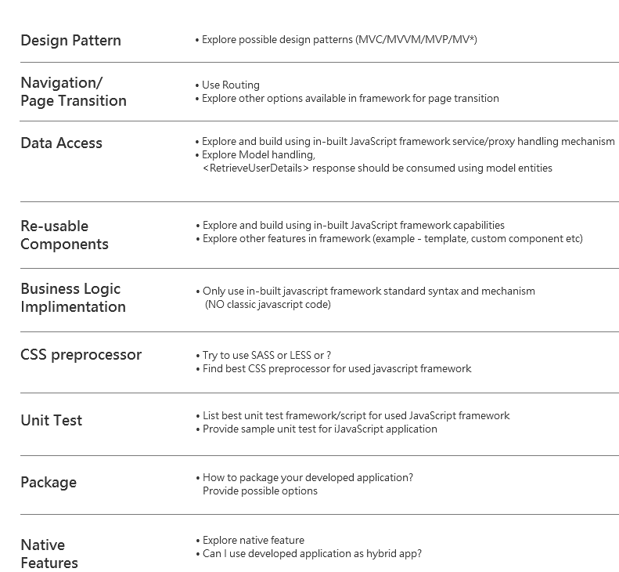

* 1. PAGE 1.0 Login
     1. User Interface

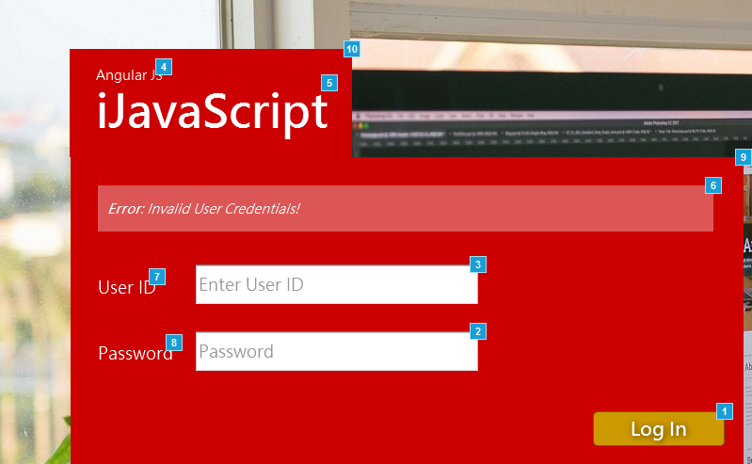

* + 1. Widget Table

| Footnote | Name | Interactions | Note |
| --- | --- | --- | --- |
| 1 | login button | OnClick:  Case 1:  Open PAGE 2.0 Dashboard in Current Window OnSelected:  Case 1:  Open PAGE 2.0 Dashboard in Current Window | **TECHNOLOGY**  FORM Handling  Routing  **REQUIRMENT**  Apply Routing for navigation  **ON CLICK**  - validate FORM data  - call 'AuthenticateUser' service  **BUSINESS RULE**  IF Form Valid && Service success && isUserAuthenticated = true  Move to PAGE0.2 Dashboard  ELSE  Show top level error  **STYLE**  background-color: #CC9900  border-color: #775900  color: #FFF |
| 2 | password_field |  | **VALIDATION RULE**  MIN LENGTH >=8  MAX LENGTH = 20  input type = password  **STYLE**  padding: 5px |
| 3 | userid_field |  | **VALIDATION RULE**  MIN LENGTH >=8  MAX LENGTH = 20  **STYLE**  padding: 5px |
| 4 | js_framework |  | **DISPLAY LOGIC**  Dynamic Text  **BUSINESS LOGIC**  Change Text as per technology.  ex - React JS or Ember JS  **STYLE**  font-family: Microsoft JhengHei  font-size: 14px |
| 5 | heading |  | **DISPLAY LOGIC**  Static Text  **STYLE**  font-family: Microsoft JhengHei  font-size: 48px |
| 6 | top_error_panel |  | **DISPLAY LOGIC**  Dynamic Text  Hidden (by default)  **BUSINESS LOGIC**  Show on click of login button if  scenerio #1 -  Invalid Form  content = 'Please enter login credentials to continue'  scenerio#2 -  user credential fail  IF  'AuthenticateUser' service response  isAuthenticated: FALSE  content = 'Invalid User Credentials!'  scenerio#3 -  service FAIL (Technical or Business exceptions)  content = 'Sorry unable to connect to system!' |
| 7 | user_id_label |  | **DISPLAY LOGIC**  Static Text  **STYLE**  font-family: Arial  font-size: 18px  color: #FFF |
| 8 | password_label |  | **DISPLAY LOGIC**  Static Text  **STYLE**  font-family: Arial  font-size: 18px  color: #FFF |
| 9 | login_box |  | **STYLE**  background-color: #CC0000  width: 715px  height: 326px  padding: 20px |
| 10 | top_banner |  | **STYLE**  background-color: #CC0000  width: 300px  height: 115px  padding: 20px |

* 1. PAGE 2.0 Dashboard
     1. User Interface

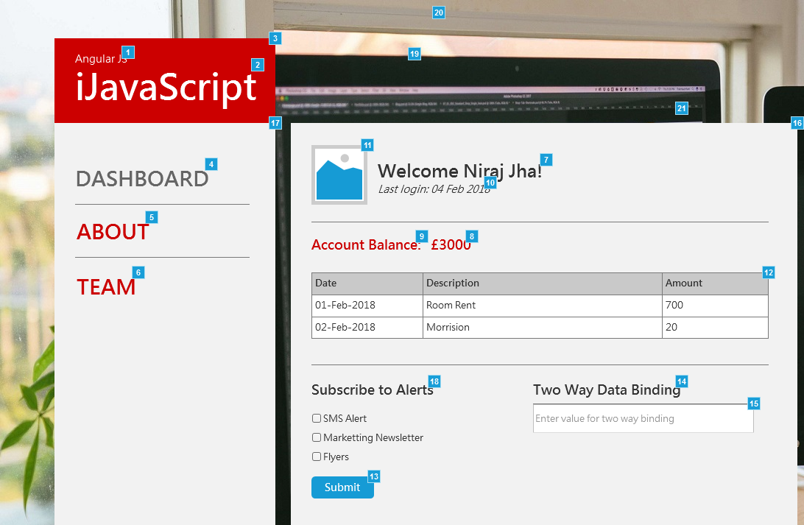

* + 1. Widget Table

| Footnote | Name | Interactions | Note |
| --- | --- | --- | --- |
| 1 | js_framework |  | **DISPLAY LOGIC**  Dynamic Text  **BUSINESS LOGIC**  Change Text as per technology.  ex - React JS or Ember JS  **STYLE**  font-family: Microsoft JhengHei  font-size: 14px |
| 2 | heading |  | **DISPLAY LOGIC**  Static Text  **STYLE**  font-family: Microsoft JhengHei  font-size: 48px |
| 3 | top_banner |  | **STYLE**  background-color: #CC0000  width: 300px  height: 115px  padding: 20px |
| 4 |  |  | **TECHNOLOGY**  Routing  **REQUIRMENT**  Apply Routing for navigation  **STYLE**  font-family: Microsoft JhengHei, arial  font-weight: bold  font-size: 28px  color: #666666  Active page  color: #666666  **ON CLICK**  remove hyperlink - No action |
| 5 |  | OnClick:  Case 1:  Open PAGE 3.0 About in Current Window | **TECHNOLOGY**  Routing  **REQUIRMENT**  Apply Routing for navigation  **STYLE**  font-family: Microsoft JhengHei, arial  font-weight: bold  font-size: 28px  color: #CC0000  Active page  color: #666666  **ON CLICK**  show PAGE 3.0 About |
| 6 |  | OnClick:  Case 1:  Open PAGE 4.0 Team in Current Window | **TECHNOLOGY**  Routing  **REQUIRMENT**  Apply Routing for navigation  **STYLE**  font-family: Microsoft JhengHei, arial  font-weight: bold  font-size: 28px  color: #CC0000  Active page  color: #666666  **ON CLICK**  show PAGE 4.0 Team |
| 7 |  |  | **TECHNOLOGY**  Data Access  Data Handling  **DISPLAY LOGIC**  Dynamic Text  Welcome + <CUSTOMER.USERNAME>  **STYLE**  <h2>  font-size: 24px  **MODEL ENTITY**  <RetrieveUserDetails>  node = {username} |
| 8 |  |  | **TECHNOLOGY**  Data Access  Data Handling  **DISPLAY LOGIC**  Dynamic Text  <CUSTOMER.BALANCE>  **STYLE**  <h3>  font-size: 18px  color: #CC0000  **MODEL ENTITY**  <RetrieveUserDetails>  node = {customer.balance} |
| 9 |  |  | **DISPLAY LOGIC**  static Text  **STYLE**  <h3>  font-size: 18px  color: #CC0000 |
| 10 |  |  | **TECHNOLOGY**  Data Access  Data Handling  **DISPLAY LOGIC**  Dynamic Text  Last Login + <CUSTOMER.LASTLOGIN>  **STYLE**  font-size: 14px  font-style: italic  **MODEL ENTITY**  <RetrieveUserDetails>  node = {last_login} |
| 11 |  |  | DISPLAY LOGIC  static image  <placeholder user image> |
| 12 |  |  | **TECHNOLOGY**  Complex Data structure  Data Access  Data Handling  **DISPLAY LOGIC**  Dynamic Text  Grid layout  **MODEL ENTITY**  <RetrieveUserDetails>  node:  Date: {customer.transaction.date}  Description: {customer.transaction.desc}  Amount: {customer.transaction.amount} |
| 13 |  | OnClick:  Case 1:  Show (Group) fade 500 ms | **TECHNOLOGY**  Form Data handling  **ON CLICK**  show modal window  alert box content = selected values  **STYLE**  background-color: #169BD5  color: #FFF  padding: 5px 10px |
| 14 |  |  | **TECHNOLOGY**  Data Binding  **DISPLAY LOGIC**  dynamic text  Apply binding as per text box value  default text = Two Way Data Binding  **STYLE**  <h3> |
| 15 |  |  | **TECHNOLOGY**  Data Binding  **EVENT**  Apply Two way data binding with heading label  **STYLE**  padding: 5px |
| 16 |  |  | **STYLE**  width: 688px  height: auto  background-color: #F2F2F2  padding:20px  margin-left:20px |
| 17 |  |  | **STYLE**  Width: 300px  min-height: 500px  background-color: #F2F2F2 |
| 18 |  |  | **STYLE**  <h3> |
| 19 |  |  | **DISPLAY**  dynamic text - user selected value from alert field |
| 20 |  |  | **DISPLAY**  static text |
| 21 |  | OnClick:  Case 1:  Hide (Group) |  |

* + 1. Unnamed
       1. State1
  1. PAGE 3.0 About
     1. User Interface

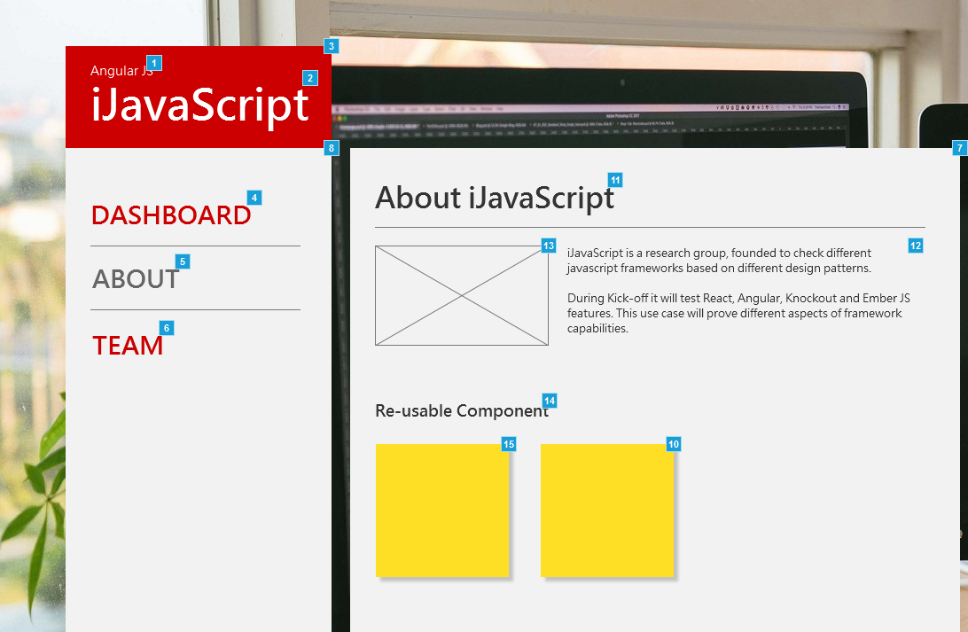

* + 1. Widget Table

| Footnote | Name | Interactions | Note |
| --- | --- | --- | --- |
| 1 | js_framework |  | **DISPLAY LOGIC**  Dynamic Text  **BUSINESS LOGIC**  Change Text as per technology.  ex - React JS or Ember JS  **STYLE**  font-family: Microsoft JhengHei  font-size: 14px |
| 2 | heading |  | **DISPLAY LOGIC**  Static Text  **STYLE**  font-family: Microsoft JhengHei  font-size: 48px |
| 3 | top_banner |  | **STYLE**  background-color: #CC0000  width: 300px  height: 115px  padding: 20px |
| 4 |  | OnClick:  Case 1:  Open PAGE 2.0 Dashboard in Current Window | **TECHNOLOGY**  Routing  **REQUIRMENT**  Apply Routing for navigation  **STYLE**  font-family: Microsoft JhengHei, arial  font-weight: bold  font-size: 28px  color: #CC0000  Active page  color: #666666  **ON CLICK**  show PAGE 2.0 Dashboard |
| 5 |  |  | **TECHNOLOGY**  Routing  **REQUIRMENT**  Apply Routing for navigation  **STYLE**  font-family: Microsoft JhengHei, arial  font-weight: bold  font-size: 28px  color: #666666  Active page  color: #666666  **ON CLICK**  remove hyperlink - No action |
| 6 |  | OnClick:  Case 1:  Open PAGE 4.0 Team in Current Window | **TECHNOLOGY**  Routing  **REQUIRMENT**  Apply Routing for navigation  **STYLE**  font-family: Microsoft JhengHei, arial  font-weight: bold  font-size: 28px  color: #CC0000  Active page  color: #666666  **ON CLICK**  show PAGE 4.0 Team |
| 7 |  |  | **STYLE**  width: 688px  height: auto  background-color: #F2F2F2  padding:20px  margin-left:20px |
| 8 |  |  | **STYLE**  Width: 300px  min-height: 500px  background-color: #F2F2F2 |
| 9 | reusable | OnClick:  Case 1:  Toggle red_color_animation | **TECHNOLOGY**  Reusable Components  **REQUIREMENT**  Develop to re-use same component multiple times.  **EVENT**  on click change color to red using javascript framework |
| 10 |  |  | **TECHNOLOGY**  Reusable Components  **REQUIREMENT**  call and use same left re-usable component  **EVENT**  follow re-usable event logic |
| 11 |  |  | **DISPLAY LOGIC**  Static Text  **STYLE**  <h2>  font-family: Microsoft JhengHei  font-size: 32px |
| 12 |  |  | **DISPLAY LOGIC**  Static Text |
| 13 |  |  | **DISPLAY LOGIC**  Static placeholder image |
| 14 |  |  | **DISPLAY LOGIC**  Static Text  **STYLE**  <h3>  font-family: Microsoft JhengHei  font-size: 18px |
| 15 | red_color_animation | OnClick:  Case 1:  Hide red_color_animation OnLoad:  Case 1:  Hide red_color_animation | **STYLE**  color: #FF0000  width: 150px  height: 150px |

* + 1. red_color_animation
       1. State1
  1. PAGE 4.0 Team
     1. User Interface

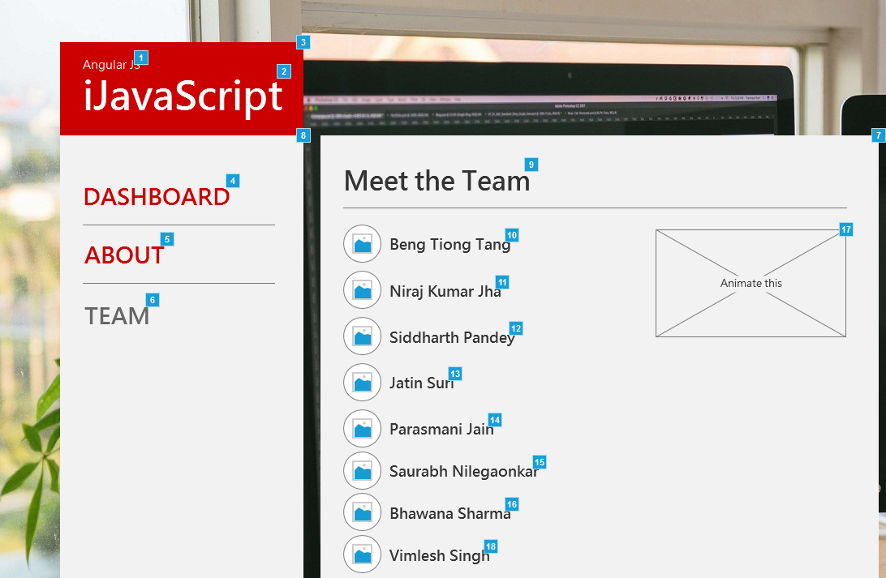

* + 1. Widget Table

| Footnote | Name | Interactions | Note |
| --- | --- | --- | --- |
| 1 | js_framework |  | **DISPLAY LOGIC**  Dynamic Text  **BUSINESS LOGIC**  Change Text as per technology.  ex - React JS or Ember JS  **STYLE**  font-family: Microsoft JhengHei  font-size: 14px |
| 2 | heading |  | **DISPLAY LOGIC**  Static Text  **STYLE**  font-family: Microsoft JhengHei  font-size: 48px |
| 3 | top_banner |  | **STYLE**  background-color: #CC0000  width: 300px  height: 115px  padding: 20px |
| 4 |  | OnClick:  Case 1:  Open PAGE 2.0 Dashboard in Current Window | **TECHNOLOGY**  Routing  **REQUIRMENT**  Apply Routing for navigation  **STYLE**  font-family: Microsoft JhengHei, arial  font-weight: bold  font-size: 28px  color: #CC0000  Active page  color: #666666  **ON CLICK**  show PAGE 2.0 Dashboard |
| 5 |  | OnClick:  Case 1:  Open PAGE 3.0 About in Current Window | **TECHNOLOGY**  Routing  **REQUIRMENT**  Apply Routing for navigation  **STYLE**  font-family: Microsoft JhengHei, arial  font-weight: bold  font-size: 28px  color: #CC0000  Active page  color: #666666  **ON CLICK**  show PAGE 3.0 About |
| 6 |  |  | **TECHNOLOGY**  Routing  **REQUIRMENT**  Apply Routing for navigation  **STYLE**  font-family: Microsoft JhengHei, arial  font-weight: bold  font-size: 28px  color: #666666  Active page  color: #666666  **ON CLICK**  remove hyperlink - No action |
| 7 |  |  | **STYLE**  width: 688px  height: auto  background-color: #F2F2F2  padding:20px  margin-left:20px |
| 8 |  |  | **STYLE**  Width: 300px  min-height: 500px  background-color: #F2F2F2 |
| 9 |  |  | **DISPLAY LOGIC**  Static Text  **STYLE**  <h2>  font-family: Microsoft JhengHei  font-size: 32px |
| 10 |  |  | **DISPLAY LOGIC**  static text  **STYLE**  <h3>  font-size:18px |
| 11 |  |  | **DISPLAY LOGIC**  static text  **STYLE**  <h3>  font-size:18px |
| 12 |  |  | **DISPLAY LOGIC**  static text  **STYLE**  <h3>  font-size:18px |
| 13 |  |  | **DISPLAY LOGIC**  static text  **STYLE**  <h3>  font-size:18px |
| 14 |  |  | **DISPLAY LOGIC**  static text  **STYLE**  <h3>  font-size:18px |
| 15 |  |  | **DISPLAY LOGIC**  static text  **STYLE**  <h3>  font-size:18px |
| 16 |  |  | **DISPLAY LOGIC**  static text  **STYLE**  <h3>  font-size:18px |
| 17 | animated_box | OnClick:  Case 1:  Move animated_box by (0,200) swing 500ms | **TECHNOLOGY**  Animation  **EVENT**  onClick  Animate box from top to bottom: 200px |
| 18 |  |  | **DISPLAY LOGIC**  static text  **STYLE**  <h3>  font-size:18px |

* 1. Mobile
     1. User Interface

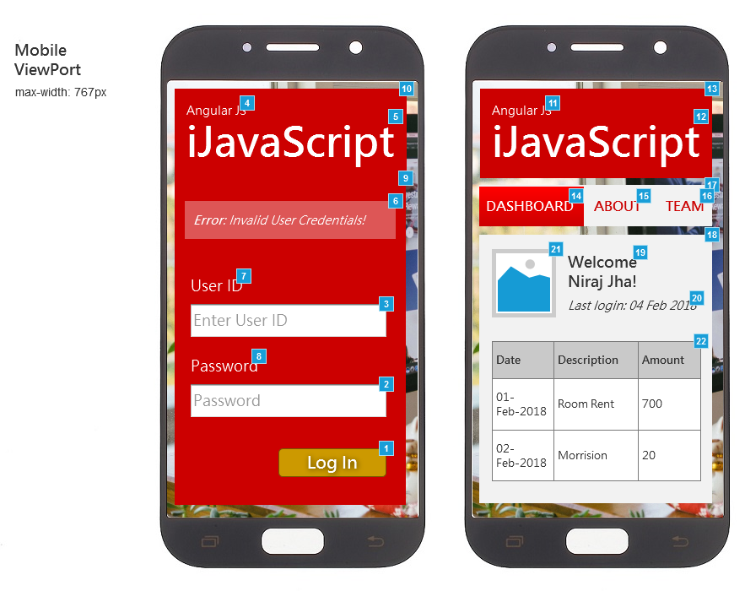

* + 1. Widget Table

| Footnote | Name | Interactions | Note |
| --- | --- | --- | --- |
| 1 | login button | OnClick:  Case 1:  Open PAGE 2.0 Dashboard in Current Window OnSelected:  Case 1:  Open PAGE 2.0 Dashboard in Current Window | **TECHNOLOGY**  FORM Handling  Routing  **REQUIRMENT**  Apply Routing for navigation  **ON CLICK**  - validate FORM data  - call 'AuthenticateUser' service  **BUSINESS RULE**  IF Form Valid && Service success && isUserAuthenticated = true  Move to PAGE0.2 Dashboard  ELSE  Show top level error  **STYLE**  background-color: #CC9900  border-color: #775900  color: #FFF |
| 2 | password_field |  | **VALIDATION RULE**  MIN LENGTH >=8  MAX LENGTH = 20  input type = password  **STYLE**  padding: 5px |
| 3 | userid_field |  | **VALIDATION RULE**  MIN LENGTH >=8  MAX LENGTH = 20  **STYLE**  padding: 5px |
| 4 | js_framework |  | **DISPLAY LOGIC**  Dynamic Text  **BUSINESS LOGIC**  Change Text as per technology.  ex - React JS or Ember JS  **STYLE**  font-family: Microsoft JhengHei  font-size: 14px |
| 5 | heading |  | **DISPLAY LOGIC**  Static Text  **STYLE**  font-family: Microsoft JhengHei  font-size: 48px |
| 6 | top_error_panel |  | **DISPLAY LOGIC**  Dynamic Text  Hidden (by default)  **BUSINESS LOGIC**  Show on click of login button if  scenerio #1 -  Invalid Form  content = 'Please enter login credentials to continue'  scenerio#2 -  user credential fail  IF  'AuthenticateUser' service response  isAuthenticated: FALSE  content = 'Invalid User Credentials!'  scenerio#3 -  service FAIL (Technical or Business exceptions)  content = 'Sorry unable to connect to system!' |
| 7 | user_id_label |  | **DISPLAY LOGIC**  Static Text  **STYLE**  font-family: Arial  font-size: 18px  color: #FFF |
| 8 | password_label |  | **DISPLAY LOGIC**  Static Text  **STYLE**  font-family: Arial  font-size: 18px  color: #FFF |
| 9 | login_box |  | **STYLE**  background-color: #CC0000  width: 100%  height: auto  padding: 10px |
| 10 | top_banner |  | **STYLE**  background-color: #CC0000  width: 100%  height: auto  padding: 10px |
| 11 | js_framework |  | **DISPLAY LOGIC**  Dynamic Text  **BUSINESS LOGIC**  Change Text as per technology.  ex - React JS or Ember JS  **STYLE**  font-family: Microsoft JhengHei  font-size: 14px |
| 12 | heading |  | **DISPLAY LOGIC**  Static Text  **STYLE**  font-family: Microsoft JhengHei  font-size: 48px |
| 13 | top_banner |  | **STYLE**  background-color: #CC0000  width: 100%  height: auto  padding: 10px |
| 14 |  |  | **TECHNOLOGY**  Routing  **REQUIRMENT**  Apply Routing for navigation  **STYLE**  font-family: Microsoft JhengHei, arial  font-weight: bold  font-size: 28px  color: #666666  Active page  color: #666666  **ON CLICK**  remove hyperlink - No action |
| 15 |  | OnClick:  Case 1:  Open PAGE 3.0 About in Current Window | **TECHNOLOGY**  Routing  **REQUIRMENT**  Apply Routing for navigation  **STYLE**  font-family: Microsoft JhengHei, arial  font-weight: bold  font-size: 28px  color: #CC0000  Active page  color: #666666  **ON CLICK**  show PAGE 3.0 About |
| 16 |  | OnClick:  Case 1:  Open PAGE 4.0 Team in Current Window | **TECHNOLOGY**  Routing  **REQUIRMENT**  Apply Routing for navigation  **STYLE**  font-family: Microsoft JhengHei, arial  font-weight: bold  font-size: 28px  color: #CC0000  Active page  color: #666666  **ON CLICK**  show PAGE 4.0 Team |
| 17 |  |  | **STYLE**  Width: 300px  min-height: 500px  background-color: #F2F2F2 |
| 18 |  |  | **STYLE**  Width: 300px  min-height: 500px  background-color: #F2F2F2 |
| 19 |  |  | **TECHNOLOGY**  Data Access  Data Handling  **DISPLAY LOGIC**  Dynamic Text  Welcome + <CUSTOMER.USERNAME>  **STYLE**  <h2>  font-size: 18px  **MODEL ENTITY**  <RetrieveUserDetails>  node = {username} |
| 20 |  |  | **TECHNOLOGY**  Data Access  Data Handling  **DISPLAY LOGIC**  Dynamic Text  Last Login + <CUSTOMER.LASTLOGIN>  **STYLE**  font-size: 14px  font-style: italic  **MODEL ENTITY**  <RetrieveUserDetails>  node = {last_login} |
| 21 |  |  | DISPLAY LOGIC  static image  <placeholder user image> |
| 22 |  |  | **TECHNOLOGY**  Complex Data structure  Data Access  Data Handling  **DISPLAY LOGIC**  Dynamic Text  Grid layout  **MODEL ENTITY**  <RetrieveUserDetails>  node:  Date: {customer.transaction.date}  Description: {customer.transaction.desc}  Amount: {customer.transaction.amount} |

* 1. Tablet
     1. User Interface

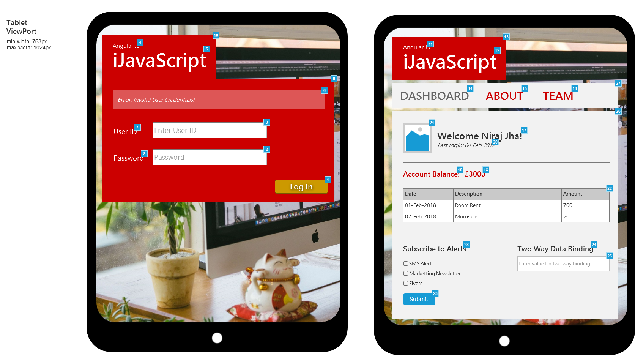

* + 1. Widget Table

| Footnote | Name | Interactions | Note |
| --- | --- | --- | --- |
| 1 | login button | OnClick:  Case 1:  Open PAGE 2.0 Dashboard in Current Window OnSelected:  Case 1:  Open PAGE 2.0 Dashboard in Current Window | **TECHNOLOGY**  FORM Handling  Routing  **REQUIRMENT**  Apply Routing for navigation  **ON CLICK**  - validate FORM data  - call 'AuthenticateUser' service  **BUSINESS RULE**  IF Form Valid && Service success && isUserAuthenticated = true  Move to PAGE0.2 Dashboard  ELSE  Show top level error  **STYLE**  background-color: #CC9900  border-color: #775900  color: #FFF |
| 2 | password_field |  | **VALIDATION RULE**  MIN LENGTH >=8  MAX LENGTH = 20  input type = password  **STYLE**  padding: 5px |
| 3 | userid_field |  | **VALIDATION RULE**  MIN LENGTH >=8  MAX LENGTH = 20  **STYLE**  padding: 5px |
| 4 | js_framework |  | **DISPLAY LOGIC**  Dynamic Text  **BUSINESS LOGIC**  Change Text as per technology.  ex - React JS or Ember JS  **STYLE**  font-family: Microsoft JhengHei  font-size: 14px |
| 5 | heading |  | **DISPLAY LOGIC**  Static Text  **STYLE**  font-family: Microsoft JhengHei  font-size: 48px |
| 6 | top_error_panel |  | **DISPLAY LOGIC**  Dynamic Text  Hidden (by default)  **BUSINESS LOGIC**  Show on click of login button if  scenerio #1 -  Invalid Form  content = 'Please enter login credentials to continue'  scenerio#2 -  user credential fail  IF  'AuthenticateUser' service response  isAuthenticated: FALSE  content = 'Invalid User Credentials!'  scenerio#3 -  service FAIL (Technical or Business exceptions)  content = 'Sorry unable to connect to system!' |
| 7 | user_id_label |  | **DISPLAY LOGIC**  Static Text  **STYLE**  font-family: Arial  font-size: 18px  color: #FFF |
| 8 | password_label |  | **DISPLAY LOGIC**  Static Text  **STYLE**  font-family: Arial  font-size: 18px  color: #FFF |
| 9 | login_box |  | **STYLE**  background-color: #CC0000  width: 100%  height: auto  padding: 20px |
| 10 | top_banner |  | **STYLE**  background-color: #CC0000  width: 300px  height: 115px  padding: 20px |
| 11 | js_framework |  | **DISPLAY LOGIC**  Dynamic Text  **BUSINESS LOGIC**  Change Text as per technology.  ex - React JS or Ember JS  **STYLE**  font-family: Microsoft JhengHei  font-size: 14px |
| 12 | heading |  | **DISPLAY LOGIC**  Static Text  **STYLE**  font-family: Microsoft JhengHei  font-size: 48px |
| 13 | top_banner |  | **STYLE**  background-color: #CC0000  width: 300px  height: 115px  padding: 20px |
| 14 |  |  | **TECHNOLOGY**  Routing  **REQUIRMENT**  Apply Routing for navigation  **STYLE**  font-family: Microsoft JhengHei, arial  font-weight: bold  font-size: 28px  color: #666666  Active page  color: #666666  **ON CLICK**  remove hyperlink - No action |
| 15 |  | OnClick:  Case 1:  Open PAGE 3.0 About in Current Window | **TECHNOLOGY**  Routing  **REQUIRMENT**  Apply Routing for navigation  **STYLE**  font-family: Microsoft JhengHei, arial  font-weight: bold  font-size: 28px  color: #CC0000  Active page  color: #666666  **ON CLICK**  show PAGE 3.0 About |
| 16 |  | OnClick:  Case 1:  Open PAGE 4.0 Team in Current Window | **TECHNOLOGY**  Routing  **REQUIRMENT**  Apply Routing for navigation  **STYLE**  font-family: Microsoft JhengHei, arial  font-weight: bold  font-size: 28px  color: #CC0000  Active page  color: #666666  **ON CLICK**  show PAGE 4.0 Team |
| 17 |  |  | **TECHNOLOGY**  Data Access  Data Handling  **DISPLAY LOGIC**  Dynamic Text  Welcome + <CUSTOMER.USERNAME>  **STYLE**  <h2>  font-size: 24px  **MODEL ENTITY**  <RetrieveUserDetails>  node = {username} |
| 18 |  |  | **TECHNOLOGY**  Data Access  Data Handling  **DISPLAY LOGIC**  Dynamic Text  <CUSTOMER.BALANCE>  **STYLE**  <h3>  font-size: 18px  color: #CC0000  **MODEL ENTITY**  <RetrieveUserDetails>  node = {customer.balance} |
| 19 |  |  | **DISPLAY LOGIC**  static Text  **STYLE**  <h3>  font-size: 18px  color: #CC0000 |
| 20 |  |  | **TECHNOLOGY**  Data Access  Data Handling  **DISPLAY LOGIC**  Dynamic Text  Last Login + <CUSTOMER.LASTLOGIN>  **STYLE**  font-size: 14px  font-style: italic  **MODEL ENTITY**  <RetrieveUserDetails>  node = {last_login} |
| 21 |  |  | DISPLAY LOGIC  static image  <placeholder user image> |
| 22 |  |  | **TECHNOLOGY**  Complex Data structure  Data Access  Data Handling  **DISPLAY LOGIC**  Dynamic Text  Grid layout  **MODEL ENTITY**  <RetrieveUserDetails>  node:  Date: {customer.transaction.date}  Description: {customer.transaction.desc}  Amount: {customer.transaction.amount} |
| 23 |  | OnClick:  Case 1:  Show/Hide Widget | **TECHNOLOGY**  Form Data handling  **ON CLICK**  show modal window  alert box content = selected values  **STYLE**  background-color: #169BD5  color: #FFF  padding: 5px 10px |
| 24 |  |  | **TECHNOLOGY**  Data Binding  **DISPLAY LOGIC**  dynamic text  Apply binding as per text box value  default text = Two Way Data Binding  **STYLE**  <h3> |
| 25 |  |  | **TECHNOLOGY**  Data Binding  **EVENT**  Apply Two way data binding with heading label  **STYLE**  padding: 5px |
| 26 |  |  | **STYLE**  width: 100%  height: auto  background-color: #F2F2F2  padding:20px  margin-left:20px |
| 27 |  |  | **STYLE**  width: 100%  min-height: 500px  background-color: #F2F2F2 |
| 28 |  |  | **STYLE**  <h3> |

* 1. Model
     1. User Interface

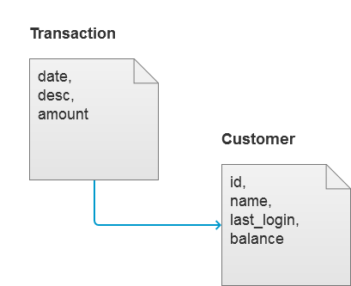

* 1. AuthenticateUser
     1. User Interface

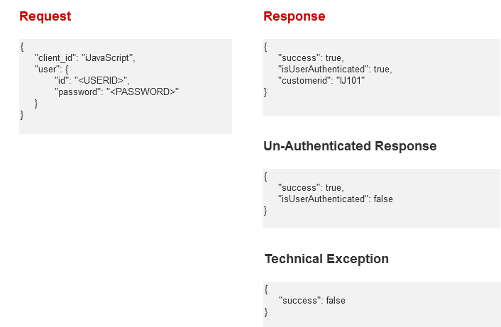

* 1. RetrieveUserDetails
     1. User Interface

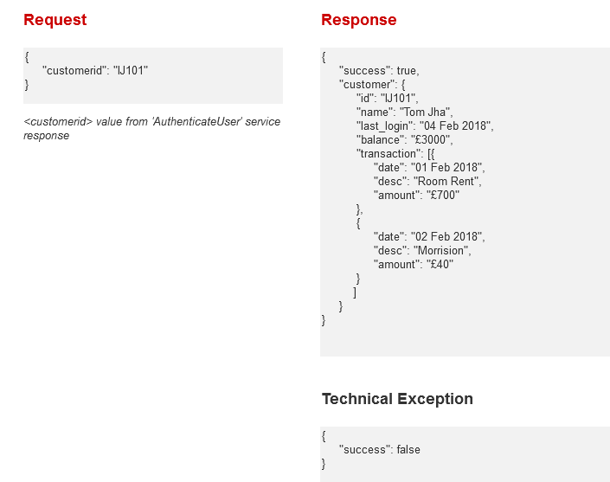

* 1. Global Styles
     1. User Interface

