**AIRWidget – A Simple Arduino-based IR Widget**

**1. What is an IR Widget?**

An IR Widget is a tool for capturing and displaying infrared remote control signals on a PC. It is used together with IRScope, a program that displays and analyses the data from the widget. It is also one of the capture devices supported by IrScrutinizer, a powerful program for capturing, generating, analyzing, importing, and exporting of infrared (IR) signals. More about these programs is given in section XX.

The IR Widget was originally designed by Kevin Timmerman in 2007, who also wrote the original version of IRScope. That design is fully described here:

[IR Widget - Consumer infrared remote control capture and visualization (compendiumarcana.com)](http://www.compendiumarcana.com/irwidget/)

together with links to all the details needed to build one. Building one, however, requires having the means to program a PIC chip. Ready-made IR Widgets to this design have been available for many years from Tommy Tyler, see this link:

[Tommy Tyler widget (weebly.com)](https://ir-widget.weebly.com/)

but he now accepts orders only from addresses within the continental United States.

**2. What is the AIRWidget?**

To make access to Widgets more readily available, Tommy has led a project to design the AIRWidget, an Arduino-based IR Widget. This is a collaboration between Tommy himself, Graham Dixon and Douglas Miles. It uses an absolute minimum of parts which are all readily available, it can be assembled on a circuit breadboard without soldering or is easily soldered in a more permanent form if desired. The parts are an Arduino Nano clone, a QSE159 photo diode to read the IR signal, an LED to make the signal visible and a 1K resistor to limit the LED current. Here is the circuit diagram:

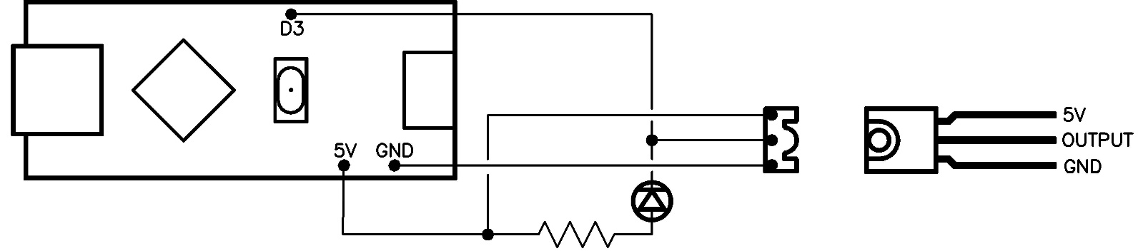

The photo diode is shown in the circuit as viewed from above with the sensor window facing to the right. The separate plan of the diode shows it lying flat with the window upwards. The LED has two wires but needs to be connected the right way round. Generally, on a new LED the leads are different lengths and the longer one is the positive lead. There is also a flat edge to the case of the LED next to the negative lead, which can distinguish them if the leads have been trimmed. Finally, it will do no harm to connect the LED the wrong way round, provided the resistor is in place, as it will not light and the connections simply need to be reversed. As can be seen in the diagram, there are only three connections to the Arduino, two to the 5 volt and ground (0 volt) pins and also the pin marked D3 which receives the output from the photo diode. This picture shows one assembled on a small circuit breadboard. The LED used there is white, but that is not essential.

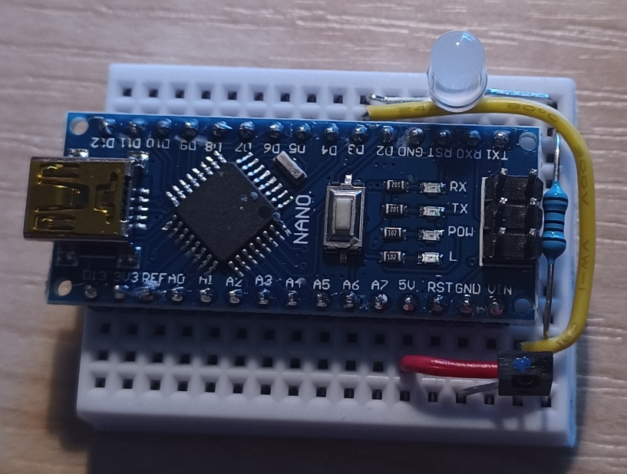

**3. Installing the program**

When the device has been constructed, the next step is to program the Arduino. To do this you need the Arduino IDE from this link:

[Software | Arduino](https://www.arduino.cc/en/software)

At the time of writing, there is a version 2.0.0 of the Arduino IDE that is still under development so the latest release is the legacy version 1.8.19. I recommend using this legacy version and the instructions below are for this version. In addition to this IDE you will need a driver for the CH340 USB-to-Serial converter that these clones use, as a genuine Nano uses an FTDI chip and not the CH340. The driver may install automatically, but if not then you can get the driver from the manufacturer's website here:

[CH341SER.ZIP - NanjingQinhengMicroelectronics (wch-ic.com)](http://www.wch-ic.com/downloads/CH341SER_ZIP.html)

You also need the AIRWidget sketch (Arduino’s name for a program). This is the file AIRWidget_V0_09.ino which you can download here:

<Link to file to be added later>

For the IDE to upload the sketch, you need to create a folder called AIRWidget_V0_09 (the name of the sketch without the extension) and copy the sketch file into it. Then connect your Arduino to the PC. Note that Arduino Nano clones usually use a mini-USB connector rather than the more common micro-USB one. Open the Arduino IDE and make, or at least check, three settings under the Tools menu. Under Board select Arduino AVR boards > Arduino Nano. Under Processor there are three choices, "ATmega328P", "ATmega328P (Old Bootloader)" and "ATmega168". It should be one of the first two. Try one and if the software does not upload (as described below), try the other. I needed the Old Bootloader one despite this apparently being for Nanos from 2017 and earlier. Finally select the Port. Unless you have other USB ports connected, there should only be one choice listed.

Now go to File > Open and navigate to the downloaded sketch in its new folder, select it and press Open. The status bar should say Compiling sketch, then Upoading, and finally Done uploading. You can now disconnect the board and close the Arduino IDE, which you do not need again. The AIRWidget is now complete.

**4. Using the AIRWidget**

As mentioned in section 1, Kevin’s IR Widget was designed to be used with his IRScope program. That program has been considerably enhanced since then by Graham Dixon and until this current project, the latest version was v2.01a. A comprehensive guide to the use of the Widget with this version can be downloaded here:

[IRScope and Widget Guide (hifi-remote.com)](http://www.hifi-remote.com/forums/dload.php?action=file&file_id=9696)

Due to slight differences in operation between Kevin’s design and the AIRWidget, Graham Dixon has updated IRScope to v3.00, adding a new mode of operation that is specifically intended for the AIRWidget. This version can be downloaded here:

[IRScope v3.00 (hifi-remote.com)](http://www.hifi-remote.com/forums/dload.php?action=file&file_id=26615)

The guide applies almost unchanged to this version, but please note the following

* Ignore the section on IR Widget Driver Installation as you will have already installed the driver for the CH340 USB-to-serial converter that the Arduino clone uses instead of the FTDI chip that the guide mentions.
* The guide tells you to select *IR Widget Count* in the drop-down *Hardware and Mode* box. Instead, select *Arduino Widget* which is the new entry and is the last in the drop-down list.

The remainder of the guide applies unchanged.

The IR Widget is also supported by IrScrutinizer, a powerful program written by Bengt Martensson. This is available here:

[GitHub - bengtmartensson/IrScrutinizer: IrScrutinizer is a program for IR signal analysis, decoding, generation and much more.](https://github.com/bengtmartensson/IrScrutinizer)

Select *tags* in the header line of the page that displays. The available versions are listed there together with download links. As mentioned in connection with IRScope, there are slight differences in operation between Kevin’s design and the AIRWidget. You should still select IRWidget as the capture device but use continuous capture modes rather than single capture, to get the best out of the AIRWidget.

Graham Dixon

11 October 2022