Below are a set of screenshots demonstrating the survey questions and flow used in this experiment. The overall flow, which is identical for the control and the treatment groups, are displayed only once. The different text that the treatment and the control groups read are shared separately at the end of the file.

Information that may identify the people and the institution involved in this study are hidden by using black rectangular shapes.

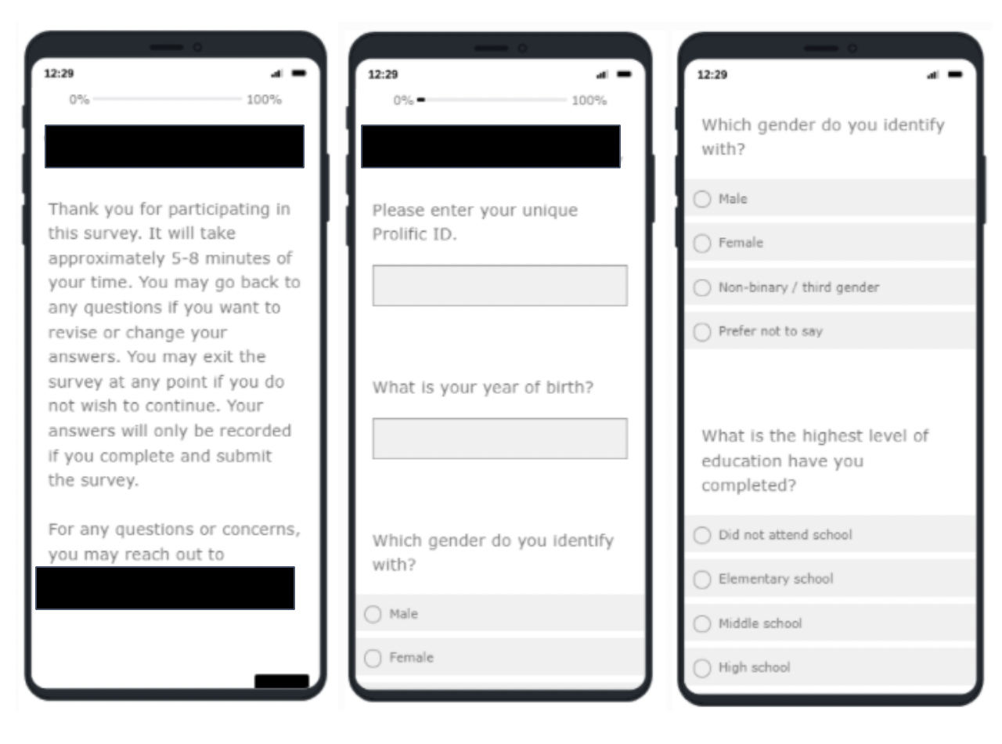

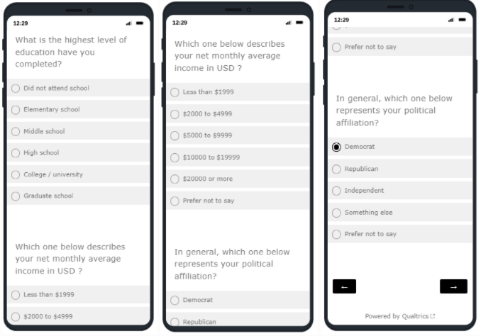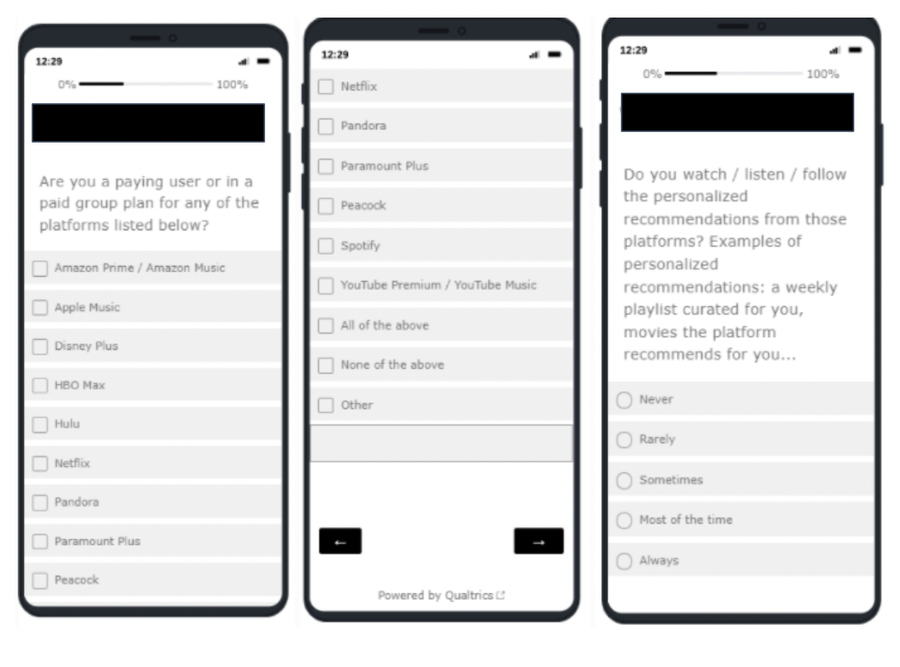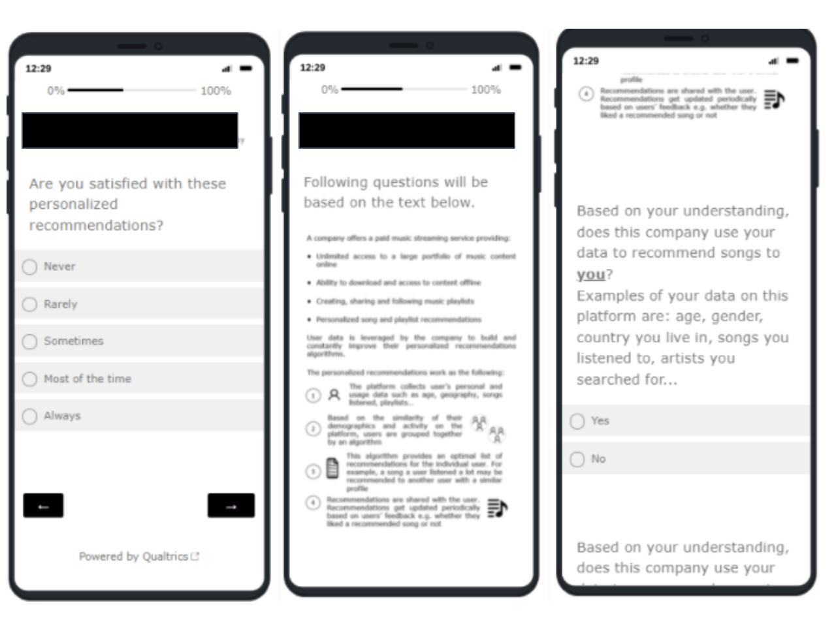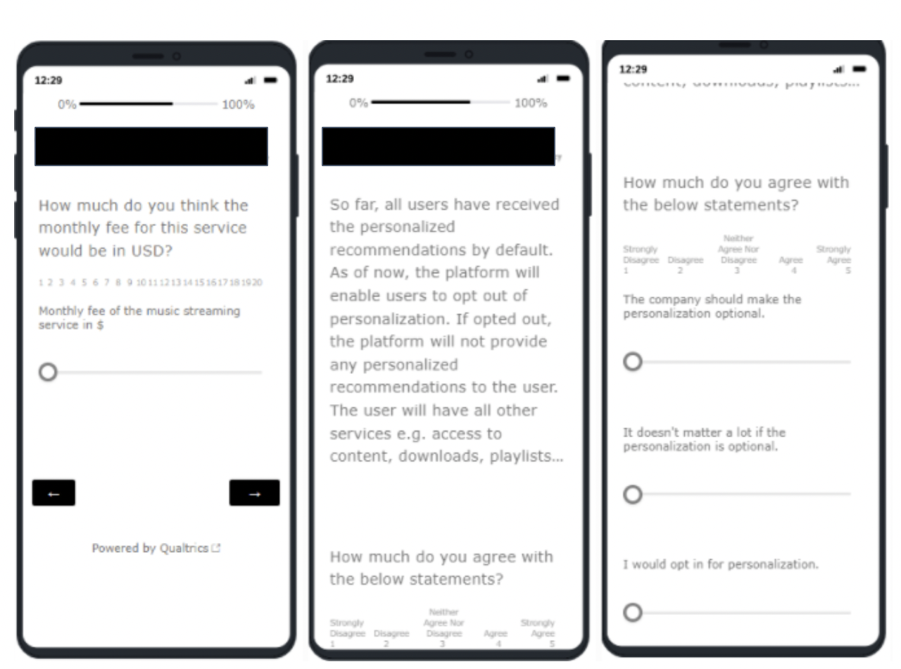

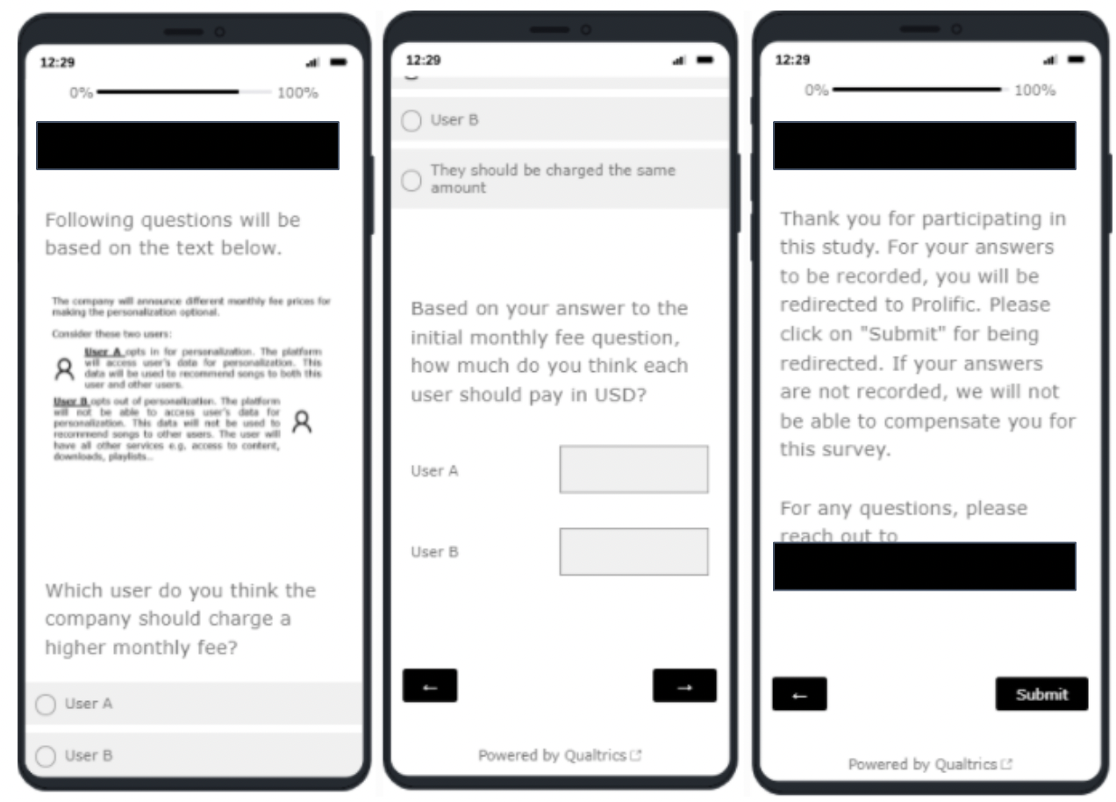

Below is the experiment text that the treatment group read.

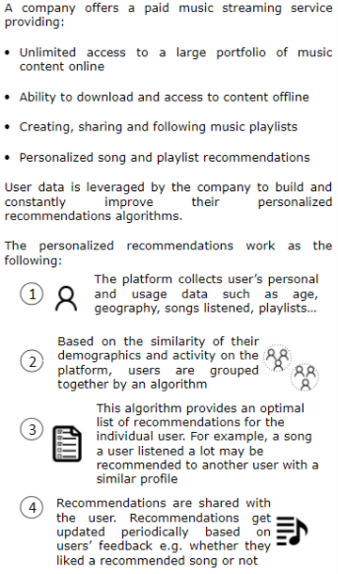

Below is the experiment text that the control group read:

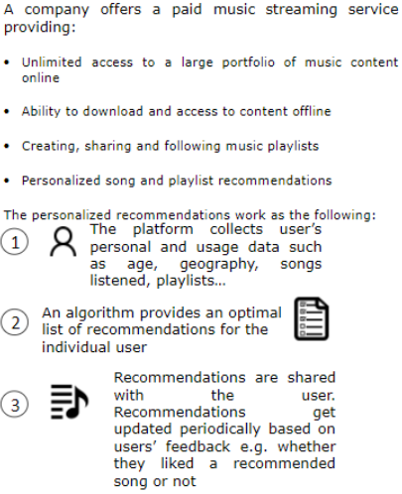

Below is the follow up text that the treatment group read:

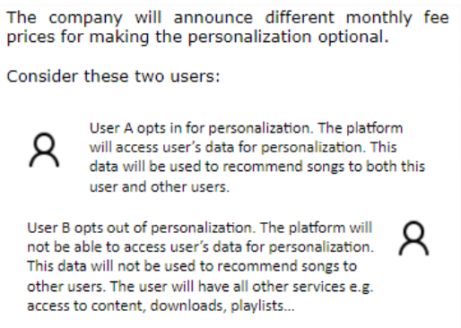

Below is the follow up text that the control group read:

