ESTIMATION ERROR IN
PORTFOLIO OPTIMISATION
Bayesian Shrinkage, CVaR and Wasserstein Distributional Robustness
Ben Heskin | Independent Quantitative Finance Research Project | August 2026
Abstract
I compare five monthly portfolio rules across twelve value-weighted US industry portfolios: equal weighting, sample mean-variance optimisation, empirical-Bayes/Ledoit-Wolf mean-variance optimisation, historical 95% Conditional Value-at-Risk (CVaR) optimisation, and Wasserstein robust CVaR. The study uses a nested 60-month walk-forward design from January 2015 to September 2025. Hyperparameters are selected before each test month, and each strategy pays 10 basis points per unit of one-way turnover.
Principal findings
- The 1/N benchmark achieved the highest compound return, 11.43% per year, and terminal wealth of 3.20 from an initial dollar.
- Sample MVO was fragile: it returned 7.63%, suffered a -29.6% maximum drawdown, and turned over 22.0% per month.
- Shrinkage MVO cut annualised volatility to 12.3% and improved maximum drawdown to -19.3%, but did not recover the benchmark's return.
- Wasserstein robust CVaR produced the highest zero-rate Sharpe ratio among the optimisation methods (0.766) and a more diversified allocation, but its Sharpe difference from 1/N was not statistically distinguishable from zero.
Interpretation The modern methods mainly improved risk control and stability. They did not establish a statistically reliable return advantage over naive diversification.

1. Research question and motivation
Markowitz (1952) frames investment choice as a trade-off between expected return and covariance risk. In practice, both inputs are estimated with error, and optimisation can turn small errors into large changes in portfolio weights.
The comparison adds empirical-Bayes mean shrinkage, covariance shrinkage, a lower-tail CVaR objective, and Wasserstein robustness to the classical model.
1.1 Testable research question
Research question When the data-generating distribution is estimated from a short rolling history, do shrinkage and distributionally robust tail-risk models generate better out-of-sample portfolios than sample Markowitz optimisation and equal weighting?
1.2 Prior evidence
Ledoit and Wolf (2004) show why a convex combination of the sample covariance matrix and a structured target can be better conditioned than the raw sample estimator. Rockafellar and Uryasev (2000) provide a linear-programming representation of CVaR, making tail-risk optimisation computationally practical. Mohajerin Esfahani and Kuhn (2018) show that data-driven optimisation over Wasserstein ambiguity sets can often be reformulated as tractable convex programmes. DeMiguel, Garlappi and Uppal (2009), however, demonstrate that 1/N is difficult to beat out of sample because estimation error can offset the theoretical gains from optimisation.
1.3 Pre-specified hypotheses
- H1: sample MVO will exhibit the highest concentration and turnover.
- H2: mean and covariance shrinkage will reduce realised volatility and drawdown relative to sample MVO.
- H3: CVaR-based portfolios will improve lower-tail risk relative to variance-based portfolios.
- H4: Wasserstein robustness will reduce concentration relative to historical CVaR.
- H5: no advanced model will show a statistically reliable return advantage over 1/N after costs.

2. Data and experimental protocol
The asset universe is the twelve value-weighted US industry portfolios from the Kenneth R. French Data Library: non-durables, durables, manufacturing, energy, chemicals, business equipment, telecommunications, utilities, shops, health, money and other. The bundled research vintage contains 189 contiguous monthly observations from January 2010 to September 2025. Returns are total percentage returns converted to decimals.
Design element | Specification
Universe | 12 US industry portfolios
Data frequency | Monthly
Input sample | 2010-01 to 2025-09
Out-of-sample period | 2015-01 to 2025-09 (129 months)
Estimation window | Rolling 60 months
Internal validation | Final 12 months of each estimation window
Portfolio constraints | Long-only; sum to 1; 35% cap per industry
Trading cost | 10 bps per unit of one-way turnover
Tail probability | 95% CVaR
2.1 Nested walk-forward procedure
- At each test month, take only the immediately preceding 60 observations.
- Use the first 48 months to fit candidate models and the final 12 months to select MVO risk aversion or the Wasserstein radius by realised validation Sharpe.
- Refit the selected specification on all 60 observations, fix the portfolio weights, and then reveal the next monthly return.
- Calculate turnover from drifted pre-trade weights, deduct costs, and roll forward by one month.
2.2 Bias controls
The test month is never used for model selection. Parameters are not tuned on the final sample, and all reported returns are net of trading costs. Equal weight uses the same cost convention. The report uses a fixed French data vintage because CRSP revisions can change historical results.
Measurement convention The reported Sharpe statistic assumes a zero monthly risk-free rate and is labelled 'zero-rate Sharpe'. This avoids mixing the portfolio comparison with a separately sourced interest-rate series.

3. Statistical estimators and allocation rules
3.1 Classical sample mean-variance optimisation
For monthly return vector r_t, the classical model estimates the sample mean mu_hat and covariance Sigma_hat and solves a long-only quadratic programme. Gamma is selected in the internal validation period.
min_w 0.5 gamma w' Sigma_hat w - mu_hat' w
Subject to 1'w = 1 and 0 <= w_i <= 0.35.
Expected-return errors enter linearly, while covariance inversion and optimisation can amplify noise. The cap prevents a single-industry solution but does not eliminate concentration.
3.2 Empirical-Bayes mean shrinkage
Each industry's sample mean is shrunk toward the cross-sectional grand mean. Let m_i be the sample mean, v_i/T its sampling variance, m_0 the grand mean and tau^2 the estimated between-industry prior variance. The posterior approximation is:
mu_i^B = B_i m_i + (1-B_i)m_0, B_i = tau^2 / (tau^2 + v_i/T)
Noisy industries receive more shrinkage; more precise estimates retain more of their sample signal.
3.3 Ledoit-Wolf covariance shrinkage
Sigma_LW = delta F + (1-delta) Sigma_hat
The target F is a scaled identity in the implementation provided by scikit-learn, and the shrinkage intensity delta follows the Ledoit-Wolf formula. The resulting covariance is positive definite and better conditioned. Shrinkage MVO combines mu^B and Sigma_LW in the same constrained quadratic programme as sample MVO.
Comparison Sample and shrinkage MVO use the same objective and constraints, isolating the effect of regularised inputs.

4. Tail risk and distributional robustness
4.1 Historical mean-CVaR
For portfolio loss L_t = -w'r_t, CVaR is represented using an auxiliary threshold eta and non-negative excess-loss variables u_t. The portfolio minimises empirical 95% CVaR subject to an estimated-return floor equal to the empirical-Bayes expected return of the equal-weight portfolio.
min_{w,eta,u} eta + [1/((1-alpha)T)] sum_t u_t
u_t >= -w'r_t - eta; u_t >= 0; (mu^B)'w >= (mu^B)'(1/N)
The return floor prevents the optimiser from reducing tail risk by accepting a lower estimated return than the benchmark. SciPy/HiGHS solves the linear programme.
4.2 Wasserstein robust CVaR
Historical CVaR treats the empirical distribution as exact. The robust model instead considers all distributions inside a 1-Wasserstein ball of radius epsilon around it. With an L1 ground metric and linear portfolio loss, the worst-case CVaR adds an infinity-norm concentration penalty:
Robust CVaR = Empirical CVaR + [epsilon/(1-alpha)] ||w||_infinity
For long-only weights, ||w||_infinity is linearised by introducing m with m >= w_i. The radius epsilon is chosen on the internal validation block from 0.0005, 0.001, 0.002 and 0.004. Its median selected value was 0.002 monthly-return units.
4.3 Implementation and validation
- Python package with separate data, estimation, optimisation, backtest, metrics and plotting modules.
- Quadratic programmes solved by SLSQP; CVaR programmes solved by HiGHS linear programming.
- Unit tests check data continuity, covariance positive semidefiniteness, full investment, long-only bounds and the robust concentration penalty.
- All 129 monthly fits completed without an optimiser failure.

5. Main out-of-sample results
Strategy | Return | Vol. | Sharpe | Max DD | CVaR loss
Equal Weight | 11.4% | 15.6% | 0.77 | -23.2% | 9.3%
Sample MVO | 7.6% | 16.5% | 0.53 | -29.6% | 9.2%
Shrinkage MVO | 8.1% | 12.3% | 0.70 | -19.3% | 7.7%
Historical Mean-CVaR | 9.5% | 13.2% | 0.75 | -21.1% | 7.7%
Wasserstein Robust CVaR | 9.9% | 13.6% | 0.77 | -23.3% | 8.3%
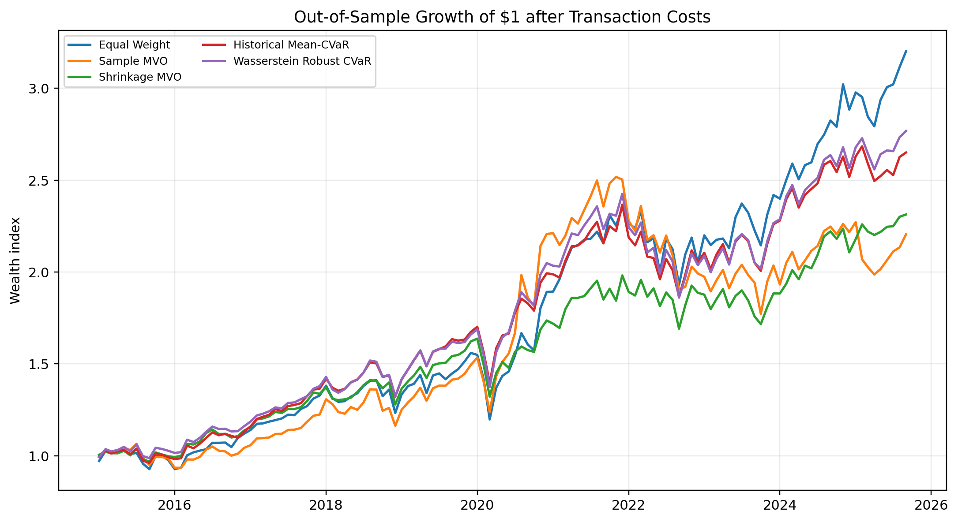
Figure 1. Growth of one dollar after monthly turnover costs, January 2015-September 2025.
Equal weight finished with terminal wealth of 3.20 and the highest compound return. Sample MVO finished at 2.21 with slightly more annualised volatility than 1/N. Shrinkage MVO had the lowest volatility and best maximum drawdown. Both CVaR strategies improved risk control relative to sample MVO while retaining more upside than shrinkage MVO.
Result Controlling estimation error and the risk objective mattered more than maximising the in-sample mean-variance criterion.

6. Downside risk and economic behaviour
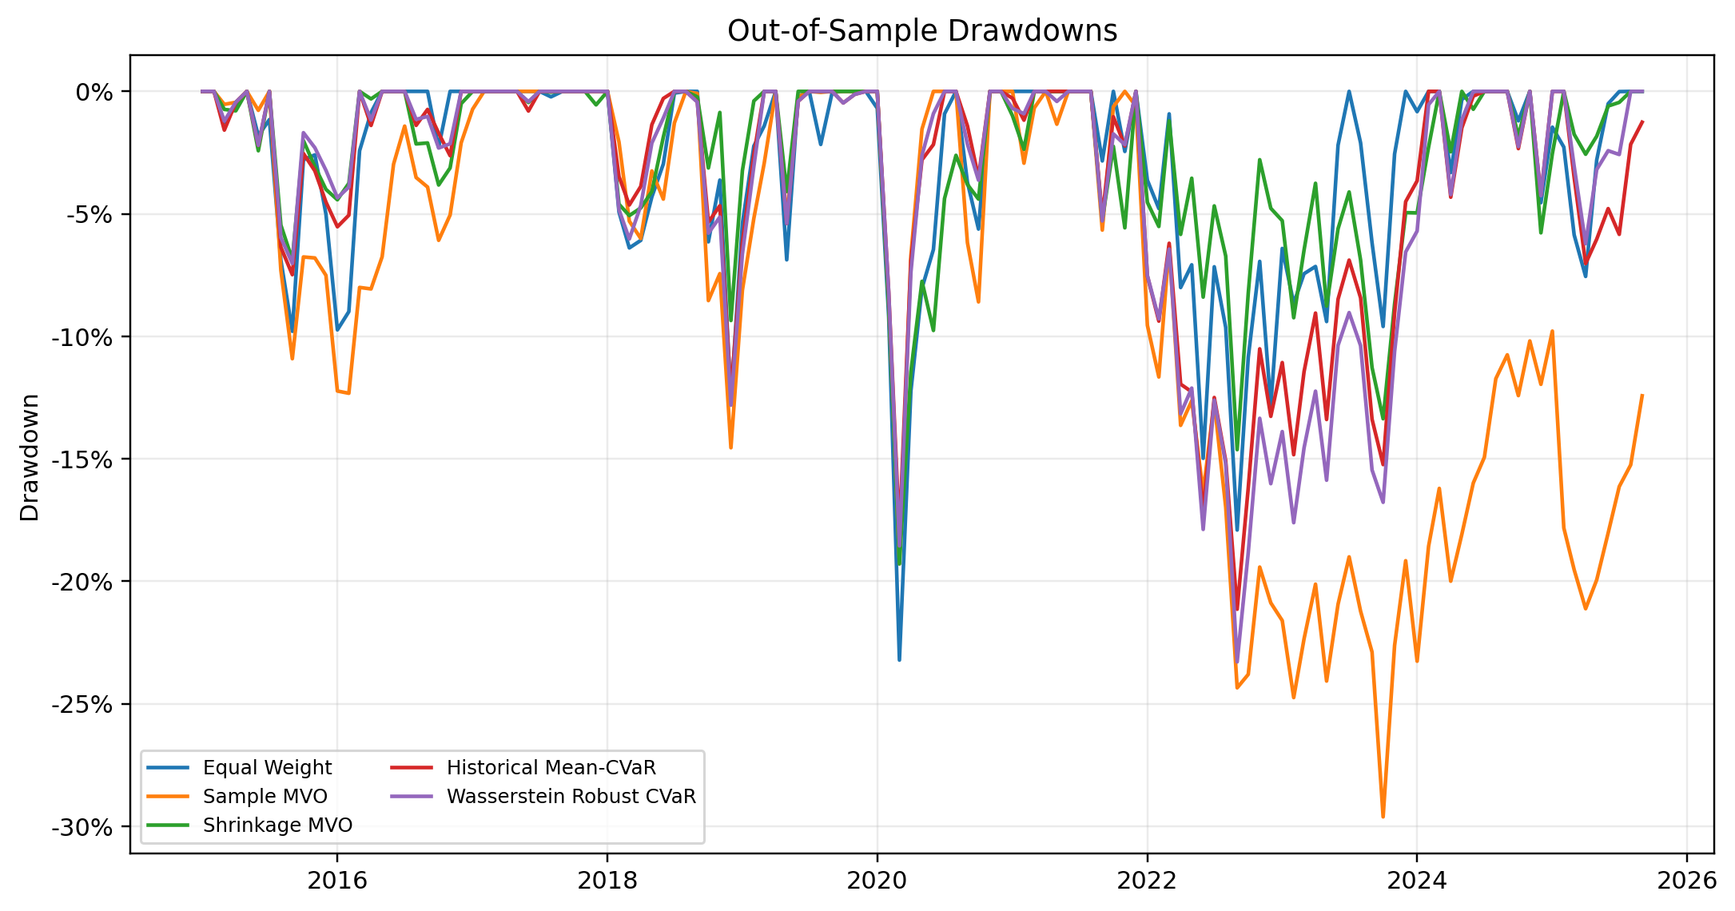
Figure 2. Drawdown paths based on net monthly returns.
Sample MVO experienced the deepest drawdown at -29.6%. Shrinkage MVO limited its maximum drawdown to -19.3%, while historical CVaR reached -21.1%. The estimated 95% monthly CVaR loss fell from 9.3% for equal weight to 7.7% for shrinkage MVO and 7.7% for historical CVaR.
6.1 Stress episodes
Strategy | COVID sell-off | 2022 tightening
Equal Weight | -22.7% | -10.9%
Sample MVO | -19.3% | -23.3%
Shrinkage MVO | -19.3% | -8.2%
Historical Mean-CVaR | -18.0% | -16.2%
Wasserstein Robust CVaR | -18.6% | -18.8%
Historical CVaR lost 18.0% in the February-March 2020 sell-off, compared with 22.7% for 1/N. During the 2022 tightening episode, shrinkage MVO performed best (-8.2%) and robust CVaR lost 18.8%. Distributional robustness does not protect against every regime.

7. Turnover, concentration and regime dependence
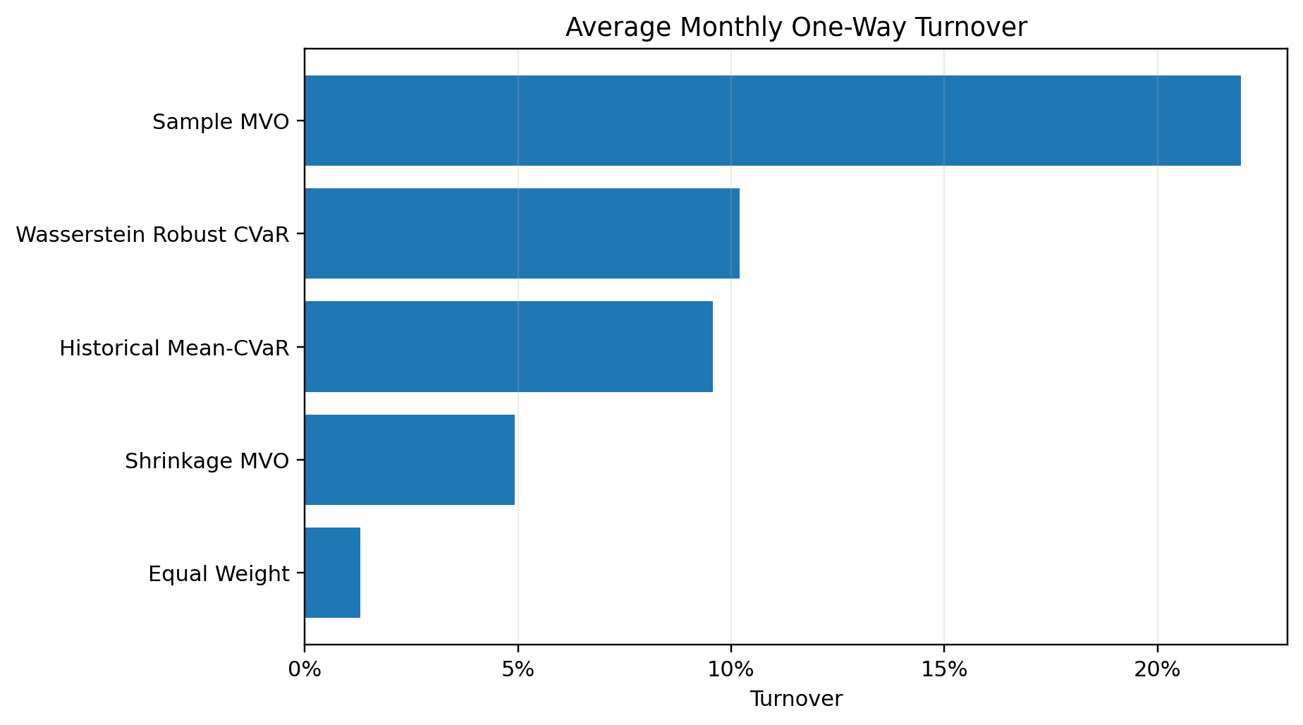
Figure 3. Average monthly one-way turnover. Ten basis points are charged per unit of turnover.
Strategy | Turnover | Cost drag | Effective N | Avg. max wt.
Equal Weight | 1.3% | 0.02% | 12.0 | 8.3%
Sample MVO | 22.0% | 0.26% | 3.5 | 34.4%
Shrinkage MVO | 4.9% | 0.06% | 4.0 | 34.4%
Historical Mean-CVaR | 9.6% | 0.11% | 3.6 | 35.0%
Wasserstein Robust CVaR | 10.2% | 0.12% | 4.8 | 24.4%
Sample MVO reallocated 22.0% per month on average and held an effective 3.5 industries. Its average largest position was close to the 35% cap. Wasserstein robustness increased effective breadth to 4.8 industries and reduced the average largest position to 24.4% because the L1 ambiguity penalty directly penalises the largest weight.
7.1 Volatility regimes
Strategy | High-vol. Sharpe | Lower-vol. Sharpe
Equal Weight | 0.90 | 0.64
Sample MVO | 0.74 | 0.24
Shrinkage MVO | 0.67 | 0.78
Historical Mean-CVaR | 0.91 | 0.57
Wasserstein Robust CVaR | 0.89 | 0.63
Historical CVaR had the strongest high-volatility Sharpe (0.91), narrowly above equal weight (0.90). Shrinkage MVO performed better in lower-volatility months (0.78) than in high-volatility months (0.67). Sample MVO's lower-volatility Sharpe was only 0.24, consistent with unstable mean estimates rather than compensation for systematic stress exposure.

8. Statistical inference, robustness and limitations
A 2,000-draw circular moving-block bootstrap with six-month blocks preserves short-run dependence. Each optimisation strategy is compared with equal weight using annualised arithmetic mean-return and zero-rate Sharpe differences. Confidence intervals are percentile intervals.
Strategy vs 1/N | Mean diff. | 95% CI | Sharpe diff. | 95% CI
Sample MVO | -3.4% | [-8.2%, 1.7%] | -0.25 | [-0.58, 0.04]
Shrinkage MVO | -3.5% | [-7.3%, 0.1%] | -0.08 | [-0.33, 0.17]
Historical Mean-CVaR | -2.1% | [-5.5%, 0.8%] | -0.02 | [-0.26, 0.17]
Wasserstein Robust CVaR | -1.7% | [-4.7%, 1.1%] | -0.01 | [-0.21, 0.18]
Every mean-return difference was negative. The confidence intervals for historical and robust CVaR included zero, while the shrinkage MVO interval ended close to zero. No Sharpe-difference interval showed a positive advantage. Robust CVaR's observed Sharpe was 0.008 below 1/N, with a 47.3% bootstrap probability of a positive difference. This supports non-superiority, not equality.
8.1 Limitations
- Industry portfolios are research constructs rather than directly investable securities; implementation costs for actual products may differ.
- The universe excludes bonds, cash and international assets, so results are not a complete strategic asset-allocation study.
- Sixty monthly observations leave only a few empirical observations in the 5% CVaR tail, increasing sampling uncertainty.
- The Wasserstein radius is validation-selected rather than calibrated as a formal confidence radius.
- A zero risk-free rate is used for the labelled Sharpe statistic, and inference is sensitive to block length and sample length.
- Historical backtests cannot establish future profitability; model and data vintages may change.
Reproducibility The repository stores monthly weights, returns, turnover, selected hyperparameters, bootstrap results and figures.

9. Conclusion
Sample MVO performed poorly because noisy means and covariances produced concentrated, high-turnover decisions. Empirical-Bayes and Ledoit-Wolf shrinkage improved realised risk. CVaR shifted the objective from variance to tail losses and performed better in the COVID sell-off.
Wasserstein robustness produced a broader portfolio than historical CVaR and the strongest Sharpe among the optimisation methods, but it did not beat equal weighting on compound return or statistical inference. The robust penalty therefore helped control concentration and distributional uncertainty without solving the more fundamental problem of forecasting expected returns. Equal weighting remained the strongest overall benchmark.
Financial models should separate estimation, decision and evaluation. A sophisticated objective has value only if its decisions hold up on unseen data, after costs and under stress.
References
DeMiguel, V., Garlappi, L. and Uppal, R. (2009). Optimal Versus Naive Diversification: How Inefficient Is the 1/N Portfolio Strategy? Review of Financial Studies, 22(5), 1915-1953. doi:10.1093/rfs/hhm075.
French, K. R. (2025 data vintage). 12 Industry Portfolios. Kenneth R. French Data Library, Dartmouth College.
Ledoit, O. and Wolf, M. (2004). A Well-Conditioned Estimator for Large-Dimensional Covariance Matrices. Journal of Multivariate Analysis, 88(2), 365-411. doi:10.1016/S0047-259X(03)00096-4.
Markowitz, H. (1952). Portfolio Selection. Journal of Finance, 7(1), 77-91. doi:10.1111/j.1540-6261.1952.tb01525.x.
Mohajerin Esfahani, P. and Kuhn, D. (2018). Data-Driven Distributionally Robust Optimization Using the Wasserstein Metric. Mathematical Programming, 171, 115-166. doi:10.1007/s10107-017-1172-1.
Rockafellar, R. T. and Uryasev, S. (2000). Optimization of Conditional Value-at-Risk. Journal of Risk, 2(3), 21-41. doi:10.21314/JOR.2000.038.
Repository deliverables
The accompanying repository includes the versioned data snapshot, official-data downloader, tested Python package, walk-forward runner, all output CSV files, figures, editable Word report and PDF report.

