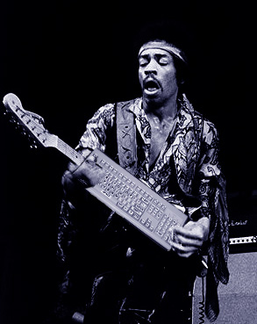 | The BTAR – 3000  “more than just a keyboard”  Benjamin Hammond  MUMT 502 Final Project

ABSTRACT:
Converts your computer keyboard and computer into a midi controller, synthesizer, effects pedalboard, analog controller, and microphone synthesizer. All that, and anyone can use it. For Free.

Advancements in Digital Audio throughout the past few decades have revolutionized the way the average person approaches music. Using nothing more than a laptop, children can make multitrack recordings that were only theorized less than half a century ago. Likewise, realistic emulation of acoustic sound, and recreation of an instrument’s physical and acoustical anomalies are now not only possible, but applicable in many fields, both commercial and academic.
The implications and applications of this technology for professional musicians and technology theorists have been widely explored, but there also exists a large role for these advancements in the fields of music education and music therapy. In both these disciplines, the ability of the machine to adapt to the human can compensate for attention deficits, learning disorders, physical disabilities, or other musical handicaps. In the case of therapeutic treatments, the quality of music is not what is emphasized so much as the overall development and advancement of the player. Use of percussion and other “accessible” instruments is widespread in this field, as are limited scale instruments, such as pentatonic or diatonic keyboards. For the same reasons that these percussive instruments are useful, so too would be a digital instrument whose complexity could be adjusted as the patient advanced. Moreover, in the case of education, studies suggest the numerous benefits of improvisational techniques in the classroom. Again, an adaptive instrument would complement any curriculum fostering improvisation and musical creativity.
Enter the BTAR 3000. Originally conceived as an interface for a “band-in-box” type project in 2003, the BTAR has since grown into a midi controller, synthesizer, drum machine, multi-effects pedalboard, digital bass guitar with “flick” add-on, mic to MIDI converter, and all kinds of hybrid combinations. Central to the design is the idea that the average user can download a simple program for free to their home or classroom computer and access the majority of the functionality, enabling them to create music and improvise at any time. Similar in nature to the “MIDIGRID” by Andy Hunt, the BTAR provides an entry into the world of music without requiring expensive instruments, music lessons or precise motor control. It differs from the “MIDIGRID” in that the overall experience is intended to inspire ROCKIN OUT in whoever is holding the power. The player, hereafter referred to as the “rockstar” has multiple modes of control: keyboard, mouse, microphone, and the optional USB flick add-on. Each of these inputs then includes multiple implementations for a customized experience. Inside the BTAR, there are 4 “voices”, the Synthesizer, the MIDI solo, MIDI bass, and MIDI drums. The signal from the synthesizer (or microphone/linein) can then be run to an array of digital effects pedals, resulting in a true rockstar experience. I will discuss each input method, then the guts of the machine (synthesis, controls, midi) and finally a brief discussion of the digital effects pedals.

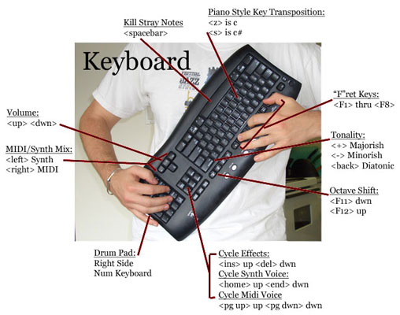
I. USER INTERFACE
The Keyboard
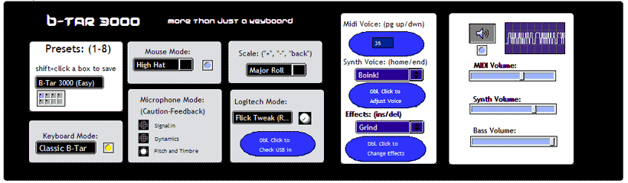
The sensible solution to mapping piano keys to a computer is to use the keyboard. But alas, something was missing. In a band, who do you look at, the piano/keyboard player with his seemingly limitless arsenal of sounds, or the sexy guitarist with the instrument hanging somewhere around his knees? Neither! You look at the keytar player, because he’s got the best of both worlds. The “something” that was missing had finally arrived when my concept to use the keyboard to control certain parameters literally got turned UPSIDE-DOWN. By holding the computer keyboard like a guitar, I had a new outlook on the music, the program and life in general. The oft-overlooked “Function” keys mapped naturally as frets, and with that the BTAR was born. Other desired functionality included volume controls, voice control, scale selection, octave and semitone transposition, and user presets to store complicated setups. A priority in the layout of controls for me was user-friendliness. Struggling to learn new software can be the most frustrating thing in the world, so making a logical layout was a top concern. This was doubly important considering the target audience included children, non-musicians and persons of limited capabilities. According the article The Psychopathology of Everyday Things: “…the fundamental principles of designing for people: (1) provide a good conceptual model and (2) make things visible” (Norman, 11). The conceptual model is how the user imagines the object to be functioning. Using the concept of abstraction, it is certainly not necessary that the user be correct in their assumptions, they just need to know how what they put in will come out. The worst case scenario would be a vague design which would imply functionality that did not exist, or imply limited capabilities when more were possible. In this way of thinking, a 1-to-1 mapping was adopted, with a clear diagram and user feedback for every button pressed.
Specifically, the “solo” voice is controlled by the function keys, with a depression resulting in a note on, and the key release as a note off. This allows for sustained organ chords, or short choppy rhythms depending on the style of playing. The second most often used functionality is certainly the volume control, so a high profile set of keys was needed. Implementing a crossfader allowed a blend between synthesizer and midi instruments, providing an even greater sonic range. In this way up and down stayed as overall volume control, while right and left control the blend between the two voices. Following that, the block of 6 keys from insert to pagedown laid nicely as controls to cycle through effects, midi voices, and synth presets. F11 and F12 became octave up and down (for some reason F9 and F10 are not picked up by Max, so that was the reason behind using only 1 through 8 as keyboard notes). Lastly, as great as the key of C is, I needed to compensate for the fact that some more pretentious musicians are “too good” for just one key. A digital capo of sorts was realized as a one octave keyboard using “z” as C and “s” as C# and continuing up in a piano style mapping to “m” as B natural. A press of one of these keys transposes the scale to start with that note. Lastly, the number keyboard on the right was a perfect compliment as a drum controller. An ergonomic layout features a selection of choice general midi samples and facilitates comfortable control of the phattest beats.

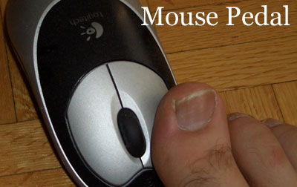
The Mouse
The BTAR 3000 features not only improved and extended keyboard controls, but also use of its input counterpart, the mouse. A unique approach was to have the mouse function as a foot pedal, since both hands are involved with controlling the keyboard. Currently there are two modes, one that creates a hihat on every click, and another the plays a bass drum on the depression, and a snare on the release. The alternating of these essential drums allows for some clever beats in a wide range of styles.

The Microphone (optional)
Hands and feet are both in use, now what’s left? Well, the voice of course! The microphone input provides a trio of non-exclusive functionalities; signal in, dynamics, and pitch/timbre. The first simply runs the signal of your mic input into the effects pedal, useful with the endless delay setting for vocal loops or simply for adding a reverb or delay to your voice. The second dynamic setting isn’t fully implemented, but the concept is the volume of your voice maps onto the midi velocity of your keyboard, similar to some breath pressure midi controllers. This allows for dynamic control, giving the rockstar the ability to woo chicks with the softest love ballad and then blast them across the room with a screaming solo. This is assuming of course that chicks are actually at the show. The last mode uses the Fiddle~ object by Miller Pucket to analyze both the fundamental and the overtone structure of the microphone input. This information is then converted into midi (and then possibly sent to the synth voice), with the fundamental providing the note on, then the overtone structure choosing between two different midi voices (default bass for dull sounds and violins for rich sounds). This is accomplished by measuring the difference in semitones between the fundamental and the 5th harmonic, the “throat-singing harmonic”. Though the entire structure changes with different values, the 5th harmonic is strongly associated with the vowel, and by throat singing up a scale with the overtone (droning one note and moving the overtone up incrementally) one can watch the transcription of the 5th harmonic correspond directly. This difference value is then run into a table, with values above a certain range resulting in one midi voice, and those below another voice.
An interesting side effect of the microphone functionality, especially using the timbre/pitch input, is what I call “freaky alive mode”. By setting up a feedback loop between the midi and synth note triggering and the mic to midi input, the BTAR comes alive and starts playing itself. Some minor volume adjustments can make a truly interesting system wherein cycles or patterns will eventually arise, and sometimes it will cease playing altogether. In this case, a simple “WAKE UP!!” yelled into the mic will jolt it out of it’s of its nap and keep it happily plonking away.

The USB “Flick” (optional)
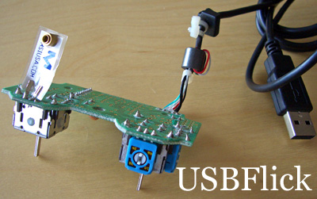
Oh microcontrollers. Oh analog to digital converters. Oh MAX/MSP. Anyone who has worked with any of these three beasts will appreciate that they are finicky at best, and endless pits of despair at worst. But have no fear, thanks to some very clever thinking of a fellow student, I was able to bypass much of the headache and almost all the cost normally associated with alternative midi analog controls. The first method I tried for prototyping involved the ATMEL microcontroller. Though slightly less user-friendly, this device is not terribly expensive, and is powerful in its configuration capabilities. Cost was a large factor in this case, especially since this control would only be an add-on to the fully functional BTAR, perhaps providing an even more realistic or creative experience. The ATMEL, due to the lack of either proper connectors, proper understanding or both, never worked, and is currently sitting on my table as a circuit board with parts hanging off it making me look smart. Phase two brought me to the music tech lab attempting to use the user-friendly wallet-unfriendly iCUBE and iCUBE wireless owned by McGill. Hours of resetting power supplies and ugly Java interfaces led me to one conclusion… it was time to scrap the analog input idea. Luckily for me, you and the BTAR, there was one last idea. A master’s student at McGill was doing a research project on the very problem of providing simple, reliable, affordable analog input into the computer. His stroke of genius lay in using a 25$ USB game controller, ripping it apart, and resoldering the leads that connected the analog directional controls to whatever other analog control one might desire. It seemed too good to be true…but for once it was not. It worked great, with each analog input reporting a value between 0 and 65355. Some simple range adjustments and mappings were made, and soon the flick bass was born. It uses a stiff plastic component to measure the velocity of a user’s flick, and values above a certain threshold are converted into note-ons of a corresponding (or independent) velocity. A second functionality was added later which mapped the velocity of the flick to the resonance and number of harmonics of the synth voice. This allows the crazy sweeping “weeeooooonn” sounds everyone wants from synths, but controllable with the flick of your finger. It is also possible to short circuit the connector providing continuous adjustment of the resonance.
II. INNER WORKINGS
Input from the solo Function keys is routed through a table that determines whether the output is a diatonic, major pentatonic(ish) scale or minor pentatonic (ish) scale. These scales provide maximum access to the realm of rock as they effectively eliminate all of the wrong notes, while leaving the good ones.
MIDI Voice
The midi voice is simply that, using MAX to send midi messages to the general midi banks you have selected, normally on the sound card or an external keyboard. The sounds can be cheesy, yes, but when combined with a touch of the synth voice and some drums or a vocal loop, they become a lot more tolerable. Not terrible, tolerable.
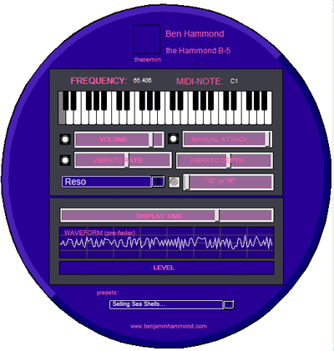
Synth Voice
The synth voice was the next logical extension of the BTAR beyond the MIDI voice. After learning the basics of MSP and digital audio in another class, I began constructing a monophonic synthesizer which contained all the usual controls; waveform selector, resonance, attack and decay, and again the ever useful presets to save your work. The basic waveforms available are sine, sawtooth, resonance-filtered noise, and an FM synthesis with equal volume harmonics.
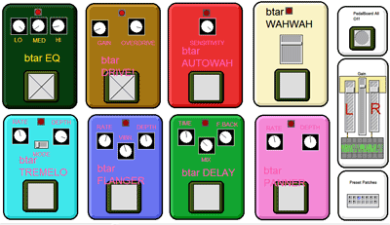
Effects Pedal Board
What is any guitar-like setup without a rack of stomp boxes? Since the signal coming in from the synth voice is already digital sound, it was easy to connect directly into an array of pedals to produce and even more exciting sonic landscape. The pedals are (in connection order): Wah-Wah, AutoWah (envelope filter), Overdrive (Distortion), 3-band EQ, Tremelo (AM Ring Mod), Flanger (Chorus), Delay (Looper), and Stereo Panner.
- 3 band EQ
Three peak-notch digital filters put together in parallel connections, which gives user EQ shaping in three differnt bands. Similar to an AMP style EQing.
- Overdrive
By shaping the wave in a non-linear fashion, the signal exceeds the alotted space and distortion (harmonic content) is created. The left knob also is a normal gain boost, to compensate for some of the other pedals weak intensities. This is the one you want to pay attention to, if you know ANYTHING about rocking.
- Auto-Wah (Envelope Filter) –
This pedal adjusts the frequency of filter in accordance with the intensity (e.g. louder equals higher frequency. This is a great effect for bassists in porno films). It consists of one band pass filter. This frequency is sweepable, and this gives the characteristic WahWah sound.
- WahWah Pedal
This pedal consists of one band pass filter. This frequency is sweepable, and this gives the characteristic WahWah sound.
- Tremelo
Modulating the Amplitude of the signal by a sine wave gives the surf guitar tremolo sound. By increasing the intensity and depth of the AM modulation, one can achieve synthesis effects by making two distinct tones, equally above and below the original tone. A switch is provided to have the given rate in a musical tremelo range, or a wacky AM range.
- Flanger
By taking a signal and running it through a comb filter, you change the timbral quality by boosting certain parts of the waveform and decreasing other. By varying this time sent to the all-pass, you get a flanging effect. The controls include RATE, VIBRATO (controls the feedforward amount) and the FLANGE DEPTH (controls the feedback amount). Everything can use a little flange...
- Delay
This patch has one tap out, after n samples, and also includes a direct line. One can adjust the blend between the two. It also includes a feed-back loop that determines how long the decay value is. Setting the FEEDBACK to highest value results in endless looping, which can be very exciting. Try and see! Try and see! Try and see! Try and see!
- Stereo Panner
This patch basically divides the mono signal into two channels, and pans back and forth between them. User controls the rate and depth of panning. This is the only pedal with two outputs.

III. Conclusion
Ultimately, the goal of this project has already been achieved, in that I have officially jammed with other musicians using nothing but my laptop and the BTAR software. Of course, the next step would be a jam where someone other then myself filled the BTAR Rockstar role, so if you decide to be the first, contact me and I’ll put your picture on the website. The entire project is built as a collective for PC, and also will be ported to MAC OS X, meaning any user can fire it up without ever installing a version of MAX or having to connect a single patchcord. This simplicity of setup, combined with a friendly interface, will hopefully entice users from a wide variety of musical and technological skills to get excited about music, with no money spent and no added frustration of squeaking reeds and confusing scales. Of course, the ultimate future of the BTAR is in your hands, and I strongly encourage you to download your own copy and write me back with suggestions for improvement. And with that, I leave you with the single most instruction on using the BTAR-3000… “ROCK ON!”

WORKS CITED

Hunt, Andy. MIDIGRID: Past, Present and Future.
www.music.mcgill.ca/musictech/nime/onlineproceedings/Papers/NIME03_Hunt.pdf . 2003.

MAX/MSP Externals – “Fiddle”. http://crca.ucsd.edu/~tapel/software.html.

Norman, Donald. The Design of Everyday Things. (New York: Doubleday,
1990), 1-34.

