COLLEGE INFRASTRUCTURE COMPLAINT PORTAL

A PROJECT REPORT

Submitted by

BENHER BASHEER

VDA23MCA-2015

To

The APJ Abdul Kalam Technological University
in partial fulfillment of the requirements for the award of the Degree of
Master of Computer Applications



Department of Computer Applications
College of Engineering Vadakara November 2024

DEPARTMENT OF COMPUTER APPLICATIONS COLLEGE OF ENGINEERING VADAKARA


CERTIFICATE

This is to certify that the report entitled COLLEGE INFRASTRUCTURE COMPLAINT PORTAL submitted by BENHER BASHEER (VDA23MCA-2015) to the APJ Abdul Kalam Technological University in partial fulfillment of the requirements for the award of the Master of Computer Applications is a bonafide record of the project work carried out by him under my guidance and supervision. This report in any form has not been submitted to any other University or Institute for any purpose.

Date:
Signature:
Name: Dr.Bindu S Mony

Internal supervisor
Signature:

Name: Fathima A
Head of the Department

DECLARATION

I undersigned hereby declare that the project report COLLEGE INFRASTRUCTURE COMPLAINT PORTAL, submitted for partial fulfillment of the requirements for the award of Degree of Master of Computer Applications of the APJ Abdul Kalam Technological University, Kerala, is a bonafide work done by me under the supervision of Dr. Bindu S Mony, Assistant Professor, Department of Computer Applications. This submission represents my ideas in my own words and where ideas or words of others have been included, I have adequately and accurately cited and referenced the original sources. I also declare that I have adhered to ethics of academic honesty and integrity and have not misrepresented or fabricated any data or idea or fact or source in my submission. I understand that any violation of the above will be a cause for disciplinary action by the institute and/or the University and can also evoke penal action from the sources which have thus not been properly cited or from whom proper permission has not been obtained. This report has not been previously formed the basis for the award of any Degree, Diploma or similar title of any other University.

Place: VADAKARA
BENHER BASHEER

Date: VDA23MCA-2015

Acknowledgement
My endeavor stands incomplete without dedicating my gratitude to a few people who have contributed towards the successful completion of my project. I pay my gratitude to the Almighty for his invisible help and blessing for the fulfillment of this work. At the outset I express my heartful thanks to Dr. Vinod Pottakulath, Principal College of Engineering Vadakara for giving me an opportunity to complete my project successfully. I extremely grateful to Fathima A V, Assistant Professor and HOD, Department of Computer Applications for permitting me to do this project. I take this opportunity to express my profound gratitude to Dr. Bindu S Mony, Assistant Professor, Department of Computer Applications, my guide, for her valuable support and help in doing my project. I am also grateful to all our teaching and non-teaching staff for their encouragement, guidance and wholehearted support. Last but not least, I am gratefully indebted to my family and friends, who gave me a precious help in doing my project.

BENHER BASHEER
VDA23MCA-2015

Abstract

The College Infrastructure Complaint Portal is an innovative web application designed to streamline the process of reporting, managing, and resolving infrastructure-related issues within college campus. Built using the MERN (MongoDB, Express.js, React.js, Node.js) stack, the portal facilitates efficient communication between students, administrative staff, and maintenance workers, ensuring a smooth resolution of complaints.

Students can easily report issues related to infrastructure or facilities by submitting detailed complaints through a user-friendly interface. Each complaint includes a title, description, relevant department, category (e.g., electrical, plumbing, carpentry, ragging), and optional media uploads for better clarity. The system provides a Student Dashboard for users to track complaint statuses, view complaint history, update their profiles, and provide feedback post-resolution.

On the administrative side, the Admin Dashboard allows staff to manage incoming complaints, assign tasks to appropriate workers, and oversee worker accounts and credentials. Maintenance workers access the Worker Dashboard to view their assigned tasks and update the status of ongoing work.

TABLE OF CONTENTS

SL. NO | CONTENTS |  |  | PAGE NO.
1. | INTRODUCTION |  |  | 1
 | 1.1 | BACKGROUND |  | 2
 | 1.2 | OBJECTIVE |  | 2
 | 1.3 | PROJECT DESCRIPTION |  | 3
2. | GENERAL BACKGROUND |  |  | 4
 | 2.1 | EXISTING SYSTEM |  | 5
 | 2.2 | PROPOSED SYSTEM |  | 5
 | 2.3 | MODULE DESCRIPTION |  | 6
 |  | 2.3.1 | ADMIN MODULE | 6
 |  | 2.3.2 | USER MODULE | 6
 |  | 2.3.3 | WORKER MODULE | 6
3. | METHODOLOGY |  |  | 7
 | 3.1 | AGILE SOFTWARE DEVELOPMENT |  | 8
 | 3.2 | SCRUM FRAMEWORK |  | 9
 | 3.3 | USER STORY |  | 9
 | 3.4 | SPRINT |  | 10
4. | SYSTEM ANALYSIS AND DESIGN |  |  | 13
 | 4.1 | DATA FLOW DIAGRAM |  | 14
5. | TOOLS AND TECHNOLOGIES |  |  | 17
 | 5.1 | MongoDB |  | 18
 | 5.2 | Express.js |  | 19
 | 5.3 | React.js |  | 19
 | 5.4 | Node.js |  | 20
 | 5.5 | Technologies |  | 22
6. | IMPLEMENTATION |  |  | 23

 | 6.1 | FRONTEND IMPLEMENTATION |  | 24
 | 6.2 | BACKEND IMPLEMENTATION |  | 24
 | 6.3 | DATABASE IMPLEMENTATION |  | 25
 | 6.4 | SECURITY AND DATA VALIDATION |  | 25
 | 6.5 | TESTING AND DEPLOYMENT |  | 26
7. | RESULTS AND CONCLUSION |  |  | 27
 | 7.1 | CONCLUSION |  | 28
 | 7.2 | SCOPE OF FUTURE WORK |  | 28
8. | REFERENCES |  |  | 30
9. | APPENDIX |  |  | 32
 | 9.1 | DATABASE DESIGN |  | 33
 | 9.2 | PROJECT IMAGES |  | 37
 |  | 9.2.1 | USER IMAGES | 37
 |  | 9.2.2 | ADMIN IMAGES | 39
 |  | 9.2.3 | WORKER IMAGES | 40

- INTRODUCTION

BACKGROUND
Efficient management of college infrastructure and facilities is essential to maintaining a productive and safe environment for students, teachers, and staff. Traditional methods of reporting issues, such as verbal communication or paper-based forms, are often inefficient, leading to delays in addressing problems. These challenges can disrupt daily operations, diminish user satisfaction, and negatively impact the overall learning experience.
With the increasing reliance on digital solutions to streamline processes, a centralized system for managing complaints has become a necessity. Such a system can simplify the reporting process, ensure transparency, and enable faster resolution of issues by automating complaint assignment and tracking. This project aims to address these challenges by providing a comprehensive software solution for managing complaints related to college facilities.

OBJECTIVE

The objective of College Infrastructure Complaint Portal is to develop a centralized complaint management system that enables students, teachers, and staff to easily report issues with college facilities. The system aims to streamline the reporting process, ensure transparency in complaint tracking, and facilitate timely resolution by automating work assignment and status updates, ultimately improving the efficiency and quality of campus maintenance.

PROJECT DESCRIPTION

This project involves the development of a web-based complaint management system designed for college campus. The system allows students, teachers, and staff to report issues related to infrastructure and facilities through an intuitive interface. Users can submit complaints by providing details such as title, category, department, description, and optional media uploads.
An admin dashboard facilitates efficient management by categorizing complaints, assigning tasks to relevant workers, and tracking their progress. Workers can access their dashboard to view assigned tasks and update the status of complaints. Additionally, students can monitor the progress of their complaints, provide feedback after resolution, and access their complaint history.

By integrating automation, real-time updates, and streamlined workflows, this system aims to enhance efficiency, accountability, and overall satisfaction in managing campus maintenance operations.

GENERAL BACKGROUND

EXISTING SYSTEM
Currently, the process of reporting and resolving issues with facilities is manual and inefficient. Complaints are often conveyed verbally, through handwritten notes, or via emails, leading to several challenges:
- Lack of Structure: Complaints are not categorized, making it difficult to prioritize or assign tasks effectively.
- Delayed Resolution: Without a centralized system, tracking complaints and ensuring timely resolution is cumbersome.
- Poor Communication: Students and staff are often unaware of the status of their complaints, resulting in frustration and lack of accountability.
- Limited Documentation: Verbal or paper-based systems lack proper records, making it hard to review past issues or analyze data for future improvements.
These inefficiencies highlight the need for a robust and streamlined digital solution that addresses the limitations of the existing system.

PROPOSED SYSTEM
The proposed system COLLEGE INFRASTRUCTURE COMPLAINT PORTAL designed to address the inefficiencies of the existing manual process. It provides a centralized and user-friendly solution for students, teachers, and staff to report issues related to college infrastructure and facilities. The system introduces an intuitive interface where users can submit complaints by specifying details such as the title, department, category, description, and optional media uploads.
The system includes a robust admin dashboard that allows administrators to categorize complaints, assign tasks to workers, and monitor the progress of each complaint in real-time. Workers have access to their own dashboard, where they can view assigned complaints and update their status upon resolution. Students and staff can also track the status of their complaints, access complaint history, and provide feedback once the issue is resolved.
By automating task assignment and providing real-time updates, the proposed system ensures timely resolution of complaints while enhancing transparency and accountability. The platform also maintains a centralized database of complaints, enabling efficient record-keeping and analytics to identify recurring issues and improve overall facility management. This digital solution is designed to create a more efficient, transparent, and satisfactory process for handling college infrastructure complaints.

MODULE DESCRIPTION

The platform will consist of three primary user modules: the Administrator, User , Worker
module.

    - ADMIN MODULE
- Login
- Add worker
- Worker Management
- Complain t management.

    - WORKER MODULE
- Login
- View/Edit Profile
- View and manage works

    - USER MODULE
- Registration
- Login
- Register Complaint
- Complaint History

METHODOLOGY

AGILE SOFTWARE DEVELOPMENT

Agile software development was chosen as the most suitable approach for this project due to its focus on client satisfaction through the continuous delivery of functional components. Agile methodology emphasizes delivering small, incremental requirements rather than attempting to complete the entire product at once. This is particularly advantageous for a project with various individual requirements, allowing for partial deliveries and iterative improvements.

One of the primary methods within Agile is the Scrum framework, which provides a structured yet flexible approach to managing complex product development. Rather than dictating specific processes or techniques, Scrum serves as a framework that enables the development team to utilize diverse approaches within each cycle. This framework supports lean software development and emphasizes efficient and effective software building. Agile is known for its adaptability, continuous improvement, rapid delivery, and emphasis on constant feedback, making it well-suited for dynamic project requirements.

In Agile development, testing and integration are ongoing processes rather than sequential stages. This allows users to make adjustments at any point during the development phase, enabling the customer to view and provide feedback on their product throughout its production. This adaptability is especially valuable in projects with evolving requirements, as it ensures flexibility and the ability to meet client expectations
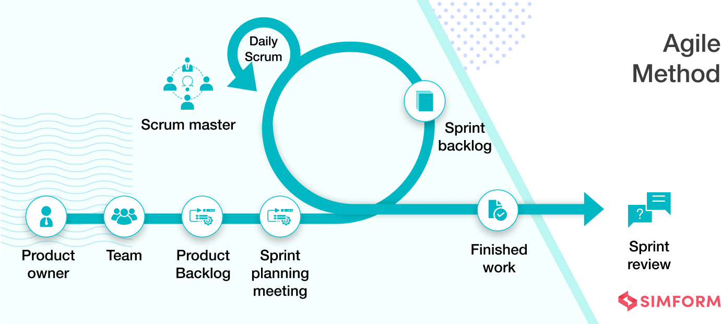

SCRUM FRAMEWORK

The Scrum framework is implemented in this project to facilitate team-based development and streamline the Agile process. Scrum focuses on three main roles, which together form the backbone of the development process:

- Product Owner (PO): Represents stakeholders and the business. The PO prioritizes the backlog to ensure the most valuable features are developed first.
- Scrum Master: Facilitates the Scrum process, removing any impediments that may slow down the team and ensuring that the team follows Agile principles.
- Development Team: A cross-functional, self-organizing team responsible for analysis, design, development, and testing. This team organizes itself to complete each sprint.

In Scrum, projects are divided into sprints, each representing a short, focused development cycle where specific goals are achieved. Sprints encourage rapid progress, as each sprint cycle requires the team to plan, set goals, and complete work within a defined timeframe. By focusing on one sprint at a time, the team can maintain high productivity and continually deliver increments of the project.

USER STORY

A user story is a core component of Agile development, focusing on the end-user experience. User stories prioritize people by centering development around user needs and real-world applications. Written in non-technical language, user stories help clarify the purpose of a particular feature and the value it will create for users. For the development team, this provides essential context and a shared understanding of the project’s purpose.

In Agile, a user story describes a feature from the end-user's perspective, answering key questions: Who will use it, what do they need, and why? User stories drive collaboration, foster creativity, and ensure that each requirement supports the user’s needs and the project’s goals.

SPRINT

A sprint is a fundamental concept in Scrum, representing a time-boxed period during which a set amount of work is completed. Each sprint typically lasts 1-4 weeks, allowing the team to focus on specific objectives and tasks within that timeframe. Sprint goals, determined during planning sessions, help the team stay focused on priorities and ensure continuous progress. With each sprint, the team delivers incremental project components, gradually building toward the final product.

Code | As a/an | I want to perform | So that I can
US1 | Admin | Log into the app securely | Access and manage the system effectively
US2 | Admin | Manage Workers | Add new workers and see updated Worker list.
US3 | Admin | Manage complaints | Manage complaints and assign them to workers.
US4 | User | Submit a complaint | Report issues related to infrastructure or facilities.
US5 | User | View my complaint history | Review past issues I have reported.
US6 | User | Securely log into the platform | Protect my personal and complaint data.
US7 | Worker | Log into the app securely | Access and manage assigned tasks.
US8 | Worker | View assigned complaints | Know which tasks to prioritize and resolve.
US9 | Worker | Update complaint status | Inform the admin and users about progress or resolution.

Scrum Agile User Stories

Milestones | Completion Date
User Stories Collection | 21/08/2024
Feature List Finalization | 15/08/2024
High level Sprint Planning | 28/08/2024
UI and Database Design | 07/09/2024
Sprint 1 | 15/09/2024
Sprint 2 | 25/09/2024
Sprint 3 | 03/10/2024
Sprint 4 | 15/10/2024
Sprint 5 | 25/10/2024
Major Milestones

Sprint Breakdown:
• Sprint 1: User Registration and Login
- Goal: Enable users to register, create accounts, and log in securely, including basic profile management functionality.
• Sprint 2: Complaint Submission
- Goal: Allow users to submit complaints. The complaint form will include fields like title, department, category, description, and an option for media uploads.
• Sprint 3: Admin Dashboard Setup
- Goal: Create an admin dashboard to allow the admin to view, categorize, and assign complaints to workers. Include functionality for managing worker profiles (add, update, remove).
• Sprint 4: Worker Dashboard Setup
- Goal: Develop the worker dashboard, enabling workers to log in, view assigned complaints, and update the status of each task (e.g., In Progress, Resolved).
• Sprint 5: Complaint Tracking and History
- Goal: implement a feature for users to view the status of their complaints in real-time and access their complaint history.

SYSTEM ANALYSIS AND DESIGN

DATA FLOW DIAGRAM
Data flow diagrams are used to graphically represent the flow of data in a business information system. DFD describes the processes that are involved in a system to transfer data from the input to the file storage and reports generation.

Level 0 DFD

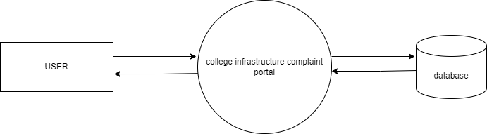

Level 1 ADMIN

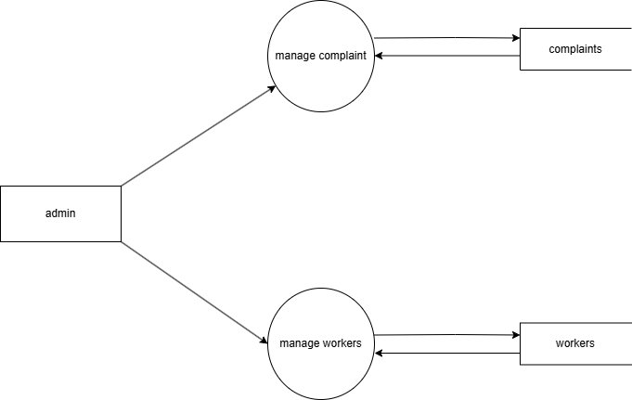

Level 1 USER

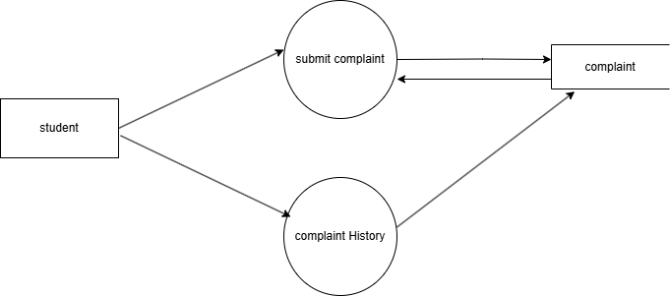

Level 1 WORKER

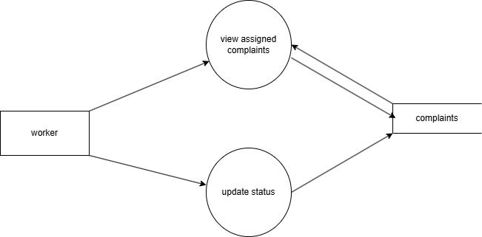

TOOLS AND TECHNOLOGIES

The development of the college infrastructure complaint portal leverages the MERN stack, a popular web development framework known for its efficiency, scalability, and seamless integration between frontend and backend components. The MERN stack consists of four key technologies:

- MongoDB
- Express.js
- React.js
- Node.js

Each of these technologies plays a critical role in building the application.

5.1 MongoDB

MongoDB is a NoSQL database that uses a document-oriented data model. In the MERN stack, MongoDB serves as the database layer, storing data in a format similar to JSON, which is intuitive for developers working in JavaScript.

- Document-Oriented: MongoDB stores data as BSON documents (binary JSON) which allows for flexible and hierarchical data structures, making it ideal for applications that require scalability and fast access to large volumes of data.
- Scalability: MongoDB is designed to scale both horizontally and vertically. It allows for data sharding, which enables the distribution of data across multiple servers to handle increased loads.
- Integration with Node.js: MongoDB is optimized for JavaScript environments, which makes it well-suited to work with Node.js for server-side operations. Using MongoDB, developers can perform CRUD (Create, Read, Update, Delete) operations on data without needing complex data transformation processes.

In the Sports Wear platform, MongoDB stores user data, product details, order history, and transaction records, supporting both structured and semi-structured data for efficient data handling.

Express.js

Express.js is a minimal and flexible Node.js web application framework. It serves as the backend application layer in the MERN stack, handling routing, middleware, and server-side logic.

- Routing and Middleware: Express.js simplifies the process of setting up server routes and integrating middleware to manage requests and responses. This is essential for a RESTful API structure where different routes can handle user authentication, product listings, and order processing.
- Efficient Handling of HTTP Requests: Express.js allows the application to respond quickly to client requests, handling HTTP methods such as GET, POST, PUT, and DELETE efficiently.
- Middleware Support: Express supports middleware functions, which enable seamless integration with various third-party libraries, such as authentication, logging, and request validation.

In the Sports Wear project, Express.js powers the backend API, which provides data to the frontend React.js interface. It manages business logic, handles database interactions, and secures routes for user authentication.

React.js

React.js is a JavaScript library developed by Facebook for building interactive and responsive user interfaces. In the MERN stack, React serves as the frontend framework, handling the client-side rendering of the application.

- Component-Based Architecture: React allows developers to build reusable components, making it easier to manage and scale the user interface. Components such as Product Cards, Shopping Cart, and User Profile ensure a modular, efficient design.
- Virtual DOM: React uses a Virtual DOM to optimize UI rendering by updating only the parts of the page that have changed, improving application speed and performance.

- State Management: React’s state and lifecycle management make it easy to create interactive and dynamic UI experiences. Libraries like Redux or Context API can also be used for more complex state management if needed.

React powers the Sports Wear platform’s interface, allowing users to browse products, add items to their cart, view order history, and perform secure checkouts, all with a smooth, responsive experience.

Node.js

Node.js is a JavaScript runtime environment that enables server-side execution of JavaScript code. Node.js serves as the backend runtime in the MERN stack, allowing for the execution of JavaScript on the server side.

- Non-Blocking I/O Model: Node.js operates on a single-threaded, non-blocking event loop, which makes it highly scalable and efficient, especially for applications with a large number of concurrent users.
- JavaScript Runtime: Node.js allows JavaScript code to run on the server, which means that both the frontend and backend of the application can be built using the same language, reducing complexity.
- Rich Ecosystem: Node.js has a vast package ecosystem, known as npm (Node Package Manager), providing access to a wide variety of libraries and tools that simplify development tasks.

In the Sports Wear platform, Node.js acts as the foundation for running the server-side code and supports Express.js to handle HTTP requests, interact with MongoDB, and
manage APIs for the frontend.

TECHNOLOGIES

Frontend:
- React.js - A JavaScript library for building dynamic, interactive, and reusable user interfaces.
- Tailwind CSS - A utility-first CSS framework for responsive design, making it easier to create custom UI elements.
- Vite - A fast build tool optimized for frontend development, providing a smooth development and build experience.
- React Router v6 - For managing navigation and routing, enabling seamless transitions between different pages.
- Axios - A promise-based HTTP client used to fetch and send data between the frontend and backend.
- JavaScript (ES6+) - The core programming language for handling frontend logic and interactions.

Backend:
- Node.js - A JavaScript runtime for executing server-side code, enabling fast and scalable backend processing.
- Express.js - A web framework for Node.js used to create RESTful API endpoints and handle server logic.
- MongoDB - A NoSQL database designed for storing data in flexible, JSON-like documents, suitable for high scalability.
- Mongoose - An ODM (Object Data Modeling) library for MongoDB, simplifying data validation and schema definition.
- JWT (jsonwebtoken) - Used to implement secure user authentication and protect routes.
- Multer - Middleware for handling image uploads, useful for product images and profile pictures.
- bcrypt - A library for hashing passwords, enhancing security in user authentication.

Additional Tools and Libraries:

- Nodemon - A development tool that automatically restarts the server when file changes are detected.
- dotenv - For securely managing environment variables, such as API keys and database credentials.
- CORS - Middleware to allow cross-origin requests, ensuring the frontend and backend communicate seamlessly.

IMPLEMENTATION

The implementation phase focuses on putting together the frontend, backend, database, and supporting infrastructure to create a functional e-commerce platform for sportswear. Each part of the application is developed and integrated to achieve a seamless and responsive user experience.

FRONTEND IMPLEMENTATION
The frontend of this project is developed using HTML, CSS, and JavaScript, focusing on creating a responsive, user-friendly interface. Below is a breakdown of the key components and steps involved:
    - Page Components: Separate components are created for each page and feature, such as Home, Product, Cart, and Checkout. React Router v6 is used for smooth navigation between these pages.
    - UI Design: Tailwind CSS is used to style components, ensuring a responsive layout that adapts well across various devices. Tailwind’s utility classes make customization straightforward, allowing for a polished, modern UI.

BACKEND IMPLEMENTATION
The backend is developed using Django and SQLite, ensuring efficient management of data and secure user interactions. Below are the major backend features:
    - API Development: RESTful API endpoints are created for various operations, such as product browsing, adding items to the cart, order management, and user authentication. Each endpoint is designed to return JSON data, enabling seamless communication with the frontend.
    - User Authentication: JWT (jsonwebtoken) is used for user authentication. Upon login, a token is generated, which the client stores and sends with each subsequent request, ensuring that only authenticated users can access certain features.
    - File Uploads: Multer is used for handling image uploads, particularly for product and profile pictures, which can be stored locally or managed via Cloudinary for scalable image storage.

DATABASE IMPLEMENTATION

MongoDB is used as the database, leveraging its flexibility and scalability for handling complex data types:

    - Schema Design: Mongoose is used to define schemas for the core entities in the system, such as users, products, and orders. Each schema enforces a structure on the stored data, such as fields for product descriptions, user details, and payment status.
    - CRUD Operations: Mongoose’s methods provide streamlined access to MongoDB, allowing efficient handling of Create, Read, Update, and Delete (CRUD) operations. Examples include fetching product details, updating cart items, and managing user profiles.

SECURITY AND DATA VALIDATION
To ensure data security and maintain integrity, the following measures are implemented:
To ensure data security and maintain integrity:
    - Password Hashing: bcrypt is used to hash user passwords, ensuring they are securely stored in the database and cannot be easily compromised.
    - Data Validation: Validator.js is used to validate and sanitize user inputs across both frontend and backend to prevent malicious data entry.
    - CORS: CORS (Cross-Origin Resource Sharing) is configured on the server to permit requests from the client application, enabling smooth data transfer between frontend and backend.

TESTING AND DEPLOYMENT

    - Continuous Testing: The agile methodology is followed with continuous integration and testing after each sprint. Postman is used to test API endpoints, ensuring reliability.
    - Deployment: The platform is deployed on cloud hosting services like Heroku (backend) and Netlify (frontend). Environment variables and secrets, managed through dotenv, are configured during deployment for secure and efficient service.

This implementation combines these tools and platforms to create a centralized, scalable, and user-friendly e-commerce platform designed to streamline the sportswear shopping experience while supporting small businesses.

RESULTS AND CONCLUSION

The implementation of the Complaint Management System effectively resolves inefficiencies in handling infrastructure-related issues within educational institutions. By providing a centralized platform, the system streamlines complaint submission, categorization, assignment, and resolution, ensuring a transparent and efficient process. Students and staff benefit from a user-friendly interface to report problems and track their status, while administrators gain powerful tools to manage complaints and monitor worker performance.

The platform's features, including secure data handling, real-time status updates, and role-specific dashboards, enhance user satisfaction and reduce administrative overhead. Workers can efficiently manage their tasks and update complaint statuses, ensuring timely and accountable resolutions. This system significantly improves the management of college facilities, fostering a more organized and responsive environment for all stakeholders.

CONCLUSION
In conclusion, the Complaint Management System addresses the major challenges of traditional complaint-handling processes by adopting a technology-driven approach. It provides a seamless and efficient platform for students, staff, administrators, and workers, ensuring accessibility, transparency, and satisfaction. By simplifying complaint submission, enhancing task management, and promoting timely resolutions, the system achieves its goal of improving the efficiency and reliability of facility maintenance. This solution serves as a sustainable model for modernizing complaint management in educational institutions, offering long-term benefits to all stakeholders and fostering a more responsive campus environment.

SCOPE OF FUTURE WORK
The Complaint Management System has significant potential for future improvements to enhance its functionality, scalability, and user experience. Some possible areas for future work include:
- AI-Driven Automation
  - Implementing AI to categorize complaints automatically based on content and keywords.
  - Using machine learning to prioritize complaints based on urgency and predict recurring issues.
- Mobile Application Development
  - Developing a dedicated mobile application for students, staff, workers, and admins.
  - Including features like push notifications for complaint updates and task reminders to improve accessibility and convenience.
- Feedback and Rating System
  - Introducing a feedback mechanism where students and staff can rate resolved complaints and provide comments on worker performance.
  - Allowing admins to analyze feedback for quality improvement and resource planning.
- Advanced Analytics and Reporting
  - Adding detailed analytics dashboards for admins to identify trends in complaints, worker efficiency, and recurring infrastructure problems.
  - Enabling the generation of custom reports to support data-driven decision-making and preventive maintenance.
- Real-Time Monitoring and Updates
  - Providing real-time updates on complaint resolution progress for users.
  - Enabling admins to monitor worker activity and task completion rates in real time.
- Enhanced Security Features
  - Introducing multi-factor authentication for secure login.
  - Implementing advanced encryption for complaint data to ensure user privacy and regulatory compliance.
- Scalability for Multi-Campus Use
  - Expanding the system to support multi-campus or multi-department setups.
  - Customizing workflows and complaint categories to meet the specific needs of different institutions.
- Integration with External Systems
  - Linking the system with other campus management platforms, such as attendance or resource management systems.
  - Automating notifications to relevant departments for quicker action on specific complaints.
- Gamification Features
  - Introducing rewards or recognition for workers based on performance metrics, such as timely complaint resolution.
  - Creating leaderboards to encourage healthy competition among workers.
- Offline Support and Syncing
  - Adding offline functionality for mobile apps to allow users to submit complaints without internet access.
  - Synchronizing data when the connection is restored.
These enhancements will ensure the system remains adaptable, user-friendly, and efficient, addressing future needs while providing a superior experience for all stakeholders involved.

REFERENCES

- Documentation and Tutorials

  - MongoDB Documentation: https://www.mongodb.com/docs/
  - Express.js Official Guide: https://expressjs.com/
  - React.js Documentation: https://react.dev/
  - Node.js API Reference: https://nodejs.org/docs/latest/api/

- Books and Other Resources

  - JavaScript: The Definitive Guide by David Flanagan – Covers JavaScript and core concepts used in the frontend.
  - Learning React by Alex Banks and Eve Porcello – A guide for developers on using React.js effectively.

- Software and Tools Documentation

  - GitHub Documentation: https://docs.github.com/ – Used for version control and project collaboration.
  - Postman API Documentation: https://learning.postman.com/docs/ – Essential for testing backend API routes.

- Project-Specific APIs and Libraries

  - Axios GitHub Repository: https://github.com/axios/axios – For handling HTTP requests on the frontend.
  - Razorpay Documentation: https://razorpay.com/docs/ – For handling local payment methods in India.

- Cloud and Hosting

  - Cloudinary Documentation: https://cloudinary.com/documentation – For handling image uploads and storage.
Heroku Documentation: https://devcenter.heroku.com/categories/reference – Used for cloud hosting of the backend API

APPENDIX

DATABASE DESIGN

1.Admin schema

email: {
type: String,
required: true,
unique: true,
},

password: {
type: String,
required: true,
},

2.User Schema

name: {
type: String,
required: true,
},
username: {
type: String,
required: true,
unique: true,
},
email: {
type: String,
required: true,
unique: true,
},
password: {
type: String,
required: true,
},

3.Worker schema

{
name: {
type: String,
required: true,
},
username: {
type: String,
required: true,
unique: true,
},
email: {
type: String,
required: true,
unique: true,
},
password: {
type: String,
required: true,
},
category: {
type: String,
required: true,
enum: ["plumber", "electrician", "carpenter"],
}
}

4.complaint schema

{
title: {
type: String,
required: true,
},
department: {
type: String,
required: true,
},
category: {
type: String,
required: true,
},
description: {
type: String,
required: true,
},
}

PROJECT IMAGES

USER IMAGES
HOME

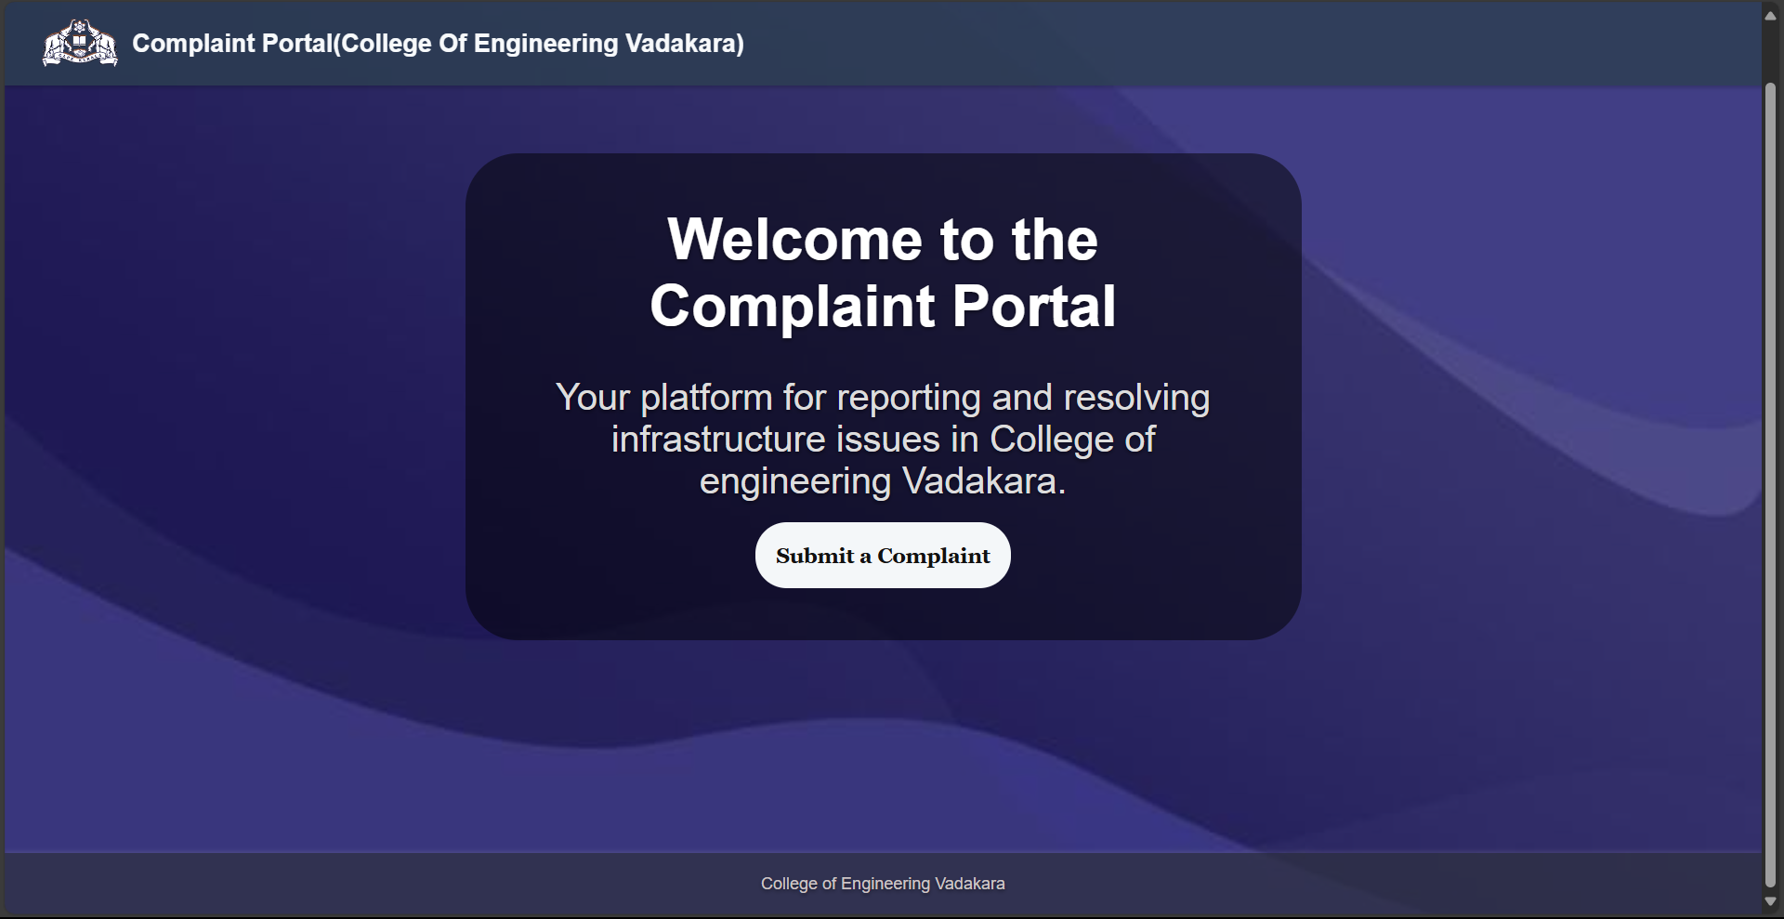

LOGIN

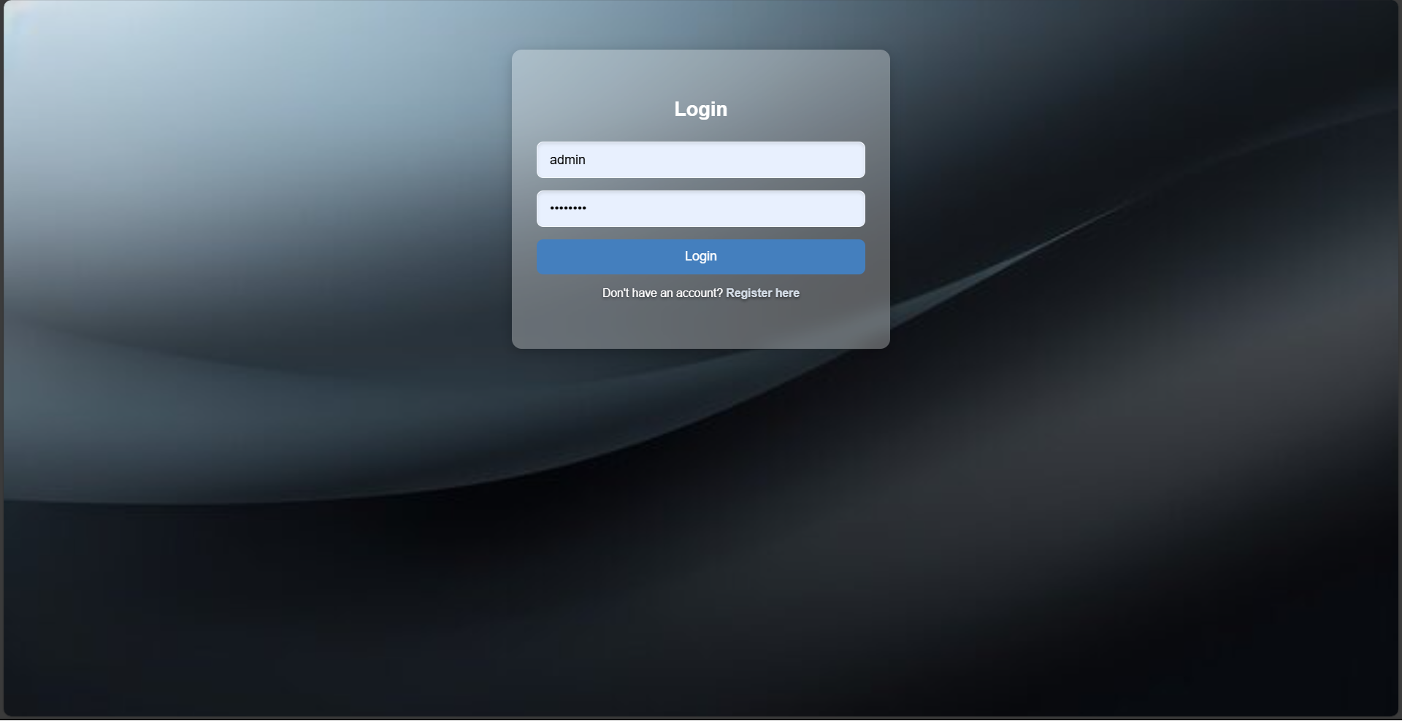

REGISTRATION

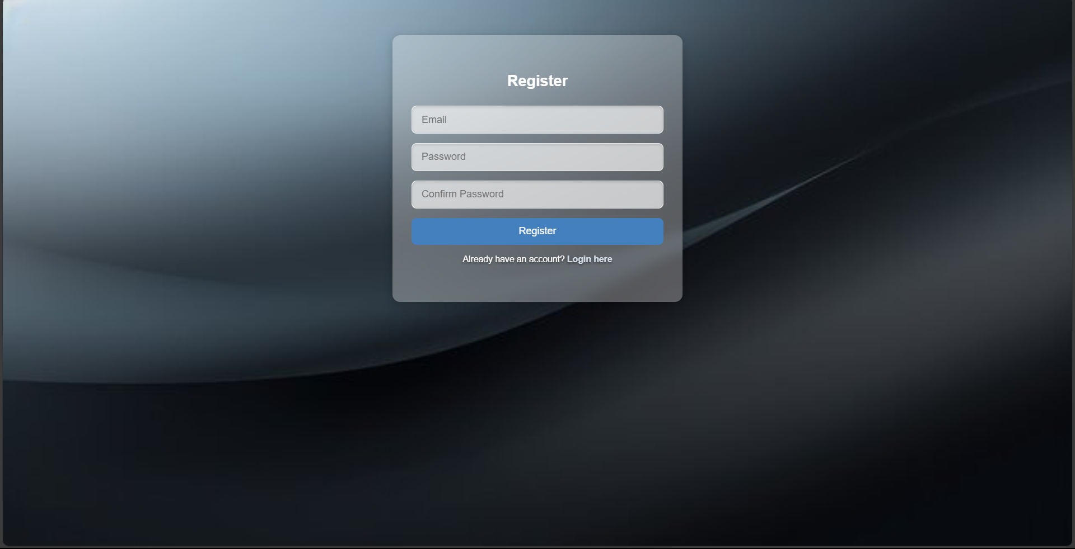

COMPLAINT FORM

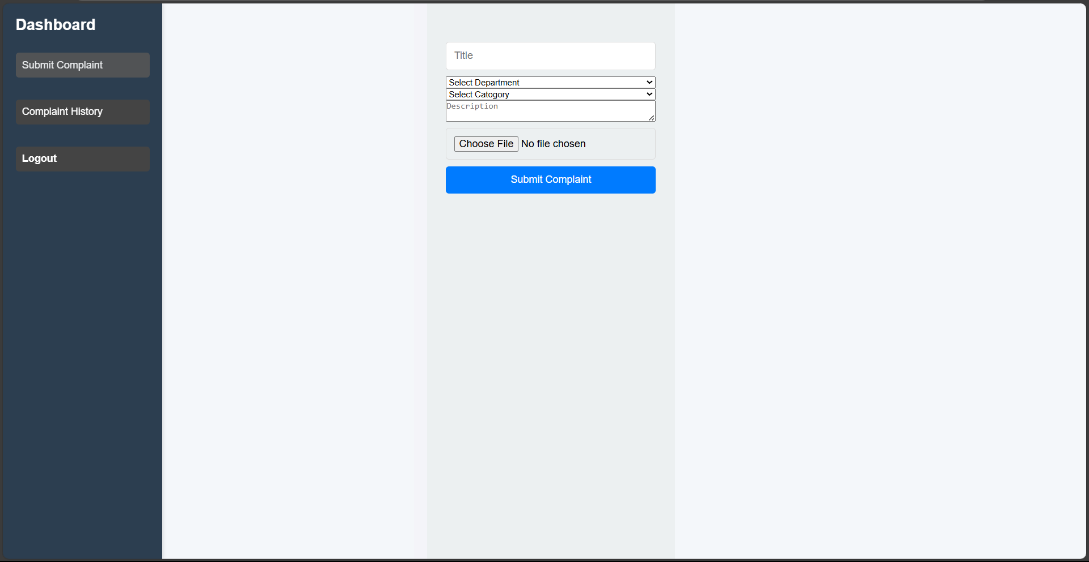

COMPLAINT HISTORY

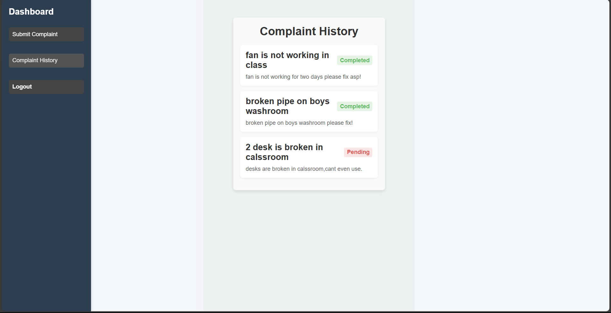

ADMIN IMAGES
COMPLAINTS

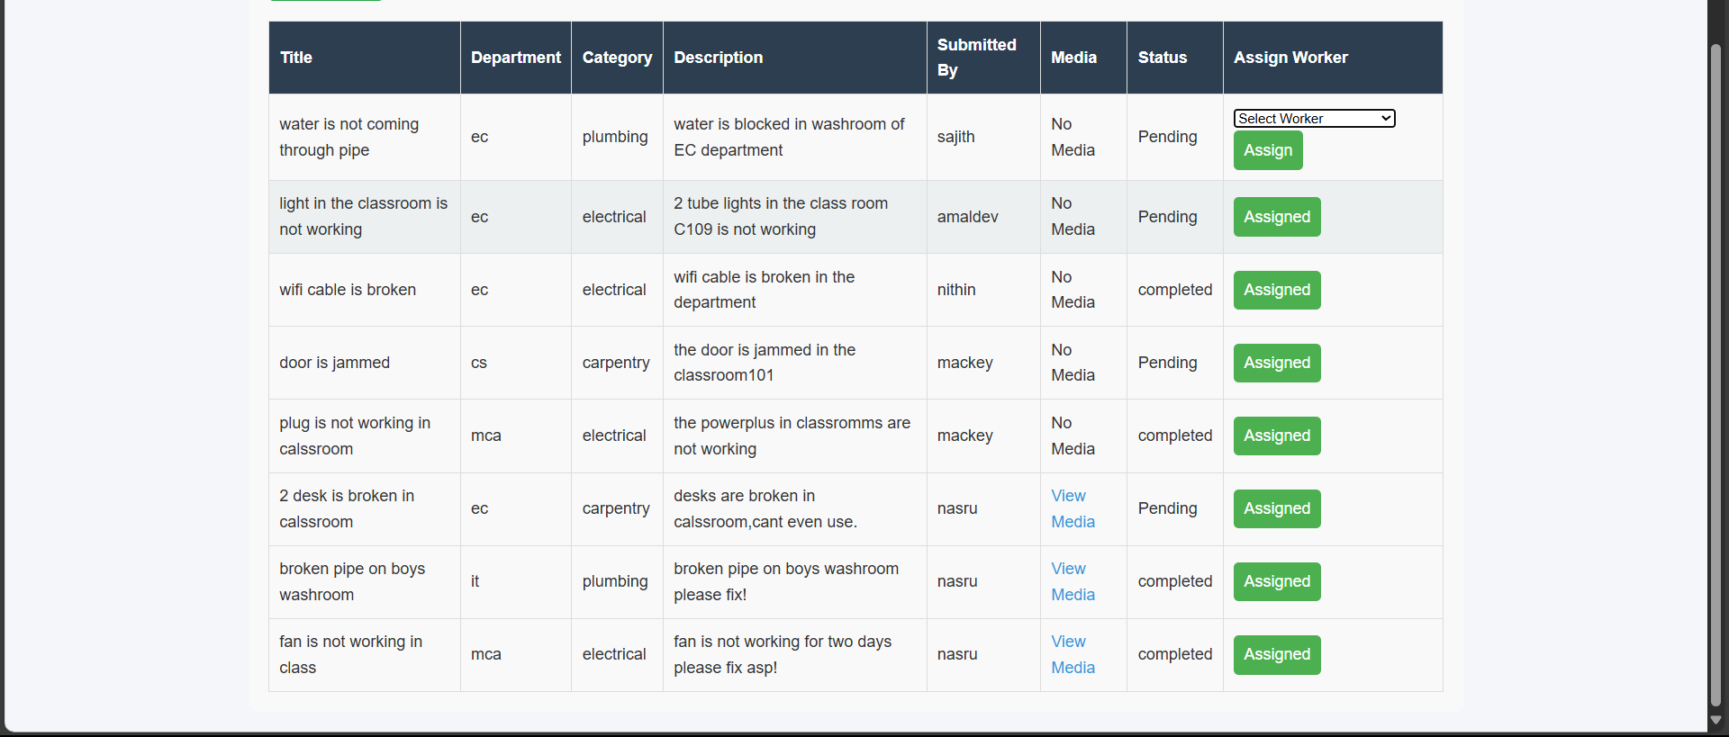

WORKERS

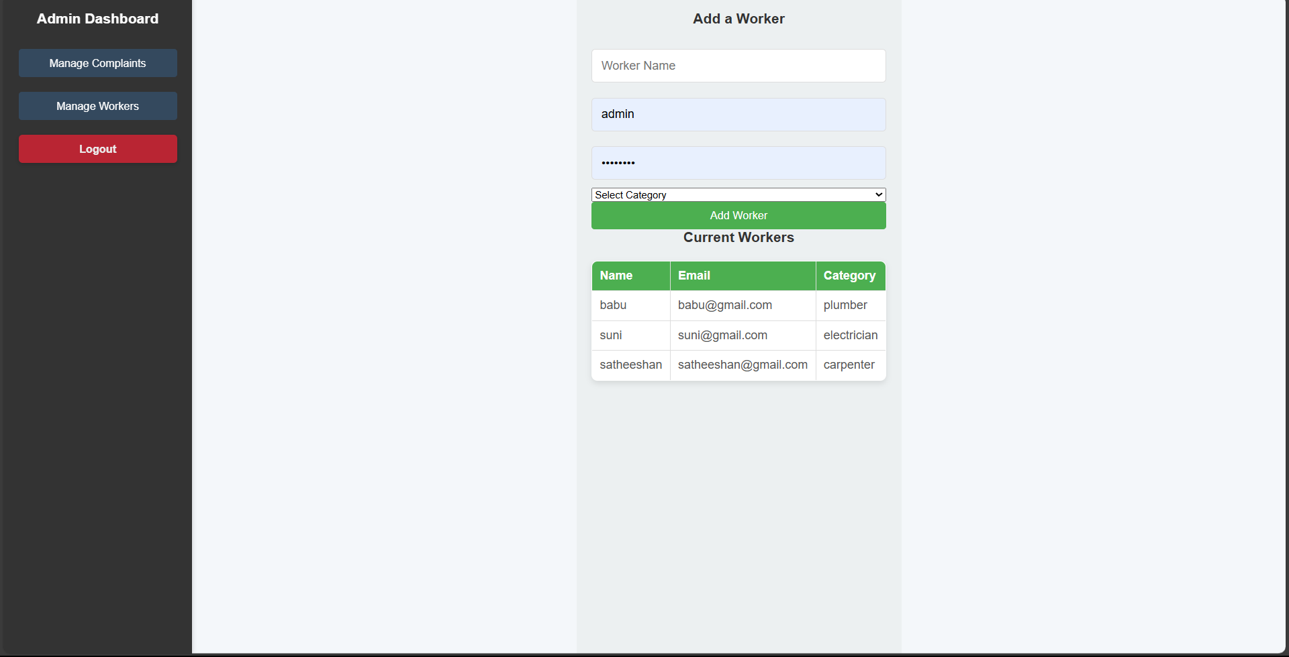

9.2.1 WORKER IMAGE

