Identification of the problem

In college, for the IT BTEC students, viewing progress is very difficult. Each student has to complete pass criteria 1-8 merit criteria 1-3 and distinction criteria 1 and 2. This obviously depends on what grade they are working towards. Each unit of work has a topic on the Collyers VLE, where you can select each piece of work. When you do this it takes you to an upload point, with a very brief description of what you have to complete to get a pass for this piece of work. When you upload the work, and when the teacher marks it, it displays the grade you have been given for this and some feedback.

For the teachers they are notified when a student uploads work, and then then have to mark the work and give an appropriate grade and matching feedback. They can see the grades that they have given for each student on a single upload point. The teachers then have to keep track of students work in excel documents on their local user accounts.

The problem is that viewing progress across the course is difficult from both ends, as a student I often find myself spending an extended period of time getting an overview of my own progress and marks received, and the teachers spend a long time transferring marks across to a spreadsheet of their own, then when the marks are sent to the head of subject, all the teachers have to combine their spreadsheets. Any inconsistencies including errors or spelling mistakes could have serious consequences.

A new system that combines the teacher’s spreadsheets and viewing progress for students would benefit everyone involved with the IT BTEC course, making the grading and checking of submitted work to be easier. A summary of progress across the course would let you know where you stand and what grades you are likely to achieve as a student. The teachers would also have the need for separate grading sheets eliminated, which would minimise the chance of any mistakes.

Initial interview
- What does the system need to do in general?
Students marks are currently recorded with the work submitted on the VLE. The mark is recorded and as pass/not pass/not submitted. Dependant on the teacher the marks are downloaded/transcribed into a spreadsheet. In the spreadsheet they are colour coded. This is how an overview for the students in generated. The students keep a copy also of their own personal progress. They transcribe the grades as they cannot download them. The current system is time consuming, the accuracy can be an issue due to human error and the students/teachers cannot see each other’s spreadsheets, and this causes confusion as the different students cannot see an overview of their work.

There is an overall tracking sheet for all students and all units. That shows the final grade achieved and the overall course. This does not include separate units. These grades are emailed from teachers to the head of unit to put into the sheet which is used to submit final grades to the exam board.
The new system needs to eliminate the need to manually copy marks from one system to another. Ideally it will rid of the spreadsheets and will give an interactive spreadsheet layout view on the website. There needs to be 3 views, student, teacher and head of subject. The students would need to be able to see their own work and no one else’s, but if this is not possible, the students can track their own and this can be a teacher only project.
The new system has to in keep with a spreadsheet kind of look to make the data as accessible as possible.

- What does the system need to work in parallel with, eg other systems in place or specific operating systems
The system needs to be able to run on windows 7 desktop. This is what is used at college and what most students run at home. More specifically it will have to be run in a web browser. The VLE system needs to be running alongside it, so that the new system will take data on a read only basis from the Collyers VLE Moodle.
- Is there a pre-existing web server and domain name in place, or will a new one be needed?
There is a domain and server in place under www.collyerstudent.biz. However the system would be best running from the local servers at the college. Probably on the same server as the Collyers VLE Moodle, it would be easier keeping everything together.
- Who will use the system?
The main users will be the BTEC students, all IT teachers and the head of subject, possibly the technician also alongside the IT Support staff. They will need database access also.
- Does the system need to be split into separate parts for different authorisation levels?
Yes, the system needs to have 3 levels of access. The Students will have to have one level where they can see their work, the Teachers where they can see their own classes progress and the Head of house and administrator levels where they can see all classes progress.
- Will the new system be phased in slowly, as testing, or will it replace the old system straight away?
The new system would have to be tested using another separate/backup copy of the Collyers VLE Moodle. It can run alongside that until we are happy that it works without bugs, which it can then be phased in and classes introduced to it.
- What security issues need to be dealt with? Eg any personal information and exam grades
The main secure information would be the grades that the students achieve, as some will not want that shown to everyone in the class. This means that students can see their own progress only, the teachers will have to see the students in their own class, and the Head of subject will be able to see all classes and students.
- Do any extra security measures need to be in place?
Password protection needs to be in place, where students and teachers can login using their college logins. This system must be secure and only accessible to current students.

Observation record
Description of current system
The current system is very basic and requires much unnecessary work. The students upload their work which is graded on the Collyers VLE Moodle. Feedback and grades are only available to see by students on the VLE.
The teachers however, once they have marked all of the work on the VLE, have to transcribe progress to a separate, local spreadsheet. Once they have done this for each student, across each unit of work, must be kept up to date every time a student re-uploads/amends a piece of work. At the end of the year, once the teacher has checked all of the grades they assigned are correct and up to date, have to email the spreadsheet to the head of subject. It is their job to port the information from each teacher’s spreadsheet to a main student tracking sheet where final grades are calculated. This tracking sheet is then sent on to the exams office where it is transcribed and sent to the exam board.
There are many problems with this system; the main, worrying one is human error. This could be from the surplus transcribing of grades. The other is the fact that it takes so long. The teachers simply do not have the time. A new system could also incorporate feedback displays with the grade and would have to eliminate all of the transcribing.

Student observations
Process | What I observed | Any problems
- Task for work is set on www.collyerstudent.biz | Students go to collyerstudent website to view task for the lesson and complete on their own or with help of teachers. | Website confusing layout and no way of seeing which tasks you have completed
- Student completes work and uploads to VLE | The student completes the work and uploads it to the VLE | Doesn’t hold full description of work set, and each grade given is spread out across the system, so difficult to see overall progress
- Teacher marks work | VLE shows list of submitted work and has the files uploaded a score box and feedback box. This is arranged by student in class | None
- Students review work | An email is sent by system to students saying the work has been marked and the students can view their marks and comments on the work | Each grade given is on a different page, which makes it difficult to see the overall progress.

Teacher’s observations
Process | What I observed | Any problems
- Task for work is set on www.collyerstudent.biz | Students go to collyerstudent website to view task the lesson and complete on their own or with help of teachers | Website confusing layout and no way of seeing which tasks students have completed or which course they have enrolled onto
- Student completes work and uploads to VLE | The student completes the work and uploads it to the VLE | None
- Teacher marks work | VLE shows list of submitted work and has the files uploaded a score box and feedback box. This is arranged by student in class. The marks and feedback given are recorded in the Moodle gradebook. | The moodle gives an overview for specific pieces of work. No way of seeing a compact view of progress via class.
- Teachers spreadsheets | The teachers transcribe the marks into an excel document of their own. These have the overall module grades for each student in a class | Transcribing causes errors (possibly?), and takes a long period of time, and will need to be updated regularly
- Sending of grades | The spreadsheets are sent to the head of subject. The head of subject then enters these into their own large spreadsheet of unit completion for each student. | Errors from before/new errors can miscalculate an overall grade, also very time consuming
10.Final grading | The final grades are sent from the head of subject to the exam board, the Collyers exams office, the registry and an email is sent to the student. | Any errors can cause big problems for overall grading for the course, and for students overall grades, possibly inhibiting future career and university applications. Could cause a low grade

Evidence
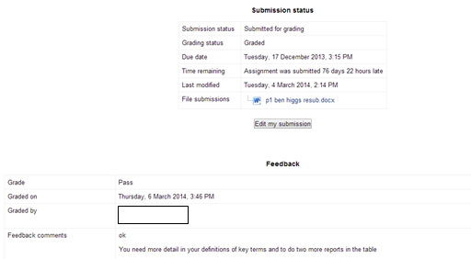
The above image shows the progress received on a piece of my own work.
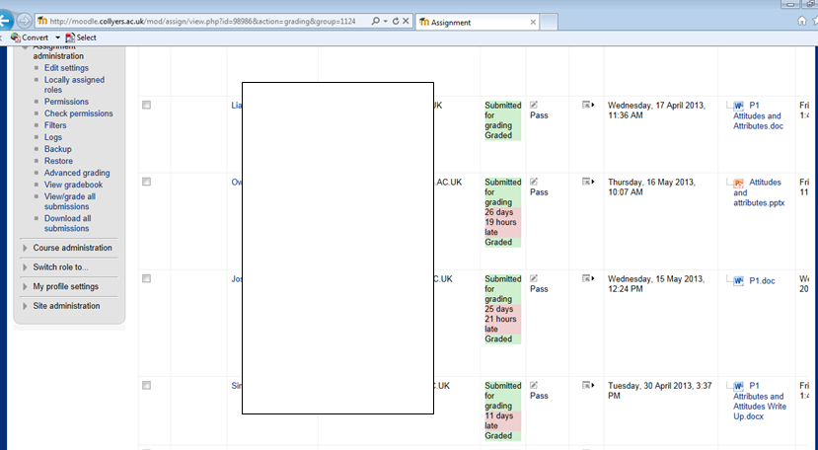
This is evidence of the making system on the VLE. You can see the feedback and grades given for each part of work and the submission itself.

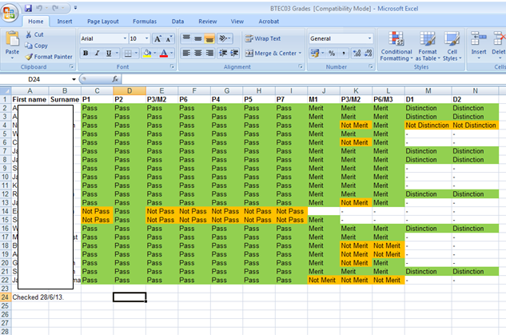
This is evidence of teacher tracking. This is based on each module in a unit. Here the teacher can see individual progress of each student.

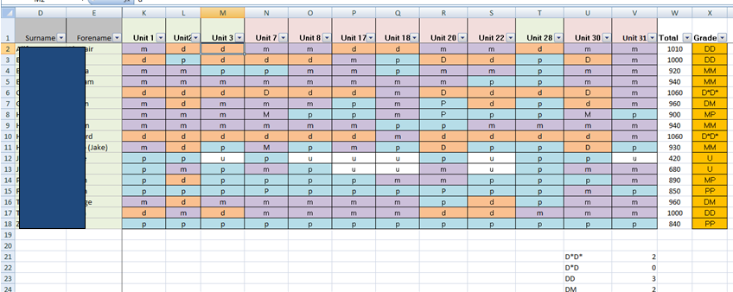
This is the head of subject tracking document. This allows the head of subject to view each student’s overall course progress and calculates the overall grades.
What did I find out?

I discovered that the teachers have a very long winded way of sending grades and data to the head of subject, and that every teacher has their own way of laying out their spreadsheets. This makes it difficult for the head of subject to transcribe and input into the subject tracking spreadsheet. I can now see the dire need for a new, more efficient system.

Document Collection/Analysis

Document | Purpose | Observations
Teacher tracking spreadsheet | The teacher is able to record progress on a modular basis. | The tracking sheets can contain mistakes when manually entering details, the marks are also for a single unit. No feedback details are present either
Head of subject tracking spreadsheet | The head of house is able to record progress on a unit basis. | The tracking sheet can contain mistakes and also does not show individual modules and only units.
Teacher view of Moodle upload site | The work is there to download, feedback panel and marking box | The teachers can download the work and mark it and record the progress themselves

Research methods
I had to use an interview to find out as much information from my client as possible. This was the best way possible to provide a personal and factual interface between myself and my client. It meant that i could structure my questions appropriately.
The client told me all about the current system, how it works and all that was good, but mostly bad about it. This included everything about the teacher tracking sheets and how they are sent around to the head of subject. I also found out about many possible errors and just how much that the work is checked and checked again to avoid these.
The interview, and also the collection of documents that i collected helped me choose how to base the new system, and what would work best for my client and the college for the current situation.

Data sources and destinations
The data is currently stored as database entries for raw grades on the VLE, they are also stored as Microsoft Excel spread sheets. This allows the users to keep local copies of data, but means that they must be constantly updated. This will be different for the new system where there will need to be more data stored.
Data Volumes
There will be a lot of data stored for the new system, many new data items will need to be created as well as old ones from the previous system used.
The system will connect to the Moodle database, so data items such as the feedback and progress, which would have been in vast quantities, will not need to be stored.
New ones will need to be stored though, usernames and passwords, Moodle Ids (so data can be referenced from the moodle databases), teacher ids, class ids, students in each class, teachers per class, head of subject and administrator and class names . These will need a fully functional database set up to handle the quantity of data. This would be most effective because i will not need to write to text documents, which could easily be corrupted.
Data dictionary for current system
Field name | Purpose | Type | Example
username | The users unique college username | String | 12higgsbr44
Class name | The classes name | String | F-TEA
Student grade (piece of work) | The students grade for the piece of work and feedback | String | Not pass, incomplete submission
Student grade(unit) | The student grade for the unit | Character | M
Student grade(course) | The student grade for the course | Character | D
Student name | The students first and second name | String | John Doe
Email address | The students email address | Email, string followed by @domain name .com | 12doej99@collyers.ac.uk
Feedback | The feedback given for a piece of submitted work | String | “Not merit – There simply isn’t enough description”

Data flow diagram of current system
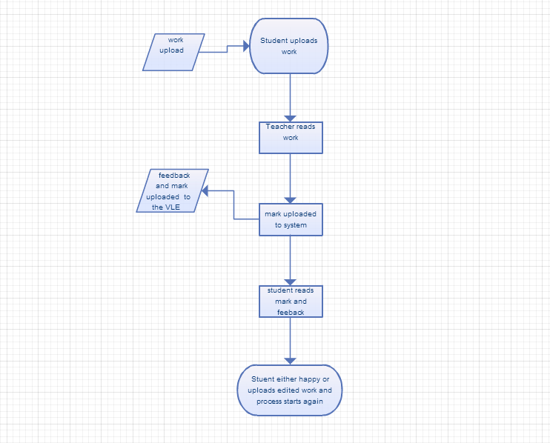
This is a data flow diagram for the upload and marking of work to the VLE

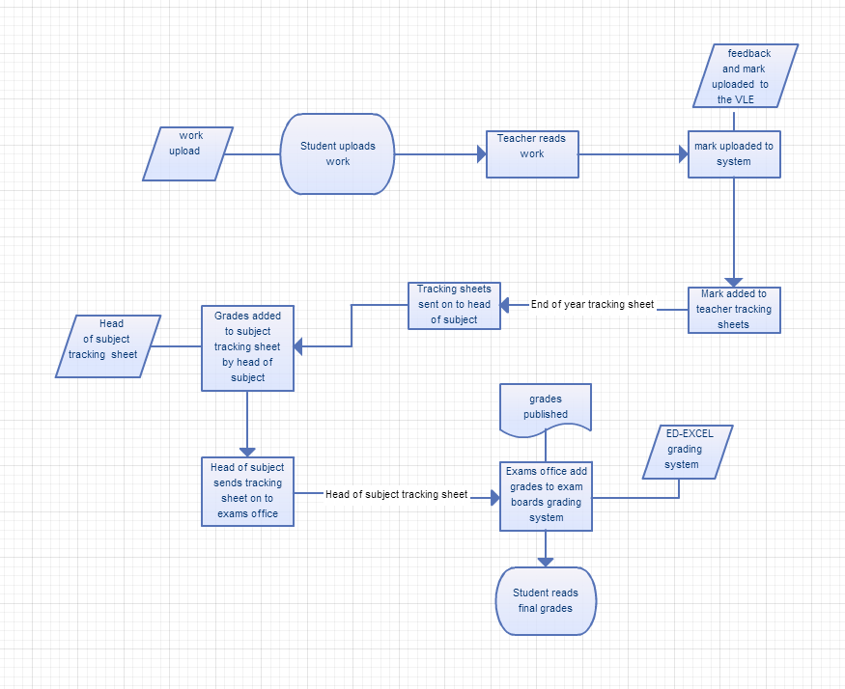
This is a data flow diagram of how work is marked, and how the marks are sent around departments at college.

Identifications of user needs and acceptable limitations
There are many problems that may occur in the future to do with the college and the way the course is structured. This means the system will need to be adaptable.
Admin/Head of Subject users
These users need to have access to each and every record that the system can and will ever possibly output. This means that they must have access to each class view to be able to see each student’s progress. They should also have privileges to manage classes, which will have to include adding teachers and students to class lists.
Limitations of these functions may be a change in head if subject or administrator, which will have to be kept as a list somewhere within the code or in the database.
Teachers
These users need to have access to each of their class member’s data; they should be limited to only classes that they teach. They should have limited options to choose from.
Limitations of this may include the promotion or demotion of a teacher; they may change class or gain new classes. They may also gain students in their classes.
Students
These users need to have access to their own personal data. They should also have limited options to choose from.
Limitations of these aspects may be a change in class or password. The student may also leave the course, so will need to be removed from the system.
General usage
Limitations for the overall system design may include a change of personnel, students, course layout and new units for the IT course.
Constraints for the system shouldn’t include hardware or software, as students should have an up to date computer to access the system from. It may include unfamiliarity with the system, that work has not been graded on the VLE and the fact that teachers and admin may require a session of being taught how to use the system, especially head of subject/admin.

End Users
The users of the system will be:
Students
Teachers
Head of subject

There will be different views available for different levels of authorisation.
The students will get a basic student view, where they can see only their progress. They will be able to see their own progress on a modular and unit basis.
The Teachers will get a teacher view, where they can see everything they need to and view classes and overall progress for every student on a modular and unit basis.

All users should have knowledge of how to use the system basically. It will be a very self-explanatory and easy to navigate system. The home screen should provide a description of how to use the system. All users will have competent IT skills and should use computers on a regular basis. It is safe to assume this because they are either teaching or completing the IT BTEC course at college.
The system will be a website, so hopefully, users will be able to connect from wherever they like, which makes the website more accessible, and if they do suffer from any kind of impairment such as visual impairment, the settings are done through their browser and not the website, this will mean that the website is not over complicated in design because otherwise the browser will not fully understand the layout. The chosen colour scheme should be viewable and not hard to see the text underneath. It should also fit in with the other Collyers sites.
The users will all have a user account, which will be their Collyers login. And they will not need training on how to use the site; however a user guide will be created taking a potential user through detailed navigation and all error messages, so they understand how to login and use the options that will be presented.
The data will not be entered directly into this system, as this system will have access to the Moodle gradebook file, and will be able to extract the necessary data automatically.

Potential solutions
 | Option 1 | Option 2 | Option3
Programming language | Python with extensions  Python would be good as it’s a language that I am already familiar with and it has web extensions and CGI support or has a good console that helps you as you code.  It is not so good at providing a web platform as a CGI bin would need to be setup. | HTML and PHP  HTML and PHP would be good as I know HTML and PHP is a simpler language to pick up. It is also well known for its support of phpmyadmin and sql queries.  I do not know PHP, so would have to spend time learning this language as I code the project. | HTML and JavaScript  HTML and JavaScript would be good as i know html and JavaScript provides interactivity between the user and the web pages, offering interactive content.  I do not know JavaScript, so would have to spend a while learning this more complicated language.
Data storage | Local files stored or exported as a common exe file.  This would be good as no files will need to be loaded from online, and would be safer.  This would be a bad choice as it would be only accessible from school computers | Web server with a phpmyadmin database  This would be good as it would be accessible anywhere in the world as long as they have internet access. Phpmyadmin would be a good sql choice as it is easy to use and manage
interface | A local program with a set layout.  This would be good as everyone in college would have access to it without opening a web browser  This would be bad because the program would be accessible only at college. | A web interface, with set layout and options.  This would be good because it would fit in with the college websites, the system would also be accessible anywhere with web access.  This would be bad because there would be limited options | A web layout that is fully customisable.  This would be good because it would provide users the chance to customise their website. The system would also be accessible anywhere with web access.  This would be bad because it will not fit in with the college websites.

Justification of chosen solution
I have chosen option 2 from my list of possible solutions.
My system needs to be an online feature, this would be best done in a common, and efficient language that is designed for online features. This limits my options to 2 and 3. My preferable language to learn would be PHP. This is because it is a good language to learn, and is fairly simple and similar to Python, a language that I am already very familiar with.
Data storage for both of the remaining options is the same, a phpmyadmin database would be setup and used for this. I feel that this is the most appropriate option for setup and storage of data. This would also be the same as the Collyers Moodle database, so all queries would be very similar.
The interface of the systems would have to be online and would have to fit in with the other Collyers college sites. This leaves me with a choice, customisability or a fixed layout and output. For the task in hand, i have chosen to go with the fixed layout and outputs. This would work best for me because it is simpler to script, there will be no JavaScript bugs and it will enforce uniformity across outputs and display features of the system. This fits in with the existing Collyers sites.

Proposed objectives

These are the objects that I and the client set at the interview process.

These objectives were edited by me, to make sure they had an appropriate and measurable objective.

Number | Objective | How it will be measured
1 | The system should be linked to the VLE gradebook and automatically take data from this source | Screen shots showing data being outputted on the system being identical to that on the VLE
2 | The system should ask the user how they wish to sort the data the system takes and then display this | Screen shots showing options for display, such as class and teacher views
3 | The system should run on a remote web server without need for maintenance | Screen shots showing the system located on a web server
4 | The system should run in any web browser on windows 7 operating system | Screen shots showing the system running on different web browsers and on windows 7
5 | The system should have a specific set of drop down boxes and options so that it easy to use and no incorrect values can be entered | Screen shots showing options and drop down boxes where possible, so no key values are entered
6 | The system must be able to hold more than one user at one time | Screen shots showing multiple users on the system at the same time
7 | The system should be secure and delete any entered passwords or fields on exit | Screen shots showing the code that clears all fields on logout
8 | The system should show all progress in a form of a table so that it is easy to read and copy if needed to into a spreadsheet | Screen shows showing the layout of progress tables and the css class that defines them
9 | The system should require a log on when accessed and should divert different users to different places | Screen shots of the login system working and the user being taken to the correct home page
10 | The system should fit in with the design of the other school websites, e.g My progress and the Moodle | Screen shots comparing the system to the other websites and feedback from my client on whether it fits in
11 | The system should eliminate the need for tracking documents for teachers and students. | Feedback from my client confirming that the system would eradicate the need for teacher tracking documents.
12 | The system should personalise the content that it displays for each different user. | Screen shows showing the personalisable content on different accounts, showing that
13 | The system should show teachers the whole classes progress | Screen shows showing the teacher class view.
14 | The system layout and design should be user friendly and accessible to everyone, including the colour blind | Screenshots showing the user friendliness of the system and the accessibility of it
15 | The system should show users their own progress for a selected unit of work | Screen shots showing the students progress across different units
16 | The system should create a small summary table showing users their overall progress across a unit of work | A screen shot showing one of these summary tables for a specific user and unit of work
17 | The system should know who the head of subject and administrator is so that it can show them specific content | Screen shots showing the defined head of subject and admin variables and showing their homepage
18 | The head of subject and administrator should be given a different list of options and should have more power than the teachers and students | Screen shots showing the varied options that the head of subject and administrator are presented with in comparison to the other users options
19 | The Head of subject and administrator should be able to see all classes progress | Screen shots showing that all classes are viewable for this class of users
20 | The system should have a way of managing classes and adding and removing students from them | Screen shots showing the set up of classes in the admin/head of subject options and the database entries for class setup

