Hobart Basketball Performance Summary (2019–2025)

# Executive Summary

This chapter provides a visual and statistical overview of Hobart Basketball's team performance, spanning from the 2019 to 2025 seasons. This document focuses on wins/losses over the past 5 years, breaking down success both by month and opponent, and lastly identifying some efficiency measurables. These visuals highlight dominant home performances, month-by-month win percentages, and shooting efficiencies both by Hobart and their opponents. Insights are supported with graphics for clarity and professional presentation.

*\*These graphs were made with the assistance of TheBricks and ChatGPT*

# 1. Overall Record (2019–2025)

With a total of 135 games played from 2019 – 2025, The program accumulated 90 wins and 45 losses across six seasons, yielding a win percentage of 66.7%.

# 2. Home vs. Away Win %

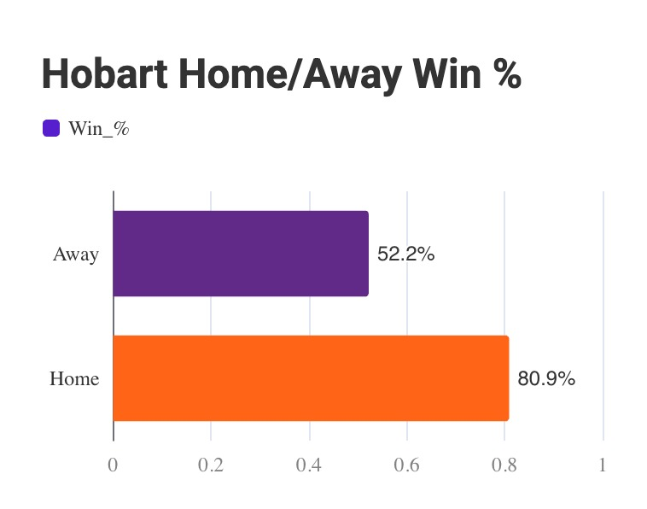

A stark contrast between home and away games highlights a significant home-court advantage with an 80.9% home win rate.

*\*Away games = true away & neutral site contests*

# 3. Home Advantage

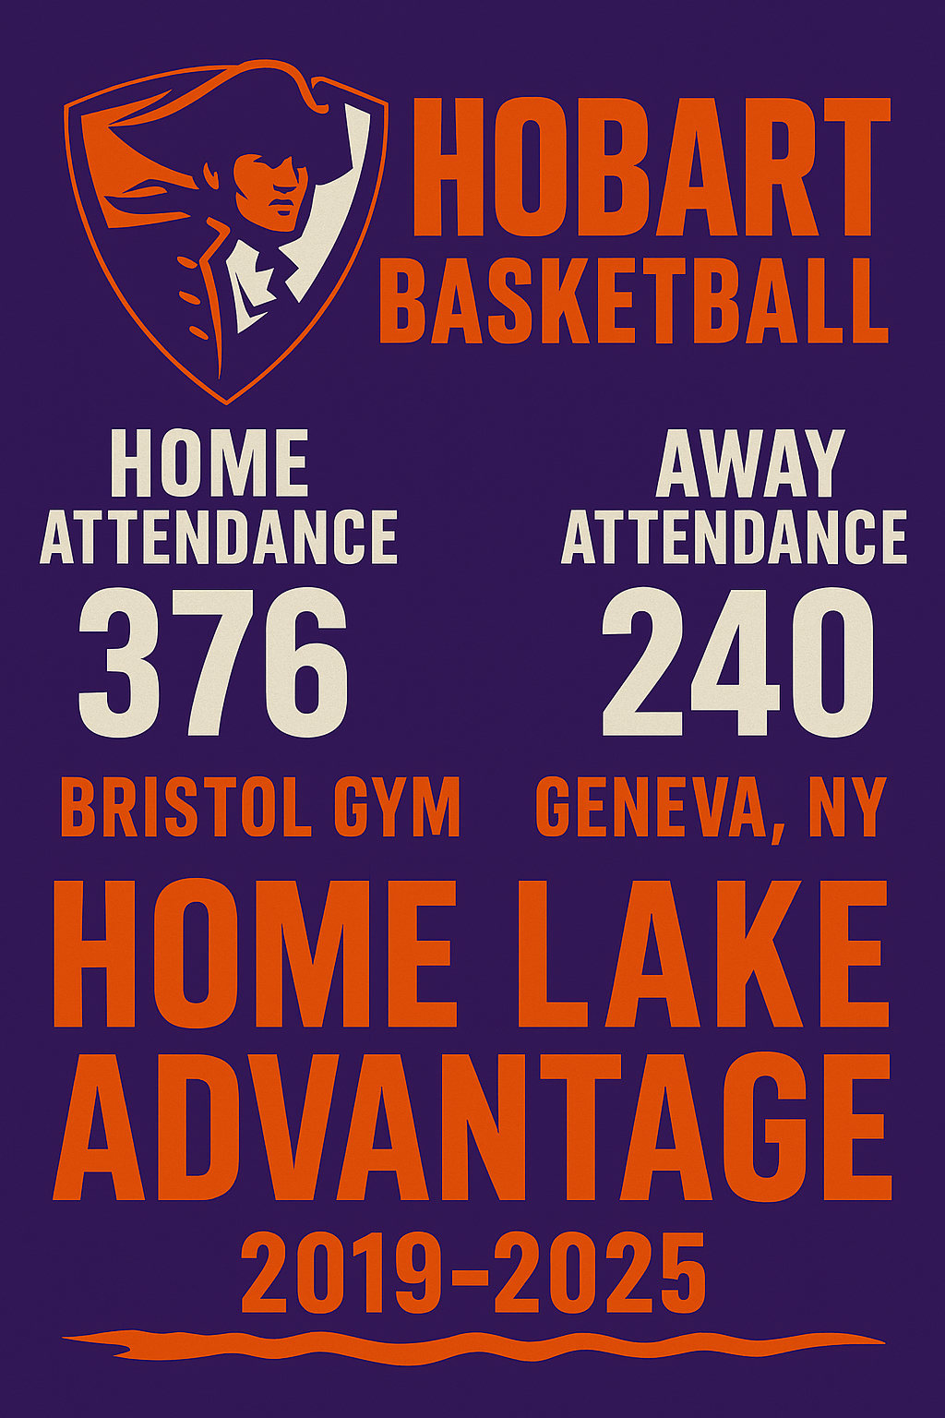Part of the success at home can be attributed to the large attendance that Hobart receives. Over the last 5 years, Hobart has averaged 376 people for their games, compared to the 240 they see as an average on the road.

# 4. Conference vs. Non-Conference Win %

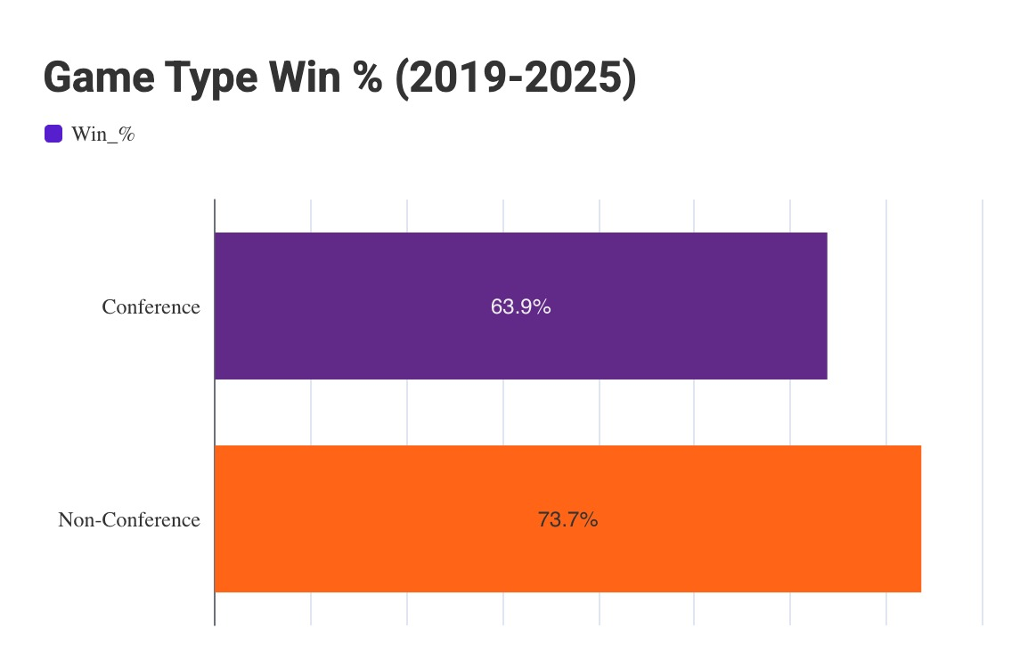

The team excelled in non-conference play with a 73.7% win rate compared to 63.9% in conference games.

# 5. Monthly Win % (2019–2025)

December shows a significantly higher win percentage (73.7%) compared to the next closest months, November and March.

# 6. Hobart Monthly Efficiency

This chart highlights Hobart's shooting trends by month, showing consistency in FG%, 3PT%, and FT% with a peak free throw percentage of 75.4% in March. Aligning with the monthly win percentage, December leads all months in FG% (46.1%).

# 7. Opponent Monthly Efficiency

Defensive performance is showcased through opponent shooting stats. Hobart consistently held opponents below 43% from the field. Holding true for the successful month of December, teams are a low FG percentage of 39.5%, and FT percentage of 65.2%.

# 8. Most Hobart Wins & Losses

It’s important to explore which teams Hobart has had the most success against, as well as which teams have proven to be the most difficult opponents. By doing so, we hope to identify the programs that have consistently struggled against Hobart, but even more importantly, identify the programs that Hobart can possibly focus more effort towards defeating in future matchups.

# Conclusion

The 2019–2025 era under Head Coach Stefan Thompson reflects a strong and consistent period for Hobart Basketball. With a **66.7% overall win rate** and standout performances both at home and in non-conference play, the program has demonstrated its ability to compete and win across varying contexts. The pronounced **home-court advantage**—driven in part by higher attendance and fan support—has made Bristol Gym a tough environment for visiting teams, contributing to an impressive **80.9% home win percentage**.

Performance by month offers additional insight, with **December emerging as a peak period** for both efficiency and wins. The team’s shooting metrics align with their success, especially their **free throw percentage in March (75.4%)**, a time of year often associated with high-stakes games. Defensively, Hobart’s consistency is clear, as opponents were regularly held under 43% shooting from the field—further validating the team’s focus on limiting high-quality chances.

Finally, analyzing Hobart’s most frequent wins and losses by opponent offers an important lens for both celebration and strategy. Recognizing the teams they've consistently beaten reinforces what’s working, while identifying recurring challenges provides a roadmap for future improvement.

This chapter tells a story of a program with a strong foundation, clear areas of strength, and the potential to elevate even further through targeted growth. The combination of **statistical awareness and performance analysis** ensures Hobart Basketball is positioned not only to reflect on success—but to build on it.