III. PRODUCT AND TECHNOLOGY

1. Product overview
The product is a street-litter monitoring system that combines fixed cameras with artificial intelligence (AI). It continuously tracks the amount of litter lying in the surrounding area and the condition of the storm-drain inlet, shows the results on a web map, and gives early warnings of locations at risk of local flooding caused by litter blocking the drain. The target users are environmental-service companies and urban-management agencies, who need information that is simple, easy to understand and immediately usable to dispatch collection crews.
For each monitoring point, the system answers three questions:
- How badly is the drain inlet blocked by litter? — the drain blockage level (%), reduced to three easy-to-read states: low, watch, needs cleaning.
- How much litter is in the surrounding area? — the area litter level, graded into four levels from low to critical.
- Where is the litter and how large is it? — litter zones are drawn directly on a real map (longitude, latitude) together with an estimated area in square metres (m²).
The indicators are aggregated per road and combined with rain forecast data to determine the alert level. The scope of this version is daytime, fair weather, one camera monitoring one drain inlet and the road surface around it. Cameras capture roughly one image per minute and the drain state is smoothed over time, so the system provides periodic monitoring and early warning, not flood forecasting.

2. System architecture
The system has four layers: image capture, central processing, AI analysis and display (Figure 1). The guiding principle is that the AI analyses the original image; its output is then “translated” into numbers and into positions on the map.
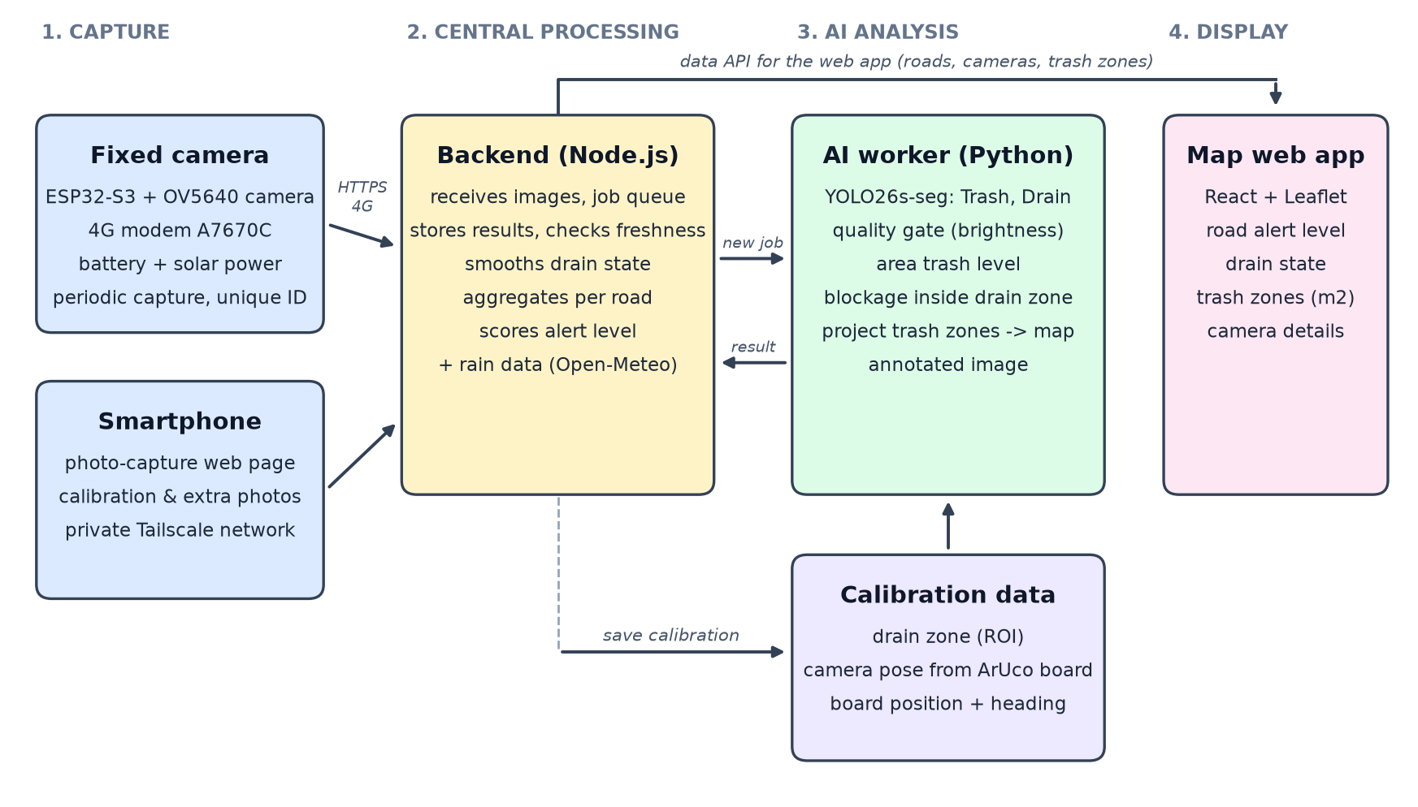
Figure 1. Overall system architecture
Table 2. System components
Component | Function | Technology
Fixed camera | Captures images periodically (~60 s apart) and sends them to the server with a unique capture ID so that re-sent images are not duplicated; retries automatically when the network drops | ESP32-S3, OV5640 camera, 4G modem A7670C, battery with solar power
Smartphone | Supplementary capture channel: calibration photo during installation and verification photos | Web photo-capture page, private Tailscale network, access code
Backend | Receives images, manages the analysis queue, stores results, checks data freshness, smooths the drain state, aggregates per road, scores the alert level | Node.js, atomic JSON storage, role-based API keys
AI worker | Fetches new images, checks quality, detects trash and drains, computes indicators, projects trash zones onto the map, produces the annotated image | Python, YOLO26s-seg, OpenCV
Calibration data | The fixed drain-inlet zone (ROI) and camera pose of each site, created once at installation | ArUco marker board, calibration tool
Map web app | Road map, alert levels, drain state, trash zones (m²), image and details of each camera | React, TypeScript, Vite, Leaflet, OpenStreetMap
Weather | Raises the alert level when rain is expected or under way | Open-Meteo

Data flow: (1) a camera captures an image and sends it over 4G via HTTPS; (2) the backend stores the image and creates an analysis job; (3) the AI worker polls for new jobs every few seconds, downloads the image, runs the model, computes the indicators and projects the trash zones onto the map using that camera’s calibration data; (4) the backend receives the result, uses only results that are newer and within 15 minutes, and updates the smoothed drain state and the road alert level; (5) the map web app periodically fetches the data and displays it. Every step tolerates re-delivery (idempotent), so a network outage or a restart never corrupts or duplicates data.

3. Core technologies

3.1. Trash and drain detection by image segmentation
The system uses the YOLO26s-seg model (instance segmentation) with two classes: Trash and Drain. The model does not merely draw boxes; it marks the exact pixels of each object, which makes area measurement possible. The training dataset (Try1) contains 1,948 training images, 552 validation images and 272 test images, split by group (images from the same capture session or the same source image always fall in the same split) to avoid data leakage; images are normalised to 1024 px and images containing drains are oversampled. The model always runs on the original, unmodified image — the domain it was trained on; all geometric operations are applied only to its output.

3.2. Area litter level
The area litter level is the fraction of the frame covered by trash (%), mapped to four levels with thresholds of 1 / 5 / 10 / 20 % (low, medium, high, critical). The thresholds were calibrated against the real data distribution. Once a camera has been calibrated with the marker board (Section 3.5), the system also provides the trash area in m² and the position of each trash zone on the map.

3.3. Drain blockage measured in a fixed zone (ROI)
The conventional method uses the “drain” region that the model can see as the denominator. Its weakness is that when litter completely covers the drain, the model can no longer see the drain and the indicator becomes “no value” — exactly when the situation is most dangerous. Because the camera does not move, the system outlines the drain-inlet zone once on a clean image (the AI proposes an outline, the installer reviews it and then accepts it). From then on:
Drain blockage = area (Trash ∩ Drain zone) / area of Drain zone × 100%
A fully covered drain can still be measured. Each time the zone is redrawn a new version is created, and measurements taken under an old version are never mixed with those of the new one.

3.4. Temporal smoothing and quality control
Single-frame measurements fluctuate because of passers-by, vehicles or shadows, which makes alerts “flicker”. The system takes the median of the last 5 measurements (at least 3 are required) and then changes state using hysteresis thresholds: entering a higher level requires exceeding a high threshold, while leaving it requires dropping below a lower one (Table 3).
Table 3. Drain state transition rules (smoothed value v, %)
Current state | → Needs cleaning | → Watch | → Low
None / unknown / Low | v ≥ 50 | 20 ≤ v < 50 | v < 20
Watch | v ≥ 50 | 12 ≤ v < 50 | v < 12
Needs cleaning | v ≥ 35 | 12 ≤ v < 35 | v < 12

- Data older than 15 minutes, or a camera that has lost its connection, is shown as “unknown” and is never defaulted to “safe”.
- Image quality gate: an image that is too dark (mean brightness below 40/255) is flagged as “unusable” instead of producing a misleading number.
- The model’s confidence score is used only as a reference label, never to reject results, because the old confidence measure decreases as an image contains more trash — that is, it would discard exactly the most important images.

3.5. Locating trash zones on the map with an ArUco marker board
This technology turns “where the trash is in the image” into “where the trash is on the map and how many square metres it covers”. When installing a camera, the installer lays an ArUco marker board (a printed sheet of known physical size; by default A3 with a 250 mm code area) flat on the ground within the camera’s view and takes one calibration photo (Figure 2).

Figure 2. The ArUco marker board printed on A3 (with a 100 mm check ruler and a field for the measured size)
Processing steps:
- Camera pose: the software detects the four corners of the board with sub-pixel accuracy and solves a PnP problem (the IPPE method for planar targets) to determine where the camera is, how high it is and which way it faces relative to the board. The lens field of view is read from the image metadata (EXIF) when available.
- Link to the map: the installer enters a single number — the real side length of the board measured with a ruler — and marks the board’s position and heading on the map. A preview shows the ground area visible to the camera so that the installer can check it by eye before saving.
- Automatic projection of every later image: each pixel of a trash region becomes a viewing ray from the camera, which is intersected with the ground to give metric coordinates around the board; these are rotated by the board’s compass heading and converted to longitude and latitude. Region outlines follow the exact pixel edges, so areas are not underestimated.
The single quality rule: if the shortest side of the board in the image is smaller than 50 pixels, the system refuses to calibrate and asks for a closer photo or a larger board. This threshold was derived from the experiment in Section 5.4. The required board size is estimated by S ≥ 50·D / (616·cos θ), where D is the camera-to-board distance and θ is the viewing angle off the board’s normal; an A3 board works well within about 2–3 m, while cameras mounted farther away use a larger board (the print tool generates boards of any size and picks a suitable paper size).

3.6. Aggregating alerts per road
The backend combines the cameras with fresh data on the same road (taking the mean, together with the maximum value and the number of cameras counted), scores the road’s severity, and raises it by one level when the rain probability is 50% or higher, or rainfall is 0.2 mm/h or more. Each road also carries a summary of its drain states and the worst-affected camera, so that collection crews know where to go first.

3.7. Safety and reliability
- Re-sending never creates duplicate data (unique capture ID); files are written atomically, so data is not corrupted by a power loss in mid-write.
- Role-based API keys (admin, device, AI); the worker downloads images only from allow-listed addresses (protection against SSRF attacks).
- The setup page is reachable only through the private Tailscale network, requires an access code, and limits repeated wrong attempts.

4. User guide

4.1. Installation and calibration (once per camera)
- Mount the camera in a fixed position facing the drain inlet and the surrounding road surface; focus it carefully (a blurry image is the most common cause of failed calibration).
- Outline the drain zone: take one image while the drain is clean; the tool proposes an outline of the drain inlet, and the installer checks the preview image and confirms.
- Print the marker board: print on A3 at 100% scale (turn off “Fit to page”); verify with the ruler printed on the sheet; measure the side of the black code area and write it down; mount the sheet on a rigid board and lay it flat on the ground within the camera’s view.
- Take the calibration photo with the same camera (or with a smartphone fixed in place, using the photo-capture page).
- On the setup page: Step 1 choose the photo, enter the measured board side and press “Detect board”; Step 2 mark the board’s position on the map and drag the arrow to the heading of the board’s +Y edge; Step 3 compare the ground area visible to the camera with reality, then press “Save calibration”. The board can then be removed.

4.2. Daily operation
- Open the map web app: each road is coloured by alert level; drain icons show three states — Low / Watch / Needs cleaning; “Unknown” means there is no fresh data and the camera should be checked.
- Click a camera to see the latest annotated image, the litter level, the drain blockage level and the capture time.
- Trash zones appear on the map (the latest in red, earlier ones in amber); click a zone to see its estimated area.
- Send collection crews first to the roads with the highest alert level, especially when rain is forecast.

4.3. Supplementary capture with a smartphone
The smartphone joins the organisation’s private Tailscale network, opens the photo-capture page and enters the 6-digit access code (once). The page has two large buttons: “Capture calibration photo” (sends a photo containing the board for the setup step) and “Capture trash photo” (sends a photo for immediate analysis; the result appears on the phone and the map updates within a few seconds).

4.4. Operating notes
- Do not move the camera after calibration; if it is bumped or re-aimed, it must be calibrated again.
- Photos taken with a smartphone must keep the same position and orientation (portrait/landscape) as the calibration photo; do not send photos through messaging apps (they are compressed and lose lens information).

5. Testing and evaluation
All criteria were fixed before the experiments were run and were not adjusted after seeing results; results that failed are reported as well. Table 4 summarises the experiments.
Table 4. Summary of experiments
# | Experiment | Data | Conclusion
5.1 | Model detection capability | 552 Try1 validation images | Precision 0.64, recall 0.44 — baseline, needs improvement
5.2 | Drain-blockage metric: fixed ROI vs. previous method | 76 annotated drains | PASSED all 4 criteria
5.3 | Temporal smoothing | 76 drains × 20 simulated frames | Flicker clearly reduced; error not improved
5.4 | Robustness of ArUco board detection | ESP32-like synthetic images, 1–12 m | Yields the 50-pixel rule
5.5 | Position and area accuracy | Synthetic objects of known size, 1–8 m | Position PASSED; area met after improvements at ≤ 2 m
5.6 | Software testing and performance | Automated tests, real images | PASSED all
5.7 | Field test with a smartphone | Objects placed at ruler-measured positions | to be filled after measurement

5.1. Model detection capability
Data and measurement: The 552 validation images of the Try1 dataset (not used for training); measured on the segmentation masks with standard metrics: precision, recall, mAP50 and mAP50-95.
Criteria: No pass/fail threshold; the purpose is to establish the model’s baseline capability so that the downstream mechanisms can be designed accordingly.
Results: mAP50 = 0.459; mAP50-95 = 0.246; precision = 0.638; recall = 0.438 (version baseline_v1_rev2, better than the previous version’s mAP50 of 0.445).
Remarks: When the model reports trash it is mostly right, but it misses a considerable amount of trash (recall below 50%); on some street images we tried, it missed trash in about two thirds of the images. This is currently the largest limitation. The fixed-ROI and smoothing mechanisms (Sections 3.3 and 3.4) are designed so that the system remains useful even when the model is imperfect; improving the model is the main direction for further work (Section 7).

5.2. Drain blockage with a fixed zone (ROI)
Data and measurement: 76 drain inlets from the validation and test sets, with hand-drawn ground truth. The previous method (M0, denominator = the drain region seen by the model) was compared with the ROI method (M1) under three image conditions: original image (C0), ESP32-like heavily compressed image (C1, the main condition) and a condition closer to real ESP32 images (C2). We measured the mean absolute error (MAE, in percentage points), the number of drains with “no value”, the number of severe misses (a heavily blocked drain reported as light or missing), and the sensitivity when the ROI is drawn 10% off.
Criteria: (1) M1 has no missing value on heavily blocked drains; (2) MAE of M1 ≤ M0; (3) the number of severe misses of M1 < M0; (4) a 10% ROI shift increases MAE by no more than 5 points. All must hold on both the pooled set and the test set alone.
Table 5. M0 vs. M1 (condition C1, pooled set of 76 drains)
Metric | Previous (M0) | Fixed ROI (M1)
Drains with no value | 47 / 76 (61.8%) | 0 / 76
Heavily blocked drains with no value | 16 / 18 | 0 / 18
MAE on the set where M0 has a value (n = 29) | 8.36 points | 6.04 points
Severe misses | 18 | 14
MAE increase when ROI is shifted 10% | — | −0.07 points (no increase)
Results: All four criteria PASSED on the pooled set and on the test set; condition C2 (closer to real ESP32) also passed all four, with an MAE of 4.34 points (M1) versus 9.37 (M0).
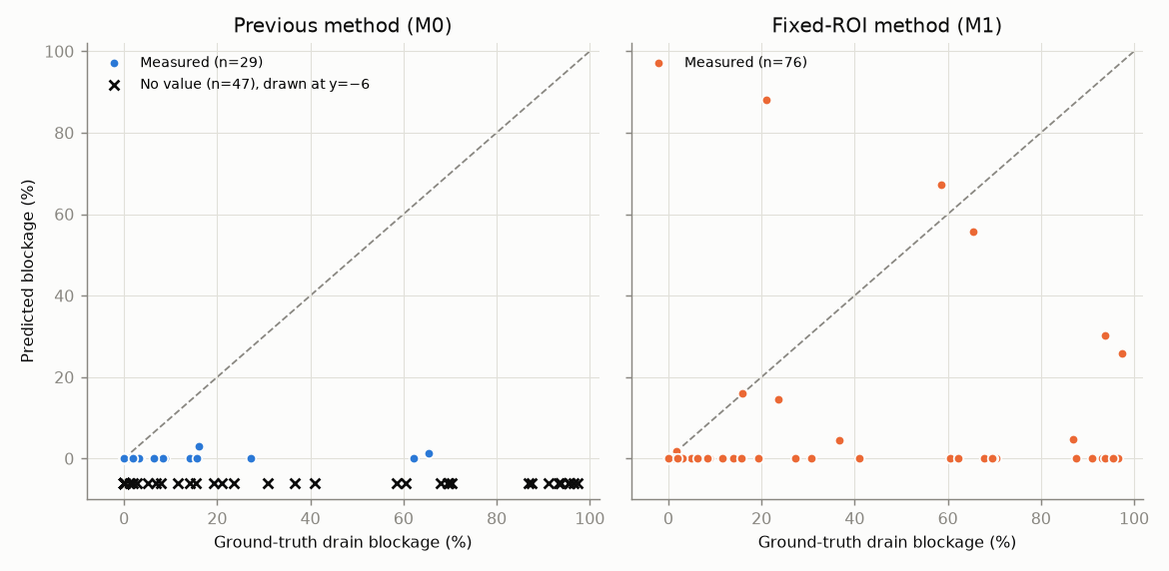
Figure 3. Ground truth vs. predicted drain blockage: previous method (left, × marks drains with no value) and fixed-ROI method (right)
Remarks: The ROI method completely removes the “no value” failure — the most dangerous one because it occurs exactly when the drain is covered — and tolerates an imprecisely drawn zone. The remaining error comes mainly from the model missing trash. Limitations: a small sample (76 drains), and the ROI was taken from the ground truth, so it is an upper bound on the accuracy that a hand-drawn zone would achieve in the field.

5.3. Temporal smoothing
Data and measurement: A simulated series of 76 drains × 20 frames with image noise, temporary occlusions and step changes in blockage; evaluated from frame 5 onward. Raw values (S0), the 5-frame median (S1) and the median with hysteresis thresholds (S2) were compared.
Criteria: (a) the number of state changes of S2 ≤ 50% of S0; (b) MAE of S1 ≤ S0; (c) state accuracy of S2 ≥ S0; (d) when blockage jumps, the red state appears exactly at the 3rd frame.
Results: (a) PASSED — state changes fell from 84 to 2; (b) not met on the pooled set (21.21 vs. 21.18) but met on the test set; (c) PASSED — 71.1% vs. 70.1%; (d) PASSED — a delay of 3 frames, as designed. Overall conclusion: no conclusion on error.
Remarks: Smoothing achieves its design goal of preventing alert flicker with a small, known delay. It does not reduce error because about 95% of the error is a systematic bias of the model (missed trash), which smoothing cannot correct.

5.4. Robustness of ArUco board detection
Data and measurement: 640×480 synthetic images resembling the ESP32 camera: distances of 1–12 m, viewing angles of 20°/45°/65°, JPEG compression from high to very low quality, plus blur and noise; 10 repetitions per condition, with ground-truth camera pose. We measured the board detection rate, rotation error and camera-position error.
Criteria: A condition is “safe” when ≥ 90% of trials simultaneously: detect the board, have a rotation error ≤ 2° and a position error ≤ 10% of the distance. The minimum board size N is the level from which all size bins reach “safe”.
Results: A 200 mm board is detected ≥ 90% of the time up to 5 m (angle ≤ 45°), but pose accuracy is the real breaking point: with sub-pixel corner refinement the “safe” condition holds up to roughly 2–3 m. Lens blur is the most damaging disturbance; JPEG compression matters little. The reprojection error cannot distinguish a correct pose from a wrong one. The data yield N = 50 pixels (Figure 4).
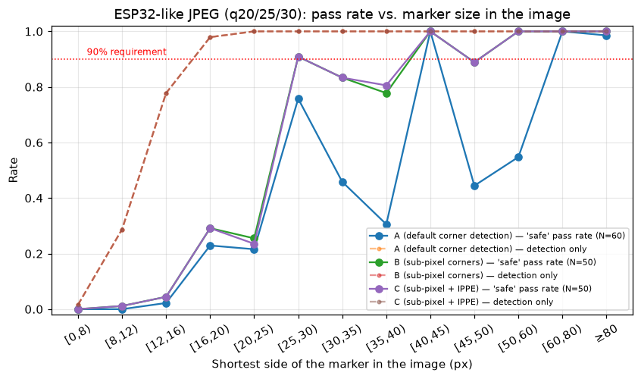
Figure 4. “Safe” pass rate versus the shortest side of the board in the image (ESP32-like compression)
Remarks: The size of the board in the image is the deciding factor. The product therefore adopts sub-pixel corner refinement plus the IPPE method, blocks calibration when the board is below 50 pixels, and chooses the board size per camera distance instead of adding complicated conditions. Careful focusing is essential during installation.

5.5. Position and area accuracy of trash
Data and measurement: 640×480 synthetic images containing flat objects of known size (squares of 0.1–0.5 m, a 1.0×0.3 m rectangle, a Ø0.4 m circle) placed at 1–8 m, plus a 0.2 m tall box to test the flat-ground assumption; the camera pose was computed from the board in the image itself. Measured area and centre were compared with the truth.
Criteria: Area error ≤ 5% at 1–3 m and ≤ 15% at 5–8 m; centre position error ≤ 0.1 m at 1–3 m; metre ↔ longitude/latitude conversion error < 0.5%.
Results: First version: position PASSED (maximum error 0.067 m at 1–3 m), coordinate conversion PASSED (error ~10⁻⁶ %), area FAILED (290/377 samples passed at 1–3 m; 97/139 at 5–8 m). Analysis identified three causes: pose from a small board at long range, heavy compression flipping the pose, and outlines through pixel centres underestimating area. After the improvements (sub-pixel corners, IPPE, outlines along pixel edges, aspect-ratio lock): a 0.3 m object within 2 m of the board has a centre error of 0.2–1.4 cm and an area error of +4% to +11%. For the 0.2 m tall box, the area is inflated from +32% (1 m) to +177% (8 m), but the edge nearest the camera is still correct within 3 cm.
Remarks: Map positioning is accurate to a few centimetres under ideal conditions close to the board; areas are reliable for flat trash close to the camera. For tall trash, position is taken from the near edge and the area is interpreted as a “projected footprint” on the ground.

5.6. Software testing and performance
Data and measurement: Automated test suites for the backend (39 cases), the AI-worker logic (19 cases, no GPU needed) and the setup/photo-capture system (171 cases: access-code authorisation, image upload, calibration, map projection, running the real model); security checks using real HTTP requests and an automated browser; measurement of inference time and a test of the quality gate on 824 daytime images.
Criteria: All test cases pass; no file outside the web directory is exposed; no valid daytime image is wrongly rejected by the quality gate.
Results: All passed. Inference takes about 27–33 ms per image on the GPU (RTX 4050) and about 0.55 s per image on the CPU — ample for a one-image-per-minute rhythm. The quality gate rejected 0 of 824 daytime images (the darkest image has a brightness of 49.6). The security review found, and we have fixed, the lack of a limit on access-code attempts.
Remarks: The software is stable and fast enough to run on an ordinary computer; a GPU is not required.

5.7. Field test with a smartphone
Data and measurement: A smartphone fixed on a stand, the ArUco board lying flat on the ground; brightly coloured flat objects placed at points marked beforehand with a ruler (0.5 m and 1 m from the board centre along the board’s two axes). The position of each trash zone drawn on the map is compared with the true position.
Criteria: Pass if the error is ≤ 0.2 m within 2 m of the board; 0.2–0.4 m is acceptable; above 0.4 m is a fail.
Results: to be filled after field measurement: number of trials, error for each object, pass rate
Remarks: to be filled after field measurement

6. Novelty of the product
Compared with Table 1 in Part II, existing solutions each address only part of the problem: scheduled route collection detects litter only when workers pass by and produces no data on where litter is or how much; the 1022 hotline depends on residents noticing and choosing to report; the police’s AI cameras target littering behaviour rather than measuring the litter that remains; and cameras mounted on collection trucks record only when a truck passes and are easily blocked by parked vehicles. Our product uses fixed cameras capturing every minute, so it detects litter during the day without relying on anyone to report it, while also measuring the litter that remains (litter level, area in m²) and its specific position on the map — information that none of the four solutions in Table 1 provides. The second difference is that the product links litter to the storm drain: the fixed-zone blockage indicator still works when the drain is fully covered and is smoothed into three easy-to-understand states, turning litter data into an early warning of local flooding that is combined with the rain forecast. Third, putting litter on the map requires only a one-time calibration with a printed sheet of paper and one hand-measured number, with no additional sensors, on low-cost, solar-powered hardware (ESP32-S3, OV5640, 4G A7670C). The product does not replace existing solutions; it adds a data layer that tells scheduled collection crews and the report-handling system where to prioritise.

7. Limitations and directions for improvement
Table 6. Current limitations and directions for improvement
Limitation | Direction for improvement
The model misses much of the trash (recall 0.44) | Add annotated data, especially images from the cameras actually deployed; retrain and evaluate regularly
Domain gap between training images (smartphone, high quality) and embedded-camera images (the simulated tests used heavily compressed 640×480 images) | Train with simulated heavy-compression images and real images from the deployed cameras; raise capture quality when bandwidth allows
Flat-ground assumption: tall objects are drawn enlarged | Take position from the near edge; label the area as a “projected footprint”; investigate height estimation
If the camera is moved, the map becomes wrong without the system noticing | Automatically match a background image against the one taken at calibration to detect movement and prompt recalibration
A default field of view is used when the image carries no lens information | Calibrate the lens properly with a checkerboard for each camera type
Board position and heading are marked by hand on the map | Use the smartphone’s compass/GPS during calibration
An A3 board suffices only for nearby cameras (2–3 m) | Larger boards or multi-marker boards (ChArUco/GridBoard) for cameras mounted high or far away
Daytime and fair weather only; one drain per camera | Infrared/illumination, quality gates for rain and reflections; support several drains in one frame
Evaluation relies mainly on synthetic data and small samples | Field tests with measurements at many locations and times
File-based storage, a single server process | Move to a database and cloud deployment when scaling the number of cameras

