Beni Young CSCI 4404 Assignment 1

Question 1

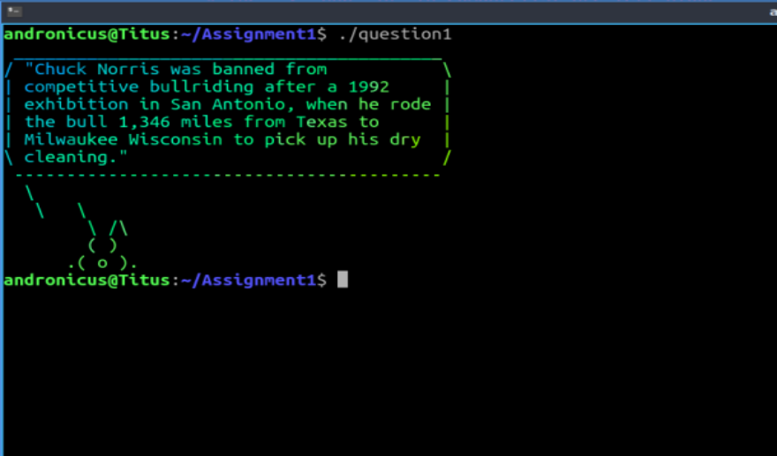

Question 2

1. Task-1 source code is question2.c
2. Task 2 source code is graph.py
3. N=4

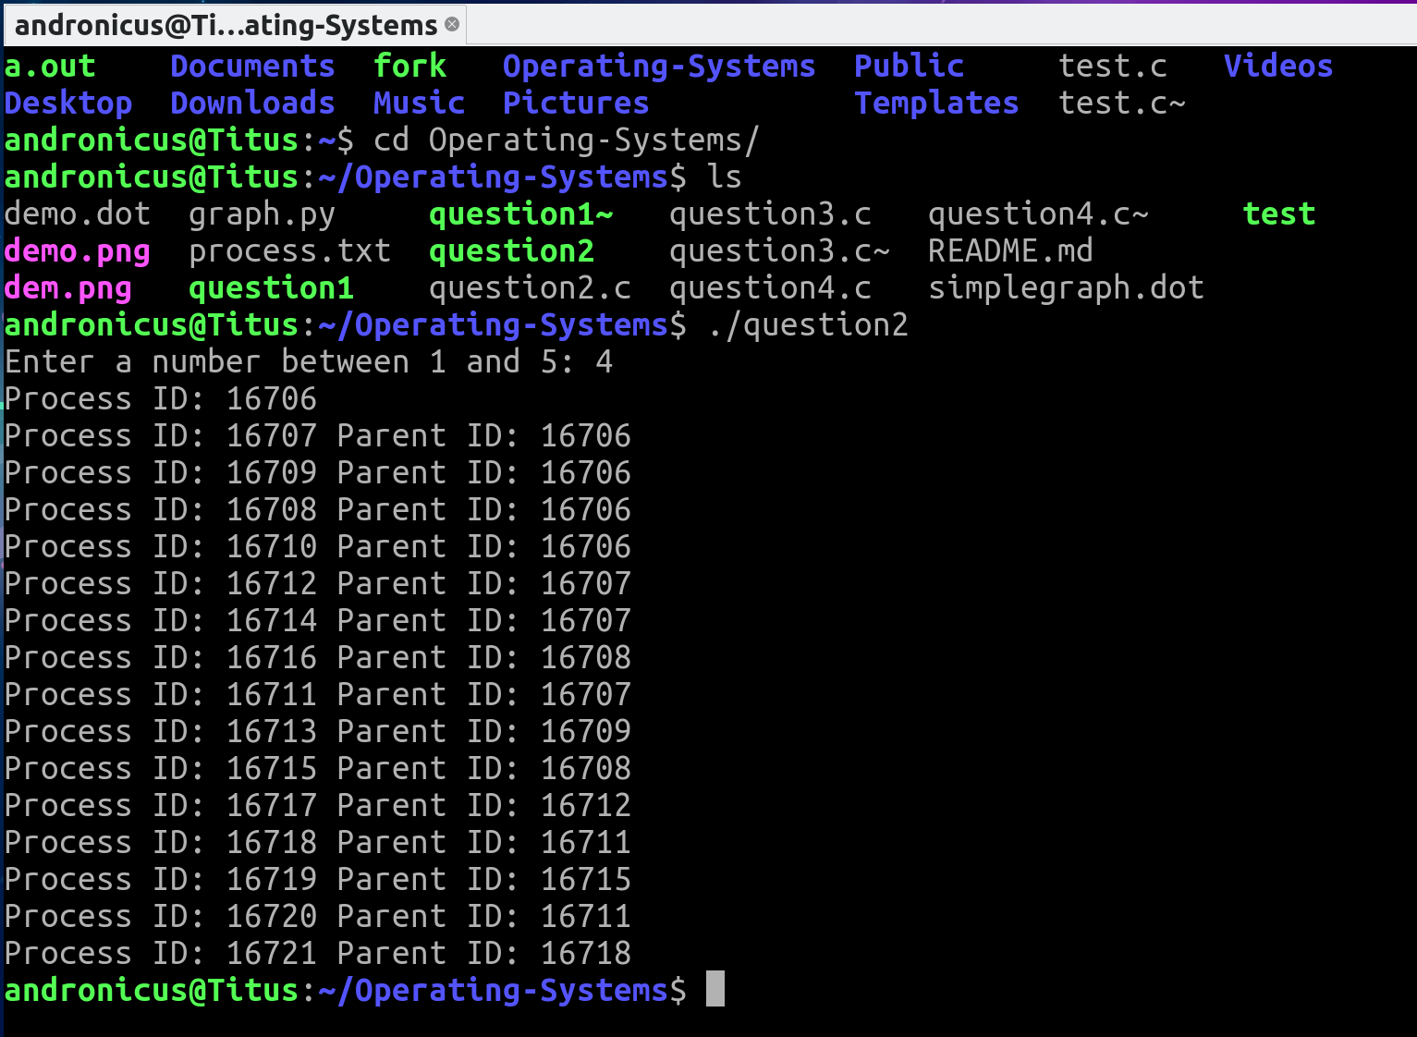

Question2_4.png

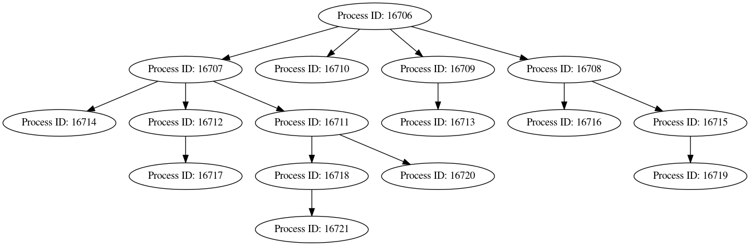

1. N=5 simplegraph_question2.dot

"Parent ID: 16744" -> "Process ID: 16749" "Parent ID: 16695" -> "Process ID: 16744"

"Parent ID: 16744" -> "Process ID: 16747"

"Parent ID: 16744" -> "Process ID: 16746"

"Parent ID: 16747" -> "Process ID: 16752"

"Parent ID: 16744" -> "Process ID: 16748"

"Parent ID: 16744" -> "Process ID: 16745"

"Parent ID: 16748" -> "Process ID: 16754"

"Parent ID: 16747" -> "Process ID: 16750"

"Parent ID: 16745" -> "Process ID: 16761"

"Parent ID: 16757" -> "Process ID: 16764"

"Parent ID: 16750" -> "Process ID: 16758"

"Parent ID: 16759" -> "Process ID: 16768"

"Parent ID: 16746" -> "Process ID: 16751"

"Parent ID: 16745" -> "Process ID: 16757"

"Parent ID: 16745" -> "Process ID: 16759"

"Parent ID: 16764" -> "Process ID: 16767"

"Parent ID: 16756" -> "Process ID: 16760"

"Parent ID: 16763" -> "Process ID: 16769"

"Parent ID: 16746" -> "Process ID: 16753"

"Parent ID: 16746" -> "Process ID: 16755"

"Parent ID: 16751" -> "Process ID: 16774"

"Parent ID: 16753" -> "Process ID: 16762"

"Parent ID: 16760" -> "Process ID: 16771"

"Parent ID: 16751" -> "Process ID: 16773"

"Parent ID: 16760" -> "Process ID: 16770"

"Parent ID: 16756" -> "Process ID: 16763"

"Parent ID: 16745" -> "Process ID: 16756"

"Parent ID: 16757" -> "Process ID: 16766"

"Parent ID: 16770" -> "Process ID: 16772"

"Parent ID: 16756" -> "Process ID: 16765"

"Parent ID: 16773" -> "Process ID: 16775"

qu

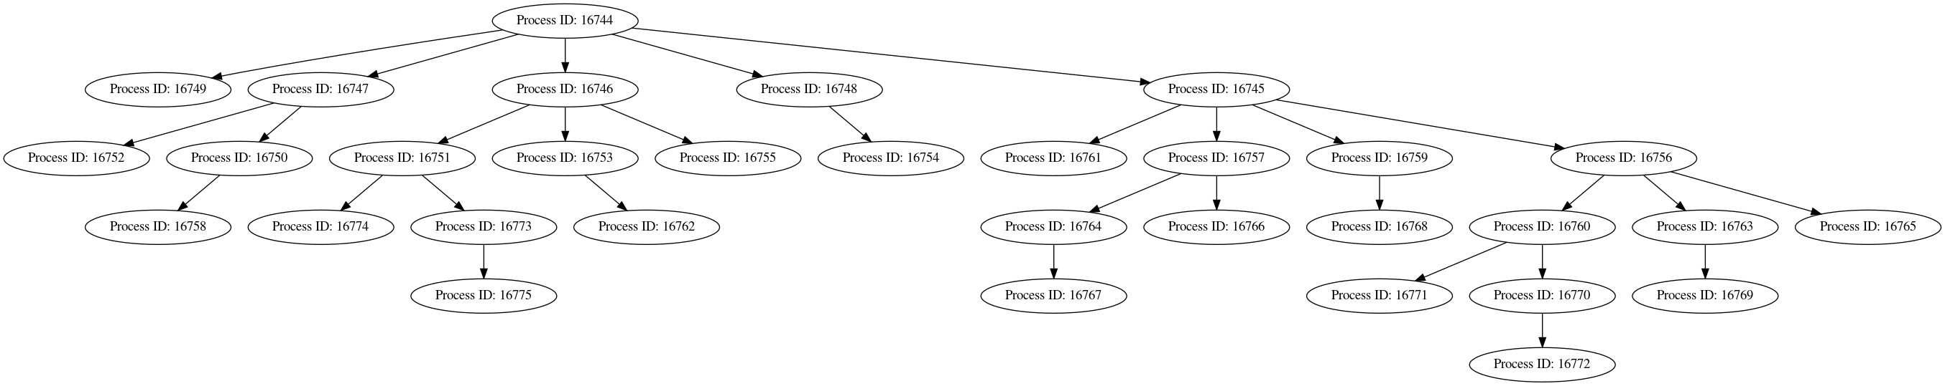

Question 3

1. Source code is question3.c
2. N=3 question3_3.png

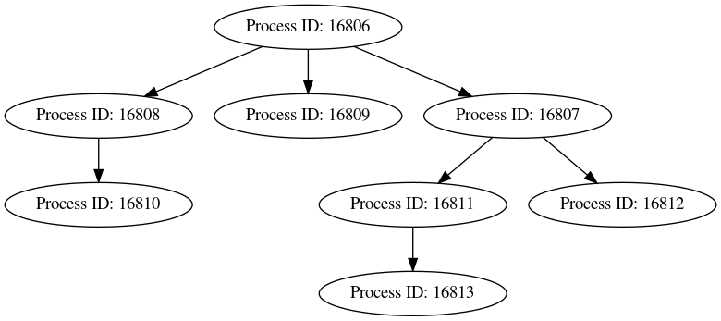

N=5 question3_5.png

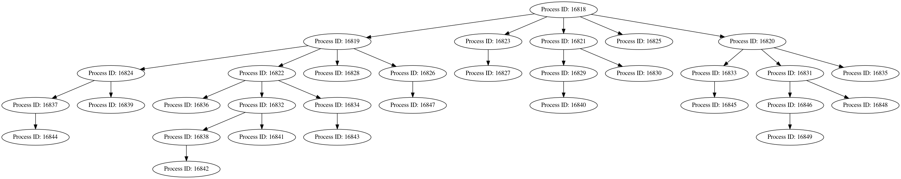

Question 4

1. Source code is question4.c
2. N=3 I wasn’t able to get the levels to print out fine obviously in graphviz

question4_3.png



N=5 You can hardly see it but the image is question4_5.png

