|  |  |
| --- | --- |
| **[Assignment / Project] – External Document** |  |
| <COMP6176>  <Human and Computer Interaction> |
| Even Semester 2020/2021 |

* Project Title

DanBam

* Introduction

**DanBam** is a restaurant that is going viral in Korea. Currently, DanBam has several branches all over Korea. DanBam Restaurant offers a menu of traditional Korean food which is packaged in a modern way.

With technological developments, **DanBam** plans to expand their reach through online media, which in this case is by making a **Website**. First, **DanBam** must create a **logo** and **company** **website** that represents **DanBam’s** image. With this website's existence, **DanBam** hopes they can improve their service towards their customers. **DanBam** entrusts you as a web designer to design and create their **logo** and **company** **website**.

* Report / Documentation

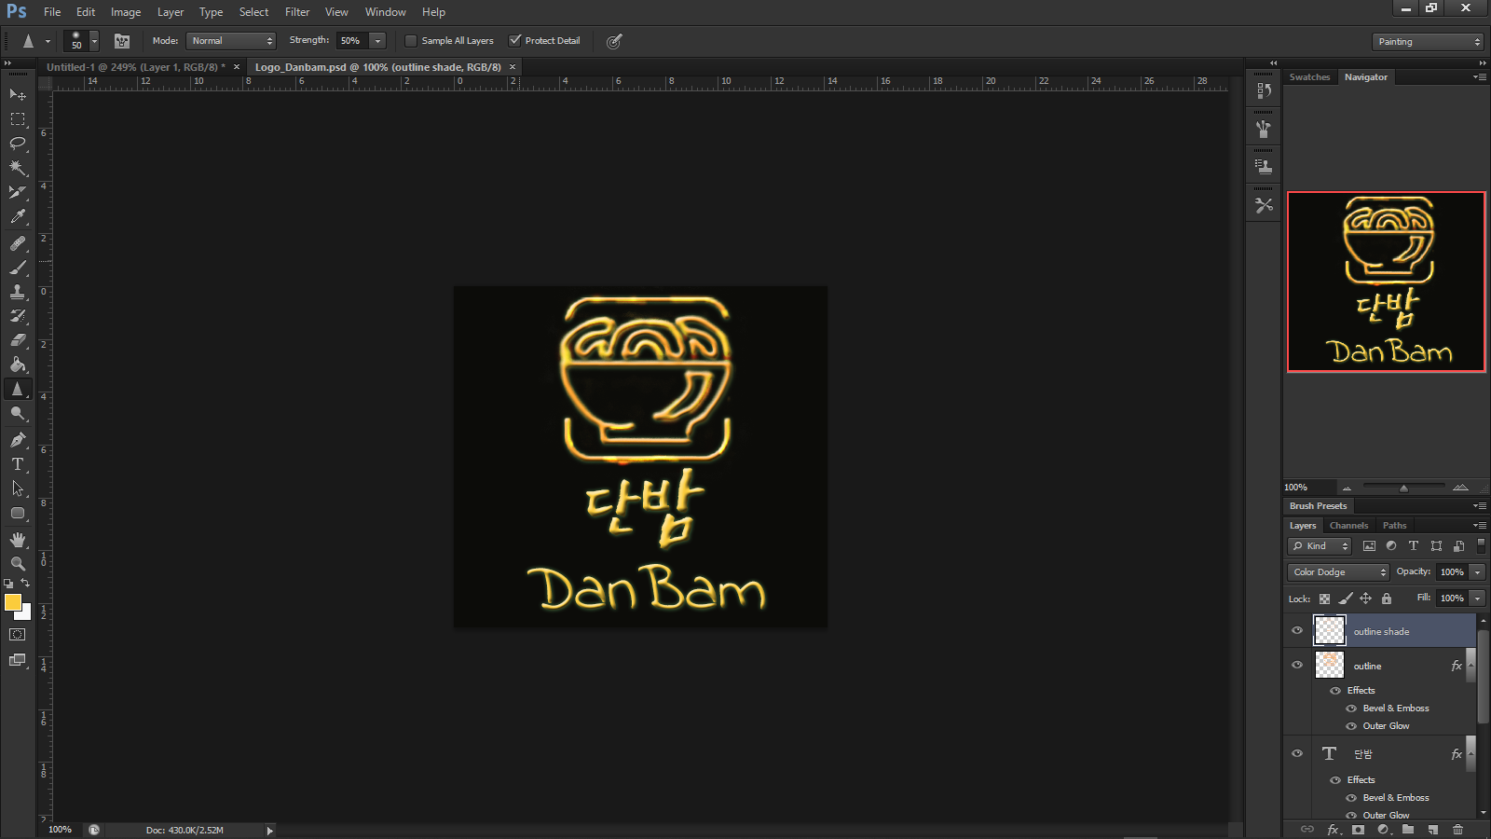

This is the logo blueprint.

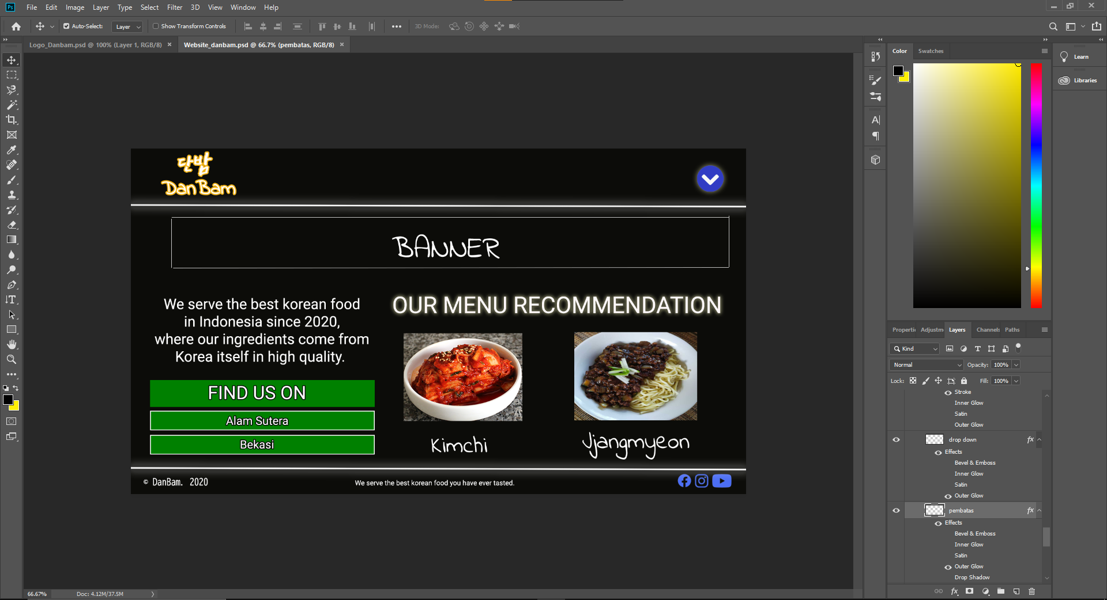

This is the homepage blueprint. We use photoshop and it’s features such as blending.

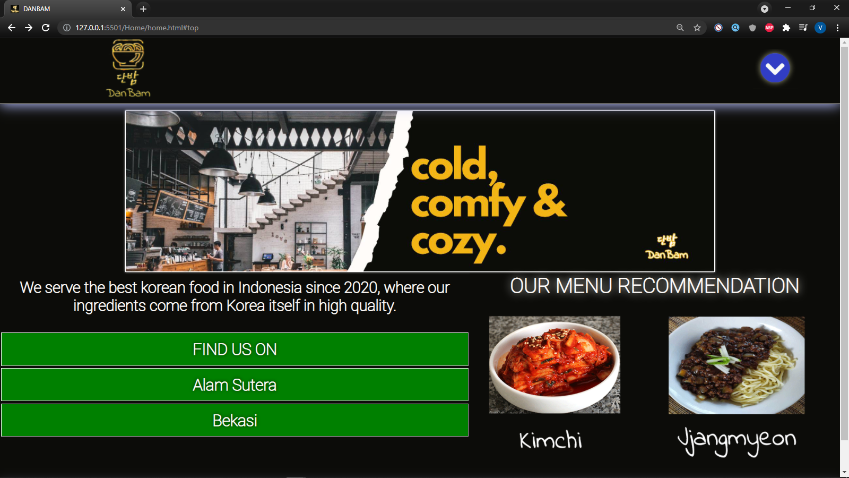

This is our website’s homepage. We use display flex to divide the page to two columns.

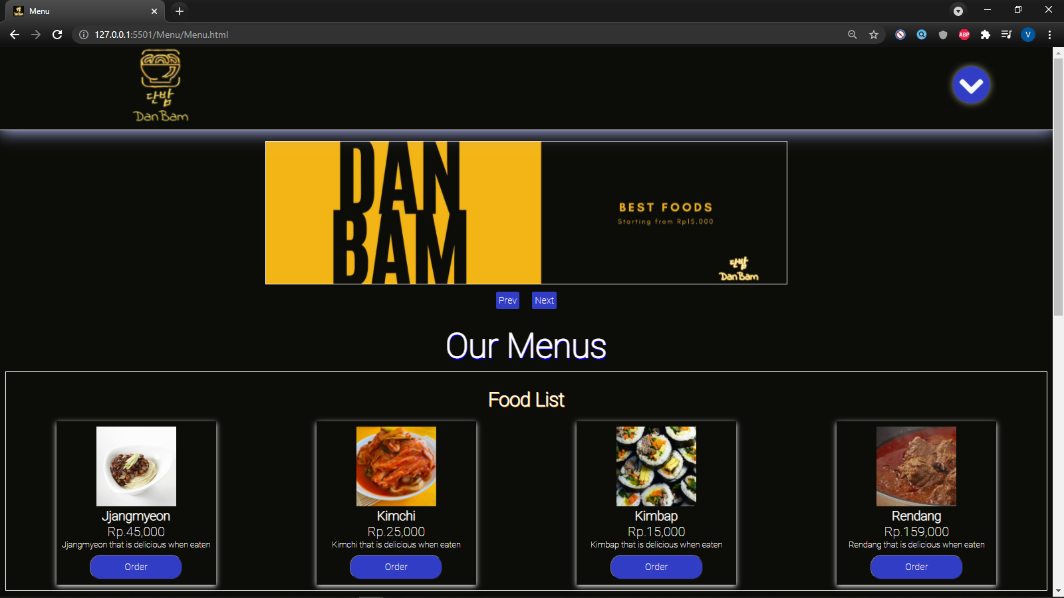

This is our website’s menu. Please ignore the absurd price of vegetables.

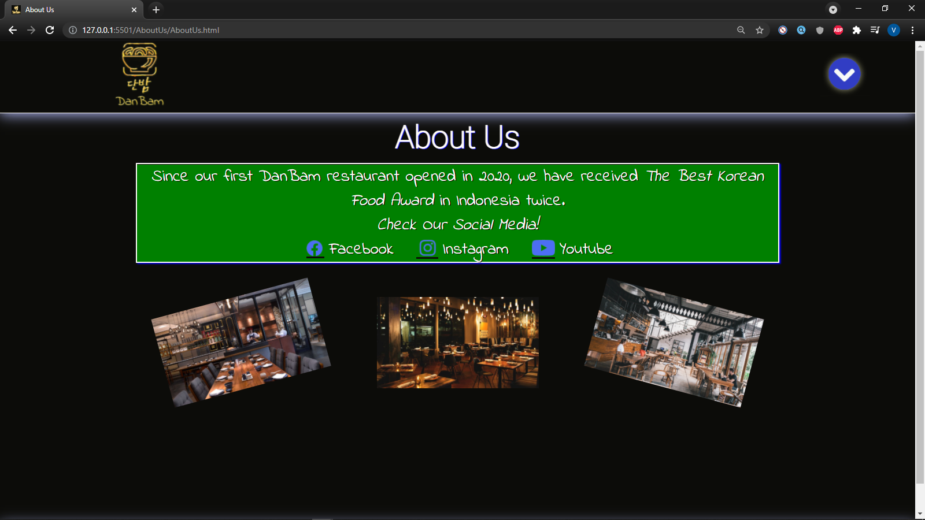

This is our website’s About Us page.

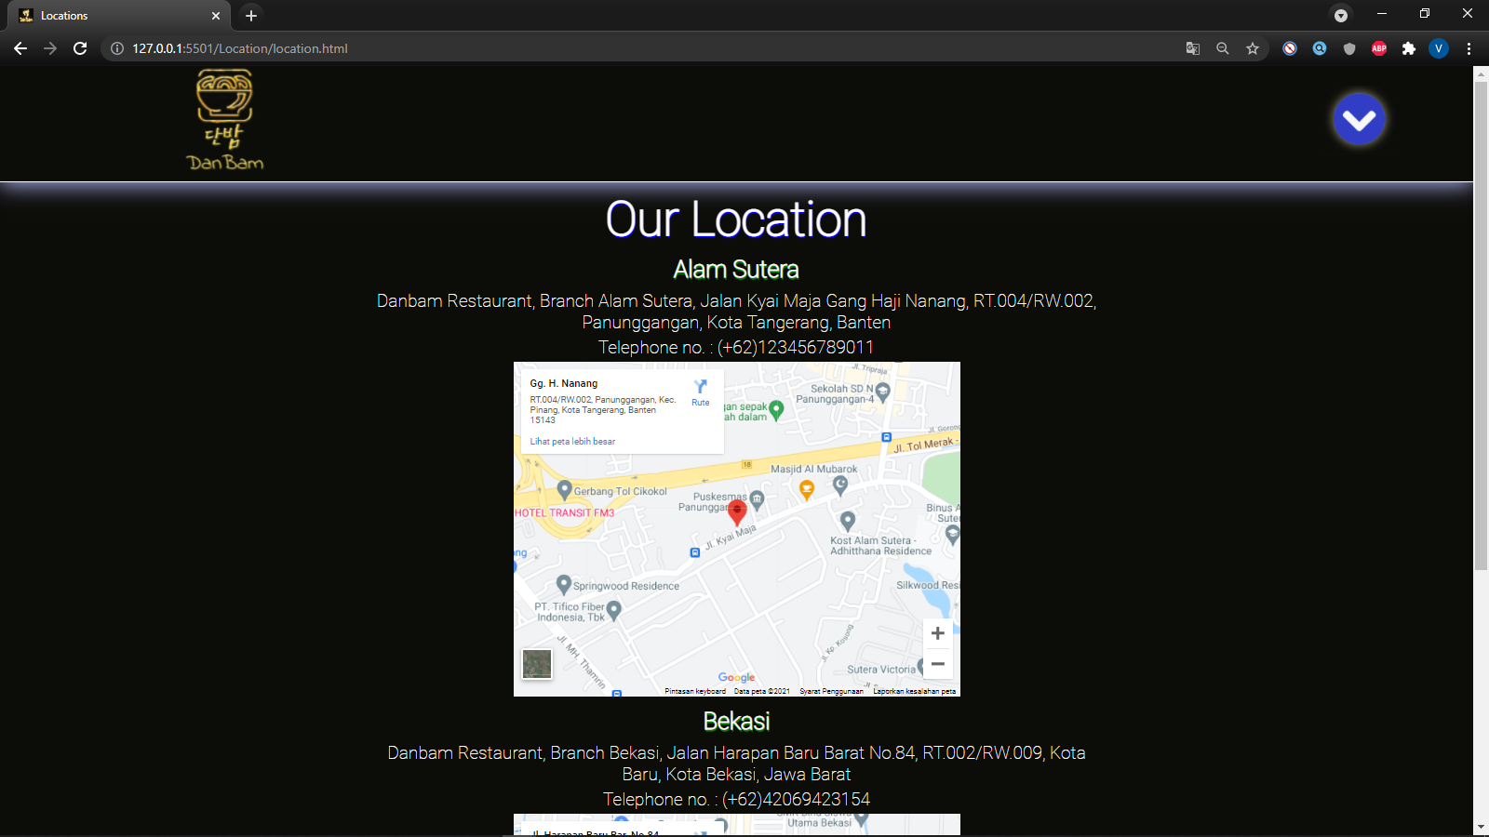

This is our website’s location page.

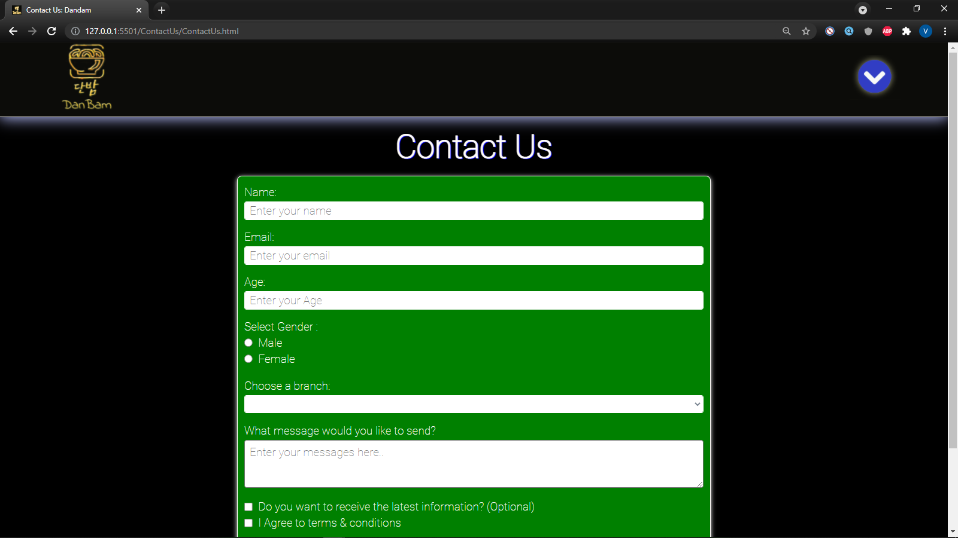

This is our website’s Contact Us.

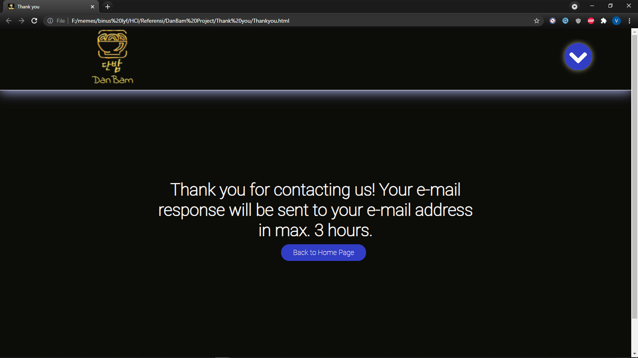

After users submit the Contact Us form, this is the thank you page.

* Reference

Fonts

<https://fonts.googleapis.com/css2?family=East+Sea+Dokdo&family=Indie+Flower&family=Roboto:wght@100&display=swap>

Banner

Dibuat dengan canva.com

Gambar Restoran

<https://www.google.com/url?sa=i&url=https%3A%2F%2Ftravel.kompas.com%2Fread%2F2017%2F09%2F22%2F210300327%2Fini-dia-daftar-restoran-bar-dan-kafe-terbaik-di-jakarta%3Fpage%3Dall&psig=AOvVaw1u55dEzSnJmzbOLcSWK6Iy&ust=1622966353214000&source=images&cd=vfe&ved=0CAIQjRxqFwoTCLDCofqCgPECFQAAAAAdAAAAABAD>

<https://awsimages.detik.net.id/community/media/visual/2020/10/20/bukan-romantis-lampu-remang-remang-di-restoran-bikin-makanan-tak-enak_169.png?w=700&q=90>

<https://www.eatout.co.za/wp-content/uploads/2020/03/Restaurants-and-coronavirus.jpg>

Gambar makanan

<https://www.royco.co.id/content/dam/unilever/knorr_world/indonesia/general_image/royco_id_5_tips_membuat_rendang_sapi_lezat_dan_empuk_tiff-2288164-jpg.jpg.ulenscale.460x460.jpg>

<https://jajabakes.com/wp-content/uploads/2018/08/kimbap2-720x720.jpg>

<https://images.tokopedia.net/img/cache/500-square/VqbcmM/2021/2/4/40e21676-5cb5-4982-9f59-eb3bf0617c15.jpg.webp>

<https://www.maangchi.com/wp-content/uploads/2014/06/Kimchi_f.jpg>

<https://upload.wikimedia.org/wikipedia/commons/7/78/Jajangmyeon.jpg>

<https://cdn.yummy.co.id/content-images/images/20200717/rdKfFbt3Gxzo1wb5QKoMSo4S2HXe6KS6-31353934393730363533d41d8cd98f00b204e9800998ecf8427e_800x800.jpg>

Gambar minuman

<https://pict.sindonews.net/dyn/360/pena/news/2021/05/15/155/427460/ini-beberapa-manfaat-yang-bisa-diperoleh-dari-mengonsumsi-kopi-kah.jpg>

<https://gowine.id/wp-content/uploads/2020/08/Jinro-Chamisul.jpg>

<https://sc04.alicdn.com/kf/Udba852d6198d492a899d7a93d74320edP.jpg>

<https://lh3.googleusercontent.com/proxy/uDQ93-OeZRt92P-IPapePYiT1N8n_BjSShlgQH9jVAGWHNm0cofxxQCNSAYPW8aDStg9gZ9IW4FQIjNXplxZEHDtRRvoup1-thx_L5hzRHMxlMunWVTpycD-EQtKaKA6K0SJ2cDuLmptVCQGvxPo>

Gambar Dessert

<https://newzodiac.al/club/new/wp-content/uploads/2020/10/milkshake-1-300x300.jpg>

<https://s3.envato.com/files/257120277/IMG_4155-1.jpg>

<https://www.theflavorbender.com/wp-content/uploads/2018/01/Pancake-Mix-Waffle-Mix-The-Flavor-Bender-Featured-Image-SQ-9.jpg>

<https://www.mapleandmango.com/wp-content/uploads/2021/02/german-waffles-feature.jpg>

* Group Member
* 2440030361 - Beni Garcia
* 2440023444 - Adrian Putraagung
* 2440030456 - Vetri Marvel Budiman