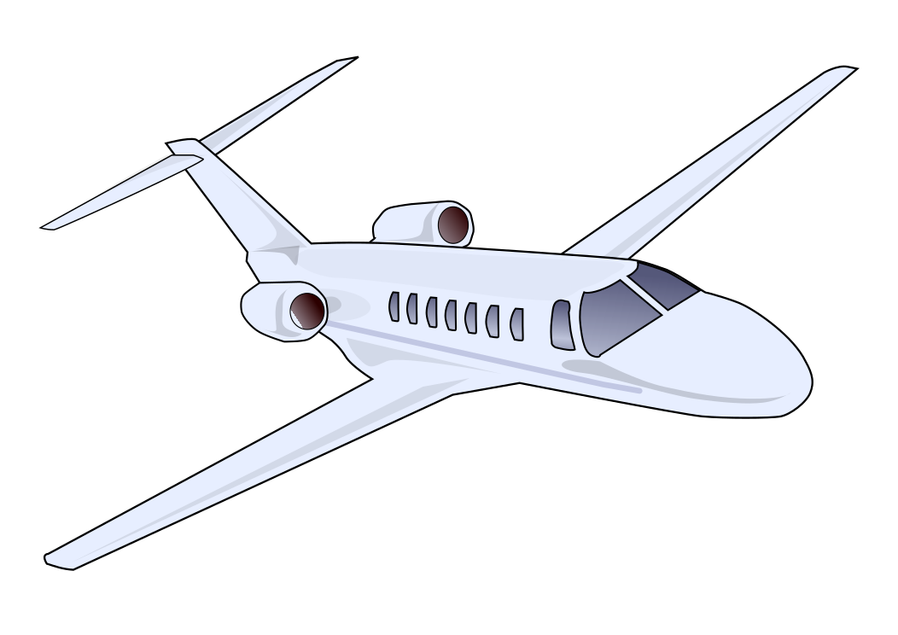




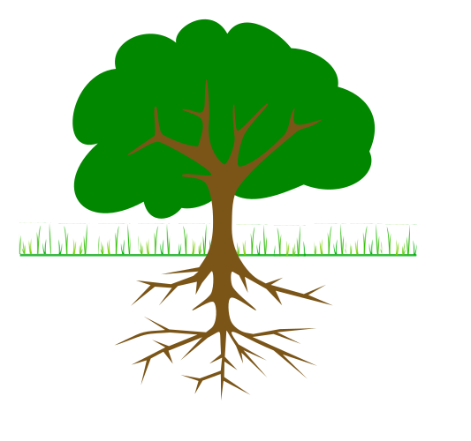
Goal Design: Vision (Dream) -> Purpose (Why) -> Goals -> Actions (weekly)
4a) Career
Vision ...........................................................................................................................................Why ..............................................................................................................................................Goals ................................................................................................................................................................................................................................................................................................................................................................
plan actions on week page
4b) Owner, Entrep, Money
Vision ...........................................................................................................................................Why ..............................................................................................................................................Goals ................................................................................................................................................................................................................................................................................................................................................................
plan actions on week page
2) Share
Vision ...........................................................................................................................................Why ..............................................................................................................................................Goals ................................................................................................................................................................................................................................................................................................................................................................
plan actions on week page
3) Grow
Vision ...........................................................................................................................................Why ..............................................................................................................................................Goals ................................................................................................................................................................................................................................................................................................................................................................
plan actions on week page
5) Experiences, Environments, Contributions
Vision ...........................................................................................................................................Why ..............................................................................................................................................Goals ................................................................................................................................................................................................................................................................................................................................................................
plan actions on week page
1) Self Care
Vision ...........................................................................................................................................Why ..............................................................................................................................................Goals ................................................................................................................................................................................................................................................................................................................................................................
plan actions on week page

