System functionality could be improved by taking advantage of the Voice Coil Motors (VCM) inside the OPU (Hwu, 2012). Compared to the manually operated micro-positioning stages currently used for OPU alignment, control of the laser spot can be performed more precisely by using the z and x axis actuators of the VCM. Focusing can be performed in the z direction, which has a range of motion ± 550 μm. Positioning in the x direction offers a motion range of ± 400 μm. The VCM has a sensitivity of 1.11 mm/V and can be precisely controlled by using a DC signal.

* VCM has an operation bandwidth of 20 kHz for moving the objective lens along the zaxis (±1000 μm)
* for data layer focusing and the x-axis (±350 μm) for following spiral data tracks, whereas tilting (±1°) compensates the data layer angular variation due to disc wobbling.
* The x- and z-axes usually have a sensitivity of 1 μm/ mV to achieve nanoscale resolution with precise diving signals that can be used in various applications.25
* 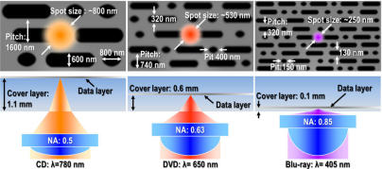
* The OPU focuses a polarized laser to the diffraction limit of light, with full width at halfmaximum being approximately 800 nm for CD, 530 nm for DVD, and 250 nm for Blu-ray disc.15 In addition, each data pit has a depth of λ/4, and when the laser hits the pit, the reflection is destructively interfered and the OPU receives a low reflection corresponding to the digital signal “0”, whereas if no pit is hit, the higher intensity reflection is translated as the digital signal “1”
* The objective lens integrates aspherical and diff ractive optical design to focus 780, 650, and 405 nm laser beams to the diff raction limit of ligh
* 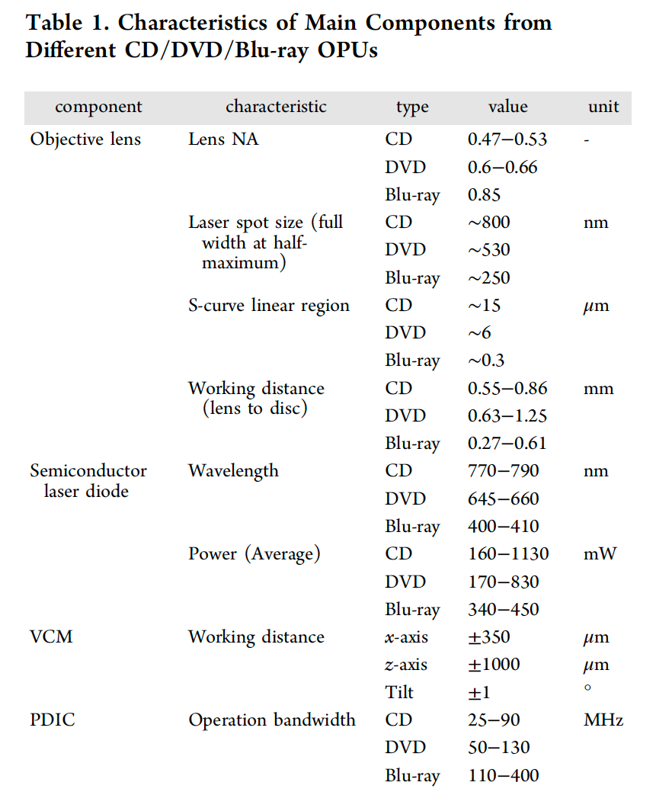

**The Rest of the assembly**

The individual parts of the assembly shown below, stripped from the sled, and arranged roughly with the same relationship they had in *situ*. Each piece has been carefully examined, and an explanation of its function explained.

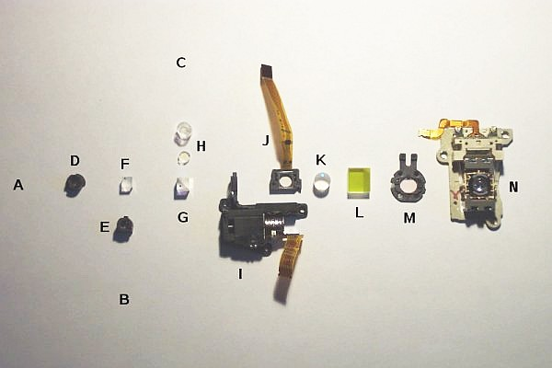

**Exploded view of the optical parts in the head**

* A: Original location of laser diode - see the [Laser Diode Page](http://repairfaq.cis.upenn.edu/Misc/Blu-ray/site1/diode.html).
* B+C: Original photodiode array positions.
* D: Holographic grating to split the beam into main and two sub-beams.
* E: Negative elliptical lens for the violet PD focus control.
* F: Small polarizing beam splitter cube for the violet LD (reflects returning violet beam into violet PD array).
* G: Large polarizing beam splitter cube for the IR/red LD (reflects returning IR/red beam into IR/red PD array).
* H: Two small plastic optics. The smaller one is a negative cylindrical lens for the IR/red PD focus control; the larger one is a diffraction grating, possibly to correct for the difference in wavelength between the IR and red LDs (660 nm and 780 nm) (Thanks Sam!)
* I: Variable focus servo unit and lens to extend the range of focal lengths of the system without the objective touching the disc).
* J: Mutli-segment LCD panel for wavefront aberration correction.
* K: Negative miniscus doublet lens (very long focal length, about 1 metre!).
* L: Turning mirror.
* M: Wave Plate. This would be expected to be a Quarter Wave Plate (QWP) based on similar optics in other pickups, but its behavior is somewhat strange compared to a known QWP.
* N: Objective (disk read) lens with voice-coil focus and tracking servos. This lens is very special and comprises of something that looks like a zone plate below a very high numerical aperture objective with a very unique shape. More below.

Item "J" is very unusual. It comprises of a small LCD, approximately 4 mm square with a polymer flex-cable attached. On the cable near the window is a small IC.

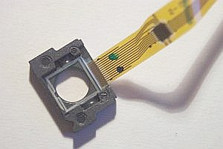

[Mike Harrison](http://www.electricstuff.co.uk/) has some pictures of the unit being powered at: <http://www.electricstuff.co.uk/violaser.html>

Since it is a peculiar item to find in an optical pickup, we trawled through the patents again, to find its exact function. According to the patents, it is there primarily to correct wavefront aberration, and in addition, spherical aberration, astigmatism, and coma. These are the following patent references, showing the segmented electrode pattern, and technical explanations:

* <http://www.freepatentsonline.com/20060067196.html>, U.S. Patent Application Publication #2006/0067196 A1: "Optical pickup and optical disk drive using same" (Sony).
* <http://www.freepatentsonline.com/20020001273.html>, U.S. Patent Application Publication #2002/0001273 A1: "Optical pickup" (Non-Sony).
* I inspected a zone plate extracted from the objective under a microscope at a magnification of 430X. One side (the bottom surface) consists of approximately 96 embossed circular rings with alternating heights differing by perhaps 0.005 mm. (So, 48 pairs.) It appears to have been molded and the lower height rings tend to accumulate debris. There is a clear area in the center (probably flat) with a diameter of about 0.19 mm with the overall diameter of the embossed area being about 2 mm. The pitch (distance between the rings) decreases smoothly from about 0.04 mm at the edge of the central clear area to about 0.005 mm at the outer edge of the embossed area. These measurements have an uncertainty of +/-25 percent or more. :) Both sides are AR coated. A simplified diagram is shown below with 5 sets of rings instead of 48 or so. The left part is of the zone plate side of the optic. Note that this is NOT the same as a Fresnel lens, though the superficial appearance is similar. For the zone plate, the rings alternate between two constant heights. A Fresnel lens consists of rings that follow the contour of the original normal bulk lens and so look more like prisms in cross-section.
* Simplified and Not To Scale!!!!  
  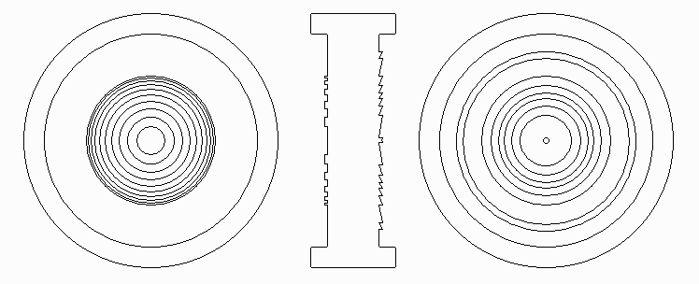  
  Left Diagram: Zone Plate (Bottom Surface); Center Diagram: Cross-Section; Right Diagram: Fresnel Corrector (Top Surface).

Dye surfaces were prepared by submerging ∼50 nM Alexa 647 in 0.05%

poly-L-lysine (Sigma Aldrich) and incubating it for ∼20 min on the waveguide chip

or coverglass followed by an optional washing step. For measurements of the

achievable localization precision using high- and low-NA objective lenses on the

inverted conventional set-up, 200 nm TetraSpeck Microspheres (Thermo Fisher

Scientific) were diluted ∼1:50 in Vectashield H-1000 (Vector Laboratories).

Storm buffer

The bu_er for the d STORM experiments on U2OS cells was prepared from ddH2 Obased

GODCAT components in ddH2 O-based supplemented with 50mM Tris-HCl

pH 8, 50mM NaCl, 2mM COT, and 143mM or 100mM MEA. – Diekmann Thesis

Hi Benedict,

So nice to heart that things are going well. I am out of the office until 28th November, i will see what i have of usable information and put it on the shared Dropbox. I already put some low NA blinking example there.

Aren't you on your way to the US soon? We can arrange a workshop here in Tromsø when you are back. If we know it in advance we can have samples ready for the mobile microscope. And either me or David(cc) can be involved in the lab. There are some rumors about me needing to write a thesis, so if I am unable to find time we will reqruit my buddy David to play the part as me. No worry, we look quite similar and David is also skilled in dSTORMing on the chip...

Ps: How is the mechanical stability of the system now? It would be realy cool if we could make it desk top friendly as well. Perhaps using some silicone or rubber cushions of some sort..

Best wishes from the heart of the Amazon rainforeset (yeah i am really out of office)

Øystein