Homework 4

Benise Limon

#call the packages I want to use   
library(tidyverse)  
library(here)  
library(lterdatasampler)  
library(performance)  
library(broom)  
library(ggeffects)  
library(car)  
library(naniar)  
library(flextable)

How does fish length predict fish weight for trout perch (across all sample years)?  
This data set, like most observational environmental or ecological data sets, is noisy (i.e. a lot of spread between points). It is also somewhat messy. You are expected to read the metadata, protocols, and all relevant information on the EDI portal before working with the data.

# Problem 1

1. Write your null and alternative hypotheses in mathematical and biological terms.

Biological:

H0: Fish length does not predict fish weight for trout perch across all sample years.

HA: Fish length does predict fish weight for trout perch across all sample years.

Mathematical:

H0: β1 = 0

HA: β1 ≠ 0

2. Create a visualization of the missing data for the filtered data set containing the  
observations you will use.

#make an object that reads the CSV file containing the data   
fish <- read.csv(here("data/ntl6_v12.csv"))

#filter the data to only include trout   
fish_clean <- fish %>%   
 filter(spname == "TROUTPERCH")

#visualize missing data   
gg_miss_var(fish_clean) +  
 #add a caption of how missing data affects hypothesis   
 labs (caption = str_wrap("Figure 1. There are 200 missing observations for fish weight. This affects our hypothesis to understand if fish length predicts fish weight.")) +  
 theme(  
 plot.caption = element_text(hjust = 0)  
 )

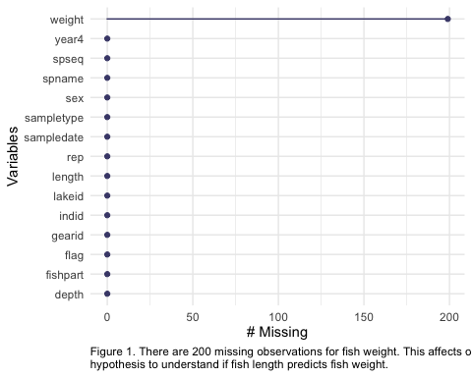

a. Write an accompanying caption explaining how/if the missing data is relevant to  
your hypotheses.

There are 200 observations from the “weight” column are missing. Since it is missing, we will have to delete the null values from the data set, meaning there are less observations to work with. The linear regression is intended to see if fish length can predict fish weight, missing some values of fish weight gives us less data to base our analysis on.

3. Run your test.

#create a model object containing the linear model for if fish length predicts weight using the filtered data frame  
modelobject <- lm(weight ~ length, data = fish_clean)

4. Visually check the assumptions of your test. Display your diagnostic plots in a grid.

# makes the viewer pane show a 2x2 grid of plots  
# format: par(mfrow = c(number of rows, number of columns))  
par(mfrow = c(2, 2))  
plot(modelobject)

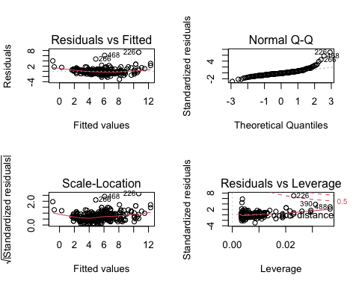

# turns off the 2x2 grid - pop this under the code chunk where you set the 2x2 grid  
dev.off()

null device   
 1

5. For each diagnostic plot, describe in 1-2 sentences what it is showing you, and what you  
decide after looking at the plot.

Residuals vs Fitted:

Scale-location:

Normal QQ:

Residuals vs Leverage:

6. Display the results from summary() using your model object.

# store the model summary as an object  
model_summary <- summary(modelobject)

7. Create a table that summarizes the ANOVA table. Make sure this table has informative  
column and row names and p-values displayed without scientific notation.

# store the ANOVA table as an object  
# anova(): special function to get analysis of variance tables for a model  
model_squares <- anova(modelobject)  
  
model_squares

Analysis of Variance Table  
  
Response: weight  
 Df Sum Sq Mean Sq F value Pr(>F)   
length 1 1432.29 1432.29 1280.8 < 2.2e-16 ***  
Residuals 288 322.05 1.12   
---  
Signif. codes: 0 '***' 0.001 '**' 0.01 '*' 0.05 '.' 0.1 ' ' 1

# don't name this chunk! some intricacies with Quarto: do not name chunks with tables in them  
  
model_squares_table <- tidy(model_squares) %>%   
 # round the sum of squares and mean squares columns to have 5 digits (could be less)  
 mutate(across(sumsq:meansq, ~ round(.x, digits = 2))) %>%   
 # round the F-statistic to have 1 digit  
 mutate(statistic = round(statistic, digits = 1)) %>%   
 # replace the very very very small p value with < 0.001  
 mutate(p.value = case_when(  
 p.value < 0.001 ~ "< 0.001"  
 )) %>%   
 # rename the length cell to be meaningful  
 mutate(term = case_when(  
 term == "length" ~ "Length (mm)",  
 TRUE ~ term  
 )) %>%   
 # make the data frame a flextable object  
 flextable() %>%   
 # change the header labels to be meaningful  
 set_header_labels(df = "Degrees of Freedom",   
 sumsq = "Sum of squares",  
 meansq = "Mean squares",  
 statistic = "F-statistic",  
 p.value = "p-value")  
  
model_squares_table

| term | Degrees of Freedom | Sum of squares | Mean squares | F-statistic | p-value |
| --- | --- | --- | --- | --- | --- |
| Length (mm) | 1 | 1,432.29 | 1,432.29 | 1,280.8 | < 0.001 |
| Residuals | 288 | 322.05 | 1.12 |  |  |

8. In 1-2 sentences, describe how the ANOVA table relates to the information you get from  
the summary() object.

The ANOVA table relates to the information from the summary() object because _____.

9. In 2-3 sentences, summarize your results in prose with in-text references to test results. Include all relevant information.

The results from this linear regression were that _____.

10. Create a visualization with model predictions and confidence intervals on top of the  
underlying data. Finalize your plot.

# extract model predictions using ggpredict  
predictions <- ggpredict(modelobject, terms = "length")  
  
predictions

# Predicted values of weight  
  
length | Predicted | 95% CI  
-----------------------------------  
 50 | -1.71 | [-2.12, -1.30]  
 60 | 0.29 | [-0.02, 0.59]  
 65 | 1.29 | [ 1.03, 1.54]  
 75 | 3.29 | [ 3.12, 3.45]  
 85 | 5.28 | [ 5.16, 5.41]  
 95 | 7.28 | [ 7.12, 7.44]  
 105 | 9.28 | [ 9.04, 9.53]  
 120 | 12.28 | [11.88, 12.68]

plot_predictions <- ggplot(data = fish_clean,   
 aes(x = length, y = weight)) +  
 # first plot the underlying data from fish_clean  
 geom_point() +  
 # then plot the predictions  
 geom_line(data = predictions,   
 aes(x = x, y = predicted),   
 color = "green", linewidth = 1) +  
 # then plot the 95% confidence interval from ggpredict  
 geom_ribbon(data = predictions,   
 aes(x = x, y = predicted, ymin = conf.low, ymax = conf.high),   
 alpha = 0.2) +  
 # theme and meaningful labels  
 theme_bw() +  
 labs(x = "Trout Perch length (mm)",  
 y = "Trout Perch weight (g)",   
 caption = "Figure 2. A visualization of using fish length to predict fish weight in Trout Perch. A ___ increase in length (mm) predicts a ___ increase in weight (g)") +  
 theme(  
 plot.caption = element_text(hjust = 1))  
  
plot_predictions

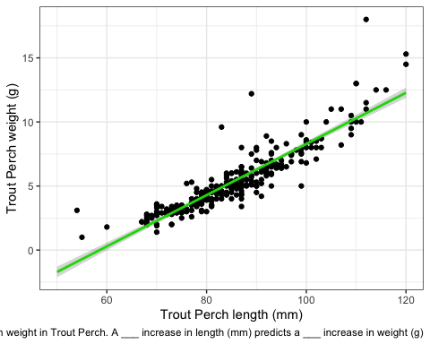

a. Write an accompanying caption.

A visualization of using fish length to predict fish weight in Trout Perch. A ___ increase in length (mm) predicts a ___ increase in weight (g)

Checklist  
Your submission should include  
- A link to your public GitHub repo for this homework assignment that includes  
- An informative readme  
- File organization  
- At least 5 commits  
- Only relevant code and outputs, with no messages or warnings  
- Annotated, spaced out code  
- Written captions and results summaries  
- Additionally, your submission should be submitted to Canvas by 11:59 PM on Tuesday 23 May