**Olatunde T. Mojisola***Data Analytics F24 Lab 05  
ITWS-6600*

***Support Vector Machine Classification (Wine Dataset)***

***Best parameters for linear SVM (Optimum C)***

*cost*

*3 1****Best parameters for radial SVM***

*gamma cost*

*49 0.0625 4****Linear SVM Performance (Overall)***

*Accuracy: 9.615385e-01  
Kappa: 9.415402e-01  
AccuracyLower: 8.678716e-01  
AccuracyUpper: 9.953077e-01  
AccuracyNull : 4.038462e-01  
AccuracyPValue : 9.898988e-18  
McnemarPValue : NaN****Linear SVM Performance (byClass)*** *Sensitivity Specificity Pos Pred Value Neg Pred Value Precision Recall F1 Prevalence*

*Class: 1 1.0000000 0.9428571 0.8947368 1.000000 0.8947368 1.0000000 0.9444444 0.3269231*

*Class: 2 0.9523810 1.0000000 1.0000000 0.968750 1.0000000 0.9523810 0.9756098 0.4038462*

*Class: 3 0.9285714 1.0000000 1.0000000 0.974359 1.0000000 0.9285714 0.9629630 0.2692308*

*Detection Rate Detection Prevalence Balanced Accuracy*

*Class: 1 0.3269231 0.3653846 0.9714286*

*Class: 2 0.3846154 0.3846154 0.9761905*

*Class: 3 0.2500000 0.2500000 0.9642857****Radial SVM Performance (Overall)***

*Accuracy: 9.807692e-01  
Kappa: 9.708193e-01  
AccuracyLower: 8.974465e-01  
AccuracyUpper: 9.995132e-01  
AccuracyNull : 4.038462e-01  
AccuracyPValue : 2.594158e-19  
McnemarPValue : NaN****Radial SVM Performance (byClass)*** *Sensitivity Specificity Pos Pred Value Neg Pred Value Precision Recall F1 Prevalence*

*Class: 1 1.000000 0.9714286 0.9444444 1.00000 0.9444444 1.000000 0.9714286 0.3269231*

*Class: 2 0.952381 1.0000000 1.0000000 0.96875 1.0000000 0.952381 0.9756098 0.4038462*

*Class: 3 1.000000 1.0000000 1.0000000 1.00000 1.0000000 1.000000 1.0000000 0.2692308*

*Detection Rate Detection Prevalence Balanced Accuracy*

*Class: 1 0.3269231 0.3461538 0.9857143*

*Class: 2 0.3846154 0.3846154 0.9761905*

*Class: 3 0.2692308 0.2692308 1.0000000*

***Using a classification method (kNN) to train a classifier based on the same features.****Best k value; 9****kNN performance (Overall)****Accuracy: 9.807692e-01*

*Kappa: 9.707042e-01*

*AccuracyLower: 8.974465e-01*

*AccuracyUpper: 9.995132e-01*

*AccuracyNull : 4.038462e-01*

*AccuracyPValue : 2.594158e-19*

*McnemarPValue : NaN****kNN Performance (byClass)***

*Sensitivity Specificity Pos Pred Value Neg Pred Value Precision Recall F1 Prevalence*

*Class: 1 1.0000000 0.9714286 0.9444444 1.000000 0.9444444 1.0000000 0.9714286 0.3269231*

*Class: 2 1.0000000 1.0000000 1.0000000 1.000000 1.0000000 1.0000000 1.0000000 0.4038462*

*Class: 3 0.9285714 1.0000000 1.0000000 0.974359 1.0000000 0.9285714 0.9629630 0.2692308*

*Detection Rate Detection Prevalence Balanced Accuracy*

*Class: 1 0.3269231 0.3461538 0.9857143*

*Class: 2 0.4038462 0.4038462 1.0000000*

*Class: 3 0.2500000 0.2500000 0.9642857*

*Visualization of k selection for kNN  
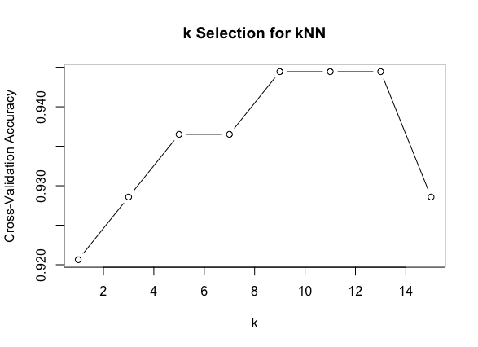*

* ***Compare the performance of the 2 models (Precision, Recall, F1)***

***Confusion Matrix of the Linear SVM*** *Reference*

*Prediction 1 2 3*

*1 17 1 1*

*2 0 20 0*

*3 0 0 13* ***Confusion Matrix of the Radial SVM*** *Reference*

*Prediction 1 2 3*

*1 17 1 1*

*2 0 20 0*

*3 0 0 14*

***Confusion Matrix of the kNN*** *Reference*

*Prediction 1 2 3*

*1 17 1 1*

*2 0 20 0*

*3 0 0 14*

***Comparison of the models (Precision, Recall, F1)*** *Model Precision Recall F1_Score*

*1 Linear SVM 0.8947368 1.0000000 0.9444444*

*2 Radial SVM 1.0000000 0.9523810 0.9756098*

*3 kNN 1.0000000 0.9285714 0.9629630*

*4 Linear SVM 0.9444444 1.0000000 0.9714286*

*5 Radial SVM 1.0000000 0.9523810 0.9756098*

*6 kNN 1.0000000 1.0000000 1.0000000*

*7 Linear SVM 0.9444444 1.0000000 0.9714286*

*8 Radial SVM 1.0000000 0.9523810 0.9756098*

*9 kNN 1.0000000 1.0000000 1.0000000*

***Support Vector Machine Regression (New York Housing Dataset)***

***SVM regression model  
Mean Squared Error: 17745098173732.1  
  
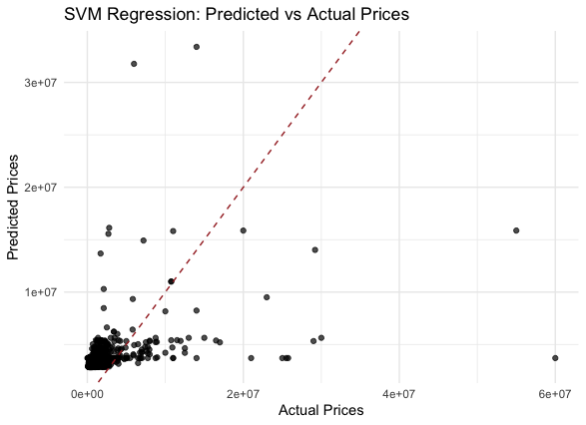***

***Linear Model  
Mean Squared Error: 17745098173732.1***

