Machine Learning Lab Observation
ITA0614
Experiment 4
Build an Artificial Neural Network by implementing the Backpropagation algorithm and test the same using appropriate data sets.
Name : Benita Johnson J | Reg.No : 192412595

Basic Concepts
An Artificial Neural Network (ANN) is made of layers of neurons joined by weighted connections. Backpropagation trains it by computing the output error and passing it backwards through the layers to find how much each weight contributed, and then adjusting the weights by gradient descent.
Forward: a = f(W · x + b) Error: E = ½ Σ (t − o)²
Output error term: δₒ = (o − t) · f′(net) Hidden error term: δₕ = (Wᵀ δₒ) · f′(net)
Weight update: w ← w − η · δ · a
Here f is the activation function (sigmoid, tanh or softmax), η is the learning rate, a is the activation feeding the weight w, and one pass over the whole training set is called an epoch.

Problem 1 : XOR Problem

Aim
To build a 2-4-1 neural network from scratch with NumPy, train it with the backpropagation algorithm on the XOR truth table (a problem a single neuron cannot solve) and test it on an input.

Algorithm
- Initialise all weights and biases with small random values and choose a learning rate η.
- Forward pass: feed a training input through the hidden layer(s) and compute the network output o.
- Compute the error between the target t and the output o (mean squared error or cross-entropy).
- Backward pass: compute the error term δ of the output layer, then propagate it back through the weights to get δ for each hidden layer (chain rule).
- Update every weight and bias by gradient descent: w ← w − η × δ × (input to that weight).
- Repeat steps 2-5 for all training examples for many epochs until the error is small, then test the trained network on unseen data and classify new samples.

Program:
● ● ● bp_a.py - Python 3
1 # Problem 1: Backpropagation on the XOR problem (2-4-1 network, sigmoid, NumPy)
2 import numpy as np
3
4 np.random.seed(1)
5 X = np.array([[0, 0], [0, 1], [1, 0], [1, 1]], dtype=float)
6 y = np.array([[0], [1], [1], [0]], dtype=float)
7
8 def sigmoid(z):
9 return 1 / (1 + np.exp(-z))
10
11 W1 = np.random.randn(2, 4); b1 = np.zeros((1, 4)) # input -> hidden
12 W2 = np.random.randn(4, 1); b2 = np.zeros((1, 1)) # hidden -> output
13 lr, epochs, losses = 0.5, 10000, []
14
15 print("Network : 2 inputs - 4 hidden - 1 output | lr =", lr, "| epochs =", epochs)
16 for ep in range(1, epochs + 1):
17 # ---- forward pass ----
18 h = sigmoid(X @ W1 + b1)
19 out = sigmoid(h @ W2 + b2)
20 loss = np.mean((y - out) ** 2)
21 losses.append(loss)
22 # ---- backward pass (chain rule) ----
23 d_out = (out - y) * out * (1 - out) # error term of output layer
24 d_h = (d_out @ W2.T) * h * (1 - h) # error term of hidden layer
25 # ---- weight update (gradient descent) ----
26 W2 -= lr * h.T @ d_out; b2 -= lr * d_out.sum(axis=0, keepdims=True)
27 W1 -= lr * X.T @ d_h; b1 -= lr * d_h.sum(axis=0, keepdims=True)
28 if ep == 1 or ep % 2000 == 0:
29 print(f"Epoch {ep:5d} Mean squared error = {loss:.6f}")
30
31 print("\nTrained network output for the XOR truth table:")
32 for x, t, o in zip(X, y, out):
33 print(f" {x.astype(int)} -> {o[0]:.4f} (target {int(t[0])}, predicted {int(o[0] > 0.5)})")
34
35 new = np.array([[1, 0]])
36 p = sigmoid(sigmoid(new @ W1 + b1) @ W2 + b2)[0, 0]
37 print(f"\nNew input {new[0]} -> output {p:.4f} -> class {int(p > 0.5)}")
38

Input
XOR data set: 4 training examples, 2 binary inputs (X1, X2) and one binary output. The data is hard-coded in the program as NumPy arrays. Hidden and output layers use the sigmoid activation, learning rate 0.5, 10000 epochs. New input to test: [1, 0].
X1 | X2 | Output (X1 XOR X2)
0 | 0 | 0
0 | 1 | 1
1 | 0 | 1
1 | 1 | 0

Output
● ● ● Terminal - Output
$ python bp_a.py
Network : 2 inputs - 4 hidden - 1 output | lr = 0.5 | epochs = 10000
Epoch 1 Mean squared error = 0.264921
Epoch 2000 Mean squared error = 0.002303
Epoch 4000 Mean squared error = 0.000808
Epoch 6000 Mean squared error = 0.000472
Epoch 8000 Mean squared error = 0.000328
Epoch 10000 Mean squared error = 0.000250

Trained network output for the XOR truth table:
[0 0] -> 0.0085 (target 0, predicted 0)
[0 1] -> 0.9855 (target 1, predicted 1)
[1 0] -> 0.9837 (target 1, predicted 1)
[1 1] -> 0.0213 (target 0, predicted 0)

New input [1 0] -> output 0.9837 -> class 1
$ _

Training Loss Curve
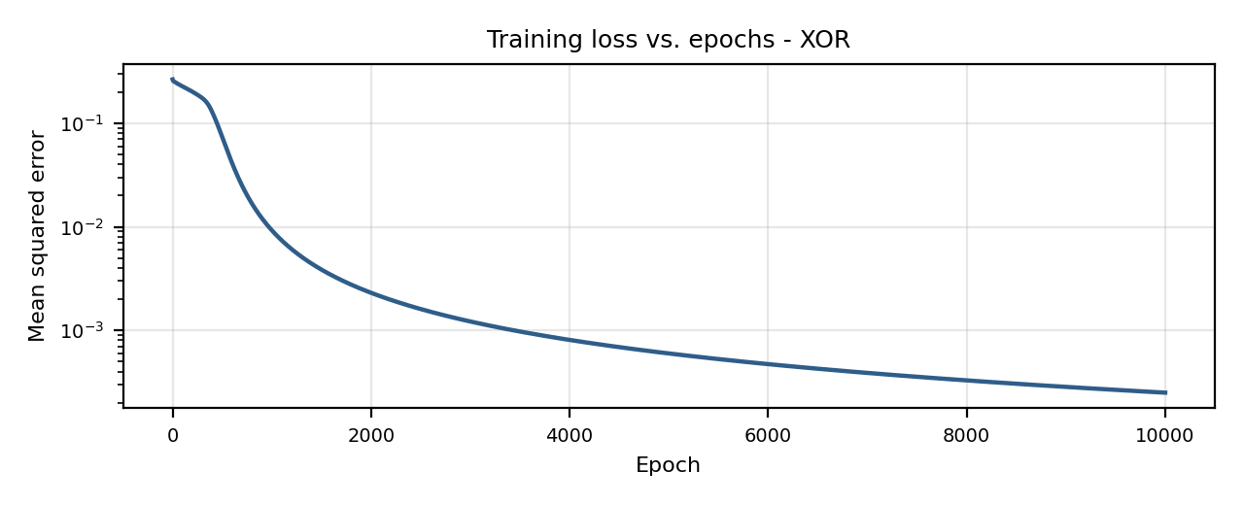

Result
The network was trained successfully: the mean squared error fell from 0.2649 at the first epoch to 0.00025 after 10000 epochs. The outputs for the four inputs (0.0085, 0.9855, 0.9837, 0.0213) are all on the correct side of 0.5, and the new input [1, 0] gives 0.9837, i.e. class 1.

Problem 2 : Student Pass / Fail

Aim
To read student records from a .CSV file with the csv module, scale the attributes, train a 2-3-1 network with backpropagation on a training split and measure its accuracy on a separate test split.

Algorithm
- Initialise all weights and biases with small random values and choose a learning rate η.
- Forward pass: feed a training input through the hidden layer(s) and compute the network output o.
- Compute the error between the target t and the output o (mean squared error or cross-entropy).
- Backward pass: compute the error term δ of the output layer, then propagate it back through the weights to get δ for each hidden layer (chain rule).
- Update every weight and bias by gradient descent: w ← w − η × δ × (input to that weight).
- Repeat steps 2-5 for all training examples for many epochs until the error is small, then test the trained network on unseen data and classify new samples.

Program:
● ● ● bp_b.py - Python 3
1 # Problem 2: Backpropagation for Student Pass/Fail data read from a CSV file (2-3-1 network)
2 import csv
3 import numpy as np
4
5 with open('students.csv') as f:
6 reader = csv.reader(f)
7 header = next(reader)
8 rows = np.array([[float(v) for v in r] for r in reader])
9
10 X = rows[:, :2] / np.array([10.0, 100.0]) # scale Hours and Attendance to 0-1
11 y = rows[:, 2:3]
12 X_tr, y_tr, X_te, y_te = X[:12], y[:12], X[12:], y[12:] # 12 train / 4 test
13 print("Attributes :", header[:-1], "| Target :", header[-1])
14 print("Training samples =", len(X_tr), "| Test samples =", len(X_te))
15
16 sig = lambda z: 1 / (1 + np.exp(-z))
17 rng = np.random.default_rng(7)
18 W1, b1 = rng.normal(0, 1, (2, 3)), np.zeros((1, 3))
19 W2, b2 = rng.normal(0, 1, (3, 1)), np.zeros((1, 1))
20 lr, losses = 0.8, []
21
22 def forward(A):
23 h = sig(A @ W1 + b1)
24 return h, sig(h @ W2 + b2)
25
26 for ep in range(1, 5001):
27 h, out = forward(X_tr)
28 losses.append(np.mean((y_tr - out) ** 2))
29 d2 = (out - y_tr) * out * (1 - out)
30 d1 = (d2 @ W2.T) * h * (1 - h)
31 W2 -= lr * h.T @ d2 / len(X_tr); b2 -= lr * d2.mean(axis=0, keepdims=True)
32 W1 -= lr * X_tr.T @ d1 / len(X_tr); b1 -= lr * d1.mean(axis=0, keepdims=True)
33 if ep % 1000 == 0:
34 print(f"Epoch {ep:4d} loss = {losses[-1]:.5f}")
35
36 acc = lambda A, t: np.mean((forward(A)[1] > 0.5) == t) * 100
37 print(f"\nTraining accuracy : {acc(X_tr, y_tr):.1f} %")
38 print(f"Test accuracy : {acc(X_te, y_te):.1f} %")
39
40 for hrs, att in [(6, 80), (2, 45)]:
41 p = forward(np.array([[hrs / 10, att / 100]]))[1][0, 0]
42 verdict = 'Pass' if p > 0.5 else 'Fail'
43 print(f"New student (Hours={hrs}, Attendance={att}%) -> P(pass) = {p:.3f} -> {verdict}")
44

Input
Student data set (students.csv): 16 examples, 2 attributes (Hours studied, Attendance %) and the target Pass (1 = Yes, 0 = No). The first 12 rows are used for training and the last 4 for testing. Hours are divided by 10 and attendance by 100. New students to test: (6 h, 80 %) and (2 h, 45 %).
Hours studied | Attendance (%) | Pass (1 = Yes)
1 | 40 | 0
2 | 55 | 0
3 | 50 | 0
4 | 60 | 0
5 | 65 | 1
6 | 85 | 1
7 | 70 | 1
8 | 90 | 1
2 | 90 | 0
3 | 95 | 1
9 | 50 | 1
1 | 95 | 0
5 | 45 | 0
7 | 92 | 1
4 | 85 | 1
6 | 55 | 0

Output
● ● ● Terminal - Output
$ python bp_b.py
Attributes : ['Hours', 'Attendance'] | Target : Pass
Training samples = 12 | Test samples = 4
Epoch 1000 loss = 0.06081
Epoch 2000 loss = 0.03184
Epoch 3000 loss = 0.01893
Epoch 4000 loss = 0.01206
Epoch 5000 loss = 0.00824

Training accuracy : 100.0 %
Test accuracy : 75.0 %
New student (Hours=6, Attendance=80%) -> P(pass) = 0.996 -> Pass
New student (Hours=2, Attendance=45%) -> P(pass) = 0.000 -> Fail
$ _

Training Loss Curve
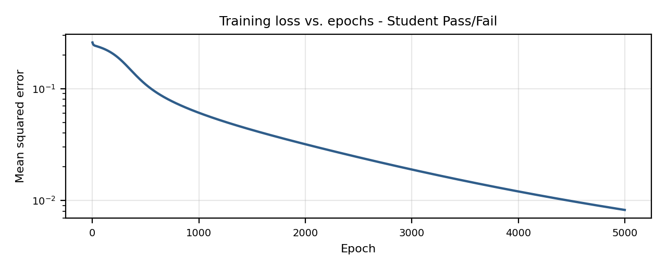

Result
The training loss decreased from 0.0608 (epoch 1000) to 0.0082 (epoch 5000). The network classified all 12 training students correctly and 3 of the 4 test students (75 % test accuracy; the test set is very small). The new student (6 h, 80 %) is predicted to Pass (0.996) and (2 h, 45 %) to Fail (0.000).

Problem 3 : Iris Flower Classification

Aim
To implement backpropagation for a multi-class problem using pandas and NumPy: a 4-6-3 network with a tanh hidden layer, a softmax output layer and cross-entropy loss, trained on the Iris data set.

Algorithm
- Initialise all weights and biases with small random values and choose a learning rate η.
- Forward pass: feed a training input through the hidden layer(s) and compute the network output o.
- Compute the error between the target t and the output o (mean squared error or cross-entropy).
- Backward pass: compute the error term δ of the output layer, then propagate it back through the weights to get δ for each hidden layer (chain rule).
- Update every weight and bias by gradient descent: w ← w − η × δ × (input to that weight).
- Repeat steps 2-5 for all training examples for many epochs until the error is small, then test the trained network on unseen data and classify new samples.

Program:
● ● ● bp_c.py - Python 3
1 # Problem 3: Backpropagation on the Iris data set (4-6-3 network, softmax, pandas + NumPy)
2 import numpy as np
3 import pandas as pd
4 from sklearn.datasets import load_iris
5
6 iris = load_iris(as_frame=True)
7 df = iris.frame
8 names = list(iris.target_names)
9 X = df.iloc[:, :4].values
10 mu, sd = X.mean(axis=0), X.std(axis=0)
11 X = (X - mu) / sd # standardise the features
12 Y = np.eye(3)[df['target'].values] # one-hot targets
13
14 idx = np.random.default_rng(0).permutation(len(X))
15 tr, te = idx[:105], idx[105:] # 70 % train, 30 % test
16 print("Data set : Iris", df.shape, "| train =", len(tr), "| test =", len(te))
17
18 rng = np.random.default_rng(3)
19 W1, b1 = rng.normal(0, 0.5, (4, 6)), np.zeros((1, 6))
20 W2, b2 = rng.normal(0, 0.5, (6, 3)), np.zeros((1, 3))
21
22 def softmax(z):
23 e = np.exp(z - z.max(axis=1, keepdims=True))
24 return e / e.sum(axis=1, keepdims=True)
25
26 def forward(A):
27 h = np.tanh(A @ W1 + b1)
28 return h, softmax(h @ W2 + b2)
29
30 lr, losses = 0.1, []
31 for ep in range(1, 501):
32 h, p = forward(X[tr])
33 losses.append(-np.mean(np.sum(Y[tr] * np.log(p + 1e-12), axis=1))) # cross-entropy
34 d2 = (p - Y[tr]) / len(tr) # softmax + cross-entropy gradient
35 d1 = (d2 @ W2.T) * (1 - h ** 2) # tanh derivative
36 W2 -= lr * h.T @ d2; b2 -= lr * d2.sum(axis=0, keepdims=True)
37 W1 -= lr * X[tr].T @ d1; b1 -= lr * d1.sum(axis=0, keepdims=True)
38 if ep % 100 == 0:
39 print(f"Epoch {ep:3d} cross-entropy = {losses[-1]:.4f}")
40
41 pred = forward(X[te])[1].argmax(axis=1)
42 true = Y[te].argmax(axis=1)
43 print(f"\nTest accuracy : {np.mean(pred == true) * 100:.2f} %")
44 print("Confusion matrix (rows = actual, columns = predicted):")
45 print(pd.crosstab(pd.Series(true, name='actual').map(dict(enumerate(names))),
46 pd.Series(pred, name='predicted').map(dict(enumerate(names)))))
47
48 new = (np.array([[5.1, 3.5, 1.4, 0.2]]) - mu) / sd
49 prob = forward(new)[1][0]
50 print("\nNew flower [5.1, 3.5, 1.4, 0.2] -> probabilities", np.round(prob, 3))
51 print("Predicted species :", names[prob.argmax()])
52

Input
Iris data set (150 flowers, loaded with scikit-learn only to obtain the data; the network itself is written in NumPy): 4 attributes (sepal and petal length and width) and 3 classes (setosa, versicolor, virginica). The features are standardised, the classes are one-hot encoded, and the data is split 105 training / 45 test. A few sample rows are shown below. New flower to test: [5.1, 3.5, 1.4, 0.2].
Sepal length | Sepal width | Petal length | Petal width | Species
5.1 | 3.5 | 1.4 | 0.2 | setosa
4.9 | 3.0 | 1.4 | 0.2 | setosa
4.7 | 3.2 | 1.3 | 0.2 | setosa
7.0 | 3.2 | 4.7 | 1.4 | versicolor
6.4 | 3.2 | 4.5 | 1.5 | versicolor
6.9 | 3.1 | 4.9 | 1.5 | versicolor
6.3 | 3.3 | 6.0 | 2.5 | virginica
5.8 | 2.7 | 5.1 | 1.9 | virginica
7.1 | 3.0 | 5.9 | 2.1 | virginica

Output
● ● ● Terminal - Output
$ python bp_c.py
Data set : Iris (150, 5) | train = 105 | test = 45
Epoch 100 cross-entropy = 0.2991
Epoch 200 cross-entropy = 0.2195
Epoch 300 cross-entropy = 0.1545
Epoch 400 cross-entropy = 0.1179
Epoch 500 cross-entropy = 0.0983

Test accuracy : 97.78 %
Confusion matrix (rows = actual, columns = predicted):
predicted setosa versicolor virginica
actual
setosa 13 0 0
versicolor 0 16 1
virginica 0 0 15

New flower [5.1, 3.5, 1.4, 0.2] -> probabilities [0.986 0.014 0. ]
Predicted species : setosa
$ _

Training Loss Curve
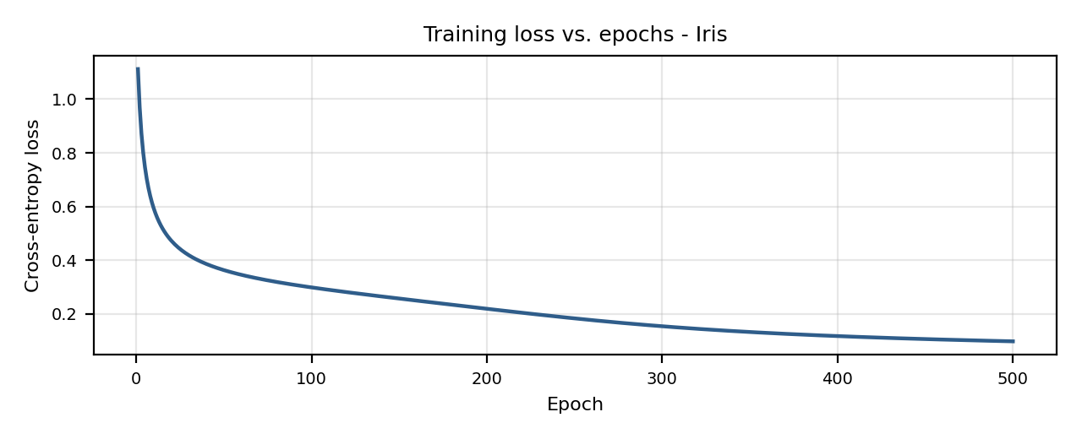

Result
The cross-entropy loss decreased from 0.2991 (epoch 100) to 0.0983 (epoch 500). The network reached 97.78 % test accuracy (44 of 45 flowers); the only error is one versicolor predicted as virginica. The new flower [5.1, 3.5, 1.4, 0.2] is classified as setosa with probability 0.986.

Problem 4 : Breast Cancer Diagnosis

Aim
To implement backpropagation as a reusable NeuralNetwork class with mini-batch gradient descent, and test it on a larger real data set to classify tumours as benign or malignant.

Algorithm
- Initialise all weights and biases with small random values and choose a learning rate η.
- Forward pass: feed a training input through the hidden layer(s) and compute the network output o.
- Compute the error between the target t and the output o (mean squared error or cross-entropy).
- Backward pass: compute the error term δ of the output layer, then propagate it back through the weights to get δ for each hidden layer (chain rule).
- Update every weight and bias by gradient descent: w ← w − η × δ × (input to that weight).
- Repeat steps 2-5 for all training examples for many epochs until the error is small, then test the trained network on unseen data and classify new samples.

Program:
● ● ● bp_d.py - Python 3
1 # Problem 4: Reusable NeuralNetwork class with mini-batch backpropagation (Breast Cancer data)
2 import numpy as np
3 from sklearn.datasets import load_breast_cancer
4
5 class NeuralNetwork:
6 def __init__(self, sizes, lr=0.05, seed=0):
7 rng = np.random.default_rng(seed)
8 self.lr = lr
9 self.W = [rng.normal(0, 0.3, (a, b)) for a, b in zip(sizes[:-1], sizes[1:])]
10 self.b = [np.zeros((1, b)) for b in sizes[1:]]
11
12 @staticmethod
13 def sigmoid(z):
14 return 1 / (1 + np.exp(-z))
15
16 def forward(self, X):
17 acts = [X]
18 for i, (W, b) in enumerate(zip(self.W, self.b)):
19 z = acts[-1] @ W + b
20 acts.append(np.tanh(z) if i < len(self.W) - 1 else self.sigmoid(z))
21 return acts
22
23 def backward(self, acts, y):
24 delta = (acts[-1] - y) / len(y) # sigmoid + cross-entropy
25 for i in reversed(range(len(self.W))):
26 gW, gb = acts[i].T @ delta, delta.sum(axis=0, keepdims=True)
27 if i > 0:
28 delta = (delta @ self.W[i].T) * (1 - acts[i] ** 2) # tanh derivative
29 self.W[i] -= self.lr * gW
30 self.b[i] -= self.lr * gb
31
32 def fit(self, X, y, epochs=100, batch=32):
33 history = []
34 for ep in range(1, epochs + 1):
35 order = np.random.default_rng(ep).permutation(len(X))
36 for s in range(0, len(X), batch):
37 k = order[s:s + batch]
38 self.backward(self.forward(X[k]), y[k])
39 p = self.forward(X)[-1]
40 history.append(-np.mean(y * np.log(p + 1e-9) + (1 - y) * np.log(1 - p + 1e-9)))
41 if ep % 20 == 0:
42 print(f"Epoch {ep:3d} loss = {history[-1]:.4f}")
43 return history
44
45 def predict(self, X):
46 return (self.forward(X)[-1] > 0.5).astype(int)
47
48 data = load_breast_cancer()
49 X = (data.data - data.data.mean(axis=0)) / data.data.std(axis=0)
50 y = data.target.reshape(-1, 1).astype(float)
51 idx = np.random.default_rng(1).permutation(len(X))
52 tr, te = idx[:455], idx[455:] # 80 % train, 20 % test
53 print("Samples:", X.shape[0], "| Features:", X.shape[1], "| Train/Test:", len(tr), "/", len(te))
54
55 net = NeuralNetwork([30, 8, 1], lr=0.05)
56 losses = net.fit(X[tr], y[tr], epochs=100)
57
58 print(f"\nTraining accuracy : {np.mean(net.predict(X[tr]) == y[tr]) * 100:.2f} %")
59 print(f"Test accuracy : {np.mean(net.predict(X[te]) == y[te]) * 100:.2f} %")
60 for i in te[:3]:
61 print(f"Test sample {i}: predicted = {data.target_names[net.predict(X[i:i+1])[0, 0]]:9s}"
62 f" actual = {data.target_names[int(y[i, 0])]}")
63

Input
Breast Cancer Wisconsin data set: 569 samples, 30 numeric features and the target Diagnosis (malignant / benign). The data is loaded with scikit-learn, standardised and split 455 training / 114 test. A 30-8-1 network (tanh hidden layer, sigmoid output) is trained for 100 epochs with batch size 32. Four of the 30 features are shown below.
Mean radius | Mean texture | Mean perimeter | Mean area | Diagnosis
17.99 | 10.38 | 122.80 | 1001.00 | malignant
20.57 | 17.77 | 132.90 | 1326.00 | malignant
19.69 | 21.25 | 130.00 | 1203.00 | malignant
13.54 | 14.36 | 87.46 | 566.30 | benign
13.08 | 15.71 | 85.63 | 520.00 | benign
9.50 | 12.44 | 60.34 | 273.90 | benign

Output
● ● ● Terminal - Output
$ python bp_d.py
Samples: 569 | Features: 30 | Train/Test: 455 / 114
Epoch 20 loss = 0.0829
Epoch 40 loss = 0.0659
Epoch 60 loss = 0.0584
Epoch 80 loss = 0.0533
Epoch 100 loss = 0.0488

Training accuracy : 98.68 %
Test accuracy : 94.74 %
Test sample 354: predicted = benign actual = benign
Test sample 92: predicted = benign actual = benign
Test sample 365: predicted = malignant actual = malignant
$ _

Training Loss Curve
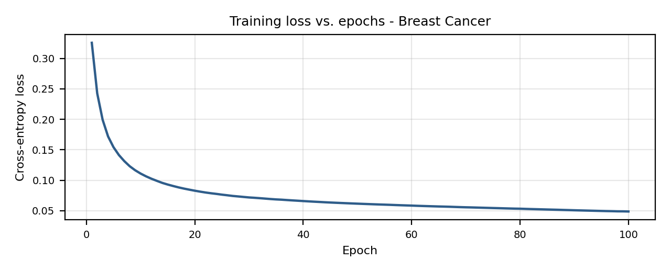

Result
The loss decreased steadily from 0.0829 (epoch 20) to 0.0488 (epoch 100). The network achieved 98.68 % training accuracy and 94.74 % test accuracy on 114 unseen patients, and the three sample test cases printed were all classified correctly.

Problem 5 : Function Approximation (Regression)

Aim
To use backpropagation for regression rather than classification: train a 1-8-1 network with a linear output layer and momentum to approximate y = sin(x), then test it on inputs it has not seen.

Algorithm
- Initialise all weights and biases with small random values and choose a learning rate η.
- Forward pass: feed a training input through the hidden layer(s) and compute the network output o.
- Compute the error between the target t and the output o (mean squared error or cross-entropy).
- Backward pass: compute the error term δ of the output layer, then propagate it back through the weights to get δ for each hidden layer (chain rule).
- Update every weight and bias by gradient descent: w ← w − η × δ × (input to that weight).
- Repeat steps 2-5 for all training examples for many epochs until the error is small, then test the trained network on unseen data and classify new samples.

Program:
● ● ● bp_e.py - Python 3
1 # Problem 5: Backpropagation with momentum for function approximation (regression on y = sin(x))
2 import numpy as np
3
4 x = np.linspace(0, 2 * np.pi, 10).reshape(-1, 1) # 10 training points
5 y = np.sin(x)
6 xs, ys = x / np.pi, y # scale input to a small range
7
8 rng = np.random.default_rng(2)
9 W1, b1 = rng.normal(0, 1, (1, 8)), np.zeros((1, 8))
10 W2, b2 = rng.normal(0, 1, (8, 1)), np.zeros((1, 1))
11 vW1, vb1, vW2, vb2 = 0, 0, 0, 0 # momentum (velocity) terms
12 lr, beta, losses = 0.05, 0.9, []
13
14 def predict(a):
15 return np.tanh(a / np.pi @ W1 + b1) @ W2 + b2 # tanh hidden layer, linear output
16
17 print("Network : 1 input - 8 tanh hidden - 1 linear output | lr =", lr, "| momentum =", beta)
18 for ep in range(1, 4001):
19 h = np.tanh(xs @ W1 + b1)
20 out = h @ W2 + b2
21 err = out - ys
22 losses.append(np.mean(err ** 2))
23 d2 = 2 * err / len(xs) # d(MSE)/d(output)
24 d1 = (d2 @ W2.T) * (1 - h ** 2)
25 vW2 = beta * vW2 - lr * h.T @ d2; vb2 = beta * vb2 - lr * d2.sum(axis=0, keepdims=True)
26 vW1 = beta * vW1 - lr * xs.T @ d1; vb1 = beta * vb1 - lr * d1.sum(axis=0, keepdims=True)
27 W2 += vW2; b2 += vb2; W1 += vW1; b1 += vb1
28 if ep % 800 == 0:
29 print(f"Epoch {ep:4d} MSE = {losses[-1]:.6f}")
30
31 print("\nUnseen inputs x predicted sin(x) error")
32 for v in [0.5, 1.5, 2.5, 4.0, 5.5]:
33 p = predict(np.array([[v]]))[0, 0]
34 print(f" {v:4.1f} {p:9.4f} {np.sin(v):8.4f} {abs(p - np.sin(v)):7.4f}")
35

Input
Training data: 10 equally spaced points of y = sin(x) for x between 0 and 2π (shown below). Hidden layer: 8 tanh neurons; output: linear; learning rate 0.05 with momentum 0.9; 4000 epochs. Unseen test inputs: 0.5, 1.5, 2.5, 4.0 and 5.5.
Point | x (radians) | y = sin(x)
1 | 0.0000 | 0.0000
2 | 0.6981 | 0.6428
3 | 1.3963 | 0.9848
4 | 2.0944 | 0.8660
5 | 2.7925 | 0.3420
6 | 3.4907 | -0.3420
7 | 4.1888 | -0.8660
8 | 4.8869 | -0.9848
9 | 5.5851 | -0.6428
10 | 6.2832 | -0.0000

Output
● ● ● Terminal - Output
$ python bp_e.py
Network : 1 input - 8 tanh hidden - 1 linear output | lr = 0.05 | momentum = 0.9
Epoch 800 MSE = 0.000689
Epoch 1600 MSE = 0.000184
Epoch 2400 MSE = 0.000101
Epoch 3200 MSE = 0.000073
Epoch 4000 MSE = 0.000057

Unseen inputs x predicted sin(x) error
0.5 0.4614 0.4794 0.0180
1.5 1.0055 0.9975 0.0080
2.5 0.5921 0.5985 0.0063
4.0 -0.7643 -0.7568 0.0075
5.5 -0.6980 -0.7055 0.0076
$ _

Training Loss Curve
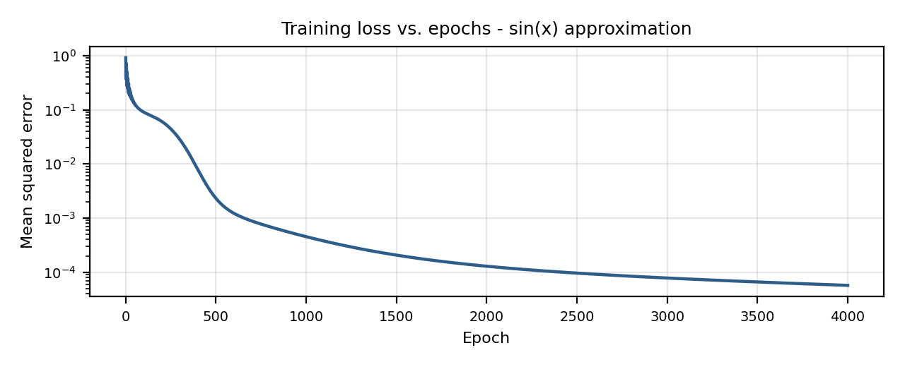

Result
The mean squared error fell from 0.000689 (epoch 800) to 0.000057 (epoch 4000). On the five unseen inputs the predictions are within 0.02 of the true sin(x) values (largest error 0.0180 at x = 0.5), so the network has learned the shape of the sine curve.

