Machine Learning Lab Observation
ITA0614
Experiment 5
Write a program for Implementation of K-Nearest Neighbours (K-NN) in Python.
Name : Benita Johnson J | Reg.No : 192412595

Basic Concepts
K-Nearest Neighbours (K-NN) is a simple instance-based algorithm. It keeps the whole training set and predicts a new sample from the k training examples that are closest to it, assuming that similar samples have similar labels. The choice of k matters: a very small k is sensitive to noise, a very large k blurs the class boundaries.
Euclidean: d(p, q) = √ Σ (pᵢ − qᵢ)² Manhattan: d(p, q) = Σ |pᵢ − qᵢ|
Classification: ŷ = mode { y₁, …, yₖ } Regression: ŷ = (1 / k) Σ yᵢ
Min-max scaling: x′ = (x − min) / (max − min)
Here p and q are two samples with the same attributes, and y₁ … yₖ are the labels (or values) of the k nearest neighbours. Features are scaled first so that no attribute dominates the distance.

Problem 1 : Iris Flower Classification

Aim
To implement K-NN from scratch as a Python class using NumPy, test it on the Iris data set for several values of k and classify a new flower.

Algorithm
- Store all labelled training examples (K-NN is a lazy learner: there is no training phase) and scale the features to the same range.
- Choose the number of neighbours k and a distance measure (Euclidean or Manhattan).
- For a new sample, compute its distance to every training example.
- Sort the distances in increasing order and select the k nearest training examples.
- Classification: output the class that occurs most often among the k neighbours (majority vote). Regression: output the average of their target values.
- Evaluate on unseen test data for different values of k, keep the best k and use it to classify new samples.

Program:
● ● ● knn_a.py - Python 3
1 # Problem 1: K-NN from scratch with NumPy on the Iris data set (class-based, accuracy vs k)
2 import numpy as np
3 from collections import Counter
4 from sklearn.datasets import load_iris
5
6 class KNN:
7 def __init__(self, k=3):
8 self.k = k
9
10 def fit(self, X, y):
11 self.X, self.y = np.asarray(X), np.asarray(y) # K-NN only stores the data
12
13 def _predict_one(self, x):
14 dist = np.sqrt(((self.X - x) ** 2).sum(axis=1)) # Euclidean distance to all points
15 nearest = np.argsort(dist)[:self.k] # indices of the k closest points
16 return Counter(self.y[nearest]).most_common(1)[0][0] # majority vote
17
18 def predict(self, X):
19 return np.array([self._predict_one(x) for x in np.asarray(X)])
20
21 iris = load_iris()
22 X, y, names = iris.data, iris.target, iris.target_names
23 idx = np.random.default_rng(0).permutation(len(X))
24 tr, te = idx[:105], idx[105:] # 70 % train, 30 % test
25 lo, hi = X[tr].min(axis=0), X[tr].max(axis=0)
26 X = (X - lo) / (hi - lo) # min-max scaling
27
28 print("Samples:", len(X), "| Train:", len(tr), "| Test:", len(te))
29 print("\n k Test accuracy")
30 ks, accs = [1, 3, 5, 7, 9, 11, 13, 15], []
31 for k in ks:
32 model = KNN(k)
33 model.fit(X[tr], y[tr])
34 accs.append(np.mean(model.predict(X[te]) == y[te]) * 100)
35 print(f"{k:3d} {accs[-1]:6.2f} %")
36
37 model = KNN(5)
38 model.fit(X[tr], y[tr])
39 new = np.array([[6.0, 2.9, 4.5, 1.5]])
40 pred = model.predict((new - lo) / (hi - lo))[0]
41 print("\nNew flower", new[0].tolist(), "(k = 5) -> predicted species:", names[pred])
42

Input
Iris data set (150 flowers, loaded with scikit-learn only to obtain the data): 4 attributes (sepal and petal length and width) and 3 classes. The features are min-max scaled and the data is split 105 training / 45 test. A few sample rows are shown below. New flower to classify: [6.0, 2.9, 4.5, 1.5] with k = 5.
Sepal length | Sepal width | Petal length | Petal width | Species
5.1 | 3.5 | 1.4 | 0.2 | setosa
4.9 | 3.0 | 1.4 | 0.2 | setosa
4.7 | 3.2 | 1.3 | 0.2 | setosa
7.0 | 3.2 | 4.7 | 1.4 | versicolor
6.4 | 3.2 | 4.5 | 1.5 | versicolor
6.9 | 3.1 | 4.9 | 1.5 | versicolor
6.3 | 3.3 | 6.0 | 2.5 | virginica
5.8 | 2.7 | 5.1 | 1.9 | virginica
7.1 | 3.0 | 5.9 | 2.1 | virginica

Output
● ● ● Terminal - Output
$ python knn_a.py
Samples: 150 | Train: 105 | Test: 45

k Test accuracy
1 93.33 %
3 97.78 %
5 97.78 %
7 97.78 %
9 97.78 %
11 97.78 %
13 97.78 %
15 97.78 %

New flower [6.0, 2.9, 4.5, 1.5] (k = 5) -> predicted species: versicolor
$ _

Graph
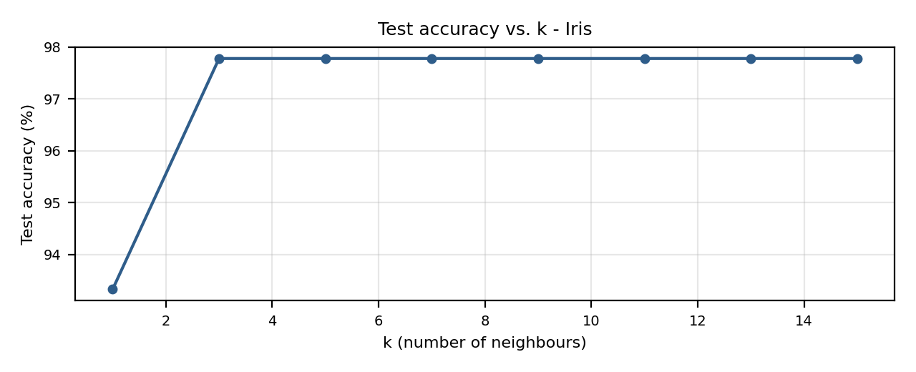

Result
K-NN gave 93.33 % test accuracy for k = 1 and 97.78 % (44 of 45 flowers) for every k from 3 to 15, so a small k was slightly affected by noise. The new flower [6.0, 2.9, 4.5, 1.5] is classified as versicolor.

Problem 2 : Fruit Classification

Aim
To implement K-NN using only plain Python lists and user-defined functions, print the nearest neighbours of each new sample and show how the value of k can change the prediction.

Algorithm
- Store all labelled training examples (K-NN is a lazy learner: there is no training phase) and scale the features to the same range.
- Choose the number of neighbours k and a distance measure (Euclidean or Manhattan).
- For a new sample, compute its distance to every training example.
- Sort the distances in increasing order and select the k nearest training examples.
- Classification: output the class that occurs most often among the k neighbours (majority vote). Regression: output the average of their target values.
- Evaluate on unseen test data for different values of k, keep the best k and use it to classify new samples.

Program:
● ● ● knn_b.py - Python 3
1 # Problem 2: K-NN with plain Python lists and user-defined functions (Fruit Classification)
2 import math
3 from collections import Counter
4
5 # Weight (g), Diameter (cm), Fruit
6 train = [(150, 7.0, 'Apple'), (160, 7.5, 'Apple'), (170, 7.2, 'Apple'), (155, 7.1, 'Apple'),
7 (200, 8.0, 'Orange'), (210, 8.4, 'Orange'), (190, 7.8, 'Orange'), (205, 8.2, 'Orange'),
8 (100, 5.0, 'Lemon'), (110, 5.5, 'Lemon'), (95, 4.8, 'Lemon'), (105, 5.2, 'Lemon')]
9
10 w_min, w_max = min(t[0] for t in train), max(t[0] for t in train)
11 d_min, d_max = min(t[1] for t in train), max(t[1] for t in train)
12
13 def scale(w, d):
14 return (w - w_min) / (w_max - w_min), (d - d_min) / (d_max - d_min)
15
16 def distance(p, q):
17 return math.sqrt((p[0] - q[0]) ** 2 + (p[1] - q[1]) ** 2)
18
19 def classify(weight, diameter, k, show=True):
20 q = scale(weight, diameter)
21 dists = sorted((distance(q, scale(w, d)), w, d, label) for w, d, label in train)
22 neighbours = dists[:k]
23 if show:
24 print(f"\nNew fruit: weight = {weight} g, diameter = {diameter} cm, k = {k}")
25 print(" Rank Distance Weight Diameter Fruit")
26 for r, (dist, w, d, label) in enumerate(neighbours, 1):
27 print(f" {r:4d} {dist:8.4f} {w:6d} {d:8.1f} {label}")
28 votes = Counter(n[3] for n in neighbours)
29 if show:
30 print(" Votes :", dict(votes))
31 return votes.most_common(1)[0][0]
32
33 for w, d in [(165, 7.3), (195, 8.1), (102, 5.1)]:
34 print(" ==> Prediction :", classify(w, d, k=5))
35
36 # effect of k on a borderline fruit
37 print("\nBorderline fruit (180 g, 7.6 cm):")
38 for k in [1, 3, 5, 7]:
39 print(f" k = {k} -> {classify(180, 7.6, k, show=False)}")
40

Input
Fruit data set: 12 training examples, 2 attributes (Weight in grams, Diameter in cm) and 3 classes (Apple, Orange, Lemon). The data is stored in the program as a list of tuples. New fruits: (165 g, 7.3 cm), (195 g, 8.1 cm), (102 g, 5.1 cm) with k = 5, and a borderline fruit (180 g, 7.6 cm) tested with k = 1, 3, 5, 7.
Weight (g) | Diameter (cm) | Fruit
150 | 7.0 | Apple
160 | 7.5 | Apple
170 | 7.2 | Apple
155 | 7.1 | Apple
200 | 8.0 | Orange
210 | 8.4 | Orange
190 | 7.8 | Orange
205 | 8.2 | Orange
100 | 5.0 | Lemon
110 | 5.5 | Lemon
95 | 4.8 | Lemon
105 | 5.2 | Lemon

Output
● ● ● Terminal - Output
$ python knn_b.py

New fruit: weight = 165 g, diameter = 7.3 cm, k = 5
Rank Distance Weight Diameter Fruit
1 0.0516 170 7.2 Apple
2 0.0705 160 7.5 Apple
3 0.1032 155 7.1 Apple
4 0.1548 150 7.0 Apple
5 0.2580 190 7.8 Orange
Votes : {'Apple': 4, 'Orange': 1}
==> Prediction : Apple

New fruit: weight = 195 g, diameter = 8.1 cm, k = 5
Rank Distance Weight Diameter Fruit
1 0.0516 200 8.0 Orange
2 0.0913 205 8.2 Orange
3 0.0940 190 7.8 Orange
4 0.1548 210 8.4 Orange
5 0.3313 170 7.2 Apple
Votes : {'Orange': 4, 'Apple': 1}
==> Prediction : Orange

New fruit: weight = 102 g, diameter = 5.1 cm, k = 5
Rank Distance Weight Diameter Fruit
1 0.0328 100 5.0 Lemon
2 0.0381 105 5.2 Lemon
3 0.1032 95 4.8 Lemon
4 0.1311 110 5.5 Lemon
5 0.6729 150 7.0 Apple
Votes : {'Lemon': 4, 'Apple': 1}
==> Prediction : Lemon

Borderline fruit (180 g, 7.6 cm):
k = 1 -> Orange
k = 3 -> Apple
k = 5 -> Apple
k = 7 -> Apple
$ _

Graph
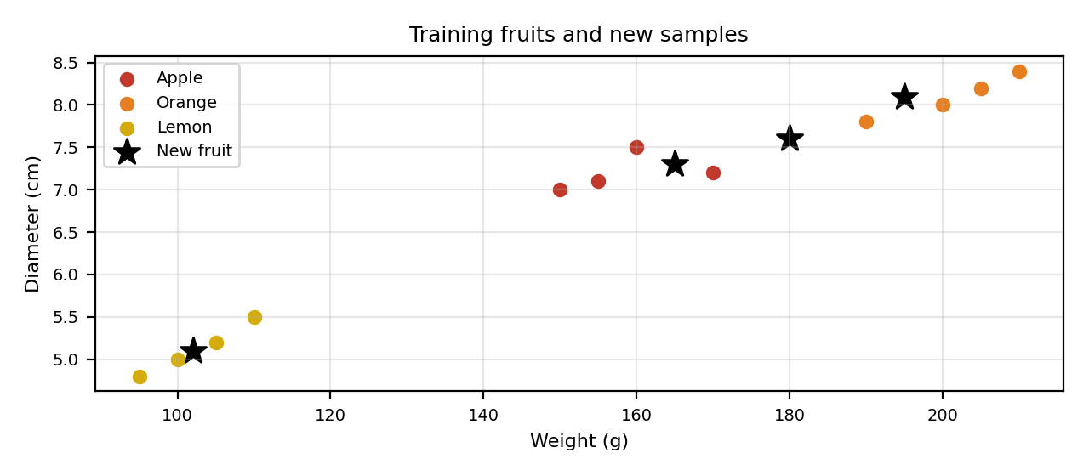

Result
The three new fruits were classified as Apple, Orange and Lemon, each with 4 of the 5 neighbours voting for the winning class. The borderline fruit (180 g, 7.6 cm) is an Orange for k = 1 but an Apple for k = 3, 5 and 7, which shows that the choice of k can change the result.

Problem 3 : Wine Classification

Aim
To implement K-NN with pandas and vectorised NumPy distances, compare the Euclidean and Manhattan distance measures and evaluate the best model with a confusion matrix.

Algorithm
- Store all labelled training examples (K-NN is a lazy learner: there is no training phase) and scale the features to the same range.
- Choose the number of neighbours k and a distance measure (Euclidean or Manhattan).
- For a new sample, compute its distance to every training example.
- Sort the distances in increasing order and select the k nearest training examples.
- Classification: output the class that occurs most often among the k neighbours (majority vote). Regression: output the average of their target values.
- Evaluate on unseen test data for different values of k, keep the best k and use it to classify new samples.

Program:
● ● ● knn_c.py - Python 3
1 # Problem 3: K-NN with pandas on the Wine data set - Euclidean vs Manhattan distance
2 import numpy as np
3 import pandas as pd
4 from sklearn.datasets import load_wine
5
6 wine = load_wine(as_frame=True)
7 df, names = wine.frame, list(wine.target_names)
8 X = df.drop(columns='target').values
9 y = df['target'].values
10 mu, sd = X.mean(axis=0), X.std(axis=0)
11 Xs = (X - mu) / sd # standardise all 13 features
12
13 idx = np.random.default_rng(5).permutation(len(Xs))
14 tr, te = idx[:124], idx[124:] # about 70 % / 30 %
15 print("Wine data:", df.shape, "| Train:", len(tr), "| Test:", len(te))
16
17 def knn_predict(Xtr, ytr, Xq, k, metric):
18 diff = np.abs(Xq[:, None, :] - Xtr[None, :, :]) # all query-train differences
19 dist = np.sqrt((diff ** 2).sum(axis=2)) if metric == 'euclidean' else diff.sum(axis=2)
20 nearest = np.argsort(dist, axis=1)[:, :k]
21 return np.array([np.bincount(ytr[row]).argmax() for row in nearest])
22
23 ks = list(range(1, 16, 2))
24 acc_euc, acc_man = [], []
25 print("\n k Euclidean Manhattan")
26 for k in ks:
27 acc_euc.append(np.mean(knn_predict(Xs[tr], y[tr], Xs[te], k, 'euclidean') == y[te]) * 100)
28 acc_man.append(np.mean(knn_predict(Xs[tr], y[tr], Xs[te], k, 'manhattan') == y[te]) * 100)
29 print(f"{k:3d} {acc_euc[-1]:8.2f} % {acc_man[-1]:8.2f} %")
30
31 best = ks[int(np.argmax(acc_euc))]
32 pred = knn_predict(Xs[tr], y[tr], Xs[te], best, 'euclidean')
33 print(f"\nBest k (Euclidean) = {best}. Confusion matrix (rows = actual, columns = predicted):")
34 print(pd.crosstab(pd.Series(y[te], name='actual').map(dict(enumerate(names))),
35 pd.Series(pred, name='predicted').map(dict(enumerate(names)))))
36
37 new = np.array([[13.0, 2.0, 2.4, 20.0, 100, 2.5, 2.4, 0.3, 1.8, 5.0, 1.0, 3.0, 1000]])
38 p = knn_predict(Xs[tr], y[tr], (new - mu) / sd, best, 'euclidean')[0]
39 print("\nNew wine sample (13 chemical measurements) -> predicted cultivar:", names[p])
40

Input
Wine data set: 178 samples, 13 chemical attributes and 3 cultivars (class_0, class_1, class_2). It is loaded with scikit-learn into a pandas DataFrame, standardised and split 124 training / 54 test. Four of the 13 attributes are shown below. A new wine sample with 13 measurements is classified at the end.
Alcohol | Malic acid | Ash | Magnesium | Cultivar
14.23 | 1.71 | 2.43 | 15.60 | class_0
13.20 | 1.78 | 2.14 | 11.20 | class_0
12.37 | 0.94 | 1.36 | 10.60 | class_1
12.33 | 1.10 | 2.28 | 16.00 | class_1
12.86 | 1.35 | 2.32 | 18.00 | class_2
12.88 | 2.99 | 2.40 | 20.00 | class_2

Output
● ● ● Terminal - Output
$ python knn_c.py
Wine data: (178, 14) | Train: 124 | Test: 54

k Euclidean Manhattan
1 92.59 % 94.44 %
3 92.59 % 94.44 %
5 90.74 % 92.59 %
7 96.30 % 94.44 %
9 96.30 % 96.30 %
11 94.44 % 98.15 %
13 94.44 % 96.30 %
15 96.30 % 96.30 %

Best k (Euclidean) = 7. Confusion matrix (rows = actual, columns = predicted):
predicted class_0 class_1 class_2
actual
class_0 15 0 0
class_1 1 20 1
class_2 0 0 17

New wine sample (13 chemical measurements) -> predicted cultivar: class_0
$ _

Graph
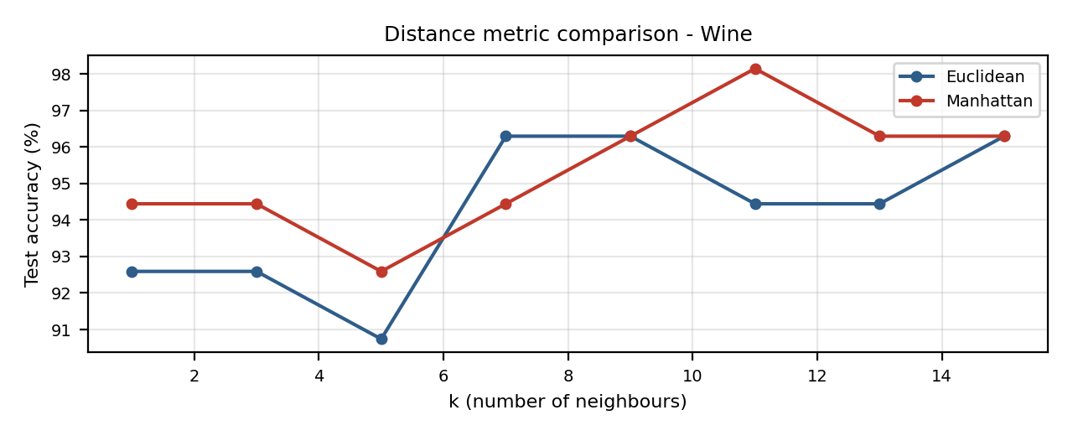

Result
Euclidean distance reached its best accuracy of 96.30 % (52 of 54) at k = 7, and Manhattan distance reached up to 98.15 % at k = 11. The confusion matrix shows only two errors, both for class_1. The new wine sample is classified as class_0.

Problem 4 : Breast Cancer Diagnosis

Aim
To choose the best value of k with 5-fold cross-validation on the training data and compare ordinary majority voting with distance-weighted voting on a larger data set.

Algorithm
- Store all labelled training examples (K-NN is a lazy learner: there is no training phase) and scale the features to the same range.
- Choose the number of neighbours k and a distance measure (Euclidean or Manhattan).
- For a new sample, compute its distance to every training example.
- Sort the distances in increasing order and select the k nearest training examples.
- Classification: output the class that occurs most often among the k neighbours (majority vote). Regression: output the average of their target values.
- Evaluate on unseen test data for different values of k, keep the best k and use it to classify new samples.

Program:
● ● ● knn_d.py - Python 3
1 # Problem 4: K-NN on Breast Cancer data - choosing k by 5-fold cross-validation, weighted voting
2 import numpy as np
3 from sklearn.datasets import load_breast_cancer
4
5 data = load_breast_cancer()
6 X = (data.data - data.data.mean(axis=0)) / data.data.std(axis=0)
7 y = data.target
8 idx = np.random.default_rng(1).permutation(len(X))
9 tr, te = idx[:455], idx[455:] # 80 % train, 20 % test
10 print("Samples:", len(X), "| Features:", X.shape[1], "| Train:", len(tr), "| Test:", len(te))
11
12 def predict(Xtr, ytr, Xq, k, weighted=False):
13 dist = np.sqrt(((Xq[:, None, :] - Xtr[None, :, :]) ** 2).sum(axis=2))
14 nearest = np.argsort(dist, axis=1)[:, :k]
15 out = []
16 for i, row in enumerate(nearest):
17 w = 1 / (dist[i, row] + 1e-9) if weighted else np.ones(k) # 1/distance weights
18 score = np.bincount(ytr[row], weights=w, minlength=2)
19 out.append(score.argmax())
20 return np.array(out)
21
22 def cross_val(k, folds=5):
23 parts, accs = np.array_split(tr, folds), []
24 for i in range(folds):
25 val = parts[i]
26 trn = np.concatenate([p for j, p in enumerate(parts) if j != i])
27 accs.append(np.mean(predict(X[trn], y[trn], X[val], k) == y[val]))
28 return np.mean(accs) * 100
29
30 ks = list(range(1, 22, 2))
31 cv_acc = [cross_val(k) for k in ks]
32 print("\n k 5-fold CV accuracy")
33 for k, a in zip(ks, cv_acc):
34 print(f"{k:3d} {a:6.2f} %")
35
36 best = ks[int(np.argmax(cv_acc))]
37 print(f"\nBest k from cross-validation : {best}")
38 for weighted in (False, True):
39 p = predict(X[tr], y[tr], X[te], best, weighted)
40 kind = 'distance-weighted' if weighted else 'majority vote'
41 print(f"Test accuracy ({kind:17s}) : {np.mean(p == y[te]) * 100:.2f} %")
42
43 for i in te[:3]:
44 guess = data.target_names[predict(X[tr], y[tr], X[i:i + 1], best)[0]]
45 print(f"Test sample {i}: predicted = {guess:9s} actual = {data.target_names[y[i]]}")
46

Input
Breast Cancer Wisconsin data set: 569 samples, 30 numeric features and the target Diagnosis (malignant / benign). The features are standardised and the data is split 455 training / 114 test. Cross-validation is run for odd k from 1 to 21. Four of the 30 features are shown below.
Mean radius | Mean texture | Mean perimeter | Mean area | Diagnosis
17.99 | 10.38 | 122.80 | 1001.00 | malignant
20.57 | 17.77 | 132.90 | 1326.00 | malignant
19.69 | 21.25 | 130.00 | 1203.00 | malignant
13.54 | 14.36 | 87.46 | 566.30 | benign
13.08 | 15.71 | 85.63 | 520.00 | benign
9.50 | 12.44 | 60.34 | 273.90 | benign

Output
● ● ● Terminal - Output
$ python knn_d.py
Samples: 569 | Features: 30 | Train: 455 | Test: 114

k 5-fold CV accuracy
1 95.60 %
3 96.48 %
5 96.92 %
7 96.48 %
9 96.70 %
11 96.48 %
13 96.48 %
15 95.82 %
17 96.04 %
19 96.04 %
21 95.82 %

Best k from cross-validation : 5
Test accuracy (majority vote ) : 96.49 %
Test accuracy (distance-weighted) : 96.49 %
Test sample 354: predicted = benign actual = benign
Test sample 92: predicted = benign actual = benign
Test sample 365: predicted = malignant actual = malignant
$ _

Graph
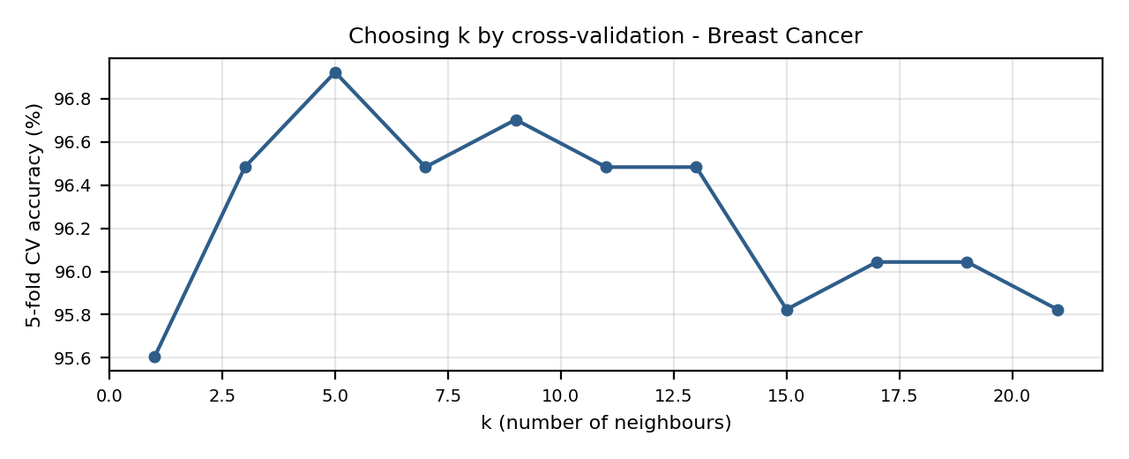

Result
Cross-validation gave the best accuracy of 96.92 % at k = 5. With k = 5 both majority voting and distance-weighted voting reached 96.49 % test accuracy (110 of 114 patients), and the three sample test cases printed were all classified correctly.

Problem 5 : House Price Prediction (K-NN Regression)

Aim
To use K-NN for regression: predict a continuous value (house price) as the average of the k nearest houses, and choose k with leave-one-out evaluation.

Algorithm
- Store all labelled training examples (K-NN is a lazy learner: there is no training phase) and scale the features to the same range.
- Choose the number of neighbours k and a distance measure (Euclidean or Manhattan).
- For a new sample, compute its distance to every training example.
- Sort the distances in increasing order and select the k nearest training examples.
- Classification: output the class that occurs most often among the k neighbours (majority vote). Regression: output the average of their target values.
- Evaluate on unseen test data for different values of k, keep the best k and use it to classify new samples.

Program:
● ● ● knn_e.py - Python 3
1 # Problem 5: K-NN regression (average of the k nearest neighbours) - House Price prediction
2 import numpy as np
3
4 # Area (sq ft), Bedrooms, Age (years), Price (lakhs)
5 data = np.array([[1000, 2, 10, 45], [1200, 2, 8, 55], [1500, 3, 5, 75],
6 [1800, 3, 4, 90], [2000, 4, 3, 110], [850, 1, 15, 35],
7 [1100, 2, 12, 48], [1600, 3, 6, 80], [2200, 4, 2, 125],
8 [1400, 3, 9, 68], [900, 2, 20, 38], [2500, 5, 1, 150]], dtype=float)
9 X, y = data[:, :3], data[:, 3]
10 lo, hi = X.min(axis=0), X.max(axis=0)
11 Xs = (X - lo) / (hi - lo)
12
13 def knn_regress(Xtr, ytr, q, k):
14 dist = np.sqrt(((Xtr - q) ** 2).sum(axis=1))
15 return ytr[np.argsort(dist)[:k]].mean() # mean price of k neighbours
16
17 print("Houses:", len(X), "| Features: Area, Bedrooms, Age | Target: Price (lakhs)")
18 print("\nLeave-one-out evaluation:")
19 print(" k Mean absolute error (lakhs)")
20 ks, maes = [1, 2, 3, 4, 5, 6], []
21 for k in ks:
22 errs = []
23 for i in range(len(X)):
24 keep = np.arange(len(X)) != i # leave house i out
25 errs.append(abs(knn_regress(Xs[keep], y[keep], Xs[i], k) - y[i]))
26 maes.append(np.mean(errs))
27 print(f"{k:3d} {maes[-1]:8.2f}")
28
29 best = ks[int(np.argmin(maes))]
30 new = np.array([1700, 3, 5])
31 price = knn_regress(Xs, y, (new - lo) / (hi - lo), best)
32 print(f"\nBest k = {best}")
33 print(f"New house (Area=1700, Bedrooms=3, Age=5) -> predicted price = {price:.2f} lakhs")
34

Input
House data set: 12 houses, 3 attributes (Area in sq ft, Bedrooms, Age in years) and the target Price in lakhs. The attributes are min-max scaled. New house to price: Area = 1700, Bedrooms = 3, Age = 5.
Area (sq ft) | Bedrooms | Age (years) | Price (lakhs)
1000 | 2 | 10 | 45
1200 | 2 | 8 | 55
1500 | 3 | 5 | 75
1800 | 3 | 4 | 90
2000 | 4 | 3 | 110
850 | 1 | 15 | 35
1100 | 2 | 12 | 48
1600 | 3 | 6 | 80
2200 | 4 | 2 | 125
1400 | 3 | 9 | 68
900 | 2 | 20 | 38
2500 | 5 | 1 | 150

Output
● ● ● Terminal - Output
$ python knn_e.py
Houses: 12 | Features: Area, Bedrooms, Age | Target: Price (lakhs)

Leave-one-out evaluation:
k Mean absolute error (lakhs)
1 9.92
2 8.58
3 8.47
4 10.00
5 12.22
6 15.40

Best k = 3
New house (Area=1700, Bedrooms=3, Age=5) -> predicted price = 81.67 lakhs
$ _

Graph
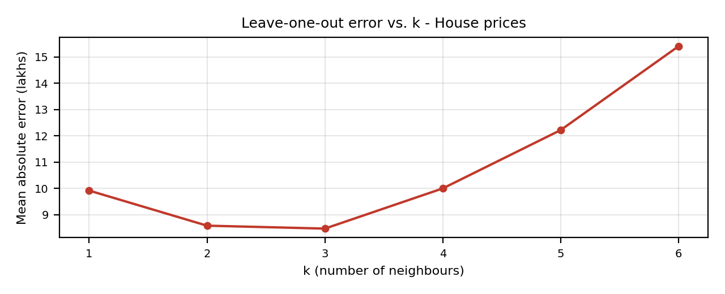

Result
The leave-one-out mean absolute error was lowest for k = 3 (8.47 lakhs); it was 9.92 for k = 1 and rose to 15.40 for k = 6. With k = 3 the new house is predicted to cost 81.67 lakhs.

