Machine Learning Lab Observation
ITA0614
Experiment 6
Write a program to implement the Naïve Bayes algorithm in Python and to display the results using confusion matrix and accuracy.
Name : Benita Johnson J | Reg.No : 192412595

Basic Concepts
The Naïve Bayes classifier applies Bayes’ theorem with the “naive” assumption that the attributes are independent of each other once the class is known. It is fast, needs little training data and works well for text and numeric data.
Bayes’ theorem: P(C | x) = P(x | C) · P(C) / P(x) Naive: P(x | C) = Π P(xᵢ | C)
Laplace smoothing: P(xᵢ | C) = (count + 1) / (Nᶜ + number of values)
Gaussian: P(x | C) = 1 / √(2πσ²) · exp( − (x − μ)² / 2σ² )
Accuracy = (TP + TN) / total Precision = TP / (TP + FP) Recall = TP / (TP + FN)
A confusion matrix lists the actual classes in rows and the predicted classes in columns, so the diagonal holds the correct predictions and every other cell is an error. TP, TN, FP and FN are true/false positives and negatives.

Problem 1 : Play Tennis (Categorical Data)

Aim
To implement the Naïve Bayes classifier from scratch for categorical attributes with Laplace smoothing, display the confusion matrix and accuracy, and classify a new weather sample.

Algorithm
- Collect the labelled training data and compute the prior probability P(C) of every class from the class frequencies.
- For every class and attribute estimate the likelihood P(x | C): frequency counts with Laplace smoothing for categorical or word attributes, mean and variance (Gaussian) for numeric attributes.
- For a new sample compute the score P(C) × P(x₁ | C) × … × P(xₙ | C) for every class, using logarithms to avoid very small numbers.
- Predict the class with the highest score (maximum a posteriori decision).
- Compare the predictions with the true labels of the test data and build the confusion matrix (TP, FN, FP, TN).
- Calculate the accuracy = correct predictions / total predictions, together with precision and recall.

Program:
● ● ● nb_a.py - Python 3
1 # Problem 1: Naive Bayes for categorical data from scratch (Play Tennis, Laplace smoothing)
2 import math
3 from collections import Counter, defaultdict
4
5 attrs = ['Outlook', 'Temp', 'Humidity', 'Wind']
6 data = [
7 ['Sunny', 'Hot', 'High', 'Weak', 'No'], ['Sunny', 'Hot', 'High', 'Strong', 'No'],
8 ['Overcast', 'Hot', 'High', 'Weak', 'Yes'], ['Rain', 'Mild', 'High', 'Weak', 'Yes'],
9 ['Rain', 'Cool', 'Normal', 'Weak', 'Yes'], ['Rain', 'Cool', 'Normal', 'Strong', 'No'],
10 ['Overcast', 'Cool', 'Normal', 'Strong', 'Yes'], ['Sunny', 'Mild', 'High', 'Weak', 'No'],
11 ['Sunny', 'Cool', 'Normal', 'Weak', 'Yes'], ['Rain', 'Mild', 'Normal', 'Weak', 'Yes'],
12 ['Sunny', 'Mild', 'Normal', 'Strong', 'Yes'], ['Overcast', 'Mild', 'High', 'Strong', 'Yes'],
13 ['Overcast', 'Hot', 'Normal', 'Weak', 'Yes'], ['Rain', 'Mild', 'High', 'Strong', 'No'],
14 ]
15 labels = ['Yes', 'No']
16
17 def train(rows):
18 class_n = Counter(r[-1] for r in rows)
19 count = defaultdict(int) # (attribute, value, class) -> frequency
20 values = [set(r[i] for r in data) for i in range(len(attrs))]
21 for r in rows:
22 for i, v in enumerate(r[:-1]):
23 count[(i, v, r[-1])] += 1
24 return class_n, count, values
25
26 def scores(model, x):
27 class_n, count, values = model
28 total = sum(class_n.values())
29 out = {}
30 for c in labels:
31 s = math.log(class_n[c] / total) # log prior
32 for i, v in enumerate(x): # log likelihoods with Laplace smoothing
33 s += math.log((count[(i, v, c)] + 1) / (class_n[c] + len(values[i])))
34 out[c] = s
35 return out
36
37 def predict(model, x):
38 s = scores(model, x)
39 return max(s, key=s.get)
40
41 # ---- evaluate on the training examples -> confusion matrix ----
42 model = train(data)
43 cm = [[0, 0], [0, 0]] # rows = actual, columns = predicted
44 for row in data:
45 cm[labels.index(row[-1])][labels.index(predict(model, row[:-1]))] += 1
46
47 tp, fn, fp, tn = cm[0][0], cm[0][1], cm[1][0], cm[1][1]
48 print("Confusion matrix (training data, positive class = Yes):")
49 print(" Pred Yes Pred No")
50 print(f" Actual Yes {tp:8d} {fn:7d}")
51 print(f" Actual No {fp:8d} {tn:7d}")
52 print(f"\nAccuracy = {(tp + tn) / len(data) * 100:.2f} %")
53 print(f"Precision = {tp / (tp + fp):.4f} Recall = {tp / (tp + fn):.4f}")
54
55 hits = sum(predict(train(data[:i] + data[i + 1:]), r[:-1]) == r[-1] for i, r in enumerate(data))
56 print(f"Leave-one-out accuracy (stricter test) = {hits / len(data) * 100:.2f} %")
57
58 new = ['Sunny', 'Cool', 'High', 'Strong']
59 s = scores(model, new)
60 z = sum(math.exp(v) for v in s.values())
61 print("\nNew sample", new)
62 for c in labels:
63 print(f" P(PlayTennis = {c:3s} | sample) = {math.exp(s[c]) / z:.4f}")
64 print("Prediction:", predict(model, new))
65

Input
Play Tennis data set: 14 examples, 4 attributes (Outlook, Temp, Humidity, Wind) and the target PlayTennis (Yes / No), stored as a list in the program. Because the data set is tiny, the confusion matrix is built on the training examples, and a leave-one-out accuracy is also printed as a stricter test. New sample: <Sunny, Cool, High, Strong>.
Outlook | Temp | Humidity | Wind | PlayTennis
Sunny | Hot | High | Weak | No
Sunny | Hot | High | Strong | No
Overcast | Hot | High | Weak | Yes
Rain | Mild | High | Weak | Yes
Rain | Cool | Normal | Weak | Yes
Rain | Cool | Normal | Strong | No
Overcast | Cool | Normal | Strong | Yes
Sunny | Mild | High | Weak | No
Sunny | Cool | Normal | Weak | Yes
Rain | Mild | Normal | Weak | Yes
Sunny | Mild | Normal | Strong | Yes
Overcast | Mild | High | Strong | Yes
Overcast | Hot | Normal | Weak | Yes
Rain | Mild | High | Strong | No

Output
● ● ● Terminal - Output
$ python nb_a.py
Confusion matrix (training data, positive class = Yes):
Pred Yes Pred No
Actual Yes 9 0
Actual No 1 4

Accuracy = 92.86 %
Precision = 0.9000 Recall = 1.0000
Leave-one-out accuracy (stricter test) = 50.00 %

New sample ['Sunny', 'Cool', 'High', 'Strong']
P(PlayTennis = Yes | sample) = 0.2799
P(PlayTennis = No | sample) = 0.7201
Prediction: No
$ _

Confusion Matrix
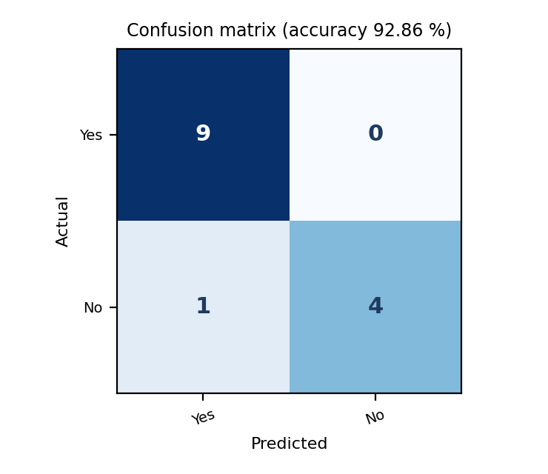

Result
On the training data the classifier gave 92.86 % accuracy (13 of 14 days) with precision 0.90 and recall 1.00; the one error is a “No” day predicted as “Yes”. The stricter leave-one-out accuracy is only 50 %, which shows how little data the 14 examples provide. The new sample gets P(Yes) = 0.2799 and P(No) = 0.7201, so it is classified as PlayTennis = No.

Problem 2 : Iris Flower Classification (Gaussian)

Aim
To implement Gaussian Naïve Bayes as a Python class using NumPy for numeric attributes, and evaluate it with a three-class confusion matrix, accuracy, precision and recall.

Algorithm
- Collect the labelled training data and compute the prior probability P(C) of every class from the class frequencies.
- For every class and attribute estimate the likelihood P(x | C): frequency counts with Laplace smoothing for categorical or word attributes, mean and variance (Gaussian) for numeric attributes.
- For a new sample compute the score P(C) × P(x₁ | C) × … × P(xₙ | C) for every class, using logarithms to avoid very small numbers.
- Predict the class with the highest score (maximum a posteriori decision).
- Compare the predictions with the true labels of the test data and build the confusion matrix (TP, FN, FP, TN).
- Calculate the accuracy = correct predictions / total predictions, together with precision and recall.

Program:
● ● ● nb_b.py - Python 3
1 # Problem 2: Gaussian Naive Bayes from scratch with NumPy on the Iris data set
2 import numpy as np
3 from sklearn.datasets import load_iris
4
5 class GaussianNB:
6 def fit(self, X, y):
7 self.classes = np.unique(y)
8 self.prior = np.array([np.mean(y == c) for c in self.classes])
9 self.mean = np.array([X[y == c].mean(axis=0) for c in self.classes])
10 self.var = np.array([X[y == c].var(axis=0) + 1e-9 for c in self.classes])
11 return self
12
13 def log_posterior(self, X):
14 out = []
15 for i in range(len(self.classes)):
16 log_pdf = (-0.5 * np.log(2 * np.pi * self.var[i])
17 - (X - self.mean[i]) ** 2 / (2 * self.var[i]))
18 out.append(np.log(self.prior[i]) + log_pdf.sum(axis=1)) # log P(C) + sum log P(x|C)
19 return np.array(out).T
20
21 def predict(self, X):
22 return self.classes[np.argmax(self.log_posterior(X), axis=1)]
23
24 iris = load_iris()
25 X, y, names = iris.data, iris.target, list(iris.target_names)
26 idx = np.random.default_rng(0).permutation(len(X))
27 tr, te = idx[:105], idx[105:] # 70 % train, 30 % test
28
29 model = GaussianNB().fit(X[tr], y[tr])
30 pred = model.predict(X[te])
31
32 labels = names
33 cm = np.zeros((3, 3), dtype=int)
34 for t, p in zip(y[te], pred):
35 cm[t, p] += 1 # rows = actual, columns = predicted
36
37 print("Train:", len(tr), "| Test:", len(te))
38 print("\nConfusion matrix (rows = actual, columns = predicted):")
39 print(" " + "".join(f"{n:>12s}" for n in names))
40 for n, row in zip(names, cm):
41 print(f"{n:12s} " + "".join(f"{v:12d}" for v in row))
42 print(f"\nAccuracy = {np.trace(cm) / cm.sum() * 100:.2f} %")
43 for i, n in enumerate(names):
44 print(f"{n:12s} precision = {cm[i, i] / cm[:, i].sum():.3f} recall = {cm[i, i] / cm[i].sum():.3f}")
45
46 new = np.array([[6.0, 2.9, 4.5, 1.5]])
47 lp = model.log_posterior(new)[0]
48 prob = np.exp(lp - lp.max()); prob /= prob.sum()
49 print("\nNew flower [6.0, 2.9, 4.5, 1.5] -> probabilities", np.round(prob, 3))
50 print("Predicted species:", names[prob.argmax()])
51

Input
Iris data set (150 flowers, loaded with scikit-learn only to obtain the data): 4 numeric attributes and 3 classes. The data is split 105 training / 45 test. A few sample rows are shown below. New flower to classify: [6.0, 2.9, 4.5, 1.5].
Sepal length | Sepal width | Petal length | Petal width | Species
5.1 | 3.5 | 1.4 | 0.2 | setosa
4.9 | 3.0 | 1.4 | 0.2 | setosa
4.7 | 3.2 | 1.3 | 0.2 | setosa
7.0 | 3.2 | 4.7 | 1.4 | versicolor
6.4 | 3.2 | 4.5 | 1.5 | versicolor
6.9 | 3.1 | 4.9 | 1.5 | versicolor
6.3 | 3.3 | 6.0 | 2.5 | virginica
5.8 | 2.7 | 5.1 | 1.9 | virginica
7.1 | 3.0 | 5.9 | 2.1 | virginica

Output
● ● ● Terminal - Output
$ python nb_b.py
Train: 105 | Test: 45

Confusion matrix (rows = actual, columns = predicted):
setosa versicolor virginica
setosa 13 0 0
versicolor 0 16 1
virginica 0 0 15

Accuracy = 97.78 %
setosa precision = 1.000 recall = 1.000
versicolor precision = 1.000 recall = 0.941
virginica precision = 0.938 recall = 1.000

New flower [6.0, 2.9, 4.5, 1.5] -> probabilities [0. 0.983 0.017]
Predicted species: versicolor
$ _

Confusion Matrix
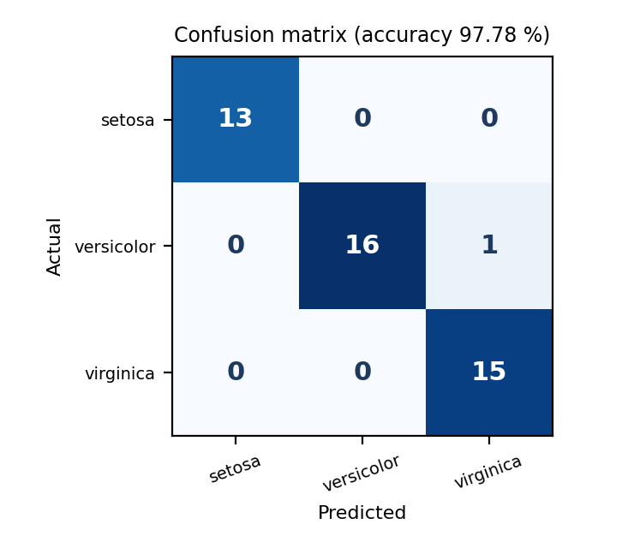

Result
The classifier reached 97.78 % accuracy (44 of 45 test flowers). All setosa flowers were found; one versicolor was predicted as virginica (versicolor recall 0.941, virginica precision 0.938). The new flower is classified as versicolor with probability 0.983.

Problem 3 : Spam Message Filter (Text Data)

Aim
To implement Multinomial Naïve Bayes for text with a bag-of-words model and Laplace smoothing, and to display the confusion matrix and accuracy for spam and ham messages.

Algorithm
- Collect the labelled training data and compute the prior probability P(C) of every class from the class frequencies.
- For every class and attribute estimate the likelihood P(x | C): frequency counts with Laplace smoothing for categorical or word attributes, mean and variance (Gaussian) for numeric attributes.
- For a new sample compute the score P(C) × P(x₁ | C) × … × P(xₙ | C) for every class, using logarithms to avoid very small numbers.
- Predict the class with the highest score (maximum a posteriori decision).
- Compare the predictions with the true labels of the test data and build the confusion matrix (TP, FN, FP, TN).
- Calculate the accuracy = correct predictions / total predictions, together with precision and recall.

Program:
● ● ● nb_c.py - Python 3
1 # Problem 3: Multinomial Naive Bayes for text (Spam vs Ham messages) with Laplace smoothing
2 import math
3 from collections import Counter
4
5 train = [("win free prize now", "spam"), ("free cash offer click now", "spam"),
6 ("claim your free prize today", "spam"), ("urgent offer win cash now", "spam"),
7 ("limited offer free gift click", "spam"), ("congratulations you win free cash", "spam"),
8 ("meeting at ten tomorrow", "ham"), ("please send the report today", "ham"),
9 ("lunch with the team today", "ham"), ("project deadline is tomorrow", "ham"),
10 ("can we reschedule the meeting", "ham"), ("thanks for the report", "ham")]
11 test = [("free gift offer today", "spam"), ("win cash prize now", "spam"),
12 ("claim your cash today", "spam"), ("report meeting tomorrow", "ham"),
13 ("team lunch today", "ham"), ("send the free project report", "ham")]
14 labels = ['spam', 'ham']
15
16 vocab = sorted({w for text, _ in train for w in text.split()})
17 class_docs = Counter(c for _, c in train)
18 word_count = {c: Counter() for c in labels}
19 for text, c in train:
20 word_count[c].update(text.split())
21 total_words = {c: sum(word_count[c].values()) for c in labels}
22 print("Vocabulary size:", len(vocab), "| Training messages:", len(train), "| Test messages:", len(test))
23
24 def log_scores(text):
25 out = {}
26 for c in labels:
27 s = math.log(class_docs[c] / len(train)) # log prior
28 for w in text.split():
29 if w in vocab: # ignore unseen words
30 s += math.log((word_count[c][w] + 1) / (total_words[c] + len(vocab)))
31 out[c] = s
32 return out
33
34 def predict(text):
35 s = log_scores(text)
36 return max(s, key=s.get)
37
38 cm = [[0, 0], [0, 0]] # rows = actual, columns = predicted
39 for text, actual in test:
40 p = predict(text)
41 cm[labels.index(actual)][labels.index(p)] += 1
42 print(f" {text:30s} actual = {actual:4s} predicted = {p}")
43
44 tp, fn, fp, tn = cm[0][0], cm[0][1], cm[1][0], cm[1][1]
45 print("\nConfusion matrix (positive class = spam):")
46 print(" Pred spam Pred ham")
47 print(f" Actual spam {tp:9d} {fn:8d}")
48 print(f" Actual ham {fp:9d} {tn:8d}")
49 print(f"\nAccuracy = {(tp + tn) / len(test) * 100:.2f} %")
50 print(f"Precision = {tp / (tp + fp):.4f} Recall = {tp / (tp + fn):.4f}")
51
52 for msg in ["free prize click now", "see you at the team meeting"]:
53 print(f"\nNew message: '{msg}' -> {predict(msg).upper()}")
54

Input
Message data set: 12 training messages (6 spam, 6 ham) and 6 test messages (3 spam, 3 ham), stored as a list of (text, class) pairs and listed below. The vocabulary of the training messages has 34 words. New messages: “free prize click now” and “see you at the team meeting”.
Set | Message | Class
Train | win free prize now | spam
Train | free cash offer click now | spam
Train | claim your free prize today | spam
Train | urgent offer win cash now | spam
Train | limited offer free gift click | spam
Train | congratulations you win free cash | spam
Train | meeting at ten tomorrow | ham
Train | please send the report today | ham
Train | lunch with the team today | ham
Train | project deadline is tomorrow | ham
Train | can we reschedule the meeting | ham
Train | thanks for the report | ham
Test | free gift offer today | spam
Test | win cash prize now | spam
Test | claim your cash today | spam
Test | report meeting tomorrow | ham
Test | team lunch today | ham
Test | send the free project report | ham

Output
● ● ● Terminal - Output
$ python nb_c.py
Vocabulary size: 34 | Training messages: 12 | Test messages: 6
free gift offer today actual = spam predicted = spam
win cash prize now actual = spam predicted = spam
claim your cash today actual = spam predicted = spam
report meeting tomorrow actual = ham predicted = ham
team lunch today actual = ham predicted = ham
send the free project report actual = ham predicted = ham

Confusion matrix (positive class = spam):
Pred spam Pred ham
Actual spam 3 0
Actual ham 0 3

Accuracy = 100.00 %
Precision = 1.0000 Recall = 1.0000

New message: 'free prize click now' -> SPAM

New message: 'see you at the team meeting' -> HAM
$ _

Confusion Matrix
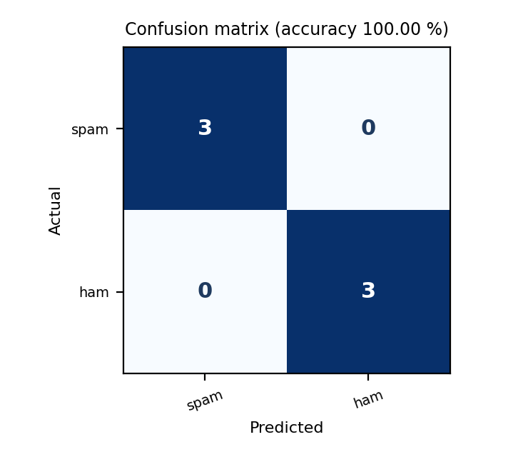

Result
All 6 test messages were classified correctly (accuracy 100 %, precision 1.00, recall 1.00), including the ham message “send the free project report” that contains the spam-like word “free”. The new messages were classified as SPAM and HAM. The test set is very small, so this score should not be over-interpreted.

Problem 4 : Breast Cancer Diagnosis

Aim
To implement Gaussian Naïve Bayes with pandas group-by statistics on a larger medical data set and report the confusion matrix, accuracy, precision, recall and F1-score for each class.

Algorithm
- Collect the labelled training data and compute the prior probability P(C) of every class from the class frequencies.
- For every class and attribute estimate the likelihood P(x | C): frequency counts with Laplace smoothing for categorical or word attributes, mean and variance (Gaussian) for numeric attributes.
- For a new sample compute the score P(C) × P(x₁ | C) × … × P(xₙ | C) for every class, using logarithms to avoid very small numbers.
- Predict the class with the highest score (maximum a posteriori decision).
- Compare the predictions with the true labels of the test data and build the confusion matrix (TP, FN, FP, TN).
- Calculate the accuracy = correct predictions / total predictions, together with precision and recall.

Program:
● ● ● nb_d.py - Python 3
1 # Problem 4: Gaussian Naive Bayes with pandas on Breast Cancer data (precision, recall, F1)
2 import numpy as np
3 import pandas as pd
4 from sklearn.datasets import load_breast_cancer
5
6 bc = load_breast_cancer(as_frame=True)
7 df, names = bc.frame, list(bc.target_names) # 0 = malignant, 1 = benign
8 idx = np.random.default_rng(1).permutation(len(df))
9 train, test = df.iloc[idx[:455]], df.iloc[idx[455:]] # 80 % train, 20 % test
10 features = [c for c in df.columns if c != 'target']
11
12 prior = train['target'].value_counts(normalize=True)
13 mean = train.groupby('target')[features].mean()
14 var = train.groupby('target')[features].var() + 1e-9
15
16 def predict(row_values):
17 best, best_score = None, -np.inf
18 for c in (0, 1):
19 log_pdf = -0.5 * np.log(2 * np.pi * var.loc[c].values) \
20 - (row_values - mean.loc[c].values) ** 2 / (2 * var.loc[c].values)
21 score = np.log(prior[c]) + log_pdf.sum()
22 if score > best_score:
23 best, best_score = c, score
24 return best
25
26 pred = np.array([predict(r) for r in test[features].values])
27 actual = test['target'].values
28
29 labels = names
30 cm = pd.crosstab(pd.Series(actual, name='Actual').map(dict(enumerate(names))),
31 pd.Series(pred, name='Predicted').map(dict(enumerate(names))))
32 cm = cm.reindex(index=names, columns=names, fill_value=0)
33 print("Train:", len(train), "| Test:", len(test), "| Features:", len(features))
34 print("\nConfusion matrix:")
35 print(cm)
36
37 cm = cm.values
38 accuracy = np.trace(cm) / cm.sum()
39 print(f"\nAccuracy = {accuracy * 100:.2f} %")
40 print("Class Precision Recall F1-score")
41 for i, n in enumerate(names):
42 p, r = cm[i, i] / cm[:, i].sum(), cm[i, i] / cm[i].sum()
43 print(f"{n:11s} {p:9.3f} {r:6.3f} {2 * p * r / (p + r):8.3f}")
44

Input
Breast Cancer Wisconsin data set: 569 samples, 30 numeric features and the target Diagnosis (malignant / benign). The data is split 455 training / 114 test, and the mean and variance of every feature are computed per class with groupby. Four of the 30 features are shown below.
Mean radius | Mean texture | Mean perimeter | Mean area | Diagnosis
17.99 | 10.38 | 122.80 | 1001.00 | malignant
20.57 | 17.77 | 132.90 | 1326.00 | malignant
19.69 | 21.25 | 130.00 | 1203.00 | malignant
13.54 | 14.36 | 87.46 | 566.30 | benign
13.08 | 15.71 | 85.63 | 520.00 | benign
9.50 | 12.44 | 60.34 | 273.90 | benign

Output
● ● ● Terminal - Output
$ python nb_d.py
Train: 455 | Test: 114 | Features: 30

Confusion matrix:
Predicted malignant benign
Actual
malignant 32 6
benign 2 74

Accuracy = 92.98 %
Class Precision Recall F1-score
malignant 0.941 0.842 0.889
benign 0.925 0.974 0.949
$ _

Confusion Matrix
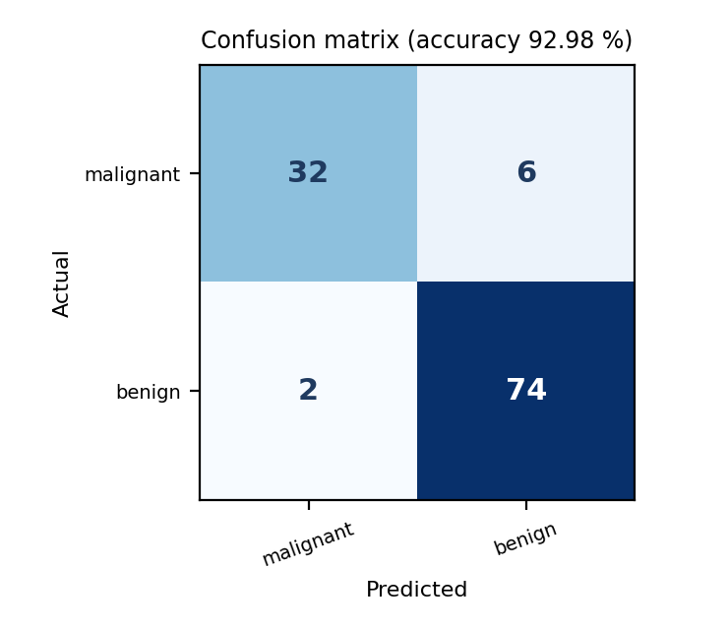

Result
The classifier achieved 92.98 % accuracy (106 of 114 patients). Benign tumours were found very reliably (recall 0.974), but 6 malignant tumours were predicted as benign (malignant recall 0.842, F1 0.889), which is the more serious kind of error in a medical setting.

Problem 5 : Wine Classification (scikit-learn)

Aim
To use the GaussianNB classifier of scikit-learn together with the confusion_matrix, accuracy_score and classification_report functions to evaluate Naïve Bayes on a multi-class data set.

Algorithm
- Collect the labelled training data and compute the prior probability P(C) of every class from the class frequencies.
- For every class and attribute estimate the likelihood P(x | C): frequency counts with Laplace smoothing for categorical or word attributes, mean and variance (Gaussian) for numeric attributes.
- For a new sample compute the score P(C) × P(x₁ | C) × … × P(xₙ | C) for every class, using logarithms to avoid very small numbers.
- Predict the class with the highest score (maximum a posteriori decision).
- Compare the predictions with the true labels of the test data and build the confusion matrix (TP, FN, FP, TN).
- Calculate the accuracy = correct predictions / total predictions, together with precision and recall.

Program:
● ● ● nb_e.py - Python 3
1 # Problem 5: Naive Bayes with scikit-learn on the Wine data set - confusion matrix and report
2 import numpy as np
3 from sklearn.datasets import load_wine
4 from sklearn.model_selection import train_test_split
5 from sklearn.naive_bayes import GaussianNB
6 from sklearn.metrics import confusion_matrix, accuracy_score, classification_report
7
8 wine = load_wine()
9 X, y, labels = wine.data, wine.target, list(wine.target_names)
10 X_tr, X_te, y_tr, y_te = train_test_split(X, y, test_size=0.3, random_state=42, stratify=y)
11 print("Samples:", X.shape[0], "| Features:", X.shape[1], "| Train:", len(X_tr), "| Test:", len(X_te))
12
13 model = GaussianNB()
14 model.fit(X_tr, y_tr)
15 pred = model.predict(X_te)
16
17 cm = confusion_matrix(y_te, pred)
18 print("\nConfusion matrix (rows = actual, columns = predicted):")
19 print(cm)
20 print(f"\nAccuracy = {accuracy_score(y_te, pred) * 100:.2f} %")
21 print("\nClassification report:")
22 print(classification_report(y_te, pred, target_names=labels, digits=3))
23
24 print("Class priors learned :", np.round(model.class_prior_, 3))
25 new = X_te[:1]
26 print("First test sample -> predicted:", labels[model.predict(new)[0]],
27 "| actual:", labels[y_te[0]], "| probabilities:", np.round(model.predict_proba(new)[0], 3))
28

Input
Wine data set: 178 samples, 13 chemical attributes and 3 cultivars. A stratified split gives 124 training / 54 test samples. Four of the 13 attributes are shown below.
Alcohol | Malic acid | Ash | Magnesium | Cultivar
14.23 | 1.71 | 2.43 | 15.60 | class_0
13.20 | 1.78 | 2.14 | 11.20 | class_0
12.37 | 0.94 | 1.36 | 10.60 | class_1
12.33 | 1.10 | 2.28 | 16.00 | class_1
12.86 | 1.35 | 2.32 | 18.00 | class_2
12.88 | 2.99 | 2.40 | 20.00 | class_2

Output
● ● ● Terminal - Output
$ python nb_e.py
Samples: 178 | Features: 13 | Train: 124 | Test: 54

Confusion matrix (rows = actual, columns = predicted):
[[18 0 0]
[ 0 21 0]
[ 0 0 15]]

Accuracy = 100.00 %

Classification report:
precision recall f1-score support

class_0 1.000 1.000 1.000 18
class_1 1.000 1.000 1.000 21
class_2 1.000 1.000 1.000 15

accuracy 1.000 54
macro avg 1.000 1.000 1.000 54
weighted avg 1.000 1.000 1.000 54

Class priors learned : [0.331 0.403 0.266]
First test sample -> predicted: class_0 | actual: class_0 | probabilities: [1. 0. 0.]
$ _

Confusion Matrix
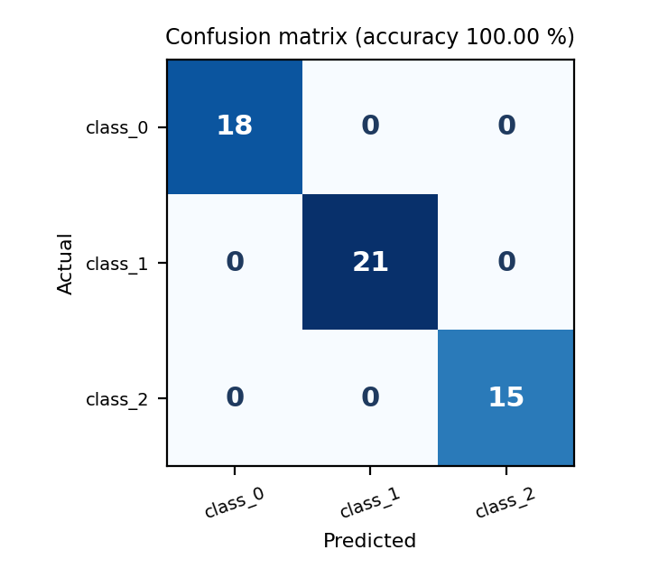

Result
The model classified all 54 test wines correctly (accuracy 100 %, precision, recall and F1 all 1.000 for every class), and the first test sample was assigned to class_0 with probability 1.0. This is a perfect score on one split of a well-separated data set, not a guarantee for other data.

