Machine learning Lab Observation
ITA0614
Experiment 1
Implement and demonstrate the FIND-S algorithm for finding the most specific hypothesis based on a given set of training data samples.
Name : Benita Johnson J
Reg.No : 192412595
Problem 1 : Student Result
Aim
To implement the FIND-S algorithm in Python on student result data stored in a list and to obtain the most specific hypothesis for passing the course.
Algorithm
- Initialise h to the most specific hypothesis in H: h = <0, 0, ..., 0>.
- For each training example x:
(a) If x is a negative example, ignore it.
(b) If x is a positive example, then for each attribute constraint ai in h:
if ai is satisfied by x, do nothing; otherwise replace ai by the next more general constraint that is satisfied by x (the first positive example copies its values; later mismatches become "?").
- Output the hypothesis h.
Program:
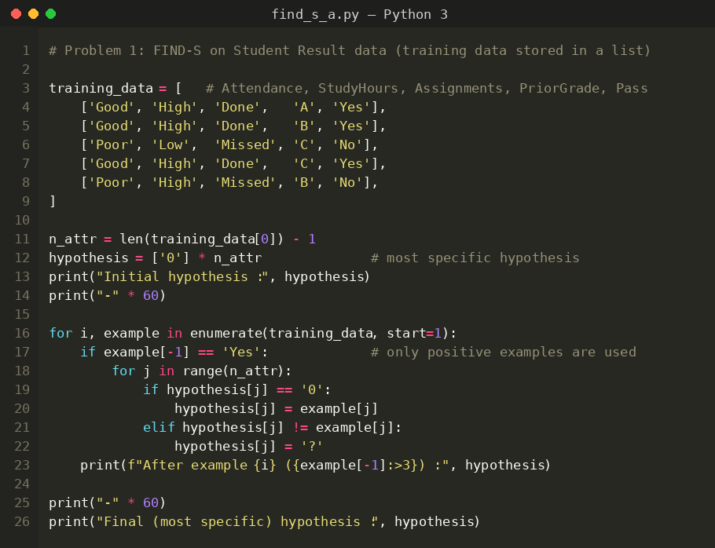
Input
Student Result data set: 5 training examples, 4 attributes (Attendance, StudyHours, Assignments, PriorGrade) and the target concept Pass (Yes = positive, No = negative). The data is hard-coded in the program as a list of lists.
Attendance | StudyHours | Assignments | PriorGrade | Pass
Good | High | Done | A | Yes
Good | High | Done | B | Yes
Poor | Low | Missed | C | No
Good | High | Done | C | Yes
Poor | High | Missed | B | No
Output
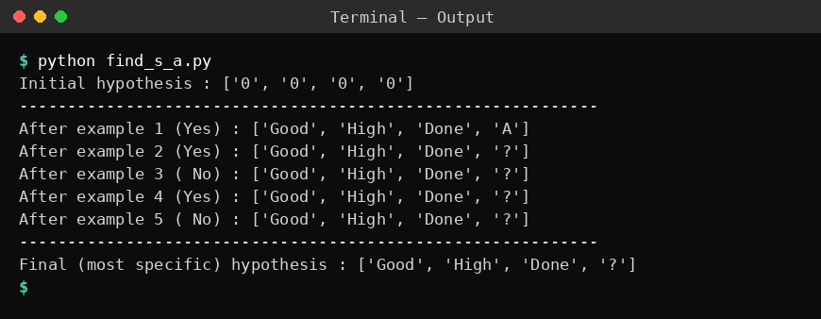
Result
The FIND-S algorithm was implemented and executed successfully. The most specific hypothesis consistent with the positive examples is <Good, High, Done, ?>: a student passes when attendance is good, study hours are high and assignments are done, whatever the prior grade. The negative examples did not change the hypothesis.
Problem 2: Movie Preference
Aim
To implement the FIND-S algorithm by reading movie preference training examples from a .CSV file using the csv module of Python.
Algorithm
- Initialise h to the most specific hypothesis in H: h = <0, 0, ..., 0>.
- For each training example x:
(a) If x is a negative example, ignore it.
(b) If x is a positive example, then for each attribute constraint ai in h:
if ai is satisfied by x, do nothing; otherwise replace ai by the next more general constraint that is satisfied by x (the first positive example copies its values; later mismatches become "?").
- Output the hypothesis h.
Program:
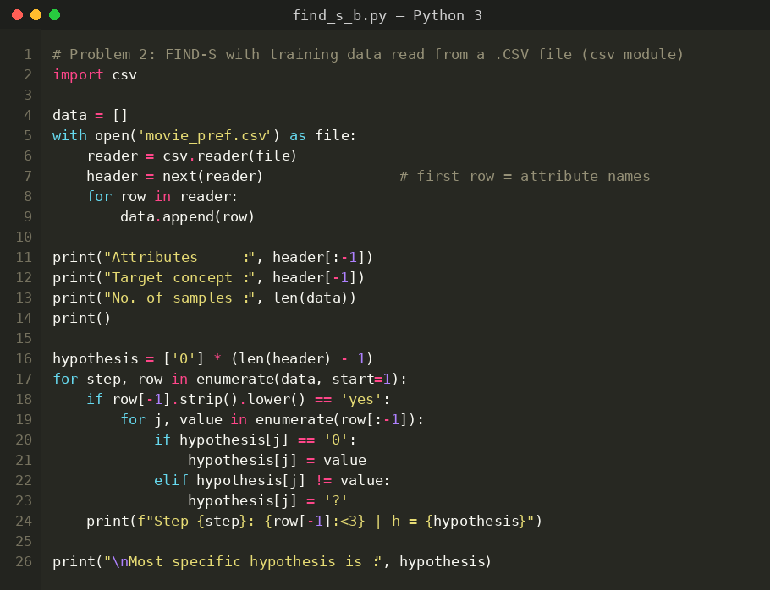
Input
Movie Preference data set (movie_pref.csv): 5 examples, 4 attributes (Genre, Language, Rating, Length) and the target concept Watch (Yes / No). The first row of the file holds the attribute names.
Genre | Language | Rating | Length | Watch
Action | English | High | Long | Yes
Comedy | Tamil | Low | Short | No
Action | English | High | Short | Yes
Action | English | Medium | Long | Yes
Drama | English | High | Long | No
Output
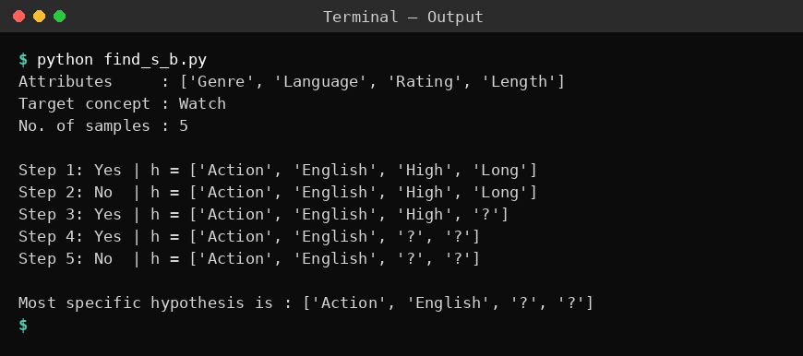
Result
The FIND-S algorithm was executed on the data read from the CSV file. The most specific hypothesis obtained is <Action, English, ?, ?>, i.e. the person watches a movie when it is an English Action movie, irrespective of rating and length.
Problem 3: Car Purchase
Aim
To implement the FIND-S algorithm using pandas DataFrame operations and find the most specific hypothesis for the Car Purchase data.
Algorithm
- Initialise h to the most specific hypothesis in H: h = <0, 0, ..., 0>.
- For each training example x:
(a) If x is a negative example, ignore it.
(b) If x is a positive example, then for each attribute constraint ai in h:
if ai is satisfied by x, do nothing; otherwise replace ai by the next more general constraint that is satisfied by x (the first positive example copies its values; later mismatches become "?").
- Output the hypothesis h.
Program:
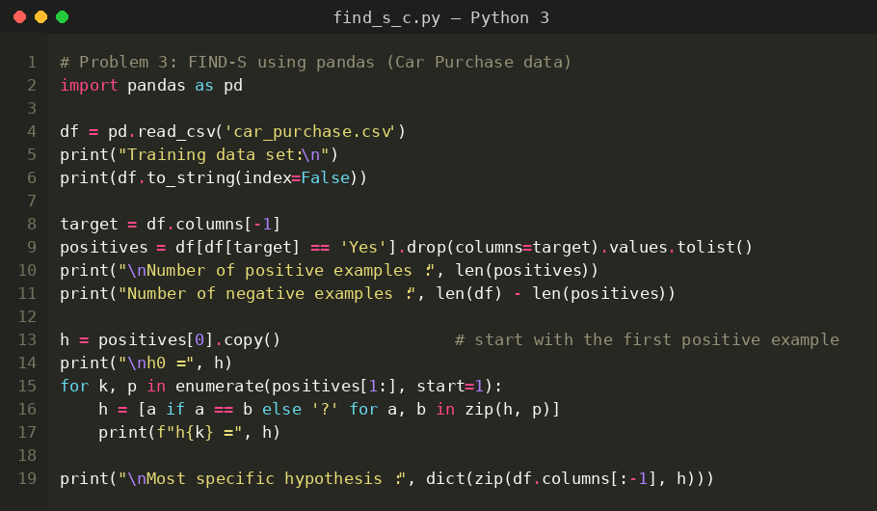
Input
Car Purchase data set (car_purchase.csv): 6 examples, 4 attributes (Fuel, Mileage, Seats, Price) and the target concept Buy (Yes / No), loaded into a pandas DataFrame.
Fuel | Mileage | Seats | Price | Buy
Petrol | High | 5 | Medium | Yes
Diesel | Low | 7 | High | No
Petrol | High | 5 | Low | Yes
Petrol | Low | 5 | Medium | No
Petrol | High | 7 | Medium | Yes
CNG | Low | 5 | High | No
Output
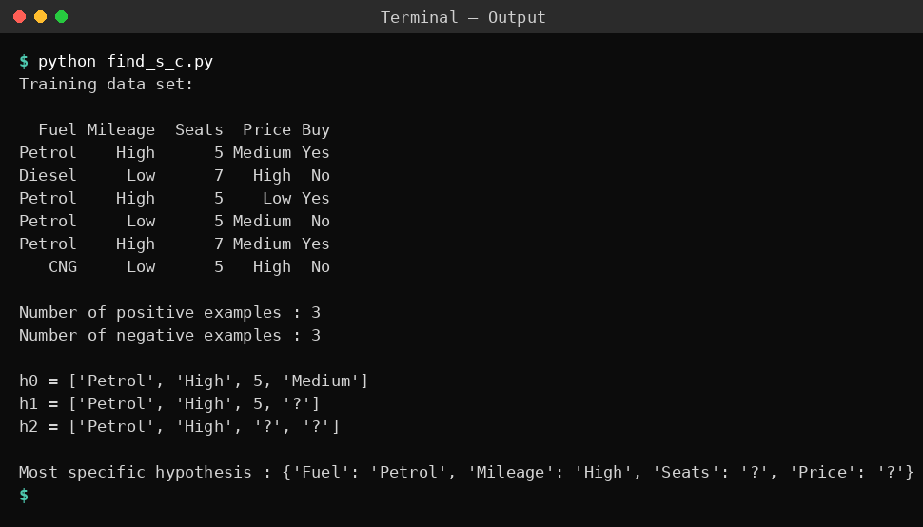
Result
FIND-S was implemented with pandas. The most specific hypothesis is <Petrol, High, ?, ?>: the car is bought when the fuel is Petrol and the mileage is High, irrespective of the number of seats and the price.
Problem 4: Spam Email
Aim
To implement FIND-S using user-defined functions, show the hypothesis after every training example in a trace table and use the learned hypothesis to classify new emails.
Algorithm
- Initialise h to the most specific hypothesis in H: h = <0, 0, ..., 0>.
- For each training example x:
(a) If x is a negative example, ignore it.
(b) If x is a positive example, then for each attribute constraint ai in h:
if ai is satisfied by x, do nothing; otherwise replace ai by the next more general constraint that is satisfied by x (the first positive example copies its values; later mismatches become "?").
- Output the hypothesis h.
Program:
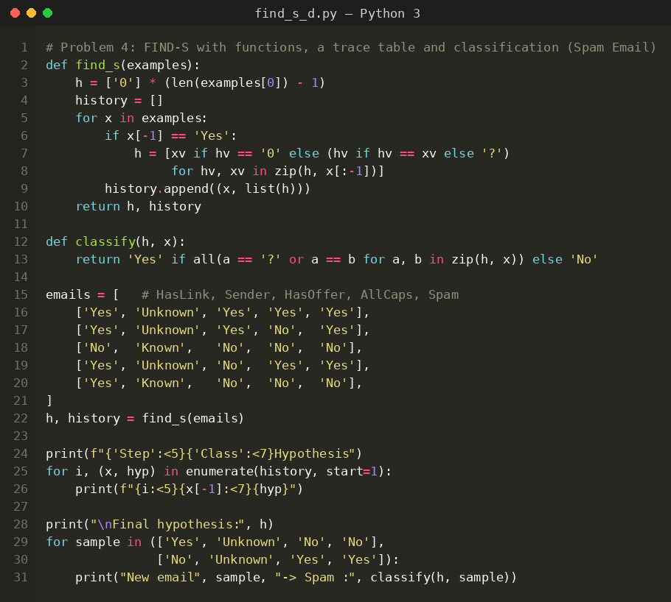
Input
Spam Email data set: 5 examples, 4 attributes (HasLink, Sender, HasOffer, AllCaps) and the target concept Spam (Yes / No). The data is stored in the program.
HasLink | Sender | HasOffer | AllCaps | Spam
Yes | Unknown | Yes | Yes | Yes
Yes | Unknown | Yes | No | Yes
No | Known | No | No | No
Yes | Unknown | No | Yes | Yes
Yes | Known | No | No | No
Output
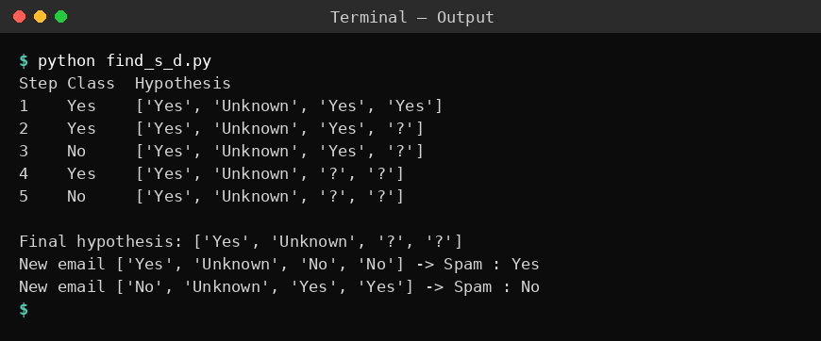
Result
The most specific hypothesis found is <Yes, Unknown, ?, ?>. Using it, the new email (Yes, Unknown, No, No) is classified as spam (Yes) and (No, Unknown, Yes, Yes) as not spam (No).
Problem 5: Job Selection
Aim
To implement FIND-S using NumPy arrays and verify that the hypothesis covers all positive and no negative examples of the job selection data.
Algorithm
- Initialise h to the most specific hypothesis in H: h = <0, 0, ..., 0>.
- For each training example x:
(a) If x is a negative example, ignore it.
(b) If x is a positive example, then for each attribute constraint ai in h:
if ai is satisfied by x, do nothing; otherwise replace ai by the next more general constraint that is satisfied by x (the first positive example copies its values; later mismatches become "?").
- Output the hypothesis h.
Program:
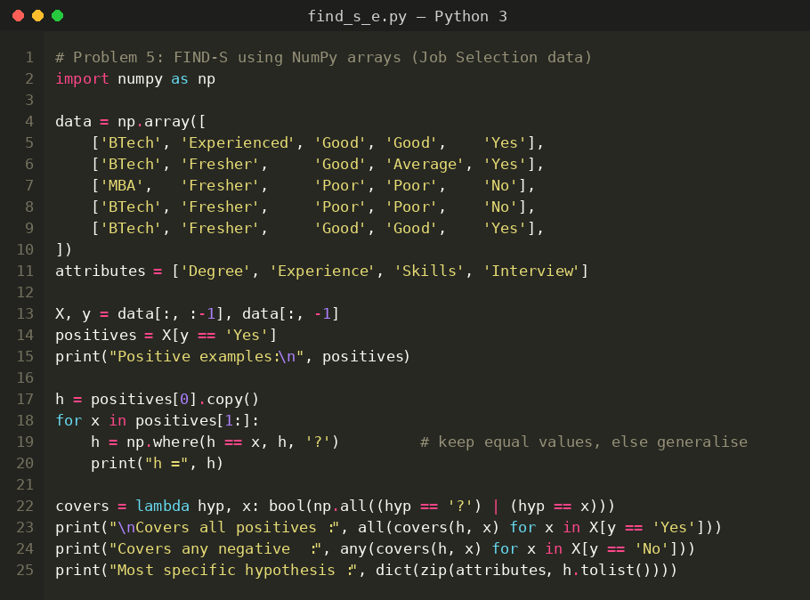
Input
Job Selection data set: 5 examples, 4 attributes (Degree, Experience, Skills, Interview) and the target concept Selected (Yes / No), stored as a NumPy string array.
Degree | Experience | Skills | Interview | Selected
BTech | Experienced | Good | Good | Yes
BTech | Fresher | Good | Average | Yes
MBA | Fresher | Poor | Poor | No
BTech | Fresher | Poor | Poor | No
BTech | Fresher | Good | Good | Yes
Output
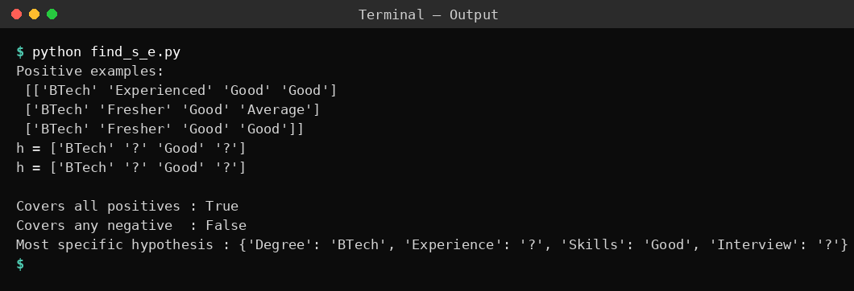
Result
The most specific hypothesis obtained is <BTech, ?, Good, ?>. The verification shows that it covers all positive examples and none of the negative examples, so a candidate is selected when the degree is BTech and the skills are Good.

