Machine learning Lab Observation
ITA0614
Experiment 2
For a given set of training data examples stored in a .CSV file, implement and demonstrate the Candidate-Elimination algorithm in python to output a description of the set of all hypotheses consistent with the training examples.
Name : Benita Johnson J
Reg.No : 192412595
Problem 1 : Outdoor Play
Aim
To implement the Candidate-Elimination algorithm on the Outdoor Play training data stored in a .CSV file and output the S and G boundary sets of the version space.
Algorithm
- Initialise G to the maximally general hypothesis, <?, ?, ..., ?>, and S to the maximally specific hypothesis, <0, 0, ..., 0>.
- For each training example d:
If d is a positive example: remove from G every hypothesis inconsistent with d. For each s in S that is inconsistent with d, remove s and add all minimal generalisations h of s such that h is consistent with d and some member of G is more general than h. Remove from S any hypothesis that is more general than another hypothesis in S.
If d is a negative example: remove from S every hypothesis inconsistent with d. For each g in G that is inconsistent with d, remove g and add all minimal specialisations h of g such that h is consistent with d and some member of S is more specific than h. Remove from G any hypothesis that is less general than another hypothesis in G.
- Output the boundary sets S and G (the version space lies between them).
Program:
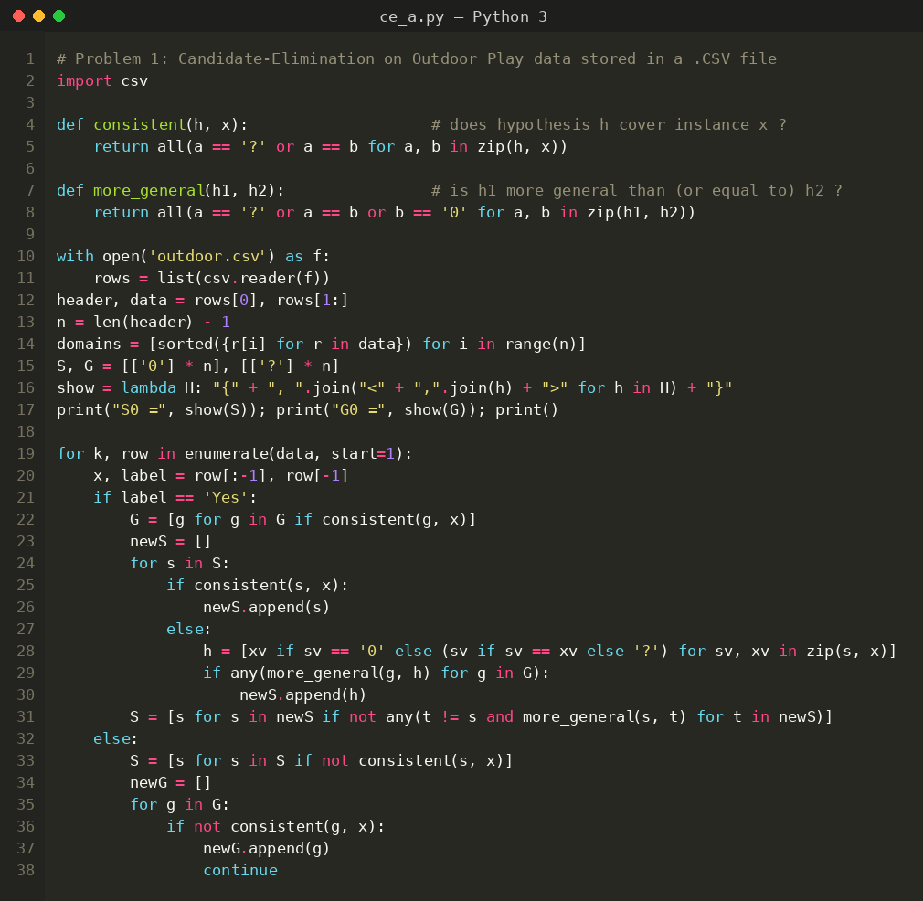
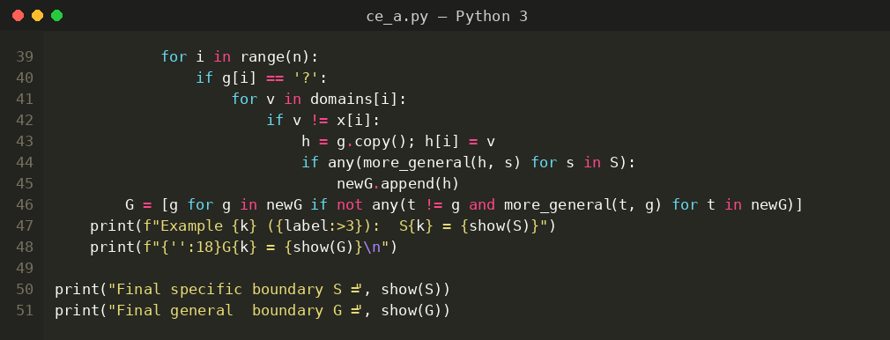
Input
Outdoor Play data set (outdoor.csv): 5 examples, 4 attributes (Outlook, Temp, Humidity, Wind) and the target concept PlayOutside (Yes / No). The attribute domains are taken automatically from the file.
Outlook | Temp | Humidity | Wind | PlayOutside
Sunny | Warm | Normal | Weak | Yes
Sunny | Warm | High | Weak | Yes
Rainy | Cold | High | Strong | No
Sunny | Warm | High | Strong | Yes
Cloudy | Warm | Normal | Weak | No
Output
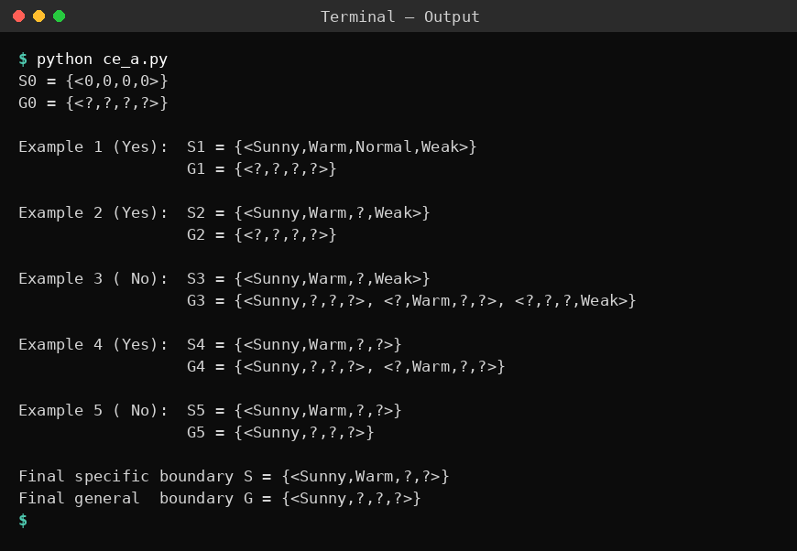
Result
The version space for the Outdoor Play data is bounded by S = {<Sunny, Warm, ?, ?>} and G = {<Sunny, ?, ?, ?>}. The hypothesis <?, Warm, ?, ?> was removed from G after the fifth example (Cloudy, Warm, Normal, Weak), which is a negative example that it wrongly covered.
Problem 2: Smartphone Purchase
Aim
To implement the Candidate-Elimination algorithm using the pandas library on smartphone purchase data and to find the boundary sets S and G.
Algorithm
- Initialise G to the maximally general hypothesis, <?, ?, ..., ?>, and S to the maximally specific hypothesis, <0, 0, ..., 0>.
- For each training example d:
If d is a positive example: remove from G every hypothesis inconsistent with d. For each s in S that is inconsistent with d, remove s and add all minimal generalisations h of s such that h is consistent with d and some member of G is more general than h. Remove from S any hypothesis that is more general than another hypothesis in S.
If d is a negative example: remove from S every hypothesis inconsistent with d. For each g in G that is inconsistent with d, remove g and add all minimal specialisations h of g such that h is consistent with d and some member of S is more specific than h. Remove from G any hypothesis that is less general than another hypothesis in G.
- Output the boundary sets S and G (the version space lies between them).
Program:
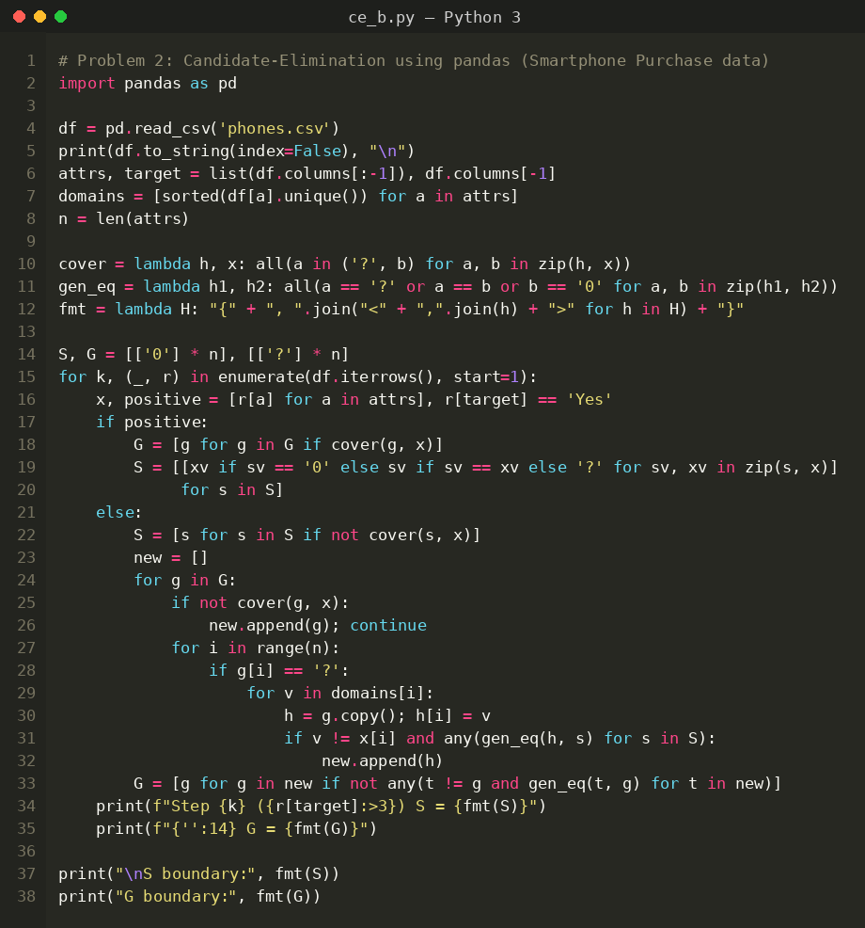
Input
Smartphone Purchase data set (phones.csv): 5 examples, 4 attributes (Brand, RAM, Camera, Price) and the target concept Buy (Yes / No), loaded as a pandas DataFrame.
Brand | RAM | Camera | Price | Buy
Samsung | 8GB | Good | High | Yes
Samsung | 8GB | Good | Low | Yes
Xiaomi | 4GB | Average | Low | No
Samsung | 4GB | Good | High | Yes
Apple | 8GB | Average | High | No
Output
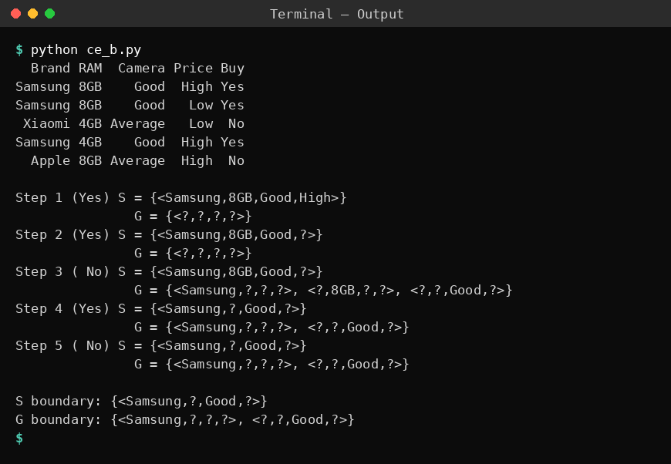
Result
After processing all five examples the boundaries are S = {<Samsung, ?, Good, ?>} and G = {<Samsung, ?, ?, ?>, <?, ?, Good, ?>}. Every hypothesis between these two boundaries is consistent with the smartphone training data.
Problem 3: Animal Classification
Aim
To implement the Candidate-Elimination algorithm in the form in which S is initialised with the first positive training example, using animal classification data from a .CSV file.
Algorithm
- Initialise G to the maximally general hypothesis, <?, ?, ..., ?>, and S to the maximally specific hypothesis, <0, 0, ..., 0>.
- For each training example d:
If d is a positive example: remove from G every hypothesis inconsistent with d. For each s in S that is inconsistent with d, remove s and add all minimal generalisations h of s such that h is consistent with d and some member of G is more general than h. Remove from S any hypothesis that is more general than another hypothesis in S.
If d is a negative example: remove from S every hypothesis inconsistent with d. For each g in G that is inconsistent with d, remove g and add all minimal specialisations h of g such that h is consistent with d and some member of S is more specific than h. Remove from G any hypothesis that is less general than another hypothesis in G.
- Output the boundary sets S and G (the version space lies between them).
Program:
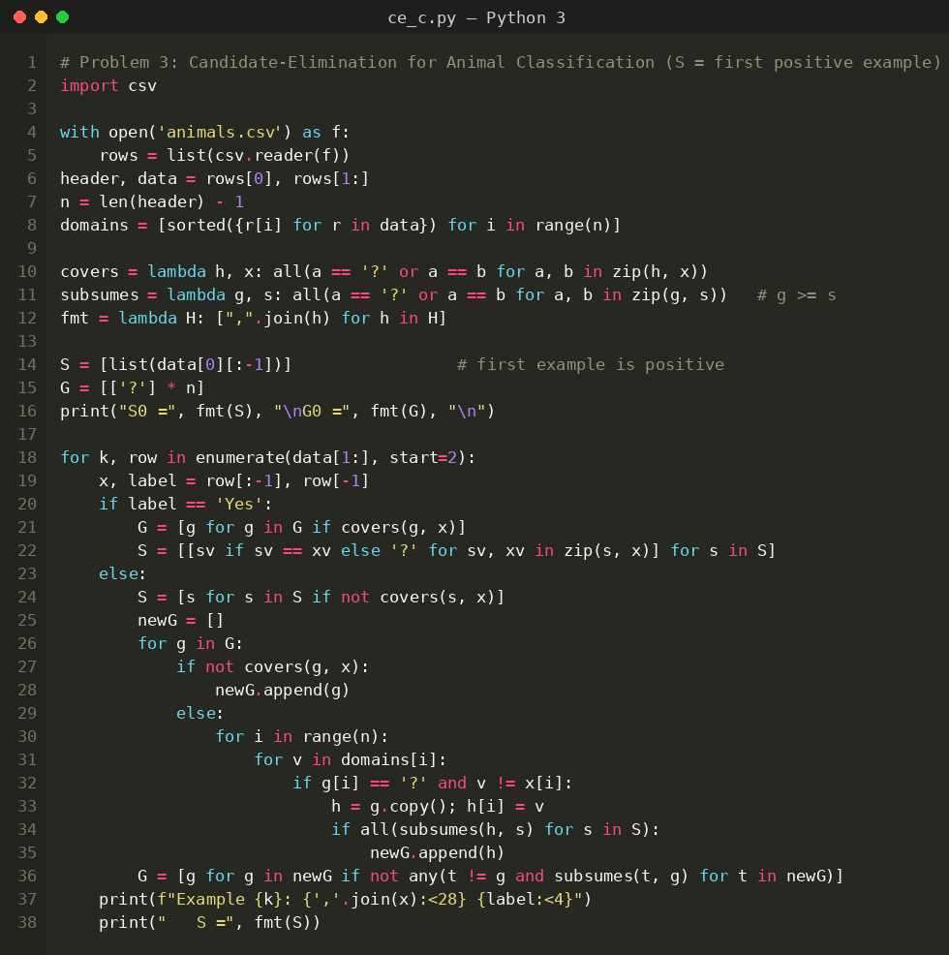
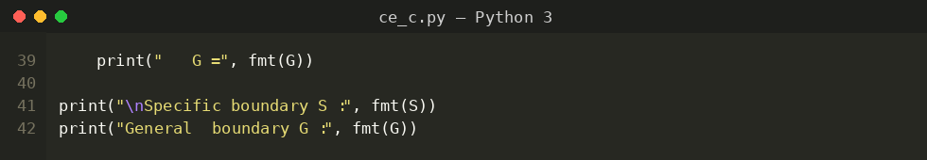
Input
Animal data set (animals.csv): 5 examples, 4 attributes (BodyCover, Habitat, Legs, Diet) and the target concept Mammal (Yes / No). The first row of data is a positive example.
BodyCover | Habitat | Legs | Diet | Mammal
Fur | Land | Four | Herbivore | Yes
Fur | Land | Four | Carnivore | Yes
Feathers | Air | Two | Carnivore | No
Fur | Water | None | Carnivore | Yes
Scales | Water | None | Carnivore | No
Output
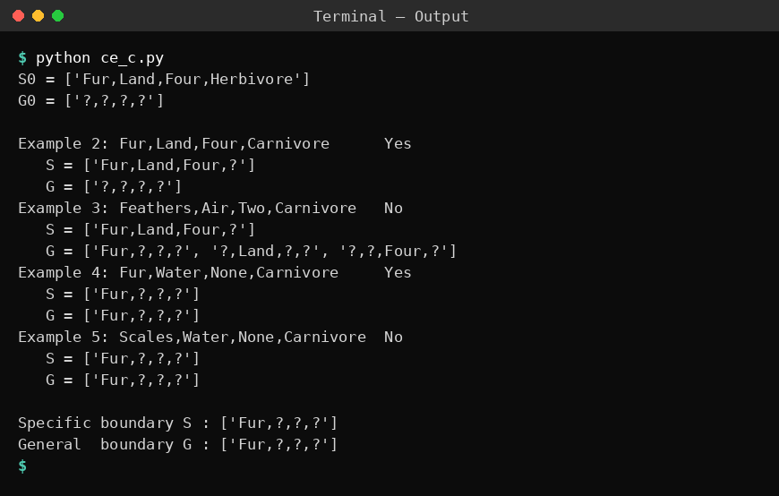
Result
Both boundaries converge to the single hypothesis S = G = {<Fur, ?, ?, ?>}. The version space contains only this hypothesis, so an animal is a mammal if and only if its body cover is Fur.
Problem 4: Hotel Booking
Aim
To implement Candidate-Elimination as a Python class and to enumerate every hypothesis of the version space that lies between the S and G boundaries for hotel booking data.
Algorithm
- Initialise G to the maximally general hypothesis, <?, ?, ..., ?>, and S to the maximally specific hypothesis, <0, 0, ..., 0>.
- For each training example d:
If d is a positive example: remove from G every hypothesis inconsistent with d. For each s in S that is inconsistent with d, remove s and add all minimal generalisations h of s such that h is consistent with d and some member of G is more general than h. Remove from S any hypothesis that is more general than another hypothesis in S.
If d is a negative example: remove from S every hypothesis inconsistent with d. For each g in G that is inconsistent with d, remove g and add all minimal specialisations h of g such that h is consistent with d and some member of S is more specific than h. Remove from G any hypothesis that is less general than another hypothesis in G.
- Output the boundary sets S and G (the version space lies between them).
Program:
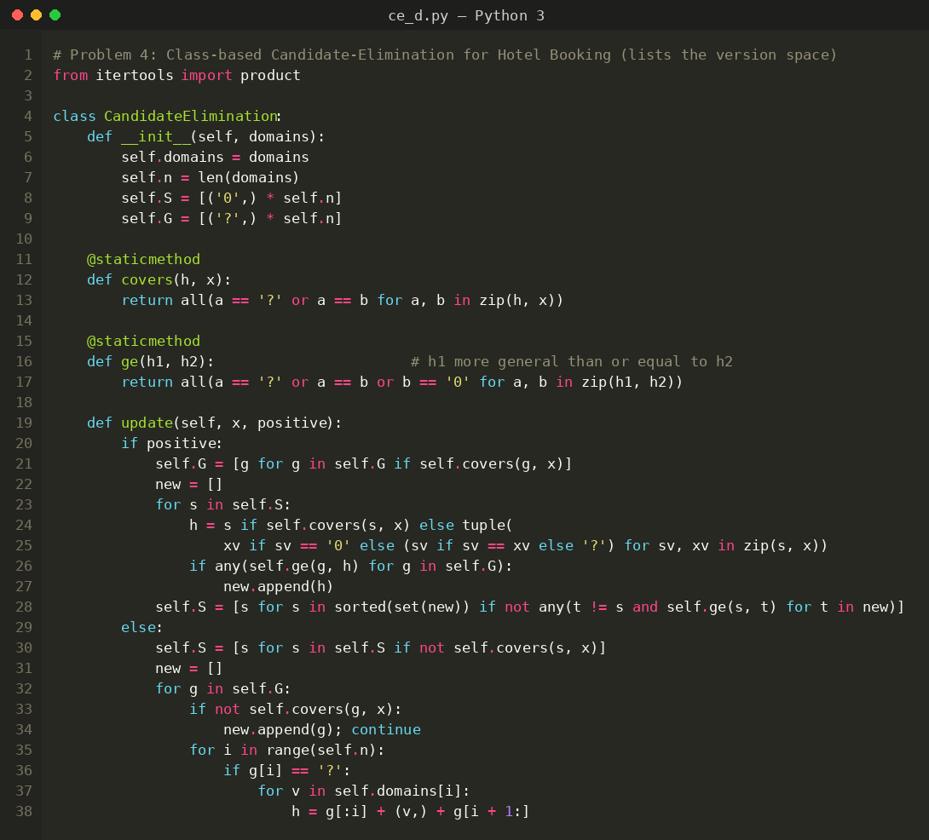
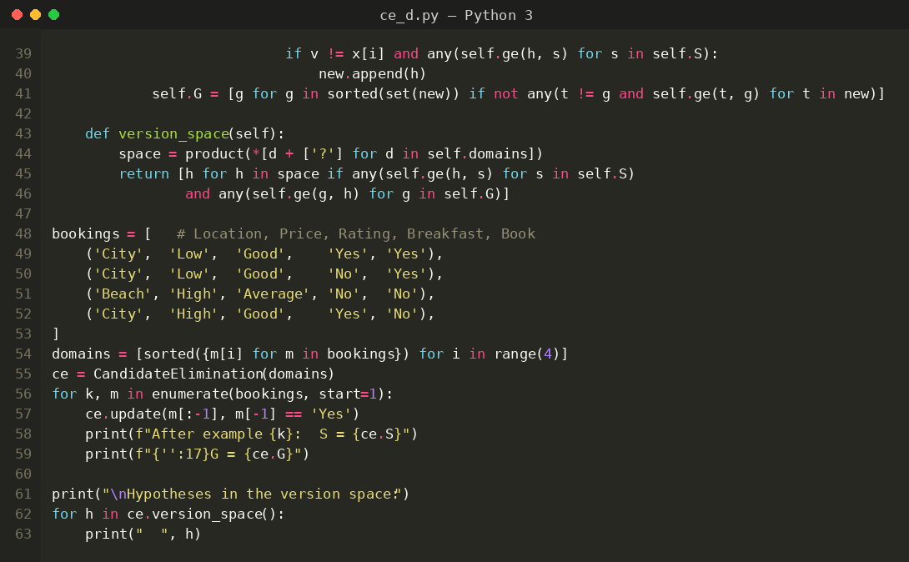
Input
Hotel Booking data set: 4 examples, 4 attributes (Location, Price, Rating, Breakfast) and the target concept Book (Yes / No). The data is stored in the program as tuples.
Location | Price | Rating | Breakfast | Book
City | Low | Good | Yes | Yes
City | Low | Good | No | Yes
Beach | High | Average | No | No
City | High | Good | Yes | No
Output
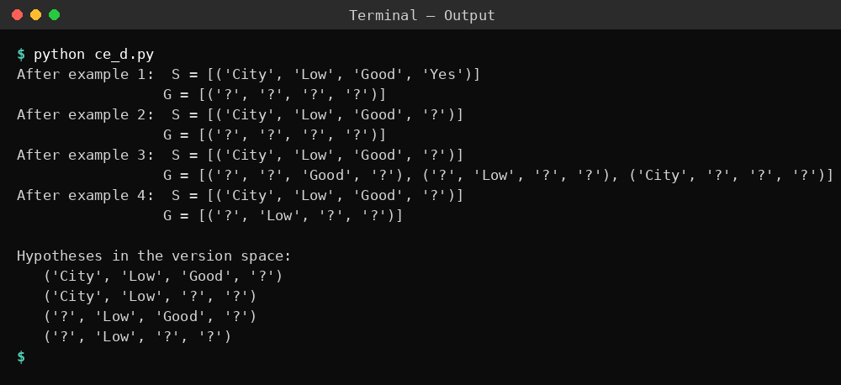
Result
The final boundaries are S = {<City, Low, Good, ?>} and G = {<?, Low, ?, ?>}. The version space contains exactly four hypotheses: <City, Low, Good, ?>, <City, Low, ?, ?>, <?, Low, Good, ?> and <?, Low, ?, ?>.
Problem 5: Customer Purchase
Aim
To apply the Candidate-Elimination algorithm to customer purchase data and to use the S and G boundaries to classify new customers.
Algorithm
- Initialise G to the maximally general hypothesis, <?, ?, ..., ?>, and S to the maximally specific hypothesis, <0, 0, ..., 0>.
- For each training example d:
If d is a positive example: remove from G every hypothesis inconsistent with d. For each s in S that is inconsistent with d, remove s and add all minimal generalisations h of s such that h is consistent with d and some member of G is more general than h. Remove from S any hypothesis that is more general than another hypothesis in S.
If d is a negative example: remove from S every hypothesis inconsistent with d. For each g in G that is inconsistent with d, remove g and add all minimal specialisations h of g such that h is consistent with d and some member of S is more specific than h. Remove from G any hypothesis that is less general than another hypothesis in G.
- Output the boundary sets S and G (the version space lies between them).
Program:
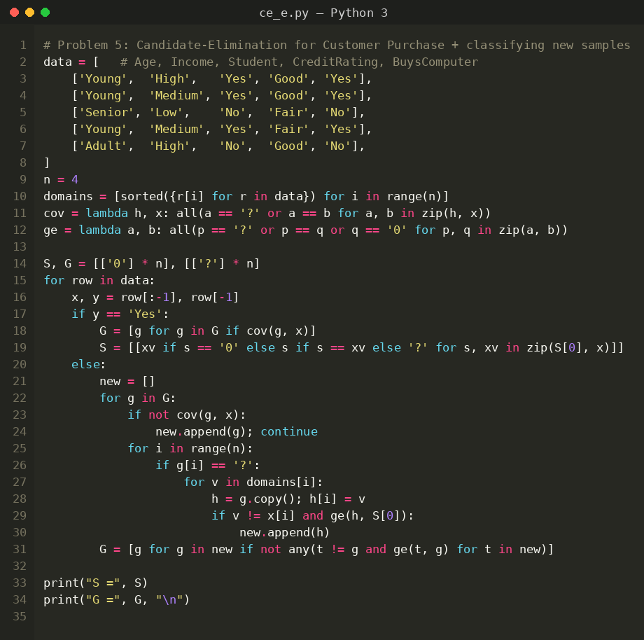
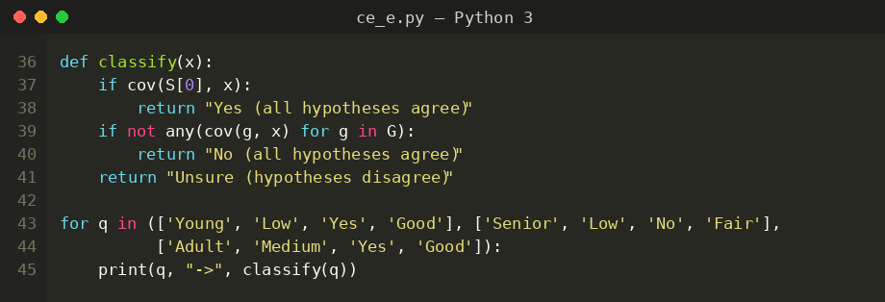
Input
Customer Purchase data set: 5 examples, 4 attributes (Age, Income, Student, CreditRating) and the target concept BuysComputer (Yes / No).
Age | Income | Student | CreditRating | BuysComputer
Young | High | Yes | Good | Yes
Young | Medium | Yes | Good | Yes
Senior | Low | No | Fair | No
Young | Medium | Yes | Fair | Yes
Adult | High | No | Good | No
Output
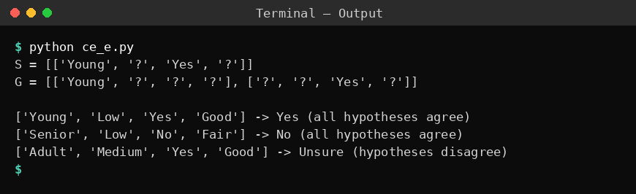
Result
The boundaries obtained are S = {<Young, ?, Yes, ?>} and G = {<Young, ?, ?, ?>, <?, ?, Yes, ?>}. Using them, (Young, Low, Yes, Good) is classified Yes, (Senior, Low, No, Fair) is classified No, and (Adult, Medium, Yes, Good) cannot be classified with certainty because the hypotheses of the version space disagree.

