Software Architecture and Design Specification
Field | Detail
Project | Online Internship & Placement Preparation Portal
Version | 1.0
Authors | Team 12
Date | 16-09-2026
Status | Final

Revision History
Version | Date | Author | Change Summary
1.0 | 16-09-2026 | Team 12 | Initial SAD

Approvals
Role | Name | Signature/Date
Project Guide | ________________ | ________________
Team Representative | ________________ | ________________

1. Introduction

1.1 Purpose
This document specifies the architecture and design of the Online Internship & Placement Preparation Portal. It translates the project SRS into implementable architecture, components, interfaces, security controls and design flows.

1.2 Scope
Covers student and recruiter registration/authentication, internship listing and search, applications and status tracking, timed aptitude tests, student progress dashboards, placement analytics, recruiter verification, administration and notifications.

1.3 Audience
Developers, QA engineers, project guides/instructors, evaluators, administrators and maintenance teams.

1.4 Definitions
JWT – JSON Web Token; RBAC – Role-Based Access Control; REST – Representational State Transfer; OTP – One-Time Password; API – Application Programming Interface; PII – Personally Identifiable Information; TLS – Transport Layer Security; UI – User Interface.

2. Document Overview

2.1 How to use this document
Provides architectural and design deliverables including component architecture, architecture rationale, technology stack, risks, requirement traceability, security architecture, sequence diagrams, API design, error handling, UX design and open issues.

2.2 Related Documents
SRS – Online Internship & Placement Preparation Portal; Software Test Plan (STP); Requirements Traceability Matrix (RTM), where maintained.

3. Architecture

3.1 Goals & Constraints
Goals: secure, modular, responsive and maintainable portal; internship search and applications; timed aptitude preparation and auto-grading; dashboards and analytics; role-based access. Constraints: MERN-based implementation, MongoDB, HTTPS/TLS, bcrypt, JWT, RBAC, time-bound aptitude-test tokens and the performance, availability and security targets in the SRS.

3.2 Stakeholders & Concerns
Stakeholder | Concerns
Students | Registration, internship search, applications, secure tests, dashboard and progress.
Recruiters | Listing creation, applicant review, status updates and controlled access.
Administrators / Placement Cell | Recruiter verification, management, analytics and auditability.
Developers | Modularity, maintainability, clear APIs and testability.
QA / Evaluators | Traceability, interfaces, error handling, security and test coverage.

3.3 Component (UML) Diagram
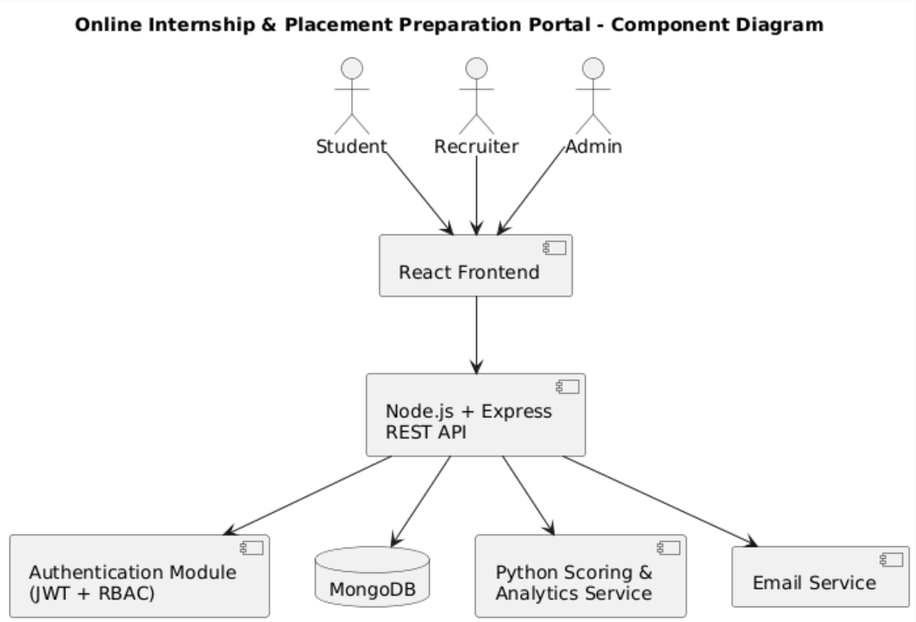
Figure 1. Component UML Diagram – Online Internship & Placement Preparation Portal

3.4 Component Descriptions
Component | Description
React Web UI | Handles user input/output, dashboards, forms, internship search, application screens and aptitude-test interface.
Authentication & Authorization | Registration, verification, login, JWT validation, bcrypt password verification, RBAC and lockout.
Node.js + Express API | REST endpoints and application/business logic.
Listing & Application Services | Internship listings, search/filtering, applications and status transitions.
Test & Scoring Services | Timed tests and Python scoring/analytics integration.
MongoDB Atlas | Users, recruiters, internships, applications, tests, attempts, notifications and audit records.
Email Service | Verification, OTP and application/status notifications.
Audit Logging | Authentication and administrative action records.

3.5 Chosen Architecture Pattern and Rationale
Layered architecture is chosen to separate presentation, application/API, data and supporting services. It supports modular implementation, testing and maintenance. Microservices are not selected for the initial project because they add deployment and operational complexity beyond the stated scope.

3.6 Technology Stack & Data Stores
Area | Technology / Design
Frontend | React.js responsive web interface
Backend | Node.js with Express.js REST APIs
Database | MongoDB / MongoDB Atlas with Mongoose
Security | HTTPS/TLS, JWT, bcrypt, RBAC, input validation
Scoring / Analytics | Python scripts/services
Notifications | Email service using SMTP or equivalent provider
Tools | Git/GitHub, draw.io/PlantUML-style UML, API testing/documentation tools

3.7 Risks & Mitigations
Risk | Mitigation
Database/service outage | Managed MongoDB deployment, health checks, monitoring and error handling.
Unauthorized access | JWT, RBAC, ownership checks and recruiter verification.
Credential compromise | bcrypt, TLS and account lockout.
Aptitude-test misuse | Time-bound tokens and server-side session validation.
Email failure | Retry transient failures and record delivery failures.
Slow queries | Indexes, pagination, efficient filters and load testing.
PII/resume exposure | Role-based access, ownership checks and secure file handling.

3.8 Traceability to Requirements
Requirement Group | Architectural Mapping
IPP-F-001 to F-005 | Authentication/authorization, React UI, MongoDB and email.
IPP-F-006 to F-009 | Listing service, search/filter API, MongoDB and notifications.
IPP-F-010 to F-013 | Application service, React UI, MongoDB and notifications.
IPP-F-014 to F-016 | Test service, timed tokens, Python scoring and MongoDB.
IPP-F-017 to F-019 | Analytics/scoring, dashboard UI and MongoDB.
IPP-F-020 to F-021 | Admin UI/API, RBAC and MongoDB.

3.9 Security Architecture
Security uses TLS 1.2+, salted bcrypt password hashing, JWT authentication, RBAC, server-side lockout, recruiter verification, time-bound aptitude-test tokens and audit logging. Threat considerations include spoofing → authentication; tampering → HTTPS and validation; information disclosure → RBAC and ownership checks; denial of service → rate limiting; elevation of privilege → RBAC and admin-only operations.

4. Design

4.1 Design Overview
The portal uses layered modules for separation of concerns. React manages presentation; Express handles business logic and security middleware; MongoDB provides persistence; Python and email services provide scoring, analytics and notifications.

4.2 UML Sequence Diagrams
The following project-specific sequence flows illustrate the interaction between the Student, React Frontend, Node.js/Express API, database, authentication module, and scoring service: (1) Student Login, Internship Search and Application; and (2) Timed Aptitude Test and Automatic Scoring.
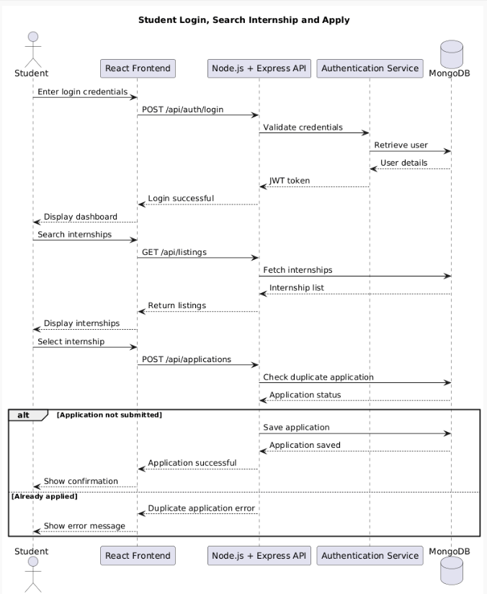
Figure 2. Sequence Diagram – Student Login, Search Internship and Apply
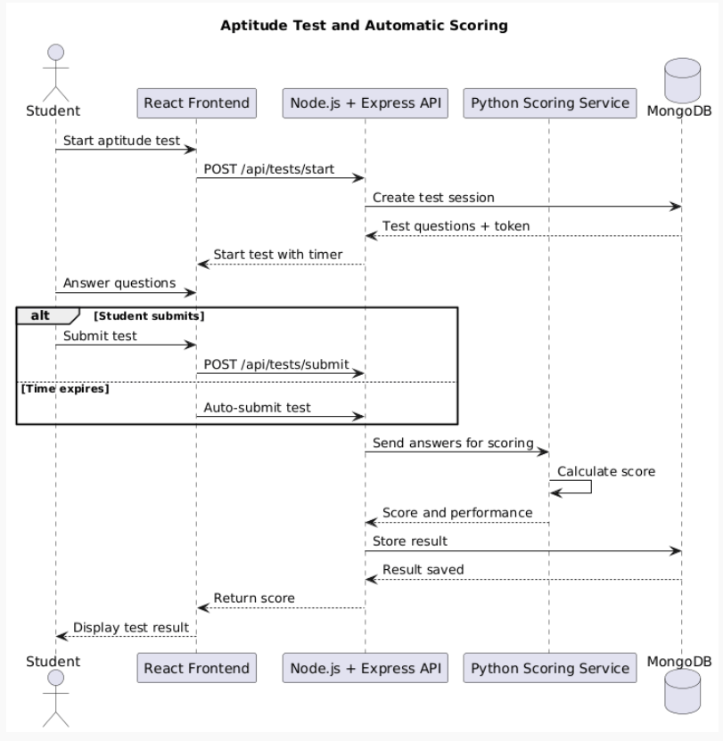
Figure 3. Sequence Diagram – Aptitude Test and Automatic Scoring

4.3 API Design
Method | Endpoint | Request / Input | Response / Output | Errors
POST | /api/auth/login | {email,password} | {token,user} | 401 invalid; 429 rate limit
GET | /api/listings | Query filters | {listings,pagination} | 400 invalid; 500 server error
POST | /api/applications | {listingId,resumeRef,coverLetter} | {applicationId,status} | 400 invalid; 409 duplicate
POST | /api/tests/start | {testId} | {sessionToken,questions,expiresAt} | 401/403 unauthorized; 404 not found
POST | /api/tests/submit | {sessionToken,answers} | {score,attemptId} | 400 invalid; 401/403 expired
PATCH | /api/applications/:id/status | {status} | {applicationId,status} | 401/403 unauthorized; 404 not found

4.4 Error Handling, Logging & Monitoring
Use standardized HTTP status codes and safe client-facing messages. Do not log passwords, OTPs or sensitive internal errors. Monitor API response time, failed authentication rate, application failures, test submission failures, database errors and service availability.

4.5 UX Design
Separate Student, Recruiter and Admin dashboards; clear validation messages; internship search filters; visible aptitude-test countdown and submission status; responsive desktop/mobile UI; accessibility aligned with the project requirement.

4.6 Open Issues & Next Steps
Open Issue / Next Step | Planned Action
Finalize production email provider | Configure provider and integration testing.
Finalize deployment | Configure staging/production with HTTPS.
Finalize analytics boundary | Confirm Python analytics interface and dashboard metrics.
Update UML/RTM | Revise when implementation requirements change.
Security validation | Perform security-focused integration testing before release.

5. Appendices

5.1 Glossary
Term | Meaning
API | Application Programming Interface
JWT | JSON Web Token
RBAC | Role-Based Access Control
OTP | One-Time Password
PII | Personally Identifiable Information
REST | Representational State Transfer
TLS | Transport Layer Security
UI | User Interface

5.2 References
Software Requirements Specification – Online Internship & Placement Preparation Portal, Version 1.0. Software Test Plan – Online Internship & Placement Preparation Portal, Version 1.0. OWASP Top 10 (2021). WCAG 2.1 AA.

5.3 Tools
Git and GitHub; draw.io / PlantUML-style UML diagramming; React.js; Node.js/Express; MongoDB/Mongoose; Python; API testing/documentation tools.

