Using Mongodb Atlas to store the dataset of Denzel movies.

1.

❯ curl -H "Accept: application/json" http://localhost:9292/movies/populate

{

"total": 56

}

2. node sandbox.js

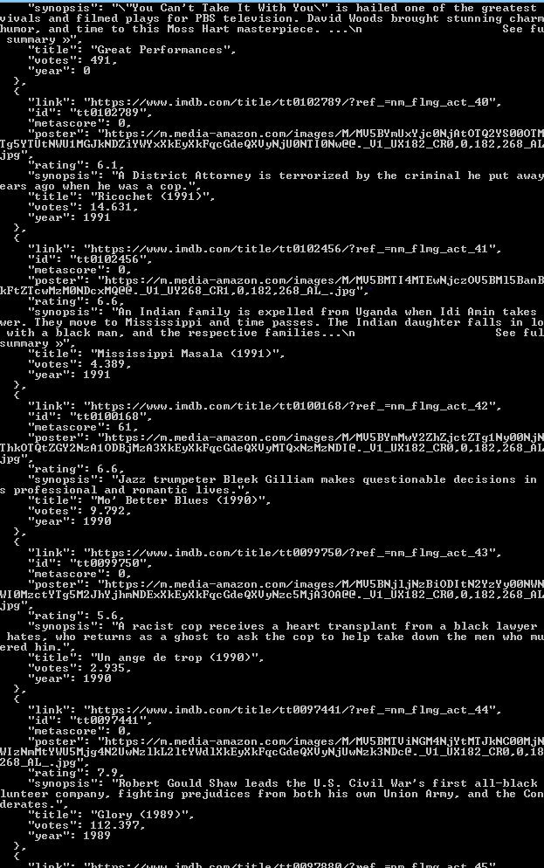

3.GET /movies

❯ curl -H "Accept: application/json" http://localhost:9292/movies

{

"id": "tt0765429",

"link": "https://www.imdb.com/title/tt0765429/?ref_=nm_flmg_act_13",

"metascore": 76,

"poster": "https://m.media-amazon.com/images/M/MV5BMTkyNzY5MDA5MV5BMl5BanBnXkFtZTcwMjg4MzI3MQ@@._V1_UY268_CR4,0,182,268_AL_.jpg",

"rating": 7.8,

"synopsis": "An outcast New York City cop is charged with bringing down Harlem drug lord Frank Lucas, whose real life inspired this partly biographical film.",

"title": "American Gangster (2007)",

"votes": 362.951,

"year": 2007

}

4. GET /movies/ :id

❯ curl -H "Accept: application/json" http://localhost:9292/movies/tt0477080

{

"id": "tt0477080",

"link": "https://www.imdb.com/title/tt0477080/?ref_=nm_flmg_act_9",

"metascore": 69,

"poster": "https://m.media-amazon.com/images/M/MV5BMjI4NDQwMDM0N15BMl5BanBnXkFtZTcwMzY1ODMwNA@@._V1_UX182_CR0,0,182,268_AL_.jpg",

"rating": 6.8,

"synopsis": "With an unmanned, half-mile-long freight train barreling toward a city, a veteran engineer and a young conductor race against the clock to prevent a catastrophe.",

"title": "Unstoppable (2010)",

"votes": 171.245,

"year": 2010

}

GET /movies/search

❯ curl -H "Accept: application/json" http://localhost:9292/movies/search?limit=5&metascore=77

{

"limit": 5,

"results": [

{

"id": "tt2671706",

"link": "https://www.imdb.com/title/tt2671706/?ref_=nm_flmg_act_3",

"metascore": 79,

"poster": "https://m.media-amazon.com/images/M/MV5BOTg0Nzc1NjA0MV5BMl5BanBnXkFtZTgwNTcyNDQ0MDI@._V1_UX182_CR0,0,182,268_AL_.jpg",

"rating": 7.2,

"synopsis": "A working-class African-American father tries to raise his family in the 1950s, while coming to terms with the events of his life.",

"title": "Fences (2016)",

"votes": 84.291,

"year": 2016

},

{

"id": "tt0115956",

"link": "https://www.imdb.com/title/tt0115956/?ref_=nm_flmg_act_31",

"metascore": 77,

"poster": "https://m.media-amazon.com/images/M/MV5BODJlOTlkNzUtN2U2OC00NWUxLTg3MjgtNGVmZGU5ZTk0ZjM4XkEyXkFqcGdeQXVyMTQxNzMzNDI@._V1_UX182_CR0,0,182,268_AL_.jpg",

"rating": 6.6,

"synopsis": "A U.S. Army officer, despondent about a deadly mistake he made, investigates a female chopper commander's worthiness for the Medal of Honor.",

"title": "À l'épreuve du feu (1996)",

"votes": 46.271,

"year": 1996

},

{

"id": "tt0112857",

"link": "https://www.imdb.com/title/tt0112857/?ref_=nm_flmg_act_32",

"metascore": 78,

"poster": "https://m.media-amazon.com/images/M/MV5BNjI3NjFiNmMtMmQ1ZC00OTUwLWJlMWMtM2UxY2M2NDQ0OWJhXkEyXkFqcGdeQXVyNTI4MjkwNjA@._V1_UX182_CR0,0,182,268_AL_.jpg",

"rating": 6.7,

"synopsis": "An African-American man is hired to find a woman, and gets mixed up in a murderous political scandal.",

"title": "Le diable en robe bleue (1995)",

"votes": 15.686,

"year": 1995

}],

"total": 3

}

POST /movies/ :id

❯ curl -X POST -d '{"date": "2019-03-04", "review": "😍 🔥"}' -H "Content-Type: application/json" http://localhost:9292/movies/tt0328107

{

"_id": "507f191e810c19729de860ea"

}

Schema

schema {

query Query

}

type Query {

movies: [Movie]

movie: Movie

}

type Movie {

link: String

metascore: Int

synopsis: String

title: String

year: Int

}

❯ curl -d '{"query": "movie {link metascore synopsis title year}"}' -H "Content-Type: application/json" http://localhost:9292/graphql

{

"data": {

"movie": {

"link": "https://www.imdb.com/title/tt0174856/?ref_=nm_flmg_act_23",

"metascore": 74,

"synopsis": "The story of Rubin \"Hurricane\" Carter, a boxer wrongly imprisoned for murder, and the people who aided in his fight to prove his innocence.",

"title": "Hurricane Carter (1999)",

"year": 1999

}

}

}