Assignment 1: Analysis and Prototyping
Name : Punit (20230818)

1. UML Class Diagram
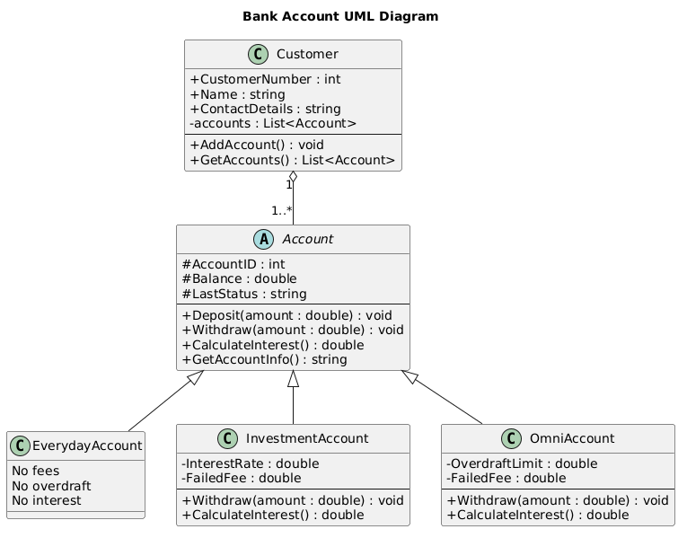

2. Technical Justification
The system architecture is based on Object-Oriented principles, in order to provide modularity, scalability and maintainability. An abstract class Account is created to describe a standard form of all type of accounts and it is not directly instantiated. This guarantees that only certain types of accounts like EverydayAccount, InvestmentAccount and OmniAccount may be created imposing real world banking restrictions.

The various account behaviours are modelled by applying inheritance. The subclasses are extensions of the base Account class, and some of the important methods like Withdraw() and CalculateInterest() are overridden by different subclasses in order to apply specific business rules. To illustrate, EverydayAccount rewrites the logic of withdrawal to guarantee no fee, no overdraft and no interest. Conversely, InvestmentAccount charges an interest rate and failure (Credit-Card) transaction fee whereas OmniAccount allows Balance overdraft and conditional interest on balances above 1000 dollars. This polymorphism enables the system to be flexible and easily extendable.
The Customer class is shown as an example of composition, storing a list of Account objects in List Account. This is a true representation of the situation in the real world where a customer may have more than one account. It also has a BankStaff class to reflect the staff positions, a 50% discount on transaction fees. This segregation makes sure that role specific logic is placed under different logic.
Access modifiers are used to enforce encapsulation, where private and protected fields are used to secure internal data but controlled access using a public method. Fees, interest, overdraft checks and other all financial calculations are all done in the domain classes and it is a clear separation of business logic and user interface.

3. Professional GUI Prototype
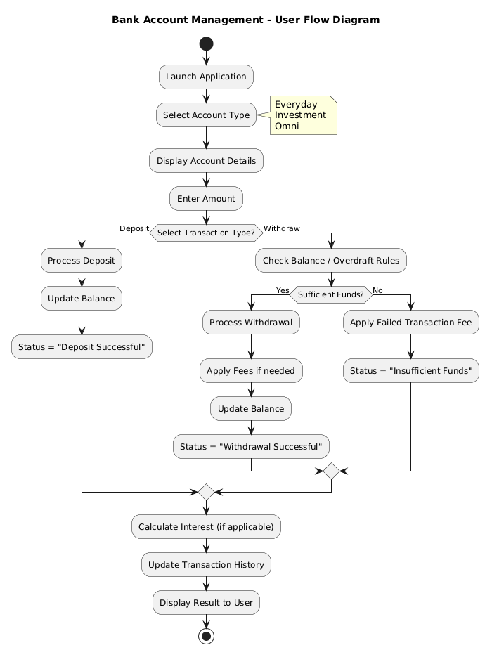

4. UI wireframe
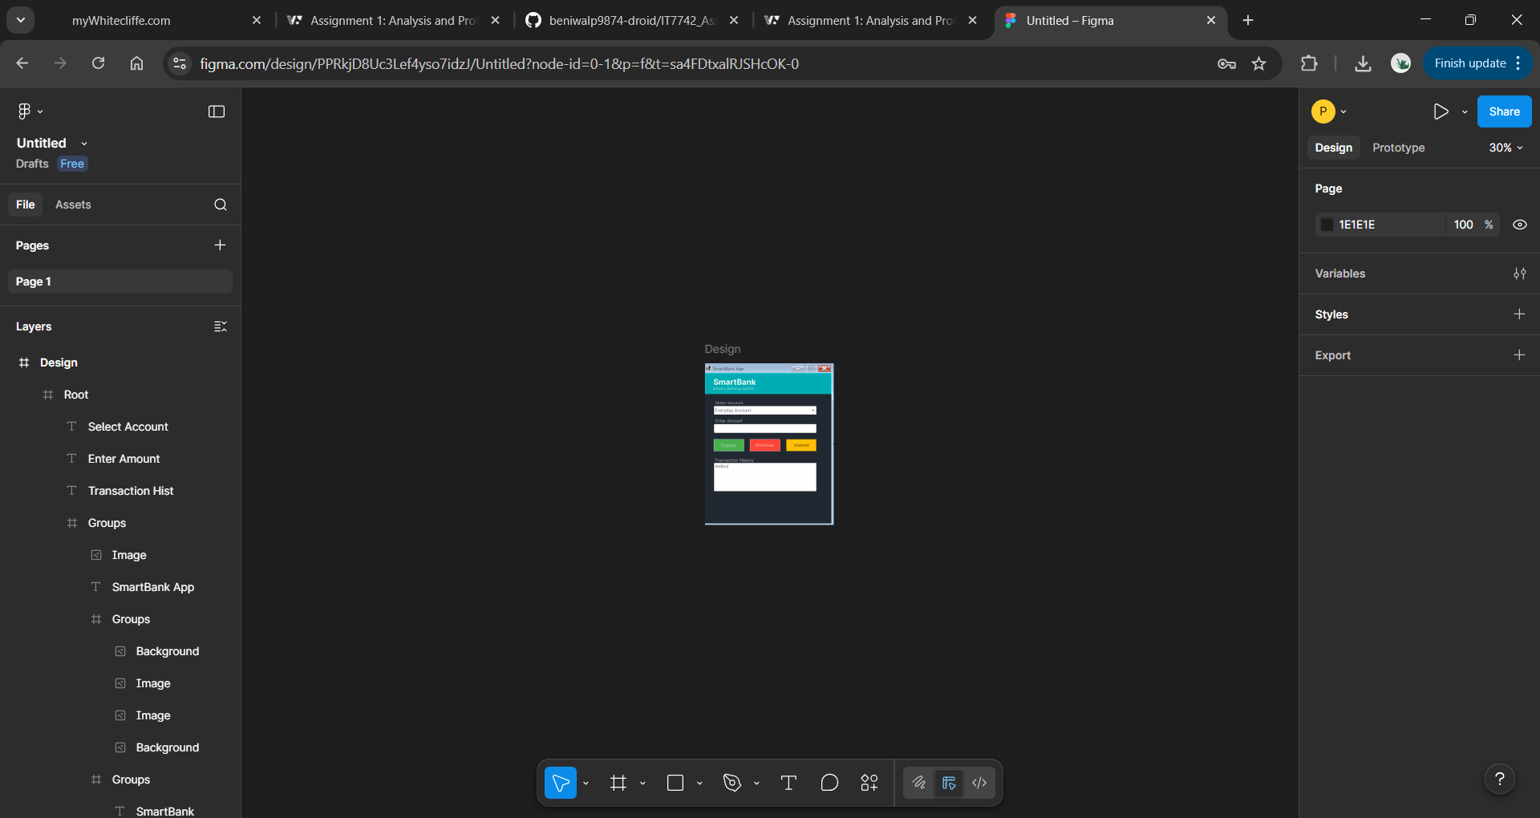
https://www.figma.com/design/PPRkjD8Uc3Lef4yso7idzJ/Untitled?node-id=0-1&t=sa4FDtxalRJSHcOK-1

5. C# implementation

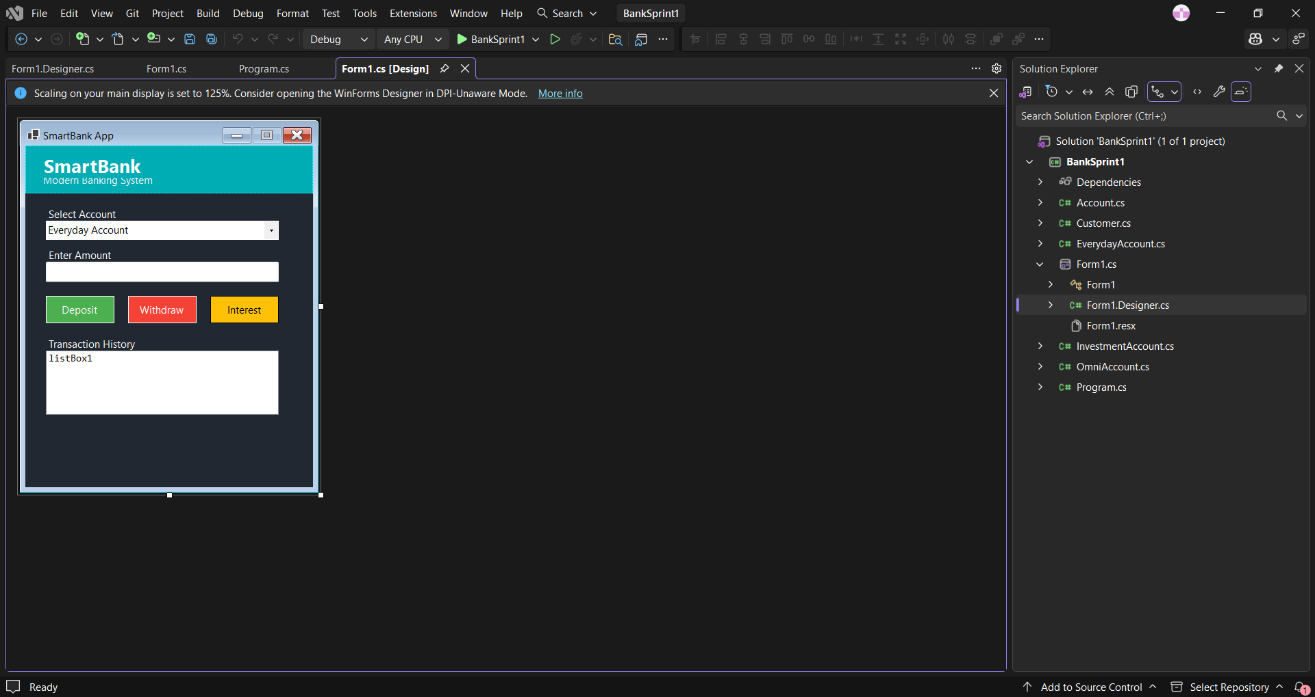

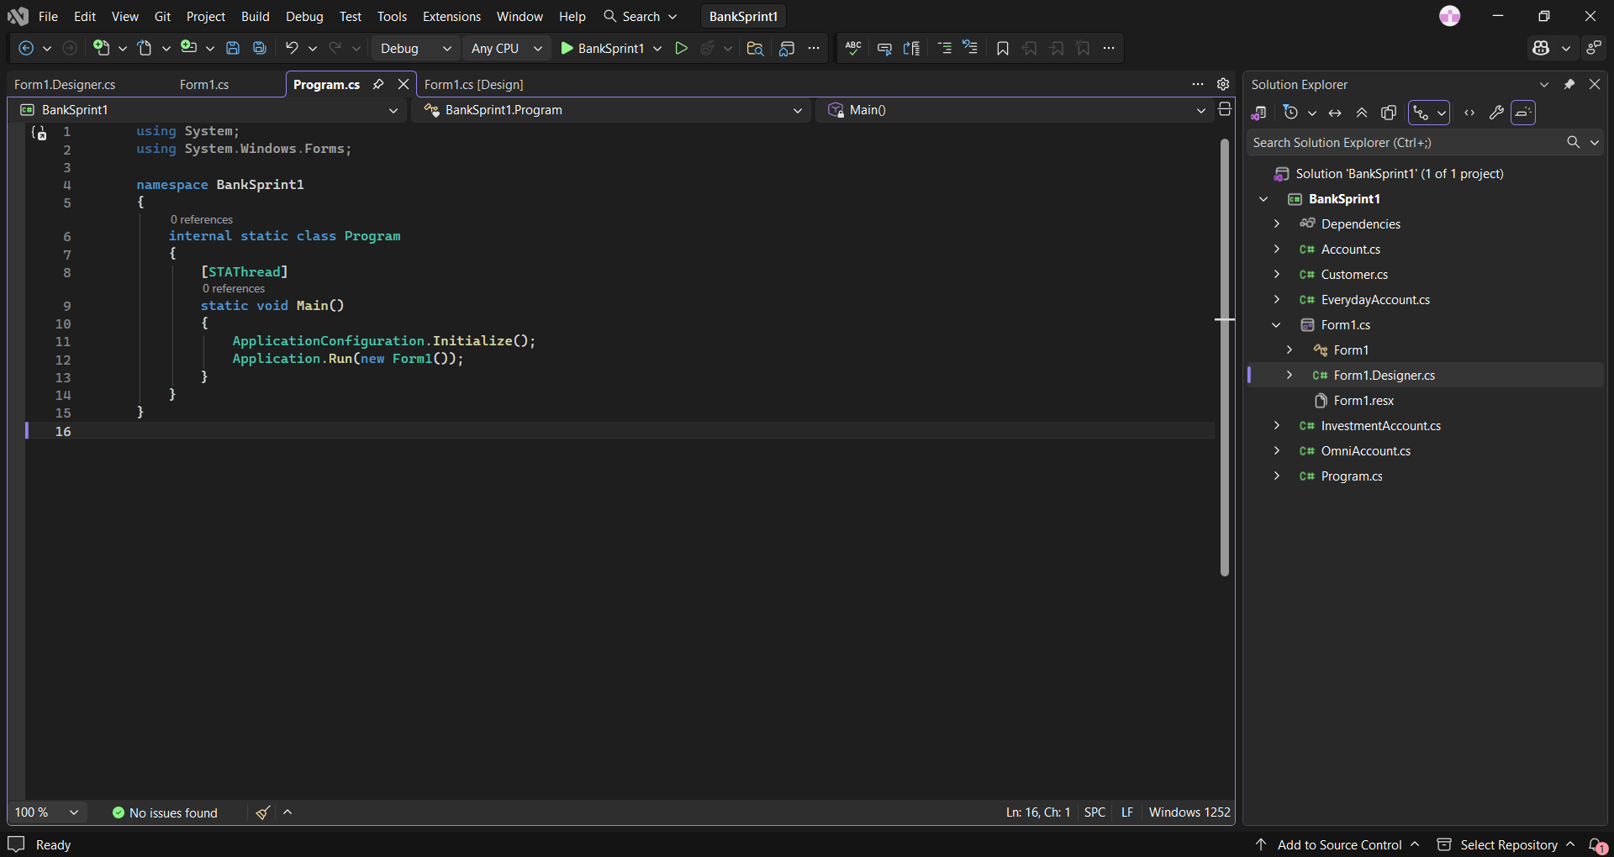

6. Github Link
https://github.com/beniwalp9874-droid/IT7742_Assignment-1-Analysis-and-Prototyping.git

