Summary of Models:

First Model:

Accuracy:

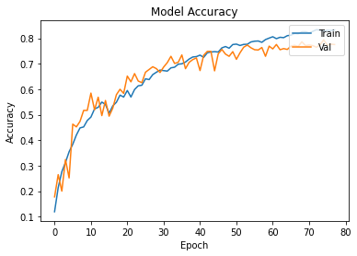

Loss:

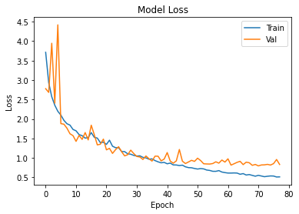

Evolution per Epoch:

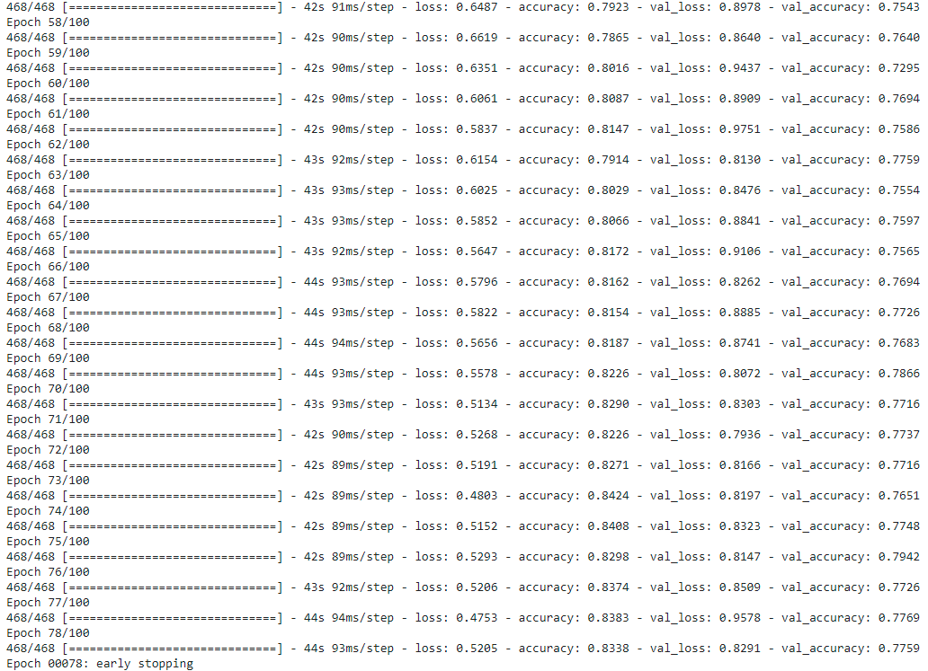

The final accuracy is of 0.8338 and the val_accuracy = 0.7759, meaning the model is good at generalizing and is not overfitting. Also, for the given Dataset, with few images and a lot of categories, the accuracy obtained is a better-than-expected result.

Transfer Learning Model:

Accuracy:

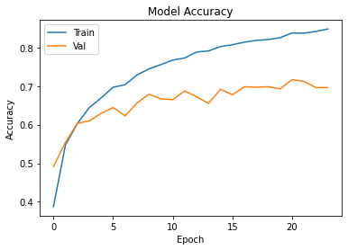

Loss:

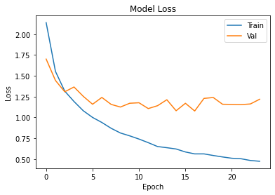

Evolution Per Epoch:

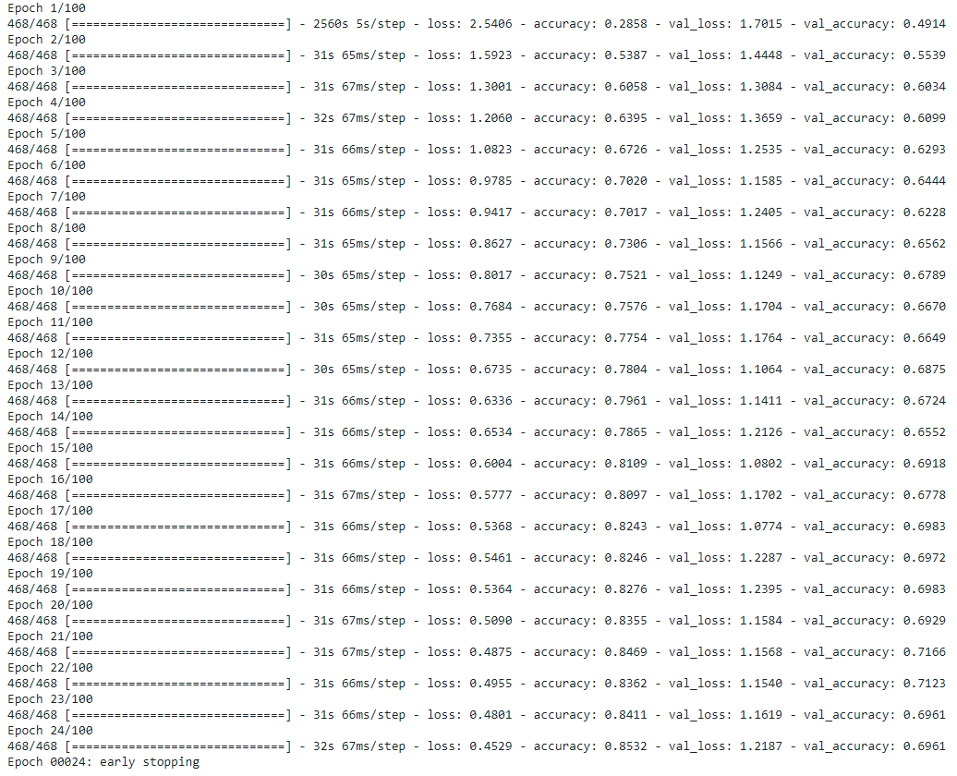

The final accuracy is of 0.8532, better than the first model, but the val_accuracy = 0.6961, meaning the model is poor at generalizing and is overfitting. It learnt the Train model with a high accuracy, but when presented with new data, it performs considerably worse.

In conclusion, the first model is more reliable, and although it had a smaller Dataset for training, it performs better for the task that was presented in categorizing in the 29 categories.