Documentation Packet [ 16 05 12 25 ] Dec 5th 2025
Student Name:
Goals:  - Update Boilerplate to cover every possible application | Events:  - No school Monday
Included Documentation  - Three Week Cycle, Week 1  - Three Week Cycle  - CIW Chapter 11  - Daily Reflections  - Weekly Reflections | Required Documentation:  - Three Week Cycle, Week 1  - Daily Reflections  - Weekly Reflections

Changes/Notes:
- Three Week Cycle in effect. See the root of the DocPac repo for more info ( “ThreeWeekCycle.docx” )
- All Exemption rules from previous weeks still apply.
- Additionally, “Conduct Scrum” and “Completed Issue Documentation” are for company work only.
- EVERYONE must complete “Document Work Completed”

CIW Lesson 11
- Log into ucertify.com with your school Google account.
- Complete Lesson 11
  - Read all pages
  - Complete all Knowledge Checks
  - Use all of the Flash Cards
  - Complete all quizzes until they are over 80%
  - Complete all Exercises over 80%
  - Copy the files from the Labs for this chapter and complete them all as instructed
- Complete and submit according to the “CIW Submission Rules” document

Conduct Scrum
- Elect a Scrum Master.
- The Scrum Master will use the flow chart to conduct the Scrum Meeting.
- Each member of the team will follow the directions for “Weekly Scrum” as per previous DocPacs.
- When the Scrum Master does an input/output step in the flow chart, every member writes down the answer to it in the table below the flow chart.
- Once the meeting is complete, each member is to start working on their issue(s).
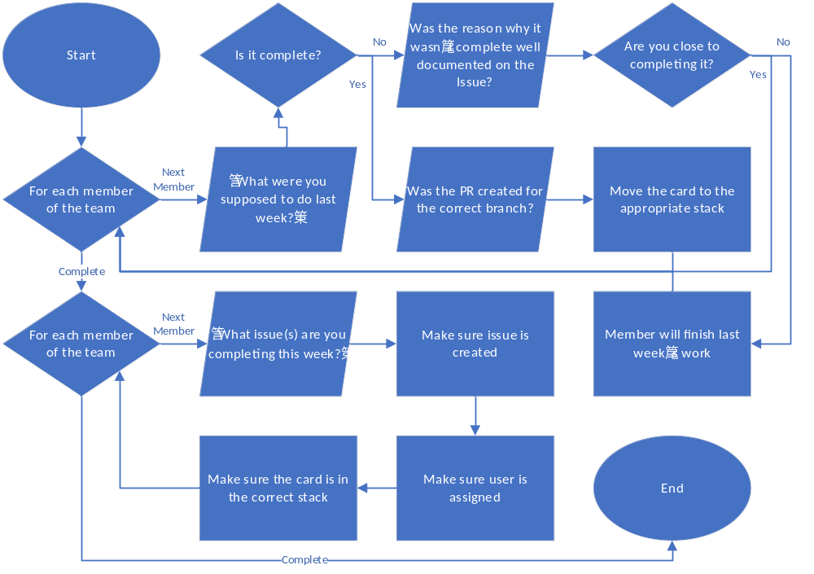
Member name
What issues are you completing this week?
Are the issues created, described, and in the correct project column?

Member name
What issues are you completing this week?
Are the issues created, described, and in the correct project column?

Member name
What issues are you completing this week?
Are the issues created, described, and in the correct project column?

Member name
What issues are you completing this week?
Are the issues created, described, and in the correct project column?

Document Work Completed
Day 1
What did you work on?
What did you complete?
What were your delays?
Day 2

Day 3

Day 4

Day 5

Completed Issue Documentation
Company / Project |  | Company / Project
Issue # |  | Issue #
PR submitting Fix |  | PR submitting Fix
Project Manager  Signature |  | Project Manager  Signature
Notes |  | Notes
Company / Project |  | Company / Project
Issue # |  | Issue #
PR submitting Fix |  | PR submitting Fix
Project Manager  Signature |  | Project Manager  Signature
Notes |  | Notes

Grading

Updated Boilerplate
1 | Due Next Week | Rubric will be placed here

CIW Lesson 11 CIW Submission Rules
1 | Submitted Correctly | Rubric will be placed here
3a | Read / Knowledge | All pages read. All Knowledge Checks completed
3b | Flash cards | All flash cards used
3c | Quizzes | All quizzes 80% or higher
3d | Exercises | All Exercises over 80%
3e | Labs | All labs complete as instructed

Conduct Scrum Company:________________________
1 | Had Meeting | Company conducted their meeting, and you were present
2 | Issues | Issues were assigned
3 | Documented | Issues were documented properly on the project’s repo.

Document Work Completed
1 | Clarity | Teacher is able to accurately determine what you worked on
2 | Time Management | The work you did reasonably matches the time given to do it

Completed Issue Documentation
1 | Time Management | Issues were completed in reasonable time
2 | Verified | Project Manager signed that you completed each issue
3 | Documentation | Issue and PR are properly documented on the Github Repo and in DocPac

DocPac and Reflection
1 | DocPac is turned in on time
2 | Answered each question in each prompt fully (no short answers)
3 | Spelling and handwriting
4 | DocPac is neatly folded
5 | DocPac is not stained or damaged
6 | No doodles, scribbles, or unnecessary writing
7 | No repeated answers from other DocPacs
8 | Did not paraphrase assigned work
9 | You are prepared to justify the use of any AI (you know what it does and why)

